FOR CA FIRMS · SURAT
KnowledgeHub AI
Client bills in. Checked data out.
Prepared for: ______________________________ Date: ______________
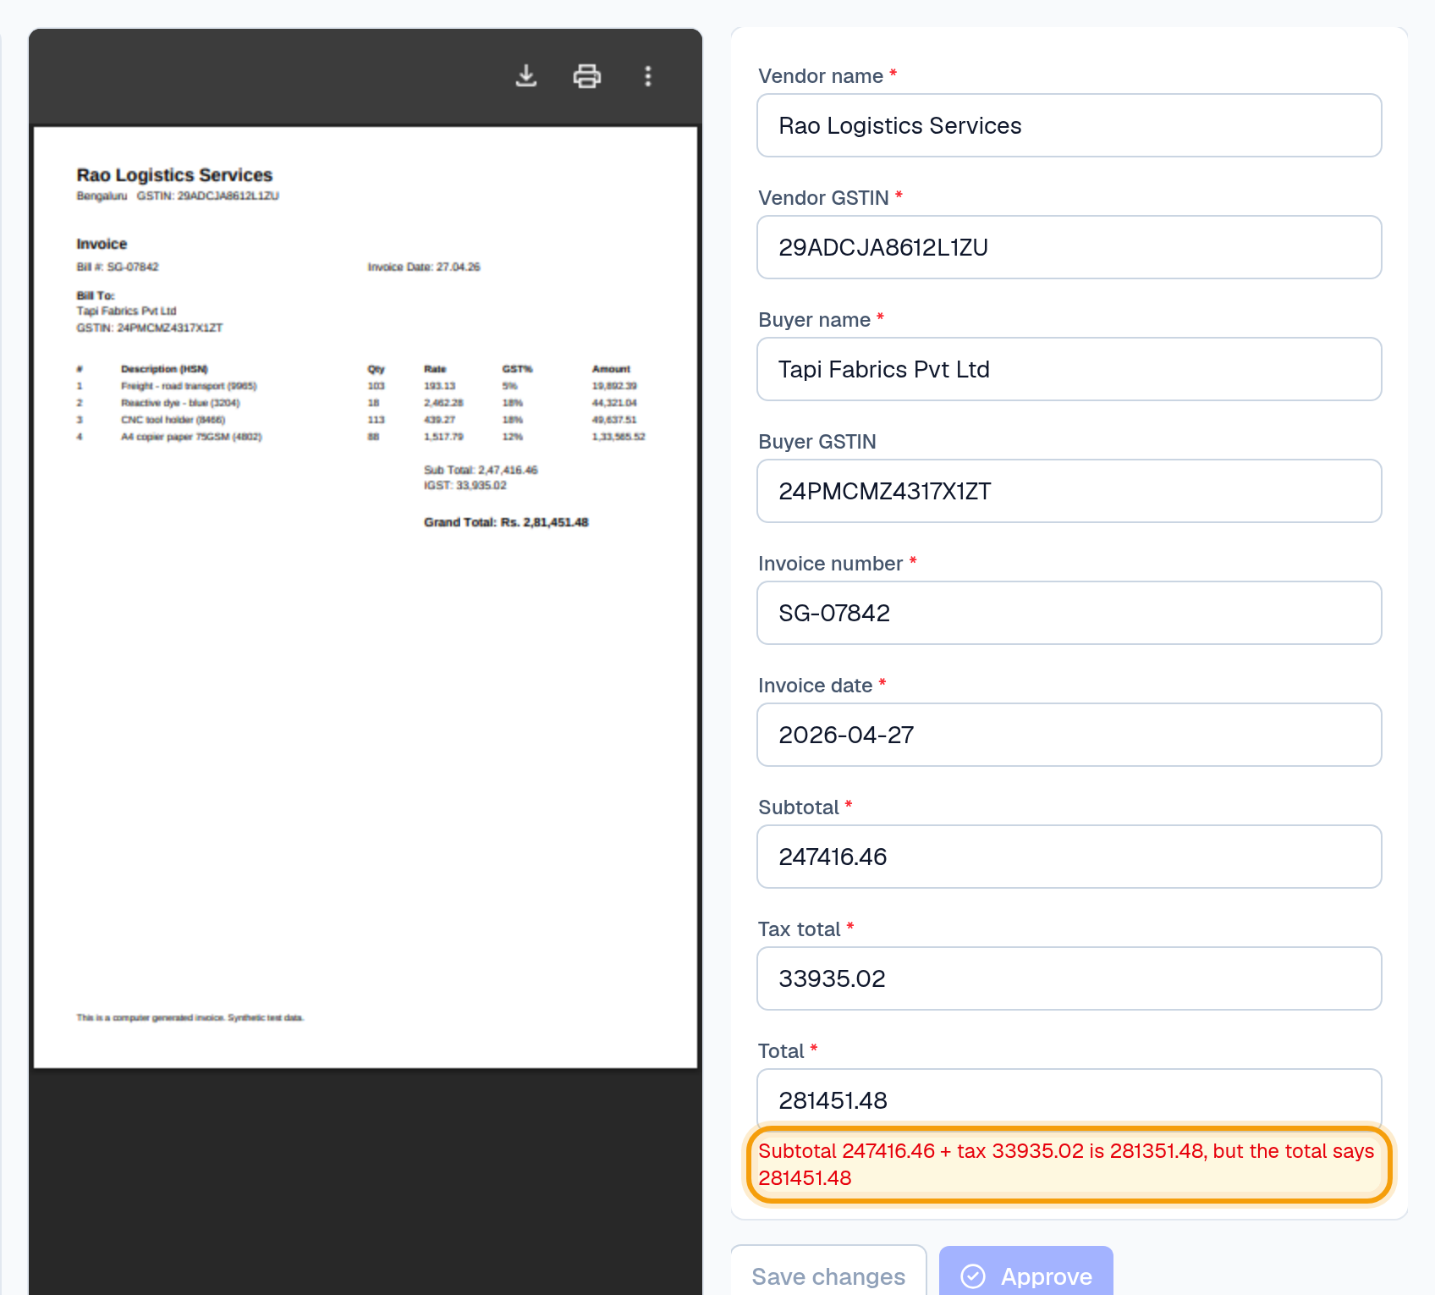
A wrong invoice total caught before it reaches the books.
In one line
KnowledgeHub AI reads your clients' purchase invoices (PDFs, scans and WhatsApp photos), checks them against your rules, and gives your team one review screen where nothing goes out unapproved, with every correction recorded.

The month-end problem
- Bills arrive everywhere: WhatsApp photos, emails, PDFs and paper, often at month-end.
- Typed in by hand: vendor, GSTIN, invoice number and amounts, client after client.
- Mistakes found late: wrong totals, invalid GSTINs, the same bill entered twice.
- Deadlines don't move: GSTR-1 on the 11th, GSTR-3B on the 20th.

How it works
Step | What happens
1 Upload | PDFs, scans, DOCX and phone photos. Merge, split, keep pages or rotate without other software.
2 Read | OCR and an invoice reader fill in vendor, GSTINs, invoice number, date and amounts.
3 Check | Your validation rules, set per client, flag problems as errors or warnings.
4 Review | Your team compares each invoice with the original and fixes anything. Every change is recorded.
5 Approve | Only invoices without errors can be approved.
6 Export | Approved invoices to Excel, with real numbers and dates (Tally export in development).

What it checks
Check | What it catches | Default
GSTIN is valid | Wrong format or check digit, e.g. OCR reading 0 as O | Error
Total = subtotal + tax | Totals that don't add up (₹1 round-off allowed) | Error
Duplicate invoice | Same vendor GSTIN and invoice number, even PDF vs photo | Error
Tax rate plausible | Tax above the expected share of the subtotal | Warning
Billed to this client | Bills carrying another GSTIN than the client's | Optional
Invoice date checks | Future dates, or bills older than a set number of days | Optional
Large amount | Totals above your threshold | Optional
Your own rules | If [field] [condition] [value] → error or warning, with your message | Optional

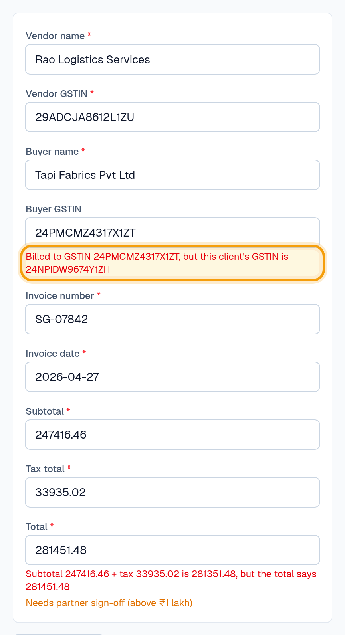
Right client name, wrong GSTIN: flagged by the 'Billed to this client' rule.

Also included
- PDF tools: merge, split into one document per page, keep selected pages, rotate. Originals never change.
- Ask your documents: plain-language questions, answered only from the client's documents, with the source page.
- Team and roles: owner, admin and member; each client in its own workspace.

Your clients' data
- Separated: each firm and each client is fully separated from every other.
- Recorded: logins, uploads, corrections (old → new value), approvals and exports, with time and user.
- Private: documents stay in the platform; AI provider keys are encrypted and never shown again.
- Honest status: no formal security certification yet.
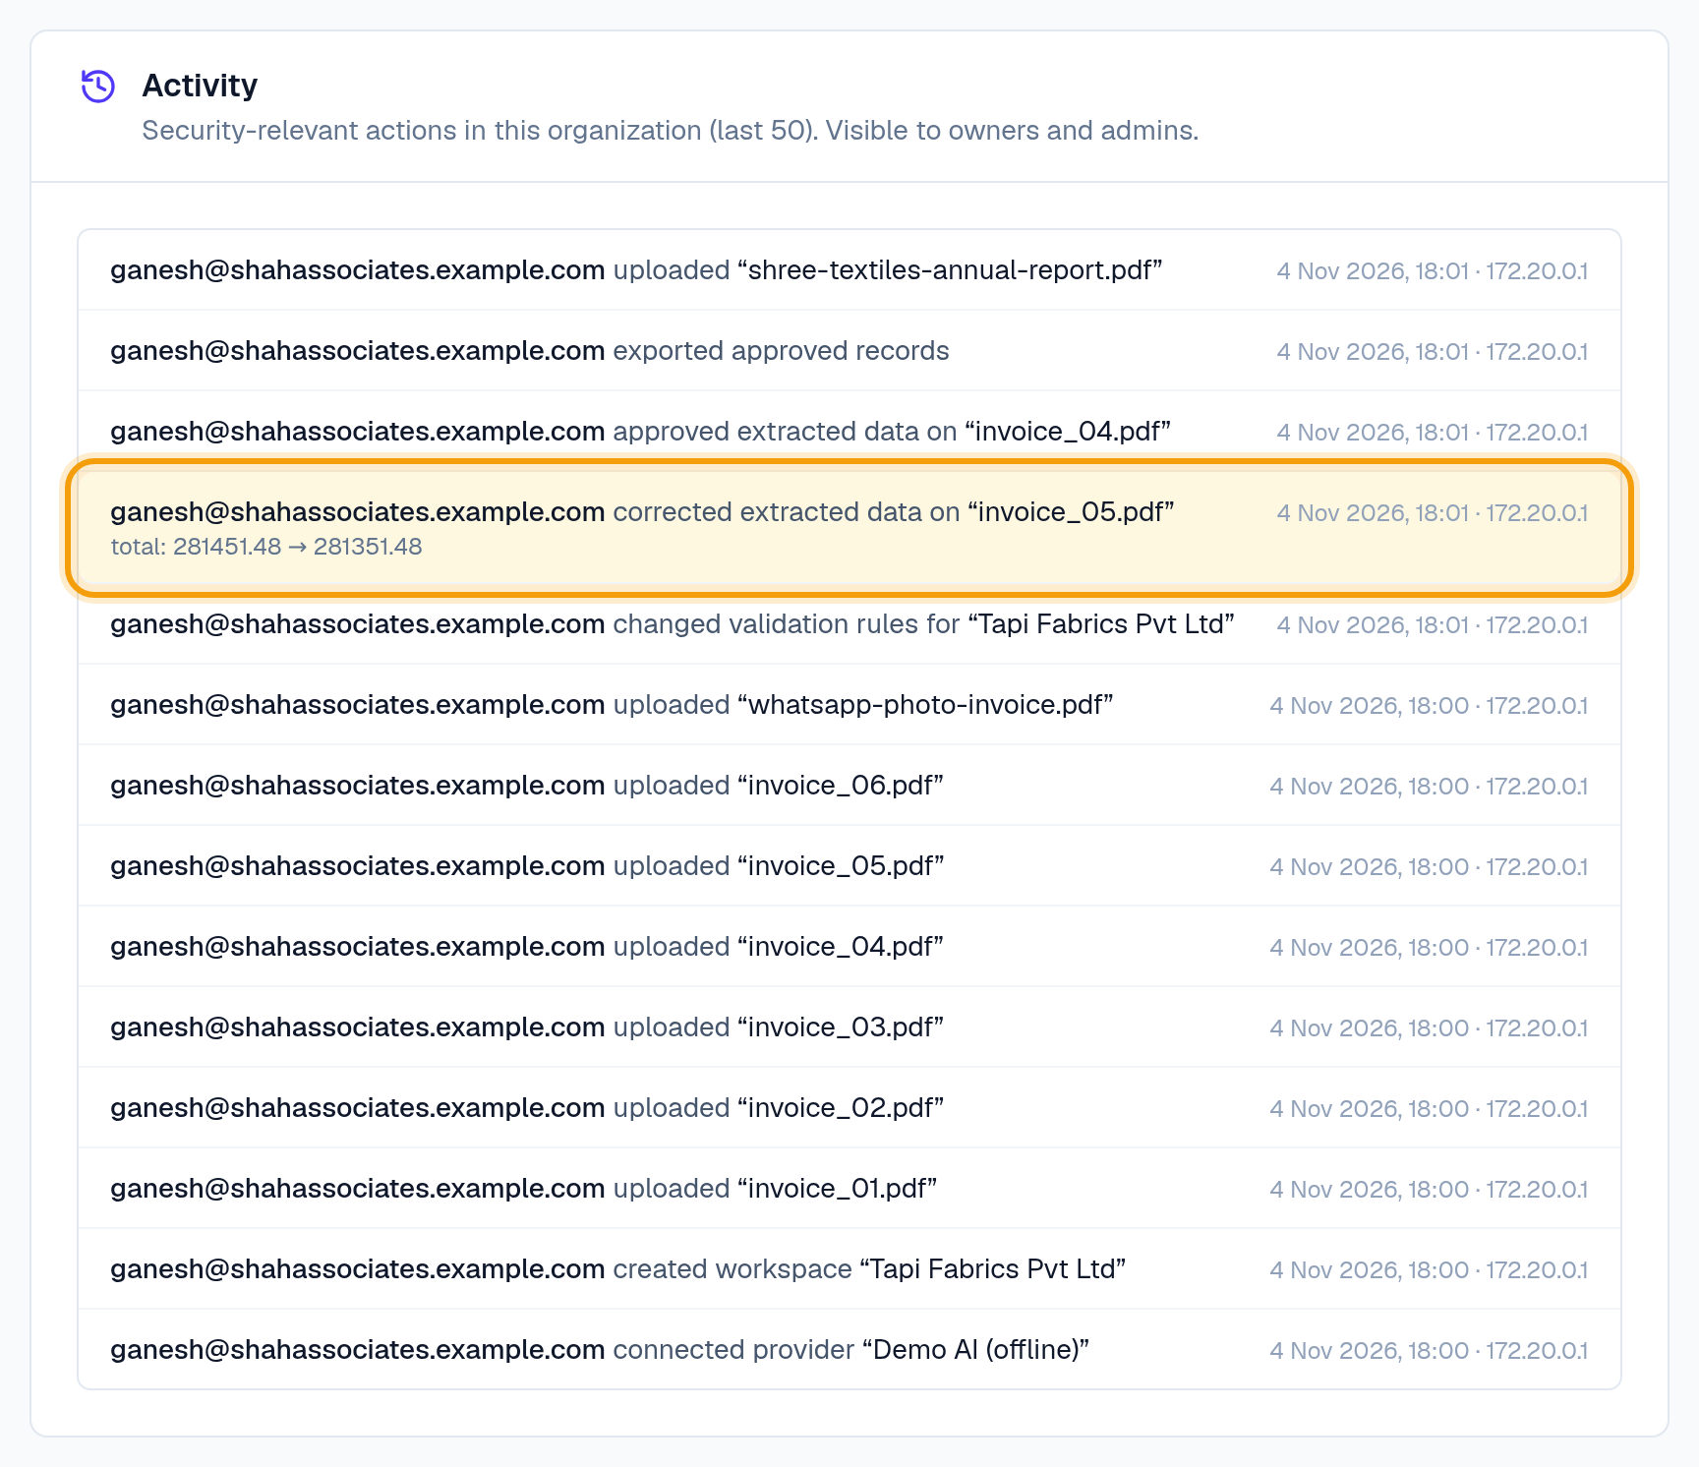
Activity log: every action recorded, including corrected figures.

Founding-firm pilot proposal
 | Proposal
Duration | 2 weeks
Scope | Your real purchase invoices, up to 300
We do | Set up your clients, rules and team; support in person in Surat
Success means | 90–95% or more of fields correct on readable invoices, and less time per invoice than today (measured before the pilot starts)
You give | Weekly feedback, and a testimonial if it works
Price | No charge for founding firms

First step
Share 50–100 of last month's purchase bills. We'll show you the results on your own data.

What we're building next
You decide the order:
- Tax breakdown: line items, HSN, CGST/SGST/IGST and rate checks.
- Tally export: Tally-importable vouchers with ledger mapping per client.
- GSTR-2B reconciliation: matched, amount differs, missing in 2B (credit at risk), missing in books.
- Faster bill collection: WhatsApp/email inbox, monthly checklist per client, reminders.

Contact
Ganesh Rajput · grt7045@gmail.com

