INTERNAL · RUNBOOK V2
KnowledgeHub AI Runbook
Run it, sell it, operate it: the product and the licence system.
5 Nov 2026 · matches commit 3bf52f8 · companion to the v1 demo playbook and docs/licensing-plan.md
What changed since v1
v1 was about demoing the product. v2 adds the business side: a customer website, an admin panel for prices and payments, and signed licences for the desktop app, plus pricing research. The desktop app does not check the licence yet and there is no Windows installer yet, so sell pilots until Phases 2–3 are done.

1. The whole system
There are two parts. Your licence server runs online; the product runs on the CA's computer. They talk only at login, for a few seconds.
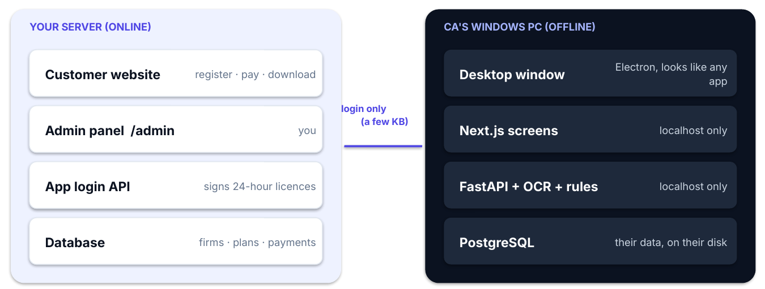
Part | Where | What it does
Customer website | Your server, / | Pricing, register, pay instructions, 'I have paid', download, computers, team
Admin panel | Your server, /admin | Plans & prices, firms, payments, trials, blocks, logins, CSV, activity log
App login API | Your server, /api/app/v1 | Checks the subscription and signs a 24-hour licence
KnowledgeHub app | CA's Windows PC | Extraction, rules, review, PDF tools, Q&A, export; data stays local

2. How the app runs offline
The product is built with web technology, but it doesn't need the internet. You already run it on your own computer: web screens on localhost:3000, the API on localhost:8001 and Postgres. The Windows installer (Phase 3) will put exactly that on the CA's PC:
- A desktop window (Electron) shows the screens. No browser and no address bar.
- Everything listens on localhost only, so nobody on their network or the internet can reach it.
- One double-click starts the database, the API and the window, and shuts them down on exit.
- Internet only at login: a few seconds when the app opens; after that up to 24 hours offline.
VS Code, Slack and WhatsApp Desktop are built the same way.

3. Running everything locally
Task | Command / address
Product app (first time) | ./setup.sh
Product app (daily) | ./run.sh → web :3000 · API :8001
Licence server (first time) | cd licensing · alembic upgrade head · python -m app.cli create-admin you@… · python -m app.cli generate-keys
Licence server (daily) | cd licensing · .venv/bin/uvicorn app.main:app --port 8002
Website / admin | http://localhost:8002 · http://localhost:8002/admin
Tests | backend: 237 tests · licensing: 66 tests (python -m pytest)

First-time setup of the licence server, step by step:
cd licensing
uv venv --python 3.12 .venv && uv pip install --python .venv/bin/python -r requirements-dev.txt
cp .env.example .env
.venv/bin/alembic upgrade head
.venv/bin/python -m app.cli create-admin you@example.com "Your Name"
.venv/bin/python -m app.cli generate-keys
.venv/bin/uvicorn app.main:app --port 8002
Guard the signing key
licensing/keys/lease_private.pem creates licences. Anyone with it can make their own. It is excluded from git: back it up offline, and keep the public key that generate-keys prints (it goes into the desktop app). Replacing the key logs out every installed app.

4. Customer journey
Step | What happens
1 Register | Customer signs up on your website and picks a plan. Firm is Pending payment.
2 Pay | Their account shows the amount incl. GST, your UPI / bank details and a KH- reference.
3 I have paid | They enter the UTR. It appears on your admin dashboard.
4 You activate | Check the UTR in your bank app → Check & activate → Record payment.
5 Download & log in | Download button appears. The app logs in with the same email and password.

Step 1 · Website
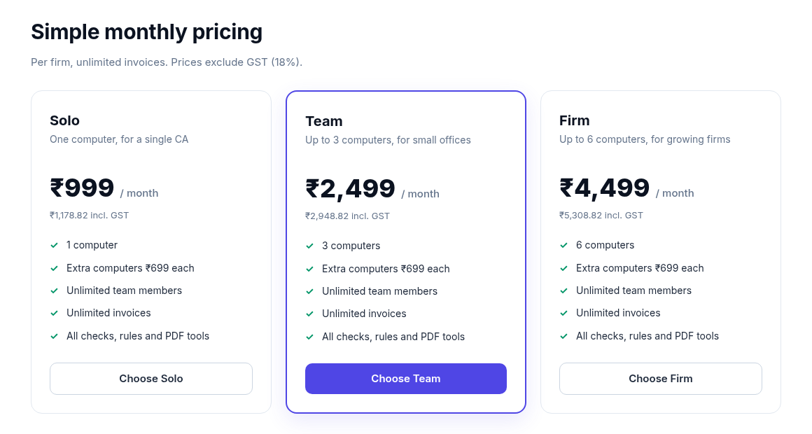
Pricing cards come live from Admin → Plans & prices.

Steps 2–3 · Payment and 'I have paid'
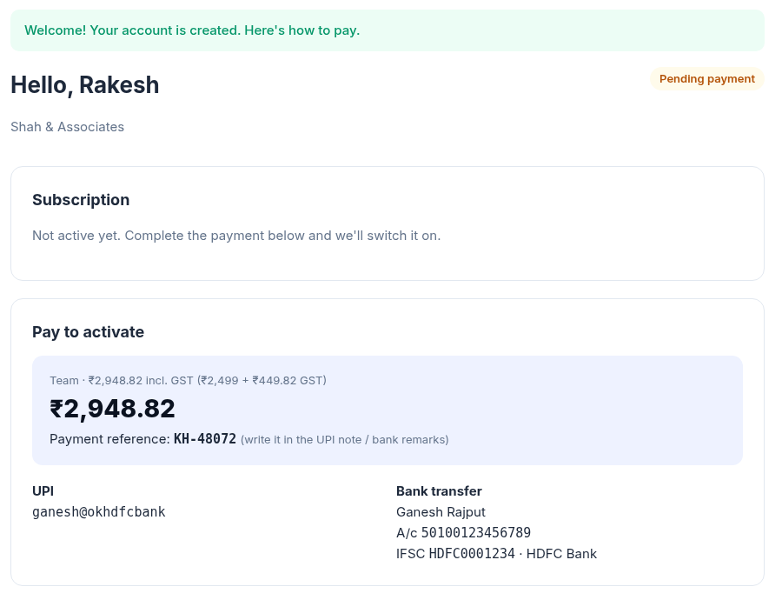
Amount incl. GST, your payment details and the KH- reference.

Step 4 · You activate
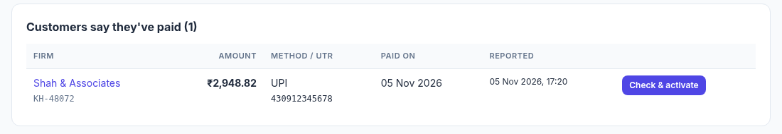
Dashboard: payments customers have reported.
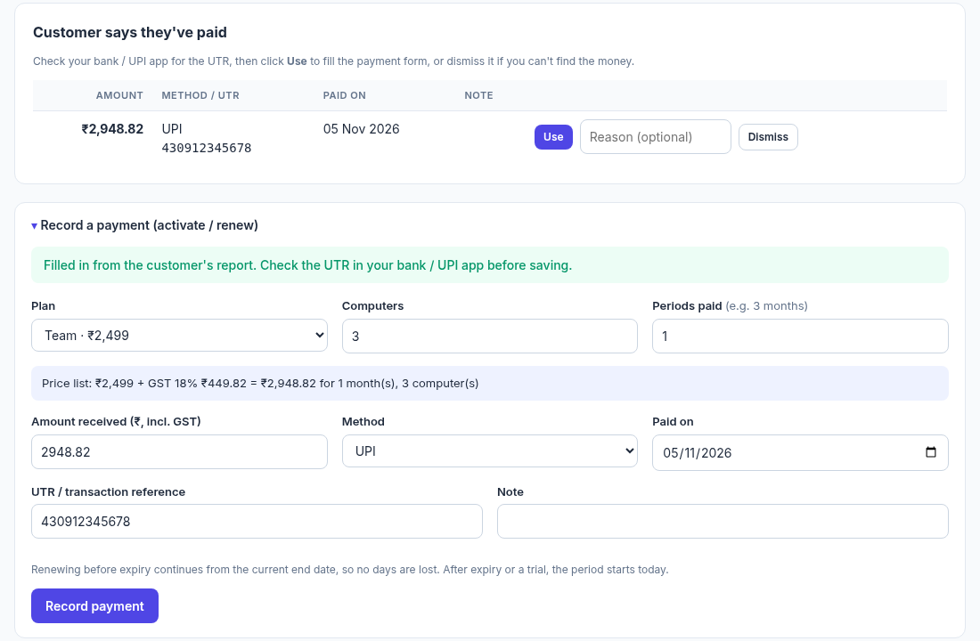
Payment form filled in from the report. Check the UTR first.
- Always find the UTR and amount in your bank or UPI app before clicking Record payment.
- Lower amount? Allowed (discounts), but the activity log notes the price-list total.
- Can't find the money? Dismiss the report with a reason; the customer can report again.

Step 5 · Download and log in
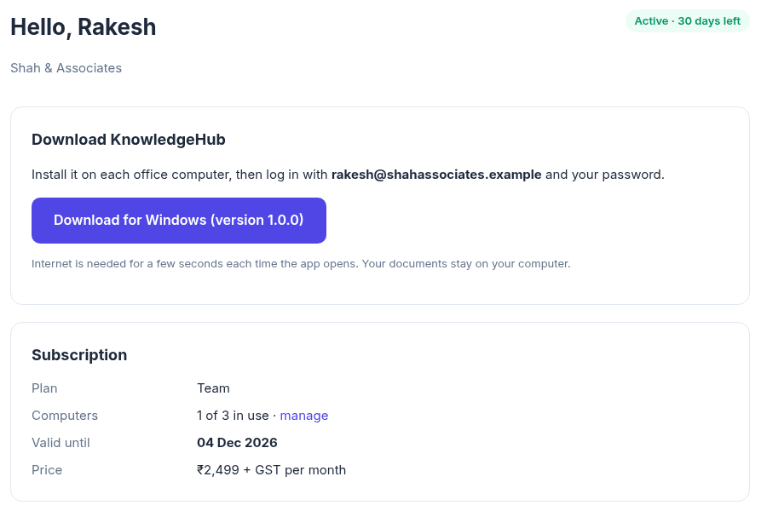
Active account: download button and subscription details.

5. Everyday admin tasks
I want to… | Where
Activate a firm after payment | Dashboard → Customers say they've paid → Check & activate → Record payment
Firm paid without reporting it | Firms → firm → Record a payment (price-list total is pre-filled)
Renew | Same form. Before expiry it continues from the end date; after expiry it starts today
Change a price / plan | Plans & prices → Edit. Existing firms keep the price they paid
Private deal | New plan with 'Show on website' unticked
Trial for a pilot | Firm → Start a free trial (days, computers)
Goodwill days / fix a mistake | Firm → Adjust end date or computers (reason required)
Customer forgot password | Firm → Logins → Set new password (also unlocks the account)
New PC but all seats used | Customer removes one in My account → Computers, or you remove it on the firm page
Licence misuse | Firm → Block firm, or block a single computer
Monthly figures for your CA | Payments → month → Download CSV
UPI, bank, GST %, grace days, download link | Settings

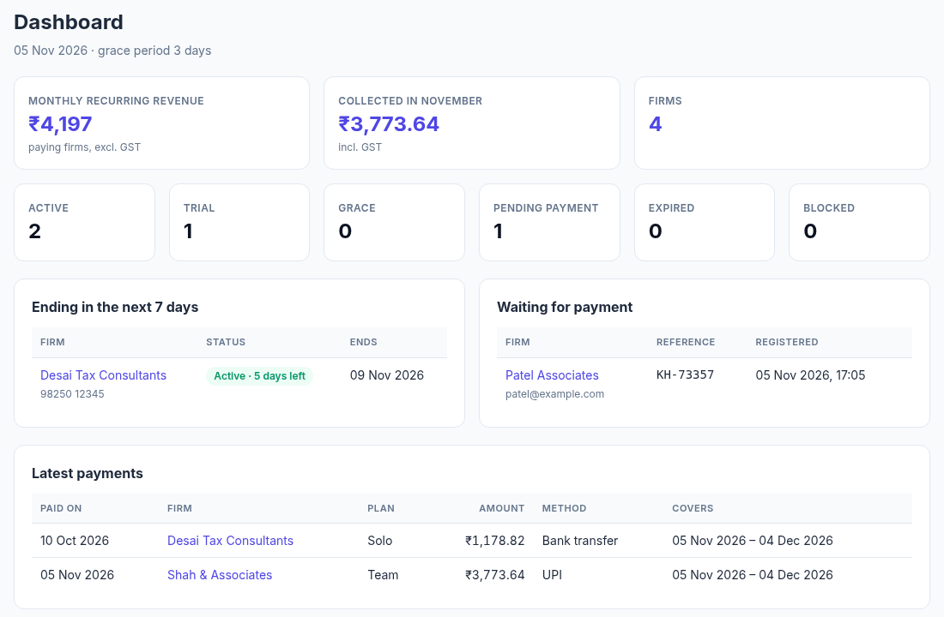
Admin dashboard: revenue, statuses, renewals due, pending payments.

6. Plans and pricing
From docs/CA-pricing-research.md (5 Nov 2026, prices excl. GST; vendor pages, see sources there):
Product | Price / model
Vyapar TaxOne (formerly Suvit) | ₹7,000/year, one 'Unlimited' plan, 7-day trial
Tally | Silver ₹22,500 + ₹4,500/yr renewal · Gold ₹67,500 · rental ₹750/month
Tally 'Docs by Ira' (invoice OCR) | ₹200 per 100 pages
Typical small firm | ₹5,000–25,000 a year per product; trials 7–30 days; multi-year 10–20% off

Suggested starting plans (recommendation, not market data)
Solo ₹999/month (1 computer) · Team ₹2,499 (3) · Firm ₹4,499 (6) · extra computer ₹699 · yearly = 10× monthly. Unlimited invoices, since OCR runs on their computer. Trials granted by hand for pilots. Note: no CA product in the research requires an online login at every start, so our 24-hour rule is stricter than usual.

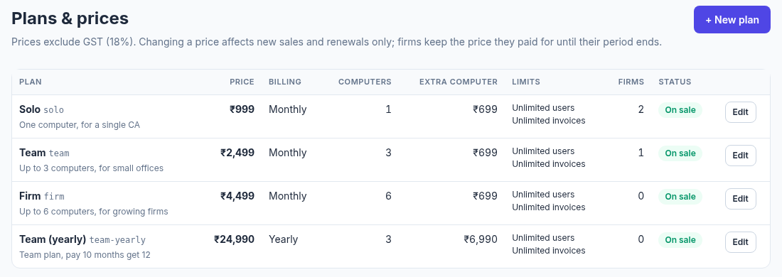
Admin → Plans & prices. Price changes apply to new sales and renewals only.

7. Licence rules and troubleshooting
- Licence length: 24 hours (Settings → Login valid for), never beyond subscription end + grace days.
- Kept in memory only, so closing the app means logging in again.
- Computers: a seat is taken at the first login on a PC; customers can free 2 seats per month.
- Blocking: takes effect at the next login, at most 24 hours later.
Customer sees | Code | What you do
Wrong email or password | invalid_credentials | Check spelling; reset password in the firm's Logins panel
Too many wrong passwords | locked | Wait 15 minutes, or set a new password (unlocks)
Subscription isn't active yet | no_subscription | Confirm their payment
Subscription ended on … | expired | Record the renewal payment
All computers in use | computer_limit | Remove an old computer, or sell extra computers
Account / computer blocked | firm_blocked / computer_blocked | Unblock if resolved
Please install the latest version | update_required | Send the download link

8. Go-live checklist
✓ | Task
☐ | Domain + small VPS (₹1–2k/month) with HTTPS (e.g. Caddy)
☐ | Licence server .env: real DATABASE_URL, COOKIE_SECURE=true, PUBLIC_URL=https://your-domain
☐ | Run uvicorn with --proxy-headers and a single worker
☐ | generate-keys on the server; back up keys/lease_private.pem offline; keep the public key for the app
☐ | Strong admin password (create-admin); daily database backup
☐ | Admin → Settings: UPI ID, bank details, GSTIN, support email/phone, grace days
☐ | Admin → Plans & prices: your real plans
☐ | Admin → Settings → Desktop app: download link + version (once the installer exists)

9. Status and next steps
Done | Not yet
Product: extraction, rules per client, review & audit, PDF tools, Q&A, Excel export | Licence check inside the desktop app (app doesn't refuse to run yet)
Licence server: customer website, admin panel, manual payments, signed 24-hour licences | Windows installer (Electron + bundled Postgres, Nuitka-compiled API)
Pricing research and suggested plans | Password-reset emails, Razorpay, GST invoices for your sales
Demo kit v1 (deck, overview, playbook) | Tally export, GSTR-2B reconciliation, line-item GST checks

Next | What
Phase 2 | Licence check in the app: login screen, lease kept in memory, every API call checked
Phase 3 | Windows installer: one click, offline, auto-update, daily backups
Phase 4 | Code signing, Razorpay auto-activation, GST invoices
Product | Tax breakdown → Tally export → GSTR-2B, ordered by what CA firms say

For product demos, the v1 playbook (demo/KnowledgeHub-AI-Demo-Playbook) still applies.

