Pipeline 1:

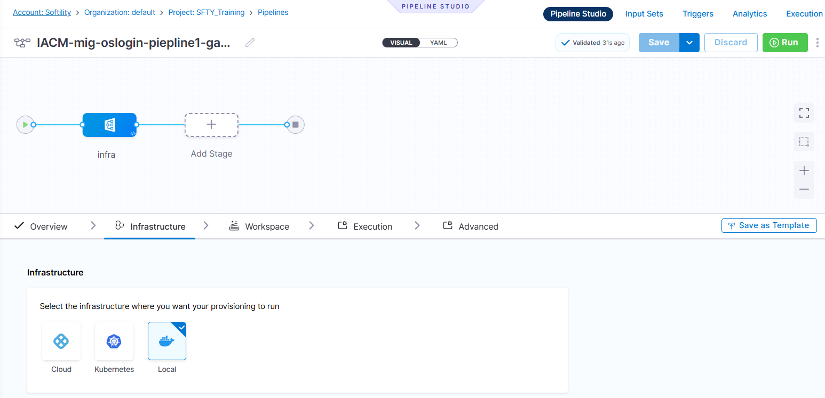

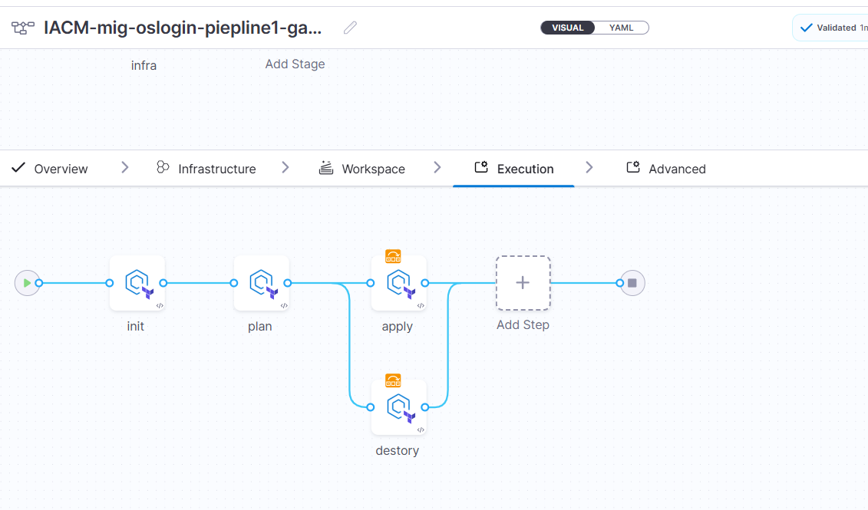Steps:

Here we just create the pipeline with variables choice   
<https://github.com/ganesh-redy/mig-oslogin-ansible.git>

Pipeline 2:

Here we take ip’s and store in ansible/hosts file and for ssh we take the private key from vault

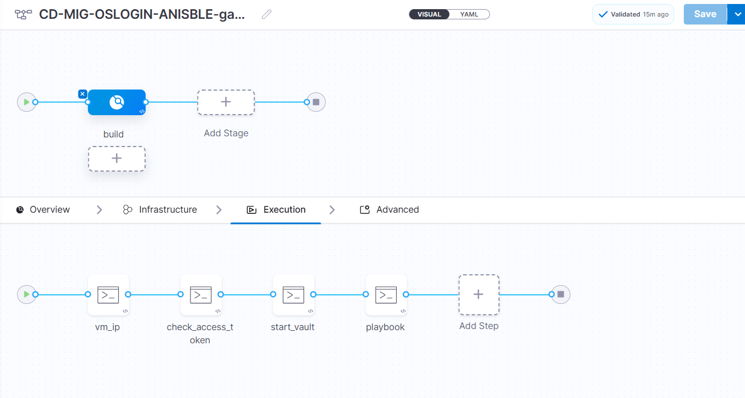Then ansible will connect to that system

Step 1: vm_ip

gcloud compute instances list   --filter="name~'^okay-.*'"   --format="value(networkInterfaces.accessConfigs.natIP)" | tr -d "[]'"  > /etc/ansible/hosts

cat /etc/ansible/hosts

Here we take the ip’s from gcp, instance named as okay because the mig instances base name is start with okay

And store in ansible/host file  
  
step2: check_access_token

echo 'token <+secrets.getValue("oslogin-delegate-token")>'

here we have Docker delegate it consist token, that token was passed in runtime and place as variable in ansible this token was store in secrets.

Step 3: start vault

#!/bin/bash

# Set Vault address

export VAULT_ADDR='http://35.202.207.99:8200'

# Stop any running Vault process

pkill vault || echo "No Vault process found."

# Start Vault server in the background

nohup vault server -config=/etc/vault.d/vault.hcl > /var/log/vault.log 2>&1 &

# Wait for Vault to start

sleep 5

# Write unseal keys to /root/text

echo '<+secrets.getValue("ganesh-vault-unseal")>' > /root/text

cat /root/text

# Unseal Vault using the keys

vault operator unseal "$(cut -d ' ' -f1 /root/text)"

vault operator unseal "$(cut -d ' ' -f2 /root/text)"

vault operator unseal "$(cut -d ' ' -f3 /root/text)"

# Login to Vault

vault login '<+secrets.getValue("vault-usertoken-ganesh")>'

vault status

# List secrets at path 'my/'

vault kv list my/

vault kv get my/private_key

# Retrieve the private key and save it securely

vault kv get -field=private-key my/private_key > /tmp/privatekey

chmod 600 /tmp/privatekey

first we need export the vault ip of or local system then we can access ui

step 4 :

#!/bin/bash

# Fail on error

set -e

ls -l /tmp/privatekey

# === [1] Variables ===

# Replace with your actual playbook and VM user if different

ANSIBLE_DIR="/etc/ansible"

INVENTORY_FILE="$ANSIBLE_DIR/hosts"

ANSIBLE_CFG="$ANSIBLE_DIR/ansible.cfg"

PRIVATE_KEY_PATH="/tmp/privatekey"

VM_USER="sa_106301816075024666979"

# === [4] Write Ansible config ===

cat <<EOF > "$ANSIBLE_CFG"

[defaults]

inventory = $INVENTORY_FILE

host_key_checking = False

retry_files_enabled = False

remote_user = $VM_USER

private_key_file = $PRIVATE_KEY_PATH

EOF

# === [5] Optional: Set environment to use this config ===

export ANSIBLE_CONFIG="$ANSIBLE_CFG"

# === [6] Run Ansible ping to test connection ===

ansible all -m ping

git clone https://github.com/ganesh-redy/mig-oslogin-ansible.git

cd  mig-oslogin-ansible

# === [7] Run your playbook ===

ansible-playbook -e 'token=<+secrets.getValue("oslogin-delegate-token")>' ansible.yaml

rm -f /tmp/privatekey