Simultaneous Gene Selection and Cancer Classification using a Hybrid Intelligent Water Drop Approach

Manish Kumar Shameek Ghosh Jayaraman Valadi Patrick Siarry*
Bioinformatics Center ECIP Shiv Nadar University Université Paris-Est Créteil
University of Pune C-DAC Uttar Pradesh - 203207 LiSSi (EA 3956),
Pune, India Pune, India India France
rishimanish123@gmail.com shameekg@cdac.in jayaraman.valadi@snu.edu.in siarry@u-pec.fr

Abstract— Computational Analysis of gene expression data is extremely difficult, owing to the complexity of the associated datasets. The complexity is due to the existence of a huge number of expression profiles and less number of instances (limited number of patients). Due to the structure of data dimensions, the efficiency and performance of most prediction algorithms are affected. Thus, to improve the robustness and efficiency of a classification algorithm, it is of significant importance to provide the same with a set of the most informative genes. In this context, we propose a hybrid Intelligent Water Drop (IWD) - Support Vector Machines (SVM) algorithm, with weighted gene ranking as a heuristic, for simultaneous gene subset selection and cancer detection. The performance of the hybrid algorithm is evaluated on three cancer gene expression datasets retrieved from the Kent Ridge Biomedical datasets collection and the libSVM data repository. Our results demonstrate that the genes selected by the IWD technique yield classification accuracies comparable to previously reported algorithms.
Keywords—Gene Selection; Cancer Classification; Intelligent Water Drop based Optimization; Weighted Ranking)

Introduction
Microarray gene expression experiments provide the expression levels of thousands of genes. This helps in the diagnosis of various types of diseases. However, an impediment to this technique is the complexity of the data. Intelligent hybridizations of computational techniques are thus necessary for classifying cancerous samples with high predictive accuracy based on the gene expression profiles. The number of genes is normally much greater than the number of samples (instances) in the dataset. Such a composition makes the classification problem difficult to solve since, out of thousands of genes, most genes do not correlate with the prediction process. To improve accuracy and to identify the biomarker genes it has now become contingent to select a subset of relevant genes from the data. This is known as Gene Selection or Feature Selection and it helps in getting rid of irrelevant and noisy genes [1]. In the process, the computational load is reduced and the overall classification performance improves.
*Corresponding authors
Two important categories of gene selection methods are: 1) wrappers and 2) filters. Wrappers use a learning algorithm to score the quality of gene subsets based on their predictive power (by internally calling a classification function). Intelligent algorithms like the Ant Colony Optimization and Genetic Algorithm in conjunction with a classifier like Support Vector Machines (SVM) may fall into this category [1-5]. On the other hand, filters select subsets of genes independently of the chosen predictor and evaluate the quality of genes considering their statistical properties. Methods like statistical tests and mutual information come under this category.
In this study, we present a hybrid gene selection methodology employing a hybrid filter-wrapper approach. We first, rank the genes based on a weighted ranking approach (filter). Second, as part of a wrapper approach we employ the Intelligent Water Drop Optimization (IWD) algorithm [6]. IWD explores the gene expression profile search space by using the weighted ranking information coupled with specific IWD transition functions to iteratively obtain the most relevant and informative gene subsets.

Methodology

Intelligent Water Drop based optimization
The Intelligent Water Drop (IWD) algorithm has been inspired by the study of the real behavior of natural drops in a flowing water source from high altitude to low altitude regions. The flow of water is governed by a massive collection of drops, each of which move, based on a naturally influenced shorter and simpler path, though subjected to several environmental constraints. Thus towards the search for a larger water source, the water flow is optimal in the sense that a shorter path (for example, one with lesser soil or obstacles) is chosen. Yet this choice of an optimal path is random in nature. Shah-Hosseini extended this natural concept to introduce the Intelligent Water Drop (IWD) algorithm for the Travelling Salesman Problem (TSP) [6].
In recent years, the IWD approach has been investigated and applied to a number of discrete optimization problems, like the Travelling Salesman Problem (TSP), Knapsack problem, Trajectory planning, Vehicle Routing Problem, Economic and Emission dispatch and Path planning [7-15]. In this work, we attempt to study IWD for the problem of gene selection and classification.
IWD based discrete optimization involves employing a collection of intelligent water drops to incrementally look for optimal solutions for a given problem. Similar to a natural water drop, an IWD consists of two major properties. These are 1) the soil content of the IWD - soil(IWD) and 2) the velocity of the IWD - vel(IWD). The behavior of an IWD is of significant importance in the construction of an optimal path and for the consequent behaviour of a swarm of intelligent water drops system. The IWD soil and velocity content dynamically change based on the path taken by the same, while flowing through the discrete problem landscape. Depending on the IWD movement, some soil is thus removed from the traversed path and the corresponding path soil is updated dynamically in the process. Such a flow results in the lowering of soil content routes in the problem environment. One can thus say that the paths with lesser soil content may be the most relevant for the search of a near optimal solution. The related emergent swarm behavior of a set of IWDs thus governs the construction of an optimal solution for the concerned problem.
Based on the original formulation for a TSP problem, we may consider a graph G= (V, E) where V is the set of nodes and E, the set of edges. An IWD can be randomly placed at any node (say i) which becomes the source of the journey. To select the next node (j), it follows the probability transition as given in equation (1).
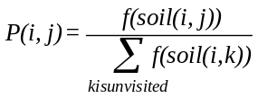 (1)
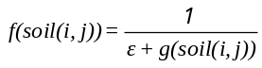 (2)

g(soil(i,j)) = soil(i,j) if minsoil 0 (3)
soil(i,j) - minsoil if minsoil <0

Here P(i,j) indicates the transition probability associated with node j. k specifically denotes all the nodes that are still to be visited. ϵ is an algorithmic parameter. Thus the selection of a node depends probabilistically on the amount of soil present on the edges between adjacent nodes given by soil(i,j). Here minsoil indicates the least soil available on a path between any node i and j. As illustrated in equations (1) to (3), the state transition probability of an IWD is thus proportional to the soil content available in the edge between nodes i and j. Thus as the soil content of a path goes down, the more probability of selection of the corresponding solution component increases.
While each IWD incrementally moves from one node i to j while constructing a solution, the IWD soil content (soil(iwd)) and the velocity of the same( vel(iwd) ) are also updated based on equations (4-5).
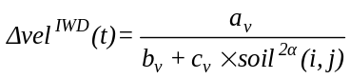 (4)
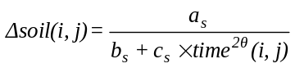 (5)

Here the IWD velocity is changed by a vel component. a_{v} ,b_{v} ,c_{v} , and α are algorithm specific parameters. Similarly the soil content of an IWD is also increased by ∆soil which is the soil content removed by the IWD while moving from location i to j. time^{2θ}(i,j) is the time required for the IWD to move from i to j which is given as –
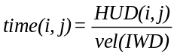 (6)
HUD is characterized as a heuristic which can be used to measure the desirability/undesirability of an IWD to select an edge between i and j. θ, in this case, is an algorithmic parameter. Thus, a larger IWD velocity contributes to minimizing the time taken by an IWD to move from i to j. The time factor in turn influences the amount of soil to be removed from a path (as shown in equation 5). Once the IWD properties are computed, the soil content of the complete solution path can be updated based on equation 7.
(7)

where ρ_{o} and ρ_{n} are between 0 and 1.According to the original IWD algorithm for the TSP, ρ_{o} = 1− ρ_{n}.

IWD based Feature Selection
For the feature selection problem, one can consider each node (in the graph above) as a feature. A solution may then be formulated as a set of feature indices. Thus if a gene expression dataset consists of 1000 features, then a possible solution could be a feature subset composed of {11,23,391,510,999} with the subset size as 5. Here each element is a feature index. Any feature index could thus be a part of the subset, where the user (5 in this case) fixes the subset size.
An initial set of IWDs are thus placed at random features from where they commence their flow. Each IWD moves to the next feature by following the probability transition given by equation (1). Once a feature has been visited, a local soil update between features i and j are performed by equation (7) as mentioned before. In the process, the IWD soil content and velocity are also updated by equation 4-5. This process, continues until a complete feature subset of the required size is constructed by the IWD. The feature subset is then used to generate a corresponding reduced dataset with the given features indices. The reduced dataset is thus fed as input to a classifier like SVM, which consequently returns a 10 fold classification cross validation accuracy (10 fold CVA).The 10 fold CVA is thus considered as the fitness measure for the corresponding feature subset(or the IWD solution). Subsequent IWDs also build up their solution vectors (feature subsets) similarly.
After each iteration, the feature subset with the maximum 10 fold CVA gets selected as the iteration best solution (TIB). A certain amount of soil is removed from the edges of the iteration-best solution based on the quality of the feature subset. Thus if TIB is given as (6,13,91,121,992), then the edges to be updated are 6-13,13-91,91-121 and 121-992.This is done according to equation (8) .
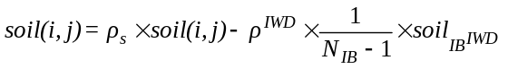 ⁽⁸⁾
Here represents the soil content of the iteration-best IWD (which owns the iteration best feature subset). NIB is the number of features in TIB .ρIWD is the global soil updating parameter selected from [0, 1]. ρs is set as (1+ ρIWD). Therefore an edge with lesser soil content turns out to have better prospects in the future in the constructing a good solution.
In addition we also maintain a global best feature subset which is given by the maximum of all the iteration best solutions. The above process is repeated till a termination criterion is reached. During this stage, the global best feature subset is reported as the most optimal solution to the feature selection problem. The IWD gene selection algorithm is thus stated as below.
Algorithm: IWD for Gene Selection
Initialization of Parameters
while (termination criteria not reached)
do{
Initial placement of IWD positions on random genes
Construction of solutions by IWDs
Select an Edge between two genes considered as nodes
Update local soil content
Obtain the iteration-best gene subset
Update Global soil on edges for adjacent genes in the iteration-best subset
Update the global-best gene subset
}
End while
Return the global-best gene subset

Weighted Gene Ranking
Owing to the massive search space of possible gene subsets, it is necessary to provide prior information for probabilistically guiding the IWD search. A weighted gene ranking composed of three filters namely Information Gain (IG), Chi-square(CS) and Correlation based feature selection (CFS), are provided as input to the IWD algorithm. Information Gain (IG) is an entropy-based measure which selects the gene that has the best capability to differentiate the samples into separate classes. A gene with a higher IG is considered to be more relevant. Chi-square (CS) is used to measure the lack of independence between a gene and a class label. Correlation-based Feature Selection (CFS) evaluates the goodness of subsets of genes. CFS thus measures the merit of gene subsets by considering the importance of individual genes for predicting the class label along with the level of inter-correlation among them [16].
The heuristic information for each individual gene is obtained by calculating the weighted sum of the Information Gain, Chi-Square and CFS scores which were obtained using the WEKA[17] data mining library. The computation of the weighted sum of a gene (WRg) is as shown in equation 9.
WR _{g} =w₁∗IG _{g} +w₂∗CS _{g} +w₃∗CFS _{g} (9)

In equation 9, w1,w2 and w3 are the weights provided for IG, CS and CFS rankings. The WRg is consequently provided as HUD(i,j) for the j-th feature, as shown in equation (6), in a modified form as given in equation (10).
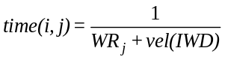 10)
The weighted gene value (WRj) is thus used to probabilistically guide the IWD search.

Support Vector Machine
Support Vector Machines (SVMs) were introduced by Vapnik et al [18] and successively extended by a number of other researchers. SVM uses a maximum margin linear hyperplane for solving binary linear classification problems. For problems that are non-linearly separable, SVM transforms the data into higher dimensional features and then employs a linear hyperplane. To deal with intractability issues it also employs appropriate kernel functions allowing computations in the input space itself. In particular, SVM with recursive feature elimination (RFE) was used by Vapnik et al [19] for gene selection and achieved notably high accuracy levels.
For our purposes, we employ the libSVM [20] library for evaluation of our candidate solutions during each generation.
A representative IWD based filter-wrapper gene subset selection process is illustrated in Figure 1.

Results and discussion
Microarray gene expression datasets specify the expression levels of different genes, which are available publicly. Three such datasets were obtained from the Kent Ridge Biomedical datasets repository [21] and the libSVM repository [20] (made available from various other sources).
The Colon Cancer dataset consists of 62 cell samples taken from colon cancer patients [22]. Among these, 40 are tumor samples while 22 otherwise. The Breast cancer [23] dataset comprises of 44 samples of which, 22 belong to class A (estrogen receptor-positive ER+) while 22 belong to class B (estrogen receptor-negative ER+). The Leukemia dataset [24] had 72 samples, of which 25 belong to Acute Myeloid Leukemia (AML) and 47 belong to the Acute Lymphoblastic Leukemia (ALL). These dimensions of the datasets are tabulated in Table I.

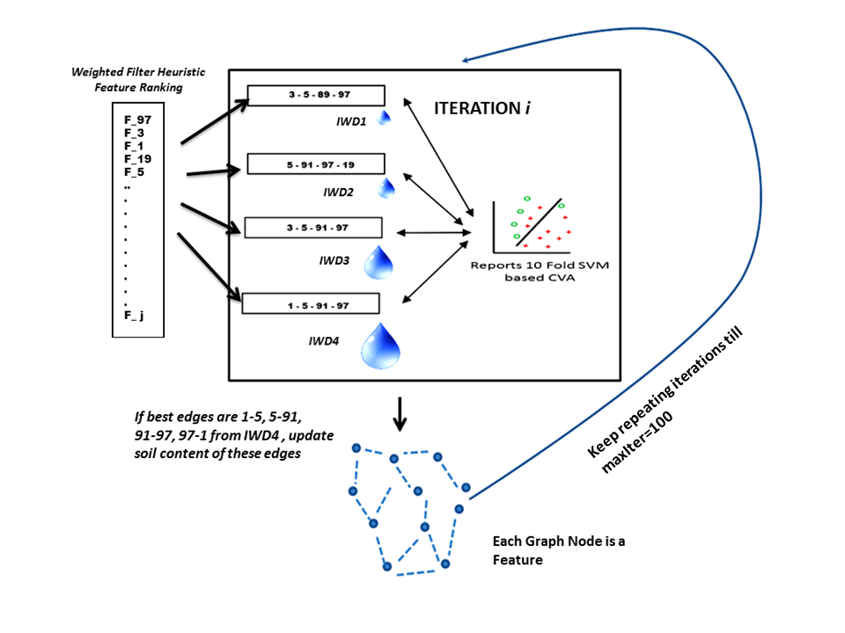
Figure 1: IWD based Filter-Wrapper Gene Selection

Extensive simulations were carried out for each dataset with separate gene rankings as Information gain, Chi-square, CFS and the weighted heuristics as described earlier. Based on the simulations, one can say that comparable results for all three datasets were observed, while considering a maximum of 50 IWDs and 100 generations. Mostly towards the end of 100 generations, the fitness values of the feature subsets would converge and not show much improvement. Parameter tuning was also carried out extensively for weighted ranking to get the best results. In our simulations with IWD parameters, we have specifically used parameters values employed by earlier authors [10]. Our simulations indicate that the SVM kernel and filter weighting parameters have a more profound influence and have thus tuned the same extensively for maximizing algorithm performance. The algorithm parameters for IWD are as shown in Table II.
Table I: Dataset Specifications
Cancer Dataset | No. of genes | No. of classes | No. of Samples  (samples for I & II)
Colon | 2000 | 2 | 62(40 & 22)
Breast | 7129 | 2 | 44( 22 & 22)
Leukemia | 7129 | 2 | 72 (25 & 47)

A comparison of the weighted IWD-SVM performance is provided along with the some recently reported best results for the same datasets. The results of the simulations are as given in Table III.
Table II. IWD Parameters
IWD Algorithm Parameters | Values
No. of IWDs | 50
w₁,w₂,w₃ | 0.5,0.3,0.2
No. of Generations | 100
a_{v},b_{v},c_{v},α | 1,0.01,1,1
a_{s},b_{s},c_{s}, θ | 1,1,0.01,2
ρ_{o} , ε | 0.1,0.5
cost,gamma(for RBF as SVM kernel),Folds | 50,0.02,10

Table III: Comparison of IWD-SVM with previously reported classification accuracies [3, 26, 27].
Colon | 95.47%  (ACO- AM) | 96.77%  (ACO-RF) | 95.16%  (IWD-SVM)
Breast | 92.00% (Bagging) | 94.00%  (Ensemble Predictors) | 97.72%  ( IWD-SVM)
Leukemia | 96.00%  (ACO-AM) | 97.06%  (SVM) | 97.22%  (IWD-SVM)

According to results in Table III, IWD-SVM performs well in comparison to previously reported algorithms for all the three datasets. The IWD based gene subset sizes selected were 15 for Colon, 15 for Breast and 19 for Leukemia. In addition, simulations with simple filters like Information Gain, Chi-square ranking and CFS were carried out separately with IWD for similar subset sizes. As per our results, the IWD-SVM with weighted ranking demonstrated superior performances than IWD-Infogain, IWD-Chi-Square and IWD-CFS.

Conclusion
The hybrid IWD-SVM has shown good results consistently on comparison with the highest accuracies for colon cancer, breast cancer and leukemia cancer datasets. In general, IWD is robust and flexible for discrete optimization owing to their typical swarm based emergent behavior. One can significantly speedup the algorithm by possible parallel implementations where the classification accuracies for individual candidate solutions may be computed in parallel.

Acknowledgment
VKJ gratefully acknowledges the Council of Scientific & Industrial Research (CSIR), New Delhi, India for financial support in the form of an Emeritus Scientist grant.

References
- I. Guyon, A. Elisseeff. "An introduction to variable and feature selection." The Journal of Machine Learning Research 3 (2003): 1157-1182.
- D. Patil, R. Raj, P. Shingade, B. Kulkarni, and V. K. Jayaraman, “Feature selection and classification employing hybrid ant colony optimization-random forest methodology,” Combinatorial Chemistry and High Throughput Screening, vol. 12, no. 5, pp. 507–513, 2009.
- S. Sharma, S. Ghosh, N. Anantharaman, and V. Jayaraman, “Simultaneous informative gene extraction and cancer classification using aco-antminer and aco-random forests,” in Proceedings of the International Conference on Information Systems Design and Intelligent Applications 2012 (INDIA 2012) held in Visakhapatnam, India, January 2012, Springer Berlin / Heidelberg, 2012, vol. 132, pp. 755–761.
- A. Gupta, V. K. Jayaraman, and B. D. Kulkarni. "Feature selection for cancer classification using ant colony optimization and support vector machines." Analysis of Biological Data: A Soft Computing Approach, ser. World Scientific, Singapore (2006): 259-280.
- S. Nikumbh, S. Ghosh, V. K. Jayaraman. "Biogeography-based informative gene selection and cancer classification using SVM and Random Forests," IEEE Congress on Evolutionary Computation (CEC), 2012, pp.1-6, 10-15 June 2012
- H. Shah_Hosseini. "Problem solving by intelligent water drops." In IEEE Congress on Evolutionary Computation, 2007. CEC 2007. pp. 3226-3231
- H. Shah-Hosseini. "Intelligent water drops algorithm: A new optimization method for solving the multiple knapsack problem." International Journal of Intelligent Computing and Cybernetics 1.2 (2008): 193-212.
- H. Duan, L. Senqi and W. Jiang. "Novel intelligent water drops optimization approach to single UCAV smooth trajectory planning." Aerospace Science and Technology 13.8 (2009): 442-449.
- T. Akbarzadeh, R. Mohammad. "Intelligent Water Drops a new optimization algorithm for solving the Vehicle Routing Problem." International Conference on Electronics and Information Engineering-ICEIE 2010. 2010.
- R. Kesavamoorthy, D. ArunShunmugam, and L. Thanga Mariappan. "Solving Traveling Salesman Problem by Modified Intelligent Water Drop Algorithm}." InIJCA Proceedings on International Conference on Emerging Technology Trends (ICETT)}, pp. 18-23.
- P. Nagalakshmi, Y. Harish, R. K. Kumar, and C. Jada. "Combined economic and emission dispatch using intelligent water drops-continuous optimization algorithm." In Recent Advancements in Electrical, Electronics and Control Engineering (ICONRAEeCE), 2011 International Conference on, pp. 168-173. IEEE, 2011.
- D. C. Hoang, R. Kumar, and S. Kumar Panda. "Optimal data aggregation tree in wireless sensor networks based on intelligent water drops algorithm."Wireless Sensor Systems, IET 2, no. 3 (2012): 282-292.
- S.H. Niu, S. K. Ong, and A. Y. C. Nee. "An improved Intelligent Water Drops algorithm for achieving optimal job-shop scheduling solutions." International Journal of Production Research 50, no. 15 (2012): 4192-4205.
- H. Shah–Hosseini. "Intelligent water drops algorithm for automatic multilevel thresholding of grey–level images using a modified Otsu's criterion."International Journal of Modelling, Identification and Control 15, no. 4 (2012): 241-249.
- H. Duan, S. Liu, and X. Lei. "Air robot path planning based on Intelligent Water Drops optimization." In Neural Networks, 2008. IJCNN 2008.(IEEE World Congress on Computational Intelligence). pp. 1397-1401. IEEE, 2008.
- J. Han and M. Kamber. Data mining: concepts and techniques. Morgan Kaufmann, 2006.
- M. Hall,E. Frank, G. Holmes, B. Pfahringer, P. Reutemann, and I. H. Witten. "The WEKA data mining software: an update."ACM SIGKDD Explorations Newsletter 11, no. 1 (2009): 10-18.
- B. E. Boser, I. M. Guyon, and V. N. Vapnik, “A training algorithm for optimal margin classifiers,” in Proceedings of the fifth annual workshop on Computational learning theory, ser. COLT ’92. New York, NY, USA: ACM, 1992, pp. 144–152
- I. Guyon, J. Weston, S. Barnhill, and V. Vapnik, “Gene selection for cancer classification using support vector machines,” Machine Learning, vol. 46, pp. 389–422, 2002
- C.-C. Chang and C.-J. Lin, “LIBSVM: A library for support vector machines,” ACM Transactions on Intelligent Systems and Technology, vol. 2, pp. 27:1–27:27, 2011
- Kent ridge bio-medical dataset, URL: http://datam.i2r.astar.edu.sg/datasets/krbd/
- U. Alon, N. Barkai, D. A. Notterman, K. Gish, S. Ybarra, D. Mack, and A. J. Levine, “Broad patterns of gene expression revealed by clustering analysis of tumor and normal colon tissues probed by oligonucleotide arrays,” Proceedings of the National Academy of Sciences, vol. 96, no. 12, pp. 6745–6750, 1999.
- M. West, C. Blanchette, H. Dressman, E. Huang, S. Ishida, R. Spang, H. Zuzan, J. A. Olson, J. R. Marks, and J. R. Nevins, “Predicting the clinical status of human breast cancer by using gene expression profiles,” Proceedings of the National Academy of Sciences, vol. 98, no. 20, pp. 11 462–11 467, 2001
- T. R. Golub, D. K. Slonim, P. Tamayo, C. Huard, M. Gaasenbeek, J. P. Mesirov, H. Coller, M. L. Loh, J. R. Downing, M. A. Caligiuri, C. D. Bloomfield, and E. S. Lander, “Molecular classification of cancer: Class discovery and class prediction by gene expression monitoring,”
- Q. Liu, A. H. Sung, Z. Chen, J. Liu, L. Chen, M. Qiao, Z. Wang, X. Huang and Y. Deng, “Gene selection and classification for cancer microarray data based on machine learning and similarity measures,” BMC Genomics, vol. 12, pp. 130–133, 2011, doi:10.1186/1471-2164-12-S5-S1.
- M. Martn-Merino, A. Blanco and J. De Las Rivas, “Combining dissimilarity based classifiers for cancer prediction using gene expression profiles,” BMC Bioinformatics, vol. 8, 2008, doi:10.1186/1471-2105-8-S8-S3.
- G. Cong, K.-L. Tan, Anthony. K. H. Tung, and X. Xu, “Mining top-k covering rule groups for gene expression data,” in Proceedings of the 2005 ACM SIGMOD international conference on Management of data, ser. SIGMOD ’05. New York, NY, USA: ACM, 2005, pp. 670–681

