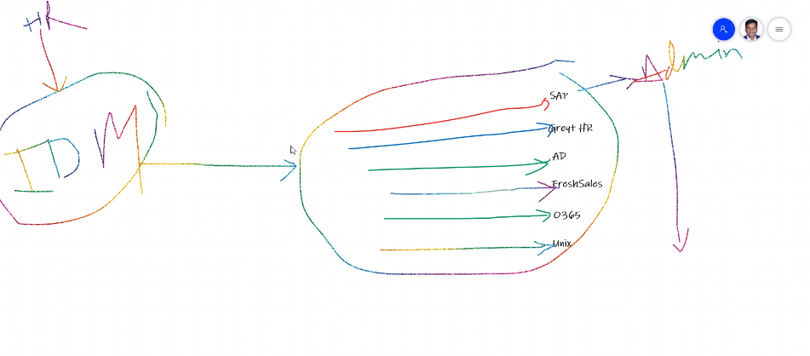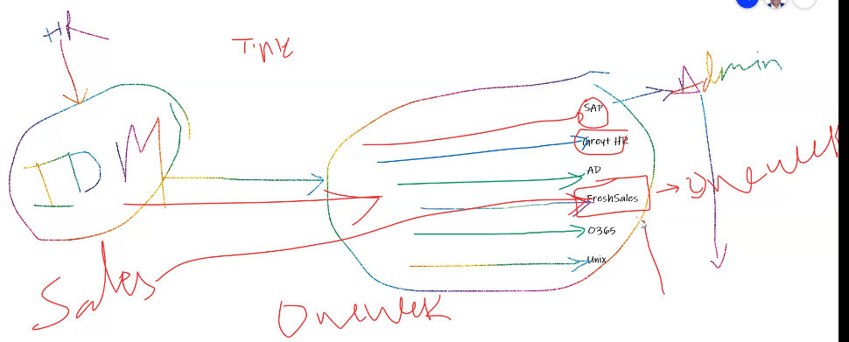

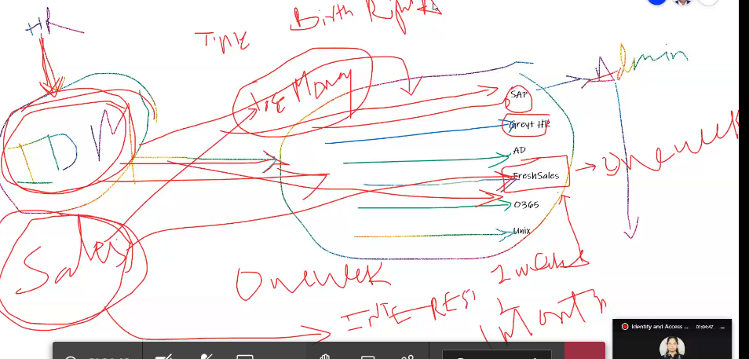

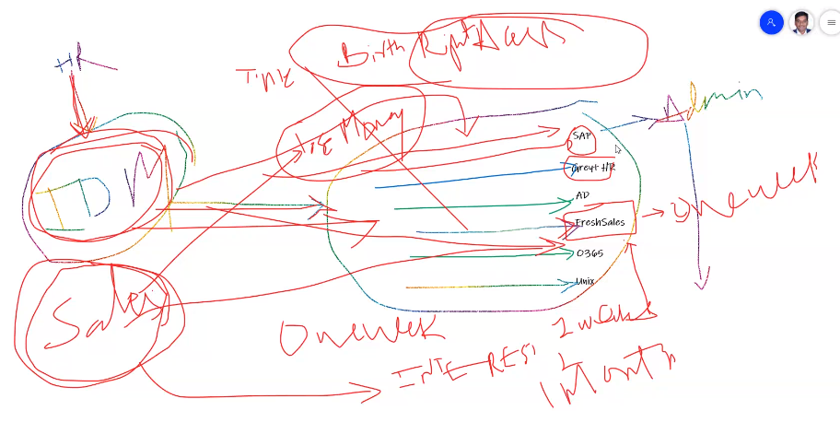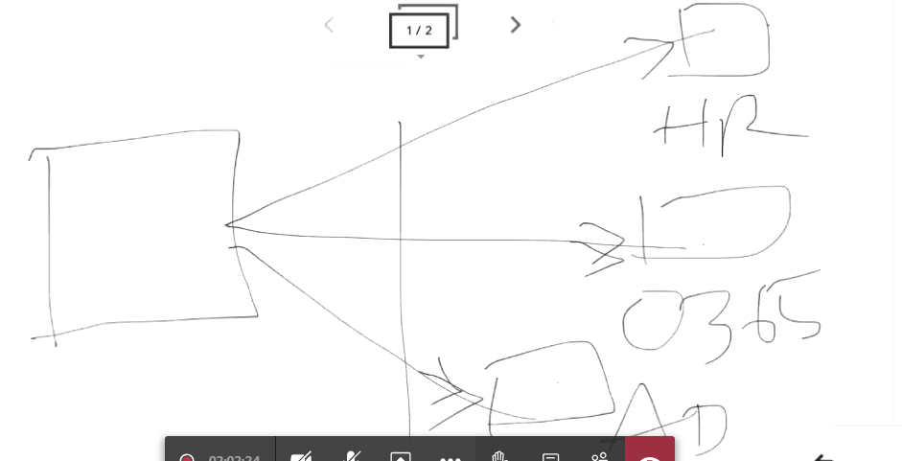

Entities:

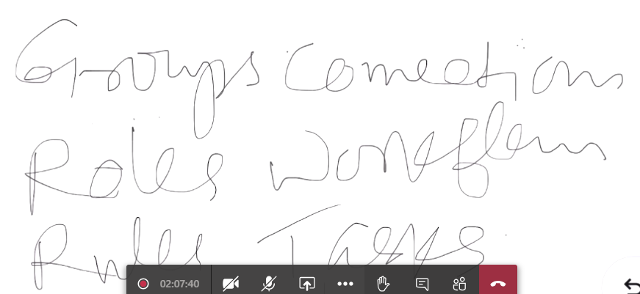

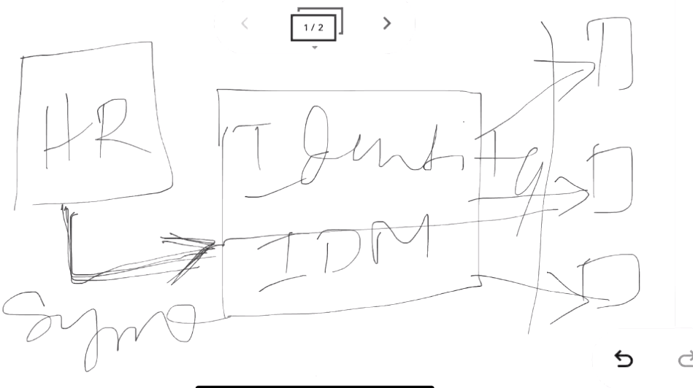

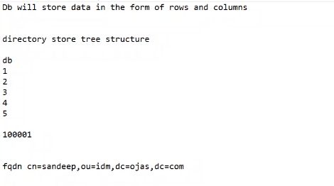

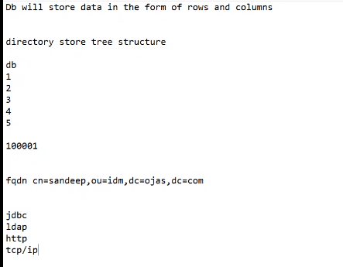

The **Lightweight Directory Access Protocol** (**LDAP** [/ˈɛldæp/](https://en.wikipedia.org/wiki/Help:IPA/English" \o "Help:IPA/English)) is an open, vendor-neutral, industry standard [application protocol](https://en.wikipedia.org/wiki/Application_protocol" \o "Application protocol) for accessing and maintaining distributed [directory information services](https://en.wikipedia.org/wiki/Directory_service" \o "Directory service) over an [Internet Protocol](https://en.wikipedia.org/wiki/Internet_Protocol" \o "Internet Protocol) (IP) network.

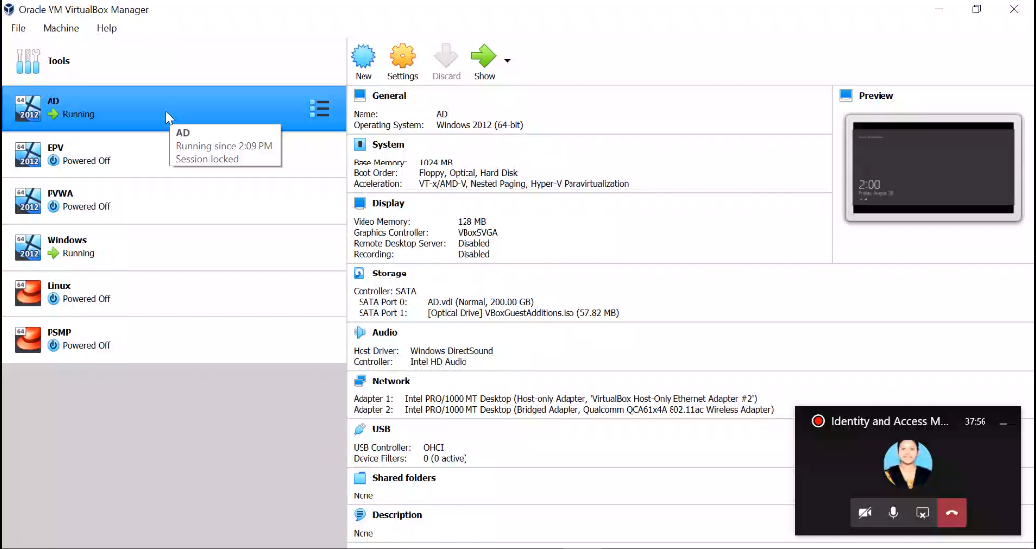

Sockets allow communication between two different processes on the same or different machines. To be more precise, it's a way to talk to other computers using standard Unix file descriptors. In Unix, every I/O action is done by writing or reading a file descriptor. A file descriptor is just an integer associated with an open file and it can be a network connection, a text file, a terminal, or something else.

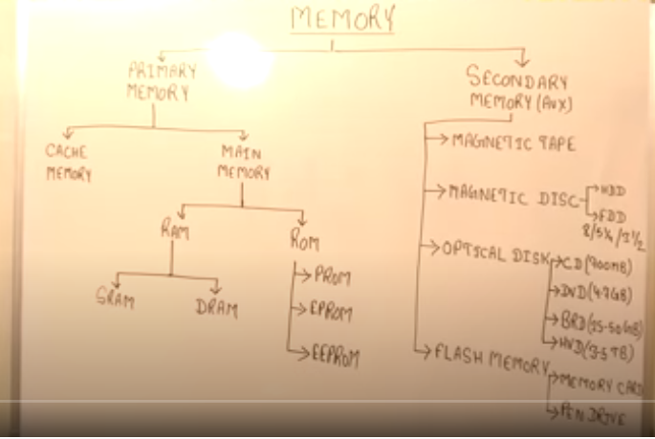

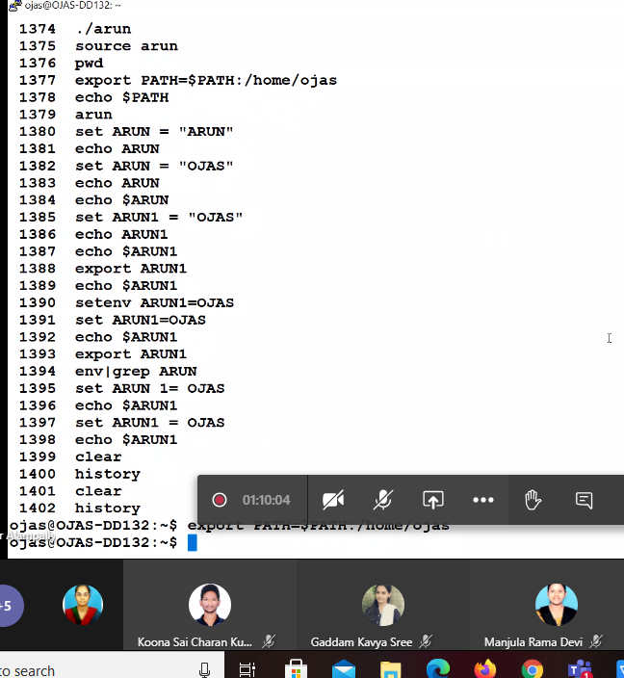

\

**Today(06/09/2020):**

**Alias**

Alias modifications perminantly by using (vi .bashrc):

Aim : kishore=’ls -lrt'

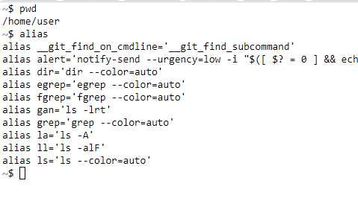

After : vi .bashrc

Enter,

Now I am adding one more alias in the [ vi .bashrc]

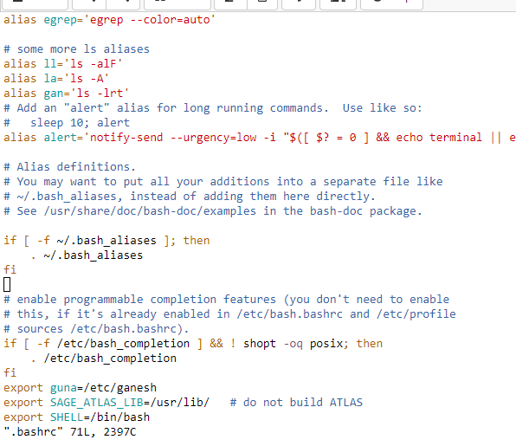

I am adding, here alias kishore=’ls -lrt’

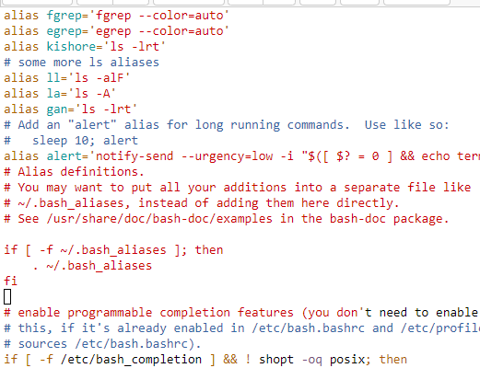

You can see kishore is present in aliases,

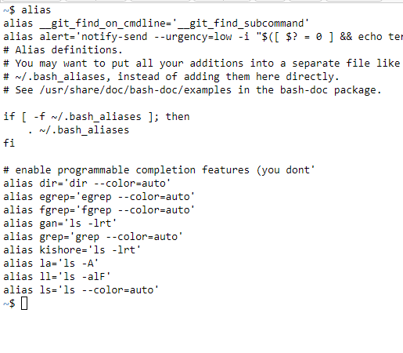

We can use in real time,

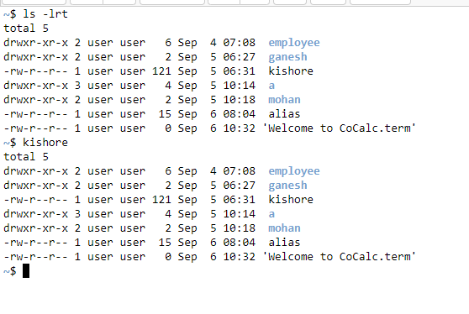

Temporarily we change so, no need to kept in the [vi .bashrc] ,

Here I done

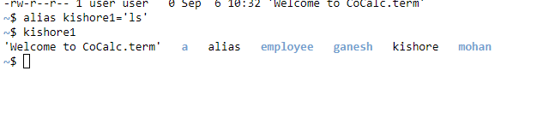

**Export**

**export command** is used to **export** a variable or function to the environment of all the child processes running in the current shell.

**Temporarily:**

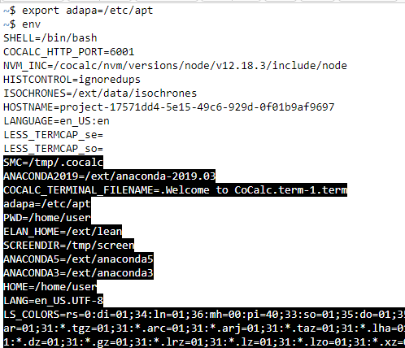

But we done, in tempararily it should be only for that session but we can make that permanently by using [vi .bashrc] folder for environmental variable setup.

**Permanentely:**

Set it in [vi .bashrc] like

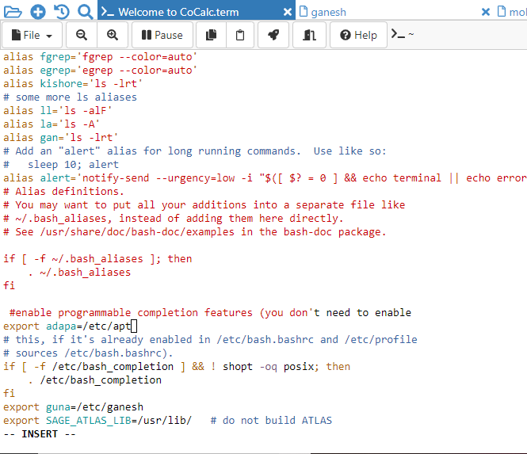

You can set perminentely,

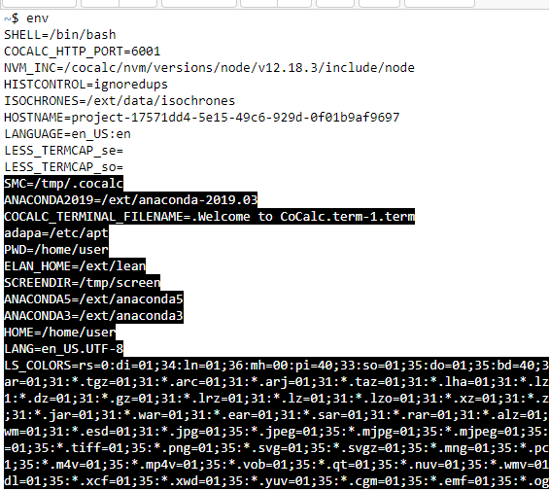

Here,

**Source:**

Is used to execute files / commands.

Example: $ source .bashrc

**grep:**

is used to match the patterns

Example: env|grep PATH

PATH

Contains binaries, they are executable. My following the exact location of that perticular file.

**Temporarily:**



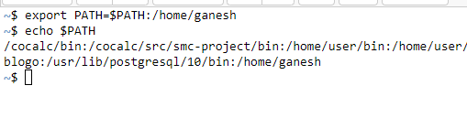

**Perminentely:**

**[vi -.bashrc]**

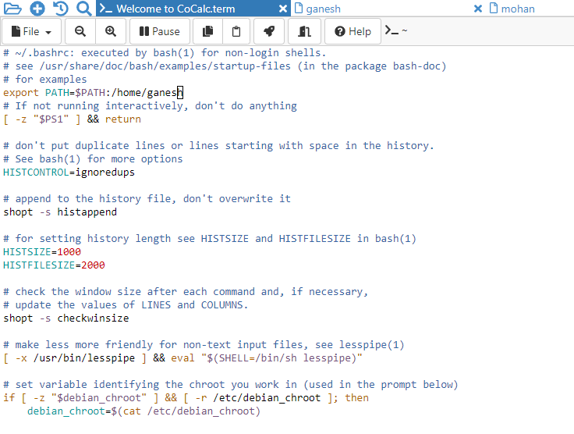

We will use ,

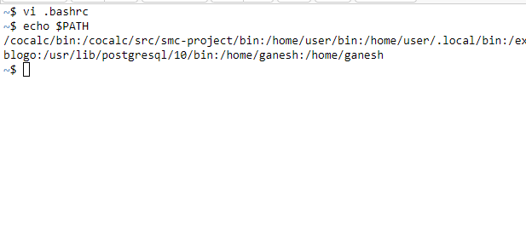

History

Uses

1. We can copy past, previous commands
2. We can execute the same command by using - !!
3. We can execute the command by using history number - !67
4. We can execute the previous commands by using only two firt characters (clear) -!cl

1. We can copy past, previous commands

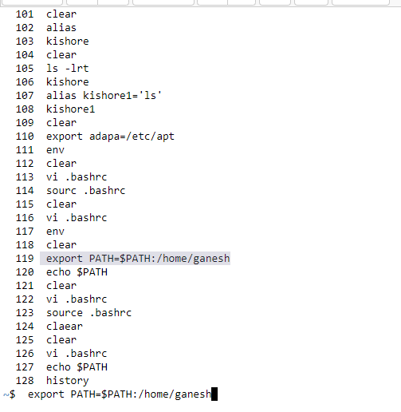

1. We can execute the same command by using - !!

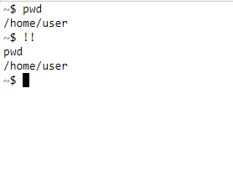

1. We can execute the command by using history number - !67

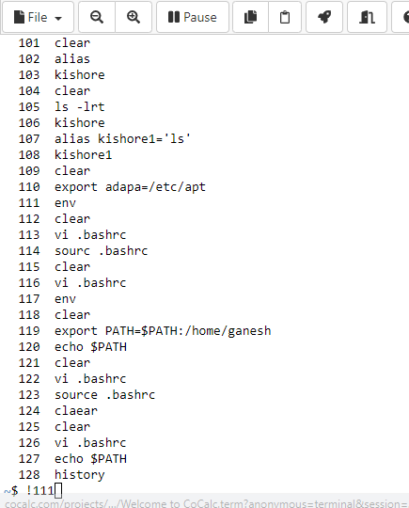

1. We can execute the previous commands by using only two firt characters (clear) -!cl

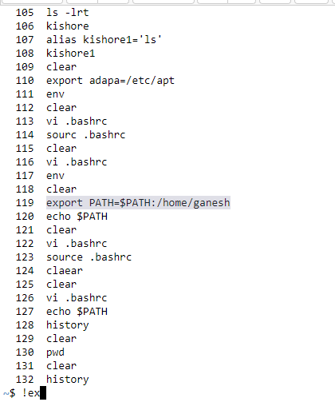

**PS**

**When ever you will open the prompt you can find, $ I wolud like to chage,**

**How**

**The process is:**

**Uisng PS**

**TEMPORARY:**

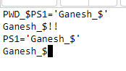

**Changing perminentely:**

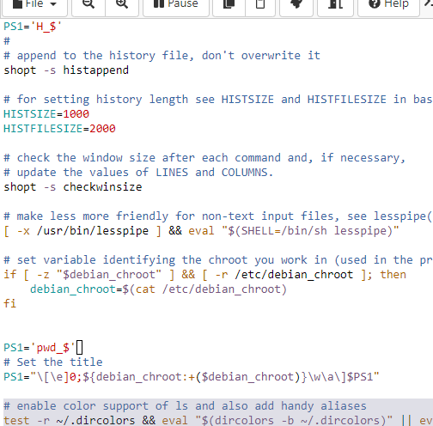

We can saw,

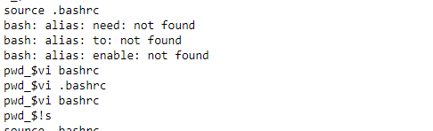

**Fianally**

**Conclusion:**

**In [vi .bashrc]**

**We can add any type of aliases, paths, exports, ps1.**

**It will be set Global Environment**

**.**