**Today(02/09/2020):**

**Shell:**

A shell is a program whose primary purpose is to read commands and run other programs.

The shell’s main advantages are its high action-to-keystroke ratio, its support for automating repetitive tasks, and its capacity to access networked machines.

The shell’s main disadvantages are its primarily textual nature and how cryptic its commands and operation can be.

1. **Explain about Shell Scripting ?**

A shell script is a text file that contains a sequence of commands for a unix or linux based operating system.

It's called a shell script because it combines into a "script" in a single file a sequence of commands that would otherwise have to be presented to the system from a keyboard one at a time.

The shell is the operating system's command interpreter and the set of commands you use to communicate with the system. A shell script is usually created for command sequences for which a user has a repeated need.

You initiate the sequence of commands in the shell script by simply entering the name of the shell script on a command line.

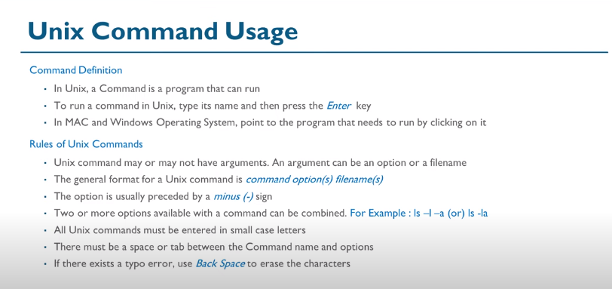

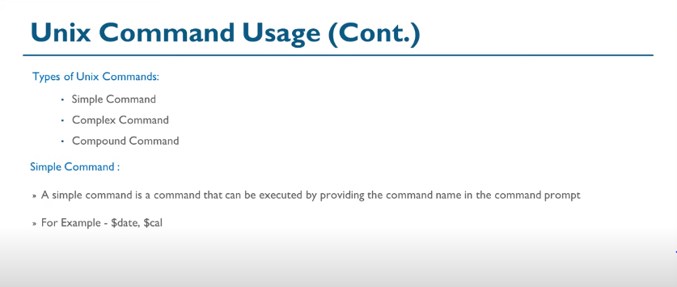

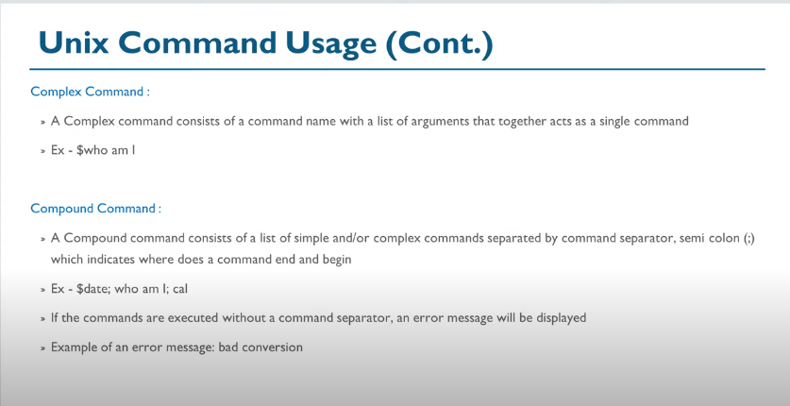

Originally Answered: What are the most useful UNIX command?

One or another command is useful when it is required. But there are basic command which you should know must and are used on daily basis.

1. man : gives information/ usage of commands
2. cd : change directory (A **directory** is a file the solo job of which is to store the file names and the related information.)
3. mkdir : make directory
4. ls : list (ll, ls -lrt any many more variations to list files)
5. cp : copy file
6. mv : move/rename file
7. cat : display file content
8. view/less/more : dislplay file content page wise
9. rm : remove file
10. gzip/gunzip : compress / extract file (**Compression**, or "data **compression**," is used to reduce the size of one or more files,An **extract :**  is a sequential dataset in the memory area of the program. You can only address the entries in the dataset within a special loop. The index or key access permitted with internal tables is not allowed.)
11. ps : show processes
12. top : show top running processes (a **process** is the instance of a computer program that is being executed by one or many threads.)
13. df -h : shows disk space usage

Some of the most useful UNIX commands are as follows :

**ls** --List files and directories

**grep**- Search for patterns within streams and files: Very powerful.

(**STREAMS** is the native framework in **Unix** System V for implementing character device drivers, network protocols, and inter-process communication. In this framework, a **stream** is a chain of coroutines that pass messages between a program and a device driver (or between a pair of programs))

**chmod**- Change permissions on files and directories  
**touch** - Make new files and change timestamps for existing ones.

**Timestamsps:**

 is a system for describing points in time, **defined** as the number of seconds elapsed since midnight proleptic Coordinated Universal Time (UTC) of January 1, 1970, not counting leap seconds.

**ps** - Process stats  
**sed/awk** - Advanced commands, but really useful.  
**find**- Find files, recursive by nature. Provides some really options for searching files.  
**mv/cp** - File movements.  
**pwd**- Current directory  
**cd**- change directory.