**Today(07/09/2020):**

**Searching commands in unix:**

1. **Find**
2. **Grep**
3. **Find**

**Find:**

The find command in UNIX is a command line utility for walking a file hierarchy. It can be used to find files and directories and perform subsequent operations on them. It supports searching by file, folder, name, creation date, modification date, owner and permissions.

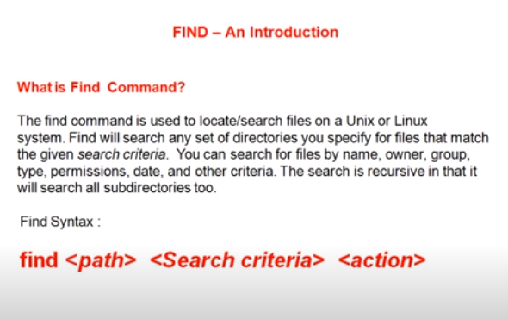

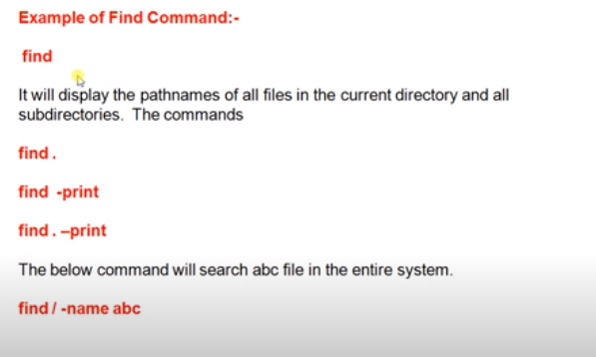

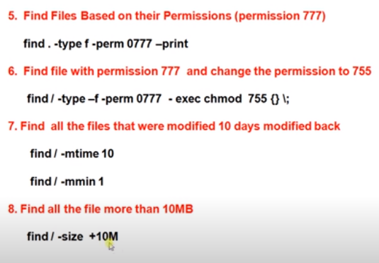

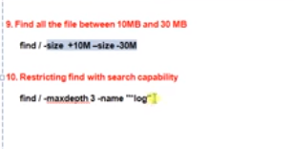

**grep Command**

**grep:**

The **grep command** is used to search text. It searches the given file for lines containing a match to the given strings or words. It is one of the most useful commands on Linux and Unix-like system.

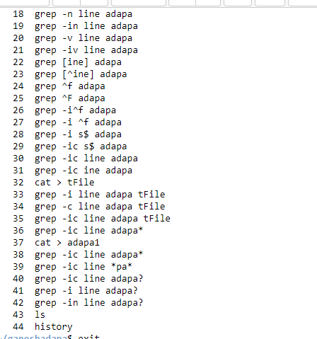

Execution:

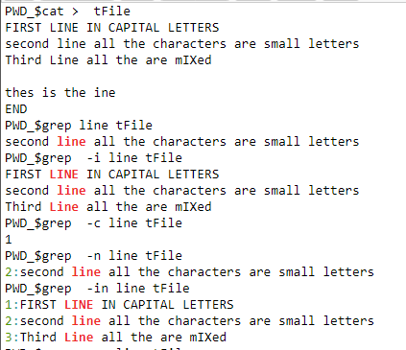

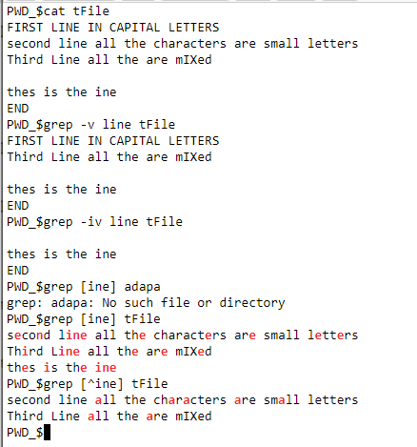

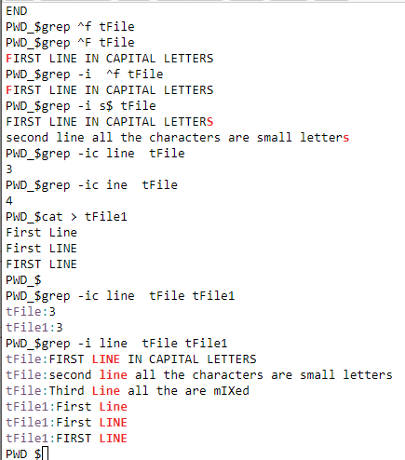

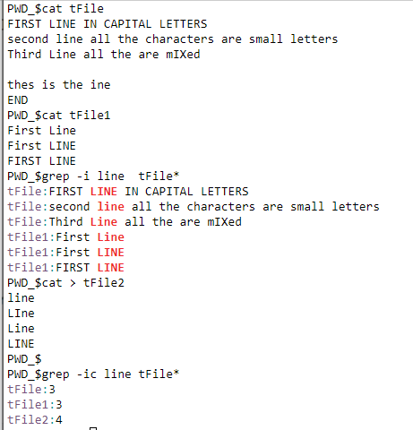

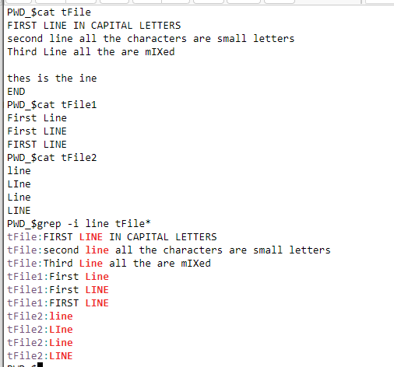

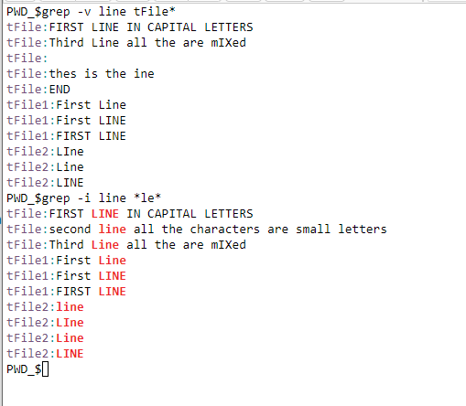

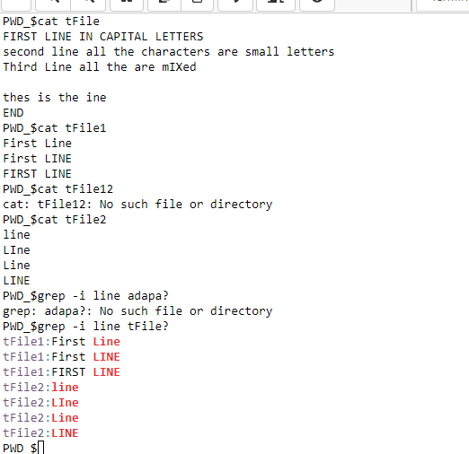

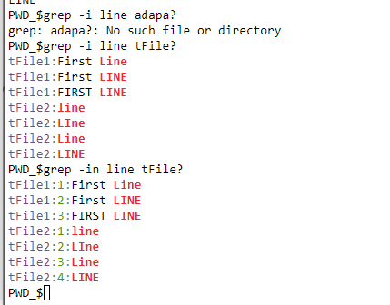

? : is only for two letters staring filename refers,

So,

Here

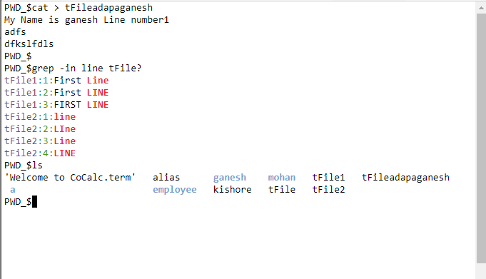

The main **difference between** the two **is** that **grep is** used to search for a particular string **in a** file whereas **find is** used to locate files **in a** directory, etc