**JSTL**

**Today(19/06/2020):**

**JstlDemo.jsp:**

<%@ taglib uri=*"http://java.sun.com/jsp/jstl/core"* prefix=*"c"* %>

<c:set var=*"name"* value=*"Ganesh"*></c:set>

<h1 style='color:*skyblue*'>Welcome to Ojas: ${name}</h1>

**Output:**

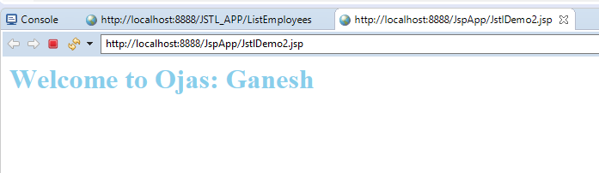

**JstlDemo1.jsp:**

<%@ taglib uri=*"http://java.sun.com/jsp/jstl/core"* prefix=*"c"* %>

<form action=*"JstlDemo.jsp"*>

Enter your Name:<input type=*"text"*name=*"uname"*><br>

<input type=*"submit"*value=*"click"*>

</form>

<c:set var=*"name"* value=*"*${param.uname}*"*></c:set>

<c:if test=*"*${name.equalsIgnoreCase('ganesh')}*"*>

<h1 style='color:*skyblue*'>Welcome to Ojas: ${name}</h1>

</c:if>

**Output:**

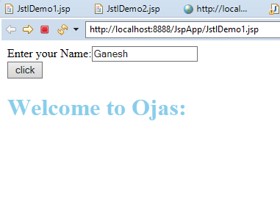

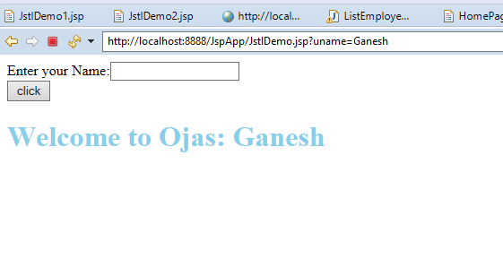

**jstlIfElso.jsp:**

<%@ taglib uri=*"http://java.sun.com/jsp/jstl/core"* prefix=*"c"* %>

<% String mName = request.getMethod();

**if** (mName.equals("GET")) {

%>

<form action=*"IfElseJstl.jsp"* method=*"post"*>

Enter your Name:<input type=*"text"*name=*"uname"*><br>

Enter your Salary:<input type=*"text"*name=*"salary"*><br>

<input type=*"submit"*value=*"click"*>

</form>

<% } **else** { %>

<c:set var=*"name"* value=*"*${param.uname}*"*></c:set>

<c:set var=*"salary"* value=*"*${param.salary}*"*></c:set>

<c:choose>

<c:when test=*"*${salary > 20000}*"*>

<h1 style='color:*green*'>Welcome to ${name}<br>Your Salary is good</h1>

</c:when>

<c:when test=*"*${salary > 10000}*"*>

<h1 style='color:*green*'>Welcome to ${name} <br> Your Salary is Ok.</h1>

</c:when>

<c:otherwise>

<h1 style='color:*green*'>No Comments</h1>

</c:otherwise>

</c:choose>

<%} %>

**Output:**

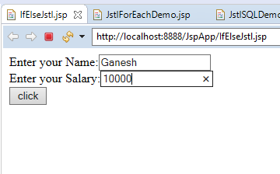

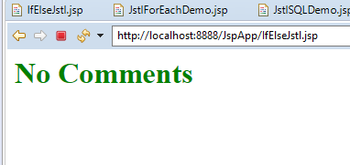

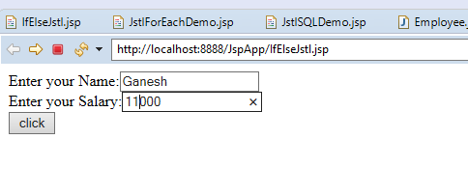

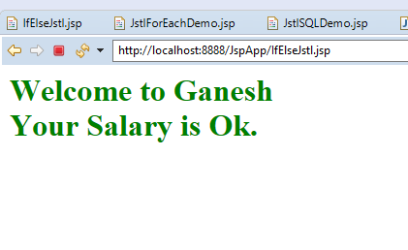

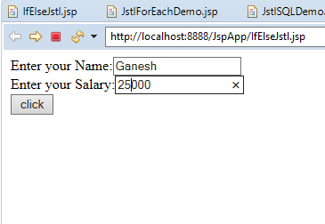

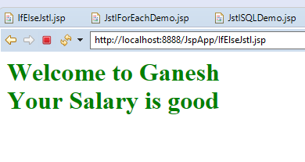

**JstlForEach.jsp:**

<%@ taglib uri=*"http://java.sun.com/jsp/jstl/core"* prefix=*"c"* %>

<% String mName = request.getMethod();

**if** (mName.equals("GET")) {

%>

<form action=*"JstlForEachDemo.jsp"* method=*"POST"*>

Enter your Name:<input type=*"text"*name=*"uname"*><br>

Enter Any Number:<input type=*"text"*name=*"snum"*><br>

<input type=*"submit"*value=*"click"*>

<a href=*'c:url value="AddStudent.html"/>'*>Home Page</a>

</form>

<% } **else** { %>

<c:set var=*"name"* value=*"*${param.uname}*"*></c:set>

<c:set var=*"number"* value=*"*${param.snum}*"*></c:set>

<c:out value =*"*${name}*"*></c:out>

<hr/>

<h3>Multiplication Table</h3>

<c:forEach var=*"i"* begin=*"1"* end =*"10"* step=*"1"*>

<c:out value=*"*${number }*"* /> * <c:out value=*"*${i}*"*/> = <c:out value=*"*${number *i }*"* /><br>

</c:forEach>

<%} %>

**Output:**

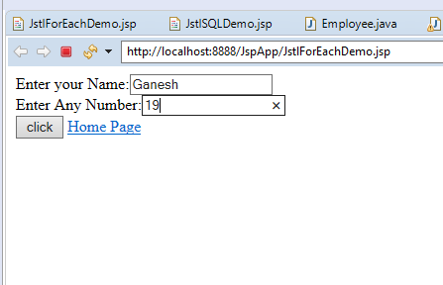

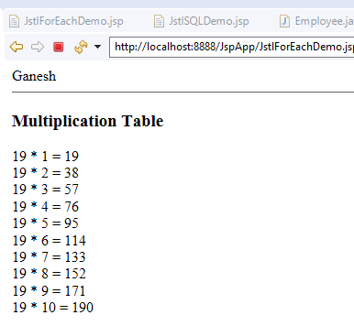

**Url:**

<a href = *"*<c:url value = *"Hobbies.jsp"* />*"*>Hobbies Home Page</a>

**Output:**

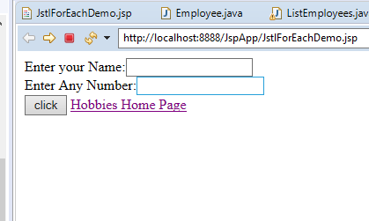

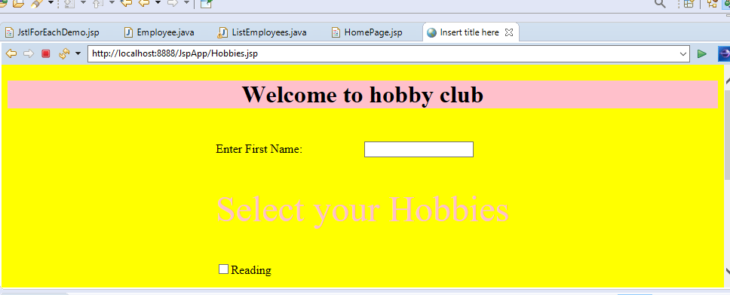

**com.model:**

Employee.java:

**package** com.model;

**public** **class** Employee {

**public** String empId;

**public** String ename;

**public** String desig;

**public** String getEmpId() {

**return** empId;

}

**public** **void** setEmpId(String empId) {

**this**.empId = empId;

}

**public** String getEname() {

**return** ename;

}

**public** **void** setEname(String ename) {

**this**.ename = ename;

}

**public** String getDesig() {

**return** desig;

}

**public** **void** setDesig(String desig) {

**this**.desig = desig;

}

}

**HomePage.jsp:**

<%@ taglib uri=*"http://java.sun.com/jstl/core_rt"* prefix=*"c"* %>

<html>

<head>

<style type=*"text/css"*>

**table,th,td** {

border: *1px solid black*;

border-collapse:*collapse*;

}

</style>

</head>

<table>

<tbody>

<tr>

<th>Id:</th>

<th>Name:</th>

<th>Role:</th>

</tr>

<c:forEach items=*"*${requestScope.empList}*"* var=*"emp"*>

<tr>

<td><c:out value=*"*${emp.empId}*"*></c:out></td>

<td><c:out value=*"*${emp.ename}*"*></c:out></td>

<td><c:out value=*"*${emp.desig}*"*></c:out></td>

</tr>

</c:forEach>

</tbody>

</table>

</html>

**ListEmployees.java:**

**package** com.controller;

**import** java.io.IOException;

**import** java.io.PrintWriter;

**import** java.util.ArrayList;

**import** java.util.List;

**import** javax.servlet.RequestDispatcher;

**import** javax.servlet.ServletException;

**import** javax.servlet.annotation.WebServlet;

**import** javax.servlet.http.HttpServlet;

**import** javax.servlet.http.HttpServletRequest;

**import** javax.servlet.http.HttpServletResponse;

**import** com.model.Employee;

**import** java.sql.*;

**import** java.io.*;

@WebServlet("/ListEmployees")

**public** **class** ListEmployees **extends** HttpServlet {

**protected** **void** service(HttpServletRequest request, HttpServletResponse response) **throws** ServletException, IOException {

System.***out***.println("Ganesh");

response.setContentType("text/html");

PrintWriter pw = response.getWriter();

List<Employee> list = **new** ArrayList<Employee>();

Employee emp1 = **new** Employee();

emp1.setEmpId("1");

emp1.setEname("Ganesh");

emp1.setDesig("Manager");

Employee emp2 = **new** Employee();

emp2.setEmpId("2");

emp2.setEname("Mahesh");

emp2.setDesig("SoftWare Engineer");

Employee emp3 = **new** Employee();

emp3.setEmpId("3");

emp3.setEname("Rehman");

emp3.setDesig("Accountant");

list.add(emp1);

list.add(emp2);

list.add(emp3);

request.setAttribute("empList",list);

RequestDispatcher rd = getServletContext().getRequestDispatcher("/HomePage.jsp");

rd.forward(request, response);

}

}

**Out.put:**

