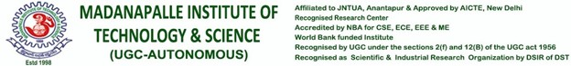

# RECOGNISED RESEARCH CENTER

***Plagiarism Verification Certificate***

This is to certify that the MCA Project report titled, “**TRAFFIC SUDHARO - USERSERVICES**” submitted by **A.GANESH (REGD. NO: 18699F0019)** has been evaluated using **Anti-Plagiarism Software, URKUND** and based on the analysis report generated by the software, the report’s similarity index is found to be **23%**.

The following is the URKUND report for the project report consisting of 40 pages.

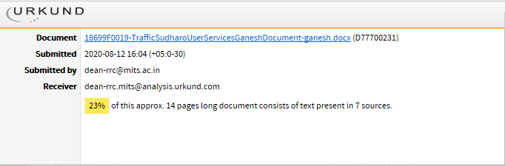

# Dean - RRC