**TRAFFIC SUDHARO - USER SERVICES**

A Project Report submitted for the partial fulfilment of the requirement for the award of the degree of

# MASTER OF COMPUTER APPLICATIONS

SUBMITTED BY

## ADAPA GANESH

**Roll No. 18699F0019**

Under the Guidance of

## Mr.V. MARUTHI PRASAD

Assistant Professor



**DEPARTMENT OF COMPUTER APPLICATIONS** MADANAPALLE INSTITUTE OF TECHNOLOGY & SCIENCE MADANAPALLE

UGC AUTONOMOUS

(Approved by AICTE, New Delhi & Affiliated to JNTUA, Anathapuramu) [www.mits.ac.in](http://www.mits.ac.in/)

# 2019-2020

**MADANAPALLE INSTITUTE OF TECHNOLOGY & SCIENCE MADANAPALLE**

## (UGC AUTONOMOUS)

(Approved by AICTE, New Delhi & Affiliated to JNTUA, Ananthapuramu)

# DEPARTMENT OF COMPUTER APPLICATIONS



**BONAFIDE CERTIFICATE**

This is to certify that the project work entitled “ **TRAFFIC SUDHARO - USER SERVICES** ” is a bonafide work carried out by **ADAPA GANESH**, Roll No. 18699F0019**,** submitted in the partial fulfilment of the requirements for the award of the degree of Master of Computer Applications in Madanapalle Institute of Technology & Science, Madanapalle, affiliated to Jawaharlal Nehru Technological University Anantapur, Anantapuramu during the academic year 2019 -2020.

## PROJECT GUIDE HEAD OF THE DEPARTMENT

**Mr.V. MARUTHI PRASAD, MCA., M.E Dr.V.L.Pavani, MCA., M.Phil, Ph.D**

Assistant Professor Assistant Professor

## Submitted for viva voce examination held on

**Internal Examiner External Examiner**

Date: Date:

# DECLARATION

I, **ADAPA GANESH**, **(Roll No. 18699F0019)** hereby declare that the project entitle **“ TRAFFIC SUDHARO - USER SERVICES** ” is done by me under the guidance of **Mr.V. MARUTHI PRASAD**, submitted in partial fulfilment of the requirements for the award of degree of Master of Computer Applications at MADANAPALLE INSTITUTE OF TECHNOLOGY & SCIENCE Madanapalle, affiliated to Jawaharlal Nehru Technological University Anantapur, Anantapuramu during the academic year 2019-2020. This work has not been submitted by anybody towards the award of any degree.

Date: Signature of the Student

**ADAPA GANESH**

Place:Madanapalle **(Roll.No.18699F0019)**

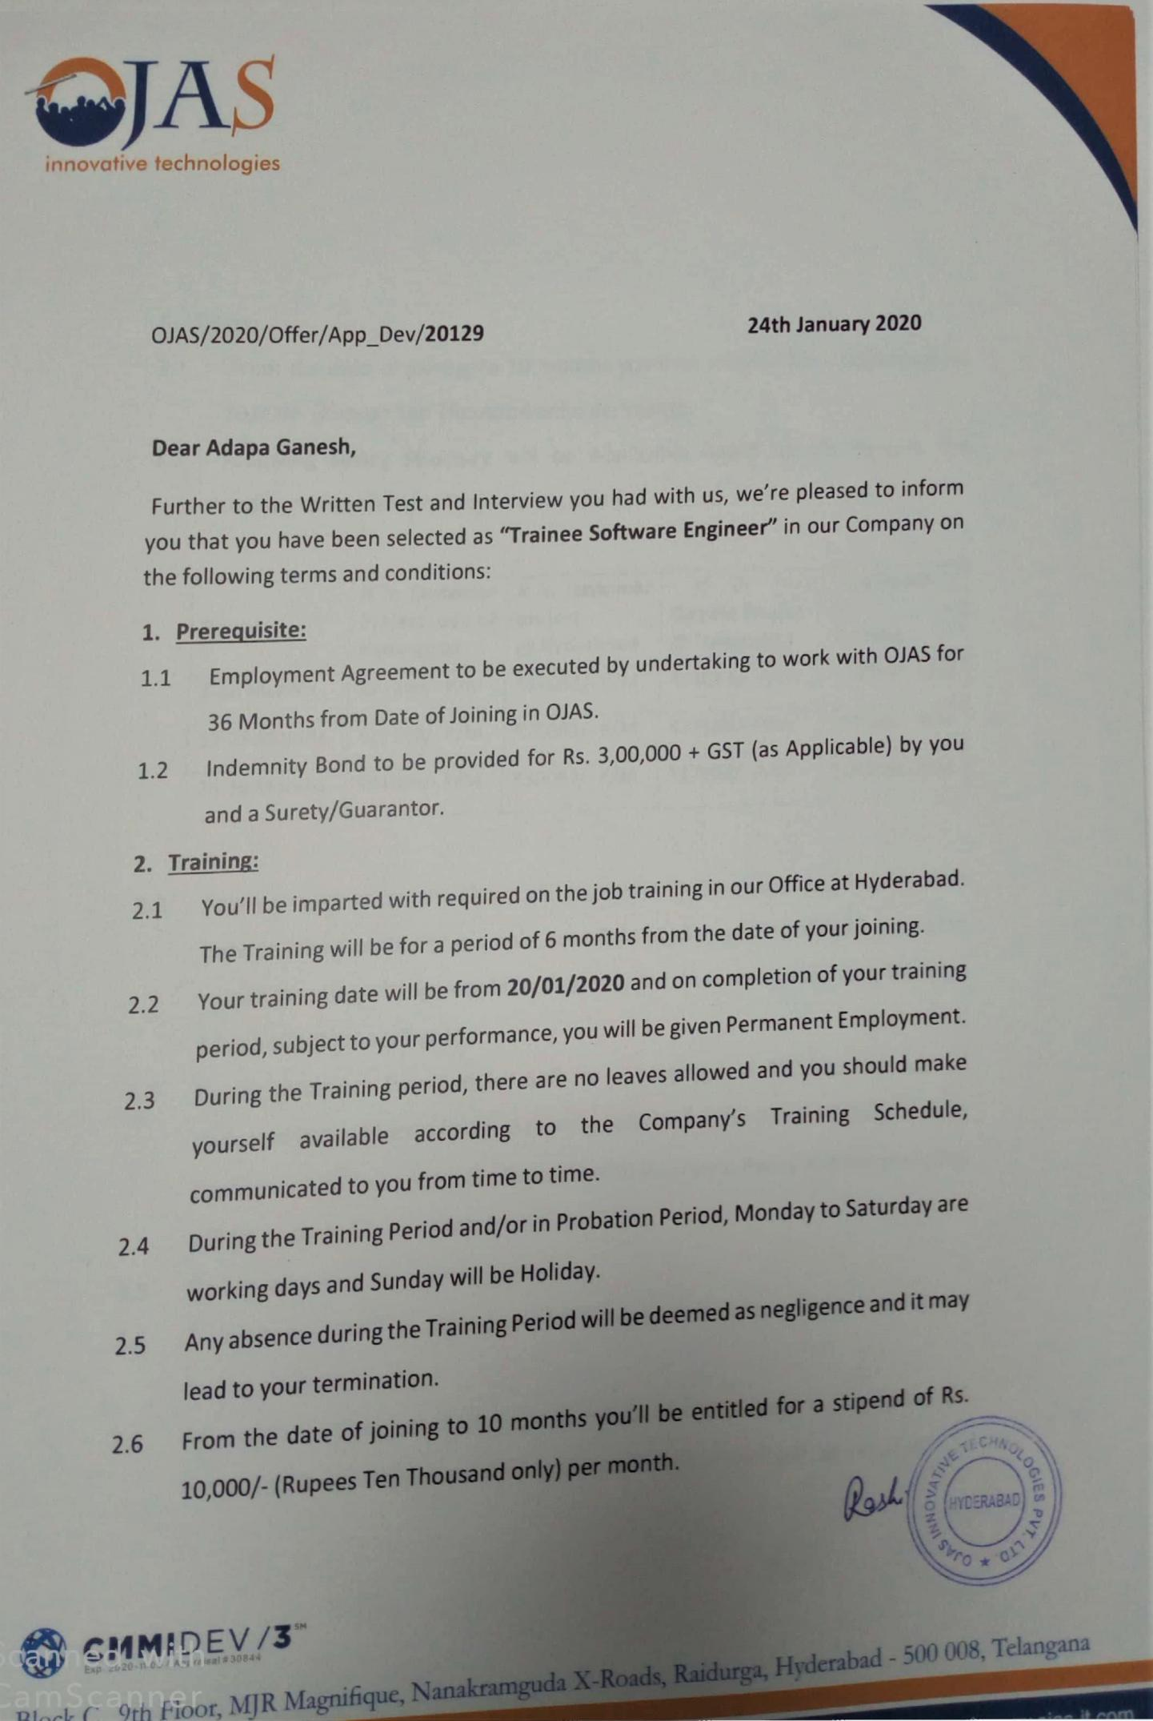

‘



# RECOGNISED RESEARCH CENTER

***Plagiarism Verification Certificate***

This is to certify that the MCA Project report titled, “**TRAFFIC SUDHARO – USER SERVICES”** submitted by ADAPA GANESH **(18699F0019)** has been evaluated using **Anti-Plagiarism Software, URKUND** and based on the analysis report generated by the software, the report’s similarity index is found to be 21**%**.

The following is the URKUND report for the project report consisting of 17 pages.

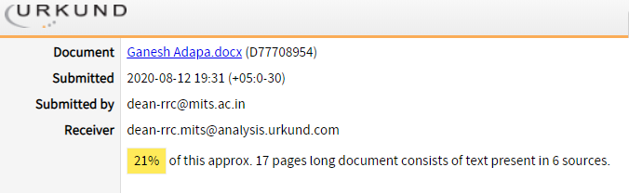

# Dean - RRC

# ACKNOWLEDGEMENT

I express my gratitude and thanks to Project Guide **Mr.V. MARUTHI PRASAD (Asst. Professor, M.C.A,M.E.,)**, who has guided me in completing the project with his cooperation, valuable guidance and immense help in giving the project a shape.

I express my deep gratitude and thanks to the Project coordinator **Dr. A. MANIMARAN, M.C.A, M.Phil., Ph.D.**, Dept. of Computer Applications, for him valuable suggestions during the project work. I am very much indebted to him for being a role model and for providing necessary guidance directly or indirectly throughout the project work.

I wish to express my grateful thanks to **Dr. V.L. PAVANI., M.C.A., M.Phil., Ph.D.**, Head of the Department, and Computer Applications for her timely advice and guidance without which the entire course work would not be fruitful.

I thank all the faculty members of the Computer Applications department for their constant support and guidance in acquiring relevant knowledge in the core Computer Applications subjects which helped us in implementation of the project work.

I thank all the nonteaching faculty of the Computer Applications department for their support and necessary help in our learning process, which helped us in implementation of the project work.

I am thankful to the Principal, **Dr. C. YUVARAJ** for his constant support and for providing us the necessary facilities, which helped us in completion of the project work and the course as well.

I am very much indebted to the institute management for providing us an opportunity with necessary academic, infrastructure facilities and immense support to carry out my graduation program successfully.

Finally, I would like to thank my parents, friends and well-wishers whose constant encouragement and faith in my abilities inspired me to deliver the best.

**ADAPA GANESH**

**Roll No.18699F0019**

**ABSTRACT**

As the name suggests, **“Traffic Sudharo”** is a great initiative enabling the Citizens to report Traffic Violations to the appropriate authority this application. This enables the user to Post Issue (Traffic Violation) by capturing the Photos from the Mobile Camera and it will automatically read the Geo Location, Date and Time Etc. It will also allow the users to report the images which they’ve captured out of the application.  
The Issues reported will be verified by Traffic Sudharo Back end team for obnoxious or obscure images and approves or rejects the issue. All the approved Issues will help the Users get Reward Points as per the Policy of Traffic Sudharo, which the Users can check in their Rewards Module in the app. These Rewards can be redeemed against various famous service providers like BookMyShow, Amazon, Swiggy and Zomato (yet to finalize the Redeem options). All the approved issues will be taken up with the respective State’s Traffic Authorities to penalize the Traffic Violators, which will result in bringing down the Traffic Chaos.  
So Let’s join hands for the great cause and capture as many violations as possible and report them in Traffic Sudharo.

This project has been developed using JAVA and MySQL

# TABLE OF CONTENTS

|  |  |  |
| --- | --- | --- |
| **CHAPTER** | **TITLE** | **PAGE NO.** |
| **I**  1.1 | **INTRODUCTION**  About the Project | 1 |
| II 2.1  2.2  2.3  2.4  2.5  2.6  2.7 | **SYSTEM ANALYSIS**  Problem Definition Existing System  Disadvantages of Existing System Proposed System  Advantages of Proposed System Hardware and Software Specification  Feasibility Study | 2  2  2  2  3  3  4 |
| **III**  3.1  3.2  3.3  3.4  3.5 | **SYSTEM DESIGN**  Modules Description Tables  Data Flow Diagram  Entity Relationship Diagrams UML Diagrams | 6  8  10  11  13 |
| **IV**  4.1  4.2  4.3 | **SYSTEM IMPLEMENTATION**  Language Selection Screen Shots Sample Code | 21  26  31 |

|  |  |  |
| --- | --- | --- |
| **V**  5.1  5.2 | **SYSTEM TESTING**  Testing Description Test Cases | 35  37 |
| **VI**  6.1  6.2 | **CONCLUSION & FUTURE ENHANCEMENT**  Conclusion  Future Enhancement | 38  38 |
| **REFERENCES** | | 39 |

**LIST OF TABLES**

|  |  |  |  |
| --- | --- | --- | --- |
| **SL.NO.** | **TABLE NO** | **TABLE NAME** | **PAGE NO.** |
| 1 | 3.2.1 | User Registration Table | 8 |
| 2 | 3.2.2 | Admin Registration Table | 8 |
| 3 | 3.2.3 | User Login Table | 9 |
| 4 | 3.2.4 | Admin Login Table | 9 |
| 5 | 3.2.5 | Post Issue Table | 9 |

**LIST OF FIGURES**

|  |  |  |  |
| --- | --- | --- | --- |
| **S.NO.** | **FIGURE NO** | **TITLE** | **PAGE NO.** |
| 1 | 3.3.1 | Data Flow Diagram | 10 |
| 2 | 3.4.1 | Entity Relationship Diagram | 11 |
| 3 | 3.5.1 | Use Case Diagram | 14 |
| 4 | 3.5.2 | Class Diagram | 15 |
| 5 | 3.5.3 | Sequence Diagram | 16 |
| 6 | 3.5.4 | Activity Diagram | 17 |
| 7 | 3.5.5 | Collaboration Diagram | 18 |
| 8 | 3.5.6 | Deployment Diagram | 19 |
| 9 | 3.5.7 | Component Diagram | 20 |
| 10 | 4.2.1 | Login Page | 26 |
| 11 | 4.2.2 | Registration | 27 |
| 12 | 4.2.3 | Home Page | 27 |
| 13 | 4.2.4 | Post Issue Page | 28 |
| 14 | 4.2.5 | View Issues Page | 28 |
| 15 | 4.2.6 | Notifications Page | 29 |
| 16 | 4.2.7 | Reward Points Page | 30 |

## LIST OF ABBREVIATIONS

|  |  |  |
| --- | --- | --- |
| **SL.NO.** | **ABBREVIATED TERM** | **EXPANSION** |
| 1 | UML | Unified Modelling Language |
| 2 | SQL | Structured Query Language |
| 3 | SE | Software Engineering |
| 4 | JSP | Java Server Page |

**CHAPTER – I**

**INTRODUCTION**

* 1. **About the Project**

“Traffic Sudharo”, first the user can register, and then login into the page, the first page consists of camera, submit, cancel buttons. Whenever the user saw the Traffic violations like Cell Phone Driving, Signal Jump, and so on. User can take the violation Picture, select the violation type and click on the Submit button after clicking the submit button, the information is transformed to the Admin(Admins are Police Officers) level.

Once the Admin will approved that Request then the user can get the rewards, and also appreciation awards will get by the Government. Without Register into the page, any one can rise the issue , but only the Registered User’s will get Rewards.

Traffic Sudharo is a great initiative enabling the Citizens to report Traffic Violations to the appropriate authority through this application. This enables the user to Post Issue (Traffic Violation) by capturing the Photos from the Mobile Camera and it will automatically read the Geo Location, Date, and Time Etc. It will also allow the users to report the images which they’ve captured out of the application.

The Issues reported will be verified by the Traffic Sudharo Back end team for obnoxious or obscure images and approves or rejects the issue. All the approved Issues will help the Users get Reward Points as per the Policy of Traffic Sudharo, which the Users can check-in their Rewards Module in the app.

This system has been developed using JAVA and MYSQL.

# CHAPTER II

# SYSTEM ANALYSIS

## Problem definition

## 

## Nearly 1.25 million people die in road crashes each year, an additional 20-50 million are injured or disabled. More than half of all road traffic deaths occur among young adults ages 15-44. Road traffic crashes rank as the 9th leading cause of death and account for 2.2% of all deaths globally.

## Traffic app is a web-based as well as android based application. The objective of this project mainly to reduce the traffic issues, the users of the application can post an issue of the traffic and get rewards for their issues and E-Challan was charged to related people. It is applicable to all vehicle types and control by the traffic department.

## Existing System

## Previously the Police Officers can only having the writes to take the pictures, when the traffic violations are happening at anywhere.

## Disadvantages of Existing System

* + - The police can only having the permission to take pictures of traffic violation, but not for the people's which leads to increase traffic violations.
    - More Number of Police officers will work on that by standing different areas.
    - They need a Special device for that particular purpose.

## Proposed System

## These is an android application, but here we are providing the access to the Public as well as police officers, the people can take pictures related to traffic violations, then the admin (police officer) will be the responsible person to make fine when the user request approved. Suppose admin get a same violation multiple time, at that time only it follows First Come First Serve (FCFS) basses remaining requests will be negligible.

## Advantages of proposed System

* + - Everyone as a writes to punish the violations makers.
    - Number of dependences will decreases.
    - There is no special device needed for this application, it will work on any smartphone.
    - Only one police officer is enough for a entire city.
    - User will get rewards.
    - By the help of this, traffic violation will surely decrease, because the fear of everyone.

## Hardware and Software Specification

The hardware and software specification for the development of the system is given

below.

## Hardware Specification

Processor - i3/i4/i5 Processor

RAM - 4GB

Hard Disk - 250GB

## Software Specification

Operating System - Windows 7/8/10

Application Server - Tomcat 8.0

Front End - HTML,CSS,BootStrap.

Scripts - JavaScript

Server side Script - Java Server Pages

Database - MySQL

* 1. **Feasibility study**

The feasibility of the project is analysed in this phase and business proposal is put forth with a very general plan for the project and some cost estimates. During system analysis, the feasibility study of the proposed system is to be carried out. This is to ensure that the proposed system is not a burden to the company. For feasibility analysis, some understanding of the major requirements for the system is essential.

Three key considerations involved in the feasibility analysis are

* + - Economic feasibility
    - Technical feasibility
    - Social feasibility

## Economic Feasibility

This study is carried out to check the economic impact that the system will have on the Organization. The amount of fund that the company can pour into the research and development of the system is limited. The expenditures must be justified. Thus, the developed system as well within the budget and this was achieved because most of the technologies used are freely available. Only the customized products had to be purchased.

This Traffic Sudharo is also developed by considering the economic feasibility while developing. Here the software used is freely available open source software. Moreover, the number of man hours is calculated to complete the project with minimal cost. If the number of hours is less the cost will be reduced.

## Technical Feasibility

This examination is completed to check the specialized achievability, that is, the specialized prerequisites of the framework. Any framework created must not have an extreme interest on the accessible specialized assets. This will prompt levels of popularity on the accessible specialized assets. This will prompt levels of popularity being put on the customer. The created framework must have prerequisite, as just negligible or invalid changes are required for actualizing this framework.

The Traffic Sudharo is developed by considering the technical feasibility. That is all the prerequisites are analyzed and it is developed. The prerequisites are considered based on the number of users, their usage of interest and their user-friendliness after the usage. This Application is developed in a user friendly manner.

## Social Feasibility

The aspect of study is to check the level of acceptance of the system by the user. This includes the process of training the user to use the system efficiently. The user must not feel threatened by the system, instead must accept it as a necessity. The level of acceptance by the users solely depends on the methods that are employed to educate the user about the system and to make him familiar with it. His level of confidence must be raised so that he is also able to make some constructive criticism, which is welcomed, as he is the final user of the system.

This Applications follows the methodology of social feasibility analysis. Once the user starts using the Traffic Sudharo Application, they start to find that the system is the most helpful one for them. The way they feel while using the system, the quality of information provided in the system are considered and based on that the system is developed

# CHAPTER-III

# SYSTEM DESIGN

The Traffic Sudharo is designed (or) developed for the help of Citizens of the County(Users) and Higher Offices(Police), to know about all the details of Traffic Violations, related to Traffic Development this is designed in java platform.

**3.1 Module Description**

## The Traffic Sudharo Project is created for the purposes of helping Government in traffic department. This project is consists of different modules they are

### 3.1.1 User Module

### As a user it is not a mandatory to register even if you are not a registered user you can post issue, for this what you have to do is whenever you saw any traffic violation you can take the picture and select the option from the violation type and click the post button, if you posted successfully posted you will get a message (i.e. violation created success). That issues will goes to admin if the issues is clear like (vehicle number, type of violation and so, on) the admin will accept your request, then you will get notification and rewards points (Note: reward points will get only registered users).

### **Post Issue:** When ever the user wants to post an Issue(Viloation Issue), click on these Post Issue Button,consists of Capture Violated Picture, Select Offence type, date, time, Location after Entering all the Information correctly, then he/She/Anyone can post an Issue.

### **Save Issue:** Some times the User will be busy, he/She unable to Post Issue at the time of Violation happened. So we are making one facility to that type of Users to post that corresponding Violated issue later, when ever he will get free time. How means, he can post Issue by Saving the Violated picture into the Traffic Sudharo Gallery Offline mode. Later on when ever he/she want to post an Issue he/she can post easily, these functionality is manily to make my Application as user friendly.

### **View Issues:** The User wants to see, how many Issues He/She posted, then he/She will click on View Issues button, there they can see All Previous Post Issues Information.

### **Notifications:**After Post the Issue, the Admin will verify that post, whether that posted issue is correct or not, then all the Information is Correct then, he will send a notification, in the sam way your request is Accepted otherwiese Rejected like that message will send by the admin, so when ever the user wants to check his/her Notifications they will know that she/he posted Issue is Rejected or Accepted.

### **Reward Points:** After the post Accepted by the Admin, he will add some reward points to User Wallet, by using that Reward points,the User can spend the money in amazon, flipcart,swiggy, zomato etc…

### **3.1.2 Admin Module**

### The admin module has been managed by the traffic department officials, for using that they has login first then they can include all the updated traffic rules in the server as per there government orders. Admin will get all the requests from the user end then you should find the correct violation with clear image of that vehicle number board, main point is admin will check the first request if there is multiple request for the same issues, remaining will be cancelled. He/she should tell the user is request is accepted are rejected through the notification module.

### **View Issues:** After Successful login by the Admin with his/her provided Login Credentials, the Admin wants to see how many Issues are came, then he/she will click on View Issues Button, there the Admin can find Information related to Posted Issues, Consists of Name, Date, Time, Violation(Offence) Type, Location etc…

### **Notifications:** After Viewing the Issues from the Users, the Admin will verify that posted Issues, whether that posted issues are correct or not, then all the Information is Correct that means, first Admin will concentrate more on the Violated type and the Number Plate of the Vehicle. Whether the Vehicle Number and the Offence Type are Visible Clearly in the posted Image or not will check. Admin will find the Genuine Infromation from the User Posted Issues, then definitely Admin will send notification to the corresponding posted User, will get Notification like these…. your Posted Issue is Accepted and at the same time the Traffic rules Violated Person will get fine based on Offence type, following the Government Orders the admin will send one message to Violated Pesrson like these pay the fine because of these Issue. Whether the Posted Issue, Offence type and Vehicle Number Plate will be not clear then the corresponding user will get the Notifiaction like these, your Posted Issue is Rejected.

### **Reward Points:** Admin, after accepting the request from the User, the Admin will send Reward Points based on Issue type user posted. Admin, after rejecting the request from the User , then the corresponding User will not get Reward Points.

## 3.2 TABLES

The following tables are created for data storage and for manipulation. The tables are buyer registration table, farmer registration table, login table and experts registration table. These tables are created in the backend to store the data from the front end interface by various users. These tables not only provide the facility of storing the data but also, to manipulate those data for flexible retrieval purpose.

**3.2.1 User Registration Table**

|  |  |  |
| --- | --- | --- |
| **Field Name** | **Data-Type** | **Size** |
| FNAME | VARCHAR | 10 |
| LNAME | VARCHAR | 30 |
| DOB | DATE | - |
| MOBILE NO. | NUMBER | 10 |
| GENDER | VARCHAR | 10 |
| EMAIL | VARCHAR | 50 |
| PASSWORD | VARCHAR | 10 |

**3.2.2 Admin Registration Table**

|  |  |  |
| --- | --- | --- |
| **Field Name** | **Datatype** | **Size** |
| ANAME | VARCHAR2 | 20 |
| PWD | VARCHAR2 | 20 |

**3.2.3 User Login Table**

|  |  |  |
| --- | --- | --- |
| **Field Name** | **Data-Type** | **Size** |
| MOBILE NO. | NUMBER | 10 |
| PWD | VARCHAR2 | 30 |

**3.2.4 Admin Login Table**

|  |  |  |
| --- | --- | --- |
| **Field Name** | **Datatype** | **Size** |
| ANAME | VARCHAR2 | 20 |
| PWD | VARCHAR2 | 20 |

**3.2.5 Post Issue Table**

|  |  |  |
| --- | --- | --- |
| **Field Name** | **Data-Type** | **Size** |
| IMAGE | LONGBLOB NOT NULL | - |
| VIOLATION TYPE | VARCHAR | 30 |
| DATE | DATE NOT NULL | - |
| TIME | TIME NOT NULL | - |
| LOCATION | VARCHAR | 50 |

**3.3 DATA FLOW DIAGRAMS**

Data flow diagrams are the diagrams that show the flow of the system from beginning to end. Different levels of data flow diagrams show the details of the system from overall level until the deeper level. Based on the necessity the user can develop the data flow diagrams from 0th level. Figure 3.3.1 shows the entire flow of the Traffic Sudharo Application in a single diagram.

**USER:**



**ADMIN:**



## Figure 3.3.1 Data Flow Diagram

**3.4 ENTITY RELATIONSHIP DIAGRAMS**

An Entity-relationship model(ER model) describes the structure of a database with the help of a diagram, Which is known as Entity Relationship Diagram(ER Diagram). An ER model is a design or blueprint of a database that can later be implemeted as a database. The main components of ER model are:

### Entity set and Relationship set.

* Rectangle : Represents Entity sets.
* Eclipse : Attributes
* Diamonds : Relationships set.
* Lines : They link attributes to Entity Sets and Entity sets to Relationship set.
* Double Eclipse : Multivalued Attributes.
* Dashed Eclipse : Derived Attributes.
* Double Rectangles : Weak Entity Sets.
* Double Lines : Total participation of an Entity.

**USER:**

\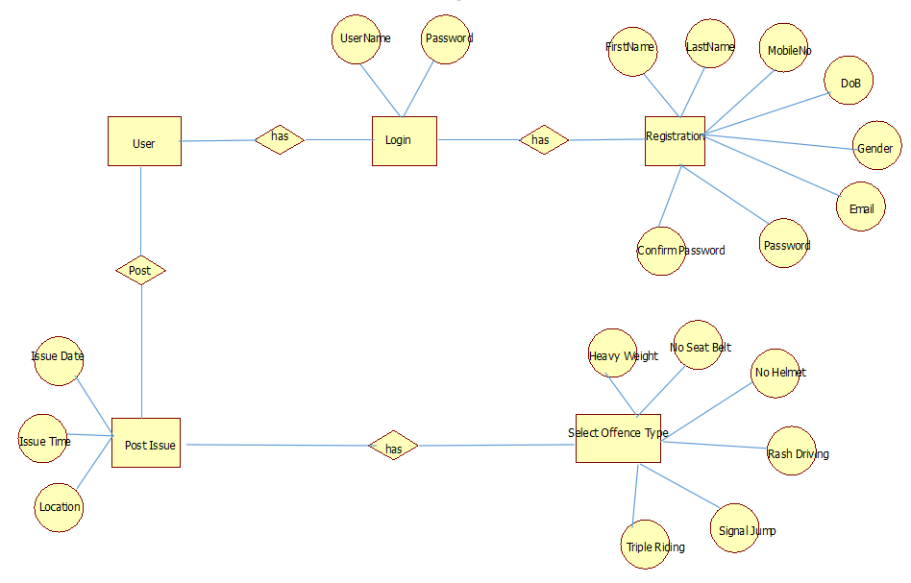

**ADMIN:**

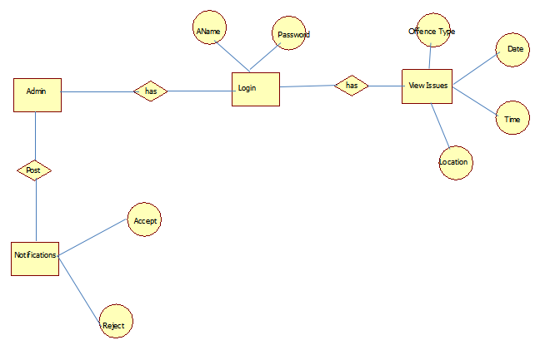

## Figure 3.4.1 Entity Relationship Diagram for Traffic Sudharo.

**3.5 UML DIAGRAMS**

UML stands for Unified Modeling Language. UML is a standardized general-purpose modeling language in the field of object-oriented software engineering. The standard is managed, and was created by, the Object Management Group. The goal is for UML to become a common language for creating models of object oriented computer software. In its current form, UML is comprised of two major components: a Meta-model and a notation. In the future, some form of method or process may also be added to; or associated with, UML.

The Unified Modelling Language is a standard language for specifying, Visualization, Constructing and documenting the artefacts of software system, as well as for business modelling and other non-software systems.

The UML represents a collection of best engineering practices that have proven successful in the modelling of large and complex systems.

The UML is a very important part of developing objects oriented software and the software development process. The UML uses mostly graphical notations to express the design of software projects.

Various UML diagrams are used in this project to understand the flow of the system easily. The system flow is depicted using

* Use case diagram,
* Class diagram,
* Sequence diagram,
* Activity diagram,
* Collaboration diagram,
* Deployment diagram,
* Component diagram etc. which are shown below

## 3.5.1 USE CASE DIAGRAM

## A use case diagram in the Unified Modeling Language (UML) is a type of behavioral diagram defined by created from a Use-case analysis. Its purpose is to present a graphical overview of the functionality provide by a system in terms of actors, their goals (represented as use case), and any dependencies between those use case. The main purpose of the use case diagram is to show what system functions are performed for which actor. Roles of the actor in the system can be depicted.



## IFigure 3.5.1 Use Case Diagram

**3.5.2 CLASS DIAGRAM**

In software engineering, a class diagram in the Unified Modeling Language (UML) is a type of static structure diagram that describes the structure of a system by showing the system's classes, their attributes, operations (or methods), and the relationships among the classes. It explains which class contains information.

In this project Traffic Sudharo , the class diagram shows different classes used in this system, and their relationship among them

Following figure shows the class diagram of Traffic Sudharo Application.

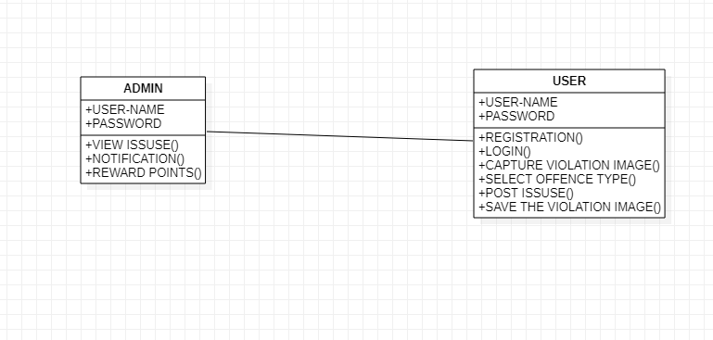

**Figure 3.5.2 Class Diagram**

**3.5.3 SEQUENCE DIAGRAM**

A sequence diagram in Unified Modeling Language (UML) is a kind of interaction diagram that shows how processes operate with one another and in what order. It is a construct of a Message Sequence Chart. Sequence diagrams are sometimes called event diagrams, event scenarios, and timing diagrams.



**Figure 3.5.3 Sequence Diagram**

## 3.5.4 ACTIVITY DIAGRAM

## 

## Activity diagrams are graphical representations of workflows of stepwise activities and actions with support for choice, iteration and concurrency. In the Unified Modeling Language, activity diagrams can be used to describe the business and operational systematic workflows of components in a system. An activity diagram shows the overall flow of control.



**Figure 3.5.4 Activity Diagram**

**3.5.5 COLLABORATION DIAGRAM**

In collaboration diagram, the method call sequence is indicated by some numbering technique as shown below. The number indicates how the methods are called one after another. We have taken the same order management system to describe the collaboration diagram. The method calls are similar to that of a sequence diagram. However, the difference is that the sequence diagram does not describe the object organization where as the collaboration diagram shows the object organization. The figure below shows the collaboration diagram of the Traffic Sudharo Application.

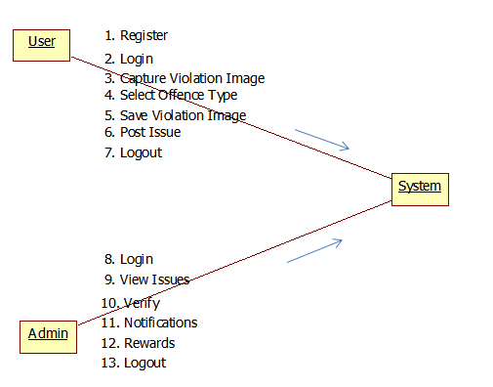

## Figure 3.5.5 Collaboration Diagram

**3.3.6 DEPLOYMENT DIAGRAM**

Deployment diagram represents the deployment view of a system. It is related to the component diagram. Because the components are deployed using the deployment diagrams. A deployment diagram consists of nodes. Nodes are nothing but physical hardware used to deploy the application. Following is the deployment diagram of Traffic Sudharo Application.



**Figure 3.5.6 Deployment Diagram**

## 3.5.7 COMPONENT DIAGRAM

## Component diagrams are used to describe the physical artifacts of a system. This artifact includes files, executables, libraries etc. So the purpose of this diagram is different, Component diagrams are used during the implementation phase of an application. However, it is prepared well in advance to visualize the implementation details. Initially the system is designed using different UML diagrams and then when the artifacts are ready component diagrams are used to get an idea of the implementation.

## The following figure shows the component diagram of the agricultural management information system.



## Figure 3.5.7 Component Diagram

**CHAPTER-IV SYSTEM IMPLEMENTATION**

* 1. **LANGAUGE SELECTION**
     1. **HTML AND CSS**

The front end is designed using of HTML, CSS. **HTML** – HTML stands for Hypertext Markup Language, the code that describes web pages. It is actually three kinds of code: HTML, which provides the structure; Cascading Style Sheets (CSS), which take care of presentation; CSS stands for Cascading Style Sheets. CSS is a standard style sheet language used for describing the presentation (i.e. the layout and formatting) of the web pages.

Prior to CSS, nearly all of the presentational attributes of HTML documents were contained within the HTML markup all the font colors, background styles, element alignments, borders and sizes had to be explicitly described within the HTML.

As a result, development of the large websites became a long and expensive process, since the style information was repeatedly added to every single page of the website. CSS was designed to enable the separation of presentation and content.

Now web designers can move the formatting information of the web pages to a separate style sheet, which results in considerably simpler HTML mark-up, and better maintainability.CSS3 is the latest version of the CSS specification. CSS3 adds several new styling features and improvements to enhance the web presentation capabilities. The biggest advantage of CSS is that it allows the separation of style and layout from the content of the document.

## Advantages of CSS

* + - * Easy Maintenance: CSS provides an easy means to update the formatting of the documents, and to maintain the consistency across multiple documents.
      * Pages Load Faster: CSS enables multiple pages to share the formatting information, which reduces complexity and repetition in the structural contents of the documents. It significantly reduces the file transfer size, which results in a faster page loading.
      * Superior Styles to HTML — CSS has much wider presentation capabilities than HTML and provide much better control over the layout of your web pages.
      * Multiple Device Compatibility — CSS also allows web pages to be optimized for more

than one type of device or media. Using CSS the same HTML document can be presented in different viewing styles for different rendering devices such as desktop, cell phones, etc.

## JAVA LANGUAGE

Java programming language was originally developed by Sun Microsystems, which was initiated by James Gosling and released in 1995 as core component of Sun Microsystems' Java platform.

**Java is Object Oriented:** In Java, everything is an Object. Java can be easily extended sinceit is based on the Object model. It has the following features.

* + - * **Platform Independent:** Unlike many other programming languages including Cand C++, when Java is compiled, it is not compiled into platform specific machine, rather into platform independent byte code. This byte code is distributed over the web and interpreted by the Virtual Machine (JVM) on whichever platform it is being run on.
      * **Simple:** Java is designed to be easy to learn. If you understand the basic concept ofOOP Java, it would be easy to master.
      * **Secure:** With Java's secure feature, it enables to develop virus-free, tamper-freesystems. Authentication techniques are based on public-key encryption.
      * **Architecture-neutral:** Java compiler generates an architecture-neutral object fileformat, which makes the compiled code executable on many processors, with the presence of Java runtime system.
      * **Portable:** Being architecture-neutral and having no implementation dependentaspects of the specification makes Java portable. Compiler in Java is written in ANSI C with a clean portability boundary, which is a POSIX subset.
      * **Robust:** Java makes an effort to eliminate error prone situations by emphasizingmainly on compile time error checking and runtime checking
      * **Multithreaded:** With Java's multithreaded feature, it is possible to write programsthat can perform many tasks simultaneously. This design feature allows the developers to construct interactive applications that can run smoothly.
      * **Interpreted:** Java byte code is translated on the fly to native machine instruction and is not stored anywhere. The development process is more rapid and analytical since the linking is an incremental and lightweight process.
      * **High Performance:** With the use of Just-In-Time compilers, Java enables highperformance.
      * **Distributed:** Java is designed for the distributed environment of the internet.
      * **Dynamic:** Java is considered to be more dynamic than C or C++ since it is designed to adapt to an evolving environment. Java programs can carry extensive amount of run-time information that can be used to verify and resolve accesses to objects on run-time.

Java is a programming language, a runtime system, a set of development tools, an application-programming interface (API). Java API contains predefined software packages with numerous platform-independent "hooks" into the native windowing and networking capabilities of the host operating system. The Java API provides a single common API across all operating system to which Java is ported.

The keys to Java's portability are its run time system, and it’s API. The run time system is very compact, evolving from earlier Sun efforts to build a software platform for consumer electronics. Because this platform was not designed around any existing microprocessor, it was built from scratch to be simple and efficient. The fact that it was not tied to a given hardware architecture enabled it to be architecture neutral.

## Java and constants

Java is pure object-oriented language. Thus, it does not support constants as such instead; constants have to be defined as final variables within a class. It is somewhat confusing for a constant to be defended as a "variable". Unlike C and C++, Java also do not support macros such as # defines that can be used, in conjunction with a pre-processor, to declare the value of a constant? There is a good reason for this. Java applets are design to be independent programs loaded over the Internet. Java therefore does not support header files or other components that need to be available in conjunction with otherwise stand-alone programs.

## Java and object orientation

Java supports the five basic elements of Object-Oriented language, namely, classes, objects, inheritance, polymorphism, and dynamic binding. Java is a pure Object-Oriented language; it does not support the classical paradigm. Thus, there are no functions or procedures, only methods or classes.

## Java and reusability

All Object-Oriented programming language supports reuse via inheritance of classes. In addition, mechanisms such as templates (in C++) and generics (in Adam) provide reuse at a higher level of abstraction. A template or generic is a module that is defined in terms of parameters. The generic is then instantiated for a particular set of parameters. There is a good reason for this. Java applets are design to be independent programs loaded over the Internet. There is a good reason for this. Java applets are design to be independent programs loaded over the Internet.

## Java database connectivity

The database is the most important component of a company's information services infrastructure. It is heart of the applications on which a company depends for its survival. Any programming language must be able to provide an application with access to these databases if it is to be considered a serious programming language. The issues surrounding database access are often very difficult; other languages use either proprietary APIs specific to individual databases or complex universal APIs such as ODBC. Before starting any program the must be a need to use through data modeling and database design.

* + 1. **JAVA SERVER PAGE**

Java Server Pages (JSP) is a technology for developing web pages that support dynamic content which helps developers insert java code in HTML pages by making use of special JSP tags, most of which start with <% and end with %>.A Java Server Pages component is a type of Java served that is designed to fulfil the role of a user interface for a Java web application. Web developers write JSPs as text files that combine HTML or XHTML code, XML elements, and embedded JSP actions and commands. Using JSP, you can collect input from users through web page forms, present records from a database or another source, and create web pages dynamically.

* + 1. **DATABASE AND HTML PAGE DESIGN**

SQL tutorial gives unique learning on Structured Query Language and it helps to make practice on SQL commands, which provides immediate results. SQL is a language of database, it includes database creation, deletion, fetching rows and modifying rows etc.SQL is an ANSI (American National Standards Institute) standard, but there are many different versions of the SQL language

**What is Structure Query language (SQL)**

SQL is Structured Query Language, which is a coding languages for putting away, controlling and

recovering information Stored in social database. SQL is the standard language for Relation Database

System. All social database the board frameworks like MySQL, MS Access, Oracle, Sybase, Informix,

and SQL Server use SQL as standard database language. Additionally, they are utilizing distinctive lingos,

for example, MS SQL Server utilizing T-SQL, Oracle utilizing PL/SQL, MS Access variant of SQL is

called JET SQL (local configuration) and so forth.

**Why Structure Query Language (SQL)**

* Allows users to define, access data in relational database management systems and facilitates

the user to embedding within other languages using SQL modules, libraries & pre-compilers.

* Allows users to create and drop databases, to create view, stored procedure, functions in a database.

### SCREEN SHOTS:

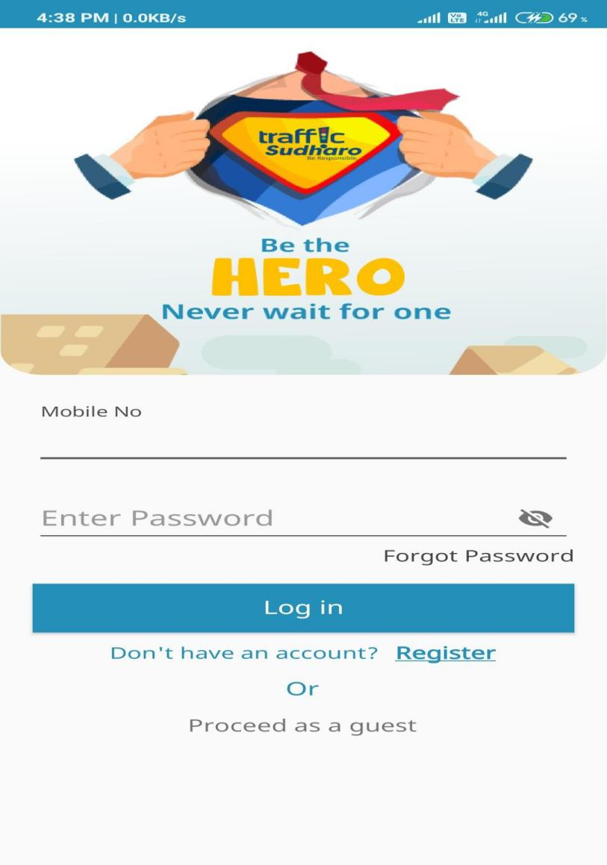

**Figure 4.2.1 Login Page**

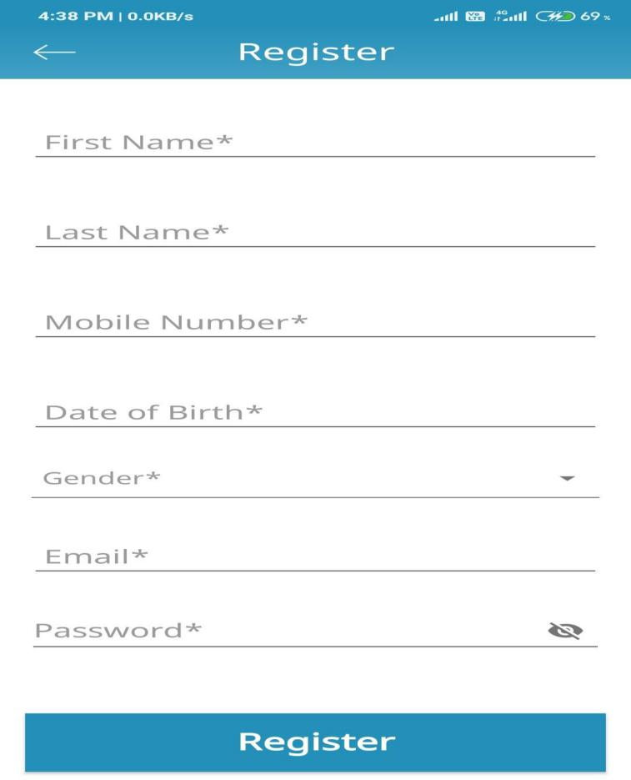

**Figure 4.2.2 Registration Page**

**Figure 4.2.3 Home Page**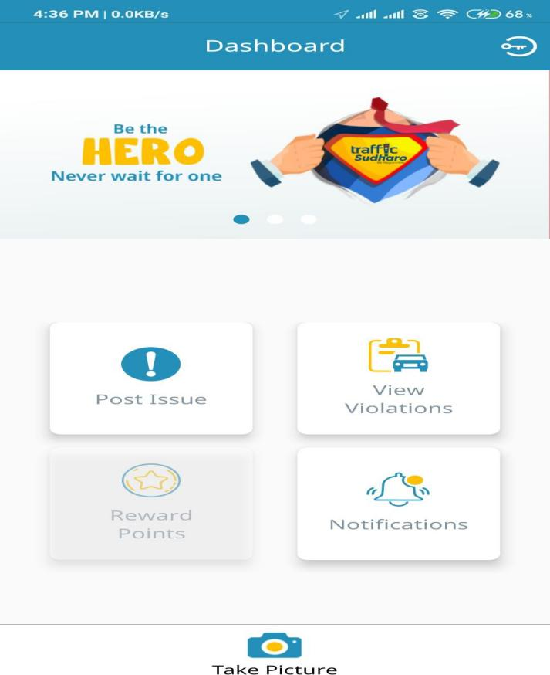

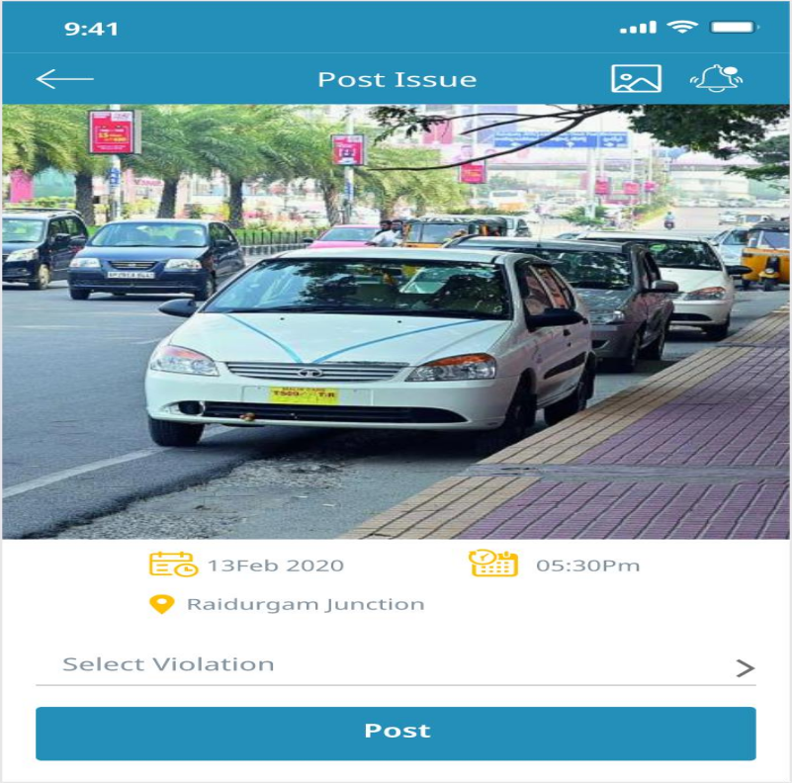

**Figure 4.2.4 Post-Issues Page**

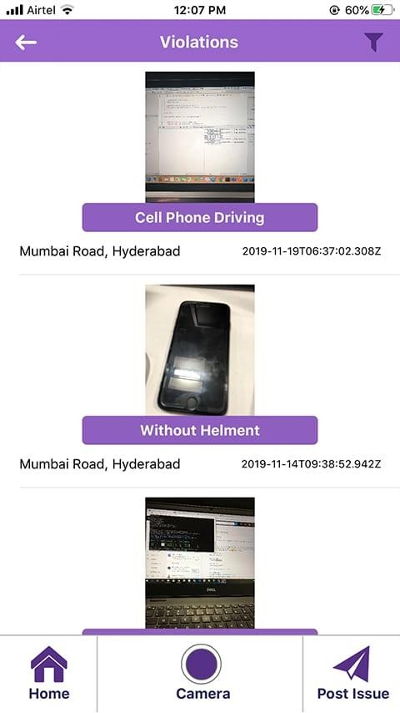

**Figure 4.2.5 View-Violation Page**

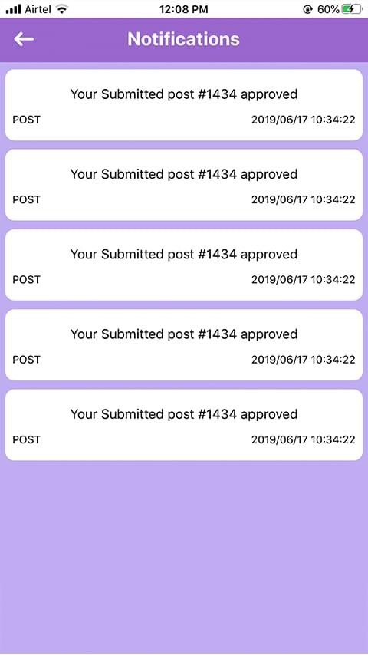

**Figure 4.2.6 Notification Page**

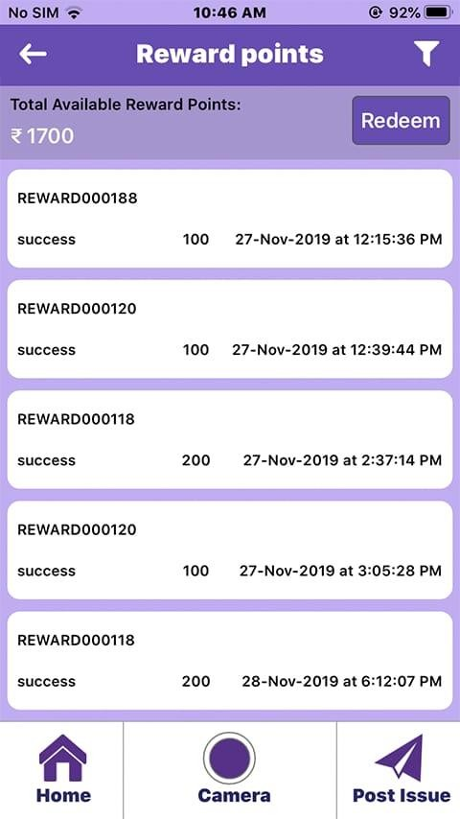

**Figure 4.2.7 Rewards Page**

* 1. **SAMPLE CODE**

<html>

<head>

<title>front-end page</title>

<script src=*”C:\Users\ks20111\Desktop\trafficscripts”*></scripts>

<link rel=”stylesheet” type= “text/css”

href = “C:\Users\ks20111\Desktop\traffic_styles”>

</head>

<body>

<form style="margin-top:30px" [formGroup]="violationTypeForm" (ngSubmit)="onSubmit()" **class**="card p-3">

<div **class**="form-row ">

<div **class**="col-2">

<h5 **class**="text-secondary text-success display">Violation Type</h5>

</div>

<!-- <div class="col-2">

<select formControlName="image">

<option *ngFor="let view of getViolationTypes">

<img src='{{view.image}}' >

</option>

</select>

</div> -->

<div **class**="col-4">

<input type="text" (keypress)="keyPress($event)" **class**="form-control" formControlName="name" placeholder="Violation Type"

[ngClass]="{ 'is-invalid': submitted && f.name.errors }" />

<div *ngIf="submitted && f.name.errors" **class**="invalid-feedback">

<div *ngIf="f.name.errors.required">Violation Type is required</div>

<div *ngIf="f.name.errors.pattern">Aplhabet is required

</div>

</div>

</div>

<div **class**="col-4">

<button **class**="btn btn-info">Add</button>

</div>

</div>

</form>

<div style="background-image:url('assets\imgs\pro.jfif')"></div>

<!-- loader -->

<div *ngIf="loading else loaded">

<div **class**="d-flex justify-content-center text-info">

<div **class**="spinner-border" role="status">

</div>

</div>

</div>

<table **class**="table table-hover bg-light mt-3">

<thead>

<tr **class**="text-secondary">

<!-- <th>Images</th> -->

<th>ViolationType</th>

<th>ViolationTypeId</th>

<th>Edit</th>

<th>Delete</th>

</tr>

</thead>

<tbody>

<tr *ngFor="let view of getViolationTypes">

<!-- <td><img src="{{view.image}}" style="width:40px; height: 40px;"></td> ->

<td>{{view.name}}</td>

<td>{{view.violationTypeId}}</td>

<td><button type="button" **class**="btn btn-info" (click)="edit(view)" data- toggle="modal"

data-target="#myModal">Edit</button>

</td>

<td><button type="button" **class**="btn btn-danger" (click)="delete(view)">Delete</button>

</td>

</tr>

</tbody>

</table>

<div **class**="modal" id="myModal">

<div **class**="modal-dialog">

<div **class**="modal-content">

<div **class**="modal-header">

<h5 **class**="modal-title text-secondary">Violation Type Update</h5>

<button type="button" **class**="close" data-dismiss="modal" #closeBtn>&times;</button>

</div>

<div **class**="modal-body">

<form [formGroup]="myform" (ngSubmit)="upDate(myform.value)">

<div **class**="row">

<div **class**="col-sm-8">

<label>Violation Type Id</label>

<input type="text" placeholder="violationTypeId" formControlName="violationTypeId" **class**="form-control"

name="violationTypeId" disabled>

</div>

</div>

<div **class**="row">

<div **class**="col-sm-8">

<label>Violation Type</label>

<input type="text" placeholder="name" (keypress)="keyPress($event)" formControlName="name" **class**="form-control" name="name">

</div>

</div><br>

<div **class**="row">

<div **class**="col-sm-8">

<label></label>

<button **class**="btn btn-info">Update</button>

</div>

</div>

</form>

</div>

<div **class**="modal-footer">

<button type="button" **class**="btn btn-secondary" data- dismiss="modal">Close</button>

</div>

</div>

</div>

</div>

</body>

</html>

# CHAPTER V SYSTEM TESTING

* 1. **TESTING DESCRIPTION**

The purpose of testing is to discover errors. Testing is the process of trying to discover every conceivable fault or weakness in a work product. It provides a way to check the functionality of components, sub-assemblies, assemblies and/or a finished product It is the process of exercising software with the intent of ensuring that the

Software system meets its requirements and user expectations and does not fail in an unacceptable manner. There are various types of test. Each test type addresses a specific testing requirement.

* + 1. **Unit testing**

Unit testing involves the design of test cases that validate that the internal program logic is functioning properly, and that program inputs produce valid outputs. All decision branches and internal code flow should be validated. It is the testing of individual software units of the application .it is done after the completion of an individual unit before integration. This is a structural testing, that relies on knowledge of its construction and is invasive. Unit tests perform basic tests at component level and test a specific business process, application, and/or system configuration. Unit tests ensure that each unique path of a business process performs accurately to the documented specifications and contains clearly defined inputs and expected results.

* + 1. **Integration testing**

Reconciliation tests are intended to test coordinated programming parts to decide whether they really keep running as one program. Testing is occasion driven and is increasingly worried about the fundamental result of screens or fields. Reconciliation tests exhibit that despite the fact that the segments were separately fulfillment, as appeared by effectively unit testing, the blend of segments is right and reliable. Mix testing is explicitly gone for uncovering the issues that emerge from the mix of segments.

# Functional testing:

Functional tests provide systematic demonstrations that functions tested are available as specified by the business and technical requirements, system documentation, and user manuals.

Functional testing is cantered on the following items

Valid Input : identified classes of valid input must be accepted. Invalid Input : identified classes of invalid input must be rejected. Functions : identified functions must be exercised.

Output : identified classes of application outputs must be exercised. Systems/Procedures: interfacing systems or procedures must be invoked.

Organization and preparation of functional tests is focused on requirements, key functions, or special test cases. In addition, systematic coverage pertaining to identify Business process flows; data fields, predefined processes, and successive processes must be considered for testing. Before functional testing is complete, additional tests are identified and the effective value of current tests is determined.

* + 1. **System Testing**

System testing ensures that the entire integrated software system meets requirements. It tests a configuration to ensure known and predictable results. An example of system testing is the configuration oriented system integration test. System testing is based on process descriptions and flows, emphasizing pre-driven process links and integration points.

* + 1. **White box Testing**

White Box Testing is a testing in which in which the software tester has knowledge of the inner workings, structure and language of the software, or at least its purpose. It is purpose. It is used to test areas that cannot be reached from a black box level.

* + 1. **Black Box Testing**

Black Box Testing is testing the software without any knowledge of the inner workings, structure or language of the module being tested. Black box tests, as most other kinds of tests, must be written from a definitive source document, such as specification or requirements document, such as specification or requirements document. It is a testing in which the software under test is treated, as a black box .you cannot “see” into it. The test provides inputs and responds to outputs without considering how the software works.

* + 1. **Acceptance Testing**

User Acceptance Testing is a critical phase of any project and requires significant participation by the end user. It also ensures that the system meets the functional requirements.

## TEST CASES

|  |  |  |  |
| --- | --- | --- | --- |
| **S.NO.** | **Test Data** | **Description** | **Test Case**  **Result** |
| **1.** | **Login Page:**  **Username: Ganeshzx Password: 3456** | **Not a valid Login.**  **Enter proper user name and passwrod** | **Pass** |
| **2.** | **Username: Ganesh**  **Password: 1234** | **System provides access** | **Pass** |
| **3.** | **Registration Page: Password:**  **Email: ganesh.gmail.com**  **Email: [ganesh@gmail.com](mailto:vasavi@gmail.com)** | **Password field must not be empty Not a valid email**  **System does not show any error** | **Pass Pass**  **Pass** |
| **4.** | **PostIssue Page:**  **PostIssue name:Nohelmet**  **Picture uploaded** | **System shows details of the Post along with picture and name** | **Pass** |
| **5.** | **View Issues Page:**  **Registered user: Ganesh** | **Details are visible in View issues page clearly with all the entered details** | **Pass** |

**Table 5.2.1 Sample Test Cases**

**CHAPTER-VI**

**CONCLUSION & FUTURE ENHANCEMENT**

* 1. **CONCLUSION**

As the name suggests, Traffic Sudharo is a great initiative enabling the Citizens to report Traffic Violations to the appropriate authority this application. It will also allow the users to report the images which they’ve captured out of the application. All the approved Issues will help the Users get Reward Points as per the Policy of Traffic Sudharo, which the Users can check in their Rewards in the app. These Rewards can be redeemed against various famous service.By the help of these Application I hope that the Traffic violations will be reduced.

By the help of this project we can make everyone has to aware of traffic rules and must follow, Otherwise you will be punished by anyone.

* 1. **FUTURE ENHANCEMENT**

Always I follow the traffic rules updates from the concern government and update in violation types.I will follow the feedback given by the users and if any reasonable suggestions found, I will follow with that and try to implement in the project.

There is always a room for improvement in any software package, however good and efficient it may be.

The important thing  is that the application should be  flexible enough for further modifications. Considering this important factor,the application is designed in such a way that the provisions are given for furture enhancements.

**REFERENCES**

## Book Resources

* + 1. E.Balagurusamy, “Programming in Java”, 5th Edition, BPB Publications, 2010
    2. Herbert Schildt, “Java – The Complete Reference”, 4th Edition, McGrawHill, 2014
    3. Abraham Silberscatz, Korth, Sudarshan – Database Management Systems, 4th Edition, McGrawHill, 2002
    4. Bruce Eckel, Thinking in Java, 2nd Edition, Prentice Hall, June 2000.
    5. Hans Bergsten, Java Server Pages, Oreille, 3rd Edition December 2003
    6. Prophet, MySQL Database" Reference 10g Release 1 (10.1), Recovered 2008-11-17.
    7. Roger S.Pressman, Software Engineering-A Practioners Approach, McGraw-Hill, 2005
    8. Santosh Kumar K and Cogent Solutions Inc, JDBC, Servlets, and JSP, Version 6.
    9. Bahlmann C., Ying Z., Ramesh V., Pellkofer M., Koehler T. A system for traffic sign detection, tracking, and recognition using color, shape, and motion information. Proceedings of Intelligent Vehicles Symposium; Las Vegas, NV, USA. 6–8 June 2005; pp. 255–260. [Google Scholar]

## Web Resources

1. www.java2share/jdbcconnectivity.html
2. www.way2java/jspintroduction.html
3. www.java2s/javapagesexamples.solvedexamples.html
4. www.roseindia/dbconnectivity.html
5. www.javatpoint/htmlregistration/example.html
6. www.ajava2all/connectingjavawithtml.html
7. [www.booksboon.com](http://www.booksboon.com/)