**Today(10/14/2020):**

**1)A departmental store announces its festival scheme to customers on cash payment. The scheme is as Follows**

**a. If purchase amount is less than 1000 then Tax=2% and discount=10%.**

**b. If purchase amount is greater than 1000 then Tax=5 % and discount=20%.**

**2)Write a shell script to find out the length of an input string.**

**3)Write a shell script to find whether an input year is leap year or not.**

**4) Make a duplicate copy of a specified file through command-line.**

**5)Write a shell script to concatenate two strings input by the user.**

**6)Write a shell script to concatenate files.**

**7)Program for command-line parameter & special variable.**

**-------------------------------------------------------------------------------------------------------------- ADAPA GANESH**

**Explanation:**

1**)A departmental store announces its festival scheme to customers on cash payment. The scheme is as Follows**

**a. If purchase amount is less than 1000 then Tax=2% and discount=10%.**

**b. If purchase amount is greater than 1000 then Tax=5 % and discount=20%.**

**Code:**

echo "Enter Purchase Amount"

read PAmount

if [ $PAmount -le 1000 ]

then

Tax=$(($PAmount * 2/100))

Discount=$(($PAmount * 10/100))

echo $(($PAmount-$Tax+Discount))

else

Tax=$((PAmount*5/100))

Discount=$((PAmount*20/100))

echo $(($PAmount-$Tax+Discount))

fi

**Output:**

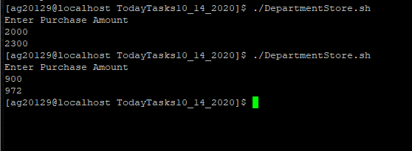

**2)Write a shell script to find out the length of an input string.**

**Code:**

echo "Enter the String"

read String

STRLENGTH=$(echo -n $String | wc -m)

echo $STRLENGTH

**output:**

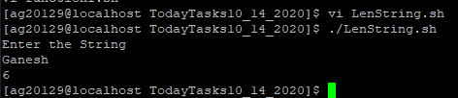

**3)Write a shell script to find whether an input year is leap year or not.**

**Code:**

echo -n "Enter year (YYYY): "

read y

if [[ $(( $y % 4 )) -eq 0 || $(( $y % 100 )) -eq 0 || $(( $y % 400 )) -eq 0 ]]

then

echo "$y is leap year"

else

echo "$y is not a leap year"

fi

**output:**

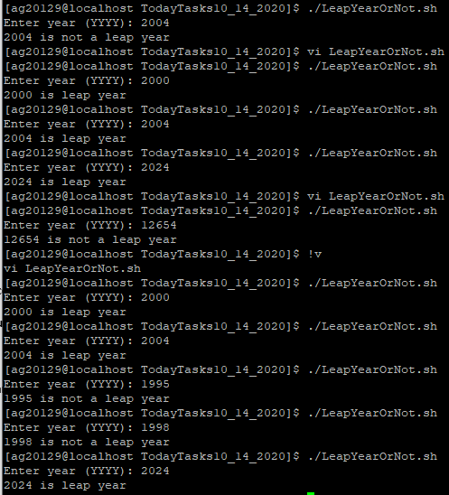

**4) Make a duplicate copy of a specified file through command-line.**

**Code:**

cp $1 $2

**output:**

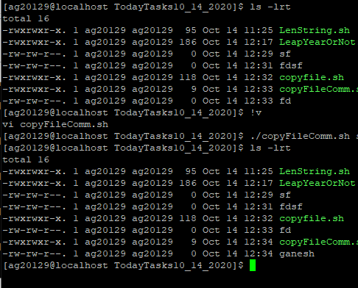

**5)Write a shell script to concatenate two strings input by the user.**

**Code:**

echo "Enter The First String"

read Str1

echo "Enter The Second String"

read Str2

echo $Str1$Str2

**output:**

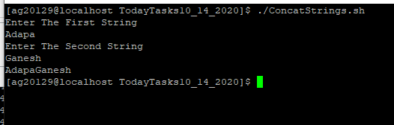

**6)Write a shell script to concatenate files.**

**Code:**

echo "Enter First File"

read FirstFile

echo "Enter Second File"

read SecondFile

echo "Enter Third File"

read TargetFile

cat $FirstFile $SecondFile > $TargetFile

echo "The Files are Concatinated"

**Output:**

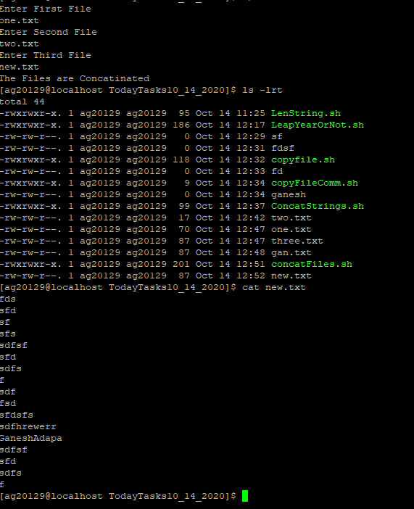

**7)Program for command-line parameter & special variable.**

**Code:**

#!/bin/sh

echo "File Name: $0"

echo "First Parameter : $1"

echo "Second Parameter : $2"

echo "Third Parameter : $3"

echo "Quoted Values: $@"

echo "Quoted Values: $*"

echo "Total Number of Parameters : $#"

**Output:**

