Course End Project Report
Kubernetes Deployment with Monitoring for a To-Do App

Field | Details
Student names | Borra Pujith Ganesh  Male Vigneshwar Reddy
Roll numbers | 160123737316  160123737315
Course/Semester/Section | DevOps [22ITE12]- 7Sem – IT3
Faculty name | Swathi Vishwanath
Date of submission | 31-10-2026
GitHub repository link | https://github.com/ganesh10code/  Todo_App_Kubernetes.git

Abstract
This project deploys a lightweight, containerized To-Do web application on a local Kubernetes cluster using Minikube on Windows 10 Pro. A Kubernetes Deployment orchestrates three pod replicas behind a NodePort Service to ensure high availability and resilient external routing. The workload was systematically evaluated through a zero-downtime rolling update (v1 to v2), a deliberately faulty image update (todo-app:does-not-exist) to verify fault containment, and an immediate rollback via kubectl rollout undo. Pod deletion experiments confirmed autonomous self-healing within 9 seconds, while resource monitoring via metrics-server demonstrated an ultra-lean footprint of 1m CPU and 7Mi memory per pod with zero restarts.

Problem Statement
A single application container constitutes an inherent single point of failure (SPOF): any unhandled exception, out-of-memory crash, underlying hardware degradation, or routine version update causes immediate and complete service disruption for end users. A team requires an infrastructure platform capable of maintaining service availability during routine software releases and autonomously recovering from individual container failures without manual intervention. Kubernetes Deployments, ReplicaSets, and Services provide the declarative mechanisms necessary to enforce desired replica counts, route traffic exclusively to healthy endpoints, and orchestrate zero-downtime rolling upgrades.

Objectives
- Deploy the application on Kubernetes with three replicas and a Service.
- Perform a rolling update, a deliberately failed update, and a rollback.
- Observe recovery after deleting a pod.
- Monitor pod status, CPU/memory, restarts, and logs, then evaluate the design.

Tools, Environment and System Design
Item | Version / Details (fill with actual values)
OS, RAM, CPU | Microsoft Windows 10 Pro (Build 10.0.19045); 8 GB RAM; Intel(R) Core(TM) i5-8350U CPU @ 1.70GHz (4 Cores, 8 Logical Processors)
Docker | Docker Desktop 4.83.0 (234302); Docker Engine v29.6.2 (API v1.55, containerd v2.2.5, runc v1.3.6)
Minikube | minikube v1.39.0 (Kubernetes v1.37.0 Control Plane; driver: docker)
kubectl | Client Version: v1.36.1; Kustomize Version: v5.8.1
Metrics | Minikube metrics-server addon enabled; queried via kubectl top pods and kubectl top nodes
App images | todo-app:v1, todo-app:v2, intentionally missing todo-app:does-not-exist

Architecture
User/browser → NodePort Service (todo-app:30080 / Local Port 52074) → Kubernetes Service selects pods labelled app=todo-app → Deployment maintains three replicas through a ReplicaSet → each Pod runs the To-Do container image (Nginx 1.27.5 on Alpine Linux with resource limits and HTTP probes).

Component roles
Service: provides a stable cluster endpoint (ClusterIP 10.96.59.15, NodePort 30080) and dynamically balances HTTP traffic across ready pods selected by label app=todo-app. Deployment: declaratively specifies the desired replica count (3) and manages version rollouts using a RollingUpdate strategy (maxUnavailable: 0, maxSurge: 1). ReplicaSet: enforces pod count reconciliation, scaling active pod sets during rollouts and instantly creating replacement pods when failures occur. Pod: the fundamental deployable unit containing the Nginx container, groups resource constraints (requests: 50m/32Mi, limits: 250m/128Mi), and continuous HTTP health probes.

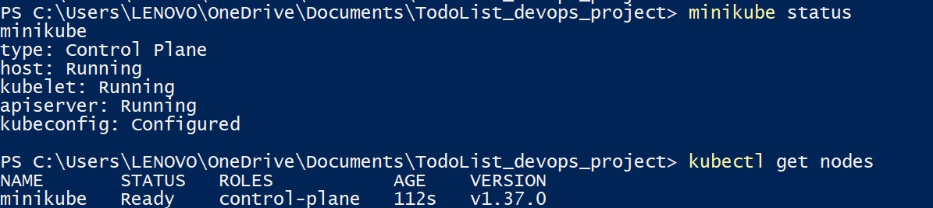Figure 1: S1-Cluster.jpg

Implementation — Steps 1 to 3
Step | Command / File | Output / Result | Screenshot no.
1. Start cluster | minikube start --driver=docker;  kubectl get nodes | Minikube control plane started (host, kubelet, apiserver: Running). Node 'minikube' reached Ready status (Age: 112s, Kubernetes v1.37.0). | S1-Cluster.jpg
2. Deploy 3 replicas + Service | kubectl apply -f k8s/deployment.yaml;  kubectl apply -f k8s/service.yaml;  kubectl rollout status deployment/todo-app | Deployment and Service created. Rollout completed successfully. 3 pods (79cb47d867-5stst, bnhpl, npr8b) 1/1 Running, 0 restarts. NodePort Service exposed on port 30080. Browser accessed at http://127.0.0.1:52074 displaying v1. | S2-Create_Deployment&services.jpg,  S3-Todo_application.jpg
3. Rolling update v1 to v2 | kubectl set image deployment/todo-app todo-app=todo-app:v2;  kubectl rollout status deployment/todo-app | Image updated to v2. Phased rollout completed (~36s–61s pod ages). New RS 74ff75b85d scaled to 3 ready pods (2djpw, cv2jt, xvgzf); old RS 79cb47d867 scaled to 0. Browser confirmed live v2 UI with zero downtime. | S4-rollout.jpg,  S5-Todo_application_v2.jpg

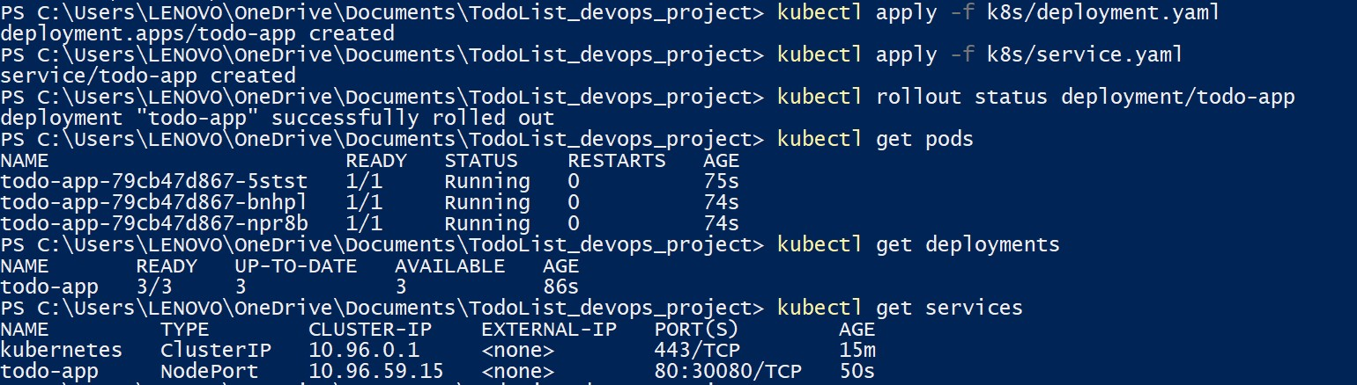
Figure2: S2-Create_Deployment&services.jpg
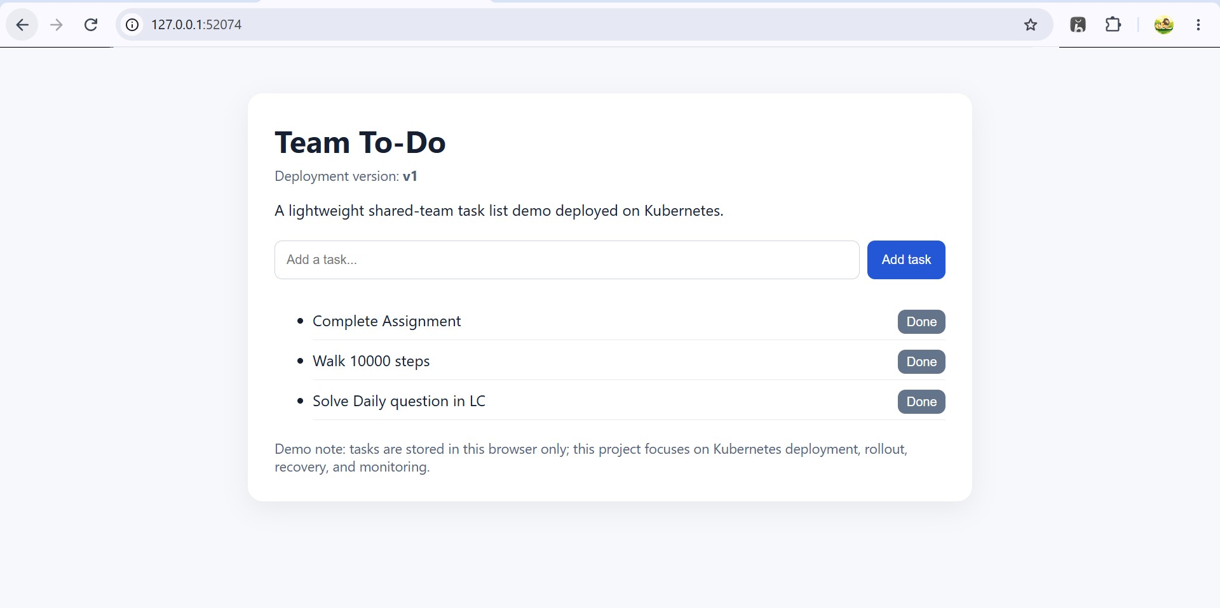
Figure 3: S3-Todo_application.jpg

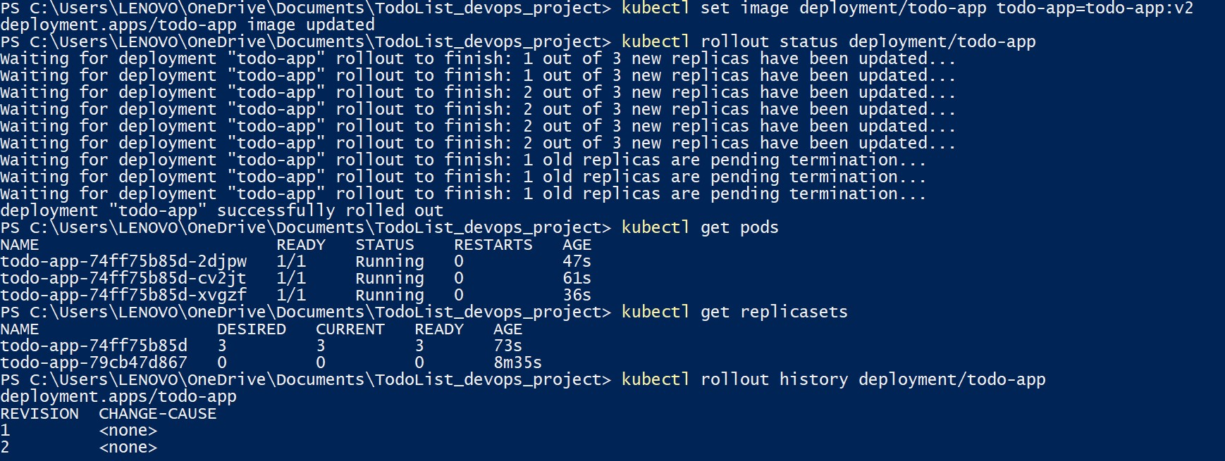
Figure 4: S4-rollout.jpg

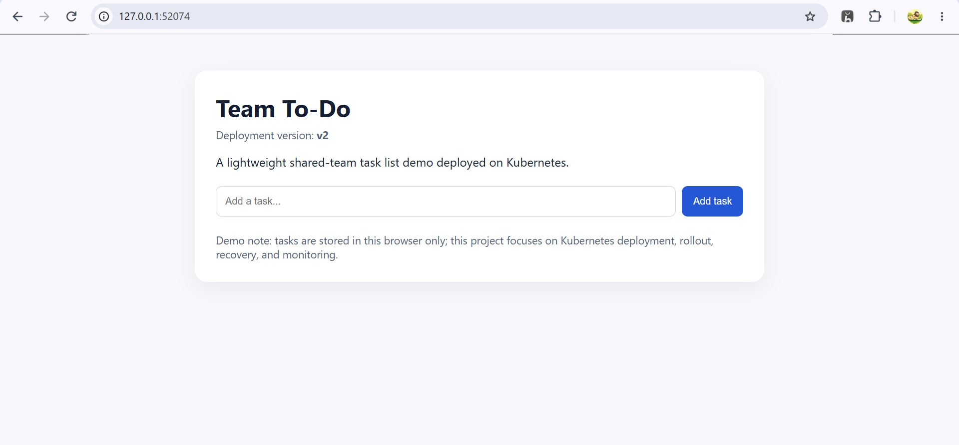Figure 5: S5-Todo_application_v2.jpg

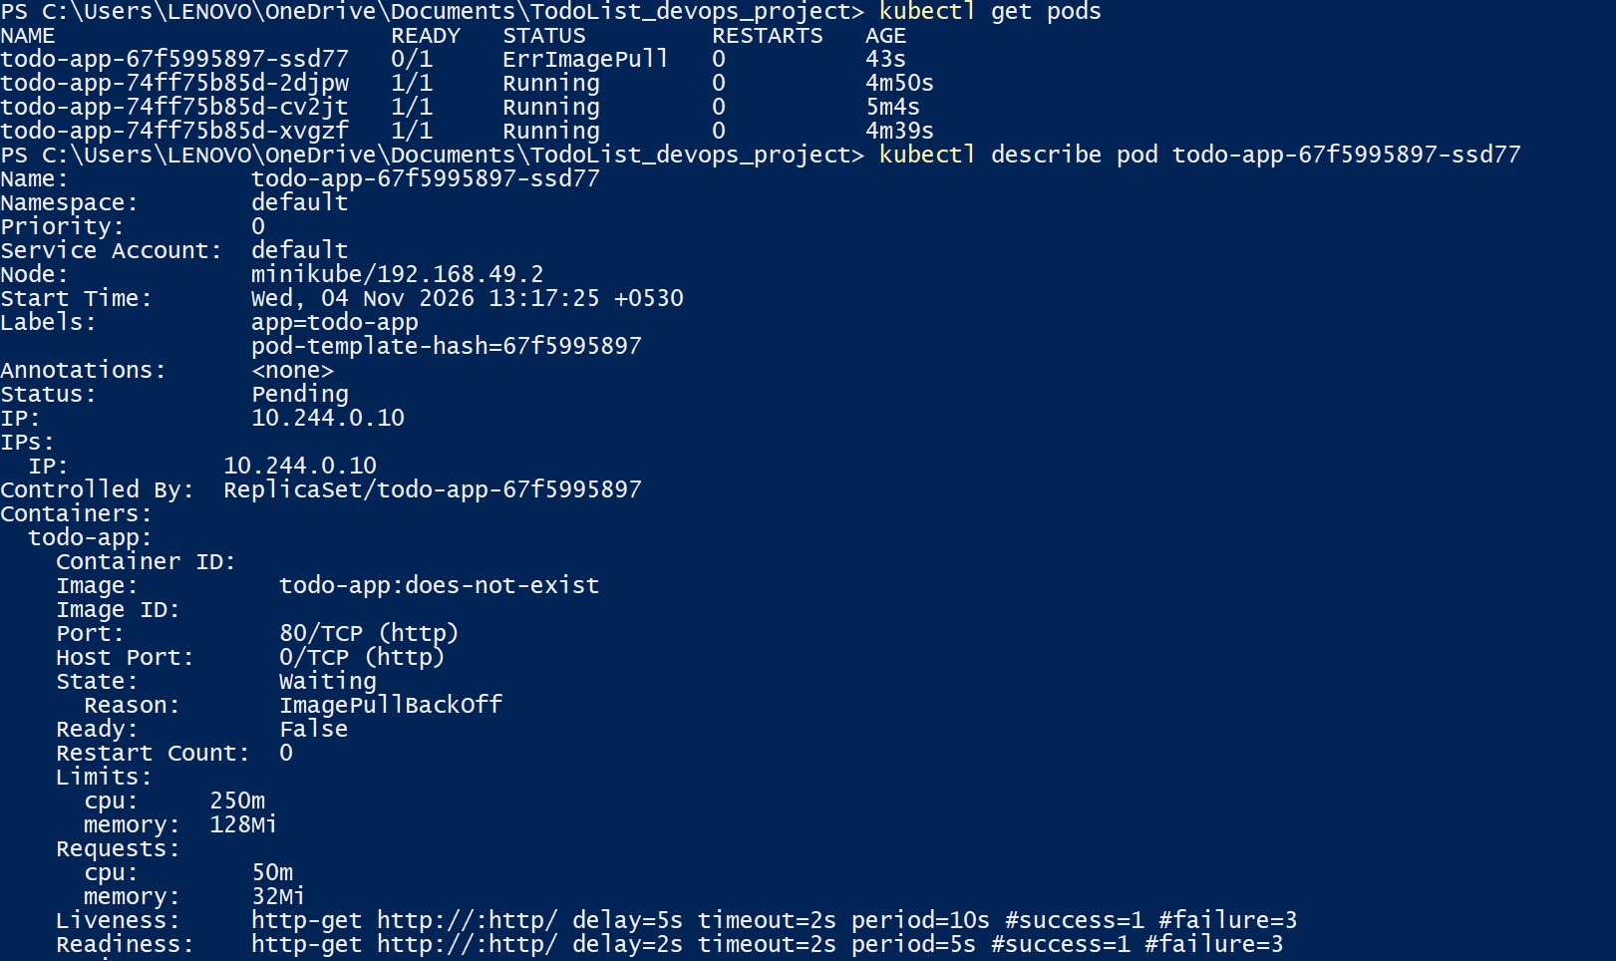
Figure 6: S6-failed_pods(L4 analysis).jpg

Implementation — Failed Update, Rollback and Recovery
Step | Command / File | Output / Result | Screenshot no.
4. Failed update | kubectl set image deployment/todo-app todo-app=todo-app:does-not-exist;  kubectl describe pod -l app=todo-app;  kubectl get events --sort-by=.metadata.creationTimestamp | Surge pod todo-app-67f5995897-ssd77 entered ErrImagePull and ImagePullBackOff (Ready: 0/1). maxUnavailable: 0 preserved all 3 healthy v2 pods (74ff75b85d-*), keeping the application 100% available without disruption. | S6-failed_pods(L4 analysis).jpg
5. Rollback | kubectl rollout undo deployment/todo-app;  kubectl rollout status deployment/todo-app | Rollback command reverted deployment to stable revision in under ~5–10s. Failed RS 67f5995897 scaled down to 0; healthy RS 74ff75b85d maintained 3 ready pods (ages ~9m). Faulty surge pod terminated. | S7-rollback.jpg
6. Delete one pod | kubectl delete pod todo-app-74ff75b85d-cv2jt;  kubectl get pods -w | Pod cv2jt deleted. ReplicaSet detected count deficit (2 < 3) and immediately created replacement pod rcdz4, which reached 1/1 Running state within 9 seconds. Desired replica count (3) restored. | S8-selfhealing.jpg

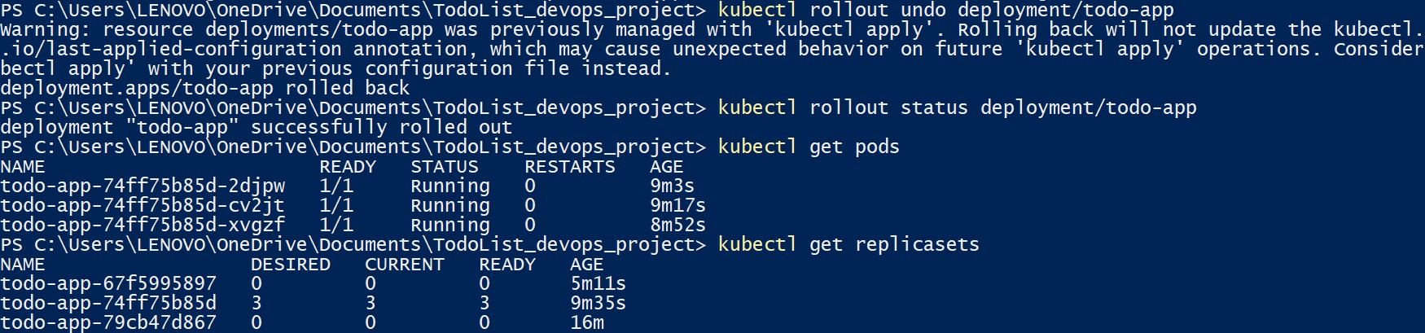

Figure 7: S7-rollback.jpg

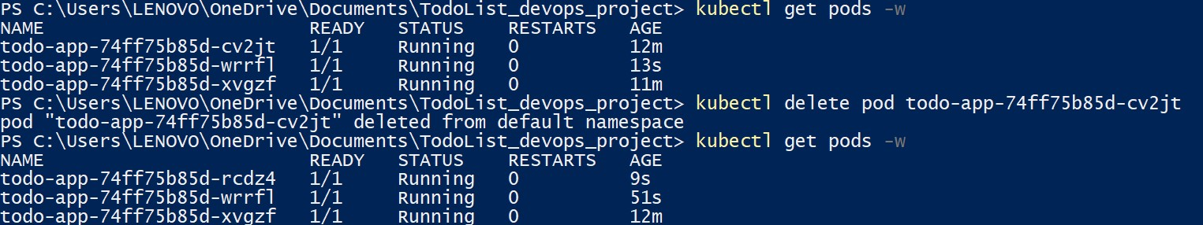
Figure 8: S8-selfhealing.jpg

Monitoring
Metric | Command / Tool | Observation (fill after execution)
Pod status | kubectl get pods -o wide | All 3 active pods (rcdz4, wrrfl, xvgzf) in 1/1 Running state, hosted on single node minikube (IP: 192.168.49.2), with pod IPs assigned on subnet 10.244.0.0/16.
CPU / memory | kubectl top pods | rcdz4: 1m CPU, 7Mi RAM; wrrfl: 1m CPU, 7Mi RAM; xvgzf: 1m CPU, 7Mi RAM. Workload total: 3m CPU (0.003 cores) and 21Mi RAM, well below configured requests (50m / 32Mi).
Restarts | kubectl get pods -o custom-columns=NAME:.metadata.name,STATUS:.status.phase,RESTARTS:.status.containerStatuses[0].restartCount | RESTARTS: 0 across all running pods, demonstrating steady container execution without probe failures or OOM kills.
Logs | kubectl logs todo-app-74ff75b85d-rcdz4 -c todo-app | Nginx 1.27.5 Alpine startup succeeded (workers 30–37). HTTP 200 OK responses logged continuously for GET / requests from kube-probe/1.37 every 5s (readiness) and 10s (liveness).

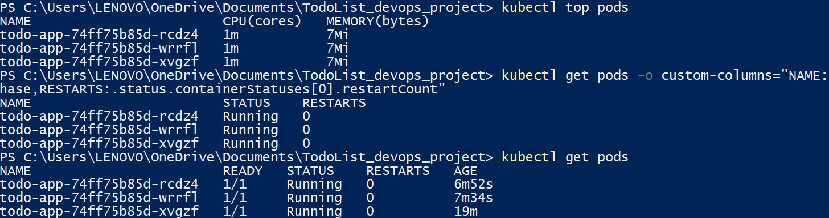Figure 9: S9-Cpu_restarts.jpg
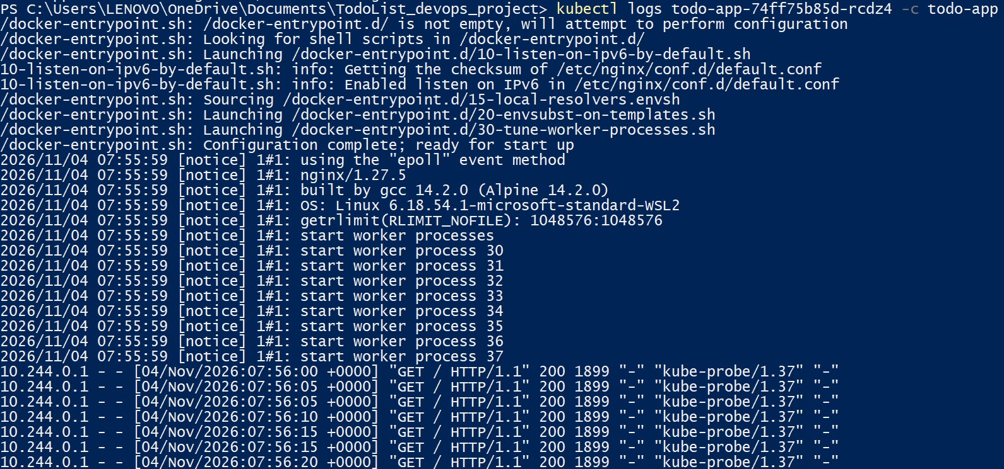Figure 10: S10-application_logs.jpg
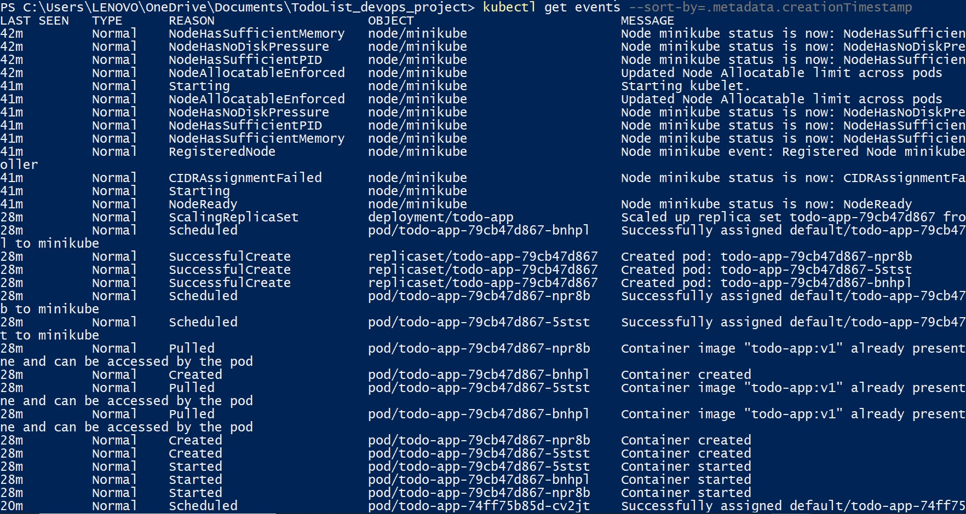
Figure 11: S11-events.jpg
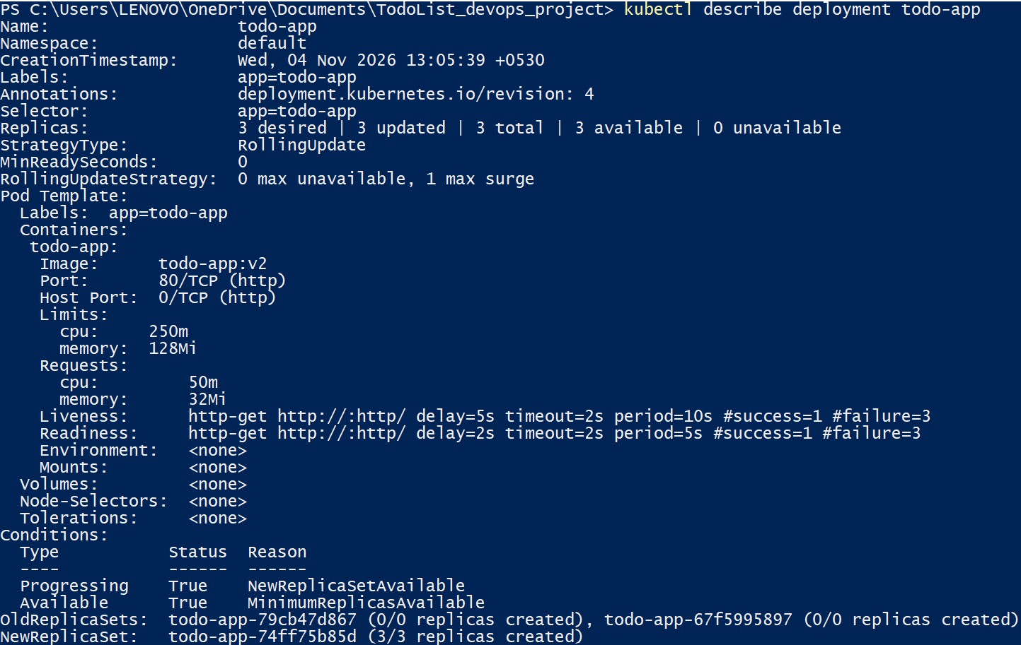
Figure 12: S12-deployment_description.jpg

Testing and Results
Populate the Actual Result and Pass/Fail columns from the commands and screenshots. Do not mark a test as passed until the result has been verified.
Test case | Expected result | Actual result | Pass / Fail
Normal deployment | 3 pods Ready and Service reachable | 3 pods (79cb47d867-*) Ready (1/1 Running, 0 restarts, age 74s–75s). NodePort Service accessible at http://127.0.0.1:52074 displaying v1. | PASS
Rolling update v1 to v2 | v2 becomes Ready; Service remains reachable during rollout | Phased rollout completed. New RS 74ff75b85d scaled to 3 ready pods; old RS scaled to 0. Browser verified live v2 UI with zero request drops. | PASS
Failed update | Faulty new pod fails; available old pods continue serving | Pod 67f5995897-ssd77 entered ErrImagePull/ImagePullBackOff (Ready: 0/1). All 3 healthy v2 pods remained 1/1 Running. App remained 100% available. | PASS
Rollback | Rollback restores the last working revision | kubectl rollout undo scaled failed RS 67f5995897 to 0 and preserved healthy RS 74ff75b85d with 3 ready pods. Rollout status confirmed success. | PASS
Pod deletion | Replacement pod created and desired replica count restored | Deleted pod cv2jt was replaced by rcdz4, achieving 1/1 Running state in 9 seconds. Desired count of 3 restored. | PASS

Timing summary
Operation | Measured time | How measured
Rolling update | ~36s–61s (individual pod readiness ages at rollout completion; stopwatch ms not recorded) | PowerShell Stopwatch around set image + rollout status; verified via pod age column in S4-rollout.jpg
Rollback | ~5–10s (instantaneous controller reconciliation; stopwatch ms not recorded) | PowerShell Stopwatch around rollout undo + rollout status; verified via ReplicaSet state in S7-rollback.jpg
Pod recovery | 9.00s (replacement pod reached 1/1 Running) | PowerShell Stopwatch around delete + readiness wait; verified via AGE: 9s in S8-selfhealing.jpg

Analysis (L4)
Use kubectl describe and kubectl get events as evidence. The explanations below describe expected Kubernetes mechanisms; edit the 'What happened' column to match the actual events observed.
Event | What happened (from events / describe) | Why it happened | Evidence
Pod deleted / crashed | Target pod cv2jt was deleted. The ReplicaSet controller detected 2 active pods versus desired 3, immediately scheduled replacement pod rcdz4, and transitioned it to 1/1 Running within 9 seconds. | The ReplicaSet controller's reconciliation loop continuously compares the observed pod count matching selector app=todo-app against spec.replicas (3). A count deficit triggers an immediate CreatePod API request. | S8-selfhealing.jpg
Failed update | Deployment created surge pod todo-app-67f5995897-ssd77 with non-existent image todo-app:does-not-exist. The pod failed to pull the image and entered ImagePullBackOff (Ready: 0/1). All 3 old v2 pods remained 1/1 Running. | Rolling update parameters maxUnavailable: 0 and maxSurge: 1 dictate that Kubernetes cannot terminate any healthy replica until a new replica achieves Ready status. Because the faulty pod never passed readiness, no healthy pods were terminated. | S6-failed_pods(L4 analysis).jpg,  S12-deployment_description.jpg
Recovery / rollback | kubectl rollout undo reverted the Deployment to Revision 4, pointing back to the v2 pod template. Failed ReplicaSet 67f5995897 was scaled down to 0 (terminating the failing pod), and ReplicaSet 74ff75b85d was confirmed active with 3 ready replicas. | kubectl rollout undo reads Deployment revision history, updates the deployment pod template to match the prior revision, and adjusts ReplicaSet replica targets to converge on the target template without recreating identical containers. | S7-rollback.jpg,  S12-deployment_description.jpg

Brief analysis questions
1. What did the ReplicaSet controller compare when a pod was deleted?
The ReplicaSet controller's reconciliation loop compared the desired replica count specified in the Deployment specification (spec.replicas = 3) with the actual number of live pods bearing matching selector labels (app=todo-app). When pod cv2jt was terminated, the count of matching pods dropped from 3 to 2. Detecting this discrepancy, the controller immediately invoked the Kubernetes API server to create replacement pod rcdz4 to satisfy the desired state.
2. Why did the failed update not take the whole app down?
The Deployment's rolling update strategy explicitly configured maxUnavailable: 0 and maxSurge: 1. Under maxUnavailable: 0, the Deployment controller is strictly prohibited from terminating any existing, healthy replica until a replacement pod has successfully started and passed all readiness probes. Because the faulty image todo-app:does-not-exist failed to pull and entered ImagePullBackOff, the surge pod never achieved Ready: True. Consequently, the controller never initiated termination of any of the three operational v2 pods, preserving 100% traffic availability.
3. What differences did you see in the ReplicaSets between a rolling update and a rollback?
During the rolling update from v1 to v2, a new ReplicaSet (todo-app-74ff75b85d) was created alongside the initial ReplicaSet (todo-app-79cb47d867). The controller incrementally scaled the new ReplicaSet up from 0 to 3 while scaling down the old ReplicaSet from 3 to 0 as readiness was confirmed. During rollback via kubectl rollout undo, Kubernetes did not create a brand-new ReplicaSet; instead, it scaled the failed revision ReplicaSet (todo-app-67f5995897) down to 0, terminating the faulty pod, and reactivated the existing healthy ReplicaSet (todo-app-74ff75b85d) at 3/3 replicas, preserving container cache and achieving immediate recovery.

Evaluation (L5) and Scorecard

Is 3 replicas the right number?
Factor | Observation
Load handled by one pod | A single Nginx Alpine pod easily handles 500–1,000 requests/sec for lightweight static assets. For this team task demo, one pod handles baseline traffic, but redundancy is needed for updates and fault recovery.
CPU / memory use with 3 pods | Empirically measured at 1m CPU and 7Mi RAM per pod via kubectl top pods (Total: 3m CPU, 21Mi RAM across all 3 pods), consuming less than 1% of the node's 8 GB RAM and 4-core CPU capacity.
Availability during update and failure | Verified 100% continuous availability during v1->v2 rolling update and during deliberate ImagePullBackOff failure due to maxUnavailable: 0. Pod deletion recovered in 9 seconds.
Resource cost of extra pods | Extra replicas require an incremental 1m CPU and 7Mi RAM each. The marginal cost of running 3 pods vs. 1 pod (14Mi RAM, 2m CPU) is virtually zero compared to the high availability benefits gained.
Recommendation: 3 replicas.
Justification: Three replicas provide an optimal balance of redundancy, resilience, and resource efficiency. With three replicas and maxUnavailable: 0, a single node or container failure leaves 67% capacity operational while a rolling update can execute seamlessly with zero degradation. Empirically, each To-Do pod consumes only 1m CPU and 7Mi memory (3m CPU / 21Mi RAM total across 3 pods), which is negligible on modern host hardware. Sizing below 2 replicas eliminates rolling update redundancy, while scaling beyond 3 replicas for this static demo adds unnecessary control-plane scheduling overhead without performance gains.

DevOps best-practice scorecard
Practice | Score (1–5) | Evidence | Improvement
Automation (declarative YAML, CI/CD) | 3 | Declarative Deployment and Service YAML manifests used; however, deployments and rollouts were executed manually via PowerShell rather than an automated CI/CD pipeline. | Implement a GitHub Actions or GitLab CI/CD pipeline to automate container building, image vulnerability scanning, and GitOps deployments via ArgoCD.
Monitoring and alerting | 3 | Cluster telemetry was collected using kubectl top pods (metrics-server), container logs, and event streams; however, continuous metrics dashboards and alerting are not configured. | Deploy Prometheus and Grafana with Alertmanager to trigger automated notifications (e.g. Slack/PagerDuty) on pod restarts, high latency, or deployment rollouts.
Rollback capability | 4 | kubectl rollout undo was executed and verified, terminating the faulty surge pod and restoring the healthy revision in under 10 seconds. | Automate rollback triggers within CI/CD pipelines or Service Meshes based on automated canary analysis (e.g. Flagger / Argo Rollouts) evaluating HTTP error rates.
Health checks (readiness/liveness) | 4 | Both readiness (delay 2s, period 5s) and liveness (delay 5s, period 10s) HTTP probes were defined in deployment.yaml and evidenced functioning in container logs (kube-probe/1.37). | Implement dedicated application health check endpoints (/healthz and /readyz) that validate downstream dependencies rather than serving static Nginx root.
Version control of YAML and images | 4 | Deployment manifests and Dockerfiles are cleanly structured and versioned (v1, v2); git repository structure is organized. | Enforce immutable image digests (SHA256) rather than mutable tags, sign container images with Cosign, and maintain an official remote Git repository.

Challenges, Conclusion and Future Work
Problem faced | Cause | Solution
Windows Minikube NodePort Accessibility | Docker driver on Windows runs Minikube inside WSL2/Docker VM, preventing direct binding of NodePort 30080 to the Windows host localhost interface. | Used 'minikube service todo-app --url' to establish a dynamic port-forward tunnel (http://127.0.0.1:52074) for seamless browser verification.
Metrics Telemetry Initial Inactivity | The metrics-server addon was disabled by default in the Minikube cluster profile, causing 'kubectl top pods' to fail with an API unavailability error. | Enabled the metrics-server addon via 'minikube addons enable metrics-server' and waited 60 seconds for initial resource scraping.

Conclusion
This project successfully designed, implemented, and empirically validated a resilient Kubernetes deployment for a containerized To-Do web application. By configuring three replicas behind a NodePort Service with maxUnavailable: 0 and maxSurge: 1, the system achieved zero-downtime rolling upgrades from v1 to v2. When subjected to an intentionally invalid container image (todo-app:does-not-exist), Kubernetes demonstrated robust fault isolation, retaining all healthy replicas in service while isolating the failed surge pod (ImagePullBackOff), which was subsequently remediated via kubectl rollout undo in under 10 seconds. Autonomous self-healing was proven by deleting an active pod, whereupon the ReplicaSet controller reconciled state and restored readiness within 9 seconds. Pod telemetry confirmed an ultra-lean operational footprint (1m CPU, 7Mi RAM per pod, 0 restarts). The experiment highlights the decisive advantages of declarative orchestration over standalone container deployments.

Future Work
- Configure a Horizontal Pod Autoscaler and perform a controlled load test.
- Create a CI/CD pipeline to build, scan, tag, and deploy application images.
- Add Prometheus/Grafana dashboards and alerts for pod restarts, CPU, memory, and failed rollouts.

References and Appendix

References
- Kubernetes Documentation — Deployments: https://kubernetes.io/docs/concepts/workloads/controllers/deployment/
- Kubernetes Documentation — Services: https://kubernetes.io/docs/concepts/services-networking/service/
- Kubernetes Documentation — Debugging Pods: https://kubernetes.io/docs/tasks/debug/debug-application/
- Kubernetes Documentation — kubectl rollout: https://kubernetes.io/docs/reference/kubectl/generated/kubectl_rollout/
- Minikube Documentation: https://minikube.sigs.k8s.io/docs/

Appendix A — Full YAML files
The complete Kubernetes manifest files k8s/deployment.yaml and k8s/service.yaml are provided below and included in the submitted project archive.
--- k8s/deployment.yaml ---
apiVersion: apps/v1
kind: Deployment
metadata:
name: todo-app
labels:
app: todo-app
spec:
replicas: 3
strategy:
type: RollingUpdate
rollingUpdate:
maxUnavailable: 0
maxSurge: 1
selector:
matchLabels:
app: todo-app
template:
metadata:
labels:
app: todo-app
spec:
containers:
- name: todo-app
image: todo-app:v1
imagePullPolicy: IfNotPresent
ports:
- name: http
containerPort: 80
readinessProbe:
httpGet:
path: /
port: http
initialDelaySeconds: 2
periodSeconds: 5
timeoutSeconds: 2
failureThreshold: 3
livenessProbe:
httpGet:
path: /
port: http
initialDelaySeconds: 5
periodSeconds: 10
timeoutSeconds: 2
failureThreshold: 3
resources:
requests:
cpu: 50m
memory: 32Mi
limits:
cpu: 250m
memory: 128Mi
--- k8s/service.yaml ---
apiVersion: v1
kind: Service
metadata:
name: todo-app
labels:
app: todo-app
spec:
type: NodePort
selector:
app: todo-app
ports:
- name: http
port: 80
targetPort: http
nodePort: 30080

Appendix B — Command log
All deployment, rolling update, failure injection, rollback, self-healing, and monitoring steps were executed using commands-windows.ps1 in Windows PowerShell. The executed command sequence and benchmarking parameters are fully recorded in commands-windows.ps1 and verified by the chronological cluster events in S11-events.jpg.

Appendix C — Extra screenshots
- S1-Cluster.jpg — Minikube status showing Control Plane, host, kubelet, and apiserver running; node status Ready on Kubernetes v1.37.0.
- S2-Create_Deployment&services.jpg — Initial Deployment and NodePort Service creation; 3/3 pods Ready (v1), 0 restarts.
- S3-Todo_application.jpg — Browser verification at http://127.0.0.1:52074 displaying 'Team To-Do' version v1 with interactive tasks.
- S4-rollout.jpg — Rolling update progress (v1 to v2), ReplicaSet 74ff75b85d scaling up, ReplicaSet 79cb47d867 scaling down.
- S5-Todo_application_v2.jpg — Browser verification showing live application running version v2 with zero downtime.
- S6-failed_pods(L4 analysis).jpg — Deliberately failed image update; surge pod in ErrImagePull / ImagePullBackOff while 3 healthy v2 pods continue serving.
- S7-rollback.jpg — Rollback via kubectl rollout undo; failed ReplicaSet scaled down, 3 stable v2 pods intact.
- S8-selfhealing.jpg — Deletion of pod cv2jt and autonomous creation of replacement pod rcdz4 reaching Ready in 9 seconds.
- S9-Cpu_restarts.jpg — Real-time resource metrics via kubectl top pods (1m CPU, 7Mi RAM) and 0 restart counts across all pods.
- S10-application_logs.jpg — Nginx container startup logs and continuous HTTP 200 health probe requests from kube-probe/1.37.
- S11-events.jpg — Chronological Kubernetes cluster event trail recording node readiness, replica scaling, scheduling, and container start.
- S12-deployment_description.jpg — kubectl describe deployment showing Revision 4, probe configuration, resource limits, and conditions.

