MASTER OF SCIENCE IN COMPUTER SCIENCE

A Decentralised Claims Registry
for AI-Ready Insurance Fraud Detection
━━━━━━━━━━━━━━━━━━━━━━━━━━━━━━━━━━━━
GANESH OLI
Student ID: 3054557
Dissertation | Submitted in partial fulfilment of the requirements for the degree
Supervisor | Dr Amin Karami
Submission | 1 September 2026

Decentralised systems • event-driven processing • explainable machine learning

Abstract
Insurance fraud is harder to investigate when records are fragmented, mutable or delivered too late for analysis. This study asks whether a decentralised claims registry and event-driven machine learning can create verifiable, AI-ready claim records without placing sensitive attributes on a public blockchain. I built a working Ethereum Sepolia prototype. An eligible claimant or representative receives an insurer-scoped EIP-712 permit and signs the exact ERC-2771 request; an isolated relayer pays gas but cannot invent a valid claim. The registry records claimant, submitter, insurer, commitments and lifecycle state. PostgreSQL, Kafka, IPFS and XGBoost support screening. Keyed fingerprints identify exact duplicate candidates, while a separate console stores append-only human outcomes without changing chain status or retraining the model.
I evaluated the model results separately from the software tests. The chronological test set contained 14,998 synthetic African motor claims. Logistic regression achieved a PR-AUC of 0.1711, compared with 0.1647 for the original XGBoost model. A paired bootstrap with 2,000 samples found a small advantage for logistic regression (mean difference 0.0065; 95% CI 0.0004 to 0.0126). Randomised tuning increased XGBoost PR-AUC to 0.1701, but the difference from logistic regression was uncertain and calibration became worse. A 100-run label-permutation test found a weak signal (p=0.0099). Country errors differed markedly with synthetic data, this reflects the generator rather than real national fraud risk. Across isolated suites, 310 behavioural checks passed: 232 Python, 34 frontend, 42 contract and two browser checks. Ruff, frontend lint and the production build passed. Branch-aware Python coverage was 74.71%, missing the 75% gate by 0.29 percentage points. No controlled latency, throughput or gas benchmark was retained. The result supports verifiable provenance and reproducible analysis under controlled conditions, not real-world accuracy, fairness, legal compliance or production scale.

Keywords: insurance fraud; blockchain; smart contracts; event-driven architecture; XGBoost; explainable AI; data provenance.

Acknowledgements
I would like to thank my supervisor, Dr Amin Karami, for the questions and guidance that helped turn a broad interest in blockchain and artificial intelligence into a more disciplined investigation. I am also grateful to the lecturers and technical staff who supported the programme, and to my family and friends for their patience throughout the design, implementation and writing of this project. Finally, I acknowledge the researchers and open-source communities whose datasets, libraries and documentation made it possible to build and evaluate the prototype reproducibly.

Contents
Abstract i
Acknowledgements ii
List of Tables v
List of Figures vi
Abbreviations vii
Chapter 1: Introduction 1
1.1 Background and motivation 1
1.2 Problem statement 2
1.3 Research question and objectives 3
1.4 Contributions 3
1.5 Scope and boundaries 4
1.6 Dissertation structure 5
Chapter 2: Literature Review 6
2.1 Distributed ledgers in insurance 6
2.2 Machine learning for claim fraud 7
2.3 Combining provenance and analytics 8
2.4 Event-driven processing and scalability 9
2.5 Privacy, explainability and governance 10
2.6 Critical synthesis and research gap 12
Chapter 3: Methodology and System Design 14
3.1 Research strategy 14
3.2 Requirements and threat model 15
3.3 Implemented architecture 17
3.4 On-chain registry and gasless authorisation 18
3.5 Off-chain storage and replay safety 19
3.6 Feature and duplicate engineering 21
3.7 Predictive modelling method 21
3.8 Evaluation design 22
3.9 Ethics, privacy and validity 23
Chapter 4: Implementation 25
4.1 Prototype implementation 25
4.2 Data and model implementation 26
4.3 Explainability and review support 27
4.4 Software verification 28
Chapter 5: Results 29
5.1 Predictive performance and uncertainty 29
5.2 Hyperparameter search 31
5.3 Signal diagnostic 32
5.4 Country-level audit 33
5.5 Calibration 34
5.6 System-evaluation boundary 35
Chapter 6: Discussion 36
6.1 Interpretation against the literature 36
6.2 Answer to the research question 36
6.3 Ethics, fairness and governance 37
6.4 Limitations and threats to validity 38
Chapter 7: Conclusion and Future Work 39
7.1 Conclusion 39
7.2 Contributions 40
7.3 Future work 40
References 43
Appendix A: Traceability Matrix 46
Appendix B: Reproducibility Record 47
Appendix C: Operational and Ethical Boundaries 48
Appendix D: Advanced Model Audit 49

List of Tables
Table 2.1. Critical comparison of representative literature 12
Table 3.1. Design requirements and verification approach 15
Table 3.2. Threats, controls and residual risks 16
Table 3.3. Evaluation questions, measures and evidence 23
Table 4.1. Executed software verification evidence 28
Table 5.1. Dataset composition and chronological split 29
Table 5.2. Held-out predictive performance 29
Table 5.3. Paired-bootstrap uncertainty 30
Table 5.4. Randomised-search result 31
Table 5.5. Label-permutation and mutual-information diagnostics 32
Table 5.6. Selected country-level error rates 33
Table 5.7. Brier-score decomposition 34
Table 6.1. Research-objective assessment 36
Table A.1. Requirement-to-evidence traceability 46
Table B.1. Reproducibility record 47
Table C.1. Permitted and prohibited deployment uses 48
Table D.1. Full country-level audit 49
Table D.2. Advanced-analysis reproducibility record 49

List of Figures
Figure 3.1. Implemented architecture and trust boundaries 17
Figure 3.2. Replay and commit boundaries 20
Figure 3.3. Chronological model-evaluation pipeline 22
Figure 4.1. SHAP summary for the integrated XGBoost artifact 27
Figure 5.1. Predictive-model comparison 30
Figure 5.2. Paired-bootstrap PR-AUC differences 31
Figure 5.3. Label-permutation signal diagnostic 32
Figure 5.4. Country-level selection and error rates 33
Figure 5.5. Reliability diagram 35

Abbreviations
Term | Meaning
API | Application programming interface
CID | Content identifier
DLT | Distributed ledger technology
DPIA | Data protection impact assessment
DSR | Design science research
EDPB | European Data Protection Board
EIP | Ethereum Improvement Proposal
EIOPA | European Insurance and Occupational Pensions Authority
ERC | Ethereum Request for Comments
GDPR | General Data Protection Regulation
HMAC | Hash-based message authentication code
IPFS | InterPlanetary File System
ML | Machine learning
NIST | National Institute of Standards and Technology
PR-AUC | Area under the precision–recall curve
ROC-AUC | Area under the receiver operating characteristic curve
SHAP | SHapley Additive exPlanations
XAI | Explainable artificial intelligence

Chapter 1: Introduction
I started this project with a practical question: if a model flags a claim, can an investigator identify the exact version that was scored and the person who authorised it? This moved the project beyond classification. Before a model ranks a claim, the insurer needs to know what was submitted, who submitted it, when it was submitted and whether a similar incident exists elsewhere. This information is often spread across policy systems, document stores, brokers and investigation tools. Even a strong model cannot fix an unreliable evidence trail. For this reason, I treat provenance and prediction as one systems problem. The claim must be useful for analysis while keeping enough context to reproduce or challenge the result.

1.1 Background and motivation
Fraud screening is not only a classification problem. Investigated fraud cases are rare compared with legitimate claims, labels arrive slowly and different errors have different costs. Recent insurance studies therefore treat fraud detection as an imbalanced decision-support problem, not a simple accuracy competition (Debener, Heinke and Kriebel, 2023; Carracedo, Hervás and Soriano-Gonzalez, 2026).
Claims handling is now mostly digital, but the information is still divided between organisations and systems. Insurers must protect customer and business data yet isolated records make repeated incidents and conflicting histories harder to find. A single shared database could make comparison easier but it would also create one powerful owner and one major breach target. It also raises a simple question: who should be trusted to change the common record? A distributed ledger offers a narrower option. Selected lifecycle events can be shared as verifiable, append-only records, while detailed evidence remains in private storage.
Blockchain is useful here only for a limited purpose. Organisations managed by different parties may need a shared, tamper-evident history without giving one party full control. Smart contracts can limit who may submit or assess a claim and can reject invalid state changes. Hashes and content identifiers can connect a small on-chain record to a larger off-chain file. These controls support integrity and accountability, but they do not make the original claim true, private or suitable for a model (European Insurance and Occupational Pensions Authority, 2022; European Data Protection Board, 2026). This distinction guided my design.
Machine learning adds a different capability. Claim amount, reporting delay, policy history, incident type and duplicate indicators can be combined to prioritise cases for investigation. The difficulty is that most claims are legitimate. False positives consume investigators’ time and can delay genuine customers, so a high accuracy figure may say very little. For that reason, the evaluation uses precision, recall, PR-AUC, threshold-dependent confusion matrices and the actual number of referrals. Explanations matter as well: a score should inform professional judgement, not quietly replace it (Schrijver, Sarmah and El-Hajj, 2024; Phillips et al., 2021).
To test the full path, I built a prototype using an Ethereum Sepolia registry, IPFS content addressing, private PostgreSQL storage, Kafka and an XGBoost worker. It is a research prototype that can be inspected and criticised, not a finished insurance product.

1.2 Problem statement
Blockchain insurance studies often focus on settlement, smart-contract execution or record integrity. Machine-learning studies usually begin with an already clean and trusted dataset (European Insurance and Occupational Pensions Authority, 2022; Schrijver, Sarmah and El-Hajj, 2024). This leaves an important gap. A model can produce a reproducible score from a record with an unclear history. In the opposite case, a ledger can preserve a claim reference without providing the timely and structured features needed by the model. A combined system must also handle identity, privacy, duplicate matching, delayed messages, replay and recovery.
This study focuses on creating a verifiable claim lifecycle that can feed an explainable fraud-screening pipeline while keeping sensitive details off a public ledger. Several trust boundaries must be checked. A request reaching an API must not automatically become an insurer transaction. Uploaded content must match the expected CID and hash. A listener restart must not lose a blockchain event, and a repeated Kafka message must not create a second assessment. A high score must remain a signal for review, not an accusation.
Central argument. The useful contribution is not ‘blockchain plus AI’ as a slogan. It is an explicit chain of custody from authorised submission, through replay-aware event delivery and deterministic feature construction, to a versioned score that can be inspected by a human reviewer.

1.3 Research question and objectives
The investigation is guided by the following research question:
Research question. How can a decentralised claims registry be designed and evaluated to provide verifiable, AI-ready insurance claim events for explainable fraud screening, while limiting the disclosure of sensitive information?

O1 — Synthesis. Critically examine research on blockchain insurance, fraud analytics, explainability and event-driven data processing, identifying the unresolved integration problem.
O2 — Design. Define a privacy-aware architecture and threat model that separates public verification data from private claim content and makes authorisation boundaries explicit.
O3 — Implementation. Build an end-to-end prototype covering claim submission, on-chain lifecycle events, asynchronous processing, duplicate screening, model scoring and explanation.
O4 — Evaluation. Evaluate predictive behaviour and software correctness using reproducible splits, operationally meaningful metrics and automated verification suites.
O5 — Critical assessment. Determine which claims about verifiability, AI readiness, privacy and scalability are supported by evidence, and identify what remains unproven.

1.4 Contributions
First, I implemented the architecture rather than stopping at a conceptual diagram. A claimant or authorised representative authenticates a wallet, the policy adapter checks eligibility and the backend issues a short-lived, single-use insurer permit. The claimant signs the exact forwarding request and the relayer pays test-network gas without gaining business authority. The registry records the claimant, submitter and insurer separately. The API, outbox, listener and worker then expose where each trust decision and durable side effect occurs.
Second, I kept the on-chain record small: claim identifier, insurer, bounded content reference, content hash, lifecycle state and assessment metadata. Raw attributes, policy references, free text and evidence files remain off-chain. In this design the ledger is a verification surface, not the operational database. I do not treat a hash or content identifier as anonymous both can remain linkable and need governance.
Third, I designed the analytical path around replay rather than assuming each event arrives once. The listener advances its checkpoint only after a block range is persisted and Kafka acknowledges publication. The worker commits its offset after the assessment and status side effects. Deterministic event identities and completed-result reuse make redelivery safe within those boundaries. This matters because neither a blockchain node nor Kafka provides a universal ‘exactly once’ guarantee across the whole system.
The final contribution is empirical and less flattering to the chosen complex model. Logistic regression and XGBoost were tested on the same chronological hold-out. XGBoost increased recall, but it performed worse on PR-AUC and F1 and generated many more false positives. I retained this result because hiding it would make the evaluation less useful. A claims team needs to see the workload created by a threshold, not simply the name of the more sophisticated model.

1.5 Scope and boundaries
The scope is fictional motor-insurance claim registration and screening. The prototype supports policy-backed public intake, gas-sponsored registration, lifecycle observation, model scoring with SHAP context, private exact-match duplicate screening and append-only human investigative outcomes. Here, public intake means that any eligible claimant or authorised representative may begin the process. It does not mean that an arbitrary wallet can register an arbitrary policy. The human outcome is not an Approved or Rejected claim decision and does not alter Sepolia state. The system does not adjudicate liability, automate payment, prove fraud or replace an investigator. Claim JSON is uploaded to public, unencrypted IPFS and must therefore remain fictional. The deployment target is Sepolia, and the documented cloud topology remains a single research virtual machine.
The model uses about 100,000 synthetic African motor-insurance records. Synthetic data supports reproducible development without exposing real claimants, but it cannot reproduce every pattern found in a real portfolio and it is not automatically private (Stadler, Oprisanu and Troncoso, 2022). The reported performance therefore applies only to this dataset and split. It should not be treated as a result for the wider insurance market. IPFS is used for content-addressed storage, but real personal or evidential claim data must never be placed on public, unencrypted IPFS in this prototype (Trautwein et al., 2022; Shibano et al., 2024).
I did not run a controlled performance benchmark. The code and automated tests show behaviour under the tested conditions, but they do not show production throughput, end-to-end latency, recovery time, gas-cost distribution or performance with several insurers. I therefore discuss scalability as a design goal and a future experiment, not as a measured result.

1.6 Dissertation structure
Chapter 2 reviews the relevant blockchain, fraud-detection, explainability, privacy and event-processing literature and derives the research gap. Chapter 3 explains the design-science method, requirements, threat model, implemented architecture, modelling protocol and evaluation plan. Chapter 4 presents the implementation evidence and software verification, while Chapter 5 reports the experimental results. Chapter 6 interprets those findings and answers the research question. Chapter 7 concludes the study and prioritises future work. The appendices provide traceability, reproducibility information and explicit operational boundaries.

Chapter 2: Literature Review
This project brings together four areas of research: distributed ledgers in insurance, machine-learning fraud detection, reliable event processing and governance of explainable automated decisions. I use the literature review to identify what each area can support, what is still uncertain and where my implemented prototype adds evidence. The purpose is not to list fashionable technologies.
I used a structured narrative review because the research question crosses insurance, machine learning, software engineering, technical standards and current regulation. I kept sources published between 2021 and 2026. I included a source when it provided empirical evidence or an authoritative technical, methodological or legal requirement relevant to provenance, fraud triage, event delivery, privacy or human oversight. I did not use vendor blogs or unreviewed commentary as evidence for empirical claims. This is not a systematic review because I did not register a protocol, search every database or use a formal screening flow.

2.1 Distributed ledgers in insurance
A blockchain keeps an ordered history that is agreed through the network's consensus rules. On a public smart-contract network, anyone can inspect included transactions and contract state, which makes unauthorised past changes difficult. This is useful when several parties need a shared history but do not fully trust one database owner. However, the blockchain cannot confirm that the submitted real-world information is true. It can show that an authorised identity recorded a value, not that an accident happened or that a document is genuine (European Insurance and Occupational Pensions Authority, 2022; European Data Protection Board, 2026).
Insurance research has applied smart contracts to submission, traceability, verification and settlement. Recent open studies show traceable claim workflows and blockchain-based controls for fraudulent healthcare claims (Chen et al., 2021; Jena et al., 2024). They show how contracts can formalise lifecycle rules and connect analytical services to shared records, but prototype results do not show field-level fraud reduction. Regulatory analysis reaches a similarly conditional conclusion: traceability and coordination are plausible benefits, yet privacy, governance, interoperability, legacy integration and use-case necessity remain material constraints (European Insurance and Occupational Pensions Authority, 2022).
Public-chain storage creates a clear privacy problem. Data copied to many nodes cannot be managed like a row in a private database, and later erasure may be impossible at protocol level. A hash or CID reduces exposure but does not automatically remove data-protection duties. A stable identifier may still be linked to a person or used to test guessed content. European guidance therefore recommends checking whether blockchain is necessary, avoiding on-chain personal data where possible and applying data protection from the design stage (European Data Protection Board, 2026).
Permissioned ledgers offer stronger membership controls and may better match a regulated consortium, while public networks provide broader independent verifiability and established tooling (European Insurance and Occupational Pensions Authority, 2022). This study uses Sepolia because the research objective is to show contract-level authorisation and observable events without production cost. The choice is a prototyping decision rather than a recommendation that insurers should publish customer-linked transactions to a public mainnet.

2.2 Machine learning for claim fraud
Fraud detection is often presented as binary classification, but in practice it is a way to prioritise cases when investigators have limited time. Labels may reflect previous investigation choices rather than all fraud, confirmed cases are rare and the cost of missing fraud is different from delaying a genuine claim (Schrijver, Sarmah and El-Hajj, 2024; Carracedo, Hervás and Soriano-Gonzalez, 2026). A useful model must be judged using prevalence, threshold choice, calibration and the number of cases the team can review. Recent insurance research therefore treats imbalance and thresholds as operational choices, not only as modelling details (Carracedo, Hervás and Soriano-Gonzalez, 2026).
The literature reports strong results from tree ensembles, boosting methods and hybrid approaches, but complexity is not a reliable proxy for operational value. Supervised and unsupervised signals can contribute complementary value when practitioners interpret the recommendations and recent imbalance-aware work has used real insurer data (Debener, Heinke and Kriebel, 2023; Carracedo, Hervás and Soriano-Gonzalez, 2026). These studies show methodological potential rather than a transferable performance ceiling. Headline accuracy or F1 cannot be moved directly between datasets with different prevalence, sampling, leakage risk and label construction. Limited public datasets and weak use of example-dependent costs remain recurring problems in automobile-fraud research (Schrijver, Sarmah and El-Hajj, 2024).
Gradient-boosted trees are attractive for heterogeneous tabular data because they capture non-linear relationships and interactions while logistic regression remains a valuable transparent baseline. A more complex model should earn its operational cost through clearly better evidence. Rebalancing may help some training settings, although synthetic oversampling can introduce noise and reduce generalization. Recent insurance-specific work treats it as an empirical choice rather than a universal remedy (Carracedo, Hervás and Soriano-Gonzalez, 2026). More generally, leakage can make complex models appear superior to simple baselines so preprocessing and threshold selection must be confined to training and validation data (Kapoor and Narayanan, 2023).
Explainability is necessary but should be described precisely. SHAP can help an investigator see which fitted-model features moved a claim score and can expose implausible dependencies during validation. It does not show causality, prove fraud or make a discriminatory model fair. NIST distinguishes producing an explanation from ensuring that it is meaningful and correctly understood by its recipient (Phillips et al., 2021; Broniatowski, 2021). For consequential decisions, an interpretable comparator and effective human review should remain serious governance controls rather than assuming that a post-hoc explanation cures opacity (Tabassi, 2023; Herm et al., 2022).

2.3 Combining provenance and analytics
The principal integration opportunity is to use ledger events as provenance-bearing inputs to an analytical pipeline. In this artifact, provenance means retaining the attributable claim commitment and the processing history needed to reproduce the model input not merely the record’s current value. A claim event can carry a stable identifier, authorised insurer address, content reference and lifecycle timestamp. The analytical layer can then retrieve a richer private record, verify its content identity and derive features. If a worker silently consumes a different object from the one committed to the registry the blockchain adds ceremony rather than provenance.
Cross-insurer analysis creates an additional tension. Duplicate incidents are valuable fraud signals, yet sharing raw policy numbers, registration identifiers or personal descriptions would exceed what participants need. The prototype compares keyed representations of selected incident fields within the trusted service boundary. This reduces direct disclosure but remains pseudonymization rather than anonymization. Equality matching retains linkage and inference risks, while key secrecy, rotation, canonicalisation and re-identification risk still require governance (European Data Protection Board, 2026).
Recent integrated systems increasingly combine smart contracts, decentralised storage and analytical services (Jena et al., 2024; European Insurance and Occupational Pensions Authority, 2022). Their architectural direction supports the hypothesis that provenance and prediction can coexist, but published evaluations frequently optimise one layer at a time. A ledger study may report gas or functional correctness without measuring model delivery, an ML study may report accuracy without an auditable chain of custody, an end-to-end proposal may not make replay behaviour explicit. The gap is therefore less about inventing another component than about making the contracts between components testable.

2.4 Event-driven processing and scalability
An event-driven design separates claim registration from slower tasks such as retrieving content, building features and running the model. This can improve responsiveness and lets consumers scale separately. It also introduces message-delivery problems. Kafka research separates guarantees inside the stream platform from completeness across the whole application. For this reason, PostgreSQL, IPFS and blockchain side effects cannot be assumed to be covered automatically (Wang et al., 2021). A blockchain listener also needs a clear confirmation policy because inclusion and finality are different. Reliable processing requires idempotent consumers, durable checkpoints and stated finality assumptions.
The transactional outbox pattern addresses one common failure. Instead of writing application state and publishing a message as two unrelated operations, the service stores both the domain change and an outbox record in one database transaction. A separate publisher retries delivery. This avoids losing an event between a successful database commit and a failed broker call, at the cost of possible duplicate publication. Similar reasoning applies at the listener and worker boundaries, where deterministic identifiers and persisted results make ambiguous failures safer to repeat (Wang et al., 2021).
Scalability is multidimensional. Throughput, queue delay, inference time, storage growth, blockchain confirmation, RPC limits and gas cost can each become the bottleneck. A design may be horizontally scalable at the worker layer while remaining constrained by a single relayer key or database instance. The IEEE software-engineering body of knowledge treats performance testing as a defined engineering activity: claims should be based on a declared workload, controlled factors and repeatable measurements rather than inferred from an architecture diagram (Washizaki, 2024). This study documents scaling seams but does not claim benchmarked production capacity from a single-VM deployment.

2.5 Privacy, explainability and governance
A fraud system processes information that can affect access to money, speed of settlement and a customer’s reputation. Data protection, fairness and contestability are not peripheral requirements. Data minimisation asks whether each field is necessary for the stated purpose, purpose limitation constrains reuse, retention policy governs how long evidence and derived features remain available. Public replication and persistence complicate rectification and erasure, so final European guidance emphasises necessity, protection by design, controller-role analysis and data-protection impact assessment before high-risk blockchain processing (European Data Protection Board, 2026).
Governance also determines who may exercise contract roles, approve model versions, rotate keys and respond to an incident. Role-based access control in code is only the technical expression of those decisions. Mature Ethereum security specifications treat privileged access and operational controls as part of the assurance boundary while the NIST (National Institute of Standards and Technology), AI (Artificial Intelligence), RMF (Risk Management Framework) treats governance as a cross-cutting lifecycle function rather than a deployment checklist (Enterprise Ethereum Alliance, 2025; Tabassi, 2023). The same applies to model governance: an assessor needs the model identifier, threshold, feature definitions, training-data lineage and a route to record disagreement.
Human oversight should be consequential rather than ceremonial. If every high score is automatically treated as fraud, an explanation panel does not create meaningful review. Current AI risk guidance requires governance, monitoring and clearly allocated responsibility across the lifecycle, while NIST (National Institute of Standards and Technology) distinguishes an explanation being produced from it being meaningful to its recipient (Tabassi, 2023; Phillips et al., 2021). In the implemented workflow, the score, duplicate evidence, provenance and explanation support triage while authority and responsibility remain with a reviewer. This supports investigation without converting a model output into an autonomous accusation.
The legal position must be described carefully. The Data (Use and Access) Act 2025 replaced the former UK GDPR Article 22 framework with Articles 22A-22D. It defines a solely automated decision as one made without meaningful human involvement and keeps safeguards for significant decisions (Data (Use and Access) Act 2025, s.80). The ICO summary lists rights to information, representation, human intervention and contest (Information Commissioner’s Office, 2025). The prototype does not automatically reject, delay or label a claim as fraud. A real insurer would still need a lawful basis, transparency, a DPIA (Data Protection Impact Assessment) where required, a competent reviewer and an effective challenge process.
The EU AI Act provides a useful additional boundary rather than a simple label. Its recitals distinguish AI used for legally provided financial-fraud detection from the listed high-risk use of AI for life and health insurance risk assessment and pricing. Classification depends on intended purpose. However, its lifecycle risk management, logging and effective human-oversight requirements provide relevant design benchmarks for consequential insurance systems (European Parliament and Council, 2024). This study uses those principles as governance guidance and does not claim a formal conformity assessment.

2.6 Critical synthesis and research gap
Table 2.1 compares representative work against the needs of this research. The comparison shows strong evidence for individual mechanisms: smart-contract traceability, content addressing, tabular classifiers and feature explanation but weaker evidence for their end-to-end composition under realistic failure semantics. Performance figures are intentionally not normalised across studies because datasets and evaluation protocols differ. The transferable question is whether each study makes provenance, privacy, delivery and operational decision costs visible.
The research gap is clear. There is a need for an implemented and critically evaluated pattern that keeps the public claim lifecycle small and authorized. Links it to off-chain content, delivers events safely to the feature pipeline and reports the model and system results honestly. It must do this without exaggerating privacy or scalability. Chapter 3 turns this gap into testable requirements and a system design.
Table 2.1. Critical comparison of representative literature
Study | Primary contribution | Evaluation emphasis | Gap relevant to this project
Chen et al. (2021) | Traceable online claim workflow using blockchain and smart contracts. | Protocol and workflow demonstration. | Limited connection to downstream model evidence and replay-aware analytics.
Jena et al. (2024) | Blockchain-based tracing of fraudulent insurance claims. | Open healthcare-claim prototype study. | Domain differs and field-level benefit is not established.
EIOPA (2022) | Regulatory review of blockchain and smart contracts in insurance. | Benefits, barriers and industry feedback. | Similar benefits may sometimes be achieved without blockchain.
Carracedo et al. (2026) | Imbalance-aware insurance-fraud modelling. | Real insurer data and threshold-sensitive comparison. | Proprietary setting limits independent transferability.
Debener et al. (2023) | Supervised and unsupervised insurer-fraud signals. | Proprietary data with practitioner evaluation. | One organisational setting cannot establish general superiority.
Schrijver et al. (2024) | Systematic review of automobile-fraud detection. | Dataset, method and metric synthesis. | Exposes comparability gaps rather than proving one best model.
Kapoor and Narayanan (2023) | Leakage analysis in machine-learning research. | Failure modes and reproducibility evidence. | Requires project-specific temporal and feature controls.
Phillips et al. (2021) | Four principles for explainable AI. | Explanation quality and knowledge limits. | Explanation is not causal evidence, fairness assurance or oversight.
Dimitriadis et al. (2024) | Joint evaluation of calibration, discrimination and utility. | Reliability, ROC and Murphy diagnostics. | Evaluation guidance needs translation into investigative workload.
This study | Public verification surface plus private, replay-aware analytical pipeline. | Chronological model test and automated system verification. | No real-claim validation or controlled production performance benchmark.

Chapter 3: Methodology and System Design
This chapter explains how I changed the research question into a working prototype and an evaluation plan. I followed a design-science process which define the problem, derive requirements, build the prototype and then evaluate its value and limits. Recent studies use similar build-and-evaluate cycles for AI decision-support systems (Landwehr et al., 2022; Herm et al., 2022). I separate what I planned, what I implemented and what I actually measured. A component that could scale is not proof that it does scale.

3.1 Research strategy
Design science was appropriate because the central output is socio-technical: contracts, services, schemas, event semantics, a trained model and a proposed human-review boundary. A stand-alone ML experiment would not show how a claim reaches the model with verifiable provenance. A conceptual architecture would hide the integration failures that appear only when components exchange real messages. I moved repeatedly between the problem, the design and executable checks, consistent with recent design-science work on explainable and AI-enabled decision support (Landwehr et al., 2022; Herm et al., 2022).
The prototype was treated as an instrument for inquiry rather than as evidence of production readiness. Evaluation combined predictive evidence and software verification, with performance benchmarking identified as a missing third stream. Recent design-science work shows that technical experiments and user or context-oriented evaluation answers different questions and can be staged across artifact maturity (Landwehr et al., 2022; Herm et al., 2022). Evaluation was mapped selectively to testing, quality, security and operational concerns in the openly available IEEE software-engineering body of knowledge. This is an organizing frame, not a claim of conformance (Washizaki, 2024). Code, migrations, model metadata and exact commands were retained because computational reproducibility depends on an inspectable execution trail (Pineau et al., 2021).
I also worked from failure questions: What happens when a message arrives twice? Can the relayer act without an insurer signature? Which fields become public? Can an assessment be overwritten? What if the listener stops after persistence but before acknowledgement? These questions were more useful than an idealised happy-path diagram because they exposed the boundaries between systems. The resulting controls are compared with current secure-development and AI risk-management guidance (Souppaya, Scarfone and Dodson, 2022; Tabassi, 2023).
The build did not follow a straight line. The first version supported insurer-originated registration and scoring. Later tests separated gas payment from authority through typed signatures and a restricted relayer. The main branch now uses a one-time wallet session, authoritative policy eligibility, an insurer-scoped ClaimPermit and a claimant-signed ERC-2771 request. This change made public intake possible while retaining an explicit policy and insurer boundary. I also added durable checkpoints, a searchable chain index and a keyed duplicate service. A Kafka review exposed another failure mode: one permanently malformed claim could be retried forever and block a partition. The worker now distinguishes temporary infrastructure failures from permanent input errors and records only a small quarantine entry before committing the rejected offset. Finally, an independent human-assessor API was added so that investigative conclusions are append-only and remain separate from both model status and claim adjudication. These changes are visible in the repository history and explain the emphasis on trust boundaries, replay and commit ordering.

3.2 Requirements and threat model
Table 3.1 states the main requirements in a testable form. Functional requirements cover registration, content binding, lifecycle state, asynchronous scoring and duplicate review. Quality requirements cover least privilege, replay safety, data minimisation, reproducibility and accessibility. Requirements are written without assuming a specific vendor, except where the prototype itself is being documented.

Table 3.1. Design requirements and verification approach
ID | Requirement | Design response | Evidence
R1 | A claimant or authorised representative may register only after identity, policy eligibility and insurer authorisation are bound to the exact request. | One-time wallet session, authoritative policy-adapter result, single-use insurer ClaimPermit and exact ERC-2771 signature. | Wallet-authentication, policy, permit, forwarder and contract tests.
R2 | A registry record must be bound to its off-chain content. | Bounded IPFS CID plus SHA-256 claim-content hash. | Content verification and schema tests.
R3 | Lifecycle transitions and participant attribution must be forward-only and auditable. | Contract state machine plus ClaimPartiesRecorded for claimant, submitter and insurer. | Solidity lifecycle, role, permit and party-attribution tests.
R4 | Confirmed claim events must reach analytics safely after restarts. | Range checkpoints, deterministic event IDs and acknowledged Kafka publication. | Listener, outbox and idempotency tests.
R5 | Repeated delivery must not create conflicting assessments. | Completed-result reuse, unique persistence keys and commit-after-side-effect ordering. | Worker replay and persistence tests.
R6 | Immutable public data must be minimised and its disclosure boundary stated. | No free text, raw policy identifier or evidence body on-chain; fictional claim JSON remains public on IPFS. | Schema, contract and storage-path inspection.
R7 | Duplicate screening must not publish raw cross-insurer identifiers. | Canonical keyed HMAC fingerprint within the private service boundary. | Feature and duplicate-screening tests.
R8 | Model results must be reproducible and reviewable. | Versioned dataset hash, split counts, threshold, metrics and SHAP artifact. | Model metadata and held-out results.
R9 | A score and investigative outcome must support review rather than automated accusation or adjudication. | Advisory model status plus append-only human outcomes; no automatic claim decision, chain transition or retraining. | API, repository and interface tests, including correction revisions and prohibited effects.

The threat model assumes that internet clients may be malicious, Kafka and RPC messages may be duplicated or delayed, services may crash between steps and public-chain data can be observed. It does not assume that most Sepolia validators are compromised, that a cloud administrator has unrestricted host access or that the cryptography is broken. I state these limits because smart-contract weaknesses can appear in architecture, code, cryptography, business rules and operations. Current smart-contract and secure-development guidance treats these areas as connected controls. One analyzer or test suite is not enough (Enterprise Ethereum Alliance, 2025; Souppaya, Scarfone and Dodson, 2022).

Table 3.2. Threats, controls and residual risks
Threat | Implemented control | Residual risk / production requirement
Unauthorised or ineligible public submission | Readable wallet challenge, short-lived session, policy eligibility, single-use insurer permit, exact forwarder signature, nonces and expiries. | Identity, policy-adapter or signing-key compromise remains possible; production needs authoritative sources, managed keys, quotas and recovery.
Unauthorised scoring or human outcome | Insurer-scoped on-chain scoring role; separate digest-key assessor API and append-only outcome revisions. | Administrative roles and API credentials remain sensitive; production needs enterprise identity, dual control, monitoring and revocation.
Content substitution | CID and explicit content hash checked before feature processing. | A legitimately submitted false document remains an oracle problem.
Event loss on crash | Durable outbox and listener checkpoint after persistence and Kafka acknowledgement. | Broker/database outage delays progress and requires monitoring.
Duplicate processing | Deterministic identity, unique state and idempotent completed-assessment reuse. | Non-idempotent external side effects would need their own deduplication keys.
Public disclosure | Minimal contract fields and fictional data only; raw policy references use separate keyed commitments. | Claim JSON, CID/hash linkability and transaction metadata remain public; real evidence requires encrypted controlled storage.
Duplicate-fingerprint guessing | Keyed HMAC rather than a plain hash. | Secret rotation and canonicalisation governance are not fully implemented.
Model misuse | Human-review status, versioned threshold and SHAP context; append-only outcomes have no automatic chain or training effect. | Bias, automation bias and domain shift require monitoring, independent supervision and a contest route.

3.3 Implemented architecture
Figure 3.1 shows the main-branch version evaluated for this revision. It separates the claimant browser, privately operated insurer services and the public Sepolia network. The private boundary contains wallet-session verification, policy eligibility, permit issuance, operational PostgreSQL state, duplicate screening and the human-outcome store. Public IPFS holds only fictional claim JSON by content address. Sepolia verifies the claimant-signed forwarding request and insurer permit, then records party attribution and lifecycle events. The stack can run on one virtual machine. Separable components are an architectural seam, not evidence of production scale.
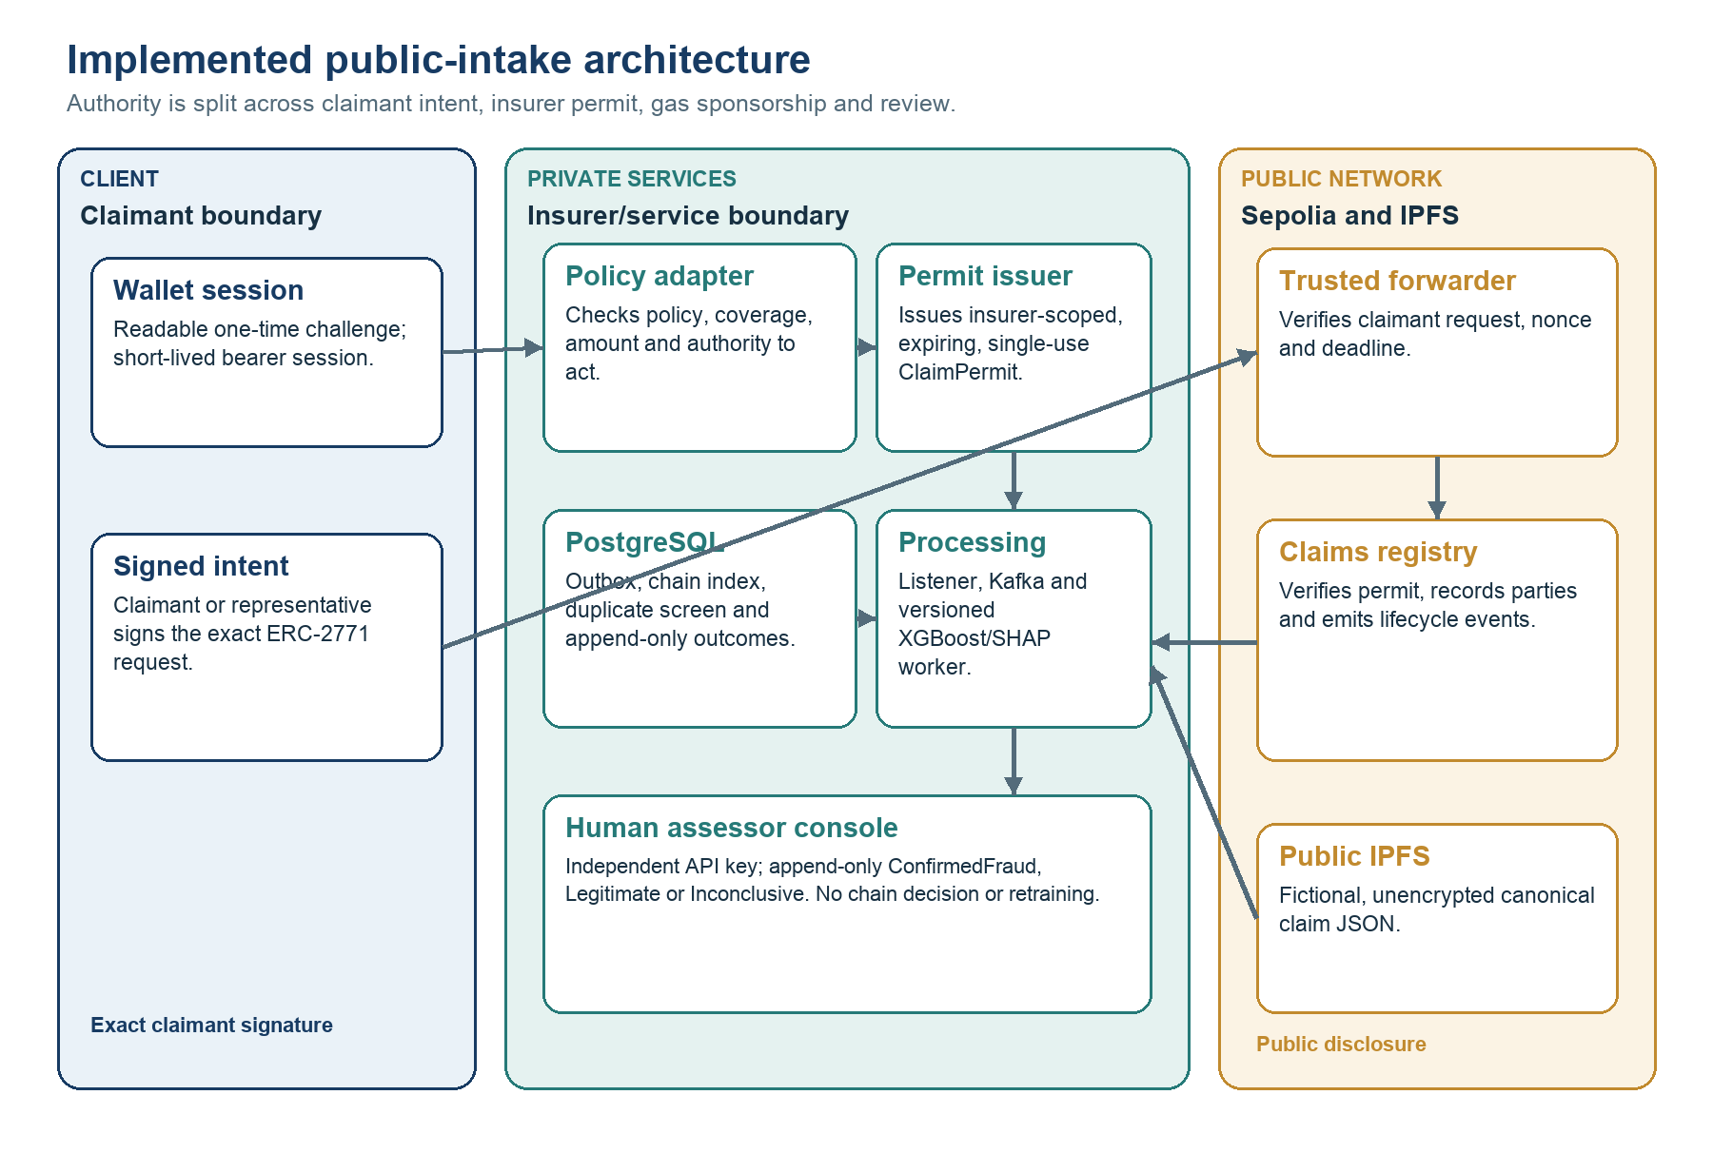
Figure 3.1. Implemented architecture and trust boundaries

The process starts with a wallet challenge that is readable before signature. A verified wallet receives a short-lived bearer session. The policy adapter then confirms that the policy exists, covers the incident type, date and amount, and permits the claimant or representative to act. The backend canonicalises the fictional claim, uploads it to IPFS, stores the exact request state and issues a short-lived, single-use EIP-712 ClaimPermit scoped to the insurer, claimant, content commitment and registry. The wallet signs the exact ERC-2771 ForwardRequest. The relayer verifies both authorisations and pays gas, but it holds no registry business role. The forwarder exposes the original signer, while the registry verifies the permit and records claimant, submitter and insurer as distinct parties. The recipient still depends on correct trusted-forwarder configuration. (Hughes et al., 2023)
After confirmation, the listener scans contract logs from its durable checkpoint, transforms them into a stable event representation and updates the application index. It then publishes work to Kafka. The worker re-verifies the referenced content, constructs an allow-listed feature vector, checks duplicate fingerprints, applies the versioned XGBoost model and generates SHAP context. The ordering follows the project’s durable side-effect rules and the distinction between stream-platform guarantees and end-to-end application completeness (Wang et al., 2021).
I assigned each technology a narrow job. The ledger is the public verification surface. IPFS provides content addressing, PostgreSQL provides transactions and private queries, Kafka buffers asynchronous work, and the model service performs analysis that can change over time. Content addressing makes changed bytes detectable but does not make content confidential or permanently available (Trautwein et al., 2022; Shibano et al., 2024).

3.4 On-chain registry and gasless authorisation
The registry uses role-based access control for administration, permit issuance, submission and scoring. Public intake does not remove these boundaries. The claimant or authorised representative signs the forwarding request, an insurer-authorised permit issuer approves the precise registration context and the relayer only sponsors gas. ClaimPartiesRecorded preserves claimant, submitter and insurer attribution. The on-chain ASSESSOR_ROLE belongs to the scoring worker and is scoped to an insurer contract. It is distinct from the off-chain human-assessor console. Lifecycle transitions remain forward-only, and the first completed model assessment is immutable at contract level.
Gas sponsorship uses two related EIP-712 authorisations. The insurer-side ClaimPermit binds the claimant, registry, insurer, content commitment, nonce and expiry. The claimant or authorised representative separately signs the exact ERC-2771 request. Changing signed calldata invalidates the request. The forwarder checks the wallet nonce and deadline. The registry checks the permit issuer, scope and one-time use. EIP-712 alone does not prevent replay, so domain separation, independent nonces, expiries and consumed-permit tracking are all required. The relayer pays gas but neither signature delegates authority to rewrite the claim. (Hughes et al., 2023)
The current public-intake research deployment is identified as sepolia-public-intake-v1. The registry address is 0xb64BaB321e0Fb19b2295f8182D5A37bAf85F7dff, the forwarder address is 0xeff61937C6a11236D87863e763c13cd7083f0BD0, the registry start block is 11,516,697 and the chain identifier is 11155111. These values identify the configured Sepolia deployment, not a service-level commitment. The earlier sepolia-gasless-v1 addresses are retained only for read-only historical reference and cannot issue public-intake permits.
An internal code-oriented security review strengthened role, lifecycle, signature, permit and replay tests, but it is not an independent professional audit. The policy adapter and permit issuer also create private trust dependencies that a contract audit alone cannot resolve. Production use would require authoritative identity and policy integrations, managed signing keys, external smart-contract and service reviews, multi-party administration, monitored quotas and abuse controls, tested migration and recovery, and a documented response to compromised sessions, permits or relayer infrastructure.

3.5 Off-chain storage and replay safety
I kept detailed claim fields out of the contract because privacy controls, schemas and model features change more quickly than a registry commitment. The on-chain record contains party attribution, bounded references, hashes and lifecycle metadata. Raw policy references are replaced by separate keyed commitments for policy lookup and claimant binding. This does not make the current storage private. The canonical fictional claim JSON is uploaded to public, unencrypted IPFS and is available to anyone who obtains its CID. The research deployment must not receive real claims. When the worker reads IPFS content, it verifies both CID and expected hash before feature extraction. Successful retrieval alone is not proof that the bytes match the committed claim.

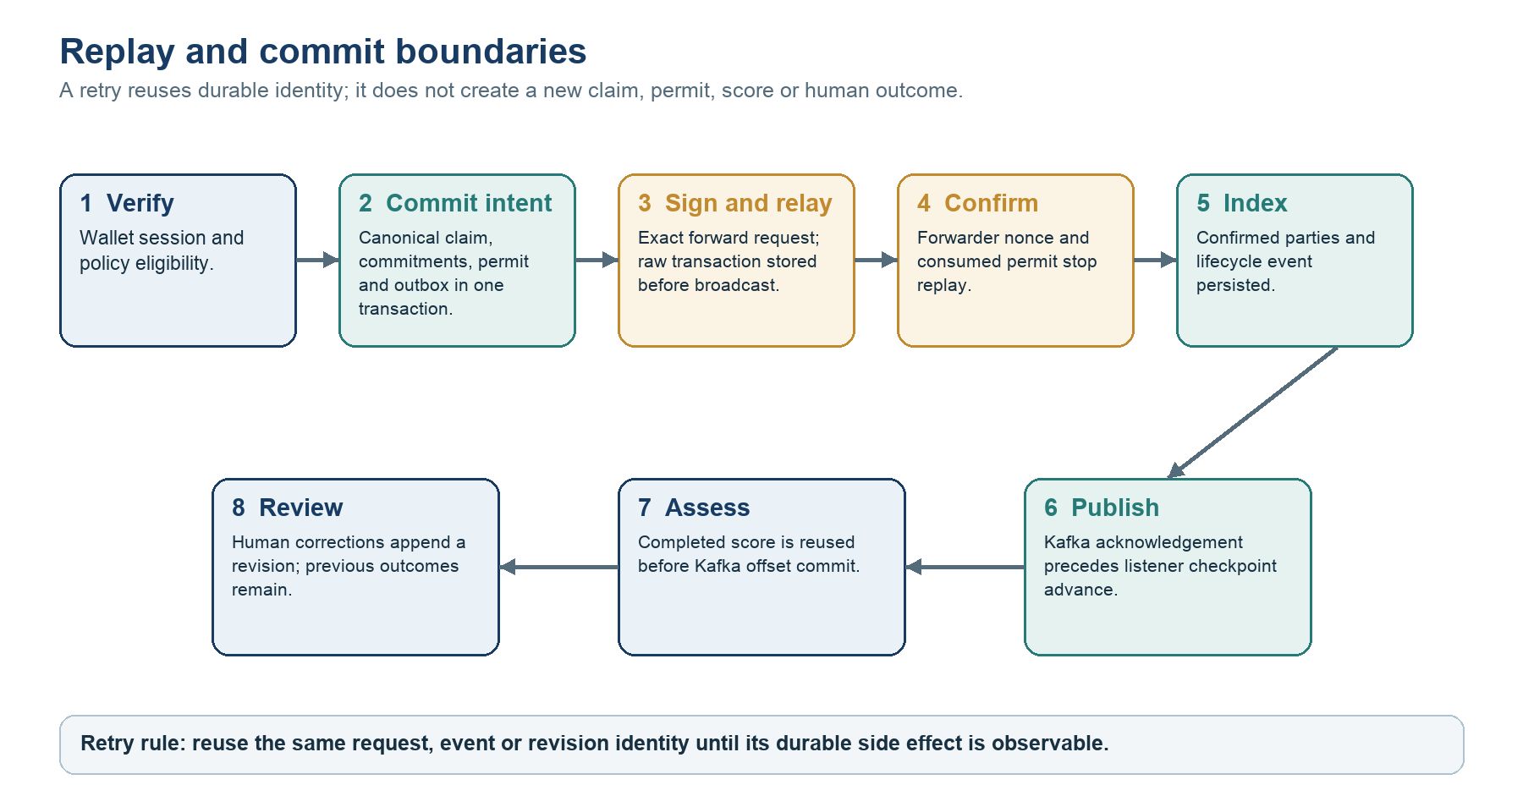
Figure 3.2. Replay and commit boundaries

Figure 3.2 makes the commit and replay boundaries explicit. The API transaction stores the canonical claim intent, policy and claimant commitments, permit state and outbox item together. The claimant signs the exact forwarding request only after that state is fixed. Before broadcasting, the relayer durably records the raw transaction so that a timeout does not cause a different request to be invented. The wallet nonce, permit nonce and consumed-permit record make repeated delivery safe. After confirmation, the listener persists indexed events and publishes Kafka work. Only acknowledged publication advances the range checkpoint. If it fails earlier the same block range is reconsidered.
The worker also assumes that Kafka may deliver a message again. It derives a deterministic event identifier, checks for a completed assessment, verifies content, runs inference where needed, persists the result and attempts the contract update. Only then may the offset be committed. After a restart, the same message can return without creating a conflicting second assessment. I describe this narrowly as effectively once behavior for the side effects covered by the idempotency rules, not as a system-wide exactly once guarantee (Wang et al., 2021).
Chain reorganisation is a related but distinct concern. The listener uses confirmed ranges and a recorded start point. A production configuration would need a documented confirmation-depth or finality policy, reorganisation detection and reconciliation for already published events. Public-test-network observation under deliberately induced reorganisations was outside the evaluation.

3.6 Feature and duplicate engineering
Feature engineering is governed by an allow-list. Numerical inputs include claim amount, premium, vehicle age, reporting delay, prior claim counts and related ratios. Categorical inputs include incident and geographic descriptors used by the versioned artifact. Free text, evidence bodies and raw policy references are excluded. Settlement amount, processing duration, source fraud probability and scenario labels were excluded because they arise after the intended decision point or expose the synthetic generator. This directly addresses temporal and target leakage, which can produce severe overestimation and misleading superiority over simpler baselines (Kapoor and Narayanan, 2023).
Duplicate screening uses a canonical representation of selected incident fields and a server-held HMAC-SHA-256 key. The keyed fingerprint is compared only inside the private service boundary and makes simple public dictionary calculation harder than an unkeyed digest, provided the key is generated and protected appropriately. A match produces a review candidate rather than proof because protected linkage retains linkage, inference and governance risks (European Data Protection Board, 2026).
A production implementation would need governance for which fields enter the fingerprint, how corrections are handled, who holds the secret, and how key rotation preserves or intentionally invalidates prior matches. It would also need controls against membership inference through repeated authorised queries. The prototype shows the engineering pattern but not a mature consortium privacy protocol.

3.7 Predictive modelling method
I used the versioned Africa Synthetic Motor Insurance Claims resource. After preprocessing, the prototype records 99,982 usable rows and the source file’s SHA-256 hash, so the input can be checked (Electric Sheep Africa, 2026). I ordered records chronologically and split them 70/15/15 into training, validation and test partitions. The test partition was not used for fitting or threshold selection. This reduces adaptation to the reported hold-out and resembles a future-use boundary more closely than a random split, although it cannot remove every dependency or future distribution shift (Kapoor and Narayanan, 2023).
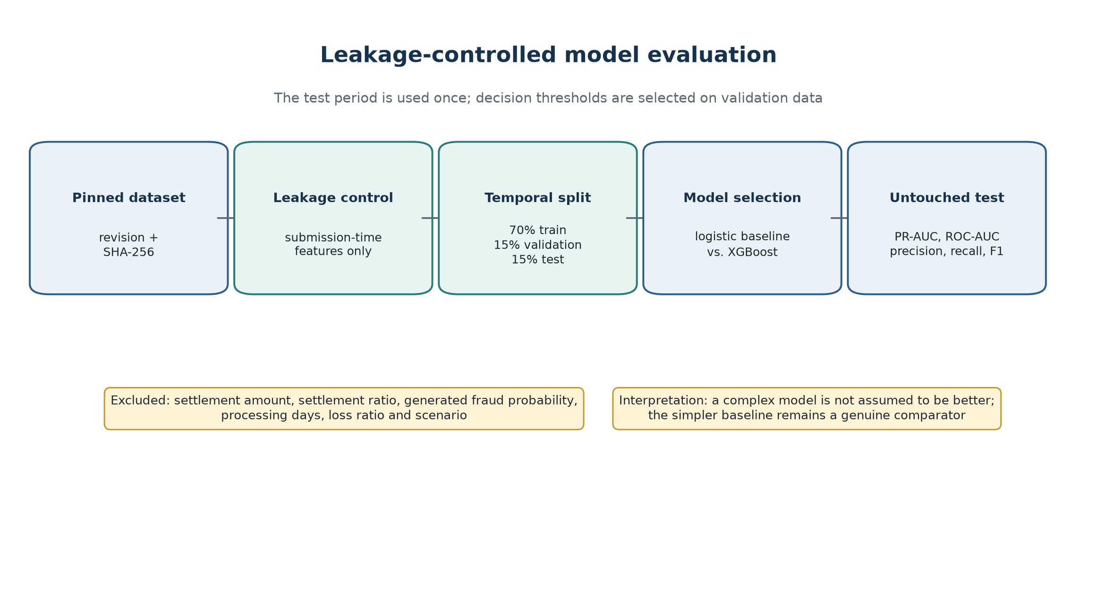
Figure 3.3. Chronological model-evaluation pipeline

Logistic regression provides the interpretable linear baseline. XGBoost supplies a regularised non-linear ensemble for feature interactions in tabular data. Preprocessing is fitted on training data, thresholds are selected on validation evidence and both are frozen for test evaluation. Because the scores are not legal findings, threshold selection is interpreted as a review-capacity and asymmetric error-cost decision rather than a universal definition of fraud (Schrijver, Sarmah and El-Hajj, 2024; Carracedo, Hervás and Soriano-Gonzalez, 2026).
Evaluation reports PR-AUC, ROC-AUC, precision, recall, F1 and Brier score. PR-AUC is foregrounded because the positive class is uncommon and the practical meaning of a positive prediction depends on prevalence and threshold. Confusion matrices translate thresholds into review outcomes. A Brier score summarises squared probability error, but one aggregate value does not replace reliability plots and subgroup calibration (Dimitriadis et al., 2024). SHAP supports diagnostic review, subject to the limitations of post-hoc feature attribution and recipient comprehension (Broniatowski, 2021; Phillips et al., 2021).

3.8 Evaluation design
I organised the evaluation around claims that the prototype could reasonably support. The predictive stream asks how the models rank and classify a fixed synthetic hold-out. The verification stream asks whether access, lifecycle, replay, feature and interface behaviour matches the implementation. A third stream would have measured performance under controlled load and failure, but that evidence was not captured. Table 3.3 keeps the missing stream visible instead of treating it as completed work.
Table 3.3. Evaluation questions, measures and evidence
Question | Measure | Evidence status | Interpretive boundary
Does the model prioritise positives? | PR-AUC, ROC-AUC and recall on chronological test set. | Captured in versioned model metadata. | Synthetic dataset, no real-portfolio external validity.
What review workload follows? | Precision, F1, threshold and confusion matrix. | Captured for logistic and XGBoost artifacts. | Investigation costs were not monetised.
Can a reviewer inspect drivers? | Global SHAP summary and stored explanation path. | Captured for integrated XGBoost artifact. | Attribution is not causality or fairness assurance.
Are contract and pipeline rules enforced? | Unit, fuzz, component and isolated browser tests. | Executed in isolated suites; 310 behavioural checks passed. | Eight infrastructure-backed Python tests were deselected; two browser paths were exercised.
Is implementation quality monitored? | Branch-aware coverage, lint and production frontend build. | 74.71% branch-aware Python coverage; Ruff, frontend lint and production build passed. | Coverage missed the configured 75% gate by 0.29 percentage points.
Does it scale under production load? | Latency percentiles, throughput, queue lag, gas and recovery time. | Not captured in a controlled evidence bundle. | No production scalability claim is made.

3.9 Ethics, privacy and validity
I used synthetic claims and test-network addresses to avoid exposing real individuals during development. That safer choice weakens external validity. Synthetic generation can preserve some patterns, remove others and create an uncertain privacy–utility trade-off (Stadler, Oprisanu and Troncoso, 2022). The labels may reflect generator rules rather than investigation outcomes, while geographic and incident variables may encode simplifications that would be unacceptable in customer treatment. For that reason, the dataset and model need explicit composition, intended-use and prohibited-use records. The word ‘synthetic’ is not an assurance by itself (Gebru et al., 2021; Tabassi, 2023). I report the results as artifact evaluation, not as evidence that the model is fair or deployable.
Privacy was addressed through separation and minimization. Private structured data is off-chain and public state is bounded. Model features exclude free text and raw policy references. Duplicate fingerprints are keyed and permitted research use is fictional data only. These controls do not complete a legal assessment. CIDs (Content Identifiers), hashes, addresses and transaction metadata may remain linkable, while public IPFS (InterPlanetary File System) does not provide confidentiality by itself (Trautwein et al., 2022; Shibano et al., 2024). A real deployment would require necessity and lawful-basis analysis, a DPIA (Data Protection Impact Assessment) where required, controller/processor allocation, access logging, retention and erasure procedures, encryption and controlled evidence storage (European Data Protection Board, 2026).
Internal validity is strengthened by a fixed data hash, chronological partitions, an untouched test set, exact metric metadata and automated verification. Construct validity is limited because fraud labels and predictive metrics stand in for investigative utility. External validity is limited by one synthetic motor dataset, one test network and one deployment. Reliability is strengthened by versioned artifacts, although independent reproduction has not occurred. Current ML reproducibility guidance expects data provenance, dependencies, metric definitions and executable procedures (Pineau et al., 2021).

Chapter 4: Implementation
This chapter describes what I implemented and verified. I report the predictive experiment separately in Chapter 5 so that the architecture, software evidence and interpretation remain distinguishable. The repository is a multi-service research artifact, not a production insurance platform. The main branch contains a React claims application and separate assessor console, FastAPI services for wallet sessions, policy eligibility, permits, relaying and assessor outcomes, PostgreSQL, a Sepolia registry and forwarder, public IPFS, a listener, Kafka and a Python scoring worker.

4.1 Prototype implementation
The browser does not receive an insurer private key. It signs a readable one-time authentication challenge, then submits policy and incident facts through a short-lived wallet session. The backend policy adapter checks eligibility before an insurer-authorised component signs a single-use ClaimPermit. The claimant or authorised representative signs the exact ERC-2771 request, and an isolated relayer pays test-network gas after verifying both signatures. The registry checks the trusted forwarder, permit issuer, scope, nonce and expiry. This composite design separates identity, policy authority, claimant intent and fee payment. Replay resistance and the relayer relationship therefore arise from the surrounding protocol, not from EIP-712 by itself. (Hughes et al., 2023)
The public record is intentionally small: an identifier, authorised address, content commitment, lifecycle state and assessment metadata. Full fictional evidence remains off-chain. An IPFS content identifier makes a byte sequence verifiable, but content addressing does not supply access control, confidentiality or guaranteed retention. Network measurements show that IPFS is a decentralised retrieval layer with availability and replication behavior of its own privacy-oriented designs therefore add controlled peers, encryption or cryptographic access mechanisms (Trautwein et al., 2022; Shibano et al., 2024). The prototype is suitable for synthetic demonstrations, not for publishing real claim evidence on public IPFS.
Two failures found during implementation changed the design. First, the listener checkpoint now moves only after the block range is stored and publication is acknowledged. Second, the worker retries temporary infrastructure failures, but it handles a permanent malformed input differently. It writes a small rejection record before moving the offset. If that write fails, the offset is not committed. These rules accept at-least-once delivery and use stable identifiers, stored outcomes and idempotent side effects to make repeats safe. Kafka transactions do not automatically include PostgreSQL, IPFS or blockchain writes, so the application must handle those effects.
The architecture in Figure 3.1 shows three trust regions: the user-facing client, the privately operated insurer services and the public Sepolia network. A public anchor can show that a commitment and state transition existed, but it cannot prove that the submitted information was true. Nor does a content hash remove controller obligations for linkable personal data. Final European guidance therefore favours data minimisation and off-chain handling where blockchain immutability conflicts with correction or erasure duties (European Data Protection Board, 2026).

4.2 Data and model implementation
The saved model record pins the synthetic dataset revision, prepared-file SHA-256 digest, chronological split, feature list, preprocessing pipeline and model hash. Ten submission-time inputs are retained: six numerical and four categorical. Settlement amount, settlement ratio, processing duration, generator fraud probability, loss-ratio outputs and scenario markers are excluded because they arise after the intended decision or disclose how the synthetic label was produced. This decision follows the temporal availability test for leakage: a feature is admissible only if it would exist at claim submission (Kapoor and Narayanan, 2023).
The revised experiment keeps the original logistic regression and deployed XGBoost model, and adds a 24-trial randomised search. The search covers tree depth, learning rate, number of estimators, child weight, sampling, regularisation and class weighting. I fitted the models on the training period, selected PR-AUC and the operating threshold on validation data, and used the chronological test period once. Random search and paired resampling were used because model selection and uncertainty are part of the experiment, not additions made after seeing the result (Pfob, Lu and Sidey-Gibbons, 2022). Appendix B records the seeds, parameters and outputs.

4.3 Explainability and review support
The worker returns a score, thresholded status, model version and local SHAP contributions. Figure 4.1 shows the saved global summary. Claim frequency is the largest average driver, followed by theft-related incident information, premium, country, vehicle age and claim amount. These values describe the fitted model. They do not show that a feature caused fraud. The prominent country contribution motivated the subgroup audit in Section 5.4 rather than an operational rule (Broniatowski, 2021; Phillips et al., 2021).
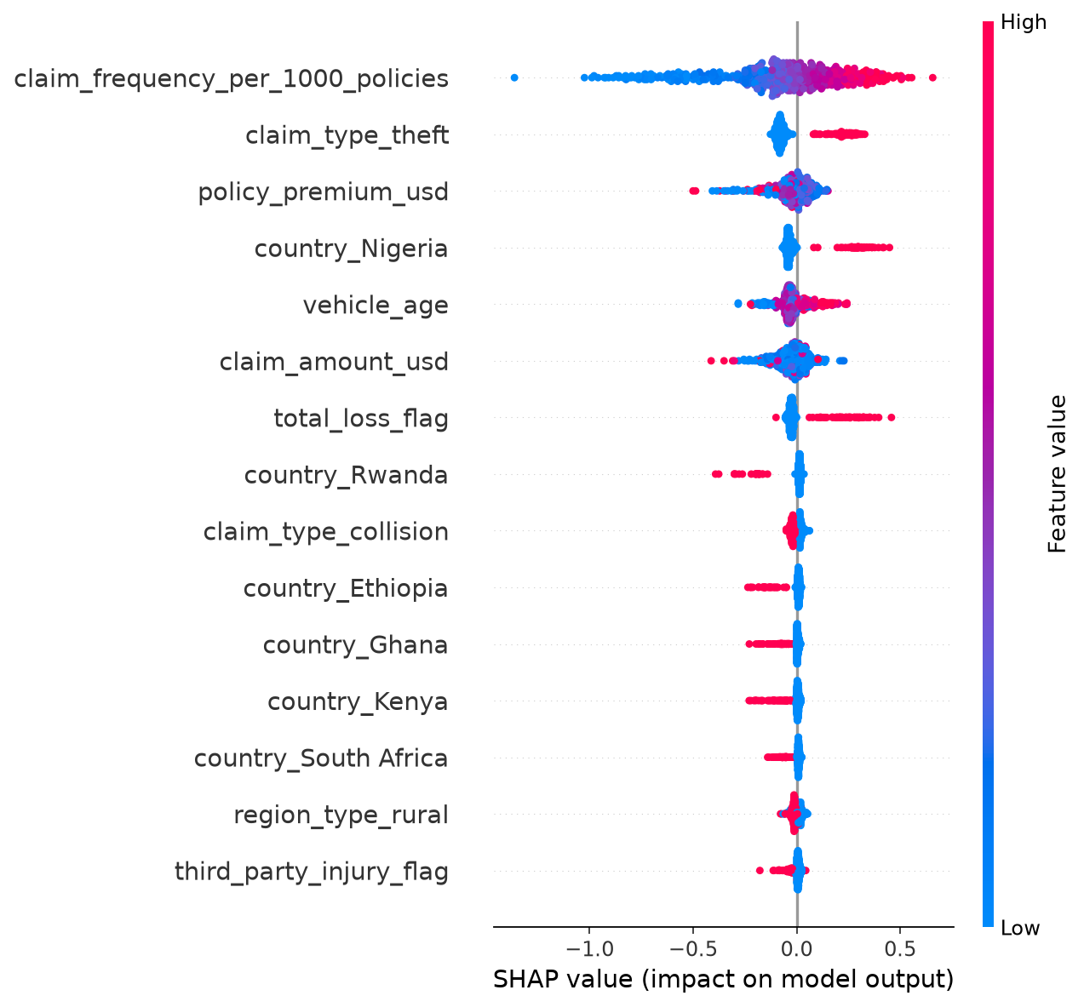
Figure 4.1. SHAP summary for the integrated XGBoost artifact
Reviewers need the feature meaning, base rate, model and threshold version, provenance and uncertainty alongside any attribution. The claims interface therefore presents the score as triage evidence. A separate console uses an independent digest-only API key and records ConfirmedFraud, Legitimate or Inconclusive as append-only PostgreSQL revisions; corrections never overwrite history. These outcomes do not approve or reject a claim, alter Sepolia state or retrain the model, and Inconclusive is excluded from binary-label eligibility. Production use would still require enterprise identity, controlled evidence access, supervision and a contest procedure. (Herm et al., 2022; Tabassi, 2023)

4.4 Software verification
The isolated suites passed 310 behavioural checks: 232 Python, 34 frontend, 42 contract and two Playwright tests. Eight infrastructure-backed Python tests were deselected and four warnings were reported. The contract total comprised 25 Solidity and 17 Node.js checks, including 256-run fuzz cases. Ruff, frontend lint and the production build passed. Branch-aware Python coverage was 74.71%, however, so the configured 75% gate failed by 0.29 percentage points. This evidence remains incomplete without infrastructure validation, independent security assessment and operational assurance. (Washizaki, 2024)
Table 4.1. Executed software verification evidence
Layer | Executed evidence | Result | Boundary
Python services | pytest excluding infrastructure-backed tests | 232 passed, 8 deselected | 74.71% branch-aware coverage; four warnings; configured gate failed.
React frontend | Unit/component tests | 34 passed in 6 files | Selected behaviour, not every browser/device.
Smart contracts | Hardhat Solidity, Node.js and fuzz tests | 42 passed: 25 Solidity, 17 Node.js | 256-run fuzzing is not formal verification.
Browser flow | Isolated Playwright scenarios | 2 passed | Assessment polling and duplicate-screening paths only.
Quality gates | Ruff, frontend lint and production build | Passed | Static gates passed; Python coverage left the overall verification gate incomplete.

Contract security remains a release condition. Current role, lifecycle, forwarding and replay tests do not replace independent review, managed administration or operational monitoring against a mature security specification. (Enterprise Ethereum Alliance, 2025; Souppaya, Scarfone and Dodson, 2022)

Chapter 5: Results
This chapter reports the results and keeps statistical significance separate from practical value. All extra analyses use the pinned prepared dataset and the same chronological 70/15/15 split. The test period contains 14,998 records, including 1,676 synthetic fraud labels (11.1748%).

5.1 Predictive performance and uncertainty
Table 5.1. Dataset composition and chronological split
Partition | Rows | Share | Use
Training | 69,987 | 70.0% | Fit preprocessing and model parameters.
Validation | 14,997 | 15.0% | Search and threshold selection.
Test | 14,998 | 15.0% | Untouched comparison, 1,676 positive labels.
Total | 99,982 | 100.0% | Chronologically ordered usable records.

Table 5.2 confirms the earlier operational trade-off. Logistic regression ranks marginally better, while the deployed XGBoost threshold retrieves more positives by flagging almost half of the test set. Its 1,032 true positives are accompanied by 5,952 false positives. Logistic regression produces 683 and 3,260 respectively. The additional 349 detections therefore require 3,041 additional referrals, or about 8.7 extra flagged claims per extra positive found.
Table 5.2. Held-out predictive performance
Model | Threshold | PR-AUC | ROC-AUC | Precision | Recall | F1 | Brier
Logistic regression | 0.54 | 0.1711 | 0.6279 | 0.1732 | 0.4075 | 0.2431 | 0.2392
Deployed XGBoost | 0.47 | 0.1647 | 0.6148 | 0.1478 | 0.6158 | 0.2383 | 0.2213
Tuned XGBoost | 0.60 | 0.1701 | 0.6239 | 0.1550 | 0.5424 | 0.2411 | 0.3086

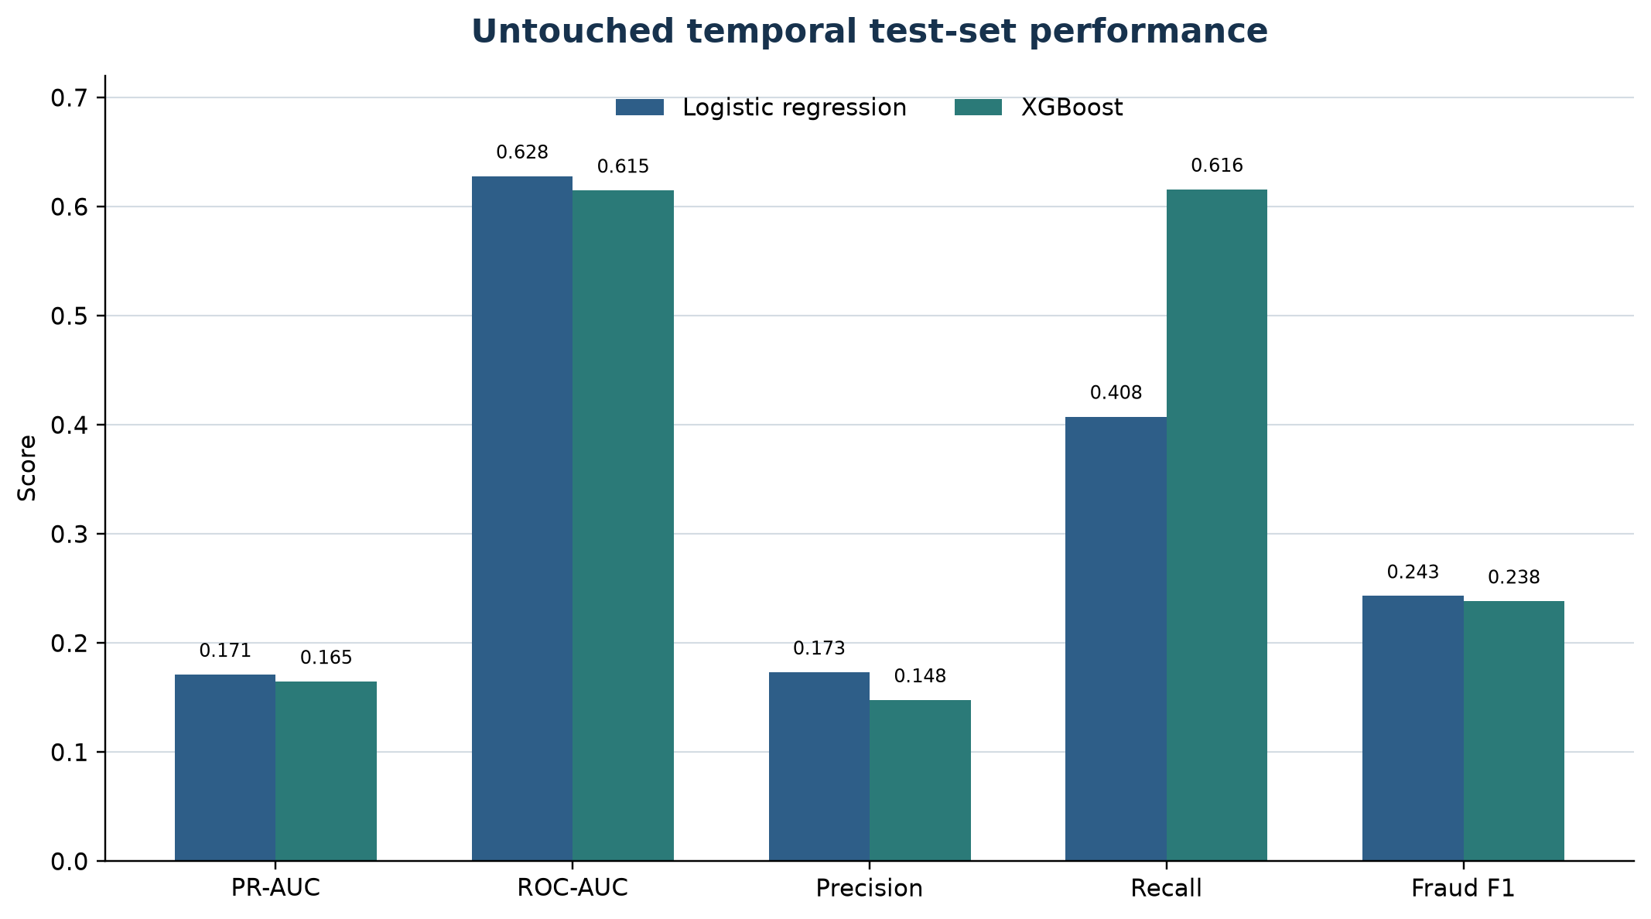
Figure 5.1. Predictive-model comparison
To quantify uncertainty, I drew 2,000 paired bootstrap samples from the same test records. Pairing matters because each model is evaluated on the same claims. The original PR-AUC difference is small but its interval narrowly excludes zero. After tuning, the interval includes zero. This corrects the initial plan’s expectation that the original gap would be indistinguishable: the observed result must take precedence over the anticipated narrative (Pfob, Lu and Sidey-Gibbons, 2022).
Table 5.3. Paired-bootstrap uncertainty
Estimate | Mean / point | 95% bootstrap interval | Interpretation
Logistic PR-AUC | 0.1711 | 0.1595 to 0.1846 | Weak ranking performance.
Deployed XGBoost PR-AUC | 0.1647 | 0.1535 to 0.1773 | Lower point estimate.
Tuned XGBoost PR-AUC | 0.1701 | 0.1582 to 0.1835 | Recovers most of the gap.
Logistic − deployed | 0.0065 | 0.0004 to 0.0126 | Small positive difference.
Logistic − tuned | 0.0010 | −0.0032 to 0.0053 | Difference remains uncertain.

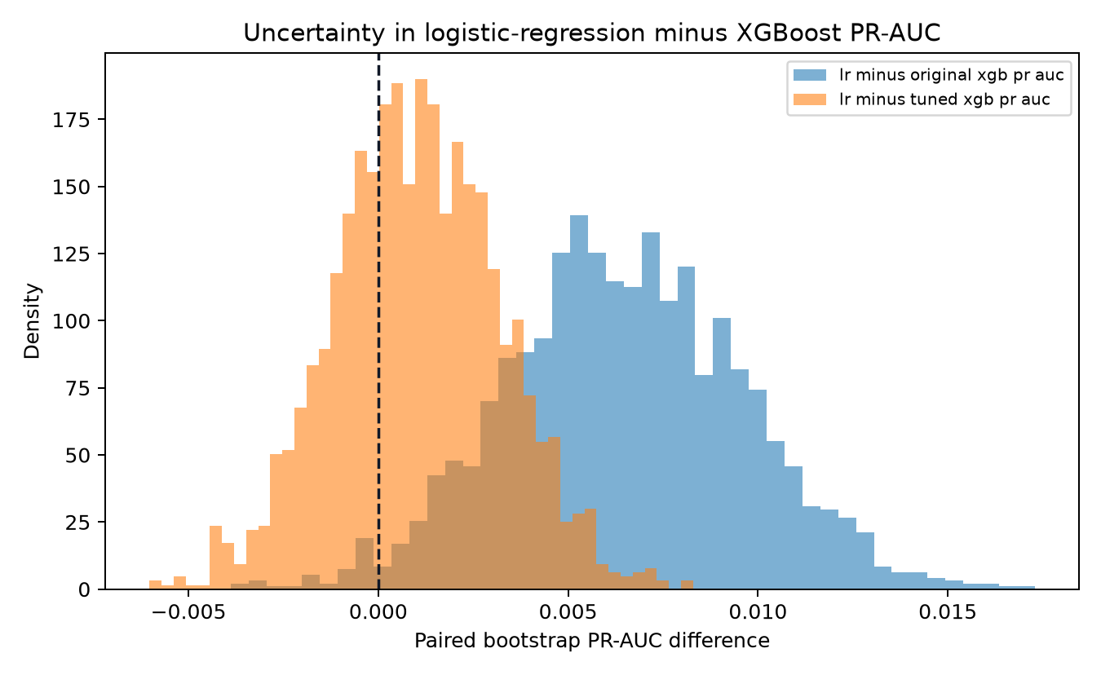
Figure 5.2. Paired-bootstrap PR-AUC differences

5.2 Hyperparameter search
The 24-trial randomised search selected a shallower model with stronger class weighting. Test PR-AUC improved from 0.1647 to 0.1701 and ROC-AUC from 0.6148 to 0.6239. However, it did not beat logistic regression and its probability calibration did not improve. This negative result is useful. Tuning changed XGBoost's behaviour, but the extra complexity still gave no clear practical advantage over the simpler baseline.
Table 5.4. Randomised-search result
Parameter | Selected value | Parameter | Selected value
max_depth | 3 | learning_rate | 0.03387
n_estimators | 350 | min_child_weight | 1
subsample | 0.65 | colsample_bytree | 0.80
reg_lambda | 0.50 | scale_pos_weight | 10.807
Validation PR-AUC | 0.1598 | Validation threshold | 0.60

5.3 Signal diagnostic
The weak PR-AUC values raised a more basic question: does the admitted feature set contain signal beyond class prevalence? I retrained logistic regression after 100 independent permutations of the training labels. The observed PR-AUC of 0.1711 exceeded every permuted run. The null mean was 0.1134 and the empirical one-sided p-value was 0.0099. The conclusion is not ‘no signal’. It is that signal is statistically detectable but small under this synthetic generator and split.
Table 5.5. Label-permutation and mutual-information diagnostics
Diagnostic | Result | Meaning
Observed logistic PR-AUC | 0.1711 | Performance with intact labels.
Permutation null | mean 0.1134, 95% 0.0955–0.1306 | Expected after destroying label association.
Empirical p-value | 0.0099 | Detectable signal, not evidence of field validity.
Largest mutual information | claim_frequency 0.00339 | All individual associations are very small.
Next variables | vehicle_age 0.00326, country 0.00290 | Potential generator structure audit required.

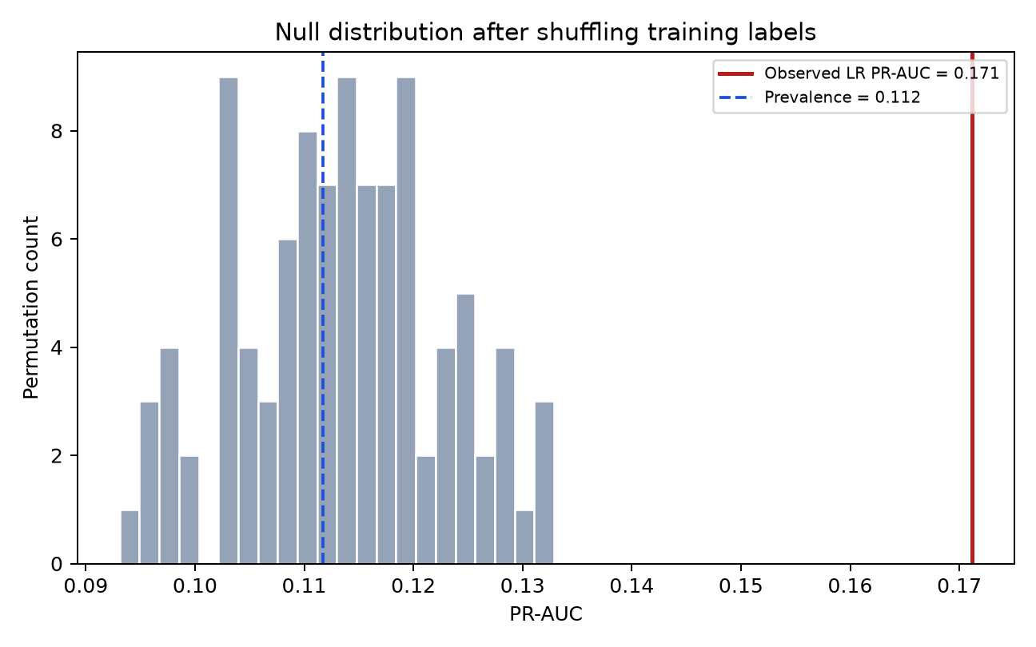
Figure 5.3. Label-permutation signal diagnostic

5.4 Country-level audit
Country is the fourth most important SHAP feature, so I compared selection, false-positive and false-negative rates for every country. The differences are too large to ignore. Nigeria has a selection rate of 0.897 and a false-positive rate of 0.893. Rwanda has a selection rate of 0.064 and a false-negative rate of 0.962. These values do not mean that one population commits more fraud because both the labels and country relationships are synthetic. They show that people from different locations would receive very different model treatment.
Table 5.6. Selected country-level error rates
Country | n | Label prevalence | Selection rate | FPR | FNR | Precision
Nigeria | 1,487 | 0.1547 | 0.8971 | 0.8934 | 0.0826 | 0.1582
Rwanda | 926 | 0.0562 | 0.0637 | 0.0652 | 0.9615 | 0.0339
South Africa | 1,659 | 0.1272 | 0.5986 | 0.5698 | 0.2038 | 0.1692

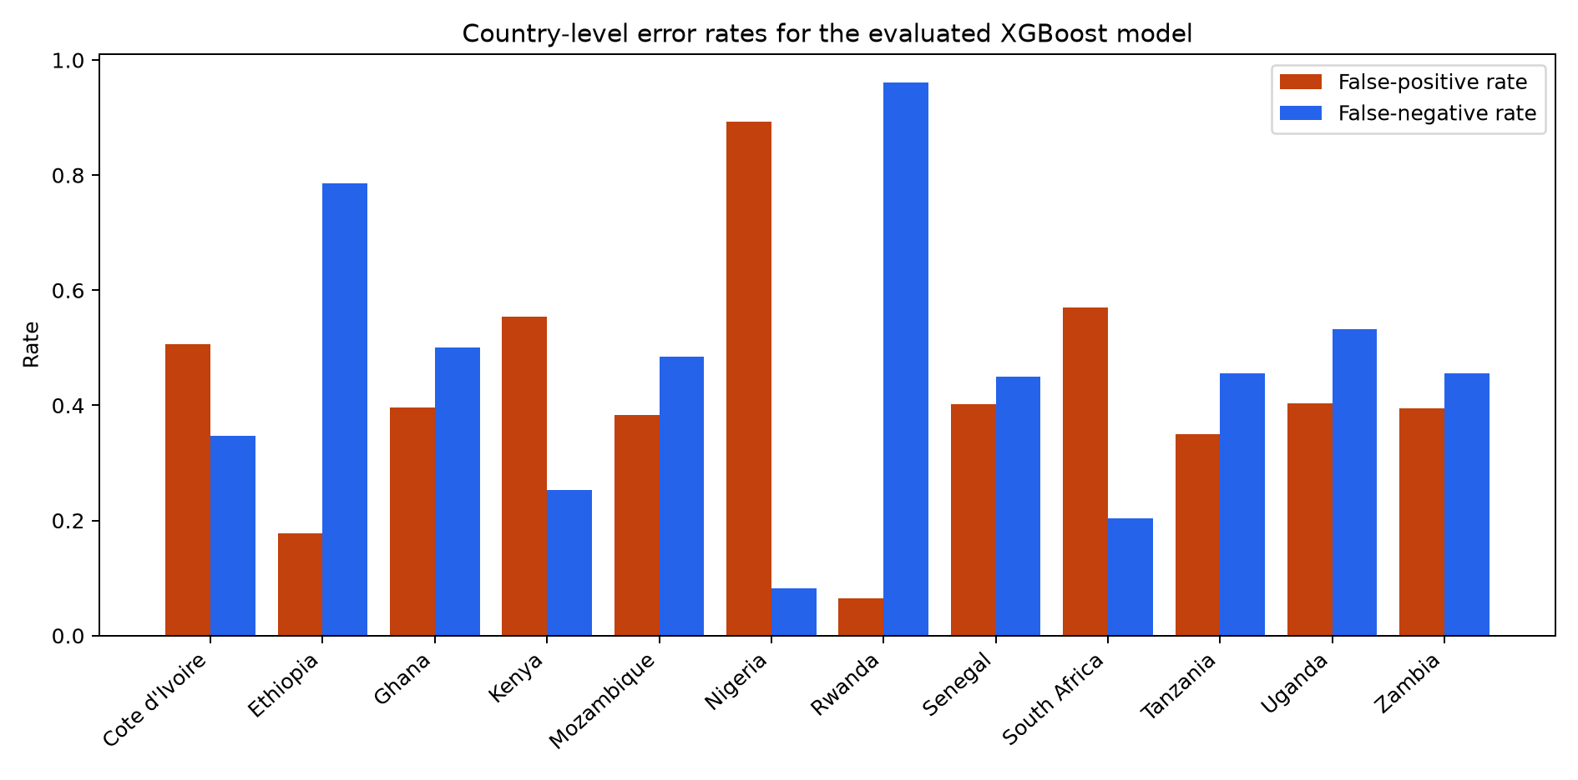
Figure 5.4. Country-level selection and error rates
Fairness metrics encode different normative choices and can conflict. The audit is therefore a screening device, not a certificate (Mitchell et al., 2021). Before any real use, country should be justified, removed or constrained. Results should be repeated on real governed data, with sample sizes and confidence intervals should be reported. Investigators and affected communities should help define the relevant harms. On the present evidence, the disparity is a deployment blocker.

5.5 Calibration
The reliability diagram and Brier decomposition separate ranking from probability quality. The deployed XGBoost artifact has the lowest overall Brier score, but all models show large reliability terms relative to their very small resolution terms. The tuned model is worst calibrated: its Brier score rises to 0.3086 despite better ranking. A probability presented as a literal fraud likelihood would therefore be misleading without calibration on representative later data (Dimitriadis et al., 2024).
Table 5.7. Brier-score decomposition
Model | Brier | Reliability | Resolution | Uncertainty
Logistic regression | 0.2392 | 0.1421 | 0.0021 | 0.0993
Deployed XGBoost | 0.2213 | 0.1234 | 0.0017 | 0.0993
Tuned XGBoost | 0.3086 | 0.2110 | 0.0020 | 0.0993

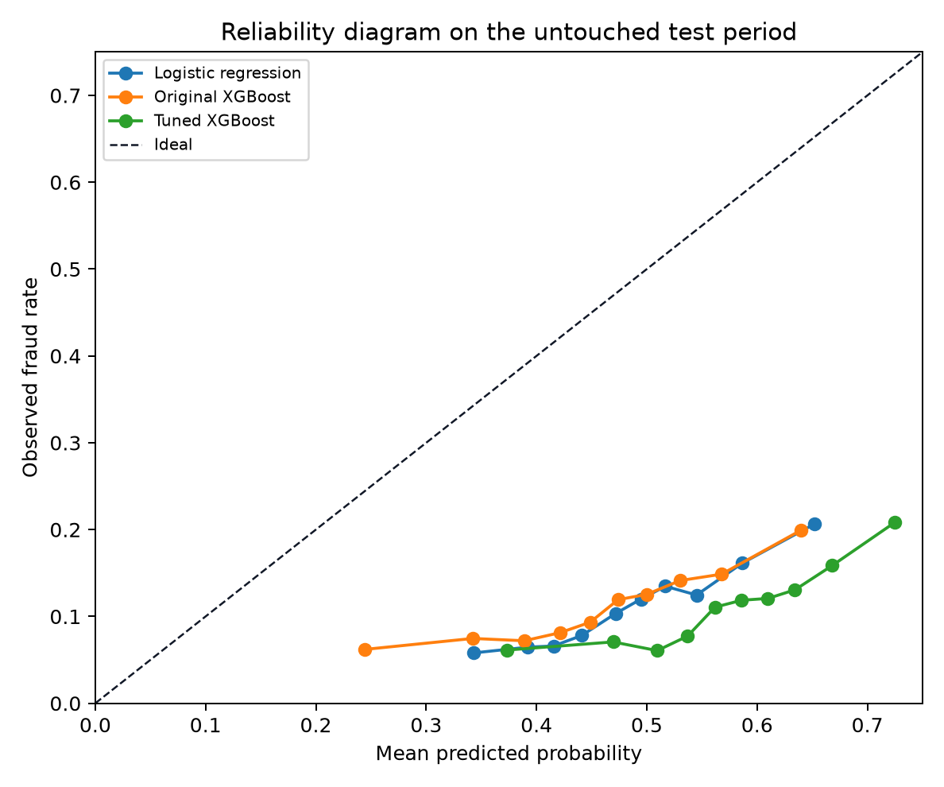
Figure 5.5. Reliability diagram

5.6 System-evaluation boundary
Functional evidence supports authorisation, content binding, replay-aware delivery, versioned scoring and representative user flows. It does not show production capacity. No controlled p50/p95/p99 latency, throughput, gas distribution, listener lag, queue depth or recovery-time benchmark was retained. I have not manufactured these measurements after the fact. A later benchmark must declare hardware and workloads, repeat runs, report uncertainty and inject failures at each commit boundary (Washizaki, 2024).

Chapter 6: Discussion
The results support a more limited claim than saying that blockchain improves fraud detection. The registry provides an attributable event history and forward-only state. The model provides reproducible triage behaviour. The registry does not make the model accurate, and the model does not make the registry private or scalable. The combined design is useful only when these boundaries and failure cases remain clear.

6.1 Interpretation against the literature
The implemented lifecycle is consistent with recent insurance research showing that smart contracts can make claims actions traceable, while this study deliberately stores less business data on chain (Chen et al., 2021; Jena et al., 2024). That restraint matters because content addressing and ledger immutability create new persistence and linkability risks rather than dissolving governance. The result also agrees with EIOPA’s (European Insurance and Occupational Pensions Authority) use-case-specific position. A ledger should be justified by inter-organisational verification needs, not selected as a default database (European Insurance and Occupational Pensions Authority, 2022).
On prediction, the study qualifies performance claims drawn from balanced or curated datasets. The paired bootstrap shows that the original small PR-AUC gap is unlikely to be sampling noise within this test set, but tuning removes any clear difference while damaging calibration. Combined with the very low mutual-information values, this suggests a weak tabular discrimination problem in which a simple baseline is difficult to beat. The permutation result confirms association under the generator, not real insurance validity (Debener, Heinke and Kriebel, 2023; Schrijver, Sarmah and El-Hajj, 2024).

6.2 Answer to the research question
Table 6.1. Research-objective assessment
Objective | Assessment | Strongest evidence | Remaining boundary
O1 Synthesis | Achieved | Critical review and explicit gap. | Fast-moving regulation and technical practice.
O2 Design | Prototype achieved | Trust boundaries, storage split and threat model. | Consortium governance and DPIA incomplete.
O3 Implementation | Achieved | End-to-end code and versioned artifacts. | No independent audit or final live bundle.
O4 Evaluation | Partly achieved | Hold-out, tuning, bootstrap, signal, fairness, calibration and tests. | No real claims or controlled system benchmark.
O5 Critical assessment | Achieved | Negative and unmeasured evidence retained. | Independent replication remains necessary.

The answer to the research question is conditional. A decentralised registry can provide verifiable, AI-ready events when public state is limited to attributable commitments, claim initiation is bound to verified policy eligibility and signed intent, and message delivery is designed for replay. Here, AI-ready means that a confirmed event can be transformed reproducibly into a versioned score, explanation and review record. It does not mean that the public IPFS payload is confidential, that the score is accurate enough for real claims, that subgroup treatment is fair, that compliance is automatic or that the deployment can scale.

6.3 Ethics, fairness and governance
The country audit changes the ethical conclusion. A model that selects almost nine out of ten claims from one synthetic country but fewer than one out of fifteen from another is not ready for deployment. Better overall accuracy would not remove the need to justify this difference. Fairness measures depend on the population, decision and type of harm. The next step is therefore not to optimise one metric alone. It is to decide whether geography should be used at all and to test the effect with governed real data and stakeholder involvement (Mitchell et al., 2021; Tabassi, 2023).
The model is a review signal, not proof of dishonesty. UK law now places safeguards around significant solely automated decisions, including information, representation, human intervention and contest routes. Those safeguards must be implemented as genuine decision authority rather than a ceremonial click after an algorithmic conclusion (Data (Use and Access) Act 2025, s.80; Information Commissioner’s Office, 2025). The EU AI Act does not automatically classify every motor-fraud triage model as high risk classification depends on the system’s intended purpose and Annex III context (European Parliament and Council, 2024).

6.4 Limitations and threats to validity
The primary limitation is the dataset. It is synthetic, and its own structure determines the labels, signal ceiling, country relationships and calibration observed here. Synthetic data can support safe engineering and reproducibility, but hold-out accuracy under a generator does not show field validity or anonymity (Decruyenaere et al., 2024; Stadler, Oprisanu and Troncoso, 2022). One dataset, one line of business and one time split cannot show generalisation.
The bootstrap quantifies sampling variation conditional on this test set. It does not account for generator misspecification or portfolio shift. The randomised search examines 24 configurations rather than an exhaustive space. One hundred permutations give a minimum attainable empirical p-value of 1/101. Country estimates vary in sample size and are descriptive, while the fairness question cannot be answered from synthetic labels alone. Calibration bins are also sample-dependent. These qualifications are why exact procedures and artifacts are retained.
Systems evidence is similarly bounded. Unit, component, contract and two browser scenarios establish selected behaviors. They do not replace infrastructure testing, penetration testing, a smart-contract audit, controlled failure injection or load measurement. Public Sepolia addresses prove deployability, not complete end-to-end use. I designed and evaluated the prototype myself, so independent replication remains the strongest control against confirmation bias.

Chapter 7: Conclusion and Future Work
I investigated how a decentralised claims registry could provide verifiable, AI-ready events for fraud screening without placing detailed attributes directly on a public ledger. The prototype combines policy-backed public intake, typed claimant and insurer authorisation, a forward-only smart-contract lifecycle, content-addressed fictional claim data, transactional outbox delivery, replay-aware processing, keyed duplicate screening, versioned XGBoost/SHAP scoring and append-only human outcomes. Its value lies in the connections between these boundaries and in stating plainly what the evaluation cannot support.

7.1 Conclusion
The study shows that a public verification layer can be kept small while still recording who acted. Policy eligibility and an insurer-scoped permit bound the registration context; the claimant or authorised representative signed the exact forwarded request. The relayer paid gas without acquiring authority to rewrite the claim. The registry then recorded claimant, submitter and insurer separately and emitted events for private analytical processing. This design reduces on-chain disclosure, but it is not confidential storage. The current claim JSON is public and unencrypted on IPFS, stable commitments remain linkable, and the research instance must therefore use fictional data only.
For me, the strongest systems result is the explicit treatment of authority and replay. Wallet sessions, policy checks, single-use permits, claimant-signed forwarding, the outbox, durable raw transactions, range checkpoints, acknowledgement order, deterministic event IDs and completed-result reuse make failure behaviour inspectable across PostgreSQL, Ethereum and Kafka. The 310 passing behavioural checks support these rules. The same review also found a quality gap: branch-aware Python coverage was 74.71%, below the configured 75% gate. Eight infrastructure tests were excluded, browser testing covers two paths and no independent security review was completed. This is evidence of an evaluated research implementation, not production assurance.
The model experiment gives a result that is not especially positive, but it is still useful. On the chronological synthetic test set, logistic regression slightly beats XGBoost on PR-AUC and F1. XGBoost increases recall from 0.4075 to 0.6158, but false positives rise from 3,260 to 5,952. The higher-recall model may be useful when missed fraud is very costly and the review team has enough capacity. Otherwise, logistic regression or a different threshold may be better. This comparison shows why an insurer should consider investigation workload instead of choosing a model because it is more complex.
The research question is answered in part. I can show a credible method for verifiable event provenance, bounded public disclosure and reproducible explainable scoring under controlled conditions. I cannot show that the model detects fraud effectively in a real portfolio, that every data-protection obligation has been met, or that the single-VM deployment scales. Those are not footnotes to the result. They are the line between a dissertation artifact and an operational insurance system.

7.2 Contributions
My main contribution is an end-to-end reference implementation whose trust decisions can be traced into code and evaluation. Public intake is constrained by wallet identity, policy eligibility, an insurer-scoped permit and exact claimant intent. Party attribution on chain separates claimant, submitter and insurer, while the relayer is limited to fee sponsorship. The storage split gives the ledger a restrained role. Checkpoints and idempotency rules make restart behaviour testable. The feature layer excludes post-decision leakage, uses keyed duplicate fingerprints and keeps human investigative outcomes append-only and separate from automated scoring.
A second contribution is the separation of claims. Predictive quality, functional correctness, privacy design and scalability require different evidence. Automated tests are not a load benchmark. SHAP is not fairness or causality evidence, and a testnet address is not an end-to-end transaction record. Keeping those distinctions makes my conclusions narrower, but easier to defend.

7.3 Future work
My priority would be the missing empirical system evaluation. A reproducible benchmark should record API acceptance, block inclusion, listener lag, queue delay, inference time, assessment completion and gas under controlled workloads. It should report tail latency and confidence intervals, repeat runs on declared hardware and inject failures at each commit boundary. That experiment would show whether replay safety survives stress and which component: the database, RPC provider, broker, model or relayer becomes the practical bottleneck.
The second priority is external predictive validation. An insurer or suitably governed research consortium should evaluate de-identified real claims from a later time period, with investigator-confirmed labels where possible. Thresholds should be chosen from review capacity and expected cost, and probability calibration should be measured. Subgroup error, drift and feature stability should be audited before and after deployment (Dimitriadis et al., 2024; Tabassi, 2023). Alternative models including calibrated boosting, graph features for related parties and anomaly detection—should be compared against the same simple baseline and split. Dataset documentation and risk records should state intended use, composition, evaluation conditions and excluded uses (Gebru et al., 2021; Tabassi, 2023).
The third priority is privacy and governance hardening. Real evidence should move to encrypted, access-controlled and preferably private content storage rather than public IPFS. The project needs a data-protection impact assessment, retention and erasure process, formal role allocation, key-rotation policy, membership-inference controls for duplicate screening and a customer contest route (Information Commissioner’s Office, 2023; European Data Protection Board, 2026). A consortium deployment should compare a permissioned ledger with a public anchoring scheme and select the least revealing architecture that meets the trust requirement.
The fourth priority is production security. Contracts and relayer changes require an independent audit. Administration should use managed keys and multi-signature approval. Services need secret management, rate limits, observability and incident response, and deployment should replace the single host with redundant databases, broker partitions and separately scaled workers. Confirmation-depth and chain-reorganisation policies must be explicit and tested. These activities should be organised as lifecycle controls rather than a one-off release gate (Souppaya, Scarfone and Dodson, 2022; Enterprise Ethereum Alliance, 2025).
Finally, future work should deepen the implemented human-review boundary rather than merely add model complexity. The current assessor console already records append-only investigative outcomes and corrections without changing chain status or retraining the model. A production workflow would still need enterprise identity, least-privilege evidence access, allocation and escalation rules, independent supervision, reasoned decision records and a claimant contest route. Where a significant decision becomes solely automated, current UK law requires information, representation, human-intervention and contest safeguards; meaningful authority must be visible in the workflow, not asserted only in policy text. Outcomes should support monitoring without turning an initial suspicion into a permanent, self-reinforcing label. This preserves the central principle of the study: technology should improve investigative quality and auditability, not automate an allegation. (Data (Use and Access) Act 2025, s.80; Information Commissioner’s Office, 2025)

References
Broniatowski, D.A. (2021) Psychological Foundations of Explainability and Interpretability in Artificial Intelligence. NISTIR 8367. https://doi.org/10.6028/NIST.IR.8367
Carracedo, P., Hervás, D. and Soriano-Gonzalez, R. (2026) ‘Class imbalance in insurance fraud detection models’, European Actuarial Journal. https://doi.org/10.1007/s13385-026-00456-9
Chen, C.-L., Deng, Y.-Y., Tsaur, W.-J., Li, C.-T., Lee, C.-C. and Wu, C.-M. (2021) ‘A traceable online insurance claims system based on blockchain and smart contract technology’, Sustainability, 13(16), 9386. https://doi.org/10.3390/su13169386
Data (Use and Access) Act 2025, c.18, s.80. Available at: https://www.legislation.gov.uk/ukpga/2025/18/section/80 (Accessed: 11 August 2026).
Debener, J., Heinke, V. and Kriebel, J. (2023) ‘Detecting insurance fraud using supervised and unsupervised machine learning’, Journal of Risk and Insurance, 90(3), pp. 743–768. https://doi.org/10.1111/jori.12427
Decruyenaere, A. et al. (2024) ‘The real deal behind the artificial appeal: inferential utility of tabular synthetic data’, Proceedings of the Fortieth Conference on Uncertainty in Artificial Intelligence, PMLR 244, pp. 966–996. Available at: https://proceedings.mlr.press/v244/decruyenaere24a.html (Accessed: 11 August 2026).
Dimitriadis, T., Gneiting, T., Jordan, A.I. and Vogel, P. (2024) ‘Evaluating probabilistic classifiers: the triptych’, International Journal of Forecasting, 40(3), pp. 1101–1122. https://doi.org/10.1016/j.ijforecast.2023.09.007
Electric Sheep Africa (2026) Africa Synthetic Motor Insurance Claims. Hugging Face Datasets. Available at: https://huggingface.co/datasets/electricsheepafrica/africa-synth-motor-insurance-claims-all (Accessed: 11 August 2026).
Enterprise Ethereum Alliance (2025) EthTrust Security Levels Specification, version 3. Available at: https://entethalliance.org/specs/ethtrust-sl/v3/ (Accessed: 11 August 2026).
European Data Protection Board (2026) Guidelines 02/2025 on Processing of Personal Data through Blockchain Technologies, version 2.0, adopted 7 July. Available at: https://www.edpb.europa.eu/documents/guideline/guidelines-on-processing-of-personal-data-through-blockchain-technologies_en (Accessed: 11 August 2026).
European Insurance and Occupational Pensions Authority (2022) Feedback Statement: Discussion Paper on Blockchain and Smart Contracts in Insurance. EIOPA-BoS-22-178. Available at: https://www.eiopa.europa.eu/system/files/2022-05/feedback_statement_-_discussion_paper_on_blockchain_and_smart_contracts_in_insurance.pdf (Accessed: 11 August 2026).
European Parliament and Council (2024) Regulation (EU) 2024/1689 laying down harmonised rules on artificial intelligence, Official Journal of the European Union, L 2024/1689. Available at: https://eur-lex.europa.eu/legal-content/EN/TXT/?uri=CELEX:32024R1689 (Accessed: 11 August 2026).
Gebru, T., Morgenstern, J., Vecchione, B., Vaughan, J.W., Wallach, H., Daumé III, H. and Crawford, K. (2021) ‘Datasheets for datasets’, Communications of the ACM, 64(12), pp. 86–92. https://doi.org/10.1145/3458723
Herm, L.-V., Steinbach, T., Wanner, J. and Janiesch, C. (2022) ‘A nascent design theory for explainable intelligent systems’, Electronic Markets, 32, pp. 2185–2205. https://doi.org/10.1007/s12525-022-00606-3
Hughes, W., Magnusson, T., Russo, A. and Schneider, G. (2023) ‘Cheap and secure metatransactions on the blockchain using hash-based authorisation and preferred batchers’, Blockchain: Research and Applications, 4(2), 100125. https://doi.org/10.1016/j.bcra.2022.100125
Information Commissioner’s Office (2023) Guidance on AI and Data Protection, updated 15 March. Available at: https://ico.org.uk/for-organisations/uk-gdpr-guidance-and-resources/artificial-intelligence/guidance-on-ai-and-data-protection/ (Accessed: 11 August 2026).
Information Commissioner’s Office (2025) ‘Data protection: Data (Use and Access) Act 2025—summary of changes’, published 19 June, updated 20 August. Available at: https://ico.org.uk/about-the-ico/what-we-do/legislation-we-cover/data-use-and-access-act-2025/the-data-use-and-access-act-2025-duaa-summary-of-the-changes/data-protection/ (Accessed: 11 August 2026).
Jena, S.K., Kumar, B., Mohanty, B., Singhal, A. and Barik, R.C. (2024) ‘An advanced blockchain-based hyperledger fabric solution for tracing fraudulent claims in the healthcare industry’, Data and Information Management, 8(2), 100411. https://doi.org/10.1016/j.dajour.2024.100411
Kapoor, S. and Narayanan, A. (2023) ‘Leakage and the reproducibility crisis in machine-learning-based science’, Patterns, 4(9), 100804. https://doi.org/10.1016/j.patter.2023.100804
Landwehr, J.P., Kühl, N., Walk, J. and Gnädig, M. (2022) ‘Design knowledge for deep-learning-enabled image-based decision support systems’, Business & Information Systems Engineering, 64, pp. 707–728. https://doi.org/10.1007/s12599-022-00745-z
Mitchell, S., Potash, E., Barocas, S., D’Amour, A. and Lum, K. (2021) ‘Algorithmic fairness: choices, assumptions, and definitions’, Annual Review of Statistics and Its Application, 8, pp. 141–163. https://doi.org/10.1146/annurev-statistics-042720-125902
Pfob, A., Lu, S.-C. and Sidey-Gibbons, C. (2022) ‘Machine learning in medicine: a practical introduction to techniques for data pre-processing, hyperparameter tuning, and model comparison’, BMC Medical Research Methodology, 22, 282. https://doi.org/10.1186/s12874-022-01758-8
Phillips, P.J., Hahn, C.A., Fontana, P.C., Yates, A.N., Greene, K., Broniatowski, D.A. and Przybocki, M.A. (2021) Four Principles of Explainable Artificial Intelligence. NISTIR 8312. https://doi.org/10.6028/NIST.IR.8312
Pineau, J. et al. (2021) ‘Improving reproducibility in machine learning research: a report from the NeurIPS 2019 reproducibility program’, Journal of Machine Learning Research, 22(164), pp. 1–20. Available at: https://www.jmlr.org/papers/v22/20-303.html (Accessed: 11 August 2026).
Schrijver, G., Sarmah, D.K. and El-Hajj, M. (2024) ‘Automobile insurance fraud detection using data mining: a systematic literature review’, Intelligent Systems with Applications, 21, 200340. https://doi.org/10.1016/j.iswa.2024.200340
Shibano, K., Ito, K., Han, C., Chu, T.T., Ozaki, W. and Mogi, G. (2024) ‘Secure processing and distribution of data managed on private InterPlanetary File System using zero-knowledge proofs’, Electronics, 13(15), 3025. https://doi.org/10.3390/electronics13153025
Souppaya, M., Scarfone, K. and Dodson, D. (2022) Secure Software Development Framework (SSDF) Version 1.1. NIST SP 800-218. https://doi.org/10.6028/NIST.SP.800-218
Stadler, T., Oprisanu, B. and Troncoso, C. (2022) ‘Synthetic data—anonymisation groundhog day’, 31st USENIX Security Symposium, pp. 1451–1468. Available at: https://www.usenix.org/conference/usenixsecurity22/presentation/stadler (Accessed: 11 August 2026).
Tabassi, E. (2023) Artificial Intelligence Risk Management Framework (AI RMF 1.0). NIST AI 100-1. https://doi.org/10.6028/NIST.AI.100-1
Trautwein, D., Raman, A., Tyson, G., Castro, I., Scott, W., Schubotz, M., Gipp, B. and Psaras, Y. (2022) ‘Design and evaluation of IPFS: a storage layer for the decentralised web’, Proceedings of ACM SIGCOMM 2022, pp. 739–752. https://doi.org/10.1145/3544216.3544232
Wang, G., Chen, L., Dikshit, A., Gustafson, J., Chen, B., Sax, M.J., Roesler, J., Blee-Goldman, S., Cadonna, B., Mehta, A., Madan, V. and Rao, J. (2021) ‘Consistency and completeness: rethinking distributed stream processing in Apache Kafka’, Proceedings of the 2021 International Conference on Management of Data, pp. 2602–2613. https://doi.org/10.1145/3448016.3457556
Washizaki, H. (ed.) (2024) Guide to the Software Engineering Body of Knowledge (SWEBOK Guide), version 4.0. IEEE Computer Society. Available at: https://ieeecs-media.computer.org/media/education/swebok/swebok-v4.pdf (Accessed: 11 August 2026).

Appendix A: Traceability Matrix
This appendix links the principal research requirements to implementation locations and the strongest available evidence. Paths are repository-relative so that the record does not depend on the author’s workstation.
Table A.1. Requirement-to-evidence traceability
Requirement | Implementation location | Primary evidence | Status
R1 Policy-backed public origin | backend claimant_auth, policy_eligibility, claim_permits; relayer; registry contract | Wallet challenge, policy, permit, forwarder and access-control tests | Implemented and tested
R2 Content binding | backend IPFS/content verification | Hash/CID validation tests | Implemented and tested
R3 Lifecycle and party attribution | registry contract and chain index | Lifecycle, scope, immutability and ClaimPartiesRecorded tests | Implemented and tested
R4 Event delivery | listener and PostgreSQL index | Range checkpoint and Kafka acknowledgement tests | Implemented and tested
R5 Replay safety | worker persistence and status writer | Idempotency/completed-result reuse tests | Implemented and tested
R6 Public minimisation | contract schema and README data classification | Code and schema inspection | Implemented legal review pending
R7 Private duplicate screen | feature processor and duplicate service | HMAC/canonicalisation behaviour tests | Implemented key governance pending
R8 Reproducible model | packages/model/artifacts/xgboost-african-motor-v1 | Dataset/model hashes, split and report metadata | Implemented and evidenced
R9 Human-review boundary | assessor outcome API, PostgreSQL repository and assessor frontend | Append-only revision, authentication and prohibited-effect tests | Implemented and tested; production IAM and user study pending
Production scalability | Partitionable service seams | No controlled benchmark | Not demonstrated

Appendix B: Source Code and Reproducibility Record
Project Source Code
The values below identify the evaluated model and the verification commands used for the final evidence review. Reproduction also requires the dependency versions and environment configuration declared in the repository. Secrets, private keys and live personal data are not part of the record.
Table B.1. Reproducibility record
Item | Recorded value
Dataset reference | electricsheepafrica/africa-synth-motor-insurance-claims-all@7b8b6e8526c28ea54ae8e6414666d48d108221a1
Dataset SHA-256 | c82a531db73cf72de8791978b29799f53e828ad5891f9a170868f3111c45b457
Model version | african-motor-xgboost-v1
Model SHA-256 | 76b020cda978fbe32ec5790261bc6914c1023a32467cdcb90e05aa7fab3e60eb
Split | Chronological 70/15/15: 69,987 / 14,997 / 14,998 rows
Python verification | python -m pytest -m 'not integration' with branch coverage threshold 75%
Frontend verification | unit tests, lint, production build
Contract verification | Hardhat tests using checked compiled artifacts, Solidity fuzz runs included
Browser verification | Playwright duplicate-screening and delayed-assessment scenarios
Deployment identity | sepolia-public-intake-v1, chain ID 11155111, start block 11,516,697
Registry | 0xb64BaB321e0Fb19b2295f8182D5A37bAf85F7dff
Forwarder | 0xeff61937C6a11236D87863e763c13cd7083f0BD0

The final main-branch review recorded 232 passing Python tests with eight infrastructure-backed tests deselected and four warnings, 34 passing frontend tests in six files, 42 passing contract tests (25 Solidity and 17 Node.js) and two passing Playwright scenarios. This gives 310 passing behavioural checks. Ruff, frontend lint and the production build passed. Branch-aware Python coverage was 74.71%, so the configured 75% coverage gate did not pass. Exact logs, dependency versions and execution timestamps should be archived with any formal submission package where institutional policy permits.

Appendix C: Operational and Ethical Boundaries
The prototype is an academic research prototype. Table C.1 states its intended and prohibited uses so that the model score and public storage choices are not detached from the limitations established in the dissertation.
Table C.1. Permitted and prohibited deployment uses
Permitted research use | Prohibited use without further work
Fictional policy-backed claim demonstrations using eligible claimant or representative wallets. | Uploading real, unencrypted personal or evidential data to public IPFS.
Testing wallet sessions, permits, contract roles, event delivery, replay behaviour and model integration. | Treating the risk score or duplicate candidate as proof of fraud.
Comparing thresholds, explanations and append-only human investigative outcomes. | Automatically rejecting, delaying or publicly labelling a claimant.
Measuring a declared test workload in an isolated environment. | Claiming production throughput, latency, resilience or cost from the current evidence.
Extending the artifact under secure development and independent review. | Mainnet or live-insurer deployment without legal assessment, external audit and key governance.

Before operational deployment, the project would require real-data validation, a data-protection impact assessment, documented lawful basis and retention, encryption and controlled evidence storage, independent security and contract review, resilient infrastructure, managed identity and keys, fairness and calibration analysis, monitored human review, and an appeal or correction process. These requirements are part of the system design, not administrative work that can be deferred after launch.

Appendix D: Advanced Model Audit
This appendix retains the full descriptive country audit and the parameters used for the additional analysis. The country rows describe model behaviour on synthetic records and must not be interpreted as estimates of fraud risk in the named countries.
Table D.1. Full country-level audit
Country | n | Prevalence | Selection | FPR | FNR | Precision | Brier
Nigeria | 1,487 | .1547 | .8971 | .8934 | .0826 | .1582 | .3084
South Africa | 1,659 | .1272 | .5986 | .5698 | .2038 | .1692 | .2462
Kenya | 1,568 | .1237 | .5784 | .5546 | .2526 | .1599 | .2403
Cote d'Ivoire | 1,300 | .1331 | .5254 | .5058 | .3468 | .1654 | .2234
Uganda | 1,128 | .1117 | .4113 | .4042 | .5317 | .1272 | .2155
Senegal | 1,220 | .0967 | .4164 | .4020 | .4492 | .1280 | .2143
Ghana | 1,380 | .1145 | .4080 | .3961 | .5000 | .1403 | .2179
Zambia | 1,108 | .1029 | .4097 | .3944 | .4561 | .1366 | .2114
Mozambique | 993 | .0997 | .3958 | .3826 | .4848 | .1298 | .2029
Tanzania | 1,200 | .0858 | .3667 | .3500 | .4563 | .1273 | .2043
Ethiopia | 1,029 | .0952 | .1808 | .1772 | .7857 | .1129 | .1702
Rwanda | 926 | .0562 | .0637 | .0652 | .9615 | .0339 | .1330

Table D.2. Advanced-analysis reproducibility record
Item | Recorded value
Analysis seed | 20260724
Randomised search | 24 sampled configurations, validation PR-AUC selection, test evaluated once.
Paired bootstrap | 2,000 paired test-set resamples percentile 95% intervals.
Permutation diagnostic | 100 independently permuted training-label fits, empirical p=(b+1)/(B+1).
Fairness audit | Country-level selection, FPR, FNR, precision, recall, Brier and calibration slope.
Calibration | Ten quantile bins and Brier reliability–resolution–uncertainty decomposition.
Primary artifact | dissertation_work/analysis_artifacts/advanced_analysis.json
Executable analysis | dissertation_work/run_advanced_analysis.py

