

A Decentralised Claims Registry for AI-Ready Insurance Fraud Detection
━━━━━━━━━━━━━━━━━━━━━━━━━━━━━━━━━━━━
GANESH OLI
Student ID: 3054557
Dissertation | Submitted in partial fulfilment of the requirements for the degree
Supervisor | Dr Amin Karami
Module | CN7000 – MSc Dissertation
Academic year | 2025/26
Term | Term 3
Submission | 1 September 2026
Assessment scheme | 50% practical implementation
Word count | Overall: 17,370 | main report: 14,446

Decentralised systems • event-driven processing • explainable machine learning

Abstract
Insurance fraud is harder to investigate when records are fragmented, mutable or delivered too late for analysis. This study asks whether a decentralised claims registry and event-driven machine learning can create verifiable, AI-ready claim records without placing sensitive attributes on a public blockchain. The study produced a working Ethereum Sepolia prototype. An eligible claimant or representative receives an insurer-scoped EIP-712 permit and signs the exact ERC-2771 request. An isolated relayer pays gas but cannot invent a valid claim. The registry records claimant, submitter, insurer, commitments and lifecycle state. PostgreSQL, Kafka, IPFS and XGBoost support screening. Keyed fingerprints identify exact duplicate candidates, while a separate console stores append-only human outcomes without changing chain status or retraining the model.
Evaluation keeps system and model claims separate. On the chronological test set of 14,998 synthetic motor claims, logistic regression achieved a PR-AUC of 0.1711 and the deployed XGBoost model 0.1647. Feature ablation showed that country or vehicle age alone was unnecessary, while strict removal of country, market frequency and vehicle age left only 34.2% and 32.7% of the original lift above prevalence. A repository-controlled rerun selected tuned XGBoost with PR-AUC 0.1720, but its paired difference from logistic regression was uncertain. Repository checks passed 310 behavioural tests. A localised baseline recorded HTTP saturation near 78 claims per second, scoring burst capacity near 26 events per second, and recovery of a 100-claim crash window without loss or duplicate writes. Both analysis packages, their machine-readable outputs, figures, manifests and checksums are archived. The advanced implementation is labelled as a replacement rerun because the historical script was not recovered. Overall, the evidence supports a well-tested provenance and screening prototype under controlled conditions, not real-world predictive validity, fairness, legal compliance or production readiness.

Keywords: insurance fraud; blockchain; smart contracts; event-driven architecture; XGBoost; explainable AI; data provenance.

Acknowledgements
I would like to thank my supervisor, Dr Amin Karami, for the questions and guidance that helped turn a broad interest in blockchain and artificial intelligence into a more disciplined investigation. I am also grateful to the lecturers and technical staff who supported the programme, and to my family and friends for their patience throughout the design, implementation and writing of this project. Finally, I acknowledge the researchers and open-source communities whose datasets, libraries and documentation made it possible to build and evaluate the prototype reproducibly.

Contents
Abstract i
Acknowledgements ii
List of Tables v
List of Figures vi
Abbreviations vii
Chapter 1: Introduction 1
1.1 Background and motivation 1
1.2 Problem statement 2
1.3 Research question and objectives 3
1.4 Contributions 3
1.5 Scope and boundaries 4
1.6 Dissertation structure 5
Chapter 2: Literature Review 6
2.1 Distributed ledgers in insurance 6
2.2 Machine learning for claim fraud 7
2.3 Combining provenance and analytics 8
2.4 Event-driven processing and scalability 9
2.5 Privacy, explainability and governance 10
2.6 Critical synthesis and research gap 12
Chapter 3: Methodology and System Design 14
3.1 Research strategy 14
3.2 Requirements and threat model 15
3.3 Implemented architecture 18
3.4 On-chain registry and gasless authorisation 19
3.5 Off-chain storage and replay safety 20
3.6 Feature and duplicate engineering 23
3.7 Predictive modelling method 24
3.8 Evaluation design 26
3.9 Ethics, privacy and validity 26
Chapter 4: System Evaluation 28
4.1 Evaluation scope and evidence provenance 28
4.2 End-to-end system behaviour 29
4.3 Functional and software verification 30
4.4 Predictive experiment and artefact provenance 31
4.5 Predictive performance and uncertainty 32
4.6 Hyperparameter search and signal diagnostic 34
4.7 Explainability, subgroup behaviour and human oversight 35
4.8 Calibration and decision-use limits 41
4.9 Localised stress test and performance evidence 42
4.10 Evaluation boundary and readiness assessment 47
Chapter 5: Discussion 51
5.1 Interpretation against the literature 51
5.2 Answer to the research question 52
5.3 Ethics, fairness and governance 52
5.4 Limitations and threats to validity 53
Chapter 6: Conclusion and Future Work 55
6.1 Conclusion 55
6.2 Contributions 56
6.3 Future work 57
References 59
Appendix A: Traceability Matrix 63
Appendix B: Source Code and Reproducibility Record 64
B.1 GitHub Code Link 64
B.2 Repository directory tree 64
B.3 Code listings 65
B.4 Reproducibility record 125
Appendix C: Operational and Ethical Boundaries 127
Appendix D: Advanced Model Audit 128
Appendix E: Updated Project Gantt Chart 130
E.1 Updated project schedule 130
E.2 Reflection on changes to the project plan 130

List of Tables
Table 2.1. Critical comparison of representative literature 13
Table 3.1. Design requirements and verification approach 16
Table 3.2. Threats, controls and residual risks 17
Table 3.3. Crash recovery and commit-state definition 22
Table 3.4. Evaluation questions, measures and evidence 26
Table 4.1. Evaluation evidence and reproducibility map 29
Table 4.2. Executed software verification evidence 31
Table 4.3. Dataset composition and chronological split 32
Table 4.4. Held-out predictive performance 32
Table 4.5. Paired-bootstrap uncertainty 33
Table 4.6. Randomised-search result 34
Table 4.7. Label-permutation and mutual-information diagnostics 35
Table 4.8. Selected country-level error rates 37
Table 4.9. Feature-ablation PR-AUC sensitivity 38
Table 4.10. Brier-score decomposition 41
Table 4.11. Preliminary localised HTTP baseline 43
Table 4.12. Preliminary localised scoring-pipeline baseline 45
Table 4.13. Preliminary recovery and contract-gas evidence 46
Table 5.1. Research-objective assessment 52
Table A.1. Requirement-to-evidence traceability 63
Table B.1. Reproducibility record 126
Table C.1. Permitted and prohibited deployment uses 127
Table D.1. Full country-level audit 128
Table D.2. Advanced-analysis reproducibility record 128
Table D.3. Country and vehicle-age ablation reproducibility record 129

List of Figures
Figure 3.1. Implemented architecture and trust boundaries 18
Figure 3.2. Formal crash-state transitions at the relay, listener and worker boundaries 21
Figure 3.3. Chronological model-evaluation pipeline 25
Figure 4.1. Predictive-model comparison 33
Figure 4.2. Paired-bootstrap PR-AUC differences 34
Figure 4.3. Label-permutation signal diagnostic 35
Figure 4.4. SHAP summary for the integrated XGBoost artefact 36
Figure 4.5. Country-level selection and error rates 37
Figure 4.6. PR-AUC across country, vehicle-age and proxy ablations 39
Figure 4.7. Capacity-matched country errors after feature ablation 40
Figure 4.8. Reliability diagram 42
Figure 4.9. Local HTTP latency by concurrency 43
Figure 4.10. Local HTTP throughput by concurrency 44
Figure 4.11. Kafka scoring-stage p95 latency 45
Figure 4.12. Submission of a fictional motor-insurance claim while the interface waits for Sepolia confirmation 48
Figure 4.13. Confirmation and fraud-risk assessment of Claim #7, including its Sepolia transaction, IPFS pointer and contributing indicators 49
Figure 4.14. Claims registry showing the indexed status and fraud score of Claim #7 50
Figure 4.15. Indexed submission and assessment events for Claim #7 50
Figure B.1. Repository directory tree 64
Figure E.1. Updated project Gantt chart 130

Abbreviations
Term | Meaning
API | Application programming interface
CID | Content identifier
DLT | Distributed ledger technology
DPIA | Data protection impact assessment
DSR | Design science research
EDPB | European Data Protection Board
EIP | Ethereum Improvement Proposal
EIOPA | European Insurance and Occupational Pensions Authority
ERC | Ethereum Request for Comments
GDPR | General Data Protection Regulation
HMAC | Hash-based message authentication code
IPFS | InterPlanetary File System
ML | Machine learning
NIST | National Institute of Standards and Technology
PR-AUC | Area under the precision–recall curve
ROC-AUC | Area under the receiver operating characteristic curve
SHAP | SHapley Additive exPlanations
XAI | Explainable artificial intelligence

Chapter 1: Introduction
The project began with a practical question: if a model flags a claim, can an investigator identify the exact version that was scored and the person who authorised it? This moved the project beyond classification. Before a model ranks a claim, the insurer needs to know what was submitted, who submitted it, when it was submitted and whether a similar incident exists elsewhere. This information is often spread across policy systems, document stores, brokers and investigation tools. Even a strong model cannot fix an unreliable evidence trail. For this reason, the study treats provenance and prediction as one systems problem. The claim must be useful for analysis while keeping enough context to reproduce or challenge the result.

1.1 Background and motivation
Fraud screening is not only a classification problem. Investigated fraud cases are rare compared with legitimate claims, labels arrive slowly and different errors have different costs. Recent insurance studies therefore treat fraud detection as an imbalanced decision-support problem, not a simple accuracy competition (Debener, Heinke and Kriebel, 2023; Carracedo, Hervás and Soriano-Gonzalez, 2026).
Claims handling is now mostly digital, but the information is still divided between organisations and systems. Insurers must protect customer and business data yet isolated records make repeated incidents and conflicting histories harder to find. A single shared database could make comparison easier, but it would also create one powerful owner and one major breach target. It also raises a simple question: who should be trusted to change the common record? A distributed ledger offers a narrower option. Selected lifecycle events can be shared as verifiable, append-only records, while detailed evidence remains in private storage.
Blockchain is useful here only for a limited purpose. Organisations managed by different parties may need a shared, tamper-evident history without giving one party full control. Smart contracts can limit who may submit or assess a claim and can reject invalid state changes. Hashes and content identifiers can connect a small on-chain record to a larger off-chain file. These controls support integrity and accountability, but they do not make the original claim true, private or suitable for a model (European Insurance and Occupational Pensions Authority, 2022; European Data Protection Board, 2026). This distinction shaped the system design.
Machine learning adds a different capability. Claim amount, reporting delay, policy history, incident type and duplicate indicators can be combined to prioritise cases for investigation. The difficulty is that most claims are legitimate. False positives consume investigators’ time and can delay genuine customers, so a high accuracy figure may say very little. For that reason, the evaluation uses precision, recall, PR-AUC, threshold-dependent confusion matrices and the actual number of referrals. Explanations matter as well: a score should inform professional judgement, not quietly replace it (Schrijver, Sarmah and El-Hajj, 2024; Phillips et al., 2021).
The full path was tested through a prototype that uses an Ethereum Sepolia registry, IPFS content addressing, private PostgreSQL storage, Kafka and an XGBoost worker. It is a research prototype that can be inspected and criticised, not a finished insurance product.

1.2 Problem statement
Blockchain insurance studies often focus on settlement, smart-contract execution or record integrity. Machine-learning studies usually begin with an already clean and trusted dataset (European Insurance and Occupational Pensions Authority, 2022; Schrijver, Sarmah and El-Hajj, 2024). This leaves an important gap. A model can produce a reproducible score from a record with an unclear history. In the opposite case, a ledger can preserve a claim reference without providing the timely and structured features needed by the model. A combined system must also handle identity, privacy, duplicate matching, delayed messages, replay and recovery.
This study focuses on creating a verifiable claim lifecycle that can feed an explainable fraud-screening pipeline while keeping sensitive details off a public ledger. Several trust boundaries must be checked. A request reaching an API must not automatically become an insurer transaction. Uploaded content must match the expected CID and hash. A listener restart must not lose a blockchain event, and a repeated Kafka message must not create a second assessment. A high score must remain a signal for review, not an accusation.
Central argument. The useful contribution is not ‘blockchain plus AI’ as a slogan. It is an explicit chain of custody from authorised submission, through replay-aware event delivery and deterministic feature construction, to a versioned score that can be inspected by a human reviewer.

1.3 Research question and objectives
The investigation is guided by the following research question:
Research question. How can a decentralised claims registry be designed and evaluated to provide verifiable, AI-ready insurance claim events for explainable fraud screening, while limiting the disclosure of sensitive information?

O1 — Synthesis. Critically examine research on blockchain insurance, fraud analytics, explainability and event-driven data processing, identifying the unresolved integration problem.
O2 — Design. Define a privacy-aware architecture and threat model that separates public verification data from private claim content and makes authorisation boundaries explicit.
O3 — Implementation. Build an end-to-end prototype covering claim submission, on-chain lifecycle events, asynchronous processing, duplicate screening, model scoring and explanation.
O4 — Evaluation. Evaluate predictive behaviour and software correctness using reproducible splits, operationally meaningful metrics and automated verification suites.
O5 — Critical assessment. Determine which claims about verifiability, AI readiness, privacy and scalability are supported by evidence, and identify what remains unproven.

1.4 Contributions
First, the project implements the architecture rather than stopping at a conceptual diagram. After a claimant or authorised representative authenticates a wallet, the policy adapter checks eligibility and the backend issues a short-lived, single-use insurer permit. The claimant signs the exact forwarding request and the relayer pays test-network gas without gaining business authority. The registry records the claimant, submitter and insurer separately. The API, outbox, listener and worker then expose where each trust decision and durable side effect occurs.
Second, the design keeps the on-chain record deliberately small: claim identifier, insurer, bounded content reference, content hash, lifecycle state and assessment metadata. Raw attributes, policy references, free text and evidence files remain off-chain. In this design the ledger is a verification surface, not the operational database. A hash or content identifier is not treated as anonymous. Both can remain linkable and require governance.
Third, the analytical path was designed around replay rather than the assumption that each event arrives only once. The listener advances its checkpoint only after a block range is persisted and Kafka acknowledges publication. The worker commits its offset after the assessment and status side effects. Deterministic event identities and completed-result reuse make redelivery safe within those boundaries. This matters because neither a blockchain node nor Kafka provides a universal ‘exactly once’ guarantee across the whole system.
The final contribution is empirical and less flattering to the chosen complex model. Logistic regression and XGBoost were tested on the same chronological hold-out. XGBoost increased recall, but it performed worse on PR-AUC and F1 and generated many more false positives. This result was retained because hiding it would make the evaluation less useful. A claims team needs to see the workload created by a threshold, not simply the name of the more sophisticated model.

1.5 Scope and boundaries
The scope is fictional motor-insurance claim registration and screening. The prototype supports policy-backed public intake, gas-sponsored registration, lifecycle observation, model scoring with SHAP context, private exact-match duplicate screening and append-only human investigative outcomes. Here, public intake means that any eligible claimant or authorised representative may begin the process. It does not mean that an arbitrary wallet can register an arbitrary policy. The human outcome is not an Approved or Rejected claim decision and does not alter Sepolia state. The system does not adjudicate liability, automate payment, prove fraud or replace an investigator. Claim JSON is uploaded to public, unencrypted IPFS and must therefore remain fictional. The deployment target is Sepolia, and the documented cloud topology remains a single research virtual machine.
The model uses about 100,000 synthetic African motor-insurance records. Synthetic data supports reproducible development without exposing real claimants, but it cannot reproduce every pattern found in a real portfolio and it is not automatically private (Stadler, Oprisanu and Troncoso, 2022). The reported performance therefore applies only to this dataset and split. It should not be treated as a result for the wider insurance market. IPFS is used for content-addressed storage, but real personal or evidential claim data must never be placed on public, unencrypted IPFS in this prototype (Trautwein et al., 2022; Shibano et al., 2024).
The study includes a controlled localised baseline for HTTP intake, Kafka scoring, crash recovery and sponsor-side contract gas. The submission path remains gasless for the claimant because the isolated relayer pays the network fee. The baseline shows how one development-host process layout behaves under synthetic load, but it does not include public IPFS or Sepolia latency, several insurers, redundant infrastructure or horizontal scaling. Scalability therefore remains a design goal rather than a demonstrated production property.

1.6 Dissertation structure
Chapter 2 reviews the relevant blockchain, fraud-detection, explainability, privacy and event-processing literature and derives the research gap. Chapter 3 explains the design-science method, requirements, threat model, implemented architecture, modelling protocol and evaluation plan. Chapter 4 evaluates the implemented system and predictive experiment together, pairing each claim with its evidence and reproducibility boundary. Chapter 5 interprets the combined findings and answers the research question. Chapter 6 concludes the study and prioritises future work. The appendices retain detailed repository traceability, reproducibility information and operational boundaries.

Chapter 2: Literature Review
This project brings together four areas of research: distributed ledgers in insurance, machine-learning fraud detection, reliable event processing and governance of explainable automated decisions. The literature review identifies what each area can support, what remains uncertain and where the implemented prototype adds evidence. The purpose is not to list fashionable technologies.
A structured narrative review was appropriate because the research question crosses insurance, machine learning, software engineering, technical standards and current regulation. The review focused on sources published between 2021 and 2026. Sources were included when they provided empirical evidence or an authoritative technical, methodological or legal requirement relevant to provenance, fraud triage, event delivery, privacy or human oversight. Vendor blogs and unreviewed commentary were not used as evidence for empirical claims. This should not be interpreted as a systematic review: no protocol was registered, not every database was searched, and no formal screening flow was used.

2.1 Distributed ledgers in insurance
A blockchain keeps an ordered history that is agreed through the network's consensus rules. On a public smart-contract network, anyone can inspect included transactions and contract state, which makes unauthorised past changes difficult. This is useful when several parties need a shared history but do not fully trust one database owner. However, the blockchain cannot confirm that the submitted real-world information is true. It can show that an authorised identity recorded a value, not that an accident happened or that a document is genuine (European Insurance and Occupational Pensions Authority, 2022; European Data Protection Board, 2026).
Insurance research has applied smart contracts to submission, traceability, verification and settlement. Recent open studies show traceable claim workflows and blockchain-based controls for fraudulent healthcare claims (Chen et al., 2021; Jena et al., 2024). They show how contracts can formalise lifecycle rules and connect analytical services to shared records, but prototype results do not show field-level fraud reduction. Regulatory analysis reaches a similarly conditional conclusion: traceability and coordination are plausible benefits, yet privacy, governance, interoperability, legacy integration and use-case necessity remain material constraints (European Insurance and Occupational Pensions Authority, 2022).
Public-chain storage creates a clear privacy problem. Data copied to many nodes cannot be managed like a row in a private database, and later erasure may be impossible at protocol level. A hash or CID reduces exposure but does not automatically remove data-protection duties. A stable identifier may still be linked to a person or used to test guessed content. European guidance therefore recommends checking whether blockchain is necessary, avoiding on-chain personal data where possible and applying data protection from the design stage (European Data Protection Board, 2026).
Permissioned ledgers offer stronger membership controls and may better match a regulated consortium, while public networks provide broader independent verifiability and established tooling (European Insurance and Occupational Pensions Authority, 2022). This study uses Sepolia because the research objective is to show contract-level authorisation and observable events without production cost. The choice is a prototyping decision rather than a recommendation that insurers should publish customer-linked transactions to a public mainnet.

2.2 Machine learning for claim fraud
Fraud detection is often presented as binary classification, but in practice it is a way to prioritise cases when investigators have limited time. Labels may reflect previous investigation choices rather than all fraud, confirmed cases are rare and the cost of missing fraud is different from delaying a genuine claim (Schrijver, Sarmah and El-Hajj, 2024; Carracedo, Hervás and Soriano-Gonzalez, 2026). A useful model must be judged using prevalence, threshold choice, calibration and the number of cases the team can review. Recent insurance research therefore treats imbalance and thresholds as operational choices, not only as modelling details (Carracedo, Hervás and Soriano-Gonzalez, 2026).
The literature reports strong results from tree ensembles, boosting methods and hybrid approaches, but complexity is not a reliable proxy for operational value. Supervised and unsupervised signals can contribute complementary value when practitioners interpret their outputs, and recent imbalance-aware work has used real insurer data (Debener, Heinke and Kriebel, 2023; Carracedo, Hervás and Soriano-Gonzalez, 2026). These studies show methodological potential rather than a transferable performance ceiling. Headline accuracy or F1 cannot be moved directly between datasets with different prevalence, sampling, leakage risk and label construction. Limited public datasets and weak use of example-dependent costs remain recurring problems in automobile-fraud research (Schrijver, Sarmah and El-Hajj, 2024).
Gradient-boosted trees are attractive for heterogeneous tabular data because they capture non-linear relationships and interactions, while logistic regression remains a valuable transparent baseline. A more complex model should earn its operational cost through clearly better evidence. Rebalancing may help some training settings, although synthetic oversampling can introduce noise and reduce generalisation. Recent insurance-specific work treats it as an empirical choice rather than a universal remedy (Carracedo, Hervás and Soriano-Gonzalez, 2026). More generally, leakage can make complex models appear superior to simple baselines so preprocessing and threshold selection must be confined to training and validation data (Kapoor and Narayanan, 2023).
Explainability is necessary but should be described precisely. SHAP can help an investigator see which fitted-model features moved a claim score and can expose implausible dependencies during validation. It does not show causality, prove fraud or make a discriminatory model fair. NIST distinguishes producing an explanation from ensuring that it is meaningful and correctly understood by its recipient (Phillips et al., 2021; Broniatowski, 2021). For consequential decisions, an interpretable comparator and effective human review should remain serious governance controls rather than assuming that a post-hoc explanation cures opacity (Tabassi, 2023; Herm et al., 2022).

2.3 Combining provenance and analytics
The principal integration opportunity is to use ledger events as provenance-bearing inputs to an analytical pipeline. In this artefact, provenance means retaining the attributable claim commitment and the processing history needed to reproduce the model input, not merely the record’s current value. A claim event can carry a stable identifier, authorised insurer address, content reference and lifecycle timestamp. The analytical layer can then retrieve a richer private record, verify its content identity and derive features. If a worker silently consumes a different object from the one committed to the registry, the blockchain adds ceremony rather than provenance.
Cross-insurer analysis creates an additional tension. Duplicate incidents are valuable fraud signals, yet sharing raw policy numbers, registration identifiers or personal descriptions would exceed what participants need. The prototype compares keyed representations of selected incident fields within the trusted service boundary. This reduces direct disclosure but remains pseudonymisation rather than anonymisation. Equality matching retains linkage and inference risks, while key secrecy, rotation, canonicalisation and re-identification risk still require governance (European Data Protection Board, 2026).
Recent integrated systems increasingly combine smart contracts, decentralised storage and analytical services (Jena et al., 2024; European Insurance and Occupational Pensions Authority, 2022). Their architectural direction supports the hypothesis that provenance and prediction can coexist, but published evaluations frequently optimise one layer at a time. A ledger study may report gas or functional correctness without measuring model delivery; an ML study may report accuracy without an auditable chain of custody; and an end-to-end proposal may not make replay behaviour explicit. The gap is therefore less about inventing another component than about making the contracts between components testable.

2.4 Event-driven processing and scalability
An event-driven design separates claim registration from slower tasks such as retrieving content, building features and running the model. This can improve responsiveness and lets consumers scale separately. It also introduces message-delivery problems. Kafka research separates guarantees inside the stream platform from completeness across the whole application. For this reason, PostgreSQL, IPFS and blockchain side effects cannot be assumed to be covered automatically (Wang et al., 2021). A blockchain listener also needs a clear confirmation policy because inclusion and finality are different. Reliable processing requires idempotent consumers, durable checkpoints and stated finality assumptions.
The transactional outbox pattern addresses one common failure. Instead of writing application state and publishing a message as two unrelated operations, the service stores both the domain change and an outbox record in one database transaction. A separate publisher retries delivery. This avoids losing an event between a successful database commit and a failed broker call, at the cost of possible duplicate publication. Similar reasoning applies at the listener and worker boundaries, where deterministic identifiers and persisted results make ambiguous failures safer to repeat (Wang et al., 2021).
Scalability is multidimensional. Throughput, queue delay, inference time, storage growth, blockchain confirmation, RPC limits, relayer funding and sponsor-side gas demand can each become the bottleneck. A design may be horizontally scalable at the worker layer while remaining constrained by a single relayer key or database instance. The IEEE Software Engineering Body of Knowledge treats performance testing as a defined engineering activity: claims should be based on a declared workload, controlled factors and repeatable measurements rather than inferred from an architecture diagram (Washizaki, 2026). This study therefore reports a localised baseline for the repository-owned path, while avoiding any claim that those measurements establish production capacity for the documented single-VM deployment.

2.5 Privacy, explainability and governance
A fraud system processes information that can affect access to money, speed of settlement and a customer’s reputation. Data protection, fairness and contestability are not peripheral requirements. Data minimisation asks whether each field is necessary for the stated purpose; purpose limitation constrains reuse; and retention policy governs how long evidence and derived features remain available. Public replication and persistence complicate rectification and erasure, so final European guidance emphasises necessity, protection by design, controller-role analysis and data-protection impact assessment before high-risk blockchain processing (European Data Protection Board, 2026).
Governance also determines who may exercise contract roles, approve model versions, rotate keys and respond to an incident. Role-based access control in code is only the technical expression of those decisions. Mature Ethereum security specifications treat privileged access and operational controls as part of the assurance boundary while the NIST AI Risk Management Framework treats governance as a cross-cutting lifecycle function rather than a deployment checklist (Enterprise Ethereum Alliance, 2025; Tabassi, 2023). The same applies to model governance: an assessor needs the model identifier, threshold, feature definitions, training-data lineage and a route to record disagreement.
Human oversight should be consequential rather than ceremonial. If every high score is automatically treated as fraud, an explanation panel does not create meaningful review. Current AI risk guidance requires governance, monitoring and clearly allocated responsibility across the lifecycle, while NIST distinguishes between producing an explanation and ensuring that it is meaningful to its recipient (Tabassi, 2023; Phillips et al., 2021). In the implemented workflow, the score, duplicate evidence, provenance and explanation support triage while authority and responsibility remain with a reviewer. This supports investigation without converting a model output into an autonomous accusation.
The legal position must be described carefully. The Data (Use and Access) Act 2025 replaced the former UK GDPR Article 22 framework with Articles 22A-22D. It defines a solely automated decision as one made without meaningful human involvement and keeps safeguards for significant decisions (Data (Use and Access) Act 2025, s.80). The ICO summary lists rights to information, representation, human intervention and contest (Information Commissioner’s Office, 2025). The prototype does not automatically reject, delay or label a claim as fraud. A real insurer would still need a lawful basis, transparency, a DPIA (Data Protection Impact Assessment) where required, a competent reviewer and an effective challenge process.
The EU AI Act provides a useful additional boundary rather than a simple label. Its recitals distinguish AI used for legally provided financial-fraud detection from the listed high-risk use of AI for life and health insurance risk assessment and pricing. Classification depends on intended purpose. However, its lifecycle risk management, logging and effective human-oversight requirements provide relevant design benchmarks for consequential insurance systems (Regulation (EU) 2024/1689, 2024). This study uses those principles as governance guidance and does not claim a formal conformity assessment.

2.6 Critical synthesis and research gap
Table 2.1 compares representative work against the needs of this research. The comparison shows strong evidence for individual mechanisms: smart-contract traceability, content addressing, tabular classifiers and feature explanation, but weaker evidence for their end-to-end composition under realistic failure semantics. Performance figures are intentionally not normalised across studies because datasets and evaluation protocols differ. The transferable question is whether each study makes provenance, privacy, delivery and operational decision costs visible.
The research gap is clear. There is a need for an implemented and critically evaluated pattern that keeps the public claim lifecycle small and authorised, links it to off-chain content, delivers events safely to the feature pipeline and reports model and system results honestly. That combination matters because assurance can fail at the seams: a valid transaction may still point to mishandled content, and a sound model may still be fed or acted on incorrectly. Such a pattern must do this without exaggerating privacy or scalability. Chapter 3 turns this gap into testable requirements and a system design.

Table 2.1. Critical comparison of representative literature
Study | Contribution | Evaluation | Relevance / limitation
Chen et al. (2021) | Blockchain/smart-contract claim workflow. | Protocol and workflow demonstration. | Little downstream-model or replay evidence.
Jena et al. (2024) | Blockchain tracing of fraudulent claims. | Open healthcare prototype. | Different domain; field-level benefit is unproven.
EIOPA (2022) | Blockchain and smart contracts in insurance. | Benefits, barriers and stakeholder feedback. | Some benefits may not require blockchain.
Carracedo et al. (2025) | Imbalance-aware insurance-fraud modelling. | Real insurer data; threshold-sensitive metrics. | Proprietary setting limits transferability.
Debener et al. (2023) | Supervised and unsupervised fraud detection. | Proprietary data; practitioner evaluation. | One organisation cannot establish general superiority.
Schrijver et al. (2021) | Systematic review of insurance-fraud detection. | Dataset, method and metric synthesis. | Shows comparability gaps, not one best model.
Kapoor and Narayanan (2023) | Analysis of data leakage in ML research. | Failure modes and reproducibility. | Requires project-specific temporal and feature controls.
Phillips et al. (2021) | Four principles for explainable AI. | Explanation quality and knowledge limits. | No causal, fairness or oversight assurance.
Dimitriadis et al. (2023) | Calibration, discrimination and utility guidance. | Reliability, ROC and Murphy analysis. | Metrics must translate to investigative workload.
This study | Public verification with private, replay-aware analytics. | Chronological test and automated controls. | No real-claim validation or production benchmark.

Chapter 3: Methodology and System Design
This chapter explains how the research question was translated into a working prototype and an evaluation plan. The study followed a design-science process: define the problem, derive requirements, build the prototype, and evaluate its value and limits. Recent studies use similar build-and-evaluate cycles for AI decision-support systems (Landwehr et al., 2022; Herm et al., 2022). The methodology distinguishes what was planned, what was implemented and what was actually measured. A component that could scale is not proof that it does scale.

3.1 Research strategy
Design science was appropriate because the central output is socio-technical: contracts, services, schemas, event semantics, a trained model and a proposed human-review boundary. A stand-alone ML experiment would not show how a claim reaches the model with verifiable provenance. A conceptual architecture would hide the integration failures that appear only when components exchange real messages. The work moved iteratively between the problem, the design and executable checks, consistent with recent design-science work on explainable and AI-enabled decision support (Landwehr et al., 2022; Herm et al., 2022).
The prototype was treated as an instrument for inquiry rather than as evidence of production readiness. Evaluation combined predictive evidence, software verification and a preliminary localised performance stream. Recent design-science work shows that technical experiments and user- or context-oriented evaluation answer different questions and can be staged as the artefact matures (Landwehr et al., 2022; Herm et al., 2022). Evaluation was mapped selectively to testing, quality, security and operational concerns in the openly available IEEE Software Engineering Body of Knowledge (Washizaki, 2026). This is an organising frame, not a claim of conformance. Code, migrations, model metadata, raw benchmark outputs and exact commands were retained because computational reproducibility depends on an inspectable execution trail (Pineau et al., 2021).
Failure questions also guided the design: What happens when a message arrives twice? Can the relayer act without an insurer signature? Which fields become public? Can an assessment be overwritten? What if the listener stops after persistence but before acknowledgement? These questions were more useful than an idealised happy-path diagram because they exposed the boundaries between systems. The resulting controls are compared with current secure-development and AI risk-management guidance (Souppaya, Scarfone and Dodson, 2022; Tabassi, 2023).
The build did not follow a straight line. The first version supported insurer-originated registration and scoring. Later tests separated gas payment from authority through typed signatures and a restricted relayer. The main branch now uses a one-time wallet session, authoritative policy eligibility, an insurer-scoped ClaimPermit and a claimant-signed ERC-2771 request. This change made public intake possible while retaining an explicit policy and insurer boundary. Subsequent revisions added durable checkpoints, a searchable chain index and a keyed duplicate service. A Kafka review exposed another failure mode: one permanently malformed claim could be retried forever and block a partition. The worker now distinguishes temporary infrastructure failures from permanent input errors and records only a small quarantine entry before committing the rejected offset. Finally, an independent human-assessor API was added so that investigative conclusions are append-only and remain separate from both model status and claim adjudication. These changes are visible in the repository history and explain the emphasis on trust boundaries, replay and commit ordering.
The updated schedule, comparing the original proposal plan with the observed implementation timeline, is provided in Appendix E.

3.2 Requirements and threat model
Table 3.1 states the main requirements in a testable form. Functional requirements cover registration, content binding, lifecycle state, asynchronous scoring and duplicate review. Quality requirements cover least privilege, replay safety, data minimisation, reproducibility and accessibility. Requirements are written without assuming a specific vendor, except where the prototype itself is being documented.

Table 3.1. Design requirements and verification approach
ID | Requirement | Design response | Evidence
R1 | A claimant or authorised representative may register only after identity, policy eligibility and insurer authorisation are bound to the exact request. | One-time wallet session, authoritative policy-adapter result, single-use insurer ClaimPermit and exact ERC-2771 signature. | Wallet-authentication, policy, permit, forwarder and contract tests.
R2 | A registry record must be bound to its off-chain content. | Bounded IPFS CID plus SHA-256 claim-content hash. | Content verification and schema tests.
R3 | Lifecycle transitions and participant attribution must be forward-only and auditable. | Contract state machine plus ClaimPartiesRecorded for claimant, submitter and insurer. | Solidity lifecycle, role, permit and party-attribution tests.
R4 | Confirmed claim events must reach analytics safely after restarts. | Range checkpoints, deterministic event IDs and acknowledged Kafka publication. | Listener, outbox and idempotency tests.
R5 | Repeated delivery must not create conflicting assessments. | Completed-result reuse, unique persistence keys and commit-after-side-effect ordering. | Worker replay and persistence tests.
R6 | Immutable public data must be minimised and its disclosure boundary stated. | No free text, raw policy identifier or evidence body is stored on-chain, fictional claim JSON remains public on IPFS. | Schema, contract and storage-path inspection.
R7 | Duplicate screening must not publish raw cross-insurer identifiers. | Canonical keyed HMAC fingerprint within the private service boundary. | Feature and duplicate-screening tests.
R8 | Model results must be reproducible and reviewable. | Versioned dataset hash, split counts, threshold, metrics and SHAP artefact. | Model metadata and held-out results.
R9 | A score and investigative outcome must support review rather than automated accusation or adjudication. | Advisory model status plus append-only human outcomes, no automatic claim decision, chain transition or retraining. | API, repository and interface tests, including correction revisions and prohibited effects.

The threat model assumes that internet clients may be malicious, Kafka and RPC messages may be duplicated or delayed, services may crash between steps and public-chain data can be observed. It does not assume that most Sepolia validators are compromised, that a cloud administrator has unrestricted host access or that the cryptography is broken. These limits are stated because smart-contract weaknesses can appear in architecture, code, cryptography, business rules and operations. Current smart-contract and secure-development guidance treats these areas as connected controls. One analyser or test suite is not enough (Enterprise Ethereum Alliance, 2025; Souppaya, Scarfone and Dodson, 2022).

Table 3.2. Threats, controls and residual risks
Threat | Implemented control | Residual risk / production requirement
Unauthorised or ineligible public submission | Readable wallet challenge, short-lived session, policy eligibility, single-use insurer permit, exact forwarder signature, nonces and expiries. | Identity, policy-adapter or signing-key compromise remains possible, production needs authoritative sources, managed keys, quotas and recovery.
Unauthorised scoring or human outcome | Insurer-scoped on-chain scoring role, separate digest-key assessor API and append-only outcome revisions. | Administrative roles and API credentials remain sensitive, production needs enterprise identity, dual control, monitoring and revocation.
Content substitution | CID and explicit content hash checked before feature processing. | A legitimately submitted false document remains an oracle problem.
Event loss on crash | Durable outbox and listener checkpoint after persistence and Kafka acknowledgement. | Broker/database outage delays progress and requires monitoring.
Duplicate processing | Deterministic identity, unique state and idempotent completed-assessment reuse. | Non-idempotent external side effects would need their own deduplication keys.
Public disclosure | Minimal contract fields and fictional data only, raw policy references use separate keyed commitments. | Claim JSON, CID/hash linkability and transaction metadata remain public, real evidence requires encrypted, controlled storage.
Duplicate-fingerprint guessing | Keyed HMAC rather than a plain hash. | Secret rotation and canonicalisation governance are not fully implemented.
Model misuse | The system provides a human-review status, a versioned threshold and SHAP context, append-only outcomes have no automatic chain or training effect. | Bias, automation bias and domain shift require monitoring, independent supervision and a contest route.

3.3 Implemented architecture
Figure 3.1 shows the main-branch version evaluated for this revision. It separates the claimant browser, privately operated insurer services and the public Sepolia network. The private boundary contains wallet-session verification, policy eligibility, permit issuance, operational PostgreSQL state, duplicate screening and the human-outcome store. Public IPFS holds only fictional claim JSON by content address. Sepolia verifies the claimant-signed forwarding request and insurer permit, then records party attribution and lifecycle events. The stack can run on one virtual machine. Separable components are an architectural seam, not evidence of production scale.
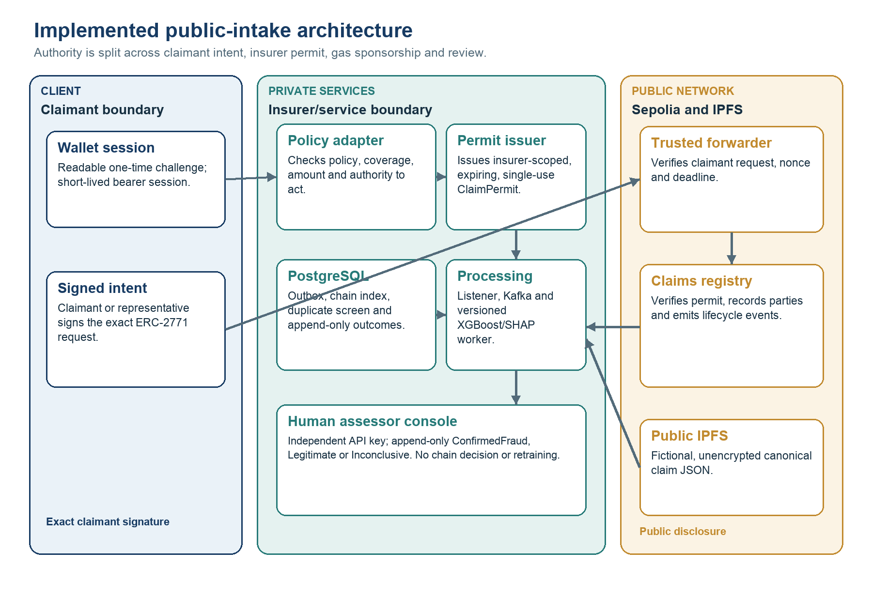
Figure 3.1. Implemented architecture and trust boundaries

The process starts with a wallet challenge that is readable before signature. A verified wallet receives a short-lived bearer session. The policy adapter then confirms that the policy exists, covers the incident type, date and amount, and permits the claimant or representative to act. The backend canonicalises the fictional claim, uploads it to IPFS, stores the exact request state and issues a short-lived, single-use EIP-712 ClaimPermit scoped to the insurer, claimant, content commitment and registry. The wallet signs the exact ERC-2771 ForwardRequest. The relayer verifies both authorisations and pays gas, but it holds no registry business role. The forwarder exposes the original signer, while the registry verifies the permit and records claimant, submitter and insurer as distinct parties. The recipient still depends on correct trusted-forwarder configuration (OpenZeppelin, no date).
After confirmation, the listener scans contract logs from its durable checkpoint, transforms them into a stable event representation and updates the application index. It then publishes work to Kafka. The worker re-verifies the referenced content, constructs an allow-listed feature vector, checks duplicate fingerprints, applies the versioned XGBoost model and generates SHAP context. The ordering follows the project’s durable side-effect rules and the distinction between stream-platform guarantees and end-to-end application completeness (Wang et al., 2021).
Each technology has a narrow role. The ledger is the public verification surface. IPFS provides content addressing, PostgreSQL provides transactions and private queries, Kafka buffers asynchronous work, and the model service performs analysis that can change over time. Content addressing makes changed bytes detectable but does not make content confidential or permanently available (Trautwein et al., 2022; Shibano et al., 2024).

3.4 On-chain registry and gasless authorisation
The registry uses role-based access control for administration, permit issuance, submission and scoring. Public intake does not remove these boundaries. The claimant or authorised representative signs the forwarding request, an insurer-authorised permit issuer approves the precise registration context and the relayer only sponsors gas. ClaimPartiesRecorded preserves claimant, submitter and insurer attribution. The on-chain ASSESSOR_ROLE belongs to the scoring worker and is scoped to an insurer contract. It is distinct from the off-chain human-assessor console. Lifecycle transitions remain forward-only, and the first completed model assessment is immutable at contract level.
Gas sponsorship uses two related EIP-712 authorisations (Bloemen, Logvinov and Evans, 2017). The insurer-side ClaimPermit binds the claimant, registry, insurer, content commitment, nonce and expiry. The claimant or authorised representative separately signs the exact ERC-2771 request (Sandford et al., 2020). Changing signed calldata invalidates the request. The forwarder checks the wallet nonce and deadline. The registry checks the permit issuer, scope and one-time use. EIP-712 alone does not prevent replay, so domain separation, independent nonces, expiries and consumed-permit tracking are all required. The relayer pays gas but neither signature delegates authority to rewrite the claim (Hughes et al., 2023).
The current public-intake research deployment is identified as sepolia-public-intake-v1. The registry address is 0xb64BaB321e0Fb19b2295f8182D5A37bAf85F7dff, the forwarder address is 0xeff61937C6a11236D87863e763c13cd7083f0BD0, the registry start block is 11,516,697 and the chain identifier is 11155111. These values identify the configured Sepolia deployment, not a service-level commitment. The earlier sepolia-gasless-v1 addresses are retained only for read-only historical reference and cannot issue public-intake permits.
An internal code-oriented security review strengthened role, lifecycle, signature, permit and replay tests, but it is not an independent professional audit. The policy adapter and permit issuer also create private trust dependencies that a contract audit alone cannot resolve. Production use would require authoritative identity and policy integrations, managed signing keys, external smart-contract and service reviews, multi-party administration, monitored quotas and abuse controls, tested migration and recovery, and a documented response to compromised sessions, permits or relayer infrastructure.

3.5 Off-chain storage and replay safety
The contract excludes detailed claim fields because privacy controls, schemas and model features change more quickly than a registry commitment. The on-chain record contains party attribution, bounded references, hashes and lifecycle metadata. Raw policy references are replaced by separate keyed commitments for policy lookup and claimant binding. This does not make the current storage private. The canonical fictional claim JSON is uploaded to public, unencrypted IPFS and is available to anyone who obtains its CID. The research deployment must not receive real claims. When the worker reads IPFS content, it verifies both CID and expected hash before feature extraction. Successful retrieval alone is not proof that the bytes match the committed claim (IPFS Project, no date a; IPFS Project, no date b).

3.5.1 Formal crash-state definition
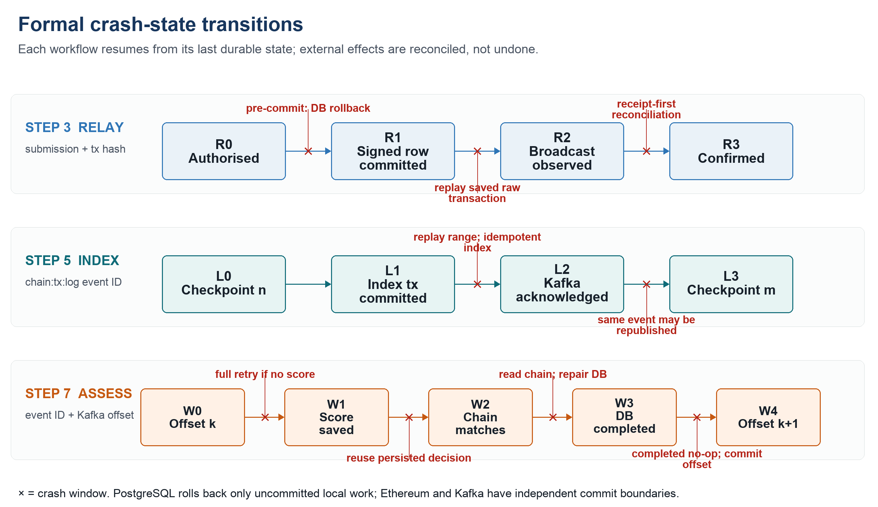
Figure 3.2. Formal crash-state transitions at the relay, listener and worker boundaries
Figure 3.2 defines three independent state machines rather than one global transaction. Relay states are R0 Authorised, R1 SignedDurable, R2 BroadcastObserved and R3 Confirmed. Listener states are L0 Checkpoint(n), L1 IndexCommitted, L2 KafkaAcknowledged and L3 Checkpoint(m). Worker states are W0 Offset(k), W1 ScoreSaved, W2 ChainMatched, W3 DatabaseCompleted and W4 Offset(k+1). A restart resumes from the last durable state. An uncommitted PostgreSQL transaction is rolled back by the database (PostgreSQL Global Development Group, no date b). An accepted Ethereum transaction or acknowledged Kafka message cannot be rolled back and must instead be detected and reconciled.
At step 3, the relayer stores the raw signed transaction, transaction hash and relayer nonce before broadcast. A crash before that database commit leaves the outbox item authorised and signing can start again. A crash after it leaves the exact signed bytes available for retry. If the node may already have accepted the transaction, restart checks the receipts of every recorded attempt before rebroadcasting. A replacement retains the same relayer account nonce and logical forwarding request. The forwarder nonce, claim-permit nonce and consumed-permit record prevent the same authorisation from registering a second logical claim. At step 5, the listener commits the immutable event and current projection in one database transaction, publishes a deterministic chain-id, transaction-hash and log-index event identifier, and advances the block checkpoint only after Kafka acknowledgement. Failure before the checkpoint therefore replays the same range. The conflict-safe inserts and ordered upserts make the index replay safe (PostgreSQL Global Development Group, no date a), while Kafka publication remains at least once (Apache Software Foundation, no date).
At step 7, automatic offset storage and commit are disabled. The worker checks for a completed row, verifies the committed content, persists the model decision under the deterministic event identifier, reconciles the contract state and marks the database row completed before committing the Kafka offset synchronously. A crash before ScoreSaved causes full redelivery and processing. A crash after ScoreSaved reuses the stored probability, threshold and reasons rather than scoring again. If the contract update completed but the database update did not, restart reads the chain. A matching status and fraud score repair the completed state without issuing a second contract write. If DatabaseCompleted exists but the offset is still old, redelivery becomes a no-op and the offset is then committed. A permanent conflict is acknowledged only after its dead-letter record has been written durably.
Table 3.3. Crash recovery and commit-state definition
Crash window | Durable state at failure | Restart or retry transition | Safety property and remaining limit
Step 3a: before signed-row commit | Authorised outbox item, no durable raw transaction. | PostgreSQL rolls back the partial update. The relayer locks the item and repeats Authorised → SignedDurable. | No chain effect exists. This is a true local rollback.
Step 3b: after signed-row commit, broadcast outcome unknown | Raw bytes, transaction hash, relayer nonce and attempt history. | Check the recorded receipts first. If no receipt is found, rebroadcast the saved bytes or, if necessary, broadcast a same-nonce fee replacement, then repair the broadcast state and continue to confirmation. | No external rollback. Forwarder and permit nonces prevent a second logical registration, RPC and confirmation assumptions remain.
Step 5a: index committed, Kafka not acknowledged | Immutable log and projection are committed, block checkpoint is unchanged. | Read the same block range again, repeat the conflict-safe index transaction and publish the same deterministic event identifier. | Database state does not duplicate or regress. Publication is still at least once.
Step 5b: Kafka acknowledged, checkpoint not saved | Index and broker event exist, the old block checkpoint remains. | Replay the range and possibly republish the same event identifier, advance the checkpoint only after the whole range succeeds again. | A duplicate Kafka delivery is possible because the database, broker and checkpoint are not one atomic transaction.
Step 7a: before score commit | Kafka offset is uncommitted, no new assessment decision is durable. | Kafka redelivers the message. Verification, feature preparation and scoring run again unless an earlier row already exists. | The deterministic event identifier prevents a second assessment row, but computation may repeat.
Step 7b: score saved, chain write pending or uncertain | Probability, threshold, reasons and intended status are stored, offset is uncommitted. | Reuse the stored decision and read the contract. Submit only from the Submitted state. If the status and score already match, mark the row completed without another chain write. | The chain effect is reconciled, not rolled back. Receipt metadata can be incomplete if the crash preceded its database save.
Step 7c: database completed, offset not committed | Completed assessment exists, Kafka still points to offset k. | Redelivery finds the completed row, returns without downloading, rescoring or writing the contract, and commits the offset synchronously. | Covered side effects exhibit effectively-once behaviour, although Kafka delivery itself remains at least once.
These transitions justify a deliberately narrow claim. The implementation provides effectively-once behaviour only for the side effects protected by durable identities, conflict-safe writes, receipt or state reconciliation and manual Kafka offset control. It does not provide system-wide exactly-once execution because PostgreSQL, Ethereum and Kafka do not participate in a shared distributed transaction. The design therefore tolerates duplicate delivery. It does not claim that duplicate delivery cannot occur (Apache Software Foundation, no date; Wang et al., 2021).
Chain reorganisation is a related but distinct concern. The listener uses confirmed ranges and a recorded start point. A production configuration would need a documented confirmation-depth or finality policy, reorganisation detection and reconciliation for already published events. Public-test-network observation under deliberately induced reorganisations was outside the evaluation.

3.6 Feature and duplicate engineering
Feature engineering is governed by an allow-list. Numerical inputs include claim amount, premium, vehicle age, reporting delay, prior claim counts and related ratios. Categorical inputs include incident and geographic descriptors used by the versioned artefact. Free text, evidence bodies and raw policy references are excluded. Settlement amount, processing duration, source fraud probability and scenario labels were excluded because they arise after the intended decision point or expose the synthetic generator. This directly addresses temporal and target leakage, which can produce severe overestimation and misleading superiority over simpler baselines (Kapoor and Narayanan, 2023).
Duplicate screening uses a canonical representation of selected incident fields and a server-held HMAC-SHA-256 key (National Institute of Standards and Technology, 2008). The keyed fingerprint is compared only inside the private service boundary and makes simple public dictionary calculation harder than an unkeyed digest, provided the key is generated and protected appropriately. A match produces a review candidate rather than proof because protected linkage retains linkage, inference and governance risks.
A production implementation would need governance for which fields enter the fingerprint, how corrections are handled, who holds the secret, and how key rotation preserves or intentionally invalidates prior matches. It would also need controls against membership inference through repeated authorised queries. The prototype shows the engineering pattern but not a mature consortium privacy protocol.

3.7 Predictive modelling method
The evaluation used the versioned African Motor Insurance Claims Dataset. After preprocessing, the prototype records 99,982 usable rows and the source file’s SHA-256 hash, so the input can be checked (Electric Sheep Africa, 2026). Records were ordered chronologically and split 70/15/15 into training, validation and test partitions. The test partition was not used for fitting or threshold selection. This reduces adaptation to the reported hold-out and resembles a future-use boundary more closely than a random split, although it cannot remove every dependency or future distribution shift (Kapoor and Narayanan, 2023).
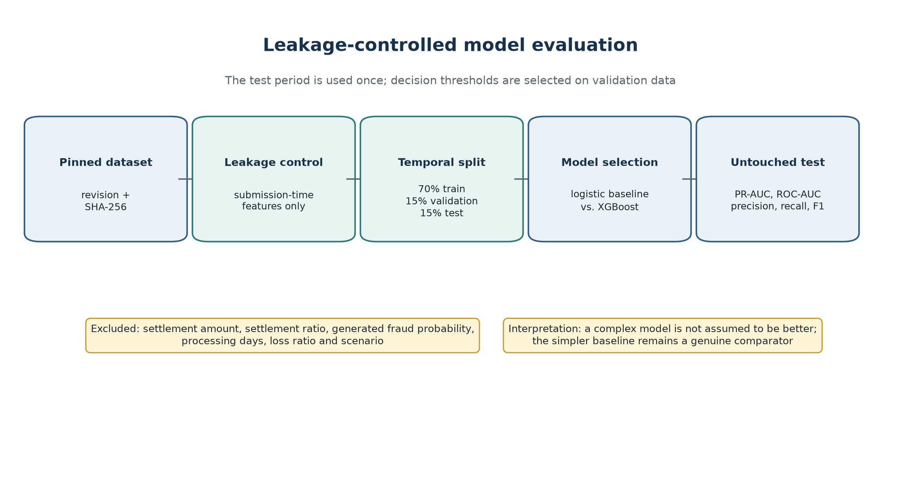
Figure 3.3. Chronological model-evaluation pipeline

Logistic regression provides the interpretable linear baseline. XGBoost supplies a regularised non-linear ensemble for feature interactions in tabular data (Chen and Guestrin, 2016). Preprocessing is fitted on training data, thresholds are selected on validation evidence and both are frozen for test evaluation (Pfob, Lu and Sidey-Gibbons, 2022). Because the scores are not legal findings, threshold selection is interpreted as a review-capacity and asymmetric error-cost decision rather than a universal definition of fraud.
Evaluation reports PR-AUC, ROC-AUC, precision, recall, F1 and Brier score. PR-AUC is foregrounded because the positive class is uncommon and the practical meaning of a positive prediction depends on prevalence and threshold. Confusion matrices translate thresholds into review outcomes. A Brier score summarises squared probability error, but one aggregate value does not replace reliability plots and subgroup calibration. SHAP supports diagnostic review, subject to the limitations of post-hoc feature attribution and recipient comprehension (Lundberg and Lee, 2017).

3.8 Evaluation design
The evaluation was organised around claims that the prototype could reasonably support. The predictive stream asks how the models rank and classify a fixed synthetic hold-out. The verification stream asks whether access, lifecycle, replay, feature and interface behaviour matches the implementation. A third stream measures a localised performance baseline under controlled HTTP concurrency, controlled and burst Kafka input, and a crash window after side effects but before offset commit. The stream is deliberately preliminary: it characterises one development-host layout and deterministic public-service adapters rather than production capacity. Table 3.4 keeps that boundary visible alongside the captured measurements.
Table 3.4. Evaluation questions, measures and evidence
Question | Measure | Evidence status | Interpretive boundary
Does the model prioritise positives? | PR-AUC, ROC-AUC and recall on chronological test set. | Captured in versioned model metadata. | Synthetic dataset, no real-portfolio external validity.
What review workload follows? | Precision, F1, threshold and confusion matrix. | Captured for logistic and XGBoost artefacts. | Investigation costs were not monetised.
Can a reviewer inspect drivers? | Global SHAP summary and stored explanation path. | Captured for integrated XGBoost artefact. | Attribution is not causality or fairness assurance.
Are contract and pipeline rules enforced? | Unit, fuzz, component and isolated browser tests. | Executed in isolated suites, 310 behavioural checks passed. | Eight infrastructure-backed Python tests were deselected, two browser paths were exercised.
Is implementation quality monitored? | Branch-aware coverage, lint and production frontend build. | Branch-aware Python coverage was 74.71%, Ruff, frontend lint and the production build passed. | Coverage missed the configured 75% gate by 0.29 percentage points.
What baseline capacity and recovery behaviour does one local process layout show? | HTTP p50/p95, throughput, queue delay, model processing, sponsor-side gas and crash/restart recovery. | Preliminary bundle: 1,200 HTTP claims, 360 pipeline events, 100-claim recovery and 100 gas observations per operation. | Development host and deterministic IPFS/RPC adapters, no production scalability claim.

3.9 Ethics, privacy and validity
The study used synthetic claims and test-network addresses to avoid exposing real individuals during development. That safer choice weakens external validity. Synthetic generation can preserve some patterns, remove others and create an uncertain privacy–utility trade-off (Stadler, Oprisanu and Troncoso, 2022). The labels may reflect generator rules rather than investigation outcomes, while geographic and incident variables may encode simplifications that would be unacceptable in customer treatment. For that reason, the dataset and model need explicit composition, intended-use and prohibited-use records. The word ‘synthetic’ is not an assurance by itself (Gebru et al., 2021; Tabassi, 2023). The results are reported as artefact evaluation, not as evidence that the model is fair or deployable.
Privacy was addressed through separation and minimisation. Private structured data is off-chain and public state is bounded. Model features exclude free text and raw policy references. Duplicate fingerprints are keyed and permitted research use is fictional data only. These controls do not complete a legal assessment. CIDs, hashes, addresses and transaction metadata may remain linkable, while public IPFS does not provide confidentiality by itself (Trautwein et al., 2022; Shibano et al., 2024). A real deployment would require necessity and lawful-basis analysis, a DPIA where required, controller/processor allocation, access logging, retention and erasure procedures, encryption and controlled evidence storage (European Data Protection Board, 2026).
Internal validity is strengthened by a fixed data hash, chronological partitions, an untouched test set, exact metric metadata and automated verification. Construct validity is limited because fraud labels and predictive metrics stand in for investigative utility. External validity is limited by one synthetic motor dataset, one test network and one deployment. Reliability is strengthened by versioned artefacts, although independent reproduction has not occurred. Current ML reproducibility guidance expects data provenance, dependencies, metric definitions and executable procedures (Pineau et al., 2021).

Chapter 4: System Evaluation
This chapter evaluates the prototype as an end-to-end research artefact. Rather than separating implementation from results, each section pairs what was built with the evidence available to assess it. The evaluation follows the claim path from authorised submission and replay-aware delivery to model scoring, explanation and human review. Repository-verified evidence, repository-reproducible replacement analyses and preliminary localised measurements are kept visibly distinct so that the strength and provenance of each conclusion are clear.

4.1 Evaluation scope and evidence provenance
The evidence base is deliberately uneven. The pinned dataset, chronological split, base models, held-out metrics, saved SHAP artefact, feature-ablation package and current advanced-analysis package are present in the repository and were checked against saved hashes or validated through execution. The advanced archive contains a replacement implementation of the previously unarchived 24-trial random search, tuned-model comparison, 2,000-sample paired bootstrap, 100-run label-permutation diagnostic, mutual-information screen, country audit and calibration decomposition. It also retains complete JSON and CSV outputs, raw resampling values, figures, software versions, an execution manifest and SHA-256 checksums. The current numerical results are therefore reproducible from the repository. The original historical script and JSON were not recovered, so the archive must not be presented as proof that every earlier unpublished run used identical code. The test period contains 14,998 records, including 1,676 synthetic fraud labels (11.1748%).
Table 4.1 links each evaluation strand to its evidence and to the narrow claim that evidence supports. This places the essential traceability beside the findings. Appendix A remains the more detailed map to repository locations.

Table 4.1. Evaluation evidence and reproducibility map
Evaluation strand | Evidence used in this chapter | Reproducibility status | Claim supported
Authorised submission and registry lifecycle | Wallet, policy, permit, forwarder, role, lifecycle and party-attribution tests. | Repository-verified | Identity, authority and state transitions behave as designed under isolated tests.
Content binding and event delivery | CID/hash validation, outbox, checkpoint, Kafka acknowledgement and replay tests. | Repository-verified | Claim events can be reconstructed and repeated delivery is handled safely in tested paths.
Predictive discrimination and workload | Pinned 70/15/15 split, logistic regression and deployed XGBoost hold-out metrics. | Repository-verified | The models show weak but measurable ranking performance on the synthetic test set.
Advanced model extensions | Replacement random search, tuned-model bootstrap, permutation, mutual-information and calibration archive. | Repository-reproducible replacement script, JSON/CSV, figures, manifest and checksums | Current rerun results are reproducible, provenance of the missing historical execution is not recoverable.
Subgroup and feature ablation | Country metrics, six controlled feature sets, paired PR-AUC intervals and capacity-matched errors. | Repository-verified script, JSON/CSV, checksums and figures | Direct country and vehicle age add little, country-linked market frequency carries much of the synthetic lift.
Explainability and human review | SHAP artefact, score/threshold metadata, assessor API and console tests. | Mixed: saved artefacts and interface behaviour verified | Scores can support triage and append-only review, they do not establish causality or adjudication.
Performance and resilience | Localised HTTP, pipeline, sponsor-side gas and crash/restart benchmark with raw timings and checksums. | Retained preliminary bundle, clean-commit target-VM rerun pending | One local process layout exposes saturation and replay behaviour, not production capacity.

4.2 End-to-end system behaviour
The end-to-end evaluation begins at the authority boundary for public intake. The browser does not receive an insurer private key. It signs a readable one-time authentication challenge, then submits policy and incident facts through a short-lived wallet session. The backend policy adapter checks eligibility before an insurer-authorised component signs a single-use ClaimPermit. The claimant or authorised representative signs the exact ERC-2771 request, and an isolated relayer pays test-network gas after verifying both signatures. The registry checks the trusted forwarder, permit issuer, scope, nonce and expiry. This composite design separates identity, policy authority, claimant intent and fee payment. Replay resistance and the relayer relationship therefore arise from the surrounding protocol, not from EIP-712 by itself (Hughes et al., 2023).
The public record is intentionally small: an identifier, authorised address, content commitment, lifecycle state and assessment metadata. Full fictional evidence remains off-chain. An IPFS content identifier makes a byte sequence verifiable, but content addressing does not supply access control, confidentiality or guaranteed retention. Network measurements show that IPFS is a decentralised retrieval layer with availability and replication behaviour of its own. Privacy-oriented designs therefore add controlled peers, encryption or cryptographic access mechanisms (Trautwein et al., 2022; Shibano et al., 2024). The prototype is suitable for synthetic demonstrations, not for publishing real claim evidence on public IPFS.
Two failures found during implementation changed the design. First, the listener checkpoint now moves only after the block range is stored and publication is acknowledged. Second, the worker retries temporary infrastructure failures, but it handles a permanent malformed input differently. It writes a small rejection record before moving the offset. If that write fails, the offset is not committed. These rules accept at-least-once delivery and use stable identifiers, stored outcomes and idempotent side effects to make repeats safe. Kafka transactions do not automatically include PostgreSQL, IPFS or blockchain writes, so the application must handle those effects.
The architecture in Figure 3.1 shows three trust regions: the user-facing client, the privately operated insurer services and the public Sepolia network. A public anchor can show that a commitment and state transition existed, but it cannot prove that the submitted information was true. Nor does a content hash remove controller obligations for linkable personal data. Final European guidance therefore favours data minimisation and off-chain handling where blockchain immutability conflicts with correction or erasure duties (European Data Protection Board, 2026).

4.3 Functional and software verification
The behavioural suites provide the strongest repository-reproducible evidence for these system claims. Across the isolated suites, 310 checks passed: 232 Python, 34 frontend, 42 contract and two Playwright tests. Eight infrastructure-backed Python tests were deselected and four warnings were reported. The contract total comprised 25 Solidity and 17 Node.js checks, including 256-run fuzz cases. Ruff, frontend lint and the production build passed. However, branch-aware Python coverage was 74.71%, so the configured 75% gate failed by 0.29 percentage points. This evidence remains incomplete without infrastructure validation, independent security assessment and operational assurance (Washizaki, 2026).
Table 4.2. Executed software verification evidence
Layer | Executed evidence | Result | Boundary
Python services | pytest excluding infrastructure-backed tests | 232 passed, 8 deselected | Branch-aware coverage was 74.71%, four warnings were reported, the configured gate failed.
React frontend | Unit/component tests | 34 passed in 6 files | Selected behaviour, not every browser/device.
Smart contracts | Hardhat Solidity, Node.js and fuzz tests | 42 passed: 25 Solidity, 17 Node.js | 256-run fuzzing is not formal verification.
Browser flow | Isolated Playwright scenarios | 2 passed | Assessment polling and duplicate-screening paths only.
Quality gates | Ruff, frontend lint and production build | Passed | Static gates passed, Python coverage left the overall verification gate incomplete.

Contract security remains a release condition. Current role, lifecycle, forwarding and replay tests do not replace independent review, managed administration or operational monitoring against a mature security specification (Enterprise Ethereum Alliance, 2025; Souppaya, Scarfone and Dodson, 2022).

4.4 Predictive experiment and artefact provenance
The predictive evaluation begins with artefact and leakage control. The saved model record pins the synthetic dataset revision, prepared-file SHA-256 digest, chronological split, feature list, preprocessing pipeline and model hash. Ten submission-time inputs are retained: six numerical and four categorical. Settlement amount, settlement ratio, processing duration, generator fraud probability, loss-ratio outputs and scenario markers are excluded because they arise after the intended decision or disclose how the synthetic label was produced. This decision follows the temporal availability test for leakage: a feature is admissible only if it would exist at claim submission (Kapoor and Narayanan, 2023).
The repository-controlled rerun keeps the original logistic regression and deployed XGBoost definitions and evaluates 24 XGBoost configurations drawn deterministically from the declared search space. The search covers tree depth, learning rate, number of estimators, child weight, row and column sampling, L2 regularisation and class weighting. Model fitting used the training period, candidate PR-AUC and the operating threshold were selected on validation data, and the chronological test period was evaluated only after selection. Random search and paired resampling were used because model selection and uncertainty are part of the experiment, not additions made after inspecting test results. The seed, all candidate results, selected parameters and raw resamples are retained in the advanced-analysis archive and summarised in Appendix D.
Table 4.3. Dataset composition and chronological split
Partition | Rows | Share | Use
Training | 69,987 | 70.0% | Fit preprocessing and model parameters.
Validation | 14,997 | 15.0% | Search and threshold selection.
Test | 14,998 | 15.0% | Untouched comparison, 1,676 positive labels.
Total | 99,982 | 100.0% | Chronologically ordered usable records.

4.5 Predictive performance and uncertainty
Table 4.4 confirms the earlier operational trade-off. Logistic regression ranks marginally better, while the deployed XGBoost threshold retrieves more positives by flagging almost half of the test set. Its 1,032 true positives are accompanied by 5,952 false positives. Logistic regression produces 683 and 3,260 respectively. The additional 349 detections therefore require 3,041 additional referrals, or about 8.7 extra flagged claims per extra positive found.
Table 4.4. Held-out predictive performance
Model | Threshold | PR-AUC | ROC-AUC | Precision | Recall | F1 | Brier
Logistic regression | 0.54 | 0.1711 | 0.6279 | 0.1732 | 0.4075 | 0.2431 | 0.2392
Deployed XGBoost | 0.47 | 0.1647 | 0.6148 | 0.1478 | 0.6158 | 0.2383 | 0.2213
Tuned XGBoost | 0.53 | 0.1720 | 0.6253 | 0.1692 | 0.4195 | 0.2411 | 0.2315

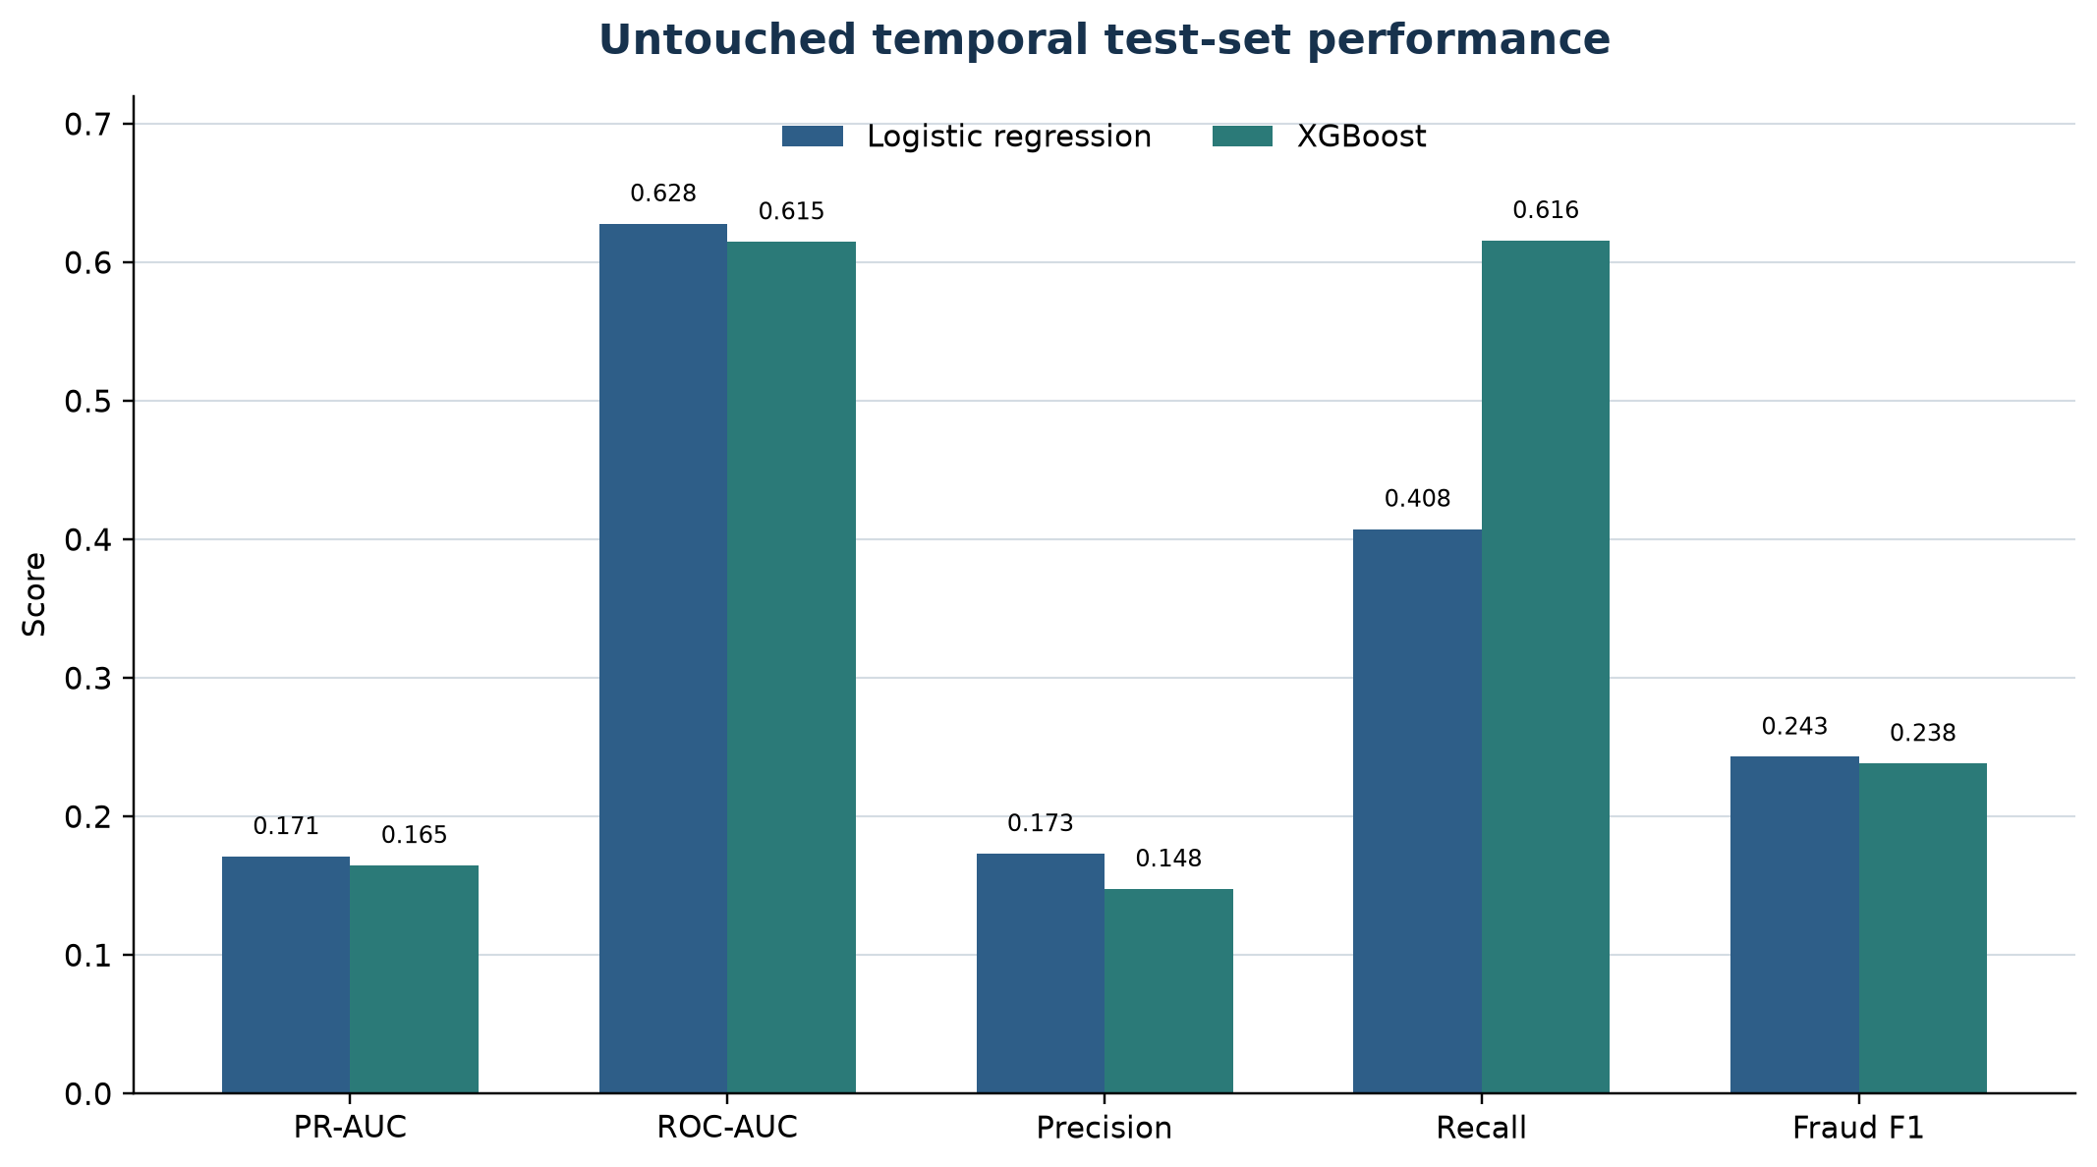
Figure 4.1. Predictive-model comparison
The archived rerun contains 2,000 paired bootstrap samples from the same test records. Pairing matters because every model is evaluated on the same claims. Logistic regression exceeded the deployed XGBoost artefact by 0.0064 PR-AUC, with a 95% interval of 0.0004 to 0.0126. The tuned model exceeded the deployed artefact by 0.0073, with an interval of 0.0031 to 0.0118. Its point estimate also exceeded logistic regression by 0.0009, but the corresponding logistic-minus-tuned interval of −0.0050 to 0.0030 crossed zero. The rerun therefore supports a small improvement over the deployed XGBoost configuration within this test set, but no reliable advantage over the simpler logistic baseline.
Table 4.5. Paired-bootstrap uncertainty
Estimate | Mean / point | 95% bootstrap interval | Interpretation
Logistic PR-AUC | 0.1711 | 0.1595 to 0.1846 | Weak ranking performance.
Deployed XGBoost PR-AUC | 0.1647 | 0.1535 to 0.1773 | Lower point estimate.
Tuned XGBoost PR-AUC | 0.1720 | 0.1600 to 0.1856 | Slightly above the logistic point estimate.
Logistic − deployed | 0.0065 | 0.0004 to 0.0126 | Small positive difference.
Logistic − tuned | −0.0009 | −0.0050 to 0.0030 | No clear difference in this test set.

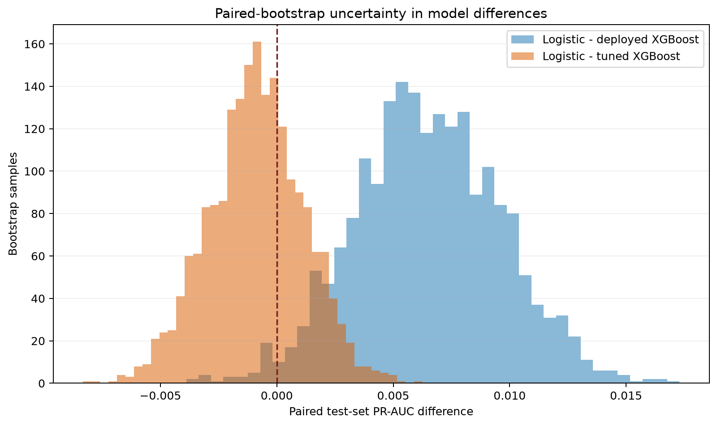
Figure 4.2. Paired-bootstrap PR-AUC differences

4.6 Hyperparameter search and signal diagnostic
The replacement 24-trial randomised search selected trial 6: a depth-three, 400-tree model with a 0.025 learning rate, 0.80 row sampling, 0.75 column sampling and class weight 7.2048. Test PR-AUC increased from 0.1647 for the deployed XGBoost artefact to 0.1720, and ROC-AUC increased from 0.6148 to 0.6253. The tuned point estimate was slightly above logistic regression, but their paired interval included zero. Its Brier score of 0.2315 was better than logistic regression's 0.2392 but worse than the deployed artefact's 0.2213. Tuning therefore improved XGBoost ranking on this synthetic test set without establishing a decisive advantage over the simpler baseline, and without making the scores suitable as literal fraud probabilities.
Table 4.6. Randomised-search result
Parameter | Selected value | Parameter | Selected value
max_depth | 3 | learning_rate | 0.025
n_estimators | 400 | min_child_weight | 2
subsample | 0.80 | colsample_bytree | 0.75
reg_lambda | 1.00 | scale_pos_weight | 7.2048
Validation PR-AUC | 0.1607 | Validation threshold | 0.53

The weak PR-AUC values raised a more basic question: does the admitted feature set contain signal beyond class prevalence? The archived rerun retrains logistic regression after 100 independent permutations of the training labels while retaining the chronological test labels. The observed PR-AUC of 0.1711 exceeded every permuted run. The null mean was 0.1134, its 95% interval was 0.0955 to 0.1306, and the corrected empirical one-sided p-value was 0.0099. The conclusion is not 'no signal'. It is that signal is statistically detectable but small under this synthetic generator and split.
Table 4.7. Label-permutation and mutual-information diagnostics
Diagnostic | Result | Meaning
Observed logistic PR-AUC | 0.1711 | Performance with intact labels.
Permutation null | mean 0.1134, 95% 0.0955–0.1306 | Expected after destroying label association.
Empirical p-value | 0.0099 | Detectable signal, not evidence of field validity.
Largest mutual information | claim_frequency 0.00339 | All individual associations are very small.
Next variables | vehicle_age 0.00326, country 0.00290 | Potential generator structure audit required.

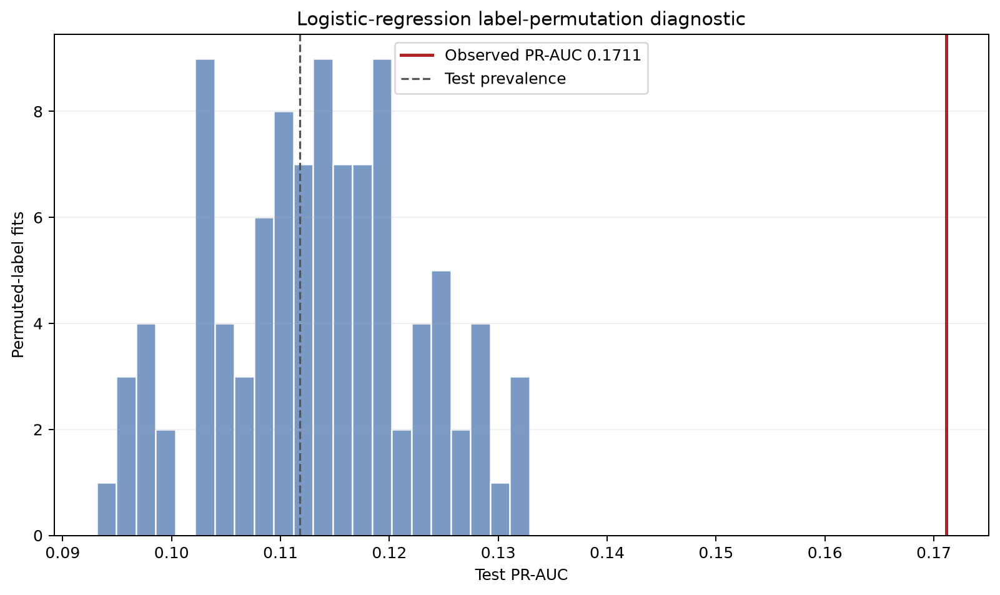
Figure 4.3. Label-permutation signal diagnostic

4.7 Explainability, subgroup behaviour and human oversight
The evaluation next asks whether the model's behaviour is intelligible enough for review. The worker returns a score, thresholded status, model version and local SHAP contributions. Figure 4.4 shows the saved global summary. Claim frequency is the largest average driver, followed by theft-related incident information, premium, country, vehicle age and claim amount. These values describe the fitted model. They do not show that a feature caused fraud. The prominent country contribution leads directly to the subgroup comparison below rather than being treated as an operational rule (Broniatowski, 2021; Phillips et al., 2021).
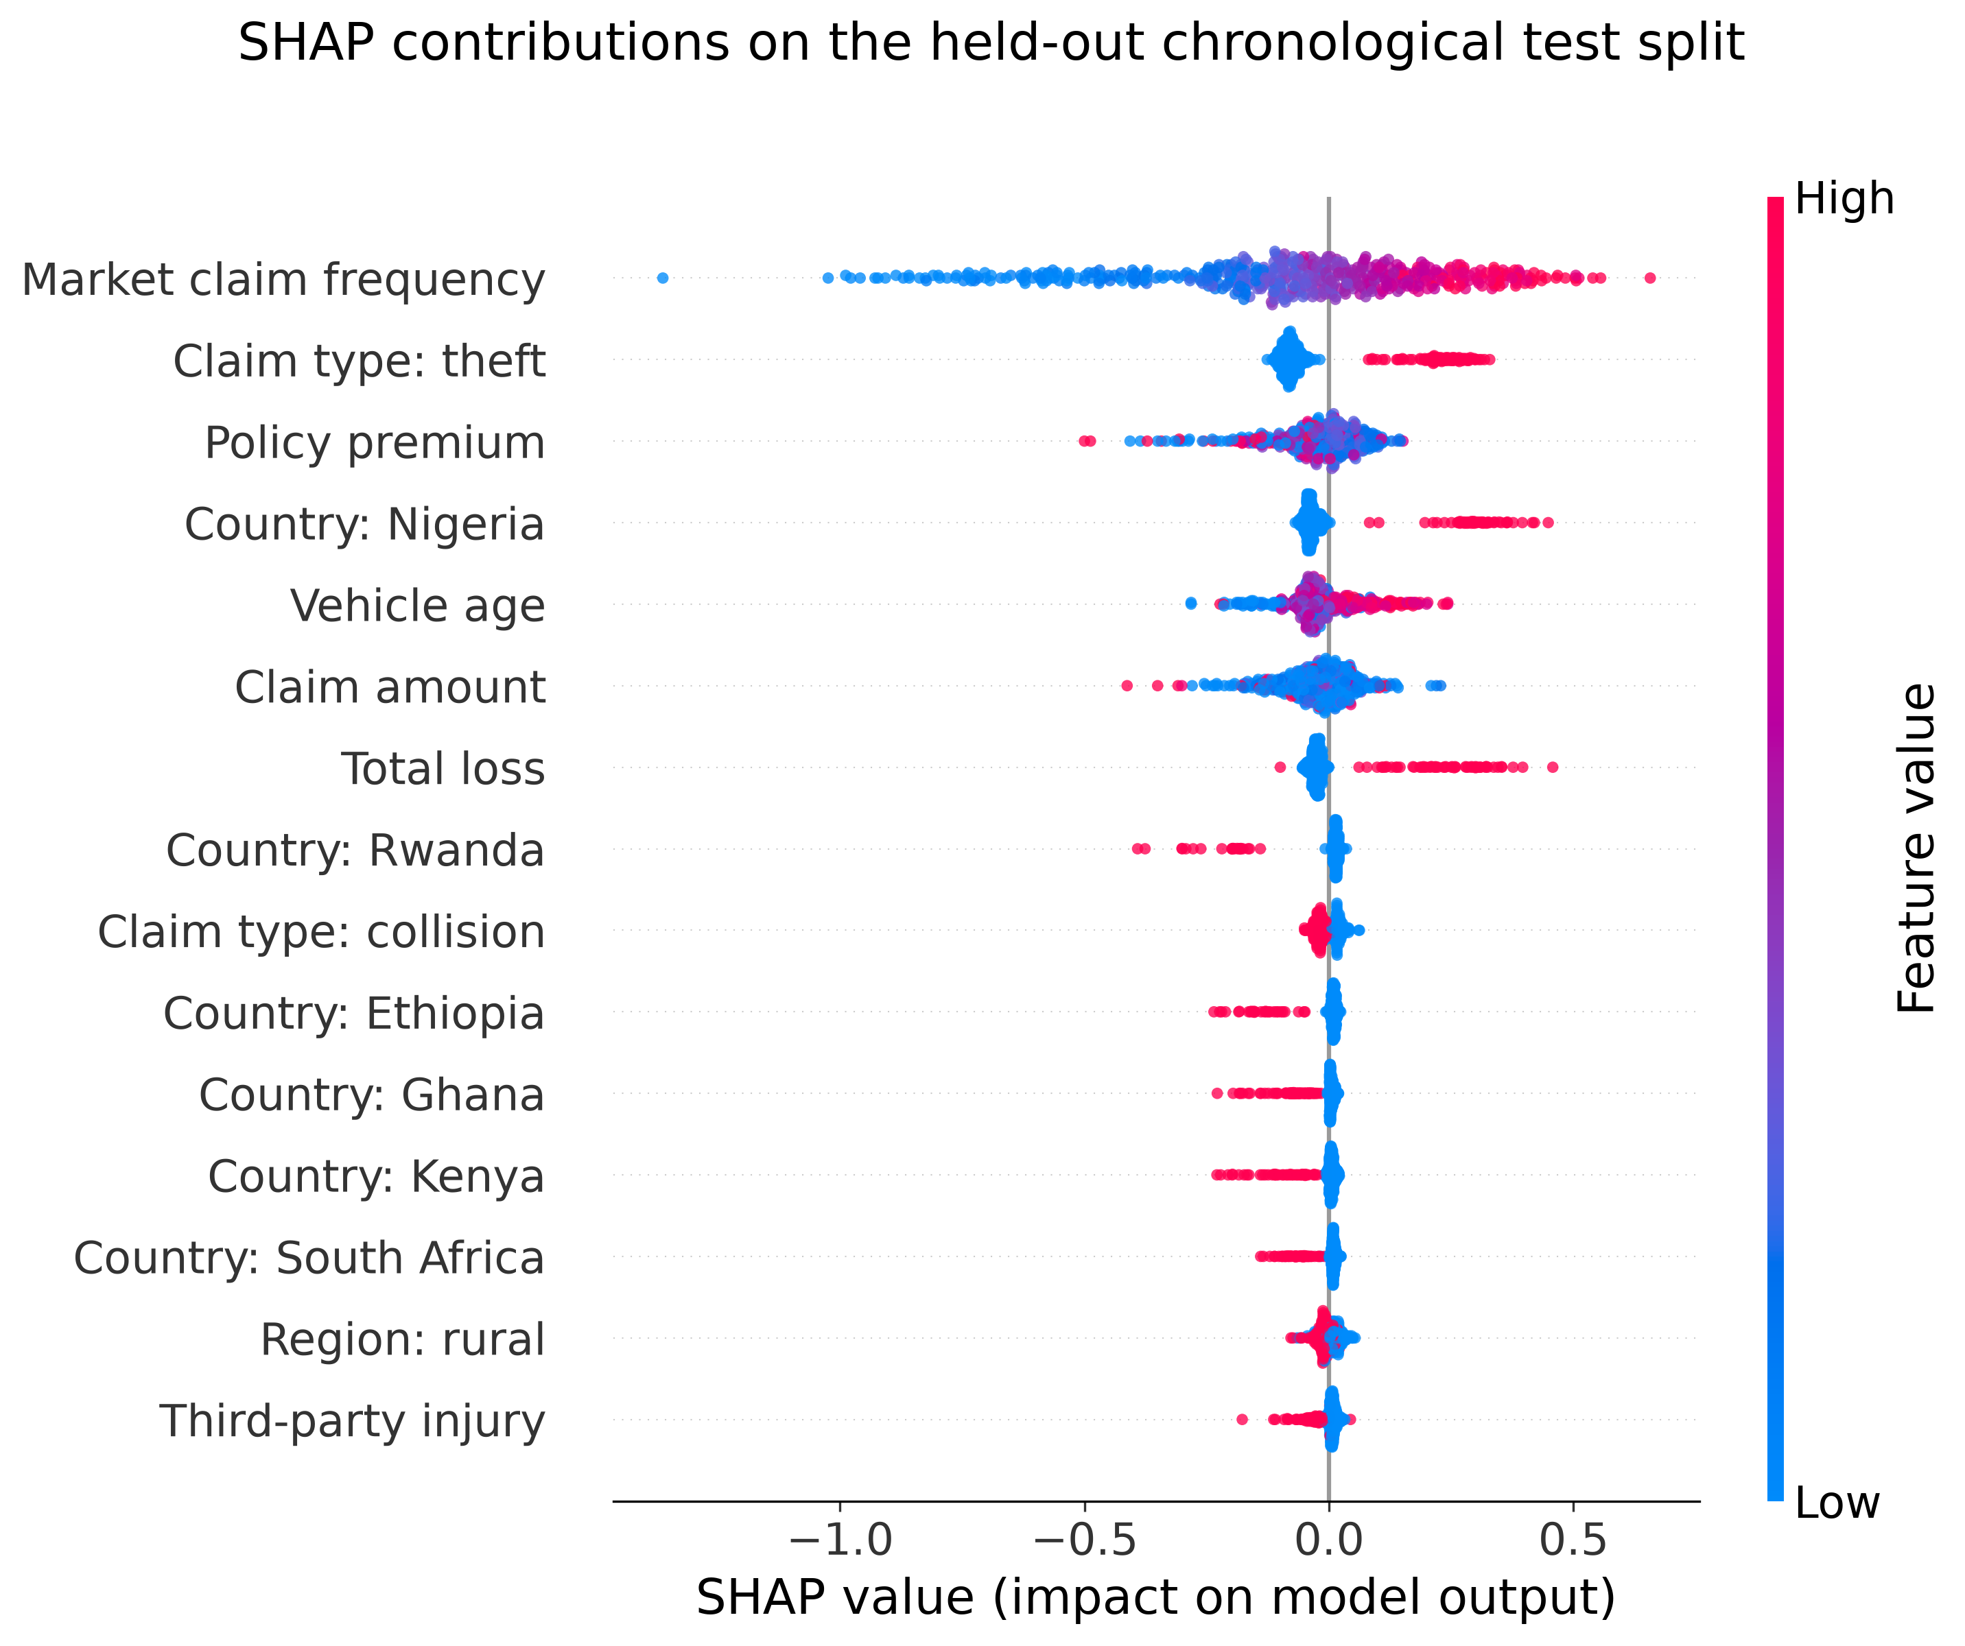
Figure 4.4. SHAP summary for the integrated XGBoost artefact
Source: held-out chronological test split of the pinned African Motor Insurance Claims Dataset, 500 sampled rows.
Country is the fourth most important SHAP feature, so the evaluation compares selection, false-positive and false-negative rates for every country. The differences are too large to ignore. Nigeria has a selection rate of 0.897 and a false-positive rate of 0.8934. Rwanda has a selection rate of 0.0637 and a false-negative rate of 0.9615. These values do not mean that one population commits more fraud because both the labels and country relationships are synthetic. They show that the fitted model would treat otherwise comparable review populations very differently.
Table 4.8. Selected country-level error rates
Country | n | Label prevalence | Selection rate | FPR | FNR | Precision
Nigeria | 1,487 | 0.1547 | 0.8971 | 0.8934 | 0.0826 | 0.1582
Rwanda | 926 | 0.0562 | 0.0637 | 0.0652 | 0.9615 | 0.0339
South Africa | 1,659 | 0.1272 | 0.5986 | 0.5698 | 0.2038 | 0.1692

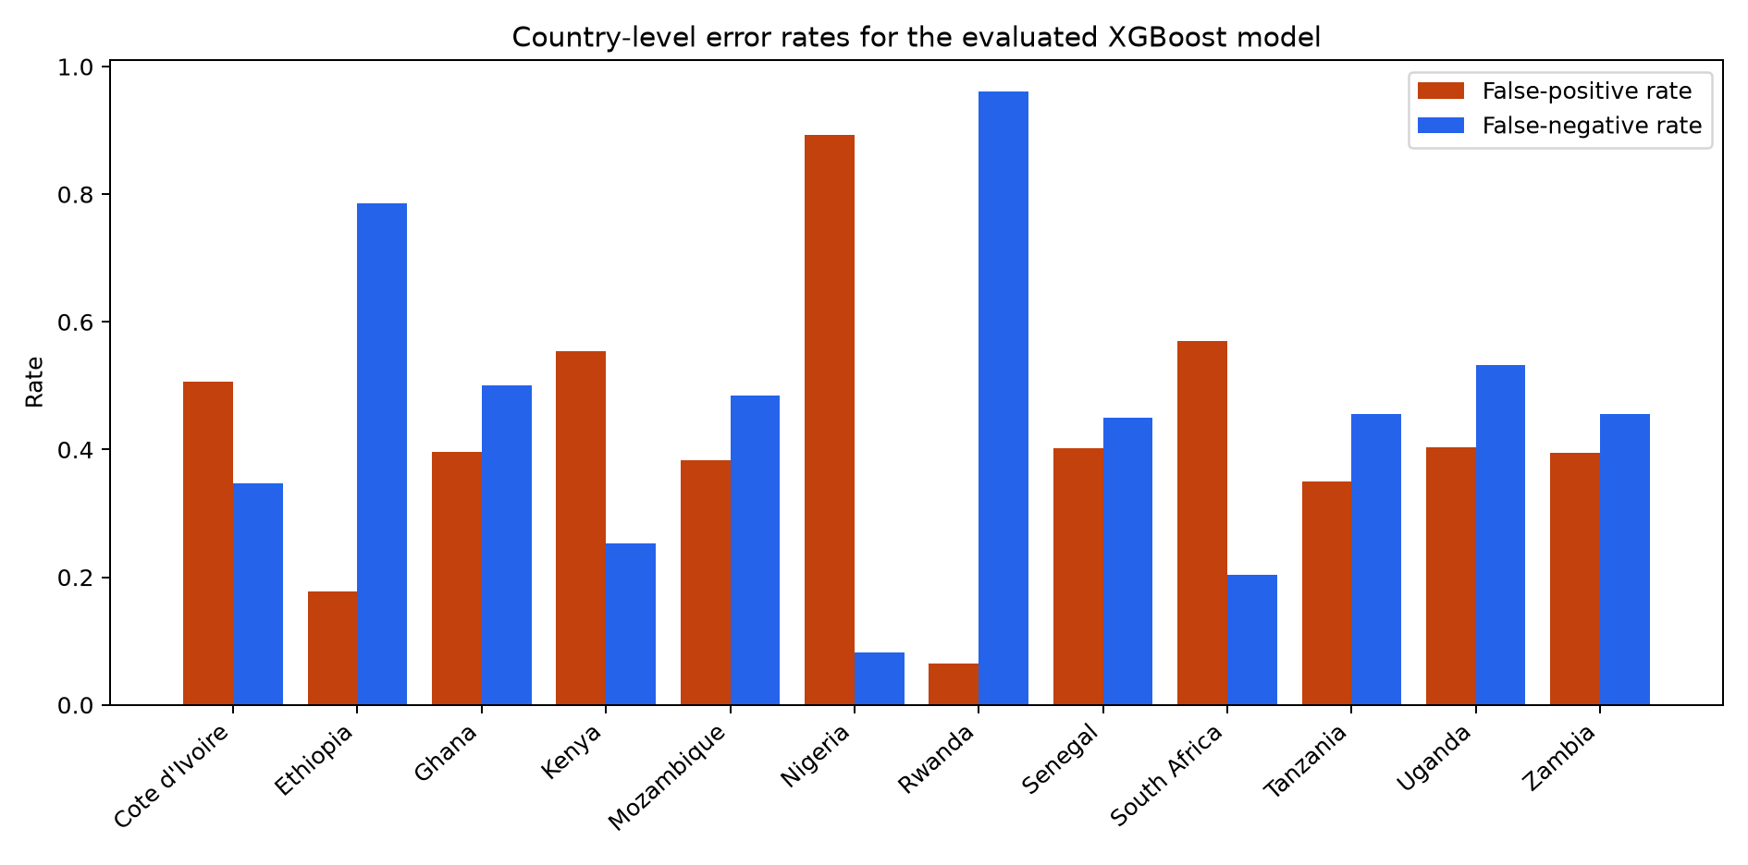
Figure 4.5. Country-level selection and error rates
Fairness metrics encode different normative choices and can conflict, so the audit is a screening device rather than a certificate (Mitchell et al., 2021). On the present evidence, the evaluated XGBoost model remains a deployment blocker. The audit alone, however, cannot show whether the direct country field causes the disparity or whether correlated generator features preserve the same structure. The following ablation addresses that narrower question.

4.7.1 Feature ablation and proxy sensitivity
Six controlled feature sets were evaluated for both logistic regression and XGBoost: the complete model, removal of country, removal of vehicle age, removal of both, removal of country and market claim frequency and a strict condition that removed country, market frequency and vehicle age. Market frequency was included because the serving pipeline derives it from country-level artefact metadata and dropping the one-hot country field alone would therefore leave a strong geographic proxy. Every condition reused the pinned data, chronological 70/15/15 split and seed, retrained preprocessing and model parameters from the beginning, selected its operating threshold on validation data and evaluated the test period once. PR-AUC intervals and paired changes from the complete model used 2,000 bootstrap resamples of the same test rows.
Table 4.9. Feature-ablation PR-AUC sensitivity
Model | Feature removal | PR-AUC | 95% interval | Change | Lift retained
Logistic | None (full) | 0.171142 | 0.159460 to 0.184635 | - | 100.0%
Logistic | Country | 0.171546 | 0.159785 to 0.185856 | +0.000404 | 100.7%
Logistic | Vehicle age | 0.170321 | 0.158520 to 0.183808 | -0.000821 | 98.6%
Logistic | Country + vehicle age | 0.170469 | 0.158452 to 0.184691 | -0.000673 | 98.9%
Logistic | Country + market freq. | 0.133185 | 0.124664 to 0.144001 | -0.037957 | 36.1%
Logistic | Country + market freq. + age | 0.132072 | 0.123733 to 0.142765 | -0.039070 | 34.2%
XGBoost | None (full) | 0.164694 | 0.153453 to 0.177296 | - | 100.0%
XGBoost | Country | 0.165719 | 0.153983 to 0.179667 | +0.001025 | 101.9%
XGBoost | Vehicle age | 0.163496 | 0.152006 to 0.176809 | -0.001198 | 97.7%
XGBoost | Country + vehicle age | 0.158232 | 0.147513 to 0.171023 | -0.006462 | 87.8%
XGBoost | Country + market freq. | 0.133997 | 0.125375 to 0.145300 | -0.030697 | 42.0%
XGBoost | Country + market freq. + age | 0.129043 | 0.120675 to 0.139122 | -0.035651 | 32.7%

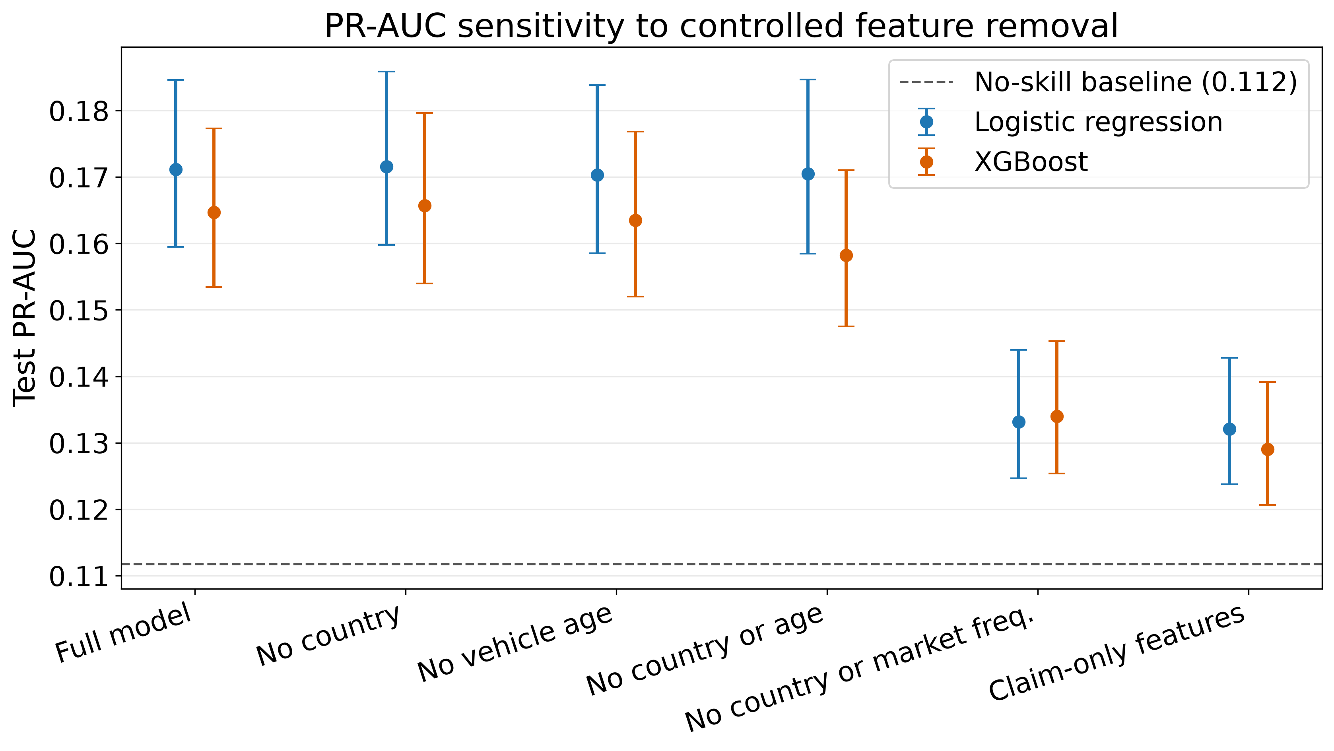
Figure 4.6. PR-AUC across country, vehicle-age and proxy ablations
Source: held-out chronological test split of the pinned African Motor Insurance Claims Dataset, 2,000 paired-bootstrap samples per condition.
Removing country alone did not reduce ranking performance. Logistic-regression PR-AUC changed from 0.171142 to 0.171546 and XGBoost from 0.164694 to 0.165719. The paired 95% intervals for both changes included zero. Removing vehicle age also produced only small, uncertain changes. The evidence therefore does not support the claim that either explicit country or vehicle age was individually necessary for the reported discrimination.
The conclusion changed when the country-linked market-frequency input was removed. PR-AUC fell to 0.133185 for logistic regression and 0.133997 for XGBoost, with paired reduction intervals of -0.048171 to -0.027960 and -0.040422 to -0.021345. Under strict removal, PR-AUC was 0.132072 and 0.129043. Both values remained above the 0.111748 prevalence reference, so the remaining claim attributes retained some synthetic ranking signal and PR-AUC did not collapse entirely to the no-skill level. Nevertheless, only 34.2% of the logistic-regression lift and 32.7% of the XGBoost lift above prevalence remained. Most of the original lift was therefore associated with the generator's geographic market-frequency structure.
Threshold-dependent fairness required a separate control. At the validation-F1 threshold, XGBoost without country and market frequency selected 99.93% of test claims. Its subgroup rates consequently appeared similar only because almost every claim was flagged. Each ablated model was therefore also matched to the complete model's validation review rate before country errors were compared. This preserves a broadly comparable investigation workload and separates a ranking change from a threshold artefact.
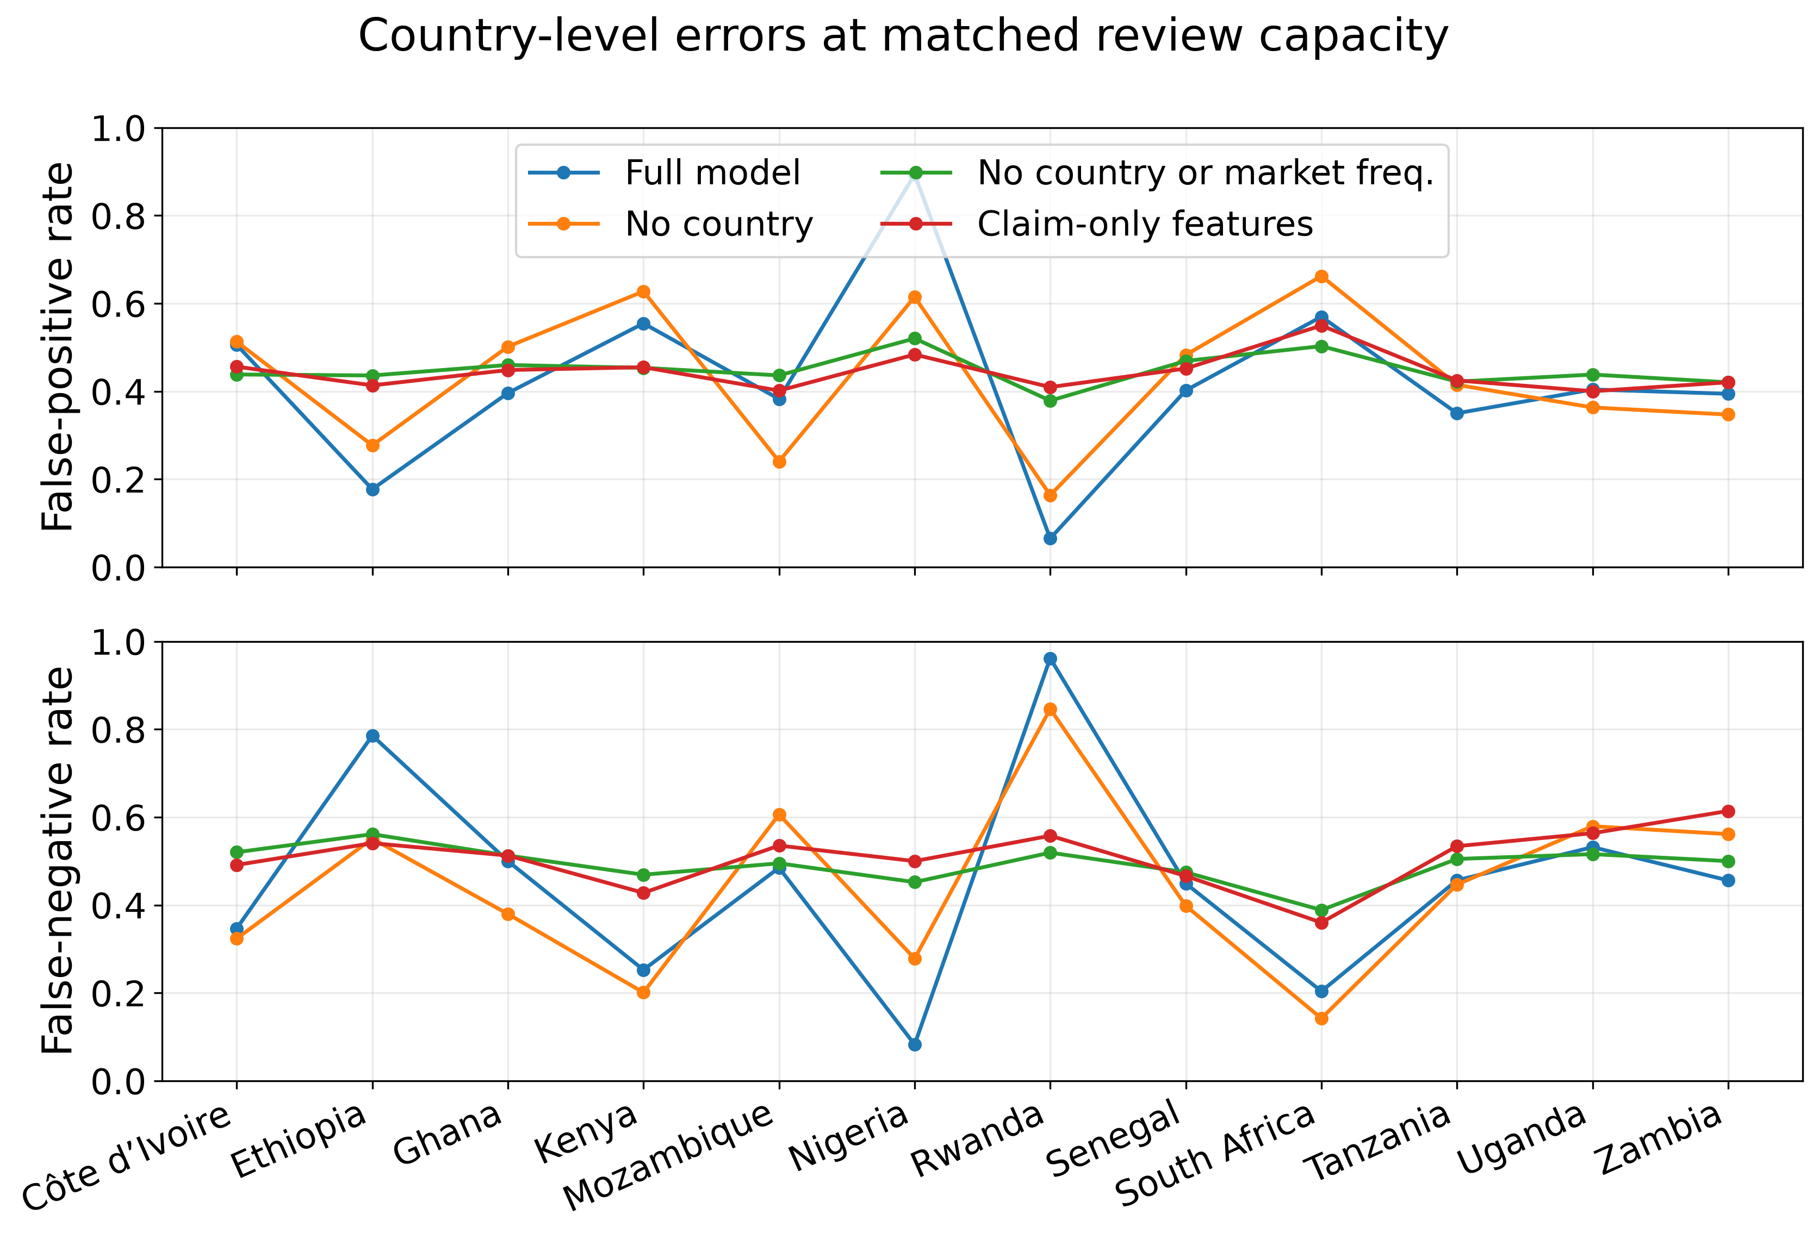
Figure 4.7. Capacity-matched country errors after feature ablation
Source: held-out chronological test split of the pinned African Motor Insurance Claims Dataset, review capacity matched to the complete model’s validation-F1 workload.
At matched review capacity, removing country alone reduced but did not resolve the XGBoost disparity: the country false-positive-rate range fell from 0.8282 to 0.4987 and the false-negative-rate range from 0.8789 to 0.7040. Strict feature removal reduced those ranges further to 0.1495 and 0.2538. This is a meaningful diagnostic improvement, but not a fairness certificate. Other features, thresholds and the synthetic label process can still generate unequal treatment. The original integrated model therefore remains blocked from deployment. The ablation explains that the concern is broader than the explicit country column and does not establish a real-world fraud signal.
The size of the observed disparity makes contextual human review essential. Reviewers need the feature meaning, base rate, model and threshold version, provenance and uncertainty alongside any attribution. The claims interface therefore presents the score as triage evidence. A separate console uses an independent digest-only API key and records ConfirmedFraud, Legitimate or Inconclusive as append-only PostgreSQL revisions corrections never overwrite history. These outcomes do not approve or reject a claim, alter Sepolia state or retrain the model, and Inconclusive is excluded from binary-label eligibility. Production use would still require enterprise identity, controlled evidence access, supervision and a contest procedure (Herm et al., 2022; Tabassi, 2023).

4.8 Calibration and decision-use limits
The final model-quality question concerns probability quality rather than ranking. The archived reliability diagram and ten-bin Brier decomposition make that distinction explicit. The deployed XGBoost artefact has the lowest Brier score at 0.2213, followed by the tuned model at 0.2315 and logistic regression at 0.2392. For all three models, the reliability term is large relative to the very small resolution term. The tuned configuration therefore improves ranking over the deployed artefact but sacrifices some of the deployed artefact's calibration advantage. None of these uncalibrated scores should be presented as a literal probability of fraud without calibration and validation on representative later data.
Table 4.10. Brier-score decomposition
Model | Brier | Reliability | Resolution | Uncertainty
Logistic regression | 0.2392 | 0.1421 | 0.0021 | 0.0993
Deployed XGBoost | 0.2213 | 0.1234 | 0.0017 | 0.0993
Tuned XGBoost | 0.2315 | 0.1342 | 0.0021 | 0.0993

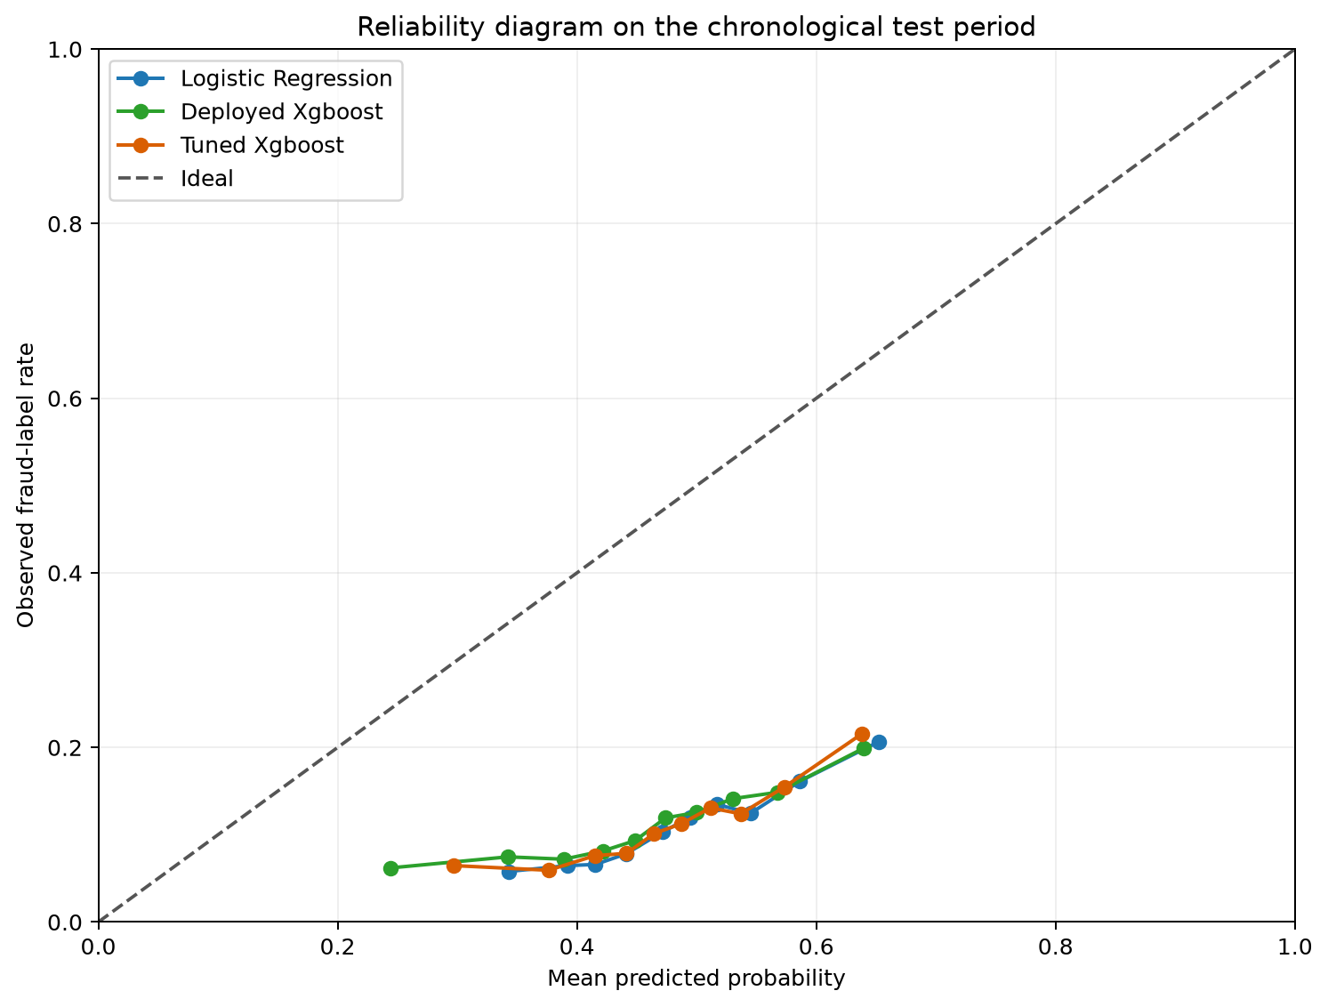
Figure 4.8. Reliability diagram

4.9 Localised stress test and performance evidence
To address the previously unmeasured performance stream, a localised stress test exercised the repository-owned processing path on 25 August 2026. The host was an Apple-silicon development machine with 14 logical CPUs and 24 GiB of memory, and Docker Desktop exposed the same CPU count and approximately 7.65 GiB of memory. The layout used one Uvicorn process, one PostgreSQL container, one three-partition single-node Kafka broker and one synchronous scoring consumer. FastAPI validation, canonical claim authorisation and hashing, PostgreSQL transactions, Kafka acknowledgement and offset commits, duplicate processing, XGBoost and SHAP remained real. Deterministic adapters replaced Pinata/IPFS transport, Ethereum RPC and block production, and assessment transaction submission. The results therefore describe local repository-owned work, not Sepolia confirmation time or production capacity.
After warm-up, the HTTP matrix submitted 100 measured claims per concurrency level in each of three repetitions: 300 observations per level and 1,200 in total. Every claim completed preparation, local EIP-712 signing and authorisation. Table 4.11 reports pooled end-to-end latency percentiles and the mean repetition-level throughput. No measured HTTP request failed.
Table 4.11. Preliminary localised HTTP baseline
Concurrent clients | n | p50 (ms) | p95 (ms) | Mean claims/s | Errors
1 | 300 | 46.00 | 49.71 | 21.57 | 0
5 | 300 | 74.22 | 89.54 | 65.96 | 0
10 | 300 | 126.41 | 149.75 | 77.44 | 0
20 | 300 | 236.41 | 341.71 | 77.78 | 0
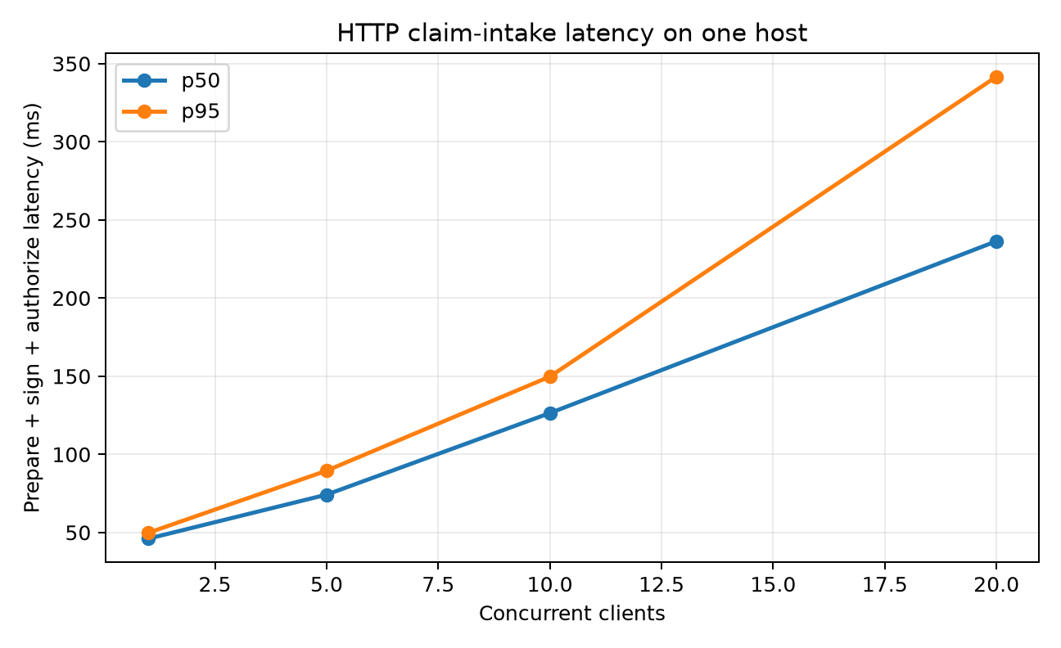
Figure 4.9. Local HTTP latency by concurrency
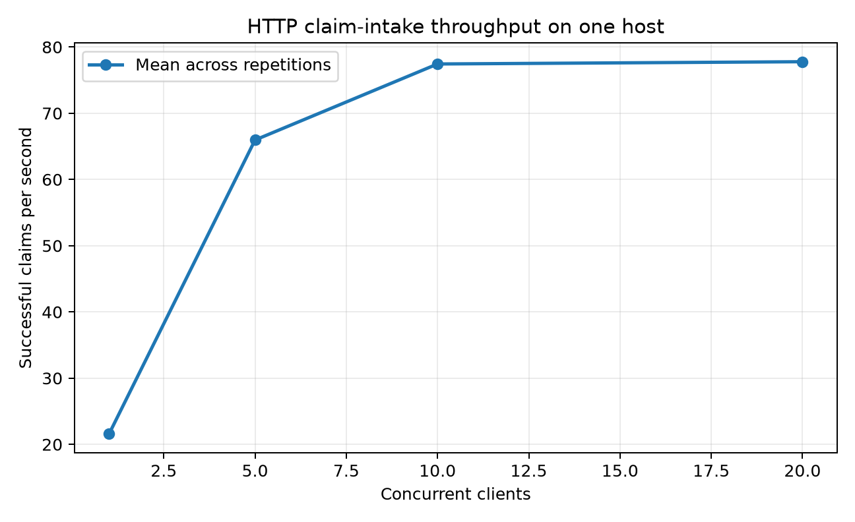
Figure 4.10. Local HTTP throughput by concurrency
Throughput rose from 21.57 claims per second with one client to 77.44 with 10 clients and 77.78 with 20. The negligible gain between 10 and 20 clients coincided with end-to-end p50 increasing from 126.41 to 236.41 ms and p95 increasing from 149.75 to 341.71 ms. For this one-process configuration, additional concurrency beyond about 10 clients mainly increased waiting rather than useful capacity. This is a local saturation signal, not a maximum for the architecture under horizontal scaling.
The asynchronous matrix published 30 measured events per offered-rate group in each of three repetitions, giving 90 observations per group and 360 in total. Positive rates were paced at 5, 10 and 20 events per second. The burst condition published as quickly as Kafka acknowledged each event. The timer separated Kafka acknowledgement, queue residence, XGBoost/SHAP inference, total handler processing and enqueue-to-completion latency.
Table 4.12. Preliminary localised scoring-pipeline baseline
Offered workload | n | End-to-end p50 (ms) | End-to-end p95 (ms) | Queue p95 (ms) | Achieved events/s
5 events/s | 90 | 64.66 | 78.41 | 7.25 | 5.11
10 events/s | 90 | 54.56 | 61.91 | 2.97 | 10.14
20 events/s | 90 | 41.15 | 44.08 | 1.70 | 20.07
Unconstrained burst | 90 | 585.99 | 1,091.31 | 1,054.16 | 25.99
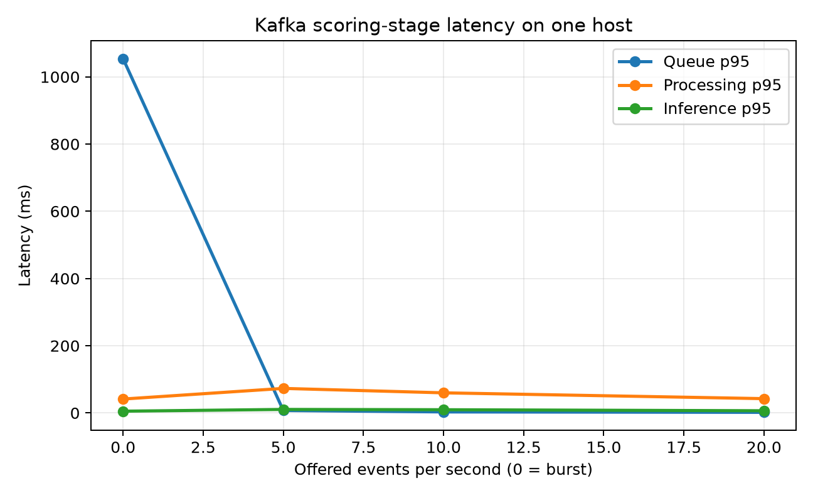
Figure 4.11. Kafka scoring-stage p95 latency
The worker kept pace with controlled input up to 20 events per second, where queue p95 remained 1.70 ms. Under unconstrained burst load, achieved throughput saturated near 25.99 events per second and queue p95 rose to 1,054.16 ms. Burst inference p95 was 5.20 ms and processing p95 was 41.30 ms, so most of the tail delay came from waiting for the single consumer rather than model execution. Differences among the controlled-rate processing values should not be over-interpreted because cache state, host scheduling and background activity were not independently controlled.
Recovery was tested by publishing 100 events, processing and committing 50, then completing the side effects for one additional event without committing its Kafka offset. After that consumer was discarded, a new consumer in the same group redelivered the crash-window event. All 100 claims completed, no claim was lost, no duplicate assessment was written, and recovery of the remaining unique backlog took 2.33 seconds. This exercise instantiates the Step 7c transition in Table 3.3. Automated tests separately exercise Step 3b receipt-first repair, Step 5 checkpoint preservation on failed publication, Step 7 chain-to-database reconciliation and the rule that a Kafka offset advances only after the handler succeeds. These results support at-least-once delivery with idempotent side effects. They do not amount to live failure injection for every window or establish a system-wide exactly-once guarantee.
Table 4.13. Preliminary recovery and contract-gas evidence
Operation or experiment | n | p50 | p95 | Observed result or range
Crash/restart recovery | 100 claims | - | - | 2.33 s, 0 lost, 0 duplicate writes, crash event replayed
Relayer-sponsored public submission | 100 tx | 271,261 gas | 271,273 gas | 270,403-272,083 gas
Assessment write | 100 tx | 37,728 gas | 37,747 gas | 37,709-37,747 gas

Public intake is gasless for the claimant, but blockchain execution is not gas-free. The claimant signs the ERC-2771 request without spending ETH. The isolated relayer pays for the forwarded submission, while the assessor account pays for the assessment write. Table 4.13 therefore reports sponsor and operator gas use, not claimant charges. The observations came from Hardhat's simulated L1 using the production compiler profile, so they are gas-unit distributions rather than Sepolia latency or fiat-cost estimates. p99 is withheld because each preliminary group contains fewer than 1,000 observations. Resource sampling covered Kafka and PostgreSQL during the HTTP run but not the host-based API and load generator, so it remains diagnostic rather than a whole-system requirement. Raw files, manifests, graphs and SHA-256 checksums are archived under benchmarks/local/results/preliminary-20260825.

4.10 Evaluation boundary and readiness assessment
Functional evidence supports authorisation, content binding, replay-aware delivery, versioned scoring and representative user flows. The localised benchmark adds preliminary p50/p95 latency, throughput, queue-delay, recovery and sponsor-side gas evidence, but it does not show production capacity. The gas figures describe the relayer and assessor burden, not a fee charged to the claimant. p99 was withheld because the sample sizes were too small for a stable tail estimate. The run used a development host, one broker and consumer, synthetic claims and deterministic substitutes for public IPFS and Ethereum dependencies. It did not measure Sepolia confirmation, RPC-provider limits, public gateway latency, several insurers or redundant infrastructure. A retained deployment benchmark should therefore be repeated from a clean commit on declared target hardware with larger groups and confidence intervals (Washizaki, 2026).
Taken together, the evaluation supports a narrow contribution: the prototype joins authorised provenance, replay-aware processing, versioned scoring and append-only human review in a traceable workflow. It does not support claims of real-world predictive validity, fair treatment, confidentiality on public IPFS, production security or scalability. These boundaries provide the basis for the interpretation in Chapter 5.

To make the integrated behaviour visible rather than leaving it only in code and test output, the following sequence follows one fictional submission through the running prototype. Claim #7 was prepared in the public interface using synthetic data and a Sepolia test wallet. The same identifier is then carried through the blockchain receipt, the indexed claims view and the operations audit stream.
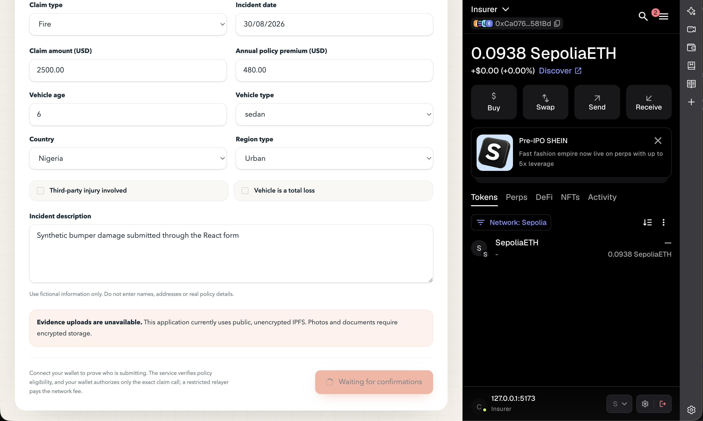
Figure 4.12. Submission of a fictional motor-insurance claim while the interface waits for Sepolia confirmation

Figure 4.12 captures the user-facing submission while the application waits for the sponsored transaction to receive confirmations. The claimant authorises the exact request, but the relayer, rather than the claimant, pays the test-network gas.

Figure 4.13. Confirmation and fraud-risk assessment of Claim #7, including its Sepolia transaction, IPFS pointer and contributing indicators

Once confirmed, the interface shows the transaction reference, IPFS pointer and claim hash alongside the model result. Claim #7 received a fraud probability of 46.02% (rounded to 46.0% in the detail card), remained below the 47% threshold and was queued for human review. The explanation lists the main contributing indicators and presents the score as a review signal rather than an automated decision.
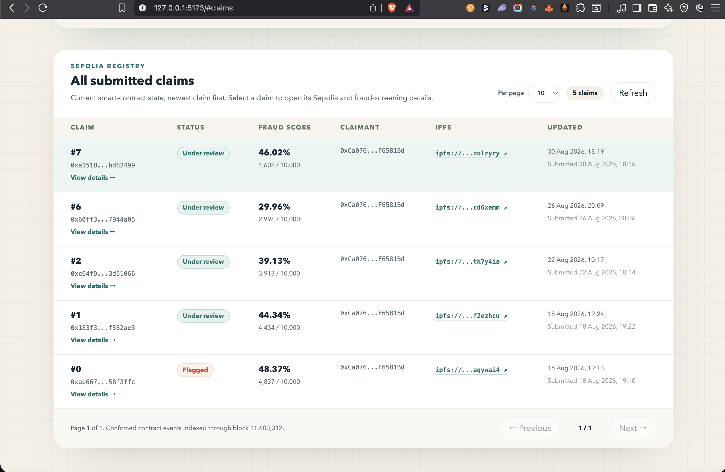
Figure 4.14. Claims registry showing the indexed status and fraud score of Claim #7

The registry view then shows the current indexed state for the same claim. Its status is Under review and the score is reported to two decimal places, providing a visible link between the detailed receipt and the claims projection.

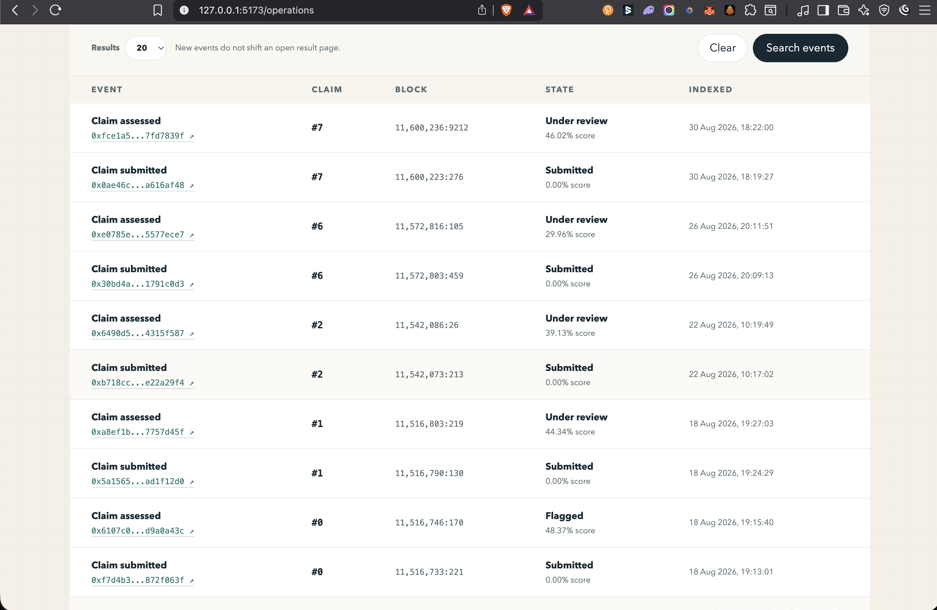
Figure 4.15. Indexed submission and assessment events for Claim #7

Finally, the operations view preserves the two confirmed lifecycle events separately. ClaimSubmitted was indexed at block 11,600,223 and ClaimAssessed at block 11,600,236, with the assessment state and 46.02% score shown beside the latter. Together, these screens provide an end-to-end product trace without relying on terminal output, while leaving the public transaction references available for independent inspection.

Chapter 5: Discussion
The combined system evaluation supports a more limited claim than saying that blockchain improves fraud detection. The registry provides an attributable event history and forward-only state. The model provides reproducible triage behaviour. The registry does not make the model accurate, and the model does not make the registry private or scalable. The combined design is useful only when these boundaries and failure cases remain clear.

5.1 Interpretation against the literature
The implemented lifecycle is consistent with recent insurance research showing that smart contracts can make claims actions traceable, while this study deliberately stores less business data on chain (Chen et al., 2021; Jena et al., 2024). That restraint matters because content addressing and ledger immutability create new persistence and linkability risks rather than dissolving governance. The result also agrees with EIOPA’s (European Insurance and Occupational Pensions Authority) use-case-specific position. A ledger should be justified by inter-organisational verification needs, not selected as a default database (European Insurance and Occupational Pensions Authority, 2022).
On prediction, the study qualifies performance claims drawn from balanced or curated datasets. The paired bootstrap shows that logistic regression has a small advantage over the deployed XGBoost artefact within this test set. The replacement tuning rerun reverses the point ordering by only 0.0009 PR-AUC, with an interval that crosses zero, while the tuned model remains less well calibrated than the deployed artefact. The ablation adds a more important result: explicit country and vehicle age contribute little on their own, whereas the country-linked market-frequency input carries much of the available lift. Strict removal leaves measurable but weak residual discrimination. Combined with the very low mutual-information values, this describes a generator-dependent tabular problem in which a simple baseline remains competitive. The permutation and ablation results confirm association inside the synthetic generator, not real insurance validity.

5.2 Answer to the research question
Table 5.1. Research-objective assessment
Objective | Assessment | Strongest evidence | Remaining boundary
O1 Synthesis | Achieved | Critical review and explicit gap. | Fast-moving regulation and technical practice.
O2 Design | Prototype achieved | Trust boundaries, storage split and threat model. | Consortium governance and DPIA incomplete.
O3 Implementation | Achieved | End-to-end code and versioned artefacts. | No independent audit or final live bundle.
O4 Evaluation | Partly achieved | Hold-out, tuning, bootstrap, signal, fairness, calibration, tests and a localised performance baseline. | No real claims, clean-commit target-VM benchmark or production-scale evidence.
O5 Critical assessment | Achieved | Negative and unmeasured evidence retained. | Independent replication remains necessary.

The answer to the research question is conditional. A decentralised registry can provide verifiable, AI-ready events when public state is limited to attributable commitments, claim initiation is bound to verified policy eligibility and signed intent, and message delivery is designed for replay. Here, AI-ready means that a confirmed event can be transformed reproducibly into a versioned score, explanation and review record. It does not mean that the public IPFS payload is confidential, that the score is accurate enough for real claims, that subgroup treatment is fair, that compliance is automatic or that the deployment can scale.

5.3 Ethics, fairness and governance
The country audit and ablation together change the ethical conclusion. The original model selects almost nine out of ten claims from one synthetic country but fewer than one out of fifteen from another. Removing the explicit country field narrows this difference without reducing PR-AUC, yet large capacity-matched error gaps remain because country-linked market frequency preserves much of the same generator structure. Removing that proxy reduces both ranking performance and subgroup disparity. This is a governance trade-off, not a reason to retain the feature automatically. The present synthetic evidence cannot determine an acceptable trade-off, and the original model remains unsuitable for deployment. Real governed data, review-capacity constraints and stakeholder-defined harms are required before geography or a geographic proxy could be justified.
The model is a review signal, not proof of dishonesty. UK law now places safeguards around significant solely automated decisions, including information, representation, human intervention and contest routes. Those safeguards must be implemented as genuine decision authority rather than a ceremonial click after an algorithmic conclusion (Data (Use and Access) Act 2025, s.80; Information Commissioner’s Office, 2025). The EU AI Act does not automatically classify every motor-fraud triage model as high risk. Classification depends on the system’s intended purpose and Annex III context (Regulation (EU) 2024/1689, 2024).

5.4 Limitations and threats to validity
The primary limitation is the dataset. It is synthetic, and its own structure determines the labels, signal ceiling, country relationships and calibration observed here. Synthetic data can support safe engineering and reproducibility, but hold-out accuracy under a generator does not show field validity or anonymity (Decruyenaere et al., 2024; Stadler, Oprisanu and Troncoso, 2022). One dataset, one line of business and one time split cannot show generalisation.
The bootstrap quantifies sampling variation conditional on this test set. It does not account for generator misspecification or portfolio shift. The randomised search examines 24 configurations rather than an exhaustive space, and one hundred permutations give a minimum attainable corrected empirical p-value of 1/101. The ablation is reproducible and its paired intervals quantify feature-removal sensitivity, but it cannot identify causal fraud mechanisms. Country estimates vary in sample size and remain descriptive, while fairness cannot be inferred from synthetic labels. Calibration bins are also sample-dependent. The replacement advanced-analysis package now retains its code, complete JSON/CSV outputs, raw bootstrap and permutation samples, figures, software versions, execution manifest and checksums. This closes the current repository-reproducibility gap. It does not recover the provenance of the missing historical script or constitute independent replication on a different environment or dataset.
Systems evidence is similarly bounded. Unit, component, contract and two browser scenarios establish selected behaviours, while the localised benchmark characterises only one development-host process layout with deterministic public-service adapters. It does not replace target-infrastructure testing, penetration testing, a smart-contract audit, live Sepolia and IPFS timing, controlled failures at every boundary or multi-node load measurement. Public Sepolia addresses demonstrate deployability, not a complete end-to-end deployment. Several central modules are also 800–1,100 lines long, creating a maintainability risk that needs refactoring before production. The prototype was designed and evaluated by a single researcher, so independent replication remains the strongest control against confirmation bias.

Chapter 6: Conclusion and Future Work
This study investigated how a decentralised claims registry could provide verifiable, AI-ready events for fraud screening without placing detailed attributes directly on a public ledger. The prototype combines policy-backed public intake, typed claimant and insurer authorisation, a forward-only smart-contract lifecycle, content-addressed fictional claim data, transactional outbox delivery, replay-aware processing, keyed duplicate screening, versioned XGBoost/SHAP scoring and append-only human outcomes. Its value lies in the connections between these boundaries and in stating plainly what the evaluation cannot support.

6.1 Conclusion
The study shows that a public verification layer can be kept small while still recording who acted. Policy eligibility and an insurer-scoped permit bound the registration context. The claimant or authorised representative signed the exact forwarded request. The relayer paid gas without acquiring authority to rewrite the claim. The registry then recorded claimant, submitter and insurer separately and emitted events for private analytical processing. This design reduces on-chain disclosure, but it is not confidential storage. The current claim JSON is public and unencrypted on IPFS, stable commitments remain linkable, and the research instance must therefore use fictional data only.
The strongest systems result is the explicit treatment of authority and replay. Wallet sessions, policy checks, single-use permits, claimant-signed forwarding, the outbox, durable raw transactions, range checkpoints, acknowledgement order, deterministic event IDs and completed-result reuse make failure behaviour inspectable across PostgreSQL, Ethereum and Kafka. The 310 passing behavioural checks support these rules. The same review also found a quality gap: branch-aware Python coverage was 74.71%, below the configured 75% gate. Eight infrastructure tests were excluded, browser testing covers two paths, and no independent security review was completed. This is evidence of an evaluated research implementation, not production assurance.
The localised benchmark adds a preliminary operational result. HTTP throughput levelled near 78 claims per second as concurrency increased, and an unconstrained scoring burst exposed a single-consumer queue before model inference became the dominant delay. The crash-window event was safely replayed and the 100-claim workload completed without loss or duplicate assessment writes. These results make the bottleneck and retry semantics observable, but they do not transfer automatically to the documented cloud VM or a production deployment.
The model experiment gives a result that is not especially positive, but it is still useful. On the chronological synthetic test set, logistic regression slightly beats XGBoost on PR-AUC and F1. XGBoost increases recall from 0.4075 to 0.6158, but false positives rise from 3,260 to 5,952. The ablation then shows that removing explicit country or vehicle age leaves PR-AUC essentially unchanged, whereas removing the country-linked market-frequency input eliminates most of the lift above prevalence. Some synthetic signal remains, but it is weak and cannot be interpreted as field-valid fraud detection. Together, these findings show why an insurer should consider feature provenance, subgroup workload and review capacity instead of selecting a model because it is more complex or has higher recall.
The research question is answered in part. The evidence demonstrates a credible method for verifiable event provenance, bounded public disclosure and reproducible explainable scoring under controlled conditions. The localised measurements show where one development-host configuration begins to queue and how its replay path recovers, but they do not establish that the model detects fraud effectively in a real portfolio, that every data-protection obligation has been met, or that the baseline generalises to the single-VM cloud topology or production scale. Those are not footnotes to the result. They are the line between a dissertation artefact and an operational insurance system.

6.2 Contributions
I designed, implemented, integrated, tested and evaluated the end-to-end reference system, whose trust decisions can be traced into code and evidence. Public intake is constrained by wallet identity, policy eligibility, an insurer-scoped permit and exact claimant intent. Party attribution on chain separates claimant, submitter and insurer, while the relayer is limited to fee sponsorship. The storage split gives the ledger a restrained role. Checkpoints and idempotency rules make restart behaviour testable. The feature layer excludes post-decision leakage, uses keyed duplicate fingerprints and keeps human investigative outcomes append-only and separate from automated scoring.
A second contribution is the separation of claims. Predictive quality, functional correctness, privacy design and scalability require different evidence. The localised load benchmark is not production scalability evidence. SHAP is not fairness or causality evidence, and a testnet address is not an end-to-end transaction record. The feature ablation adds another separation: removing a visible country field is not enough when a country-derived market-frequency input preserves the same structure. Keeping these distinctions makes the conclusions narrower, but easier to defend.

6.3 Future work
The first priority for future work is to turn the preliminary local baseline into a retained deployment benchmark. The larger matrix should run from a clean commit on the declared 2-vCPU/8-GiB research VM, keep at least 1,000 successful observations in any group used for p99, report repetition-level uncertainty and sample the API, broker, database and worker together. A small funded live-Sepolia and IPFS exercise should separately record RPC, gateway, block-inclusion and confirmation delay. Failure injection should then cover each commit boundary and recovery should be repeated at larger backlogs. This would test whether the local bottlenecks and replay behaviour persist under the documented deployment conditions.
The second priority is external predictive validation. An insurer or suitably governed research consortium should evaluate de-identified real claims from a later time period, with investigator-confirmed labels where possible. Thresholds should be chosen from review capacity and expected cost, and probability calibration should be measured. Subgroup error, drift and feature stability should be audited before and after deployment. Country and country-derived market features should be excluded by default unless their necessity, lawful use and incremental benefit are demonstrated against a proxy-aware ablation. Alternative models, including calibrated boosting, graph features for related parties and anomaly detection, should be compared against the same simple baseline and split. Dataset documentation and risk records should state intended use, composition, evaluation conditions and excluded uses.
The third priority is privacy and governance hardening. Real evidence should move to encrypted, access-controlled and preferably private content storage rather than public IPFS. The project needs a data-protection impact assessment, retention and erasure process, formal role allocation, key-rotation policy, membership-inference controls for duplicate screening and a customer contest route (Information Commissioner’s Office, 2023; European Data Protection Board, 2026). A consortium deployment should compare a permissioned ledger with a public anchoring scheme and select the least revealing architecture that meets the trust requirement.
The fourth priority is production security. Contracts and relayer changes require an independent audit. Administration should use managed keys and multi-signature approval. Services need secret management, rate limits, observability and incident response, and deployment should replace the single host with redundant databases, broker partitions and separately scaled workers. Confirmation-depth and chain-reorganisation policies must be explicit and tested. These activities should be organised as lifecycle controls rather than a one-off release gate (Souppaya, Scarfone and Dodson, 2022; Enterprise Ethereum Alliance, 2025).
Finally, future work should deepen the implemented human-review boundary rather than merely add model complexity. The current assessor console already records append-only investigative outcomes and corrections without changing chain status or retraining the model. A production workflow would still need enterprise identity, least-privilege evidence access, allocation and escalation rules, independent supervision, reasoned decision records and a claimant contest route. Where a significant decision becomes solely automated, current UK law requires information, representation, human intervention and contest safeguards (Data (Use and Access) Act 2025, s.80; Information Commissioner’s Office, 2025). Meaningful authority must be visible in the workflow, not asserted only in policy text. Outcomes should support monitoring without turning an initial suspicion into a permanent, self-reinforcing label. This preserves the central principle of the study: technology should improve investigative quality and auditability, not automate an allegation.

References
Apache Software Foundation (no date) Apache Kafka 4.2 Documentation: Design. Available at: https://kafka.apache.org/42/design/ (Accessed: 30 August 2026).
Bloemen, R., Logvinov, L. and Evans, J. (2017) ‘EIP-712: Typed structured data hashing and signing’, Ethereum Improvement Proposals, no. 712. Available at: https://eips.ethereum.org/EIPS/eip-712 (Accessed: 30 August 2026).
Broniatowski, D.A. (2021) Psychological Foundations of Explainability and Interpretability in Artificial Intelligence. NISTIR 8367. Available at: https://doi.org/10.6028/NIST.IR.8367
Carracedo, P., Hervás, D. and Soriano-Gonzalez, R. (2026) ‘Class imbalance in insurance fraud detection models’, European Actuarial Journal. Available at: https://doi.org/10.1007/s13385-026-00456-9
Chen, C.-L., Deng, Y.-Y., Tsaur, W.-J., Li, C.-T., Lee, C.-C. and Wu, C.-M. (2021) ‘A traceable online insurance claims system based on blockchain and smart contract technology’, Sustainability, 13(16), 9386. Available at: https://doi.org/10.3390/su13169386
Chen, T. and Guestrin, C. (2016) ‘XGBoost: A scalable tree boosting system’, Proceedings of the 22nd ACM SIGKDD International Conference on Knowledge Discovery and Data Mining, pp. 785–794. Available at: https://doi.org/10.1145/2939672.2939785
Data (Use and Access) Act 2025, c. 18. Available at: https://www.legislation.gov.uk/ukpga/2025/18/contents (Accessed: 11 August 2026).
Debener, J., Heinke, V. and Kriebel, J. (2023) ‘Detecting insurance fraud using supervised and unsupervised machine learning’, Journal of Risk and Insurance, 90(3), pp. 743–768. Available at: https://doi.org/10.1111/jori.12427
Decruyenaere, A., Dehaene, H., Rabaey, P., Polet, C., Decruyenaere, J., Vansteelandt, S. and Demeester, T. (2024) ‘The real deal behind the artificial appeal: inferential utility of tabular synthetic data’, Proceedings of the Fortieth Conference on Uncertainty in Artificial Intelligence, PMLR 244, pp. 966–996. Available at: https://proceedings.mlr.press/v244/decruyenaere24a.html (Accessed: 11 August 2026).
Dimitriadis, T., Gneiting, T., Jordan, A.I. and Vogel, P. (2024) ‘Evaluating probabilistic classifiers: the triptych’, International Journal of Forecasting, 40(3), pp. 1101–1122. Available at: https://doi.org/10.1016/j.ijforecast.2023.09.007
Electric Sheep Africa (2026) ‘African Motor Insurance Claims Dataset’, Hugging Face Datasets, pinned revision 7b8b6e8526c28ea54ae8e6414666d48d108221a1. Available at: https://huggingface.co/datasets/electricsheepafrica/africa-synth-motor-insurance-claims-all/tree/7b8b6e8526c28ea54ae8e6414666d48d108221a1 (Accessed: 21 August 2026).
Enterprise Ethereum Alliance (2025) EthTrust Security Levels Specification, version 3. Available at: https://entethalliance.org/specs/ethtrust-sl/v3/ (Accessed: 11 August 2026).
European Data Protection Board (2026) Guidelines 02/2025 on Processing of Personal Data through Blockchain Technologies, version 2.0, adopted 7 July. Available at: https://www.edpb.europa.eu/documents/guideline/guidelines-on-processing-of-personal-data-through-blockchain-technologies_en (Accessed: 11 August 2026).
European Insurance and Occupational Pensions Authority (2022) Feedback Statement: Discussion Paper on Blockchain and Smart Contracts in Insurance. EIOPA-BoS-22-178. Available at: https://www.eiopa.europa.eu/system/files/2022-05/feedback_statement_-_discussion_paper_on_blockchain_and_smart_contracts_in_insurance.pdf (Accessed: 11 August 2026).
Gebru, T., Morgenstern, J., Vecchione, B., Vaughan, J.W., Wallach, H., Daumé III, H. and Crawford, K. (2021) ‘Datasheets for datasets’, Communications of the ACM, 64(12), pp. 86–92. Available at: https://doi.org/10.1145/3458723
Herm, L.-V., Steinbach, T., Wanner, J. and Janiesch, C. (2022) ‘A nascent design theory for explainable intelligent systems’, Electronic Markets, 32, pp. 2185–2205. Available at: https://doi.org/10.1007/s12525-022-00606-3
Hughes, W., Magnusson, T., Russo, A. and Schneider, G. (2023) ‘Cheap and secure metatransactions on the blockchain using hash-based authorisation and preferred batchers’, Blockchain: Research and Applications, 4(2), 100125. Available at: https://doi.org/10.1016/j.bcra.2022.100125
Information Commissioner’s Office (2023) Guidance on AI and Data Protection, updated 15 March. Available at: https://ico.org.uk/for-organisations/uk-gdpr-guidance-and-resources/artificial-intelligence/guidance-on-ai-and-data-protection/ (Accessed: 11 August 2026).
Information Commissioner’s Office (2025) ‘Data protection: Data (Use and Access) Act 2025—summary of changes’, published 19 June 2025, updated 20 August 2025. Available at: https://ico.org.uk/about-the-ico/what-we-do/legislation-we-cover/data-use-and-access-act-2025/the-data-use-and-access-act-2025-duaa-summary-of-the-changes/data-protection/ (Accessed: 21 August 2026).
IPFS Project (no date a) Content Identifiers (CIDs). Available at: https://docs.ipfs.tech/concepts/content-addressing/ (Accessed: 30 August 2026).
IPFS Project (no date b) Privacy and Encryption. Available at: https://docs.ipfs.tech/concepts/privacy-and-encryption/ (Accessed: 30 August 2026).
Jena, S.K., Kumar, B., Mohanty, B., Singhal, A. and Barik, R.C. (2024) ‘An advanced blockchain-based hyperledger fabric solution for tracing fraudulent claims in the healthcare industry’, Data and Information Management, 8(2), 100411. Available at: https://doi.org/10.1016/j.dajour.2024.100411
Kapoor, S. and Narayanan, A. (2023) ‘Leakage and the reproducibility crisis in machine-learning-based science’, Patterns, 4(9), 100804. Available at: https://doi.org/10.1016/j.patter.2023.100804
Landwehr, J.P., Kühl, N., Walk, J. and Gnädig, M. (2022) ‘Design knowledge for deep-learning-enabled image-based decision support systems: evidence from power line maintenance decision-making’, Business & Information Systems Engineering, 64, pp. 707–728. Available at: https://doi.org/10.1007/s12599-022-00745-z
Lundberg, S.M. and Lee, S.-I. (2017) ‘A unified approach to interpreting model predictions’, Advances in Neural Information Processing Systems, 30. Available at: https://proceedings.neurips.cc/paper/2017/hash/8a20a8621978632d76c43dfd28b67767-Abstract.html (Accessed: 30 August 2026).
Mitchell, S., Potash, E., Barocas, S., D’Amour, A. and Lum, K. (2021) ‘Algorithmic fairness: choices, assumptions, and definitions’, Annual Review of Statistics and Its Application, 8, pp. 141–163. Available at: https://doi.org/10.1146/annurev-statistics-042720-125902
National Institute of Standards and Technology (2008) The Keyed-Hash Message Authentication Code (HMAC). FIPS 198-1. Available at: https://doi.org/10.6028/NIST.FIPS.198-1
OpenZeppelin (no date) Meta-transactions, OpenZeppelin Contracts 5.x Documentation. Available at: https://docs.openzeppelin.com/contracts/5.x/api/metatx (Accessed: 30 August 2026).
Pfob, A., Lu, S.-C. and Sidey-Gibbons, C. (2022) ‘Machine learning in medicine: a practical introduction to techniques for data pre-processing, hyperparameter tuning, and model comparison’, BMC Medical Research Methodology, 22, 282. Available at: https://doi.org/10.1186/s12874-022-01758-8
Phillips, P.J., Hahn, C.A., Fontana, P.C., Yates, A.N., Greene, K., Broniatowski, D.A. and Przybocki, M.A. (2021) Four Principles of Explainable Artificial Intelligence. NISTIR 8312. Available at: https://doi.org/10.6028/NIST.IR.8312
Pineau, J., Vincent-Lamarre, P., Sinha, K., Larivière, V., Beygelzimer, A., d’Alché-Buc, F., Fox, E. and Larochelle, H. (2021) ‘Improving reproducibility in machine learning research: a report from the NeurIPS 2019 reproducibility program’, Journal of Machine Learning Research, 22(164), pp. 1–20. Available at: https://www.jmlr.org/papers/v22/20-303.html (Accessed: 11 August 2026).
PostgreSQL Global Development Group (no date a) PostgreSQL 17 Documentation: Constraints. Available at: https://www.postgresql.org/docs/17/ddl-constraints.html (Accessed: 30 August 2026).
PostgreSQL Global Development Group (no date b) PostgreSQL 17 Documentation: Transaction Isolation. Available at: https://www.postgresql.org/docs/17/transaction-iso.html (Accessed: 30 August 2026).
‘Regulation (EU) 2024/1689 laying down harmonised rules on artificial intelligence’ (2024) Official Journal of the European Union, L 2024/1689. Available at: https://eur-lex.europa.eu/legal-content/EN/TXT/?uri=CELEX:32024R1689 (Accessed: 11 August 2026).
Sandford, R., Siri, L., Tirosh, D., Weiss, Y., Forshtat, A., Croubois, H., Tomar, S., McCorry, P., Venturo, N., Vogelsteller, F. and John, G. (2020) ‘ERC-2771: Secure Protocol for Native Meta Transactions’, Ethereum Improvement Proposals, no. 2771. Available at: https://eips.ethereum.org/EIPS/eip-2771 (Accessed: 30 August 2026).
Schrijver, G., Sarmah, D.K. and El-Hajj, M. (2024) ‘Automobile insurance fraud detection using data mining: a systematic literature review’, Intelligent Systems with Applications, 21, 200340. Available at: https://doi.org/10.1016/j.iswa.2024.200340
Shibano, K., Ito, K., Han, C., Chu, T.T., Ozaki, W. and Mogi, G. (2024) ‘Secure processing and distribution of data managed on private InterPlanetary File System using zero-knowledge proofs’, Electronics, 13(15), 3025. Available at: https://doi.org/10.3390/electronics13153025
Souppaya, M., Scarfone, K. and Dodson, D. (2022) Secure Software Development Framework (SSDF) Version 1.1. NIST SP 800-218. Available at: https://doi.org/10.6028/NIST.SP.800-218
Stadler, T., Oprisanu, B. and Troncoso, C. (2022) ‘Synthetic data—anonymisation groundhog day’, 31st USENIX Security Symposium, pp. 1451–1468. Available at: https://www.usenix.org/conference/usenixsecurity22/presentation/stadler (Accessed: 11 August 2026).
Tabassi, E. (2023) Artificial Intelligence Risk Management Framework (AI RMF 1.0). NIST AI 100-1. Available at: https://doi.org/10.6028/NIST.AI.100-1
Trautwein, D., Raman, A., Tyson, G., Castro, I., Scott, W., Schubotz, M., Gipp, B. and Psaras, Y. (2022) ‘Design and evaluation of IPFS: a storage layer for the decentralised web’, Proceedings of ACM SIGCOMM 2022, pp. 739–752. Available at: https://doi.org/10.1145/3544216.3544232
Wang, G., Chen, L., Dikshit, A., Gustafson, J., Chen, B., Sax, M.J., Roesler, J., Blee-Goldman, S., Cadonna, B., Mehta, A., Madan, V. and Rao, J. (2021) ‘Consistency and completeness: rethinking distributed stream processing in Apache Kafka’, Proceedings of the 2021 International Conference on Management of Data, pp. 2602–2613. Available at: https://doi.org/10.1145/3448016.3457556
Washizaki, H. (ed.) (2026) Guide to the Software Engineering Body of Knowledge (SWEBOK Guide), version 4.0a. IEEE Computer Society. Available at: https://ieeecs-media.computer.org/media/education/swebok/swebok-v4.pdf (Accessed: 21 August 2026).

Appendix A: Traceability Matrix
This appendix links the principal research requirements to implementation locations and the strongest available evidence. Paths are repository-relative so that the record does not depend on the author’s workstation.
Table A.1. Requirement-to-evidence traceability
Requirement | Implementation location | Primary evidence | Status
R1 Policy-backed public origin | backend claimant_auth, policy_eligibility, claim_permits, relayer, registry contract | Wallet challenge, policy, permit, forwarder and access-control tests | Implemented and tested
R2 Content binding | backend IPFS/content verification | Hash/CID validation tests | Implemented and tested
R3 Lifecycle and party attribution | registry contract and chain index | Lifecycle, scope, immutability and ClaimPartiesRecorded tests | Implemented and tested
R4 Event delivery | listener and PostgreSQL index | Range checkpoint and Kafka acknowledgement tests | Implemented and tested
R5 Replay safety | Relayer transaction journal, listener checkpoint/index and worker assessment/offset state machines | Figure 3.2, Table 3.3, receipt recovery, range replay, chain reconciliation and completed-result tests | Implemented and tested
R6 Public minimisation | contract schema and README data classification | Code and schema inspection | Implemented, legal review pending
R7 Private duplicate screen | feature processor and duplicate service | HMAC/canonicalisation behaviour tests | Implemented, key governance pending
R8 Reproducible model | packages/model/artifacts/xgboost-african-motor-v1 | Dataset/model hashes, split metadata, ablation and advanced-analysis scripts, raw resamples, archived JSON/CSV and manifests. | Base model, feature ablation and replacement advanced rerun are repository-evidenced.
R9 Human-review boundary | assessor outcome API, PostgreSQL repository and assessor frontend | Append-only revision, authentication and prohibited-effect tests | Implemented and tested, production IAM and user study pending
Production scalability | benchmarks/local harness and service seams | Retained local latency, queue, recovery and sponsor-side gas bundle | Local baseline, production scale unproven

Appendix B: Source Code and Reproducibility Record

B.1 GitHub Code Link
Permanent evaluated source snapshot: Code Link

B.2 Repository directory tree
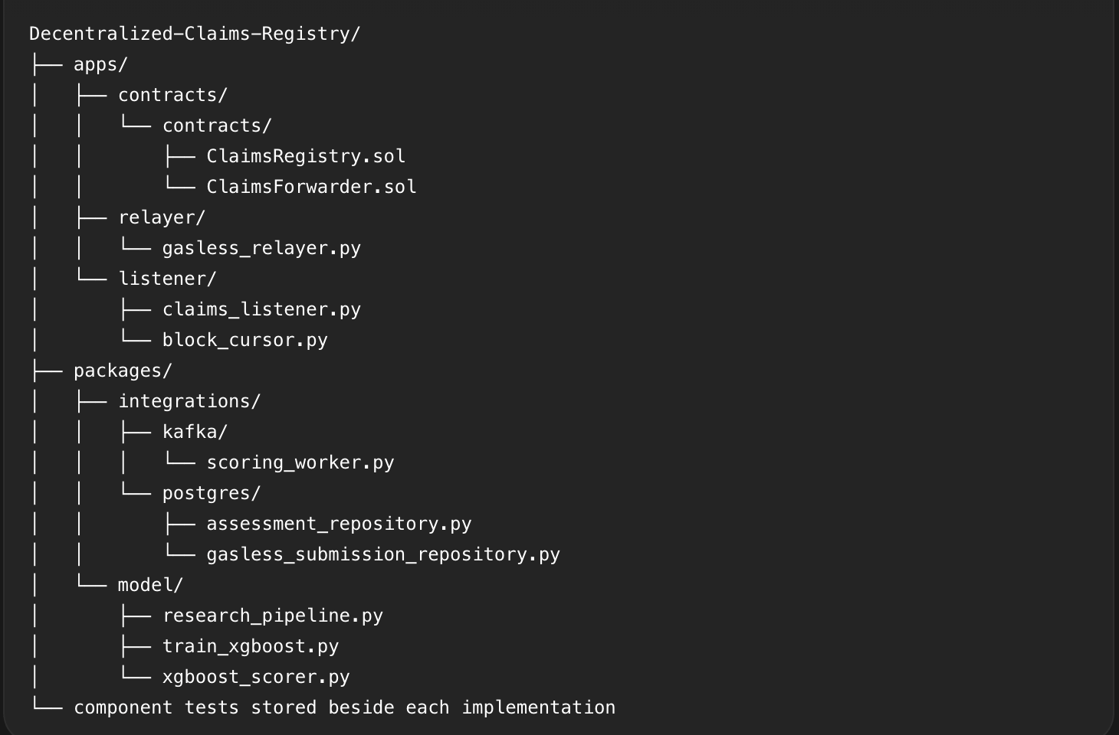
Figure B.1. Repository directory tree
The tree shows the principal components discussed in the dissertation. The smart contract records the public claim state, while the relayer, listener, scoring worker and model operate off chain. Replay protection is cross-cutting and is therefore implemented in the contract, listener checkpoint, PostgreSQL repositories and worker rather than in a single file.

B.3 Code listings

B.3.1 Registry contract
Demonstrate: Claim-permit validation, signature recovery, one-time use and claim registration.
// SPDX-License-Identifier: MIT
pragma solidity ^0.8.28;

import {
AccessControlDefaultAdminRules
} from "@openzeppelin/contracts/access/extensions/AccessControlDefaultAdminRules.sol";
import {ECDSA} from "@openzeppelin/contracts/utils/cryptography/ECDSA.sol";
import {EIP712} from "@openzeppelin/contracts/utils/cryptography/EIP712.sol";
import {ERC2771Context} from "@openzeppelin/contracts/metatx/ERC2771Context.sol";
import {Context} from "@openzeppelin/contracts/utils/Context.sol";

/// @title ClaimsRegistry
/// @notice Anchors synthetic insurance claims while keeping their payloads
/// off-chain. The pointer and hash are public; they must never reference
/// personal, confidential, or unencrypted real-claim data.
/// @dev Insurer-operated submissions remain available for controlled migration.
/// Public submissions use two independent proofs: the submitter signs the
/// ERC-2771 request and an insurer-scoped permit issuer signs the exact
/// eligible claim. The relayer supplies only gas and receives no registry
/// role or authority over claim contents.
contract ClaimsRegistry is
AccessControlDefaultAdminRules,
ERC2771Context,
EIP712
{
bytes32 public constant SUBMITTER_ROLE = keccak256("SUBMITTER_ROLE");
bytes32 public constant ASSESSOR_ROLE = keccak256("ASSESSOR_ROLE");
bytes32 public constant PERMIT_ISSUER_ROLE =
keccak256("PERMIT_ISSUER_ROLE");
bytes32 public constant CLAIM_PERMIT_TYPEHASH =
keccak256(
"ClaimPermit(address claimant,address submitter,address insurer,bytes32 claimantCommitment,bytes32 claimHash,bytes32 dataPointerHash,bytes32 permitId,uint48 deadline)"
);
uint256 public constant MAX_DATA_POINTER_LENGTH = 128;

/// @dev Stored lifecycle values. Approved and Rejected are terminal; Flagged
/// can still be resolved to either of those terminal decisions.
enum Status {
Submitted,
UnderReview,
Approved,
Rejected,
Flagged
}

/// @dev Compact public anchor. The full claim stays off-chain and can be
/// checked against `claimHash` with `verifyClaimData`.
struct Claim {
address claimant;
address insurer;
address submittedBy;
bytes32 claimantCommitment;
bytes32 claimHash;
string dataPointer;
Status status;
uint16 fraudScore;
uint64 submittedAt;
uint64 updatedAt;
bool exists;
}

/// @notice One insurer-authorized public intake operation.
/// @dev Dynamic pointer text is represented by `dataPointerHash` so wallets
/// and Solidity sign one unambiguous fixed-width EIP-712 structure.
struct ClaimPermit {
address claimant;
address submitter;
address insurer;
bytes32 claimantCommitment;
bytes32 claimHash;
bytes32 dataPointerHash;
bytes32 permitId;
uint48 deadline;
}

uint256 public claimCount;
mapping(uint256 claimId => Claim claim) private _claims;
mapping(address assessor => mapping(address insurer => bool authorized))
private _assessorScopes;
mapping(address assessor => uint256 scopeCount) private _assessorScopeCount;
mapping(address issuer => mapping(address insurer => bool authorized))
private _permitIssuerScopes;
mapping(address issuer => uint256 scopeCount) private _permitIssuerScopeCount;
mapping(bytes32 permitId => bool used) private _usedClaimPermits;

event ClaimSubmitted(
uint256 indexed claimId,
address indexed claimant,
bytes32 claimHash,
string dataPointer,
uint256 timestamp
);
event ClaimPartiesRecorded(
uint256 indexed claimId,
address indexed insurer,
address indexed submittedBy,
bytes32 claimantCommitment,
bytes32 permitId,
address permitIssuer
);
event ClaimAssessed(
uint256 indexed claimId,
Status indexed newStatus,
address indexed assessor,
uint16 fraudScore,
uint256 timestamp
);
event SubmitterUpdated(address indexed submitter, bool authorized);
event AssessorUpdated(
address indexed assessor,
address indexed insurer,
bool authorized
);
event PermitIssuerUpdated(
address indexed permitIssuer,
address indexed insurer,
bool authorized
);

error ZeroAddress();
error EmptyClaimHash();
error InvalidDataPointer();
error DataPointerTooLong(uint256 suppliedLength);
error UnknownClaim(uint256 claimId);
error InvalidFraudScore(uint16 fraudScore);
error InvalidStatusTransition(Status currentStatus, Status requestedStatus);
error FraudScoreCannotChange(uint16 currentScore, uint16 suppliedScore);
error AssessorScopeMismatch(address assessor, address insurer);
error AssessorScopeNotConfigured(address assessor, address insurer);
error PermitIssuerScopeNotConfigured(
address permitIssuer,
address insurer
);
error InsurerNotAuthorized(address insurer);
error EmptyClaimantCommitment();
error EmptyClaimPermitId();
error ClaimPermitAlreadyUsed(bytes32 permitId);
error ClaimPermitExpired(uint48 deadline);
error ClaimPermitUnauthorized(address permitIssuer, address insurer);
error ClaimPermitSubmitterMismatch(address expected, address actual);
error ClaimPermitPointerMismatch();
error RoleSeparationRequired(address account);
error UseRoleConfigurationFunction(bytes32 role);

/// @param initialAdmin Account that controls role assignment and starts
/// delayed, two-step admin transfers.
/// @param initialSubmitter Insurer service account permitted to submit.
/// @param initialPermitIssuer Eligibility signer scoped to initialSubmitter.
/// @param initialAssessor Scoring account scoped to initialSubmitter.
/// @param trustedForwarder Immutable ERC-2771 forwarder that verifies
/// submitter signatures before restoring their execution context.
/// @param adminTransferDelay Delay in seconds before an admin transfer can
/// be accepted. Production deployments should use a non-zero delay.
constructor(
address initialAdmin,
address initialSubmitter,
address initialPermitIssuer,
address initialAssessor,
address trustedForwarder,
uint48 adminTransferDelay
)
AccessControlDefaultAdminRules(adminTransferDelay, initialAdmin)
ERC2771Context(trustedForwarder)
EIP712("ClaimsRegistry", "2")
{
if (
initialSubmitter == address(0) ||
initialPermitIssuer == address(0) ||
initialAssessor == address(0) ||
trustedForwarder == address(0)
) {
revert ZeroAddress();
}
if (
initialAdmin == initialSubmitter ||
initialAdmin == initialPermitIssuer ||
initialAdmin == initialAssessor
) {
revert RoleSeparationRequired(initialAdmin);
}
if (
initialSubmitter == initialPermitIssuer ||
initialSubmitter == initialAssessor ||
initialPermitIssuer == initialAssessor
) {
revert RoleSeparationRequired(initialPermitIssuer);
}

_grantRole(SUBMITTER_ROLE, initialSubmitter);
_grantRole(PERMIT_ISSUER_ROLE, initialPermitIssuer);
_grantRole(ASSESSOR_ROLE, initialAssessor);
_permitIssuerScopes[initialPermitIssuer][initialSubmitter] = true;
_permitIssuerScopeCount[initialPermitIssuer] = 1;
_assessorScopes[initialAssessor][initialSubmitter] = true;
_assessorScopeCount[initialAssessor] = 1;

emit SubmitterUpdated(initialSubmitter, true);
emit PermitIssuerUpdated(
initialPermitIssuer,
initialSubmitter,
true
);
emit AssessorUpdated(initialAssessor, initialSubmitter, true);
}

/// @notice Record an insurer-operated claim during the public-intake migration.
/// @dev `_msgSender()` preserves the insurer identity for both direct and
/// trusted-forwarder calls. New claimant-facing integrations should use
/// `submitClaimWithPermit`, which separates all claim parties.
/// @param claimHash Keccak-256 hash of the canonical off-chain claim bytes.
/// @param dataPointer Public `ipfs://<CID>` location of those exact bytes.
/// @return claimId Monotonic identifier assigned to the new claim anchor.
function submitClaim(
bytes32 claimHash,
string calldata dataPointer
) external onlyRole(SUBMITTER_ROLE) returns (uint256 claimId) {
address submitter = _msgSender();
claimId = _recordClaim(
submitter,
submitter,
submitter,
bytes32(0),
claimHash,
dataPointer,
bytes32(0),
address(0)
);
}

/// @notice Record a policy-eligible claim signed by a public submitter.
/// @dev The forwarder signature proves who submitted. The permit signature
/// independently proves that an issuer scoped to `permit.insurer`
/// approved the exact claimant, content hash, pointer, and deadline.
/// A global permit ID makes the insurer proof single-use even when the
/// same document is accidentally prepared in two browser sessions.
/// @param permit Fixed-width claim authorization signed under this contract's
/// EIP-712 domain.
/// @param dataPointer Bare `ipfs://CID` whose hash is bound by the permit.
/// @param permitSignature Signature produced by an insurer-scoped issuer.
/// @return claimId Monotonic identifier assigned to the new claim anchor.
function submitClaimWithPermit(
ClaimPermit calldata permit,
string calldata dataPointer,
bytes calldata permitSignature
) external returns (uint256 claimId) {
address submitter = _msgSender();
if (
permit.claimant == address(0) ||
permit.submitter == address(0) ||
permit.insurer == address(0)
) {
revert ZeroAddress();
}
if (permit.claimantCommitment == bytes32(0)) {
revert EmptyClaimantCommitment();
}
if (permit.claimHash == bytes32(0)) revert EmptyClaimHash();
if (permit.permitId == bytes32(0)) revert EmptyClaimPermitId();
if (permit.submitter != submitter) {
revert ClaimPermitSubmitterMismatch(permit.submitter, submitter);
}
if (block.timestamp > permit.deadline) {
revert ClaimPermitExpired(permit.deadline);
}
if (_usedClaimPermits[permit.permitId]) {
revert ClaimPermitAlreadyUsed(permit.permitId);
}
_validateDataPointer(dataPointer);
if (keccak256(bytes(dataPointer)) != permit.dataPointerHash) {
revert ClaimPermitPointerMismatch();
}

address permitIssuer = ECDSA.recover(
_hashTypedDataV4(_hashClaimPermit(permit)),
permitSignature
);
if (!isPermitIssuerFor(permitIssuer, permit.insurer)) {
revert ClaimPermitUnauthorized(permitIssuer, permit.insurer);
}

// Mark the authorization before recording the claim. A revert in the
// remaining call unwinds both changes; a successful reentrant call can
// never consume the same permit because the used flag is already set.
_usedClaimPermits[permit.permitId] = true;
claimId = _recordClaim(
permit.claimant,
permit.insurer,
submitter,
permit.claimantCommitment,
permit.claimHash,
dataPointer,
permit.permitId,
permitIssuer
);
}

/// @notice Advance a claim through its allowed lifecycle.
/// @dev The first assessment fixes the fraud score. Later status changes
/// must carry the same score, preserving the original model output.
/// @param claimId Existing claim whose public assessment state will change.
/// @param newStatus Allowed next state in the explicit lifecycle graph.
/// @param fraudScore Model score in basis points from 0 through 10,000.
function assessClaim(
uint256 claimId,
Status newStatus,
uint16 fraudScore
) external onlyRole(ASSESSOR_ROLE) {
Claim storage claim = _claims[claimId];
address assessor = _msgSender();
if (!claim.exists) revert UnknownClaim(claimId);
if (!_assessorScopes[assessor][claim.insurer]) {
revert AssessorScopeMismatch(assessor, claim.insurer);
}
if (fraudScore > 10000) revert InvalidFraudScore(fraudScore);
if (!_isAllowedTransition(claim.status, newStatus)) {
revert InvalidStatusTransition(claim.status, newStatus);
}
if (
claim.status != Status.Submitted &&
fraudScore != claim.fraudScore
) {
revert FraudScoreCannotChange(claim.fraudScore, fraudScore);
}

claim.status = newStatus;
claim.fraudScore = fraudScore;
claim.updatedAt = uint64(block.timestamp);

emit ClaimAssessed(
claimId,
newStatus,
assessor,
fraudScore,
block.timestamp
);
}

/// @notice Return the current compact public record for one claim.
/// @dev Reverts for an unknown ID rather than returning an all-zero struct,
/// so indexers can distinguish missing data from a legitimate value.
/// @param claimId Identifier assigned by `submitClaim`.
/// @return claimant Person represented by this claim. For legacy
/// insurer-operated records this remains the insurer address.
/// @return claimHash Permanent hash of the canonical off-chain bytes.
/// @return dataPointer Public IPFS pointer supplied at submission.
/// @return status Current lifecycle state.
/// @return fraudScore Immutable first-assessment score in basis points.
/// @return submittedAt Unix timestamp recorded when the claim was created.
/// @return updatedAt Unix timestamp of the latest lifecycle transition.
function getClaim(
uint256 claimId
)
external
view
returns (
address claimant,
bytes32 claimHash,
string memory dataPointer,
Status status,
uint16 fraudScore,
uint64 submittedAt,
uint64 updatedAt
)
{
Claim storage claim = _claims[claimId];
if (!claim.exists) revert UnknownClaim(claimId);
return (
claim.claimant,
claim.claimHash,
claim.dataPointer,
claim.status,
claim.fraudScore,
claim.submittedAt,
claim.updatedAt
);
}

/// @notice Return the parties and privacy-preserving claimant reference.
/// @dev This accessor extends the stable compact `getClaim` interface so
/// existing indexers can migrate independently from public intake.
function getClaimParties(
uint256 claimId
)
external
view
returns (
address insurer,
address submittedBy,
bytes32 claimantCommitment
)
{
Claim storage claim = _claims[claimId];
if (!claim.exists) revert UnknownClaim(claimId);
return (
claim.insurer,
claim.submittedBy,
claim.claimantCommitment
);
}

/// @notice Return the exact EIP-712 digest an issuer must sign.
/// @dev Exposing this calculation gives off-chain integrations a canonical
/// preflight without weakening on-chain verification.
function claimPermitDigest(
ClaimPermit calldata permit
) external view returns (bytes32) {
return _hashTypedDataV4(_hashClaimPermit(permit));
}

/// @notice Report whether a one-time claim permit has been consumed.
function isClaimPermitUsed(bytes32 permitId) external view returns (bool) {
return _usedClaimPermits[permitId];
}

/// @notice Compare supplied off-chain bytes with the permanent claim hash.
/// @param claimId Identifier of the anchor being verified.
/// @param payload Canonical bytes downloaded from the off-chain pointer.
/// @return True only when `keccak256(payload)` equals the stored hash.
function verifyClaimData(
uint256 claimId,
bytes calldata payload
) external view returns (bool) {
Claim storage claim = _claims[claimId];
if (!claim.exists) revert UnknownClaim(claimId);
return keccak256(payload) == claim.claimHash;
}

/// @notice Report whether an account may create new claim anchors.
/// @param account Address to check against `SUBMITTER_ROLE`.
/// @return True when the account currently has submission permission.
function isSubmitter(address account) external view returns (bool) {
return hasRole(SUBMITTER_ROLE, account);
}

/// @notice Report whether an account may assess claims in its insurer scope.
/// @param account Address to check against `ASSESSOR_ROLE`.
/// @return True when at least one insurer scope keeps the role active.
function isAssessor(address account) external view returns (bool) {
return hasRole(ASSESSOR_ROLE, account);
}

/// @notice Report whether an assessor may update one insurer's claims.
/// @param assessor Scoring account whose scope is being queried.
/// @param insurer Submitter address that originally anchors the claims.
/// @return True only when the role and the exact insurer scope are active.
function isAssessorFor(
address assessor,
address insurer
) external view returns (bool) {
return
hasRole(ASSESSOR_ROLE, assessor) &&
_assessorScopes[assessor][insurer];
}

/// @notice Report whether an account may attest eligibility for one insurer.
/// @dev The global role and exact insurer scope are both required. Revoking
/// the insurer's submitter authorization also disables new permits
/// without erasing the historical issuer-scope audit trail.
function isPermitIssuerFor(
address permitIssuer,
address insurer
) public view returns (bool) {
return
hasRole(SUBMITTER_ROLE, insurer) &&
hasRole(PERMIT_ISSUER_ROLE, permitIssuer) &&
_permitIssuerScopes[permitIssuer][insurer];
}

/// @notice Grant or revoke claim-submission permission.
/// @dev Admin, submitter, permit-issuer, and assessor duties are mutually
/// exclusive. Use this function instead of generic
/// `grantRole`/`revokeRole` so that invariant cannot be bypassed.
/// @param submitter Insurer service account to configure.
/// @param authorized True to grant permission; false to revoke it.
function setSubmitter(
address submitter,
bool authorized
) external onlyRole(DEFAULT_ADMIN_ROLE) {
if (submitter == address(0)) revert ZeroAddress();
if (authorized) {
if (
submitter == defaultAdmin() ||
hasRole(ASSESSOR_ROLE, submitter) ||
hasRole(PERMIT_ISSUER_ROLE, submitter)
) {
revert RoleSeparationRequired(submitter);
}
_grantRole(SUBMITTER_ROLE, submitter);
} else {
_revokeRole(SUBMITTER_ROLE, submitter);
}
emit SubmitterUpdated(submitter, authorized);
}

/// @notice Grant or revoke an eligibility signer for one insurer.
/// @dev Issuers receive the global role only while at least one insurer
/// scope exists. The issuer is separate from the insurer,
/// assessor, and administrator so a compromised eligibility key cannot
/// administer roles, assess claims, or submit legacy claims directly.
function setPermitIssuer(
address permitIssuer,
address insurer,
bool authorized
) external onlyRole(DEFAULT_ADMIN_ROLE) {
if (permitIssuer == address(0) || insurer == address(0)) {
revert ZeroAddress();
}
if (authorized) {
if (!hasRole(SUBMITTER_ROLE, insurer)) {
revert InsurerNotAuthorized(insurer);
}
if (
permitIssuer == defaultAdmin() ||
hasRole(SUBMITTER_ROLE, permitIssuer) ||
hasRole(ASSESSOR_ROLE, permitIssuer)
) {
revert RoleSeparationRequired(permitIssuer);
}
if (!_permitIssuerScopes[permitIssuer][insurer]) {
_permitIssuerScopes[permitIssuer][insurer] = true;
unchecked {
++_permitIssuerScopeCount[permitIssuer];
}
_grantRole(PERMIT_ISSUER_ROLE, permitIssuer);
}
} else {
if (!_permitIssuerScopes[permitIssuer][insurer]) {
revert PermitIssuerScopeNotConfigured(
permitIssuer,
insurer
);
}
delete _permitIssuerScopes[permitIssuer][insurer];
uint256 remainingScopes =
_permitIssuerScopeCount[permitIssuer] - 1;
_permitIssuerScopeCount[permitIssuer] = remainingScopes;
if (remainingScopes == 0) {
_revokeRole(PERMIT_ISSUER_ROLE, permitIssuer);
}
}
emit PermitIssuerUpdated(permitIssuer, insurer, authorized);
}

/// @notice Grant a scoped assessor or revoke its existing scope.
/// @dev The global assessor role is granted with the first insurer scope and
/// revoked after the last scope is removed. Assessment authorization
/// therefore always requires both the role and a matching scope entry.
/// @param assessor Scoring account to configure.
/// @param insurer Authorized submitter whose claims it may assess.
/// @param authorized True to add the scope; false to remove it.
function setAssessor(
address assessor,
address insurer,
bool authorized
) external onlyRole(DEFAULT_ADMIN_ROLE) {
if (assessor == address(0) || insurer == address(0)) {
revert ZeroAddress();
}
if (authorized) {
if (!hasRole(SUBMITTER_ROLE, insurer)) {
revert InsurerNotAuthorized(insurer);
}
if (
assessor == defaultAdmin() ||
hasRole(SUBMITTER_ROLE, assessor) ||
hasRole(PERMIT_ISSUER_ROLE, assessor)
) {
revert RoleSeparationRequired(assessor);
}
if (!_assessorScopes[assessor][insurer]) {
_assessorScopes[assessor][insurer] = true;
unchecked {
++_assessorScopeCount[assessor];
}
_grantRole(ASSESSOR_ROLE, assessor);
}
} else {
if (!_assessorScopes[assessor][insurer]) {
revert AssessorScopeNotConfigured(assessor, insurer);
}
delete _assessorScopes[assessor][insurer];
uint256 remainingScopes = _assessorScopeCount[assessor] - 1;
_assessorScopeCount[assessor] = remainingScopes;
if (remainingScopes == 0) {
_revokeRole(ASSESSOR_ROLE, assessor);
}
}
emit AssessorUpdated(assessor, insurer, authorized);
}

/// @notice Start OpenZeppelin's delayed two-step admin transfer.
/// @dev The proposed admin cannot already be a submitter or assessor. The
/// inherited delay and explicit acceptance reduce accidental or
/// immediate transfer of the most powerful registry role.
/// @param newAdmin Proposed admin, or zero to cancel a pending transfer.
function beginDefaultAdminTransfer(
address newAdmin
) public override onlyRole(DEFAULT_ADMIN_ROLE) {
if (
newAdmin != address(0) &&
(
hasRole(SUBMITTER_ROLE, newAdmin) ||
hasRole(ASSESSOR_ROLE, newAdmin) ||
hasRole(PERMIT_ISSUER_ROLE, newAdmin)
)
) {
revert RoleSeparationRequired(newAdmin);
}
super.beginDefaultAdminTransfer(newAdmin);
}

/// @notice Accept admin control after the configured delay has elapsed.
/// @dev Rechecks role separation at acceptance because the proposed account
/// could have received a business role while the delay was pending.
function acceptDefaultAdminTransfer() public override {
address sender = _msgSender();
if (
hasRole(SUBMITTER_ROLE, sender) ||
hasRole(ASSESSOR_ROLE, sender) ||
hasRole(PERMIT_ISSUER_ROLE, sender)
) {
revert RoleSeparationRequired(sender);
}
super.acceptDefaultAdminTransfer();
}

/// @dev Resolve the multiple Context inheritance in favour of ERC-2771.
/// Direct calls still return the EVM sender, while forwarded calls
/// return the EIP-712 signer appended by the immutable forwarder.
function _msgSender()
internal
view
override(Context, ERC2771Context)
returns (address)
{
return ERC2771Context._msgSender();
}

/// @dev Strip the ERC-2771 signer suffix for forwarded calls.
function _msgData()
internal
view
override(Context, ERC2771Context)
returns (bytes calldata)
{
return ERC2771Context._msgData();
}

/// @dev ERC-2771 appends exactly one 20-byte signer address.
function _contextSuffixLength()
internal
view
override(Context, ERC2771Context)
returns (uint256)
{
return ERC2771Context._contextSuffixLength();
}

/// @dev Scoped roles must use their invariant-preserving configuration
/// functions rather than generic role administration.
function grantRole(
bytes32 role,
address account
) public override {
if (
role == SUBMITTER_ROLE ||
role == ASSESSOR_ROLE ||
role == PERMIT_ISSUER_ROLE
) {
revert UseRoleConfigurationFunction(role);
}
super.grantRole(role, account);
}

/// @dev See grantRole: scoped roles must use the invariant-preserving APIs.
function revokeRole(
bytes32 role,
address account
) public override {
if (
role == SUBMITTER_ROLE ||
role == ASSESSOR_ROLE ||
role == PERMIT_ISSUER_ROLE
) {
revert UseRoleConfigurationFunction(role);
}
super.revokeRole(role, account);
}

/// @dev Concentrate permanent storage and event ordering in one path so
/// legacy insurer submissions and permit-backed public submissions
/// cannot drift into subtly different claim records.
function _recordClaim(
address claimant,
address insurer,
address submittedBy,
bytes32 claimantCommitment,
bytes32 claimHash,
string calldata dataPointer,
bytes32 permitId,
address permitIssuer
) private returns (uint256 claimId) {
if (claimHash == bytes32(0)) revert EmptyClaimHash();
_validateDataPointer(dataPointer);

claimId = claimCount;
_claims[claimId] = Claim({
claimant: claimant,
insurer: insurer,
submittedBy: submittedBy,
claimantCommitment: claimantCommitment,
claimHash: claimHash,
dataPointer: dataPointer,
status: Status.Submitted,
fraudScore: 0,
submittedAt: uint64(block.timestamp),
updatedAt: uint64(block.timestamp),
exists: true
});

unchecked {
claimCount = claimId + 1;
}

emit ClaimSubmitted(
claimId,
claimant,
claimHash,
dataPointer,
block.timestamp
);
emit ClaimPartiesRecorded(
claimId,
insurer,
submittedBy,
claimantCommitment,
permitId,
permitIssuer
);
}

/// @dev Keep the type-hash field ordering next to the Solidity struct. The
/// corresponding backend model is tested against `claimPermitDigest`
/// so a cross-language field-order change fails before deployment.
function _hashClaimPermit(
ClaimPermit calldata permit
) private pure returns (bytes32) {
return
keccak256(
abi.encode(
CLAIM_PERMIT_TYPEHASH,
permit.claimant,
permit.submitter,
permit.insurer,
permit.claimantCommitment,
permit.claimHash,
permit.dataPointerHash,
permit.permitId,
permit.deadline
)
);
}

/// @dev Final states have no outgoing transitions.
function _isAllowedTransition(
Status currentStatus,
Status requestedStatus
) private pure returns (bool) {
if (currentStatus == Status.Submitted) {
return
requestedStatus == Status.UnderReview ||
requestedStatus == Status.Flagged;
}
if (currentStatus == Status.UnderReview) {
return
requestedStatus == Status.Approved ||
requestedStatus == Status.Rejected ||
requestedStatus == Status.Flagged;
}
if (currentStatus == Status.Flagged) {
return
requestedStatus == Status.Approved ||
requestedStatus == Status.Rejected;
}
return false;
}

/// @dev This deployment stores a bare IPFS CID only. Requiring an
/// alphanumeric target prevents malformed paths, query strings and
/// unsupported URL schemes from becoming permanent poison events.
function _validateDataPointer(string calldata dataPointer) private pure {
bytes calldata pointer = bytes(dataPointer);
if (pointer.length > MAX_DATA_POINTER_LENGTH) {
revert DataPointerTooLong(pointer.length);
}
if (
pointer.length <= 7 ||
pointer[0] != "i" ||
pointer[1] != "p" ||
pointer[2] != "f" ||
pointer[3] != "s" ||
pointer[4] != ":" ||
pointer[5] != "/" ||
pointer[6] != "/"
) {
revert InvalidDataPointer();
}

for (uint256 index = 7; index < pointer.length; ++index) {
bytes1 character = pointer[index];
bool isNumber = character >= "0" && character <= "9";
bool isUppercase = character >= "A" && character <= "Z";
bool isLowercase = character >= "a" && character <= "z";
if (!isNumber && !isUppercase && !isLowercase) {
revert InvalidDataPointer();
}
}
}
}

B.3.2 Gasless relayer
Demonstrates: Authorised, signed, broadcast and confirmed state transactions.
"""Drain authorized ERC-2771 submissions from PostgreSQL into Ethereum.

The worker runs outside FastAPI. The API never receives the relayer key, and
HTTP retries never allocate EOA nonces. PostgreSQL persists raw
signed transactions before broadcast so a crash can safely replay the same
bytes and transaction hash.

The poll loop provides *at-least-once processing* with idempotent effects. A row
may be inspected or broadcast more than once, but state predicates, persisted
raw bytes, transaction hashes, and semantic receipt checks ensure that one
logical authorization produces at most one claim. Fee replacements reuse the
same EOA nonce, and the worker checks every hash in that replacement history
because Ethereum is free to mine an earlier attempt.
"""

from __future__ import annotations

import os
from collections.abc import Callable
from datetime import UTC, datetime

from apps.backend.app.gasless_blockchain import (
GaslessBlockchainError,
GaslessRelayChain,
)
from packages.integrations.postgres import (
GaslessSubmissionRecord,
PostgresDatabase,
PostgresGaslessSubmissionRepository,
PostgresStorageError,
)
from packages.observability import (
ShutdownSignal,
configure_logging,
get_event_logger,
)

logger = get_event_logger(__name__)

class GaslessRelayWorker:
"""Move each persisted relay request through sign, broadcast, and confirm.

The worker keeps no progress in memory between polls. PostgreSQL records
each transition, which makes a process restart or a second
replica equivalent to another safe attempt at the current transition.
"""

def __init__(
self,
*,
store: PostgresGaslessSubmissionRepository,
chain: GaslessRelayChain,
confirmation_blocks: int,
stuck_transaction_seconds: int,
clock: Callable[[], datetime] = lambda: datetime.now(UTC),
) -> None:
"""Configure confirmation and replacement policy for one worker.

``confirmation_blocks`` controls when a mined receipt is considered
confirmed. ``stuck_transaction_seconds`` controls when the same
nonce may be re-signed with higher fees; it does not create a second
logical claim.
"""

if confirmation_blocks < 0:
raise ValueError("confirmation_blocks cannot be negative")
if stuck_transaction_seconds < 1:
raise ValueError("stuck_transaction_seconds must be positive")
self.store = store
self.chain = chain
self.confirmation_blocks = confirmation_blocks
self.stuck_transaction_seconds = stuck_transaction_seconds
self.clock = clock

def _broadcast(self, record: GaslessSubmissionRecord) -> GaslessSubmissionRecord:
"""Replay the persisted raw bytes, then record their broadcast.

Signing and persistence happen earlier. A crash between Ethereum and
PostgreSQL can therefore rebroadcast the identical bytes/hash safely.
"""

if not record.raw_transaction or not record.transaction_hash:
raise GaslessBlockchainError("Persisted relay transaction is incomplete")
self.chain.broadcast(record.raw_transaction, record.transaction_hash)
current = self.store.mark_broadcast(record.submission_id)
logger.info(
"gasless.relay_broadcast",
submission_id=str(current.submission_id),
transaction_hash=current.transaction_hash,
relayer_nonce=current.relayer_nonce,
relay_attempts=current.relay_attempts,
)
return current

def _is_stuck(self, record: GaslessSubmissionRecord) -> bool:
"""Decide whether the newest broadcast is old enough for a fee bump."""

broadcast_at = record.last_broadcast_at or record.broadcast_at
if broadcast_at is None:
return True
if broadcast_at.tzinfo is None:
raise GaslessBlockchainError(
"Persisted relay broadcast timestamp is not timezone-aware"
)
return (
self.clock() - broadcast_at
).total_seconds() >= self.stuck_transaction_seconds

def _receipt_for_any_attempt(self, record: GaslessSubmissionRecord):
"""Find a receipt across the original hash and every replacement hash.

Ethereum may mine any transaction sharing the nonce. Checking the full
attempt history prevents the worker from overlooking an older attempt
after a higher-fee replacement has been prepared.
"""

for transaction_hash in self.store.list_relay_transaction_hashes(
record.submission_id
):
receipt = self.chain.receipt(transaction_hash)
if receipt is not None:
return receipt
return None

@staticmethod
def _failure(exc: GaslessBlockchainError) -> tuple[str, bool]:
"""Map detailed failures to stable, non-sensitive operational codes.

Terminal errors prove that this logical request cannot safely continue.
Dependency, fee, and nonce-conflict errors remain retryable/operator
visible because changing infrastructure state may resolve them. Raw RPC
text is not saved or returned to the browser.
"""

message = str(exc).lower()
terminal_markers = {
"invalid, expired, or uses a stale nonce": "authorization_invalid",
"reverted on-chain": "relay_reverted",
"did not emit exactly one": "receipt_event_missing",
"does not match": "receipt_event_mismatch",
"target does not match": "deployment_mismatch",
"exceeds the configured gas cap": "transaction_gas_cap_exceeded",
}
for marker, code in terminal_markers.items():
if marker in message:
return code, True
if "network fees exceed" in message:
return "fee_cap_exceeded", False
if "nonce was consumed" in message:
return "relayer_nonce_conflict", False
return "relay_dependency_unavailable", False

def process(self, record: GaslessSubmissionRecord) -> None:
"""Advance one record through every immediately safe transition.

The normal path is ``authorized -> signed -> broadcast -> confirmed``.
Signed bytes are saved before network I/O, all known receipts are checked
before replacement, and replacements reuse the EOA nonce with higher
capped fees. Each step is safe when another worker or restart repeats it.
"""

current = record
try:
if current.state == "authorized":
sign = self.chain.prepare_relay_signer(current)
pending_nonce = self.chain.pending_nonce()
current = self.store.persist_signed_transaction(
current.submission_id,
relayer_address=self.chain.account.address,
rpc_pending_nonce=pending_nonce,
sign=sign,
)

if current.state not in {"signed", "broadcast"}:
return
receipt = self._receipt_for_any_attempt(current)
if receipt is not None and current.state == "signed":
# Ethereum can accept and mine persisted bytes before a crash
# prevents PostgreSQL from recording ``broadcast``. Repair the
# stored transition from the receipt evidence before confirming
# so the state machine remains auditable without rebroadcasting.
current = self.store.mark_broadcast(current.submission_id)
if receipt is None and current.state == "signed":
if not current.insurer_signature:
raise GaslessBlockchainError(
"Persisted relay authorization is incomplete"
)
# A worker restart can find signed bytes after the forward
# deadline. Reverify before spending gas, while checking all
# known receipts first covers a crash after successful broadcast.
self.chain.verify_signature(current, current.insurer_signature)
current = self._broadcast(current)
if current.state == "confirmed":
return
receipt = self._receipt_for_any_attempt(current)
if receipt is None:
if self._is_stuck(current):
if (
current.max_fee_per_gas is None
or current.max_priority_fee_per_gas is None
):
raise GaslessBlockchainError(
"Persisted relay fee quote is incomplete"
)
sign = self.chain.prepare_relay_signer(
current,
minimum_max_fee_per_gas=current.max_fee_per_gas,
minimum_priority_fee_per_gas=(current.max_priority_fee_per_gas),
)
current = self.store.persist_replacement_transaction(
current.submission_id,
sign=lambda nonce, _previous_max_fee, _previous_priority: sign(
nonce
),
)
if current.state == "signed":
self._broadcast(current)
return
if not self.chain.has_confirmations(receipt, self.confirmation_blocks):
return
result = self.chain.confirm(current, receipt)
confirmed = self.store.mark_confirmed(
current.submission_id,
transaction_hash=result.transaction_hash,
block_number=result.block_number,
claim_id=result.claim_id,
)
logger.info(
"gasless.relay_confirmed",
submission_id=str(confirmed.submission_id),
claim_id=confirmed.claim_id,
transaction_hash=confirmed.transaction_hash,
block_number=confirmed.block_number,
)
except GaslessBlockchainError as exc:
code, terminal = self._failure(exc)
self.store.record_relay_error(
current.submission_id,
error_code=code,
terminal=terminal,
)
logger.warning(
"gasless.relay_failed",
submission_id=str(current.submission_id),
error_code=code,
terminal=terminal,
exception_type=type(exc).__name__,
)

def run_once(self, *, limit: int = 20) -> int:
"""Process one bounded database batch and return the number inspected.

A bounded batch prevents a large backlog from monopolizing one poll and
gives waiting-for-confirmation records regular opportunities to advance.
"""

candidates = self.store.list_relay_candidates(limit=limit)
for record in candidates:
self.process(record)
return len(candidates)

def _non_negative_int(name: str, default: int) -> int:
"""Read a zero-or-greater worker policy value or terminate startup clearly."""

try:
value = int(os.environ.get(name, str(default)))
except ValueError as exc:
raise SystemExit(f"{name} must be a non-negative integer") from exc
if value < 0:
raise SystemExit(f"{name} must be a non-negative integer")
return value

def main() -> None:
"""Run the isolated relay poll loop until SIGINT or SIGTERM is received.

Startup validates database access, deployment bytecode, role separation,
key source, and sponsorship caps before logging the payer address. Polling
dependency failures are logged and retried without terminating the worker.
"""

configure_logging("claims-gasless-relayer")
shutdown = ShutdownSignal()
shutdown.install()
poll_seconds = _non_negative_int("GASLESS_RELAY_POLL_SECONDS", 2)
if poll_seconds == 0:
poll_seconds = 1
try:
worker = GaslessRelayWorker(
store=PostgresGaslessSubmissionRepository(PostgresDatabase.from_env()),
chain=GaslessRelayChain.from_env(),
confirmation_blocks=_non_negative_int("CONFIRMATION_BLOCKS", 12),
stuck_transaction_seconds=_non_negative_int(
"GASLESS_STUCK_TRANSACTION_SECONDS", 120
),
)
except (GaslessBlockchainError, PostgresStorageError, ValueError) as exc:
raise SystemExit(str(exc)) from exc

logger.info(
"gasless.relayer_started",
relayer_address=worker.chain.account.address,
chain_id=worker.chain.deployment.chain_id,
contract_address=worker.chain.deployment.address,
forwarder_address=worker.chain.deployment.forwarder_address,
confirmation_blocks=worker.confirmation_blocks,
)
while not shutdown.is_set():
try:
worker.run_once()
except PostgresStorageError as exc:
logger.warning(
"gasless.relayer_poll_failed",
exception_type=type(exc).__name__,
)
# Waiting-for-confirmation rows remain candidates. Always back off so a
# healthy pending transaction cannot create a database/RPC busy loop.
shutdown.wait(poll_seconds)

if __name__ == "__main__":
main()

B.3.3 Claim listener pipeline
Demonstrates: how confirmed blockchain events are transferred safely into the off-chain processing pipeline.
"""Bridge confirmed Sepolia claim events into the off-chain scoring workflow.

For each ``ClaimSubmitted`` event, the listener downloads the referenced IPFS
document and checks its Keccak-256 hash against the value stored by the contract.
Only verified events are published to Kafka. ``ClaimAssessed`` events are also
printed so an operator can follow the claim lifecycle from one terminal.

The listener reads small confirmed block ranges, projects each public event into
PostgreSQL, and saves a deployment-scoped database checkpoint. That makes public
RPC failures, container replacement, and normal restarts recoverable without
relying on an in-memory event filter. Configuration and run instructions live
in ``apps/listener/README.md`` and the root project guide.
"""

import json
import os
import sys
from collections.abc import Callable, Mapping
from datetime import datetime, timezone
from pathlib import Path
from typing import Any, Protocol

from web3 import Web3

if not __package__:
# A directly executed script sees only this folder. Add the repository root
# so it can reach the shared integrations without requiring installation.
repository_root = str(Path(__file__).resolve().parents[2])
if repository_root not in sys.path:
sys.path.insert(0, repository_root)

from packages.integrations.ethereum import (
DeploymentConfigurationError,
DeploymentValidationError,
connect_claims_deployment,
load_claims_deployment,
)
from packages.integrations.ipfs import InvalidIPFSPointer, IPFSClient, IPFSError
from packages.integrations.kafka import (
ClaimEventPublisher,
ClaimSubmittedEvent,
KafkaSettings,
create_publisher,
)
from packages.integrations.postgres import (
PostgresClaimIndexCheckpoint,
PostgresRepositories,
)
from packages.observability import (
ListenerMetrics,
ShutdownSignal,
configure_logging,
get_event_logger,
)

logger = get_event_logger(__name__)

# If you hit an "extraData" validation error on Sepolia, uncomment these:
# from web3.middleware import ExtraDataToPOAMiddleware

RPC_URL = (
os.environ.get("RPC_URL")
or os.environ.get("SEPOLIA_RPC_URL")
or "https://ethereum-sepolia.publicnode.com"
)

POLL_INTERVAL = float(os.environ.get("POLL_INTERVAL", "5"))
CONFIRMATION_BLOCKS = int(os.environ.get("CONFIRMATION_BLOCKS", "12"))
# Fifty blocks is a cautious default for an unauthenticated public RPC.
# Raising this to 250 or 500 can drain a stale checkpoint in fewer requests, but
# it also makes each eth_getLogs call heavier and more likely to hit a provider's
# timeout, result-size, or rate-limit boundary. This is an operator-tuned query
# size, not a confirmation rule or a universal production recommendation.
MAX_BLOCK_RANGE = int(os.environ.get("MAX_BLOCK_RANGE", "50"))

# Keep this order the same as the Status enum in the Solidity contract.
STATUS_NAMES = ["Submitted", "UnderReview", "Approved", "Rejected", "Flagged"]

def hx(b: Any) -> str:
"""Normalize a Web3 byte value to one lower-level ``0x`` hex representation.

``HexBytes.hex()`` and ``bytes.hex()`` differ on whether they include the
prefix. Keeping that compatibility detail here prevents event identifiers,
database values, and structured logs from representing the same chain value
in two different forms.
"""
s = b.hex()
return s if s.startswith("0x") else f"0x{s}"

def deployment_state_paths(
settings: Mapping[str, str],
*,
deployment_id: str,
chain_id: int,
contract_address: str,
) -> tuple[Path, Path]:
"""Derive deployment-scoped paths for local operational artifacts.

The PostgreSQL checkpoint controls progress; the checkpoint-shaped path is
retained for compatibility with older tooling. The dead-letter path must be
scoped by deployment, chain, and normalized contract address so switching a
local environment cannot mix quarantined events from two registries.
Explicit environment values override the generated defaults.
"""

state_dir = Path(
settings.get(
"LISTENER_STATE_DIR",
str(Path(__file__).with_name(".state")),
)
)
state_name = f"{deployment_id}-{chain_id}-{contract_address.lower()}"
state_path = Path(
settings.get(
"LISTENER_STATE_FILE",
str(state_dir / f"{state_name}-checkpoint.json"),
)
)
dead_letter_path = Path(
settings.get(
"LISTENER_DEAD_LETTER_FILE",
str(state_dir / f"{state_name}-dead-letter.jsonl"),
)
)
return state_path, dead_letter_path

def required_listener_start_block(settings: Mapping[str, str]) -> int:
"""Require an explicit replay origin before external adapters are created.

Guessing the current safe head is operationally convenient but unsafe for
an index: the service would report a healthy checkpoint while every earlier
claim was absent. Deployment configuration must therefore carry its known
creation block.
"""

raw_value = settings.get("LISTENER_START_BLOCK", "").strip()
if not raw_value:
raise ValueError(
"LISTENER_START_BLOCK is required for the PostgreSQL claim index; "
"set it to the ClaimsRegistry deployment block"
)
try:
block_number = int(raw_value)
except ValueError as exc:
raise ValueError("LISTENER_START_BLOCK must be a non-negative integer") from exc
if block_number < 0:
raise ValueError("LISTENER_START_BLOCK must be a non-negative integer")
return block_number

class ClaimPayloadReader(Protocol):
"""Minimal IPFS read capability required by the event processor."""

def download_pointer(self, pointer: str, *, attempts: int = 3) -> bytes:
"""Return exact content bytes or raise a typed pointer/download error."""

...

class BlockRangeProcessor(Protocol):
"""Process every watched log in one inclusive blockchain range."""

def process_range(self, from_block: int, to_block: int) -> None:
"""Finish all side effects for the range or raise before checkpointing."""

...

class BlockCheckpoint(Protocol):
"""Persist the last block whose entire range completed."""

def save(self, block_number: int) -> None:
"""Persist the inclusive end block without allowing regression."""

...

class ClaimIndexWriter(Protocol):
"""Persistence interface used while handling confirmed logs."""

def index_claim_submitted(self, **values: Any) -> None:
"""Idempotently project one confirmed ``ClaimSubmitted`` log."""

...

def index_claim_assessed(self, **values: Any) -> None:
"""Idempotently apply one confirmed ``ClaimAssessed`` log."""

...

class PermanentClaimEventError(RuntimeError):
"""An invalid immutable event that cannot become valid on a later retry."""

class DeadLetterSink(Protocol):
"""Persist immutable events that cannot succeed on a later replay."""

def record(self, event: Any, error: PermanentClaimEventError) -> None:
"""Record enough public provenance to diagnose or explicitly replay."""

...

class JsonlDeadLetterSink:
"""Record rejected public chain events for operator review."""

def __init__(self, path: Path) -> None:
"""Target an append-only JSONL file without creating it prematurely.

The parent directory and file are created only when a permanent failure
occurs. That keeps a healthy listener from creating unused local state
files while making each rejected log independently parseable and recoverable.
"""

self.path = path

def record(self, event: Any, error: PermanentClaimEventError) -> None:
"""Append the public event identity and rejection reason as one record.

The raw downloaded document is excluded because it is not needed
to replay the blockchain log and may contain private claim information.
``transactionHash:logIndex`` lets an operator correlate this entry with
both Etherscan and the database audit stream.
"""

args = event["args"]
transaction_hash = hx(event["transactionHash"])
entry = {
"recordedAt": datetime.now(timezone.utc).isoformat(),
"eventId": f"{transaction_hash}:{event['logIndex']}",
"event": event["event"],
"claimId": args["claimId"],
"blockNumber": event["blockNumber"],
"transactionHash": transaction_hash,
"logIndex": event["logIndex"],
"dataPointer": args["dataPointer"],
"reason": str(error),
}
self.path.parent.mkdir(parents=True, exist_ok=True)
with self.path.open("a", encoding="utf-8") as dead_letter_file:
dead_letter_file.write(
json.dumps(entry, sort_keys=True, separators=(",", ":")) + "\n"
)

class ClaimEventProcessor:
"""Verify confirmed claim logs and publish deterministic scoring events."""

event_names = ("ClaimSubmitted", "ClaimAssessed")

def __init__(
self,
*,
chain_id: int,
contract_address: str,
contract: Any,
ipfs: ClaimPayloadReader,
publisher: ClaimEventPublisher | None,
indexer: ClaimIndexWriter | None = None,
metrics: ListenerMetrics | None = None,
dead_letter: DeadLetterSink | None = None,
) -> None:
"""Keep the external adapters needed to process confirmed logs.

``contract`` supplies confirmed logs, ``ipfs`` verifies submitted bytes,
and ``publisher`` forwards verified work to scoring. ``indexer`` is
optional for isolated tests but the production entry point always
supplies it. Optional metrics and dead-letter adapters keep the core
ordering rules testable without starting infrastructure.
"""

self.chain_id = chain_id
self.contract_address = contract_address
self.contract = contract
self.ipfs = ipfs
self.publisher = publisher
self.indexer = indexer
self.metrics = metrics
self.dead_letter = dead_letter

def process_range(self, from_block: int, to_block: int) -> None:
"""Handle every watched log in an inclusive range in canonical order.

Web3 exposes one event type per query, so results are merged and sorted
by ``(blockNumber, logIndex)`` before dispatch. A permanent content error
is quarantined and processing continues; any transient adapter failure
escapes, preventing the poller from advancing its checkpoint and causing
the whole idempotent range to be retried.
"""

entries = []
for name in self.event_names:
event_type = getattr(self.contract.events, name)()
entries.extend(
event_type.get_logs(
from_block=from_block,
to_block=to_block,
)
)
# Separate event queries can return interleaved results. Restore chain
# order so a submission is never observed after its later assessment.
entries.sort(key=lambda event: (event["blockNumber"], event["logIndex"]))
for event in entries:
try:
if event["event"] == "ClaimSubmitted":
self._handle_claim_submitted(event)
elif event["event"] == "ClaimAssessed":
self._handle_claim_assessed(event)
else:
raise ValueError(f"Unsupported claim event: {event['event']}")
except PermanentClaimEventError as exc:
# The event is already immutable on-chain. Reprocessing the same
# malformed pointer or hash can never fix it, so record it
# durably and allow later claims in the range to make progress.
if self.dead_letter is None:
raise
self.dead_letter.record(event, exc)
logger.warning(
"claim.quarantined",
claim_id=event["args"]["claimId"],
block_number=event["blockNumber"],
reason=str(exc),
)

def _verified_payload(
self,
*,
claim_id: int,
pointer: str,
expected_hash: Any,
) -> bytes:
"""Download and byte-verify the IPFS document anchored by one event.

Invalid pointers and hash mismatches are permanent because the confirmed
log cannot change. Gateway/network failures remain retryable. Hashing the
exact response bytes—without JSON parsing or normalization—preserves the
Solidity commitment's byte-for-byte meaning.
"""

try:
payload = self.ipfs.download_pointer(pointer)
except InvalidIPFSPointer as exc:
logger.warning(
"ipfs.pointer_invalid",
claim_id=claim_id,
error_type=type(exc).__name__,
)
raise PermanentClaimEventError(
f"Invalid IPFS pointer for claim {claim_id}: {exc}"
) from exc
except IPFSError as exc:
logger.warning(
"ipfs.download_failed",
claim_id=claim_id,
data_pointer=pointer,
error_type=type(exc).__name__,
)
raise RuntimeError(
f"IPFS verification failed for claim {claim_id}"
) from exc

# Hash the exact downloaded bytes. A gateway response that differs by
# even one byte must never be published for scoring.
actual_hash = Web3.keccak(payload)
if actual_hash != expected_hash:
logger.error(
"ipfs.verification_failed",
claim_id=claim_id,
expected_hash=hx(expected_hash),
actual_hash=hx(actual_hash),
)
raise PermanentClaimEventError(f"IPFS hash mismatch for claim {claim_id}")

logger.info(
"ipfs.verified",
claim_id=claim_id,
data_pointer=pointer,
payload_bytes=len(payload),
claim_hash=hx(actual_hash),
)
return payload

def _handle_claim_submitted(self, event: Any) -> None:
"""Project, verify, and optionally publish one submission in that order.

PostgreSQL is written first so the public audit log is captured even if
IPFS or Kafka is temporarily unavailable. The checkpoint advances only
after all three stages succeed; on replay, the database upsert and the
Kafka event ID are deterministic, allowing downstream idempotency.
"""

# The log carries both the pointer and expected hash, so verification
# does not trust a browser receipt or a separate backend response.
args = event["args"]
logger.info(
"claim.submitted",
claim_id=args["claimId"],
claimant=args["claimant"],
claim_hash=hx(args["claimHash"]),
data_pointer=args["dataPointer"],
block_number=event["blockNumber"],
transaction_hash=hx(event["transactionHash"]),
)
# Index the immutable public log before the slower IPFS/Kafka work. If a
# later adapter fails, the range is replayed; the database upsert is
# idempotent and cannot regress a newer assessment.
if self.indexer is not None:
self.indexer.index_claim_submitted(
chain_id=self.chain_id,
contract_address=self.contract_address,
claim_id=args["claimId"],
claimant=args["claimant"],
claim_hash=hx(args["claimHash"]),
data_pointer=args["dataPointer"],
block_number=event["blockNumber"],
block_hash=hx(event["blockHash"]),
transaction_hash=hx(event["transactionHash"]),
log_index=event["logIndex"],
event_timestamp=args["timestamp"],
)
self._verified_payload(
claim_id=args["claimId"],
pointer=args["dataPointer"],
expected_hash=args["claimHash"],
)

if self.publisher is None:
if self.metrics is not None:
self.metrics.observe_event("claim_submitted")
return

# The event ID is derived from the immutable chain log. Replaying the
# same confirmed range therefore republishes the same idempotency key.
claim_event = ClaimSubmittedEvent.create(
chain_id=self.chain_id,
contract_address=self.contract_address,
claim_id=args["claimId"],
claimant=args["claimant"],
claim_hash=hx(args["claimHash"]),
data_pointer=args["dataPointer"],
block_number=event["blockNumber"],
block_hash=hx(event["blockHash"]),
transaction_hash=hx(event["transactionHash"]),
log_index=event["logIndex"],
event_timestamp=args["timestamp"],
)
self.publisher.publish(claim_event)
# Count this event only after the producer has received Kafka's
# acknowledgement. A failed attempt remains visible through the poll
# error metric and will be retried from the stored block checkpoint.
if self.metrics is not None:
self.metrics.observe_event("claim_submitted")
self.metrics.observe_kafka_publication()
logger.info(
"kafka.claim_published",
event_id=claim_event.event_id,
claim_id=claim_event.claim_id,
transaction_hash=claim_event.transaction_hash,
topic=self.publisher.topic,
)

def _handle_claim_assessed(self, event: Any) -> None:
"""Apply the latest assessment state and record its immutable audit log.

Assessment logs contain no IPFS payload and are not scoring inputs, so
they update only the PostgreSQL projection and observability stream. The
repository enforces chain-position ordering during a range replay.
"""

args = event["args"]
raw_status = args["newStatus"]
status = (
STATUS_NAMES[raw_status]
if raw_status < len(STATUS_NAMES)
else f"?{raw_status}"
)
if self.indexer is not None:
self.indexer.index_claim_assessed(
chain_id=self.chain_id,
contract_address=self.contract_address,
claim_id=args["claimId"],
status=raw_status,
fraud_score=args["fraudScore"],
block_number=event["blockNumber"],
block_hash=hx(event["blockHash"]),
transaction_hash=hx(event["transactionHash"]),
log_index=event["logIndex"],
event_timestamp=args["timestamp"],
)
logger.info(
"claim.assessed",
claim_id=args["claimId"],
status=status,
fraud_score=args["fraudScore"],
assessor=args["assessor"],
block_number=event["blockNumber"],
transaction_hash=hx(event["transactionHash"]),
)
if self.metrics is not None:
self.metrics.observe_event("claim_assessed")

class ConfirmedBlockPoller:
"""Advance a checkpoint only after every safe log succeeds."""

def __init__(
self,
*,
processor: BlockRangeProcessor,
checkpoint: BlockCheckpoint,
confirmation_blocks: int,
max_block_range: int | None = None,
) -> None:
"""Configure confirmation depth and the maximum inclusive query range.

``confirmation_blocks`` defines the safe head; ``max_block_range`` only
limits provider workload and does not weaken confirmation semantics.
Checkpoint persistence is injected so advancement can be tested without
a live PostgreSQL database.
"""

if confirmation_blocks < 0:
raise ValueError("confirmation_blocks cannot be negative")
if max_block_range is not None and max_block_range < 1:
raise ValueError("max_block_range must be at least 1")
self.processor = processor
self.checkpoint = checkpoint
self.confirmation_blocks = confirmation_blocks
self.max_block_range = max_block_range

def process_latest(self, *, latest_block: int, last_processed: int) -> int:
"""Process at most one safe range and return its stored end block.

Blocks newer than ``latest_block - confirmation_blocks`` are ignored to
reduce reorganization risk. The checkpoint is saved only after the full
range succeeds, so an exception leaves ``last_processed`` unchanged
and makes the next poll replay exactly the unfinished range.
"""

safe_block = latest_block - self.confirmation_blocks
if safe_block <= last_processed:
return last_processed

range_end = safe_block
if self.max_block_range is not None:
range_end = min(
range_end,
last_processed + self.max_block_range,
)

self.processor.process_range(last_processed + 1, range_end)
# A processing exception exits before this save, guaranteeing that the
# failed range is retried from the previous checkpoint.
self.checkpoint.save(range_end)
return range_end

def process_to_safe_head(
self,
*,
latest_block: int,
last_processed: int,
should_stop: Callable[[], bool] | None = None,
) -> int:
"""Drain a stale checkpoint to the confirmed head in bounded ranges.

Historical chunks run back-to-back rather than waiting the live polling
interval between them. ``should_stop`` is checked at chunk boundaries so
shutdown is prompt without abandoning a partially processed range.
"""

safe_block = latest_block - self.confirmation_blocks
while last_processed < safe_block:
if should_stop is not None and should_stop():
break

# MAX_BLOCK_RANGE still protects RPC providers from oversized log
# queries. The live POLL_INTERVAL must not run between these
# historical chunks: doing so made restart latency grow by five
# seconds for every 50 blocks and delayed new claims for minutes.
last_processed = self.process_latest(
latest_block=latest_block,
last_processed=last_processed,
)

return last_processed

def main() -> None:
"""Run the production listener until an operating-system shutdown signal.

Startup fails before polling if the replay origin, deployment identity,
contract bytecode, or required adapters are invalid. The first checkpoint is
one block before ``LISTENER_START_BLOCK`` so the deployment block itself is
included. Runtime adapter failures are logged and retried from PostgreSQL;
the Kafka producer is flushed and closed during orderly shutdown.
"""

configure_logging("claims-listener")
# Metrics contain no claimant data. The Ops Agent reads this private
# endpoint on the VM and forwards the samples to Cloud Monitoring.
metrics = ListenerMetrics.start_from_env()
shutdown = ShutdownSignal()
shutdown.install()

try:
configured_start_block = required_listener_start_block(os.environ)
except ValueError as exc:
raise SystemExit(str(exc)) from exc

try:
deployment = load_claims_deployment(os.environ)
except DeploymentConfigurationError as exc:
raise SystemExit(str(exc)) from exc
w3 = Web3(Web3.HTTPProvider(RPC_URL))
# If Sepolia reports an extraData validation error, inject
# ExtraDataToPOAMiddleware here before the connection check.
try:
contract = connect_claims_deployment(w3, deployment)
except DeploymentValidationError as exc:
raise SystemExit(str(exc)) from exc
contract_address = deployment.address
kafka_settings = KafkaSettings.from_env()
claim_event_publisher = create_publisher(kafka_settings)
repositories = PostgresRepositories.from_env()
chain_id = deployment.chain_id
_, dead_letter_path = deployment_state_paths(
os.environ,
deployment_id=deployment.deployment_id,
chain_id=chain_id,
contract_address=contract_address,
)
cursor = PostgresClaimIndexCheckpoint(
repositories.claims,
chain_id=chain_id,
contract_address=contract_address,
)
processor = ClaimEventProcessor(
chain_id=chain_id,
contract_address=contract_address,
contract=contract,
ipfs=IPFSClient.from_env(),
publisher=claim_event_publisher,
indexer=repositories.claims,
metrics=metrics,
dead_letter=JsonlDeadLetterSink(dead_letter_path),
)
poller = ConfirmedBlockPoller(
processor=processor,
checkpoint=cursor,
confirmation_blocks=CONFIRMATION_BLOCKS,
max_block_range=MAX_BLOCK_RANGE,
)

logger.info(
"listener.started",
event_names=list(processor.event_names),
deployment_id=deployment.deployment_id,
chain_id=chain_id,
contract_address=contract_address,
)
if claim_event_publisher is not None:
logger.info(
"kafka.publisher_enabled",
topic=kafka_settings.topic,
bootstrap_servers=kafka_settings.bootstrap_servers,
)

first_run_default = configured_start_block - 1
last_processed = cursor.load(default=first_run_default)
logger.info(
"listener.checkpoint_loaded",
checkpoint_store="postgresql",
last_processed_block=last_processed,
)
logger.info("listener.dead_letter_ready", path=str(dead_letter_path))

try:
while not shutdown.is_set():
try:
latest = w3.eth.block_number
last_processed = poller.process_to_safe_head(
latest_block=latest,
last_processed=last_processed,
should_stop=shutdown.is_set,
)
metrics.observe_poll(
latest_block=latest,
last_processed_block=last_processed,
confirmation_blocks=CONFIRMATION_BLOCKS,
)
except Exception as exc: # noqa: BLE001 - adapter failures retry safely
# RPC, IPFS and Kafka failures all retry from the saved checkpoint.
metrics.observe_poll_error()
logger.warning(
"listener.poll_failed",
error_type=type(exc).__name__,
retrying=True,
)
# Unlike time.sleep, this returns immediately when Docker asks the
# container to stop, making normal deployments quick and predictable.
shutdown.wait(POLL_INTERVAL)
finally:
if claim_event_publisher is not None:
claim_event_publisher.close()

if __name__ == "__main__":
main()

B.3.4 Scoring model implementation
Demonstrates: the serving-time use of the trained XGBoost model, not the model-training process.
"""Turn one submitted motor claim into a score a person can inspect.

This module is the small bridge between the web application and the trained
XGBoost model. In everyday terms, it does four jobs:

1. load only the reviewed model artifact and check that it has not changed;
2. reshape an application claim into the fields used during model training;
3. ask XGBoost for a fraud-risk probability; and
4. turn the five strongest local SHAP effects into readable reasons.

SHAP explains what influenced this model prediction. It does not establish that
fraud happened, and the scorer therefore returns evidence for human review
rather than an automatic approval or rejection decision.
"""

from __future__ import annotations

import hashlib
import json
import os
from dataclasses import asdict, dataclass
from pathlib import Path
from typing import Any, Protocol

import joblib
import numpy as np
import pandas as pd
import shap

from packages.model.contracts import FraudReason, FraudScore
from packages.model.research_pipeline import FEATURE_COLUMNS

# This is created by ``python -m packages.model.train_xgboost``.
# An environment variable can point to another reviewed artifact at deployment.
DEFAULT_ARTIFACT_DIR = (
Path(__file__).resolve().parent / "artifacts" / "xgboost-african-motor-v1"
)

# The model works with machine-oriented feature names. These mappings give the
# API and dashboard short labels that are easier for an investigator to read.
NUMERIC_LABELS = {
"vehicle_age": "Vehicle age",
"claim_amount_usd": "Claim amount",
"policy_premium_usd": "Policy premium",
"claim_frequency_per_1000_policies": "Market claim frequency",
"third_party_injury_flag": "Third-party injury",
"total_loss_flag": "Total loss",
}
CATEGORY_LABELS = {
"country_": "Country",
"vehicle_type_": "Vehicle type",
"claim_type_": "Claim type",
"region_type_": "Region type",
}

# The dissertation proposal commits to showing five claim-specific reasons to
# an investigator. Keeping the limit named makes any future change to that
# user-facing contract deliberate and easy to find.
SHAP_REASON_LIMIT = 5

class ScorableMotorClaim(Protocol):
"""Describe the claim information the scorer actually needs.

This is a structural interface rather than a database model. Any claim
object with these fields can be scored, which keeps the model code separate
from FastAPI, PostgreSQL and blockchain-specific classes.
"""

vehicle_age: int
claim_amount_usd: float
policy_premium_usd: float
third_party_injury_flag: bool
total_loss_flag: bool
country: str
vehicle_type: str
claim_type: str
region_type: str

@dataclass(frozen=True)
class ClaimFeaturesV1:
"""Hold one claim in exactly the same shape used during model training.

``frozen=True`` prevents a value from being changed halfway through a
prediction. The ``V1`` suffix makes the feature contract explicit: adding,
removing or renaming a field should create a deliberate new version rather
than silently changing what an existing artifact receives.
"""

vehicle_age: int
claim_amount_usd: float
policy_premium_usd: float
claim_frequency_per_1000_policies: float
third_party_injury_flag: int
total_loss_flag: int
country: str
vehicle_type: str
claim_type: str
region_type: str

@classmethod
def from_claim(
cls,
claim: ScorableMotorClaim,
*,
claim_frequency: float,
) -> ClaimFeaturesV1:
"""Build trusted model features from an application claim.

Most values come directly from the submitted claim. Market claim
frequency is supplied separately because it is a reviewed reference
value stored with the model, not a value a browser is allowed to choose.
Boolean flags become ``0`` or ``1`` because that is how the training
pipeline learned those fields.
"""

return cls(
vehicle_age=claim.vehicle_age,
claim_amount_usd=claim.claim_amount_usd,
policy_premium_usd=claim.policy_premium_usd,
claim_frequency_per_1000_policies=claim_frequency,
third_party_injury_flag=int(claim.third_party_injury_flag),
total_loss_flag=int(claim.total_loss_flag),
country=claim.country,
vehicle_type=claim.vehicle_type,
claim_type=claim.claim_type,
region_type=claim.region_type,
)

def as_frame(self) -> pd.DataFrame:
"""Return a one-row table in the model's required column order.

Scikit-learn pipelines expect tabular input. Supplying
``FEATURE_COLUMNS`` explicitly also protects the scorer from a dataclass
refactor accidentally rearranging the model input.
"""

return pd.DataFrame([asdict(self)], columns=list(FEATURE_COLUMNS))

def file_sha256(path: Path) -> str:
"""Calculate a stable fingerprint for a model file.

The file is read in one-megabyte pieces so a large artifact does not need to
be loaded into memory twice. The returned digest is compared with the
reviewed digest before joblib is allowed to deserialize the model.
"""

digest = hashlib.sha256()
with path.open("rb") as stream:
for chunk in iter(lambda: stream.read(1024 * 1024), b""):
digest.update(chunk)
return digest.hexdigest()

def _reason_label(feature: str, transformed_value: float) -> str:
"""Translate one transformed feature into a label a person can understand.

Numeric fields only need a friendly name such as ``Claim amount``.
Categorical fields were one-hot encoded into columns such as
``country_Ghana``. A transformed value of ``1`` means that category is
present; ``0`` means it is absent, so the wording becomes either
``Country: Ghana`` or ``Country is not Ghana``.

The final fallback still produces readable text if a future reviewed model
introduces a feature that has not yet been added to the label dictionaries.
"""

if feature in NUMERIC_LABELS:
return NUMERIC_LABELS[feature]

# Check known one-hot prefixes before using the generic fallback below.
for prefix, group in CATEGORY_LABELS.items():
if feature.startswith(prefix):
value = feature.removeprefix(prefix).replace("_", " ").title()
if transformed_value >= 0.5:
return f"{group}: {value}"
return f"{group} is not {value}"
return feature.replace("_", " ").title()

class XGBoostFraudScorer:
"""Provide one safe, application-friendly interface to the trained model.

Callers only need to construct the scorer once and call :meth:`score` for
each claim. The class keeps artifact validation, preprocessing, probability
prediction and SHAP-specific details behind that small interface.
"""

def __init__(self, pipeline: Any, metadata: dict[str, Any]) -> None:
"""Validate an already-loaded pipeline and prepare it for repeated use.

Application code normally uses :meth:`from_directory` or
:meth:`from_env`; this constructor performs the shared validation after
those loaders have read the files. Invalid or incomplete artifacts fail
immediately, before the worker starts accepting claims.
"""

# The schema and ordered feature list confirm that the application and
# training code agree about the artifact's structure.
if metadata.get("artifact_schema") != 2:
raise ValueError("Unsupported XGBoost artifact schema")
if metadata.get("features") != list(FEATURE_COLUMNS):
raise ValueError("XGBoost artifact feature contract does not match")

# Pull every serving-time value from the reviewed artifact in one guarded
# block. Any missing key or incompatible pipeline produces one clear
# configuration error instead of failing later during a live claim.
try:
report = metadata["report"]
model_version = str(report["model_version"])
threshold = float(report["xgboost"]["threshold"])
claim_frequency = {
str(country): float(value)
for country, value in metadata[
"market_claim_frequency_by_country"
].items()
}
preprocessor = pipeline.named_steps["prepare"]
classifier = pipeline.named_steps["classifier"]
except (KeyError, TypeError, ValueError, AttributeError) as exc:
raise ValueError("Invalid XGBoost artifact metadata or pipeline") from exc

# A threshold outside this range cannot represent a useful probability
# decision boundary. An empty frequency map would make every claim
# impossible to enrich.
if not 0 < threshold < 1:
raise ValueError("XGBoost threshold must be between zero and one")
if not claim_frequency:
raise ValueError("XGBoost metadata has no market claim frequencies")

# Keep the validated objects ready because a Kafka worker scores many
# claims with the same model and should not rebuild them for every event.
self.pipeline = pipeline
self.metadata = metadata
self.model_version = model_version
self.threshold = threshold
self.claim_frequency = claim_frequency
self.preprocessor = preprocessor
self.classifier = classifier
self.feature_names = tuple(preprocessor.get_feature_names_out())
# Building the explainer once keeps per-claim scoring small and predictable.
self.explainer = shap.TreeExplainer(classifier)

@classmethod
def from_directory(
cls,
artifact_dir: Path = DEFAULT_ARTIFACT_DIR,
*,
expected_sha256: str | None = None,
) -> XGBoostFraudScorer:
"""Load and verify a reviewed model artifact from a directory.

The directory must contain ``model.joblib`` and ``metadata.json``.
Before loading joblib, the method compares the model file with either
the explicitly configured digest or the digest recorded in metadata.
This order matters because loading an untrusted joblib file can execute
Python code.
"""

model_path = artifact_dir / "model.joblib"
metadata_path = artifact_dir / "metadata.json"

# Report missing deployment files as one understandable startup error.
if not model_path.is_file() or not metadata_path.is_file():
raise ValueError(f"XGBoost artifacts are missing from {artifact_dir}")

# Metadata is plain JSON, so it is safe to read before the model itself.
try:
metadata = json.loads(metadata_path.read_text(encoding="utf-8"))
except (OSError, json.JSONDecodeError) as exc:
raise ValueError("Could not read XGBoost metadata") from exc

# An explicit deployment digest takes priority. Otherwise, use the digest
# written by the controlled training workflow.
actual_digest = file_sha256(model_path)
reviewed_digest = expected_sha256 or metadata.get("model_sha256")
if not reviewed_digest or actual_digest != reviewed_digest:
raise ValueError("XGBoost model checksum does not match metadata")

# Joblib can execute Python objects while loading. Verify the reviewed
# checksum first and never point this loader at a user-supplied artifact.
try:
pipeline = joblib.load(model_path)
except Exception as exc:
raise ValueError("Could not load the XGBoost model pipeline") from exc
return cls(pipeline, metadata)

@classmethod
def from_env(cls) -> XGBoostFraudScorer:
"""Create the scorer from deployment environment variables.

``XGBOOST_MODEL_DIR`` selects the artifact directory and
``XGBOOST_MODEL_SHA256`` can pin the approved model digest. Local
development falls back to :data:`DEFAULT_ARTIFACT_DIR`.
"""

return cls.from_directory(
Path(os.environ.get("XGBOOST_MODEL_DIR", str(DEFAULT_ARTIFACT_DIR))),
expected_sha256=os.environ.get("XGBOOST_MODEL_SHA256") or None,
)

def score(self, claim: ScorableMotorClaim) -> FraudScore:
"""Score one claim and return both the result and five local reasons.

The returned :class:`FraudScore` contains the raw probability, an
integer form suitable for Solidity, the model threshold, the resulting
review flag, the model version and the five strongest SHAP
contributions. A positive contribution pushed this claim's prediction
toward higher risk; a negative contribution pushed it toward lower
risk.
"""

try:
# Market frequency came from the reviewed training metadata. It is not
# accepted from the browser, where a user could manipulate it.
frequency = self.claim_frequency[claim.country]
except KeyError as exc:
raise ValueError(
f"No reviewed market claim frequency for {claim.country!r}"
) from exc

features = ClaimFeaturesV1.from_claim(
claim,
claim_frequency=frequency,
)

# The full pipeline handles the same preprocessing used during training
# and returns the probability assigned to the fraud-risk class.
frame = features.as_frame()
probability = float(self.pipeline.predict_proba(frame)[0, 1])

# SHAP works on the transformed numeric matrix seen by XGBoost, so use
# the pipeline's fitted preprocessor rather than recreating those values.
transformed = np.asarray(self.preprocessor.transform(frame))
shap_values = np.asarray(self.explainer.shap_values(transformed))

# SHAP versions may return one claim as a flat vector or as a one-row
# matrix. Normalize both supported forms into the same feature vector.
if shap_values.ndim == 1:
contributions = shap_values
elif shap_values.ndim == 2:
contributions = shap_values[0]
else:
raise ValueError("Unexpected SHAP result shape")

# Absolute magnitude finds the features that moved this particular result
# most. A contribution may push risk up or down; SHAP explains the model,
# not whether fraud actually occurred.
# NumPy slicing returns all available features if an older artifact
# happens to contain fewer than SHAP_REASON_LIMIT features.
strongest = np.argsort(np.abs(contributions))[::-1][:SHAP_REASON_LIMIT]
# Keep the feature name, readable label and signed contribution together.
# The API can then show the explanation without knowing about one-hot
# encoding or NumPy positions.
reasons = tuple(
FraudReason(
feature=str(self.feature_names[index]),
label=_reason_label(
str(self.feature_names[index]),
float(transformed[0, index]),
),
contribution=round(float(contributions[index]), 6),
)
for index in strongest
)
# Solidity has no floating-point type. Basis points retain two percentage
# decimals: 0.2466 becomes 2,466 out of 10,000, displayed as 24.66%.
score_basis_points = min(max(round(probability * 10_000), 0), 10_000)
return FraudScore(
probability=probability,
score_basis_points=score_basis_points,
threshold=self.threshold,
flagged=probability >= self.threshold,
model_version=self.model_version,
reasons=reasons,
)

B.3.5 Model training pipeline
Demonstrates: Chronological splitting, baseline comparison, XGBoost training, threshold selection and SHAP
"""Train and evaluate the research fraud model without changing the demo scorer."""

from __future__ import annotations

import hashlib
import json
from dataclasses import dataclass
from datetime import UTC, datetime
from pathlib import Path
from typing import Any

import joblib
import numpy as np
import pandas as pd
from sklearn.compose import ColumnTransformer
from sklearn.impute import SimpleImputer
from sklearn.linear_model import LogisticRegression
from sklearn.metrics import (
average_precision_score,
brier_score_loss,
confusion_matrix,
f1_score,
precision_score,
recall_score,
roc_auc_score,
)
from sklearn.pipeline import Pipeline
from sklearn.preprocessing import OneHotEncoder, StandardScaler
from xgboost import XGBClassifier

RANDOM_SEED = 20_260_724
MODEL_VERSION = "african-motor-xgboost-v1"
TARGET_COLUMN = "fraud_flag"
DATE_COLUMN = "claim_date"
ID_COLUMN = "claim_id"

NUMERIC_FEATURES = (
"vehicle_age",
"claim_amount_usd",
"policy_premium_usd",
"claim_frequency_per_1000_policies",
"third_party_injury_flag",
"total_loss_flag",
)
CATEGORICAL_FEATURES = (
"country",
"vehicle_type",
"claim_type",
"region_type",
)
FEATURE_COLUMNS = NUMERIC_FEATURES + CATEGORICAL_FEATURES

# These values are known after a claim is investigated or were used to generate
# the synthetic target. Letting the model see them would make the result misleading.
LEAKAGE_COLUMNS = (
"settlement_amount_usd",
"settlement_ratio",
"fraud_probability",
"processing_days",
"loss_ratio",
"scenario",
)

@dataclass(frozen=True)
class DatasetSplit:
train: pd.DataFrame
validation: pd.DataFrame
test: pd.DataFrame

@dataclass(frozen=True)
class TrainingRun:
baseline: Pipeline
xgboost: Pipeline
split: DatasetSplit
report: dict[str, Any]

def load_claims(path: Path) -> pd.DataFrame:
"""Load the CSV and keep only fields available when a claim is submitted."""

return prepare_claims(pd.read_csv(path))

def prepare_claims(frame: pd.DataFrame) -> pd.DataFrame:
required = {ID_COLUMN, DATE_COLUMN, TARGET_COLUMN, *FEATURE_COLUMNS}
missing = sorted(required - set(frame.columns))
if missing:
raise ValueError(f"Dataset is missing required columns: {', '.join(missing)}")

prepared = frame[[ID_COLUMN, DATE_COLUMN, TARGET_COLUMN, *FEATURE_COLUMNS]].copy()
prepared[DATE_COLUMN] = pd.to_datetime(prepared[DATE_COLUMN], errors="raise")

if prepared[ID_COLUMN].duplicated().any():
raise ValueError("claim_id values must be unique")
if prepared[TARGET_COLUMN].isna().any():
raise ValueError("fraud_flag cannot contain missing values")

if not prepared[TARGET_COLUMN].isin([0, 1]).all():
raise ValueError("fraud_flag may only contain 0 and 1")

labels = set(prepared[TARGET_COLUMN].unique())
if labels != {0, 1}:
raise ValueError("fraud_flag must contain both 0 and 1")

prepared[TARGET_COLUMN] = prepared[TARGET_COLUMN].astype(int)
return prepared.sort_values([DATE_COLUMN, ID_COLUMN]).reset_index(drop=True)

def temporal_split(
frame: pd.DataFrame,
*,
train_fraction: float = 0.70,
validation_fraction: float = 0.15,
) -> DatasetSplit:
"""Keep later claims out of training so the test better reflects future use."""

if train_fraction <= 0 or validation_fraction <= 0:
raise ValueError("Split fractions must be greater than zero")
if train_fraction + validation_fraction >= 1:
raise ValueError("Training and validation must leave room for a test set")

train_end = int(len(frame) * train_fraction)
validation_end = train_end + int(len(frame) * validation_fraction)
split = DatasetSplit(
train=frame.iloc[:train_end].copy(),
validation=frame.iloc[train_end:validation_end].copy(),
test=frame.iloc[validation_end:].copy(),
)

for name, part in (
("training", split.train),
("validation", split.validation),
("test", split.test),
):
if part.empty or part[TARGET_COLUMN].nunique() != 2:
raise ValueError(f"The {name} split must contain fraud and non-fraud rows")
return split

def build_preprocessor() -> ColumnTransformer:
numeric = Pipeline(
[
("fill_missing", SimpleImputer(strategy="median")),
("scale", StandardScaler()),
]
)
categorical = Pipeline(
[
("fill_missing", SimpleImputer(strategy="most_frequent")),
(
"one_hot",
OneHotEncoder(handle_unknown="ignore", sparse_output=False),
),
]
)
return ColumnTransformer(
[
("numeric", numeric, list(NUMERIC_FEATURES)),
("category", categorical, list(CATEGORICAL_FEATURES)),
],
verbose_feature_names_out=False,
)

def choose_threshold(labels: pd.Series, probabilities: np.ndarray) -> float:
"""Choose the validation threshold with the strongest fraud-class F1 score."""

candidates = np.arange(0.05, 0.96, 0.01)
return float(
max(
candidates,
key=lambda value: f1_score(
labels,
probabilities >= value,
zero_division=0,
),
)
)

def evaluate_model(
model: Pipeline,
frame: pd.DataFrame,
*,
threshold: float,
) -> dict[str, Any]:
labels = frame[TARGET_COLUMN]
probabilities = model.predict_proba(frame[list(FEATURE_COLUMNS)])[:, 1]
predictions = probabilities >= threshold
matrix = confusion_matrix(labels, predictions)

return {
"threshold": round(threshold, 4),
"precision": round(precision_score(labels, predictions, zero_division=0), 6),
"recall": round(recall_score(labels, predictions, zero_division=0), 6),
"f1": round(f1_score(labels, predictions, zero_division=0), 6),
"roc_auc": round(roc_auc_score(labels, probabilities), 6),
"pr_auc": round(average_precision_score(labels, probabilities), 6),
"brier_score": round(brier_score_loss(labels, probabilities), 6),
"confusion_matrix": matrix.astype(int).tolist(),
}

def _fit_pipeline(classifier: Any, training: pd.DataFrame) -> Pipeline:
pipeline = Pipeline(
[
("prepare", build_preprocessor()),
("classifier", classifier),
]
)
pipeline.fit(training[list(FEATURE_COLUMNS)], training[TARGET_COLUMN])
return pipeline

def train_research_models(
frame: pd.DataFrame,
*,
xgboost_estimators: int = 250,
) -> TrainingRun:
"""Fit a simple baseline and XGBoost, then score the untouched test period."""

prepared = prepare_claims(frame)
split = temporal_split(prepared)
fraud_count = int(split.train[TARGET_COLUMN].sum())
non_fraud_count = len(split.train) - fraud_count
class_weight = non_fraud_count / fraud_count

baseline = _fit_pipeline(
LogisticRegression(
class_weight="balanced",
max_iter=1_000,
random_state=RANDOM_SEED,
),
split.train,
)
xgboost = _fit_pipeline(
XGBClassifier(
n_estimators=xgboost_estimators,
max_depth=5,
learning_rate=0.05,
min_child_weight=2,
subsample=0.8,
colsample_bytree=0.8,
scale_pos_weight=class_weight,
eval_metric="logloss",
tree_method="hist",
random_state=RANDOM_SEED,
n_jobs=1,
),
split.train,
)

validation_features = split.validation[list(FEATURE_COLUMNS)]
baseline_threshold = choose_threshold(
split.validation[TARGET_COLUMN],
baseline.predict_proba(validation_features)[:, 1],
)
xgboost_threshold = choose_threshold(
split.validation[TARGET_COLUMN],
xgboost.predict_proba(validation_features)[:, 1],
)

report = {
"model_version": MODEL_VERSION,
"split": {
"strategy": "chronological 70/15/15",
"training_rows": len(split.train),
"validation_rows": len(split.validation),
"test_rows": len(split.test),
"training_fraud_rate": round(split.train[TARGET_COLUMN].mean(), 6),
"validation_fraud_rate": round(split.validation[TARGET_COLUMN].mean(), 6),
"test_fraud_rate": round(split.test[TARGET_COLUMN].mean(), 6),
},
"baseline_logistic_regression": evaluate_model(
baseline,
split.test,
threshold=baseline_threshold,
),
"xgboost": evaluate_model(
xgboost,
split.test,
threshold=xgboost_threshold,
),
}
return TrainingRun(
baseline=baseline,
xgboost=xgboost,
split=split,
report=report,
)

def create_shap_summary(
model: Pipeline,
test_rows: pd.DataFrame,
output_path: Path,
*,
sample_size: int = 500,
) -> list[dict[str, float | str]]:
"""Save one readable SHAP chart and return the strongest global features."""

import matplotlib

matplotlib.use("Agg")
import matplotlib.pyplot as plt
import shap

sample = test_rows.sample(
n=min(sample_size, len(test_rows)),
random_state=RANDOM_SEED,
)
preprocessor = model.named_steps["prepare"]
classifier = model.named_steps["classifier"]
transformed = preprocessor.transform(sample[list(FEATURE_COLUMNS)])
feature_names = preprocessor.get_feature_names_out()

explainer = shap.TreeExplainer(classifier)
shap_values = np.asarray(explainer.shap_values(transformed))
importance = np.abs(shap_values).mean(axis=0)
order = np.argsort(importance)[::-1][:15]

output_path.parent.mkdir(parents=True, exist_ok=True)
shap.summary_plot(
shap_values,
transformed,
feature_names=feature_names,
max_display=15,
show=False,
)
plt.tight_layout()
plt.savefig(output_path, dpi=160, bbox_inches="tight")
plt.close()

return [
{
"feature": str(feature_names[index]),
"mean_absolute_shap": round(float(importance[index]), 6),
}
for index in order
]

def save_training_run(
run: TrainingRun,
output_dir: Path,
*,
dataset_reference: str,
dataset_sha256: str,
) -> dict[str, Any]:
output_dir.mkdir(parents=True, exist_ok=True)
model_path = output_dir / "model.joblib"
shap_path = output_dir / "shap-summary.png"
metadata_path = output_dir / "metadata.json"

joblib.dump(run.xgboost, model_path)
model_digest = hashlib.sha256(model_path.read_bytes()).hexdigest()
top_features = create_shap_summary(run.xgboost, run.split.test, shap_path)
claim_frequency = (
run.split.train.groupby("country")["claim_frequency_per_1000_policies"]
.median()
.sort_index()
.round(6)
.to_dict()
)
metadata = {
"artifact_schema": 2,
"created_at": datetime.now(UTC).isoformat(),
"dataset_reference": dataset_reference,
"dataset_sha256": dataset_sha256,
"model_sha256": model_digest,
"features": list(FEATURE_COLUMNS),
"excluded_leakage_fields": list(LEAKAGE_COLUMNS),
"market_claim_frequency_by_country": claim_frequency,
"report": run.report,
"shap_top_features": top_features,
}
metadata_path.write_text(
json.dumps(metadata, indent=2, sort_keys=True) + "\n",
encoding="utf-8",
)
return metadata

B.4 Reproducibility record
The values below identify the evaluated model and the verification commands used for the final evidence review. Reproduction also requires the dependency versions and environment configuration declared in the repository. Secrets, private keys and live personal data are not part of the record.
Table B.1. Reproducibility record
Item | Recorded value
Dataset reference | electricsheepafrica/africa-synth-motor-insurance-claims-all@7b8b6e8526c28ea54ae8e6414666d48d108221a1
Dataset SHA-256 | c82a531db73cf72de8791978b29799f53e828ad5891f9a170868f3111c45b457
Model version | african-motor-xgboost-v1
Model SHA-256 | 76b020cda978fbe32ec5790261bc6914c1023a32467cdcb90e05aa7fab3e60eb
Split | Chronological 70/15/15: 69,987 / 14,997 / 14,998 rows
Python verification | python -m pytest -m 'not integration' with branch coverage threshold 75%
Frontend verification | unit tests, lint, production build
Contract verification | Hardhat tests using checked compiled artefacts, Solidity fuzz runs included
Browser verification | Playwright duplicate-screening and delayed-assessment scenarios
Evaluated source and deployment | Commit 8b26e20df63b1955ce807672da4063ea8fa6ac17, sepolia-public-intake-v1, chain ID 11155111, start block 11,516,697
Registry | 0xb64BaB321e0Fb19b2295f8182D5A37bAf85F7dff
Forwarder | 0xeff61937C6a11236D87863e763c13cd7083f0BD0
Localised benchmark | benchmarks/local harness and results/preliminary-20260825: raw CSV/JSON, manifests, graphs and checksums; clean-commit target-VM rerun pending
Feature ablation | packages/model/ablation_study.py and artifacts/country-vehicle-age-ablation: JSON/CSV, 2,000-pair intervals, capacity-matched country metrics, figures and checksums.
Advanced model analysis | advanced_analysis.py and artifacts/advanced-analysis: search, paired bootstrap, permutation, calibration, JSON/CSV, figures, manifest and checksums.

The final review recorded 310 passing behavioural checks, and the static gates passed; however, 74.71% Python branch coverage missed the 75% gate. Both model-analysis archives retain executable code, machine-readable results, raw resamples, figures, environment versions, execution manifests and checksums. The advanced package is labelled as a replacement rerun because the historical script was not recovered.

Appendix C: Operational and Ethical Boundaries
The prototype is an academic research prototype. Table C.1 states its intended and prohibited uses so that the model score and public storage choices are not detached from the limitations established in the dissertation.
Table C.1. Permitted and prohibited deployment uses
Permitted research use | Prohibited use without further work
Fictional policy-backed claim demonstrations using eligible claimant or representative wallets. | Uploading real, unencrypted personal or evidential data to public IPFS.
Testing wallet sessions, permits, contract roles, event delivery, replay behaviour and model integration. | Treating the risk score or duplicate candidate as proof of fraud.
Comparing thresholds, explanations and append-only human investigative outcomes. | Automatically rejecting, delaying or publicly labelling a claimant.
Measuring a declared test workload in an isolated environment. | Claiming production throughput, latency, resilience or cost from the current evidence.
Extending the artefact under secure development and independent review. | Mainnet or live-insurer deployment without legal assessment, external audit and key governance.

Before operational deployment, the project would require real-data validation, a data-protection impact assessment, documented lawful basis and retention, encryption and controlled evidence storage, independent security and contract review, resilient infrastructure, managed identity and keys, fairness and calibration analysis, monitored human review, and an appeal or correction process. These requirements are part of the system design, not administrative work that can be deferred after launch.

Appendix D: Advanced Model Audit
This appendix records the now-archived advanced-analysis rerun alongside the feature ablation. Country-level behaviour on synthetic records is not an estimate of national fraud risk. The full-country figures are reproduced by the ablation package. The randomised search, tuned-model comparison, permutation diagnostic and calibration decomposition are reproduced by packages/model/advanced_analysis.py and its machine-readable archive. The implementation was created after the originally cited script and JSON were found missing. It is therefore described as a replacement rerun, not as the recovered historical file.
Table D.1. Full country-level audit
Country | n | Prevalence | Selection | FPR | FNR | Precision | Brier
Nigeria | 1,487 | .1547 | .8971 | .8934 | .0826 | .1582 | .3084
South Africa | 1,659 | .1272 | .5986 | .5698 | .2038 | .1692 | .2462
Kenya | 1,568 | .1237 | .5784 | .5546 | .2526 | .1599 | .2403
Cote d'Ivoire | 1,300 | .1331 | .5254 | .5058 | .3468 | .1654 | .2234
Uganda | 1,128 | .1117 | .4113 | .4042 | .5317 | .1272 | .2155
Senegal | 1,220 | .0967 | .4164 | .4020 | .4492 | .1280 | .2143
Ghana | 1,380 | .1145 | .4080 | .3961 | .5000 | .1403 | .2179
Zambia | 1,108 | .1029 | .4097 | .3944 | .4561 | .1366 | .2114
Mozambique | 993 | .0997 | .3958 | .3826 | .4848 | .1298 | .2029
Tanzania | 1,200 | .0858 | .3667 | .3500 | .4563 | .1273 | .2043
Ethiopia | 1,029 | .0952 | .1808 | .1772 | .7857 | .1129 | .1702
Rwanda | 926 | .0562 | .0637 | .0652 | .9615 | .0339 | .1330

Table D.2. Advanced-analysis reproducibility record
Item | Recorded value
Analysis seed | 20260724
Randomised search | 24 deterministic sampled configurations, validation PR-AUC selection, test evaluated after selection.
Paired bootstrap | 2,000 paired test-set resamples, with percentile-based 95% intervals.
Permutation diagnostic | 100 independently permuted training-label fits, empirical p=(b+1)/(B+1).
Fairness audit | Country-level selection, FPR, FNR, precision, recall and Brier score.
Calibration | Ten quantile bins and Brier reliability–resolution–uncertainty decomposition.
Current reproducibility status | Repository-reproducible replacement rerun, original historical script and JSON were not recovered.
Evidence archive | packages/model/advanced_analysis.py and packages/model/artifacts/advanced-analysis, script SHA-256 630da7f1c233703d8f41a3237bded961c577cd3c0e41e280ea044cf31e706cca, results JSON SHA-256 60109315876a2fe47d1870453c2d848be8f1920b5eba97cf3d2b4bfc2733e86a, dataset SHA-256 c82a531db73cf72de8791978b29799f53e828ad5891f9a170868f3111c45b457.
Table D.3. Country and vehicle-age ablation reproducibility record
Item | Recorded value
Analysis code | packages/model/ablation_study.py
Evidence archive | packages/model/artifacts/country-vehicle-age-ablation
Feature matrix | Six conditions covering country, vehicle age and country-linked market frequency.
Analysis seed | 20260724
Uncertainty | 2,000 paired test-row bootstrap resamples, percentile 95% intervals.
Dataset SHA-256 | c82a531db73cf72de8791978b29799f53e828ad5891f9a170868f3111c45b457
Analysis-script SHA-256 | b4a8b3c87e4a24978b126027703fed2e7d64ef5d20e789ee69a5f7beed565dd6
Verification | 13 focused model/ablation tests and Ruff passed; evidence hashes and row counts were verified.
Interpretive boundary | Synthetic generator sensitivity, not real-world predictive validity or fairness.
The machine-readable archive records both validation-F1 thresholds and capacity-matched thresholds. This distinction prevents near-universal selection from being presented as a subgroup improvement. The deployed model artefact was not replaced by the experiment.

Appendix E: Updated Project Gantt Chart

E.1 Updated project schedule
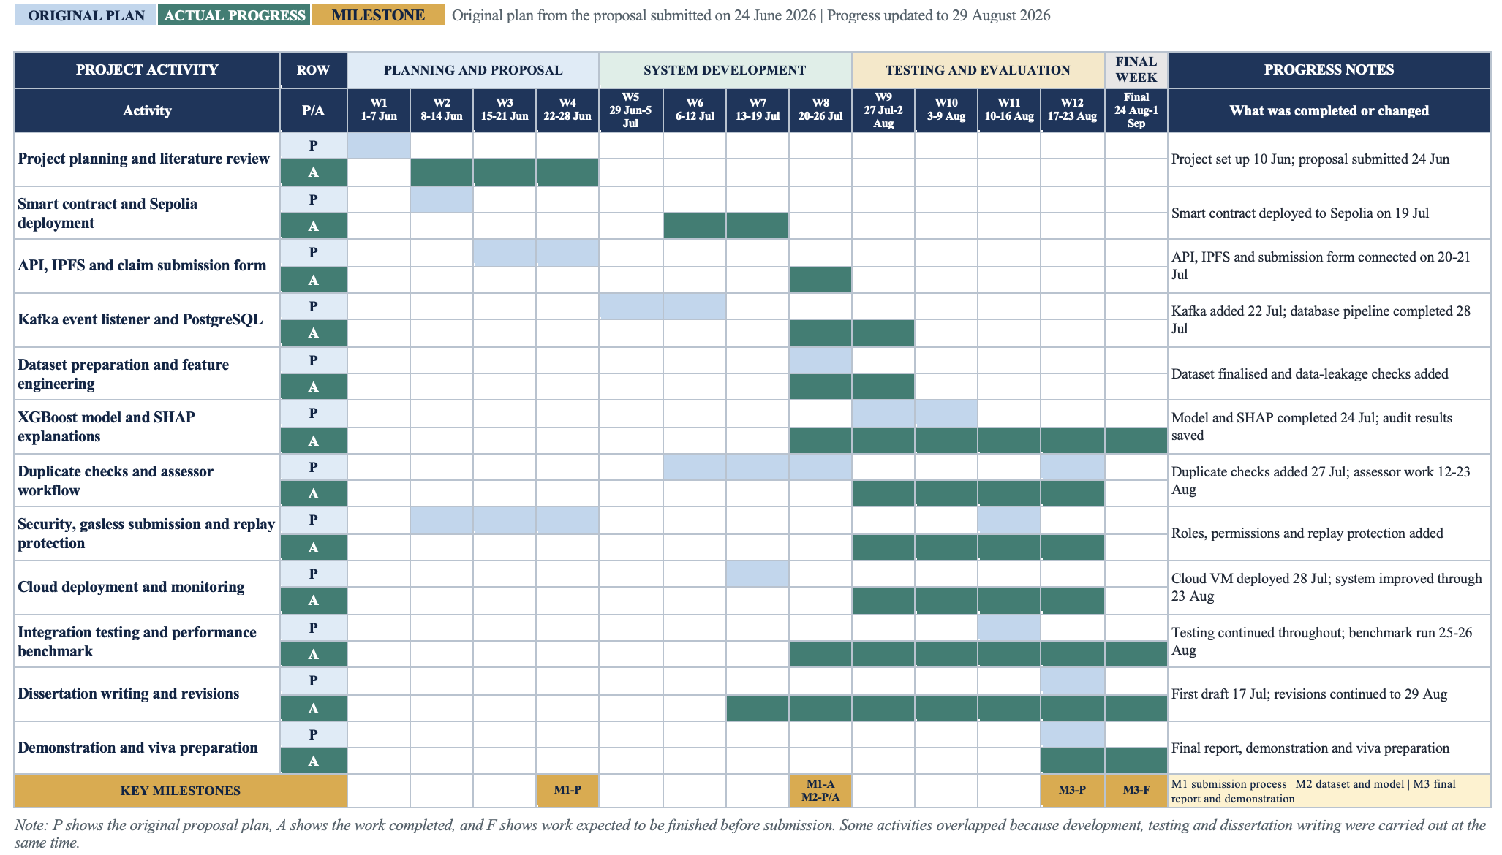
Figure E.1. Updated project Gantt chart

E.2 Reflection on changes to the project plan
During the project, the design changed from the linear process described in the proposal to a more iterative approach. I initially expected to complete the blockchain, backend and machine-learning steps one after another. However, testing showed that several parts depended on each other, so the API, event listener, database and model had to be developed and revised together. I also strengthened the security controls and added gasless submission, replay protection and the assessor workflow as the prototype developed. Although these changes affected some early milestones, they resulted in a more practical and testable system.

