Note: I have placed more emphasis on functionality rather than the UI. Additionally, I focused on writing scalable backend code and spent more time on the backend development rather than integration. Please review the code

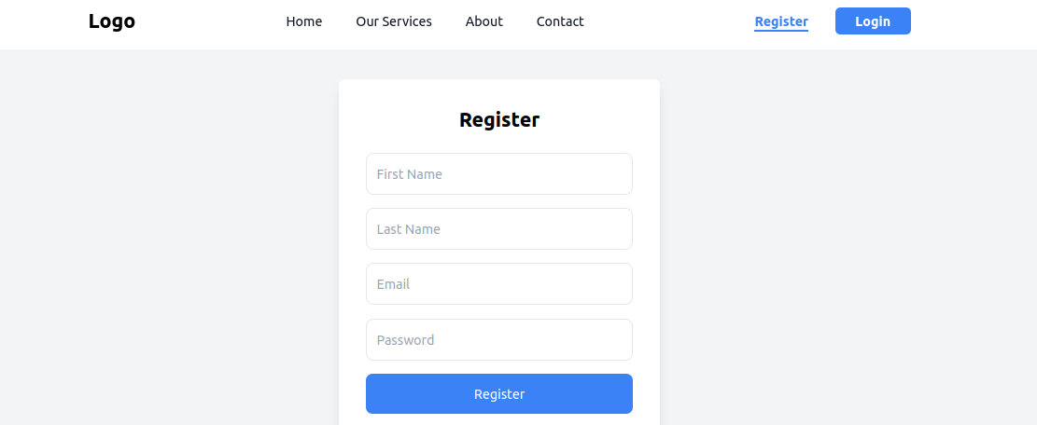
1.The following are screen for register and login

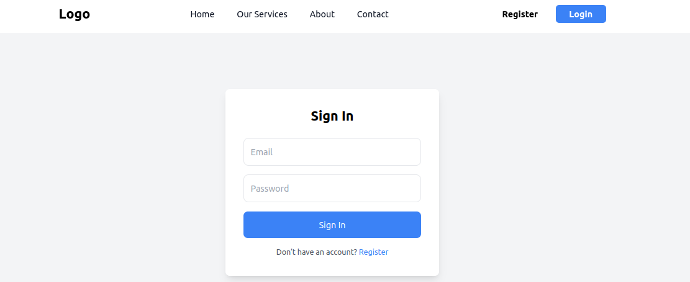

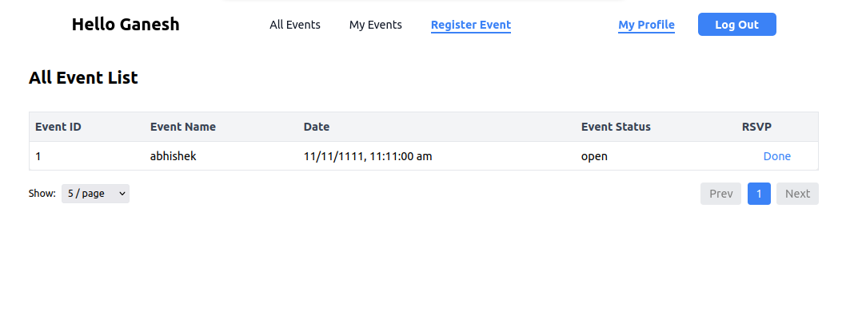
2.The following screens display the events that I have registered for.

3. The following screens display "My Events," which refers to the events created by the user. These events are visible to others in the "All Events" tab

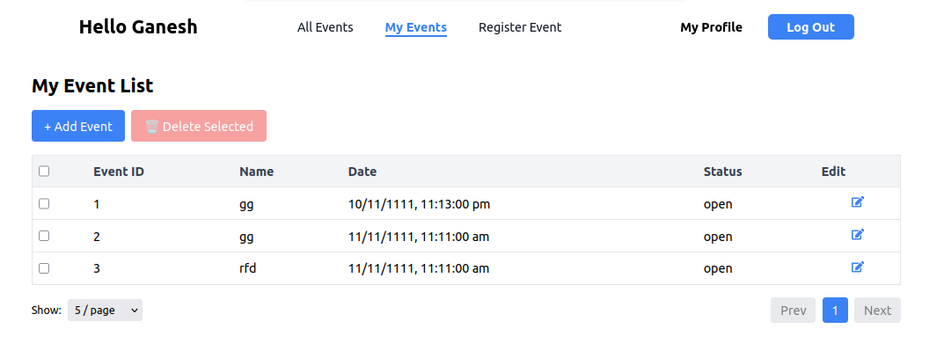
4. The following screens show all events that are visible to users, excluding the events created by the logged-in user.

