Task-1

class ParkingSystem {
int[] count;
public ParkingSystem(int big, int medium, int small) {
count = new int[]{big, medium, small};
}
public boolean addCar(int carType) {
return count[carType - 1]-- > 0;
}
}

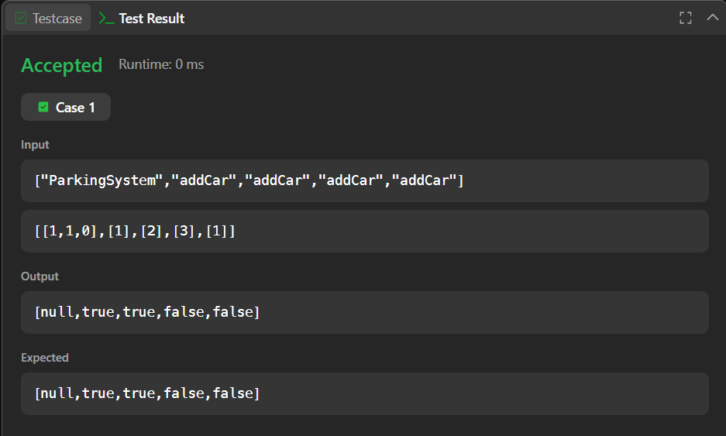

Task-2
import java.util.*;

class Student {
}

class Rockstar {
}

class Hacker {
}

public class InstanceOFTutorial {

public static void count(ArrayList myList) {
int studentCount = 0;
int rockstarCount = 0;
int hackerCount = 0;

for (Object obj : myList) {

if (obj instanceof Student) {
studentCount++;
}

if (obj instanceof Rockstar) {
rockstarCount++;
}

if (obj instanceof Hacker) {
hackerCount++;
}
}

System.out.println(studentCount + " " + rockstarCount + " " + hackerCount);
}

public static void main(String[] args) {

ArrayList myList = new ArrayList();

Scanner sc = new Scanner(System.in);

int t = sc.nextInt();

for (int i = 0; i < t; i++) {

String s = sc.next();

if (s.equals("Student")) {
myList.add(new Student());
}

if (s.equals("Rockstar")) {
myList.add(new Rockstar());
}

if (s.equals("Hacker")) {
myList.add(new Hacker());
}
}

count(myList);
}
}
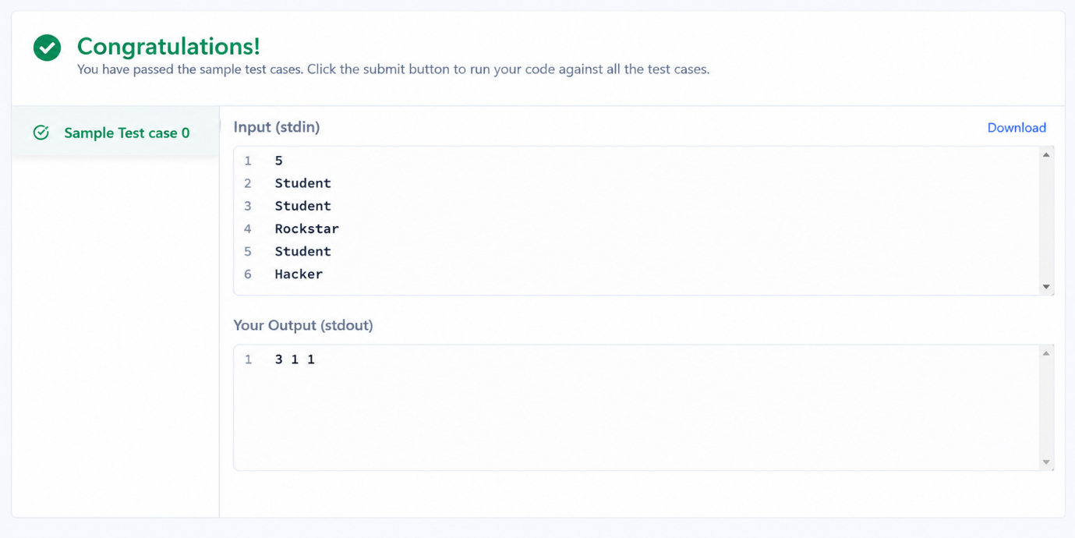
Task-3
class UndergroundSystem {
Map<Integer, Pair<String, Integer>> checkInMap = new HashMap<>();
Map<String, Pair<Double, Integer>> routeMap = new HashMap<>();

public UndergroundSystem() {}

public void checkIn(int id, String stationName, int t) {
checkInMap.put(id, new Pair<>(stationName, t));
}

public void checkOut(int id, String stationName, int t) {
Pair<String, Integer> checkIn = checkInMap.get(id);
checkInMap.remove(id);

String routeName = checkIn.getKey() + "_" + stationName;
int totalTime = t - checkIn.getValue();

Pair<Double, Integer> route = routeMap.getOrDefault(routeName, new Pair<>(0.0, 0));
routeMap.put(routeName, new Pair<>(route.getKey() + totalTime, route.getValue() + 1));
}

public double getAverageTime(String startStation, String endStation) {
String routeName = startStation + "_" + endStation;
Pair<Double, Integer> trip = routeMap.get(routeName);
return trip.getKey() / trip.getValue();
}
}
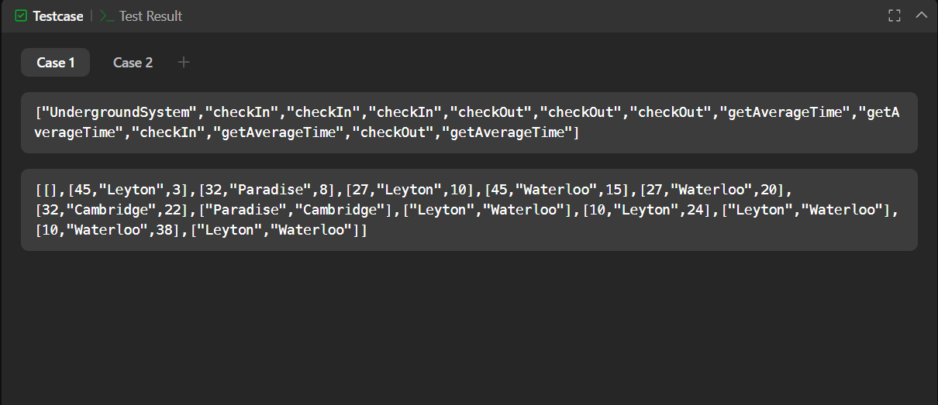

Task-4
class BrowserHistory {

public class Node{
String url;
Node next, prev;
public Node(String url) {
this.url = url;
next = null;
prev = null;
}
}

Node curr;
public BrowserHistory(String homepage) {
curr = new Node(homepage);
}

public void visit(String url) {
Node node = new Node(url);
curr.next = node;
node.prev = curr;
curr = node;
}

public String back(int steps) {
while (curr.prev != null && steps-- > 0) {
curr = curr.prev;
}
return curr.url;
}

public String forward(int steps) {
while (curr.next != null && steps-- > 0) {
curr = curr.next;
}
return curr.url;
}
}
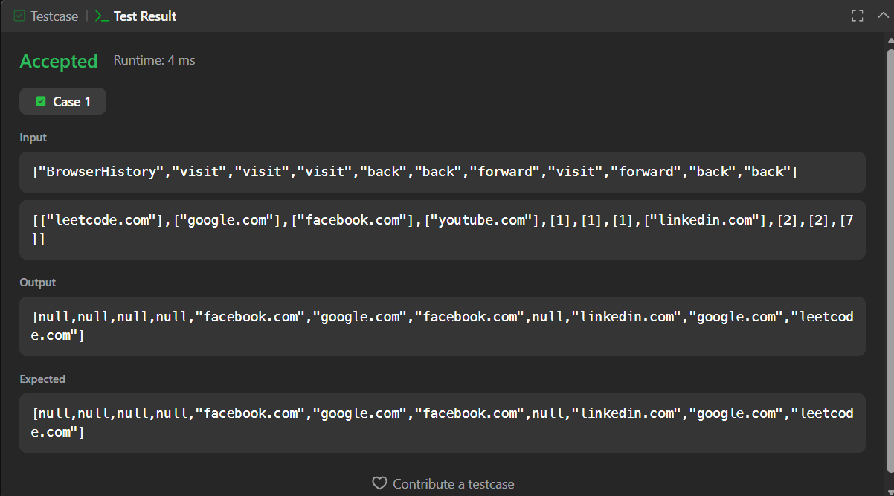

Task-5
class MyHashSet {

private boolean[] storage;

public MyHashSet() {
storage = new boolean[1_000_001];
}

public void add(int key) {
storage[key] = true;
}

public void remove(int key) {
storage[key] = false;
}

public boolean contains(int key) {
return storage[key];
}
}
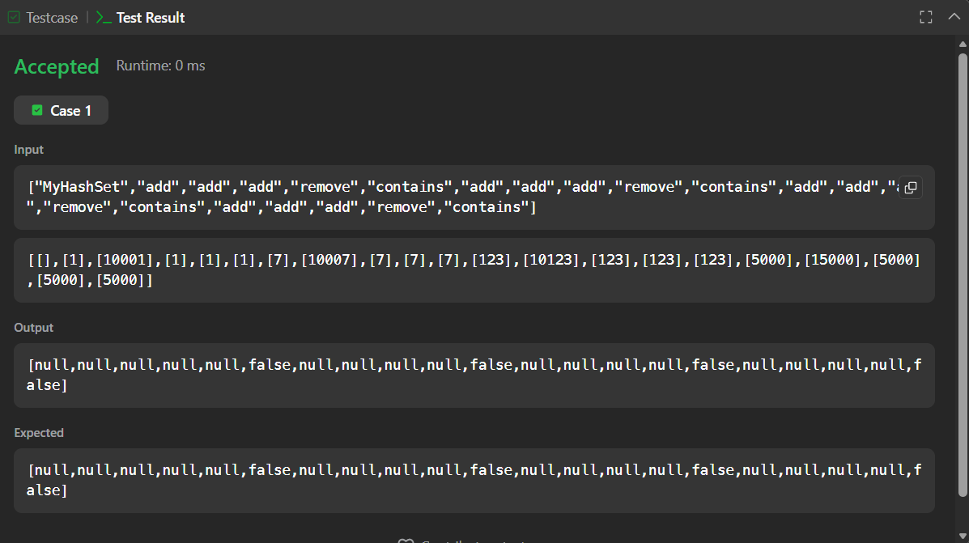

Task-6

import java.io.*;
import java.math.*;
import java.security.*;
import java.text.*;
import java.util.*;
import java.util.concurrent.*;
import java.util.function.*;
import java.util.regex.*;
import java.util.stream.*;
import static java.util.stream.Collectors.joining;
import static java.util.stream.Collectors.toList;

class Result {

/*
* Complete the 'gradingStudents' function below.
*
* The function is expected to return an INTEGER_ARRAY.
* The function accepts INTEGER_ARRAY grades as parameter.
*/

public static List<Integer> gradingStudents(List<Integer> grades) {

List<Integer> result = new ArrayList<>();

for (int grade : grades) {

// Grades below 38 are not rounded
if (grade < 38) {
result.add(grade);
}
else {
int nextMultiple = ((grade / 5) + 1) * 5;

// Round if difference is less than 3
if (nextMultiple - grade < 3) {
result.add(nextMultiple);
}
else {
result.add(grade);
}
}
}

return result;
}

}

public class Solution {
public static void main(String[] args) throws IOException {
BufferedReader bufferedReader =
new BufferedReader(new InputStreamReader(System.in));

BufferedWriter bufferedWriter =
new BufferedWriter(new FileWriter(System.getenv("OUTPUT_PATH")));

int gradesCount =
Integer.parseInt(bufferedReader.readLine().trim());

List<Integer> grades = IntStream.range(0, gradesCount)
.mapToObj(i -> {
try {
return bufferedReader.readLine().replaceAll("\\s+$", "");
} catch (IOException ex) {
throw new RuntimeException(ex);
}
})
.map(String::trim)
.map(Integer::parseInt)
.collect(toList());

List<Integer> result = Result.gradingStudents(grades);

bufferedWriter.write(
result.stream()
.map(Object::toString)
.collect(joining("\n"))
+ "\n"
);

bufferedReader.close();
bufferedWriter.close();
}
}
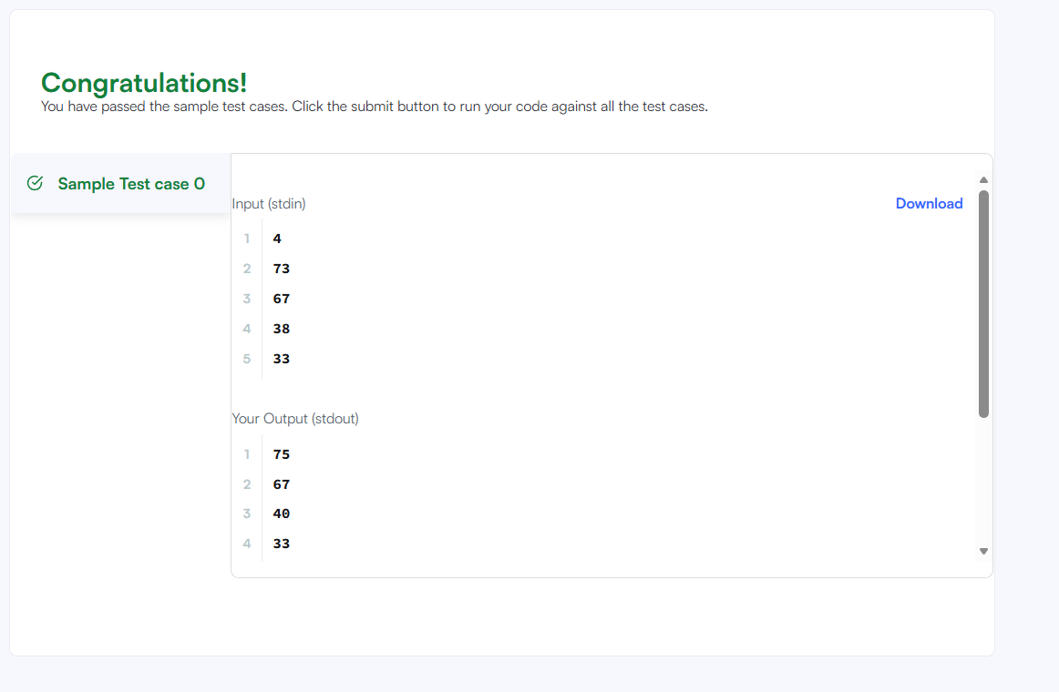
Task-7
import java.io.*;
import java.util.*;
import java.text.*;
import java.math.*;
import java.util.regex.*;

class Animal {
void walk() {
System.out.println("I am walking");
}
}

class Bird extends Animal {

void fly() {
System.out.println("I am flying");
}

void sing() {
System.out.println("I am singing");
}
}

public class Solution {

public static void main(String args[]) {

Bird bird = new Bird();

bird.walk();
bird.fly();
bird.sing();
}
}

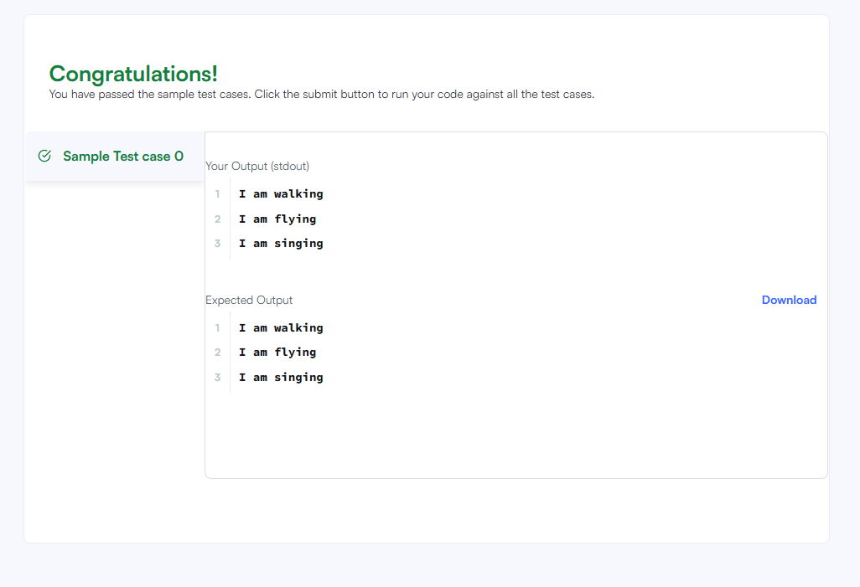
Task-8
import java.io.*;
import java.util.*;
import java.text.*;
import java.math.*;
import java.util.regex.*;

class Arithmetic {

int add(int a, int b) {
return a + b;
}
}

class Adder extends Arithmetic {
}

public class Solution {

public static void main(String[] args) {

Adder a = new Adder();

System.out.println(
"My superclass is: " +
a.getClass().getSuperclass().getName()
);

System.out.print(
a.add(10, 32) + " " +
a.add(10, 3) + " " +
a.add(10, 10) + "\n"
);
}
}

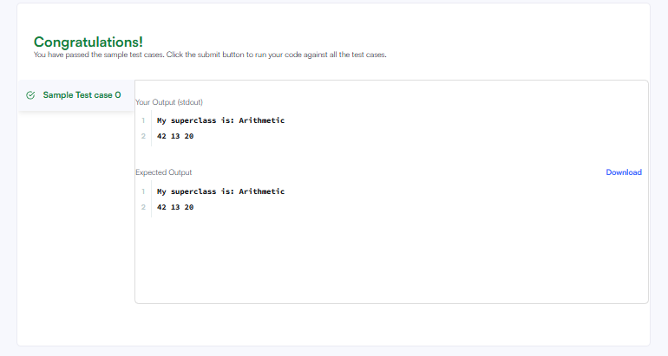
Task-9
import java.io.*;
import java.util.*;

public class Solution {

public static <T> void printArray(T[] array) {
for (T element : array) {
System.out.println(element);
}
}

public static void main(String[] args) {

Integer[] intArray = {1, 2, 3};
String[] stringArray = {"Hello", "World"};

printArray(intArray);
printArray(stringArray);
}
}
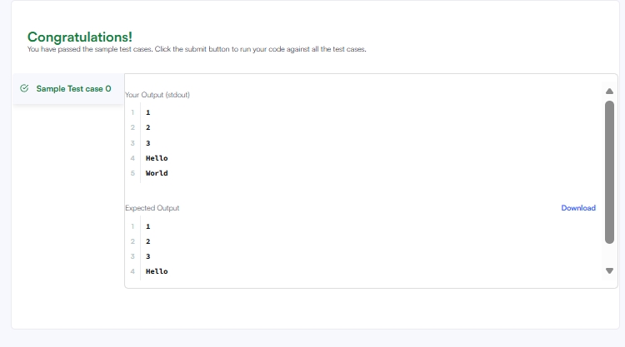
Task-10
class ThroneInheritance {
String kingName;
Map<String, List<String>> map = new HashMap<>();
Map<String, Boolean> alive = new HashMap<>();
public ThroneInheritance(String kingName) {
this.kingName = kingName;
}

public void birth(String pn, String cn) {
map.computeIfAbsent(pn, k -> new ArrayList<>());
map.get(pn).add(cn);
}

public void death(String name) {
alive.put(name, false);
}

public List<String> getInheritanceOrder() {
List<String> list = getList(kingName);
List<String> res = new ArrayList<>();
for (String s : list)
if (alive.getOrDefault(s, true)) res.add(s);
return res;
}

private List<String> getList(String p) {
List<String> res = new ArrayList<>();
res.add(p);
List<String> cs = map.getOrDefault(p, new ArrayList<>());
for (String c : cs) {
List<String> tmp = getList(c);
for (String cc : tmp) res.add(cc);
}
return res;
}
}

