**TASK-1**

**1.POST METHOD(POSTMAN)**

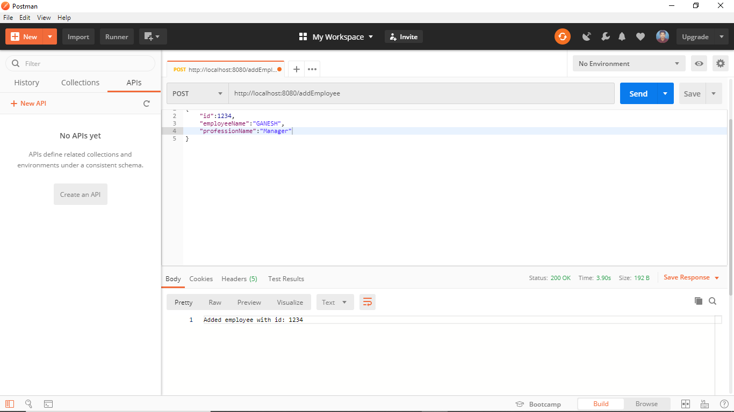

**User data stored in mongo_db**

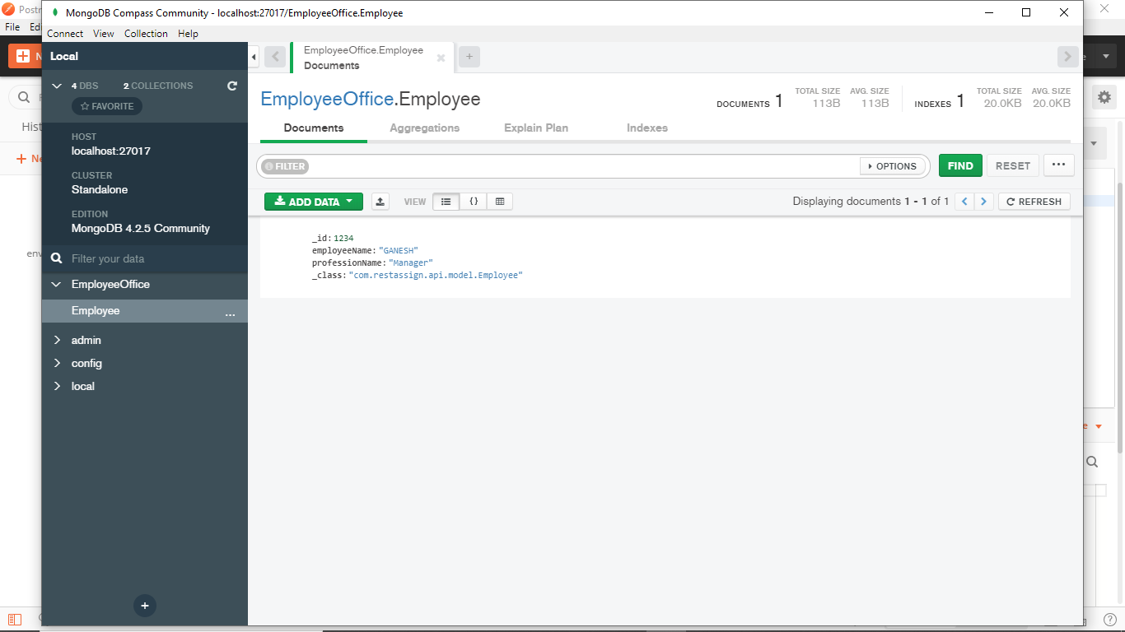

**(ADDING MORE USERS)-POSTMAN**

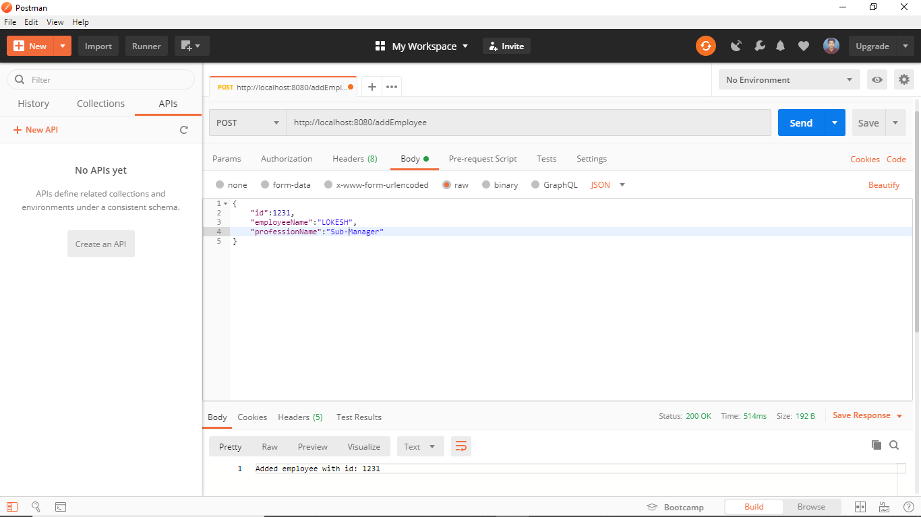

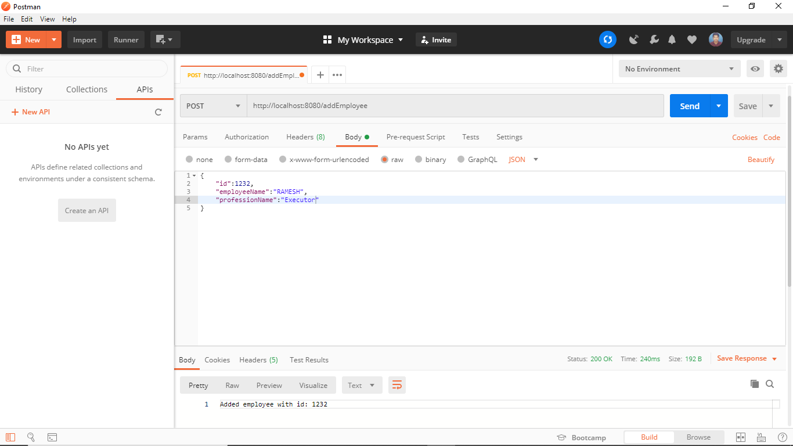

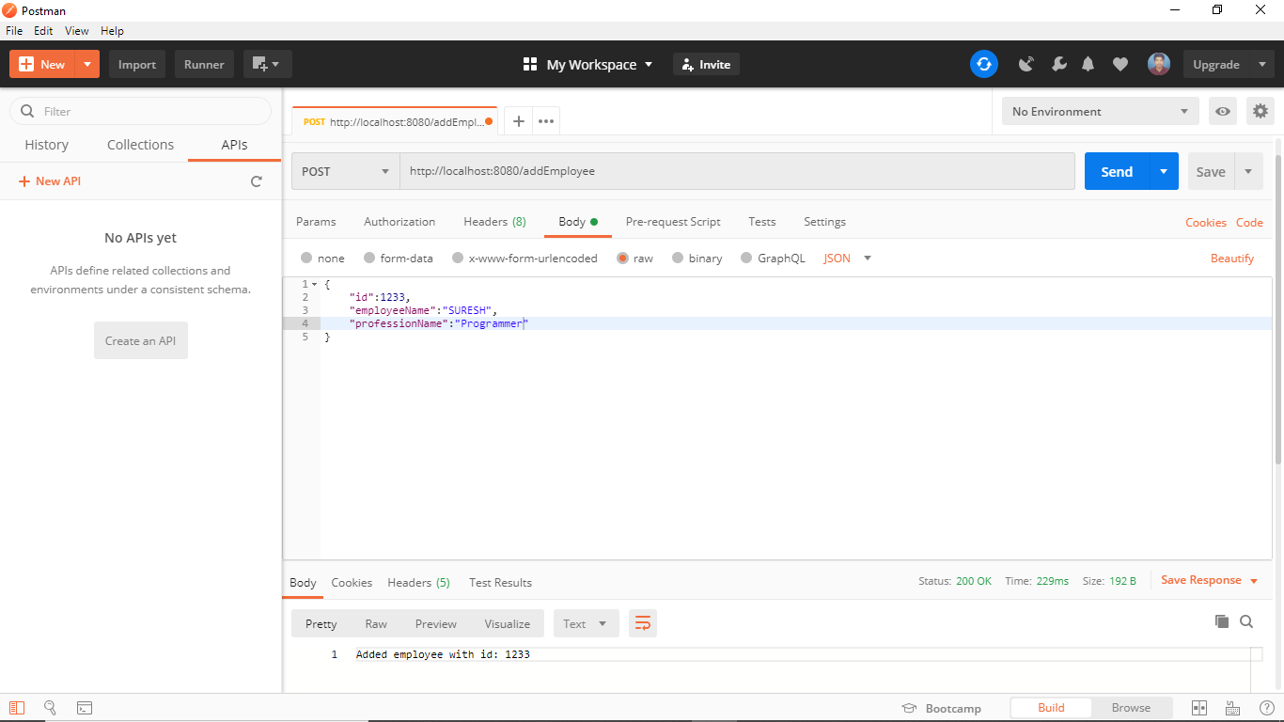

**Data stored in Mongo_db**

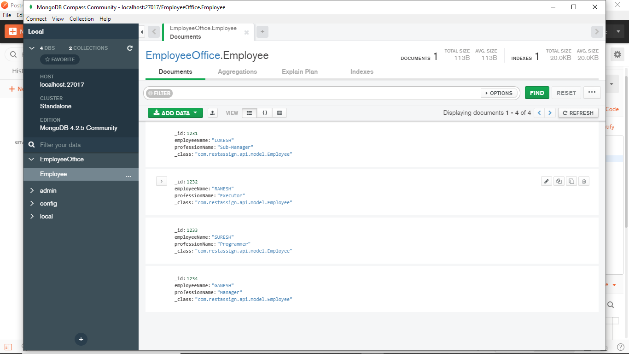

**2.GET METHOD(POSTMAN)**

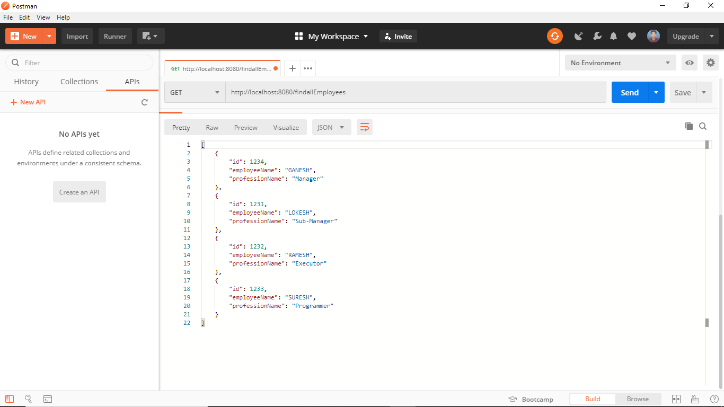

**3.DELETE METHOD(POSTMAN)**

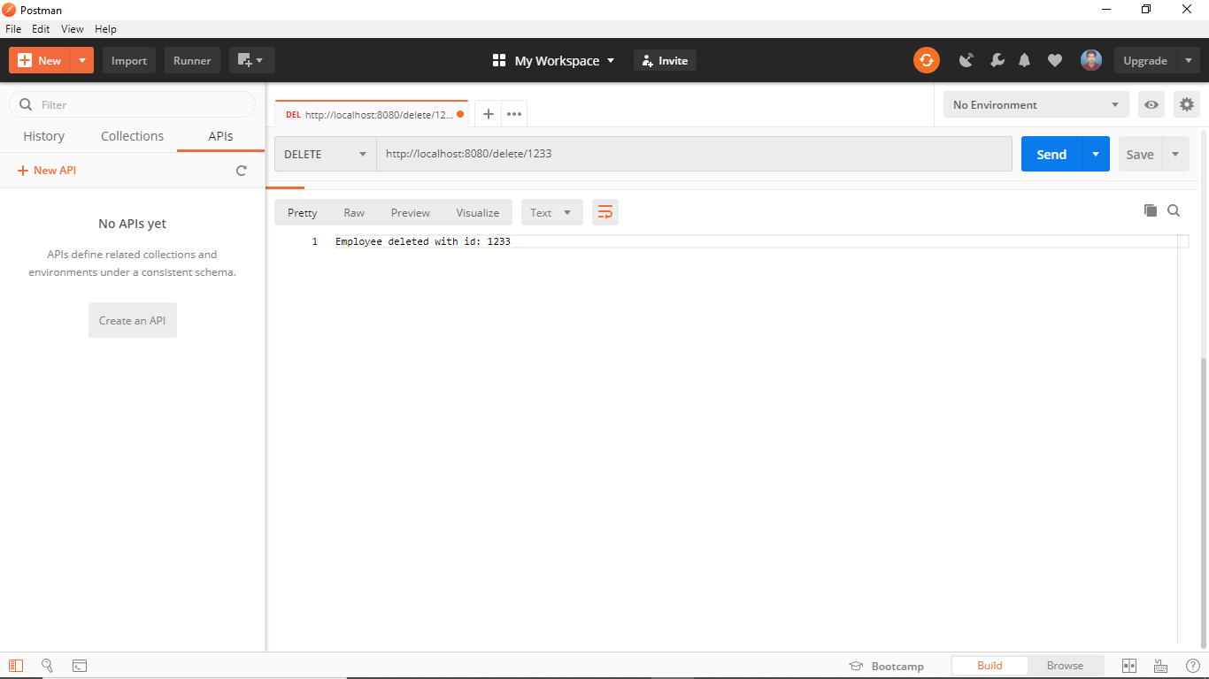

**After deleting the specific ID person(updated database)**

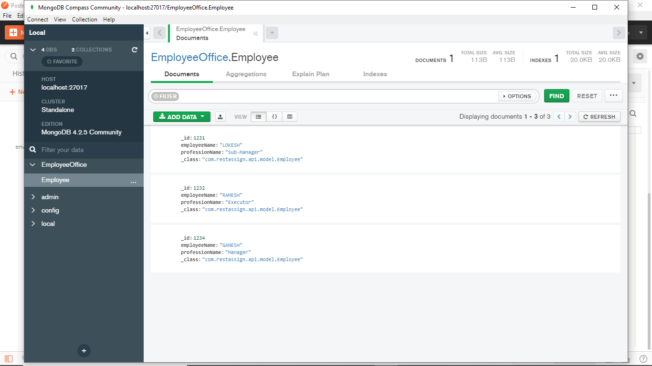

**4.UPDATE METHOD (POSTMAN)**

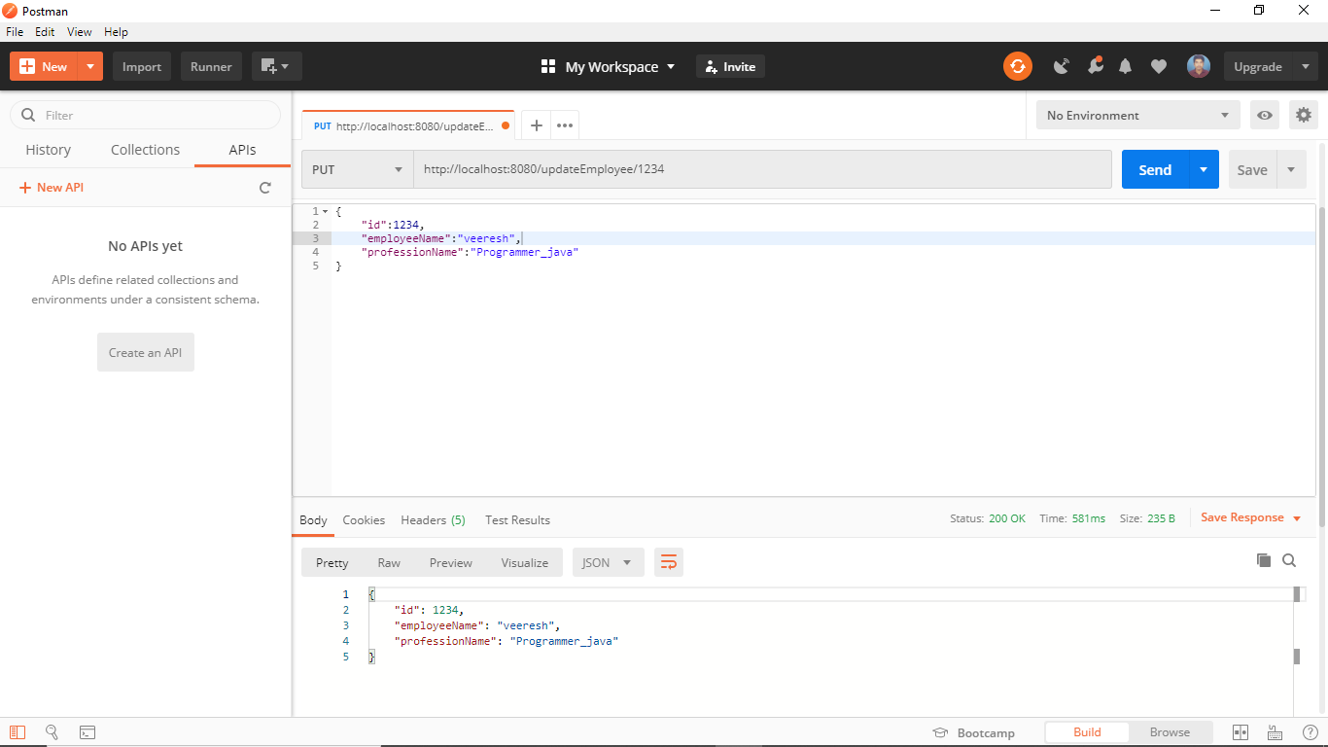

**After Updation**

