How to deploy a React app to Firebase using GitHub Actions ( step-by-step )
GitHub Actions provide a way to automate pretty much anything you want to do with your repository. It can be used to automatically test your project every time you make a pull request or push some code to it, or maybe to publish something to GitHub Packages every time you make a release. The possibilities are endless.
So, in this article, I’m going to walk you through the most obvious functionality of GitHub Actions: deploy your application to production in an automated fashion, so you never have to do it manually again.
What are we going to do exactly?
Keeping in mind that the goal of this tutorial is the deployment, not the application being deployed, we are going to set up a React application using only the template that is already provided when you set up a React app, with a few modifications to make it a little more personal.
Then, we are going to set up a project on Firebase and extract some credentials so we can use the Hosting functionality to eventually — guess what? — host our application and make it available in the internet.
Finally, we will write our workflow file, commit it to GitHub, sit back, and watch the magic of automation happen right before your eyes.
Set up a React app
This section might be unnecessary for the majority of the readers, but I’ll keep it here for those who maybe never dealt with React before and want a glimpse of this beauty. If this is like eating a candy to you, please jump to the next section.
Then buckle up, snap your fingers, and go through the following steps:
- Make sure you have NPM installed locally .
- Make sure you have NPX installed locally:
npm install -g npx
- Open a terminal of your choice, select a folder where you want your project to live, decide on a name for your project (I’ll use awesome-app for this tutorial), and use NPX to build your application’s template: npx create-react-app awesome-app
- Go grab some coffee while everything is being set up, then return to your desk, move into the recently created awesome-app folder and start the application with the following commands:
cd awesome-app
npm start
Wait for it and… Awesome! You now are the proud owner of a website
Right there running in your browser with the animated React logo and all. This is sufficient for the purposes of our demo, but go ahead and edit src/App.js to something more personal, if you so desire. Being a cat person, mine looks like this:
Now, since we already have the React app in place, let’s dig into Firebase.
Set Up the Firebase Project
For this section, let’s focus a little on Firebase, on how to set up a project on the cloud, download the CLI tools, extract an access token, and get some configuration done on the React app to get it ready to be hosted.
Create a Project in the Cloud
Navigate yourself to https://firebase.google.com/ and log in (I’m assuming you already have an account registered. Am I correct?). Then click “go to console” on the upper right corner.
Click “Add Project” to create a new project on Firebase, and follow the instructions until you have your project ready and you can see this screen:
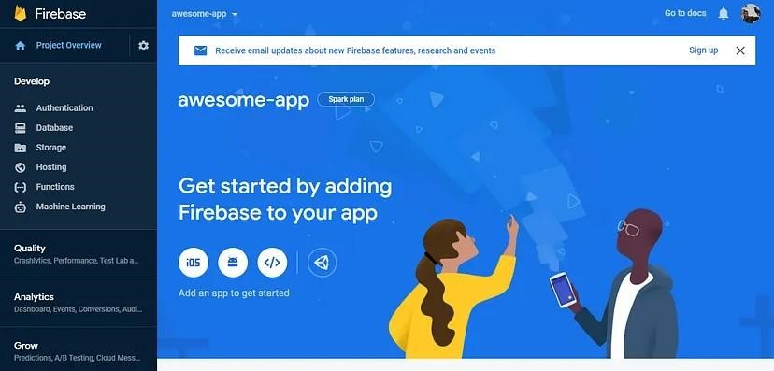
For that, we need to have firebase-tools installed, what is as easy as running this simple command from your terminal:
npm install -g firebase-tools Then, run this to extract your token: firebase login:ci
This will open a new tab in your browser asking you to authenticate to Firebase (if not, follow the displayed URL in order to authenticate). After you do so, a token will be printed to your terminal:
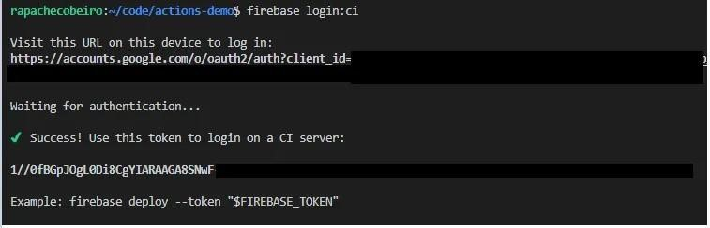
Store the Token in GitHub Secrets
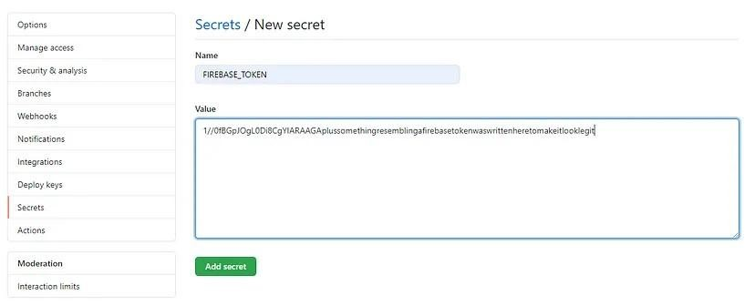
Configure you Application for Firebase
Going back to your React application’s root directory, we now need to configure it with a couple of files that Firebase will use it to know how to deploy and host your application properly. We can easily do it by running this simple command: firebase init
This will start a process in your terminal that will ask you a few questions about how do you want to configure your application. In the first screen, select only the Hosting option (you can change all configurations later on):
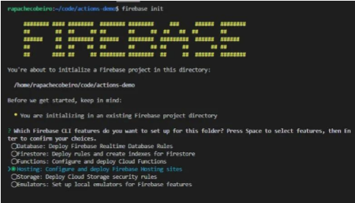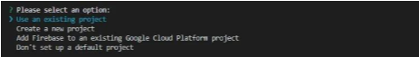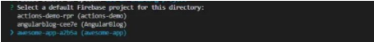
Since we’ll be deploying a React application, type in ‘build’ for your public directory. This is the name of the folder that our React script will create later when we build the application:
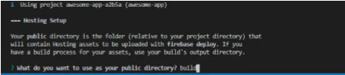
Finally, you can configure your app as a single-page app (again, you can change this configuration later), and the configuration will be complete, having two new files written just for you:
- .firebaserc : Basic config for the project. For now it has just the project name;
- firebase.json: Additional config. Tells Firebase about the public folder, which files/folders to ignore, and the re-write config to make the application a single-page app.
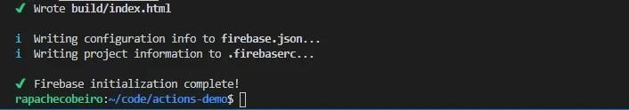
Now every single piece of configuration is ready for you to get hands on to your GitHub workflow.
Execute it!
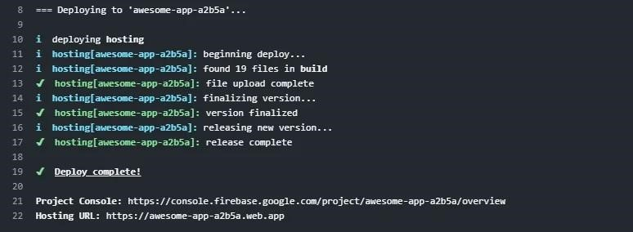
Finally, just follow the link displayed on Hosting URL (Line 22 in the example above), to witness your React app live for everyone to behold:
React code:
import React, { useState } from "react";
import Form from "react-bootstrap/Form";
import Button from "react-bootstrap/Button";
import "./Login.css";
export default function Login() {
const [email, setEmail] = useState("");
const [password, setPassword] = useState("");
function validateForm() {
return email.length > 0 && password.length > 0 ;
}
function handleSubmit(event) {
event.preventDefault();
}
return (
<div className="Login">
<Form onSubmit={handleSubmit}>
<Form.Group size="lg" controlId="email">
< Form.Label>Email</Form.Label >
< Form.Control
autoFocus
type="email"
value={email}
onChange={(e) => setEmail(e.target.value)}
/>
< /Form.Group >
<Form.Group size="lg" controlId="password">
< Form.Label>Password</Form.Label >
< Form.Control
type="password"
value={password}
onChange={(e) => setPassword(e.target.value)}
/>
< /Form.Group >
<Button block size="lg" type="submit" disabled={!validateForm()}>
Login
< /Button >
< /Form >
< /div >
) ;
}
Output:
