INDUSTRIAL VISIT REPORT
By K Ganesh Kumar
Day 01
BUSINESS MANAGEMENT:-
Business management is the process of planning, organizing, coordinating, and overseeing the activities and resources of an organization to achieve specific goals and objectives. It involves making decisions, setting policies, and guiding the direction of a business or company to ensure its success and sustainability. Business management encompasses various functions, including:

1. Planning: This involves setting goals and objectives, as well as developing strategies and action plans to achieve them.
2. Organizing: This includes designing the structure of the organization, determining roles and responsibilities, and arranging resources and processes to meet the objectives efficiently.
3. Leading: Leadership is about motivating and guiding employees or team members to work toward the common goals, fostering a positive work environment, and making important decisions.
4. Controlling: This function involves monitoring and measuring performance, comparing it to the set goals, and taking corrective actions when necessary to ensure that the organization stays on track.
5. Coordinating: Coordinating various activities and departments within an organization to ensure that they work together harmoniously and efficiently.
6. Staffing: This involves recruiting, training, and managing the workforce, ensuring that the organization has the right people with the right skills to meet its goals.
Consultants:-
- Technical Consultant: A technical consultant is a professional who offers specialized expertise and advice in technical areas or industries. These consultants are typically hired to provide guidance, solve complex technical problems, or assist in the implementation of technical solutions.
Eg: ABAP, BI, BW, BO etc

- Functional Consultant: A functional consultant is a professional who specializes in a particular business or functional area and provides expertise to organizations seeking to improve or optimize their business processes, operations, and systems within that specific domain.
Eg: MM, PP, QM, SD, WM, FICO etc

- ERP (Enterprise Resource planning): It is a type of integrated software system that organizations use to manage and streamline a wide range of business processes and functions across various departments and functions within the organization.
Company flows:-
- Safety.
- Quality.
- Customer Satisfaction.

Real Time Scenario includes:-
- Development.
- Quality.
- Pre-production.
- Production.
Testing Types:
- Positive: Real values.
- Negative: Decimal values.

Real Time 3(R/3):
Client | Application | Database
GUI | R/W,C | Storage
UIS | S Process
FIORI

- Golden server: About warranty.

ORG(Organization):
- RW(Raw Material)
- SF(Semi finished) FC/TC
- FP(Finished product)

ASAP METHODOLOGY:-
The ASAP (Accelerated SAP) methodology is an approach to implementing and managing SAP (Systems, Applications, and Products in Data Processing) software solutions in an efficient and structured manner. SAP is a leading provider of enterprise resource planning (ERP) and business software used by organizations to manage various aspects of their operations. The ASAP methodology is designed to help organizations plan, execute, and manage SAP software implementations effectively, reducing risks and ensuring that the system meets the organization's business requirements.
Key components of the ASAP methodology include:
- Project Preparation: In this initial phase, the project team is formed, and project goals and objectives are defined. The project charter is created, and the overall project plan is established. This phase focuses on getting the project off the ground and securing executive buy-in.
- Business Blueprint: During this phase, the project team works closely with business stakeholders to document and analyze the organization's existing business processes and requirements. The goal is to create a comprehensive "blueprint" of how the SAP system will align with and support these processes.
- Realization: This phase involves configuring and customizing the SAP software to align with the requirements identified in the business blueprint. It includes tasks such as system configuration, data migration, and creating test scenarios.
- Final Preparation: This phase focuses on preparing the SAP system for go-live. It includes end-user training, system testing, and quality assurance. Data migration and system performance are fine-tuned during this stage.
- Go-Live and Support: The final phase involves launching the SAP system into production. It includes the actual system deployment, monitoring for any issues, and providing support to users as they begin using the system in their day-to-day operations.

MATERIAL MANAGEMENT

Project:
- Implementation: A project implementation is a document that outlines how you will execute, monitor, and control a project.
- Support:
Basic tools
- Service Now
- First act provided by: Oracle, IBM, WIPRO.
- V-Success
- Roll Out: It is Reuse.
- Up gradation: It is used for updating the software.
ORGANIZATION STRUCTURE

WAREHOUSE MANAGEMENT

- MASTER DATA:-The data that is stored for a long time.
- Material
- Vendor
- Purchase info record
- Source list
- Quality management

Procedure to pay:-
Purchase request Request for quotation Comparison
ACTIVITY
Worked On Technical Side:-
I am K Ganesh Kumar acted as a technical side. Our team is based on business side. Bank name is UF bank(user friendly bank). I am creating this project based on some requirements given by the client so that bank application should be safe and secured.
Requiremennts provided by the client:-
- We provide on-line transactions to the teenager but we will provide debit cards after they are adult.
- We provide loans with less interest.
- Education loan
- Health loan
- we provide zero balance
- international transaction
- secure and fast transaction
- Business accounts and private accounts
As above mentioned, requirements that has been provided by the client. So we think about that and gave structure how to design for the bank application.
Structure to build bank application:-
- We need a login page that should be consist of two buttons first is (SIGN-UP) button it means user has to create a new account that consists of:
- Username (first name & last name).
- Date Of Birth (of account holder).
- Phone no.
- Aadhar card no.
- Address.
- Account type (savings & current).
- PANCARD.
- Both Parents details as per the Aadhar card.
- Digital signature of a Account holder with his and & both parents Aadhar card in the pdf file. And the pdf file space should be 10mb.
- Create a password and password should be aleast 8 characters and that consist of numbers, letters & it should re-enter the password to confirm password.
- After creating account and we need next button that is (SIGN-IN) to sign the account that has been created already and to login the account we need to enter the password that user has been created in SIGN-UP.
- We need forget password so if any user forget his password that need to be change with the user phone no by getting OTP only.
- After login we need a user interface that consist of account balance, profile, bank statement, deposits, loans, settings that consist of user details like(help, contact us, email of bank, set password, change username, language, notifications).
- For loans we need two types they are educational loan & health loan.
- For educational loan we need documents that are educational certificate, students marks card like SSLC marks card(2nd PU or Diploma)provided by digital format of pdf file and the space for the pdf file is 16mb.
- For health loan we need health certificate provided by the doctor with signature.
- At last We need a logout button to log out the user account.

Conversation between technical and scrum master:-
(technical):-I went to scrum master, to meet and to show my structure about bank application.
(scrum master):-welcomed me.
(technical):-hello sir , I have a structure related to bank application.
(scrum master):-ok ,show me the structure.
(technical):-ok then ,here is my structure for bank application.
(scrum master):-ok ,I will discuss with the various companies about this project and I will inform to your client OK.
(technical):-ok sir.

User stories:-

- As a user I need an online transaction app, so that I don’t need to go to ATM for money.
- As a teenager I need an online transaction app, so that I can send or receive money through online.
- As a user I need a zero balance account, so that there will be no penalty charges.
- As a student I need an education loan with low interest, so that I can repay the loan easily.
- As a user I need a health loan with low interest, so that it would easier to repay the loan.
- As a user I need a bank account with international transaction, so that I can use my account globally.
- As a user I need a bank account with fast transaction and more security, so that I can save my time and will have a secure transaction.
- As a user I need a business account with multiple transaction, so that there will be no limit on transaction.
- As a user I need a private account, so that there will be limit on my transaction.
- As a user I need a debit card, so that I can draw the money from my account.
- As a user I need a credit card, so that I can credit the money to my account.
- As a user I need a statement of my account, so that I can keep track of my transaction.

How to deploy a React app to Firebase using GitHub Actions ( step-by-step ):-

GitHub Actions provide a way to automate pretty much anything you want to do with your repository. It can be used to automatically test your project every time you make a pull request or push some code to it, or maybe to publish something to GitHub Packages every time you make a release. The possibilities are endless.
So, in this article, I’m going to walk you through the most obvious functionality of GitHub Actions: deploy your application to production in an automated fashion, so you never have to do it manually again.
What are we going to do exactly?
Keeping in mind that the goal of this tutorial is the deployment, not the application being deployed, we are going to set up a React application using only the template that is already provided when you set up a React app, with a few modifications to make it a little more personal.
Then, we are going to set up a project on Firebase and extract some credentials so we can use the Hosting functionality to eventually — guess what? — host our application and make it available in the internet.
Finally, we will write our workflow file, commit it to GitHub, sit back, and watch the magic of automation happen right before your eyes.
Set up a React app
This section might be unnecessary for the majority of the readers, but I’ll keep it here for those who maybe never dealt with React before and want a glimpse of this beauty. If this is like eating a candy to you, please jump to the next section.
Then buckle up, snap your fingers, and go through the following steps:
1. Make sure you have NPM installed locally .
2. Make sure you have NPX installed locally:
npm install -g npx
3. Open a terminal of your choice, select a folder where you want your project to live, decide on a name for your project (I’ll use awesome-app for this tutorial), and use NPX to build your application’s template: npx create-react-app awesome-app
4. Go grab some coffee while everything is being set up, then return to your desk, move into the recently created awesome-app folder and start the application with the following commands:
cd awesome-app
npm start
Wait for it and… Awesome! You now are the proud owner of a website
Right there running in your browser with the animated React logo and all. This is sufficient for the purposes of our demo, but go ahead and edit src/App.js to something more personal, if you so desire. Being a cat person, mine looks like this:
Now, since we already have the React app in place, let’s dig into Firebase.
Set Up the Firebase Project
For this section, let’s focus a little on Firebase, on how to set up a project on the cloud, download the CLI tools, extract an access token, and get some configuration done on the React app to get it ready to be hosted.
Create a Project in the Cloud
Navigate yourself to https://firebase.google.com/ and log in (I’m assuming you already have an account registered. Am I correct?). Then click “go to console” on the upper right corner.
Click “Add Project” to create a new project on Firebase, and follow the instructions until you have your project ready and you can see this screen:
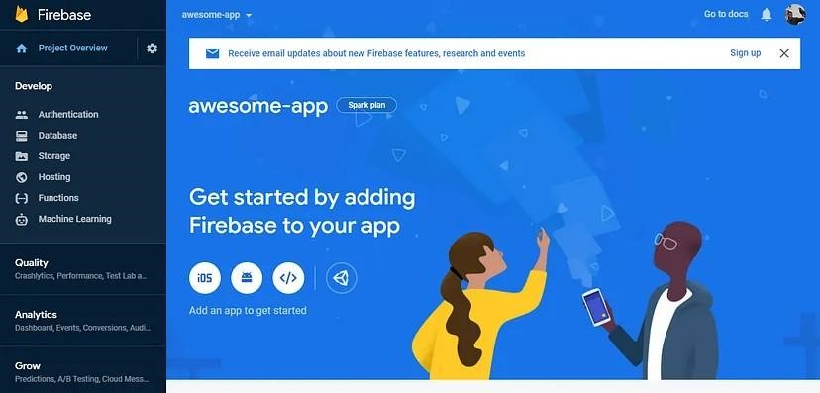
For that, we need to have firebase-tools installed, what is as easy as running this simple command from your terminal:
npm install -g firebase-tools Then, run this to extract your token: firebase login:ci
This will open a new tab in your browser asking you to authenticate to Firebase (if not, follow the displayed URL in order to authenticate). After you do so, a token will be printed to your terminal:
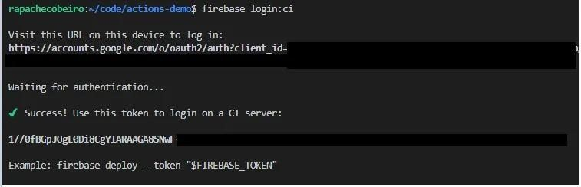
Store the Token in GitHub Secrets
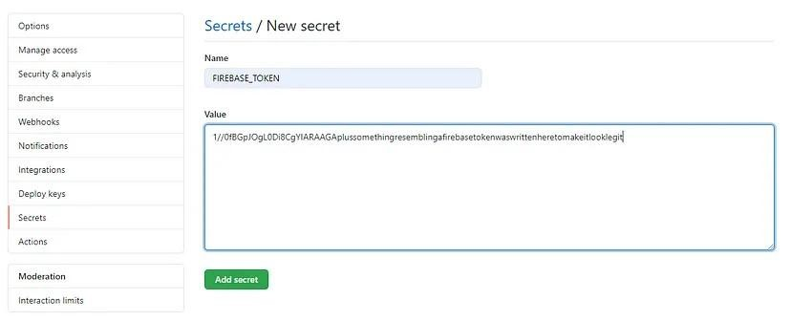
Configure you Application for Firebase
Going back to your React application’s root directory, we now need to configure it with a couple of files that Firebase will use it to know how to deploy and host your application properly. We can easily do it by running this simple command: firebase init
This will start a process in your terminal that will ask you a few questions about how do you want to configure your application. In the first screen, select only the Hosting option (you can change all configurations later on):
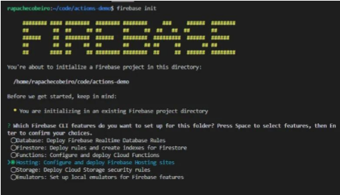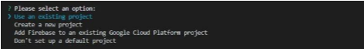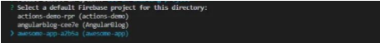
Since we’ll be deploying a React application, type in ‘build’ for your public directory. This is the name of the folder that our React script will create later when we build the application:
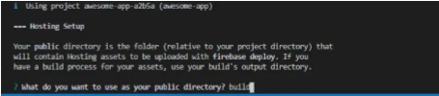

Finally, you can configure your app as a single-page app (again, you can change this configuration later), and the configuration will be complete, having two new files written just for you:
● .firebaserc : Basic config for the project. For now it has just the project name;
● firebase.json: Additional config. Tells Firebase about the public folder, which files/folders to ignore, and the re-write config to make the application a single-page app.
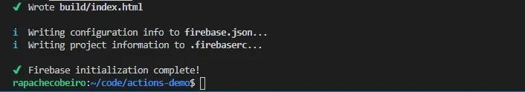

Now every single piece of configuration is ready for you to get hands on to your GitHub workflow.
Execute it!
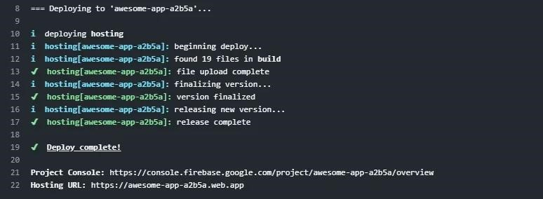

Finally, just follow the link displayed on Hosting URL (Line 22 in the example above), to witness your React app live for everyone to behold:
React code:
import React, { useState } from "react";
import Form from "react-bootstrap/Form";
import Button from "react-bootstrap/Button";
import "./Login.css";
export default function Login() {
const [email, setEmail] = useState("");
const [password, setPassword] = useState("");
function validateForm() {
return email.length > 0 && password.length > 0 ;
}
function handleSubmit(event) {
event.preventDefault();
}
return (
<div className="Login">
<Form onSubmit={handleSubmit}>
<Form.Group size="lg" controlId="email">
< Form.Label>Email</Form.Label >
< Form.Control
autoFocus
type="email"
value={email}
onChange={(e) => setEmail(e.target.value)}
/>
< /Form.Group >
<Form.Group size="lg" controlId="password">
< Form.Label>Password</Form.Label >
< Form.Control
type="password"
value={password}
onChange={(e) => setPassword(e.target.value)}
/>
< /Form.Group >
<Button block size="lg" type="submit" disabled={!validateForm()}>
Login
< /Button >
< /Form >
< /div >
) ;
}
Output:
