

**USER GUIDE**

**Logilab ELN Cloud SaaS – Offline Payment Information by Customer**



CONTENTS

1 Process Overview 3

2 Process Details 4

2.1 Receipt of Invoice email notification 4

2.2 Offline payment information by customer 5

2.3 Post-steps 10

# Process Overview

In order to inform Receivables Admin about the already-made offline payment, the customer user will have to follow these steps:

* Customer will receive the invoice in the mail for the live subscription on scheduled payment due date. The customer refers to the offline payment details from the invoice email notification
* Customer completes the payment in offline mode separately and note down the details of the same.
* Customer logs into customer portal and choose to send Email to Receivables admin about the offline payment details

The step-by-step tasks namely customer’s reference to email and send offline mail from customer portal are described in detail in the following sections.

# Process Details

## Receipt of Invoice email notification

Login to the registered email of the customer user.

Locate the Invoice email notification and open it.

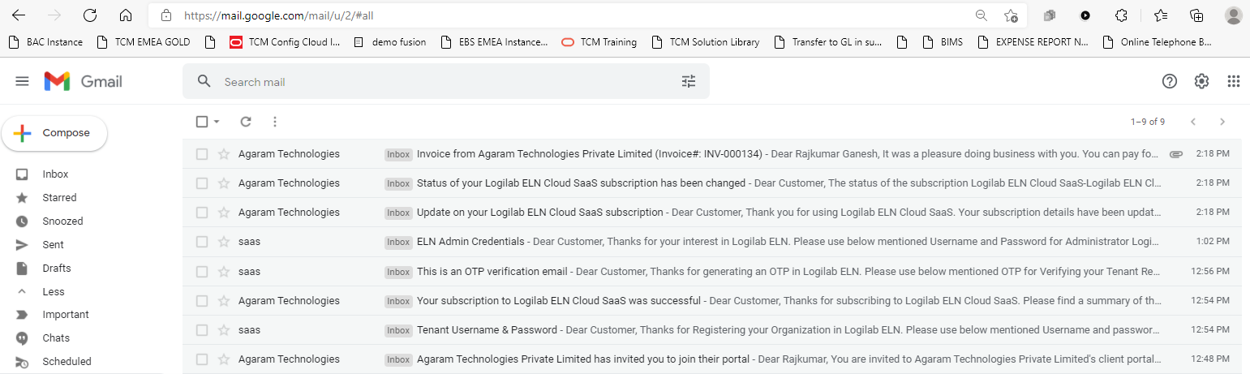

Note down the details of bank account to which offline payment needs to made

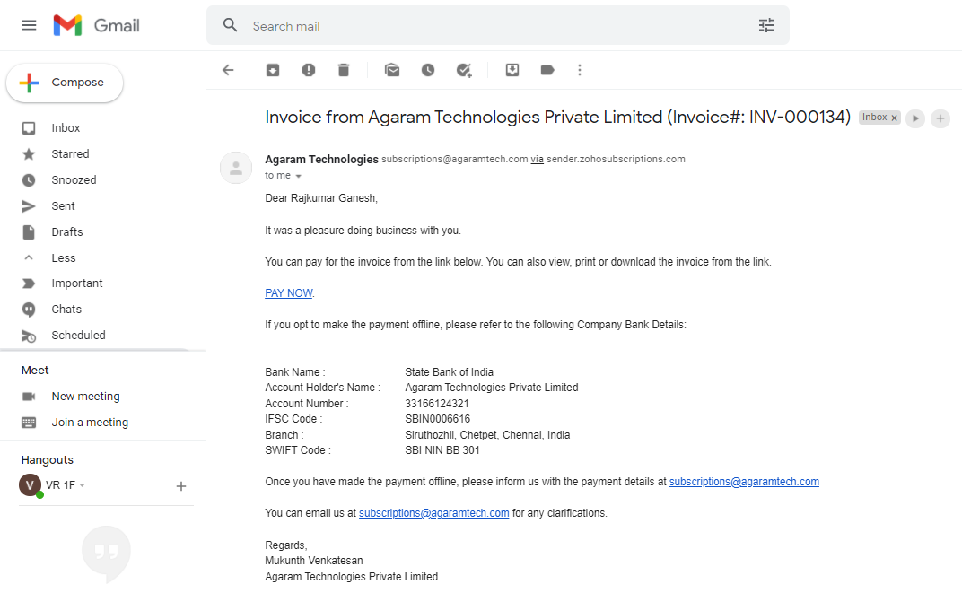

After referring to the details of offline bank transfer from the invoice notification, the customer makes the payment and notes down the payment details separately.

## Offline payment information by customer

Now the customer proceeds to inform the payment details to Receivables Admin through Customer portal.

Portal URL : [**https://subscriptions.zoho.com/portal/agaramtechsubs**](https://subscriptions.zoho.com/portal/agaramtechsubs)

In order to notify the Receivables admin about the offline payment details, the customer user signs-in to customer portal

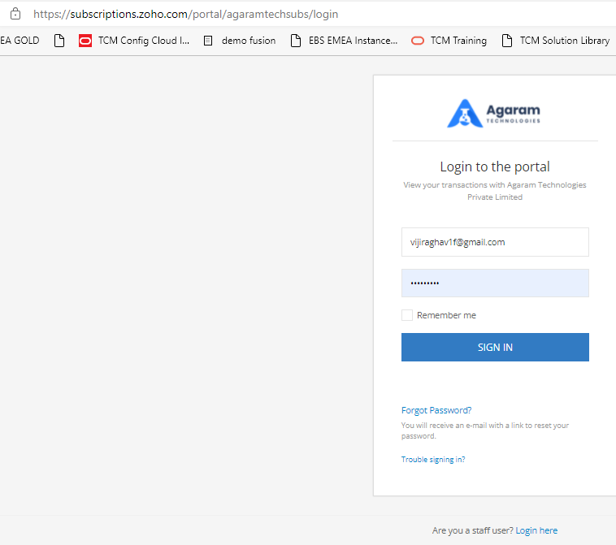

On the home page, click on 'Send Email' button.

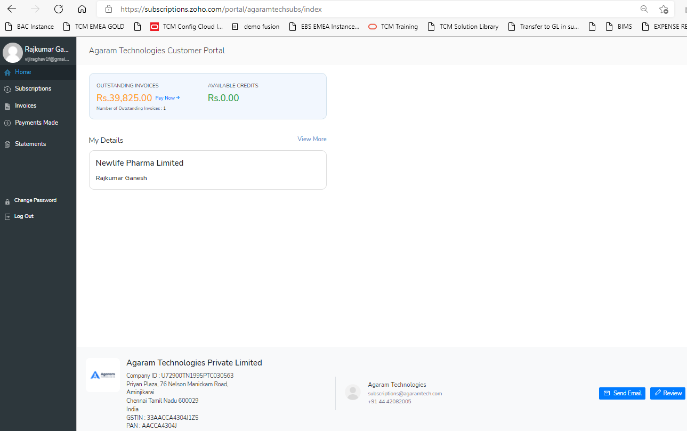

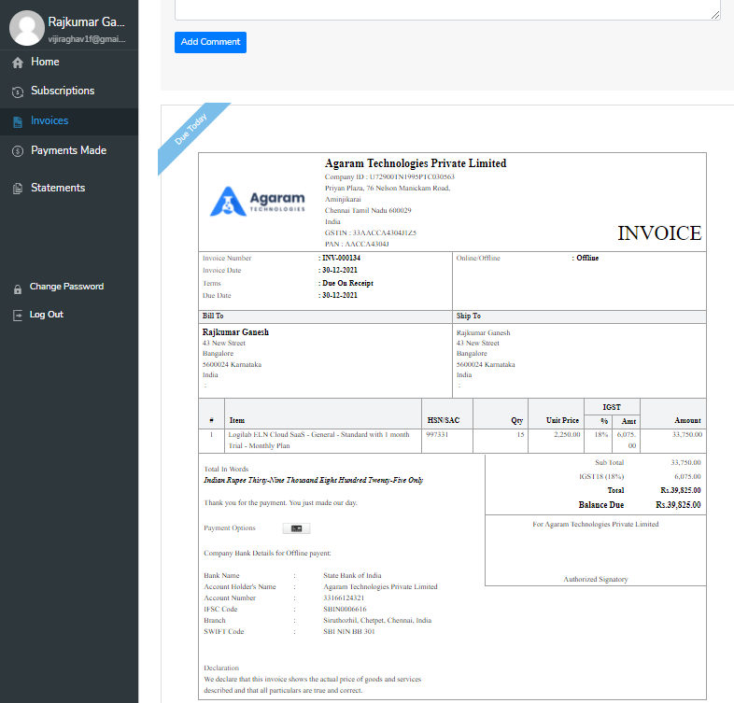

Enter the details about the bank transfer that has been made.

This may typically contain the Bank Transfer Reference number, Invoice number, amount, date of transfer, etc.

Please ensure that all the required information which are required for Receivables Admin to record the payment are provided.

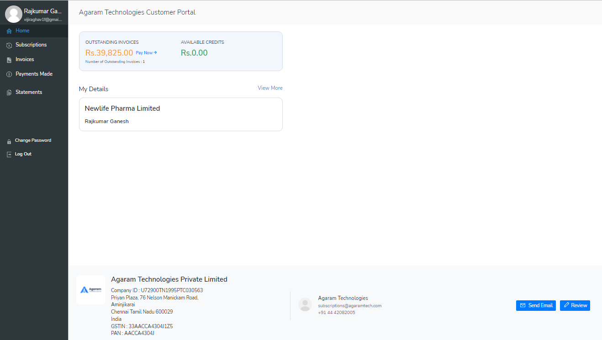

Click 'Send' button after entering all the required information in ’Mail To’ dialog pop-up.

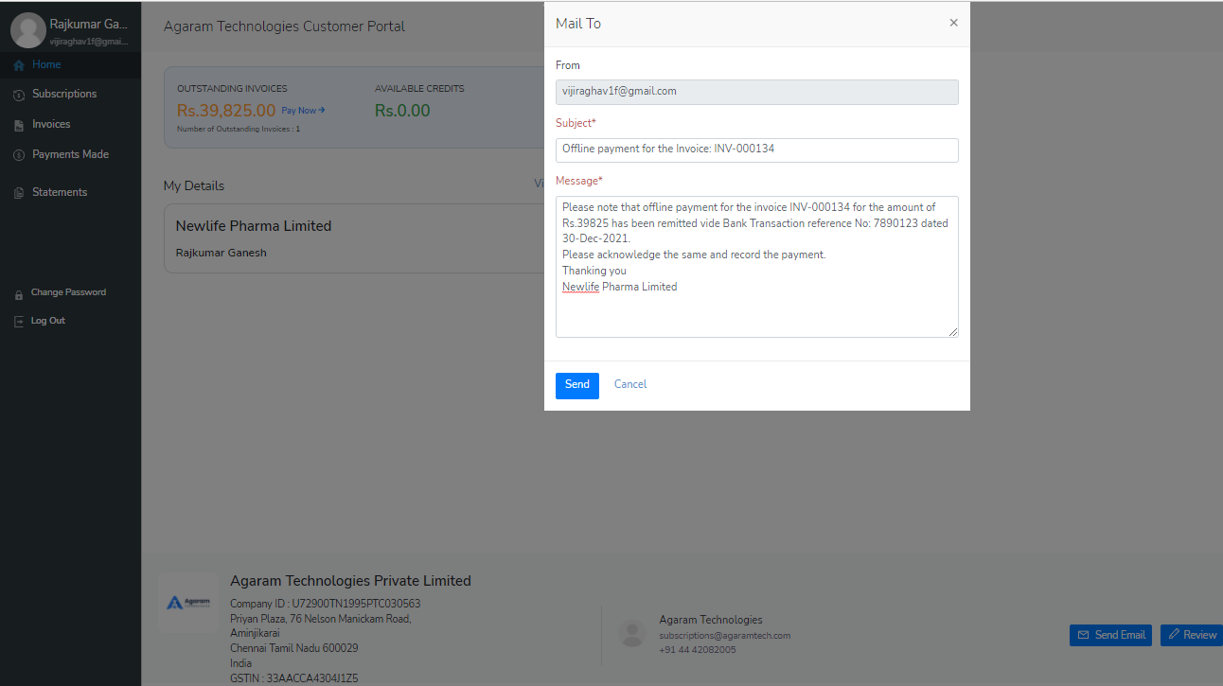



Confirmation message is displayed.

Log out of Customer portal.

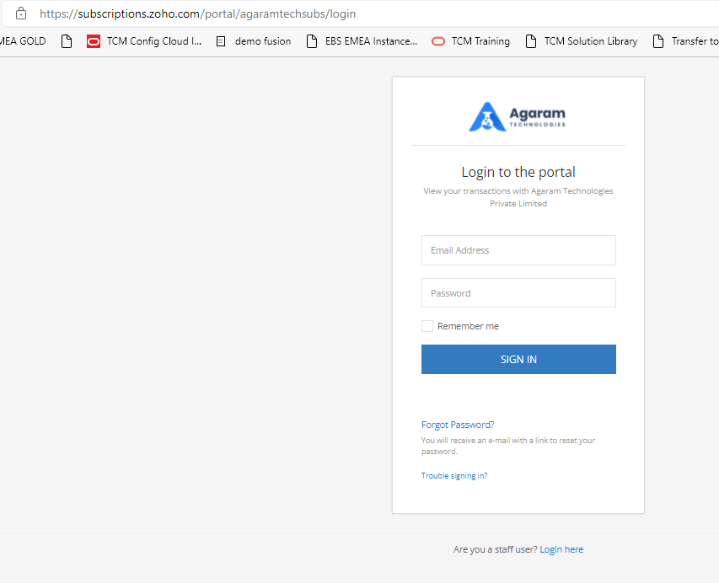

## Post-steps

The following steps will be performed after customer sends offline payment details to Receivables Admin

* The mail sent by customer from customer portal will be received by Receivables Admin.
* Receivables Admin will check with the bank and confirm the receipt of payment.
* Receivables Admin will then create payment record against the invoice in Zoho Subscription application.
* The customer will receive an automated email notification about the payment