STAT S 670 - Exploratory Data Analysis - Finals

Ganesh Nagarajan, gnagaraj@indiana.edu

December 14, 2015

# Solutions

1. Five R's of EDA
   * Resistance : The ability of the statistic/method to have minimum influence from an "Outlier" and remain faithful to the main body of the data points
   * Residuals: Examining Residuals to describe the quality of the fit, if required so using residuals as iterative parameters to update the fit.
   * Re-expression : Using Linear methods of Data Transformation to fit the data to $y=model+Residuals$ so that we might be able to analyse models that deviate from gaussian model
   * Revelation : Using Exploratory tools like Scatter Plots, Histograms, Residual vs Fit plots for data visualization, outlier detection and model conformance cheching.
   * Re-iteration : Iterative data fitting, can be best seen in resistant methods like Resistant Regression and Median polish where Residuals/Row-Column effects are calculated iteratively and consumed in the successive fits.
2. Five Number Summary : Five number summary gives an overall description of the data described by parameters
   * Sample Minimum
   * First Quantile
   * Median
   * Third Quantile
   * Sample Maximum

* #Generate 10 random numbers with mean 7 and sd 1  
  set.seed(1)  
  population <- rnorm(10,7,1)  
    
  #display population  
  print (population)
* ## [1] 6.373546 7.183643 6.164371 8.595281 7.329508 6.179532 7.487429  
  ## [8] 7.738325 7.575781 6.694612
* #display 5 number summary  
  fivenum(population)
* ## [1] 6.164371 6.373546 7.256576 7.575781 8.595281
* summary(population)
* ## Min. 1st Qu. Median Mean 3rd Qu. Max.   
  ## 6.164 6.454 7.257 7.132 7.554 8.595

1. Goals for Re-Expressing Data
   * Finding a suitable scale for data representation, Eg: Logrithmic, Square root etc for dimplyfying data analyis
   * Finding an transformation which promotes symmetry and transforms the data to a known distribution like Gaussian
   * Transforms data for straightness, spread etc to emphasis the straightness of an relationship
   * Convert complex multiplicative models to simple additive models with reduced complexity, Eg log transform converts a model say $y=ab$ to $logy=loga+logb$
   * Changing the scale of measurement to comply with the nature of the data
2. Detecting Long-Tailness
   * Long Tailness can be detected using visual methods like Histograms or q-q Plots.

* set.seed(123)  
    
  #Generate a tailed distribution  
  sample.pop<-rgamma(1000,shape=1)  
  par(mfrow=c(1,1),mfcol=c(1,2))  
    
  #Plot Histograms and q-q plots  
  hist(sample.pop,main="Histogram")  
  qqnorm(sample.pop)  
  qqline(sample.pop,col="red")
* 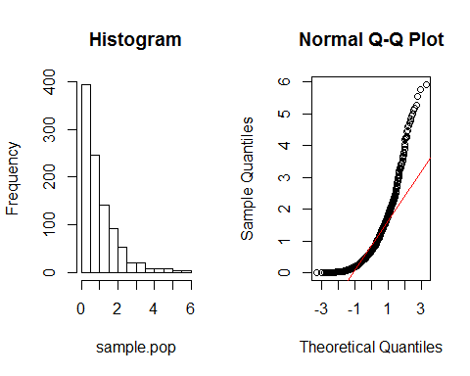
  + In the above example it can be seen that the distribution has heavy left tails, and this can be visually seen in both Histogtam and q-q plots.
  + Inorder to transform such data, few methods are Tukey's Power Transform, Transform for Symmetry and Transform for Straightness.
  + Tukey's power transform involves finding suitable power function to either "Pull In" or "Push out" the data points. example, for the above said distribution, we would need to pull in data, and according to Tukey's Power Transformation a cube root transform would be necessary.
* # Do a Cube Root Transform  
  sample.trans<-sample.pop^(1/3)  
  par(mfrow=c(1,1),mfcol=c(1,2))  
    
  #Plot the tail detection visualizations  
  hist(sample.trans,main="Histogram")  
  qqnorm(sample.trans)  
  qqline(sample.trans,col="red")
* 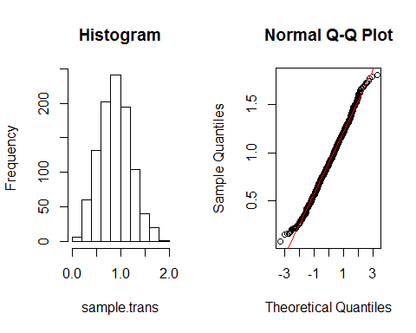
  + Other Methods like transforming for straightness and Spread involves plotting a letter value plot and using their fourth spread and midsummaries to calculate required parameters for data transformation.
  + Deterministic Method for calculating skewness and kurtosis includes the study of g-h estimates described as in the next question.

1. g-h estimates  
   From the Theory of G and H estimates,
   * g = 0 indicates no skewness, g $≤$ 0.25 = Slight Skewness, g ~ 1 implies highly skewed
   * h = 0, No long tails, h $≥$ 0 then increasingly longer tails

* Given that the given gh estimates,
  + (-0.5,0.3) has negative skewness and has light tails
  + (0.5,0.3) has positive skewness and light tails
  + (1,0.6) has high positive skewness and heavy tails

1. G - Estimates
2. q-q Plot

* a=c(1092,1137,1197,1237,1301,1523,1577,1619,1626,1644,1672,1748,1768,1780,1796,1816,1843,1844,1902,1919,1983,1993,2025,2028,2032,2036,2072,2078,2090,2137,2162,2163,2180,2185,2194,2225,2230,2233,2234,2235,2265,2270,2274,2281,2289,2319,2322,2357,2381,2398,2421,2421,2443,2522,2549,2552,2581,2618,2618,2620,2624,2642,2647,2666,2705,2721,2740,2804,2819,2823,2860,2873,2906,2913,2926,2929,2931,2931,2934,2939,2961,3020,3023,3044,3047,3048,3096,3174,3190,3199,3204,3222,3225,3278,3287,3292,3300,3339,3361,3412,3462,3503,3530,3589,3672,3734,3749,3783,3854,3901,3932,3995,4001,4006,4118,4134,4320,4346,4385,4401,4522,4565,4581,4593,4629,4855,4868,4878,4885,4907,4962,4975,5021,5127,5155,5160,5183,5229,5242,5379,5383,5513,5555,5619,5755,5774,5890,5899,5988,6161,6185,6818,7406,7419,8175,8220,8282,8827,9027,9042,9805)  
  # Plot QQ Plot  
  par(mfrow=c(1,2))  
  qqnorm(a,main="q-q Plot")  
  # Plot QQ Line  
  qqline(a)  
  #Histogram  
  hist(a,main="Histogram")
* 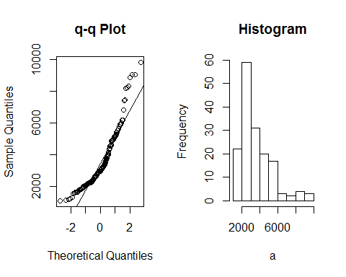
* By interpeting both Q-Q Plot and the Histogram, it is evident that the distribution of the given popultaion has light left tail and an heavy right tail. This is also evident in the histogram.
* source("lvalprogs.r")  
  source("rrline.r")  
  ll<-lval(a)  
  print(ll)
* ## Depth Lower Upper Mid Spread pseudo-s  
  ## M 81.0 2961.0 2961.0 2961.0 0 0.000  
  ## F 41.0 2265.0 4522.0 3393.5 2257 1673.117  
  ## E 21.0 1983.0 5383.0 3683.0 3400 1477.812  
  ## D 11.0 1672.0 6185.0 3928.5 4513 1470.875  
  ## C 6.0 1523.0 8220.0 4871.5 6697 1797.629  
  ## B 3.5 1217.0 8927.0 5072.0 7710 1789.798  
  ## A 2.0 1137.0 9042.0 5089.5 7905 1634.914  
  ## Z 1.5 1114.5 9423.5 5269.0 8309 1561.803  
  ## Y 1.0 1092.0 9805.0 5448.5 8713 1509.720
* There are 9 Levels, Hence the probability of expected quantile is $\frac{1}{2^{9}}$
* pp1 <- 1/2^(1:nrow(ll)-1)  
  gau1 <- abs(qnorm(pp1))  
  pp2 <- abs((pp1-1/3)/(nrow(ll)-1 + 1/3))  
  gau2 <- abs(qnorm(abs(pp2)))  
  est2.g <- log((ll[,3] - ll[1,2])/(ll[1,2]-ll[,2]))/gau2  
  print(round(cbind(pp1,pp2,gau1,gau2,est2.g),5))
* ## pp1 pp2 gau1 gau2 est2.g  
  ## M 1.00000 0.08000 Inf 1.40507 NaN  
  ## F 0.50000 0.02000 0.00000 2.05375 0.39330  
  ## E 0.25000 0.01000 0.67449 2.32635 0.38981  
  ## D 0.12500 0.02500 1.15035 1.95996 0.46774  
  ## C 0.06250 0.03250 1.53412 1.84526 0.70271  
  ## B 0.03125 0.03625 1.86273 1.79597 0.68481  
  ## A 0.01562 0.03812 2.15387 1.77287 0.67920  
  ## Z 0.00781 0.03906 2.41756 1.76167 0.71110  
  ## Y 0.00391 0.03953 2.66007 1.75615 0.73910
* #Plot L-Val Values Vs the G estimate  
  plot(1:8, est2.g[-1],  
  xlab = "Letter value number (1=F, 2=E, 3=D, ... , 8=Y)",  
  ylab = "Estimate of g")  
  abline(h=median(est2.g[-1]))  
  text(6.5,0.51,paste("median g = ",format(round(median(est2.g[-1]),3))))
* 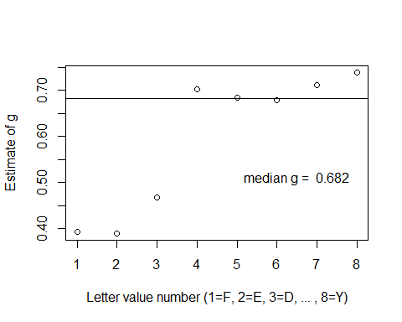
* # Estimation of g  
  est.g <- median(est2.g[-1])   
  print(est.g)
* ## [1] 0.6820059
* #Estimation of A and B  
  zp <- c(rev(qnorm(pp2)),abs(qnorm(pp2)))  
  yy <- c(rev(ll[,2]),ll[,3])  
  est.Y <- (exp(est.g*zp)-1)/est.g  
  #print(cbind(est.Y,yy))  
  plot(est.Y,yy,main="Estimate A and B")  
  rr <- run.rrline(est.Y,yy)
* ## a b |res|  
  ## 1 2798.903 1127.665 27227  
  ## 2 0.000 0.000 27227  
  ## 3 0.000 0.000 27227  
  ## 4 0.000 0.000 27227  
  ## 5 0.000 0.000 27227  
  ## 2798.903 1127.665 27227
* abline(rr$a, rr$b)
* 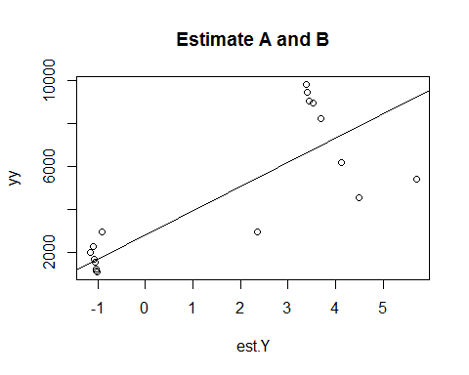
* print(paste("A Estimate ",rr$a," B Estimate ",rr$b))
* ## [1] "A Estimate 2798.90299991372 B Estimate 1127.6651769943"
* The G Estimates are as follows, g= 0.68, A= 2796, B=1127.
  1. Bootstrap Estimates
* library(ggplot2)  
   library(GGally)  
   g.dist.estimates<-function(sample.pop){  
   source("lvalprogs.r")  
   source("rrline.r")  
   ll<-lval(sample.pop)  
   pp1 <- 1/2^(1:nrow(ll)-1)  
   gau1 <- abs(qnorm(pp1))  
   pp2 <- abs((pp1-1/3)/(nrow(ll)-1 + 1/3))  
   gau2 <- abs(qnorm(abs(pp2)))  
   est2.g <- log((ll[,3] - ll[1,2])/(ll[1,2]-ll[,2]))/gau2  
    
   # Estimation of g  
   est.g <- median(est2.g[-1])   
   p <- c(0.005, 0.01, 0.025, 0.05, 0.1, 0.25, 0.5, 0.75, 0.9, 0.95, 0.975, 0.99, 0.995)  
   zp <- qnorm(p)  
   est.Y <- (exp(est.g*zp)-1)/est.g  
   rr <- run.rrline(est.Y,quantile(sample.pop,p))  
   #Run Resistant Regression for A and B Estimates  
   return (list(g=est.g,A=rr$a,B=rr$b))  
  }  
    
    
  bootstrap.g<-function(pops,sims){  
   g.est <- c()  
   A.est <- c()  
   B.est <- c()  
   for (i in 1:sims){  
  boot.sample<-sample(pops,length(pops),replace = TRUE)  
  r.val <- g.dist.estimates(boot.sample)  
  g.est[i]<-r.val$g  
  A.est[i]<-r.val$A  
  B.est[i]<-r.val$B  
   }  
   best.g <- mean(g.est)  
   g.lower <- best.g - qt(0.95,df=length(g.est)-1)*sd(g.est)  
   g.upper <- best.g + qt(0.95,df=length(g.est)-1)*sd(g.est)  
   best.A <- mean(A.est)  
   A.lower <- best.A - qt(0.95,df=length(A.est)-1)*sd(A.est)  
   A.upper <- best.A + qt(0.95,df=length(A.est)-1)*sd(A.est)  
   best.B <- mean(B.est)  
   B.lower <- best.B - qt(0.95,df=length(B.est)-1)*sd(B.est)  
   B.upper <- best.B + qt(0.95,df=length(B.est)-1)*sd(B.est)  
   cor.est <- cor (cbind(g.est,A.est,B.est))  
   es.plt <- ggpairs(as.data.frame(cbind(g.est,A.est,B.est)))  
   return(list(g=best.g,a=best.A,b=best.B,g.lower,g.upper,A.lower,A.upper,B.lower,B.upper,cor.est,es.plt))  
  }  
    
    
    
  a<-c(1092,1137,1197,1237,1301,1523,1577,1619,1626,1644,1672,1748,1768,1780,1796,1816,1843,1844,1902,1919,1983,1993,2025,2028,2032,2036,2072,2078,2090,2137,2162,2163,2180,2185,2194,2225,2230,2233,2234,2235,2265,2270,2274,2281,2289,2319,2322,2357,2381,2398,2421,2421,2443,2522,2549,2552,2581,2618,2618,2620,2624,2642,2647,2666,2705,2721,2740,2804,2819,2823,2860,2873,2906,2913,2926,2929,2931,2931,2934,2939,2961,3020,3023,3044,3047,3048,3096,3174,3190,3199,3204,3222,3225,3278,3287,3292,3300,3339,3361,3412,3462,3503,3530,3589,3672,3734,3749,3783,3854,3901,3932,3995,4001,4006,4118,4134,4320,4346,4385,4401,4522,4565,4581,4593,4629,4855,4868,4878,4885,4907,4962,4975,5021,5127,5155,5160,5183,5229,5242,5379,5383,5513,5555,5619,5755,5774,5890,5899,5988,6161,6185,6818,7406,7419,8175,8220,8282,8827,9027,9042,9805)  
  bs.val <- bootstrap.g(a,1000)
* print(paste("The g Estimate is ", bs.val[1]))
* ## [1] "The g Estimate is 0.641669506755099"
* print(paste(" and Confidence interval is between", bs.val[4],   
   " and ", bs.val[5]))
* ## [1] " and Confidence interval is between 0.521871831174727 and 0.761467182335472"
* print(paste("The A Estimate is ", bs.val[2]))
* ## [1] "The A Estimate is 2913.49184610751"
* print(paste(" and Confidence interval is between", bs.val[6],   
   " and ", bs.val[7]))
* ## [1] " and Confidence interval is between 2719.53477970354 and 3107.44891251147"
* print(paste("The B Estimate is ", bs.val[3]))
* ## [1] "The B Estimate is 1232.00294638049"
* print(paste(" and Confidence interval is between", bs.val[8],   
   " and ", bs.val[9]))
* ## [1] " and Confidence interval is between 1086.31037266022 and 1377.69552010075"
  + Correlation Matrix :
* print(bs.val[10])
* ## [[1]]  
  ## g.est A.est B.est  
  ## g.est 1.0000000 -0.5292720 -0.3418948  
  ## A.est -0.5292720 1.0000000 0.6518705  
  ## B.est -0.3418948 0.6518705 1.0000000
  + Pairs Plot:
* print(bs.val[11])
* ## [[1]]
* 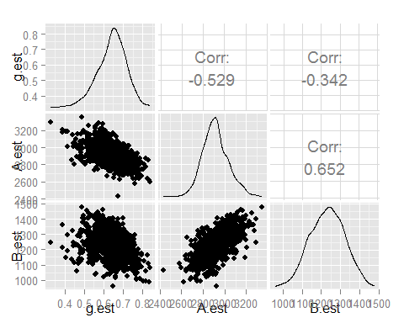
  1. Transforming back to Normalcy :
* Given the values, transforming this to normalcy.

g<-bs.val$g  
A<-bs.val$a  
B<-bs.val$b  
z<- 1/g*log(((a-A)*g)/B +1)  
par(mfrow=c(1,2))  
hist(z)  
qqnorm(z)

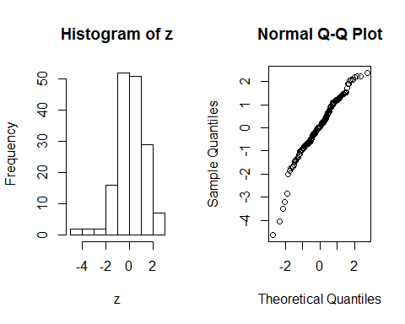

Once transformed, both the tails are now less affected and is near to the normal distribution. However, there is still skewness in the left tail.

1. GoF Tests + Pearson's Test

* gof.pearson=function (x,nbins) {  
   n = length(x)   
   m = floor(n/nbins)   
   k = n - m*nbins # This is the remainder   
   xx=sort(x)   
   index = rep(1:nbins,m)  
   if(k >0){ d=sample(1:nbins,k,replace=FALSE);   
   index=c(index,d) }   
   bincount=as.numeric(table(index))   
   binindicies = cumsum(bincount)   
   binbreaks = rev(rev(xx[binindicies])[-1])   
   binbreaks = c(-Inf,binbreaks,Inf)   
   bins=cut(x,breaks=binbreaks)  
   internalbreaks = rev(rev(xx[binindicies])[-1])   
   p = pnorm(internalbreaks,mean(x),sd(x))  
   p = c(p[1],diff(p),1-pnorm(max(internalbreaks),mean(x),sd(x)))  
   exp = n*p  
   df = data.frame(bin=levels(bins),bincount=bincount,prob=p,expectedcount=exp)  
   chisqstat = sum((bincount - exp)^2/exp)  
   pval = 1- pchisq(chisqstat,nbins-1)  
   output = list(df=df,chisq=chisqstat,pval=pval)  
   output = list(df=df,chisq=chisqstat,pval=pval)  
   }  
   out.p<-gof.pearson(z,2*sqrt(length(z))) #usinf Velleman rule  
   out.p
* ## $df  
  ## bin bincount prob expectedcount  
  ## 1 (-Inf,-2.01] 6 0.04068310 6.549979  
  ## 2 (-2.01,-1.41] 7 0.06676198 10.748678  
  ## 3 (-1.41,-1.14] 7 0.05004384 8.057058  
  ## 4 (-1.14,-0.899] 7 0.05360335 8.630139  
  ## 5 (-0.899,-0.75] 6 0.03826684 6.160961  
  ## 6 (-0.75,-0.681] 6 0.01903148 3.064068  
  ## 7 (-0.681,-0.613] 6 0.01922849 3.095786  
  ## 8 (-0.613,-0.462] 6 0.04520750 7.278407  
  ## 9 (-0.462,-0.26] 7 0.06411529 10.322562  
  ## 10 (-0.26,-0.179] 7 0.02680290 4.315267  
  ## 11 (-0.179,-0.044] 6 0.04527012 7.288489  
  ## 12 (-0.044,0.0141] 7 0.01965413 3.164315  
  ## 13 (0.0141,0.102] 6 0.02987868 4.810468  
  ## 14 (0.102,0.216] 6 0.03823414 6.155697  
  ## 15 (0.216,0.28] 6 0.02146109 3.455235  
  ## 16 (0.28,0.417] 6 0.04479630 7.212205  
  ## 17 (0.417,0.621] 7 0.06365008 10.247663  
  ## 18 (0.621,0.759] 6 0.04010828 6.457433  
  ## 19 (0.759,0.948] 6 0.05072748 8.167125  
  ## 20 (0.948,1.09] 6 0.03506716 5.645812  
  ## 21 (1.09,1.15] 6 0.01345869 2.166850  
  ## 22 (1.15,1.24] 6 0.01752753 2.821932  
  ## 23 (1.24,1.42] 7 0.03445175 5.546732  
  ## 24 (1.42,1.73] 6 0.04507174 7.256550  
  ## 25 (1.73, Inf] 6 0.07689808 12.380590  
  ##   
  ## $chisq  
  ## [1] 33.46522  
  ##   
  ## $pval  
  ## [1] 0.1036767
* ECDF Based

library("goftest")  
#Kolmogorov Test  
ks.test(z,"pnorm")

## Warning in ks.test(z, "pnorm"): ties should not be present for the  
## Kolmogorov-Smirnov test

##   
## One-sample Kolmogorov-Smirnov test  
##   
## data: z  
## D = 0.08551, p-value = 0.1897  
## alternative hypothesis: two-sided

#Anderson-Darling Test  
ad.test(z,"pnorm")

##   
## Anderson-Darling test of goodness-of-fit  
## Null hypothesis: Normal distribution  
##   
## data: z  
## An = 1.7337, p-value = 0.1294

#Cramer-von-Mises Test  
cvm.test(z,"pnorm")

##   
## Cramer-von Mises test of goodness-of-fit  
## Null hypothesis: Normal distribution  
##   
## data: z  
## omega2 = 0.20164, p-value = 0.2645

#Correlation of the QQ Data test  
qqnorm(z)  
qqline(z)

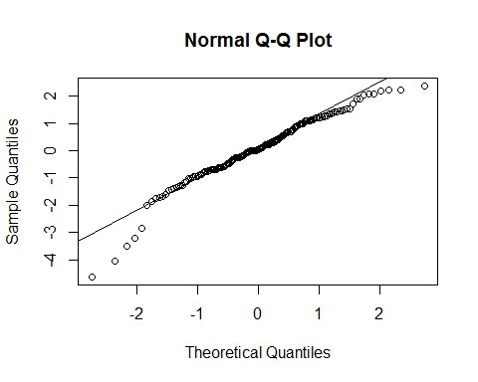

#Shapiro Wilk's Test  
shapiro.test(z)

##   
## Shapiro-Wilk normality test  
##   
## data: z  
## W = 0.95878, p-value = 0.0001055

* Inferences : Wilks Test : p-values suggest that the distribution is normal.
* P values from ECDF Tests doesn't suggest that much normality as the shapiro-wilks Test.
* Pearson Gof: On a smaller sample size, Pearson GoF Tests doesn't perform quite well. This can be identified from the test results and the p-value.
* q-q Plot: Easiest of the above GoFs, visual way of interpreting normality. Can be seen that the qq plot has slight lower tails, however the data seems more normal than it was without transformation.

1. H- Distribution

b =c(12.87,15.09,17.39,18.62,20.24,23.76,24.35, 24.74,24.81,24.96,25.19,25.75,25.89,25.97, 26.07,26.19,26.35,26.36,26.67,26.76,27.07, 27.12,27.26,27.28,27.30,27.31,27.46,27.49, 27.54,27.72,27.81,27.82,27.88,27.90,27.93, 28.03,28.05,28.06,28.07,28.07,28.17,28.19, 28.20,28.22,28.25,28.34,28.35,28.46,28.53,28.58,28.64,28.65,28.70,28.92,28.99,29.00, 29.07,29.16,29.16,29.17,29.18,29.22,29.23, 29.28,29.37,29.40,29.45,29.59,29.62,29.63, 29.71,29.74,29.81,29.82,29.85,29.86,29.86, 29.86,29.87,29.88,29.92,30.04,30.05,30.09, 30.09,30.10,30.19,30.34,30.37,30.38,30.39, 30.43,30.43,30.53,30.55,30.55,30.57,30.64, 30.68,30.77,30.86,30.93,30.98,31.08,31.22, 31.32,31.35,31.41,31.52,31.60,31.65,31.76, 31.76,31.77,31.96,31.98,32.28,32.33,32.39, 32.42,32.61,32.68,32.71,32.73,32.79,33.15, 33.18,33.19,33.20,33.24,33.33,33.35,33.43, 33.60,33.65,33.66,33.70,33.77,33.80,34.03, 34.03,34.26,34.33,34.44,34.68,34.71,34.91, 34.93,35.09,35.40,35.44,36.63,37.81,37.84, 39.47,39.58,39.72,41.00,41.49,41.52,43.50)  
par(mfrow=c(1,2))  
hist(b,prob=TRUE)  
qqnorm(b)  
qqline(b)

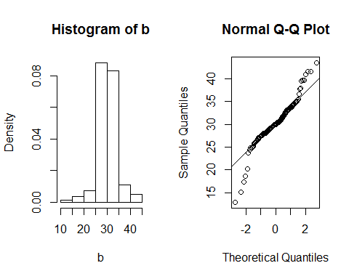

From the interpretation of the q-q plot, it is clear that the distribution has tails.

* Normal Estimates for A, B and h

est.h<-function(b){  
 source("lvalprogs.r")  
 source("rrline.r")  
 ll <- lval(b)   
 n<-length(b)  
 gh2.data <- b  
 ll.gh2 <- lval(gh2.data)  
 yy.gh2 <- log(ll.gh2[-1,6])  
 xx.gh2 <- (qnorm((ll.gh2[-1,1] - 1/3)/(161 + 1/3)))^2/2   
 plot(xx.gh2,yy.gh2,main="Estimate h and B",   
 ylab="log(pseudo-sigma)", xlab=expression(z[p]^2/2))  
 rr <- run.rrline(xx.gh2,yy.gh2)  
 abline(rr$a, rr$b)  
 return(list(h=rr$b,A=median(b),B=exp(rr$a)))  
}  
normal.h<-est.h(b)

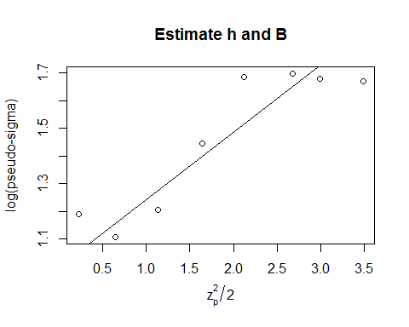

## a b |res|  
## 1 1.08115 0.20809 0.69095  
## 2 -0.08373 0.03595 0.74816  
## 3 0.00000 0.00000 0.74816  
## 4 0.00000 0.00000 0.74816  
## 5 0.00000 0.00000 0.74816  
## 0.99741 0.24404 0.74816

print (paste("H estimate is",normal.h$h))

## [1] "H estimate is 0.24404266941269"

print (paste("A estimate is",normal.h$A))

## [1] "A estimate is 29.92"

print (paste("B estimate is",normal.h$B))

## [1] "B estimate is 2.71126231385263"

est.h<-function(b){  
 source("lvalprogs.r")  
 source("rrline.r")  
 ll <- lval(b)   
 n<-length(b)  
 gh2.data <- b  
 ll.gh2 <- lval(gh2.data)  
 yy.gh2 <- log(ll.gh2[-1,6])  
 xx.gh2 <- (qnorm((ll.gh2[-1,1] - 1/3)/(161 + 1/3)))^2/2   
 #plot(xx.gh2,yy.gh2,main="Estimate h and B",   
 # ylab="log(pseudo-sigma)", xlab=expression(z[p]^2/2))  
 rr <- run.rrline(xx.gh2,yy.gh2)  
   
 return(list(h=rr$b,A=median(b),B=exp(rr$a)))  
}  
  
bootstrap.h<-function(pop,sims){  
 library(GGally)  
 est.h <-c()  
 est.A <-c()  
 est.B <-c()  
 for (i in 1:sims){  
 b<-sample(pop,length(pop),replace = TRUE)  
 b.sample <- est.h(b)  
 est.h[i]<- b.sample$h  
 est.A[i]<- b.sample$A  
 est.B[i]<- b.sample$B  
 }  
 best.h <- mean(est.h)  
 g.lower <- best.h - qt(0.95,df=length(est.h)-1)*sd(est.h)  
 g.upper <- best.h + qt(0.95,df=length(est.h)-1)*sd(est.h)  
 best.A <- mean(est.A)  
 A.lower <- best.A - qt(0.95,df=length(est.A)-1)*sd(est.A)  
 A.upper <- best.A + qt(0.95,df=length(est.A)-1)*sd(est.A)  
 best.B <- mean(est.B)  
 B.lower <- best.B - qt(0.95,df=length(est.B)-1)*sd(est.B)  
 B.upper <- best.B + qt(0.95,df=length(est.B)-1)*sd(est.B)  
 cor.est <- cor (cbind(est.h,est.A,est.B))  
 es.plt <- ggpairs(as.data.frame(cbind(est.h,est.A,est.B)))  
 return(list(h=best.h,A=best.A,B=best.B,gcil=g.lower,gciu=g.upper,Acil=A.lower,Aciu=A.upper,bcil=B.lower,bciu=B.upper,cor.est=cor.est,es.plt=es.plt))  
}  
s <- bootstrap.h(b,1000)

* Estimates for A, B and H and Their 90 % Confidence Intervals

print(paste("The H estimate is ",s$h))

## [1] "The H estimate is 0.192731211674053"

print(paste("C.I is between",s$gcil," and ",s$gciu))

## [1] "C.I is between 0.106892537807329 and 0.278569885540777"

print(paste("The A estimate is ",s$A))

## [1] "The A estimate is 29.99515"

print(paste("C.I is between",s$Acil," and ",s$Aciu))

## [1] "C.I is between 29.6154082490898 and 30.3748917509102"

print(paste("The B estimate is ",s$B))

## [1] "The B estimate is 2.94842740518267"

print(paste("C.I is between",s$bcil," and ",s$bciu))

## [1] "C.I is between 2.32254814641151 and 3.57430666395383"

* Co-Relation Pairs

#Co-Relation Plot  
s$cor.est

## est.h est.A est.B  
## est.h 1.0000000 -0.1359497 -0.7693468  
## est.A -0.1359497 1.0000000 0.1285403  
## est.B -0.7693468 0.1285403 1.0000000

* Pairs Plot

#Pairs Plot  
print(s$es.plt)

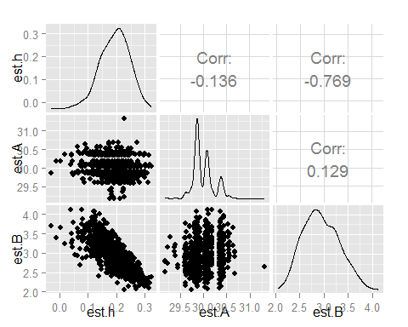

1. Transform For Normality and GoF Tests

HDistBackXform=function(h,A,B,data){  
###################################  
# This function will allow you to back solve for Z  
# under any H-distribution transform  
# the Values h, A, and B are the estimated values of  
# the H-distribution parameters. In this program  
# data is a vector of data.  
###################################  
   
n=length(data)  
 #using Veleman's rule  
output=numeric(n)  
g=function(z){z*exp(h*z^2)-((x-A)/B)}  
# Begin loop on i where data[i] is the ith data value  
for(i in 1:n){  
x=data[i]  
obj=uniroot(g,interval=c(-6,6))  
output[i]=obj$root  
}  
return(output)  
}  
  
h<-normal.h$h  
A<-normal.h$A  
B<-normal.h$B  
   
z<-HDistBackXform(h,A,B,b)  
par(mfrow=c(1,2),mar = c(4, 4, 2, 1), oma = c(0, 0, 2, 0))  
hist(z,prob=TRUE)  
lines(density(z),col="blue")  
qqnorm(z)  
qqline(z,col="red")

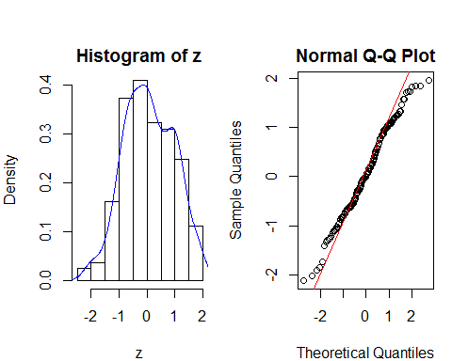

* Veleman's Rule for Pearson's GoF

noofbins=2*sqrt(length(z))  
out<-gof.pearson(z,noofbins)  
out

## $df  
## bin bincount prob expectedcount  
## 1 (-Inf,-1.4] 6 0.04775222 7.688107  
## 2 (-1.4,-1.13] 6 0.03979728 6.407362  
## 3 (-1.13,-1.02] 6 0.02108262 3.394302  
## 4 (-1.02,-0.82] 7 0.04762529 7.667671  
## 5 (-0.82,-0.692] 6 0.03691758 5.943731  
## 6 (-0.692,-0.624] 7 0.02180950 3.511329  
## 7 (-0.624,-0.569] 7 0.01842103 2.965786  
## 8 (-0.569,-0.449] 6 0.04318942 6.953497  
## 9 (-0.449,-0.306] 6 0.05622901 9.052870  
## 10 (-0.306,-0.251] 6 0.02309947 3.719014  
## 11 (-0.251,-0.11] 6 0.06031892 9.711347  
## 12 (-0.11,-0.0258] 6 0.03739291 6.020259  
## 13 (-0.0258,0] 6 0.01152358 1.855296  
## 14 (0,0.154] 7 0.06903701 11.114959  
## 15 (0.154,0.222] 6 0.03039341 4.893339  
## 16 (0.222,0.337] 7 0.05022699 8.086545  
## 17 (0.337,0.515] 7 0.07382803 11.886314  
## 18 (0.515,0.621] 6 0.04081552 6.571299  
## 19 (0.621,0.791] 6 0.05949567 9.578803  
## 20 (0.791,0.954] 6 0.04892302 7.876607  
## 21 (0.954,0.994] 6 0.01079519 1.738025  
## 22 (0.994,1.07] 6 0.01975675 3.180837  
## 23 (1.07,1.18] 6 0.02491813 4.011818  
## 24 (1.18,1.33] 7 0.02649182 4.265183  
## 25 (1.33, Inf] 7 0.08015963 12.905700  
##   
## $chisq  
## [1] 48.79955  
##   
## $pval  
## [1] 0.002337613

1. Estimation of Mode:

data = rnorm(100, 3, 2)  
  
getGaussianMax = function(data){  
 d = density(data, kernel="gaussian")  
 index = which(d$y == max(d$y), arr.ind =TRUE)  
 ans = d$x[index]  
 return(ans)  
}  
  
calculatePseudoValues = function(data) {  
 n = length(data)  
 y.all = getGaussianMax(data)  
 PV = numeric(n)  
 for( i in 1:n) {  
 yminusi = getGaussianMax(data[-i])  
 PV[i] = n*y.all - (n-1)*yminusi  
 }  
 return(PV)  
}  
  
PVAll = calculatePseudoValues(data)  
n = length(PVAll)  
print(paste("The Mode is ",mean(PVAll) ))

## [1] "The Mode is 2.23153558113482"

#Jack Knife Estimates  
  
jackKnifeEstimate = mean(PVAll)  
varJK = sum((PVAll - jackKnifeEstimate)^2)/(n*(n-1))  
seJK = sqrt(varJK)  
print(paste("The Standard Error of Jackknife Estimator",seJK))

## [1] "The Standard Error of Jackknife Estimator 0.4260511378212"

#Bootstrap Estimates'  
getbootstrapestimate = function(data, sims) {  
 theta = numeric(sims)  
 varTheta = numeric(sims)  
   
 n = length(data)  
 index = 1:n  
 for (i in 1:sims){  
 sampleindex= sample(index,n,replace=TRUE)  
 theta[i] = mean(getGaussianMax(data[sampleindex]))  
 }  
   
 return(list(thetaBS = mean(theta), varBS = var(theta), seBS = sqrt(var(theta))))  
}  
  
BS = getbootstrapestimate(data, 100)$seBS   
print(paste("The Standard Error of Bootstrap Estimates",BS))

## [1] "The Standard Error of Bootstrap Estimates 0.541847270210404"

* It can be seen from the abive numbers that, here Jackknifing performed better than bootstrapping for the given dataset

1. Fitting an Resistant Regression Line

* Raison d'etre of Resistant Regression is to be not to be influenced by the outliers or aberrant values.
* Following are the steps to perform an resistant regression
  + sort the values of x and divide these into three groups ie $(x_{L},yL),(x_{M},y_{M}),(x_{R},y_{R})$
  + Find the resistant summary statistic ie median (median x,median y) in the extremes , ie R and L extremes
  + The Slope is given by the following expression. All statistics are median here. $b=\frac{y_{R}-yL}{x_{R}-xL}$
  + The Intercept is given as follows, $a_{0}=\frac{1}{3}[(y_{L}-b_{0}x_{L})+(y_{M}-b_{0}x_{M})+(y_{R}-b_{0}x_{R})]$
  + The residuals are then ireratively used to adjust the regression parameteres till an threshold is reached.
* Advantages of Resistant Regression:
  + Less susceptible to the effect of outliers as median is more robust than mean
  + Asymptotically efficient than OLS per step
* Disadvantages of Resistant Regression:
  + Its an iterative process, hence requires iterations
  + Computations directly corresponds to resistance required. Eg, More groups can be used for RR. This requires more computational power
  + No formulic solution. Hence RR methods iterates before converging.

1. Jackknifing and Bootstrapping:
   * Both Jackknifing and Bootstrapping are re-sampling methods used to find variance, bias and standard estimate of almost all types of statistic/estimators. Historically Jackknife was the predecessor of bootstrapping. Following are the ways in which they are similar,
   * **Sampling**
     + Jackknifing: The sample for jackknifing is calculated with leave one out and calculate the estimate with rest of the values.
     + Bootstrapping: Bootstrapping instead follows an broader approach of re-sampling the distribution. The sampling is done with replacement from the sample poplulation. The key idea is that multiple sampling of the sample poplulation directly represents the true distribution of the sample. Thus generally bootstrapping gives an better estimate of the two
     + *Consequece* : Bootstrapping gives an better estimate and better model for understanding variability and bias. However since due to the nature of sampling, the estimates differ every time the method was repeated. However Jackknifing always produces an exact result.
   * *Obtaining Estimates and Standard Errors* : Due to the nature of sampling, bootstrapping requires more space and computational complexity. However Jackkife produces easier asymptotic complexity and reproduceable results.
   * Jackkinfing is mainly used to understand the bias of an point estimator. However bootstrapping helps simulating the true distribution, hence can be applied for nearly all estimation methods.
2. Inventions Dataset
3. Tabulate the dataset

library(e1071)  
library(vcd)

## Loading required package: grid

library(kequate)

## Loading required package: ltm  
## Loading required package: MASS  
## Loading required package: msm  
## Loading required package: polycor  
## Loading required package: mvtnorm  
## Loading required package: sfsmisc

inv.ds <- c(5,3,0,2,0,3,2,3,6,1,2,1,2,1,3,3,3,5,2,4,  
 4,0,2,3,7,12,3,10,9,2,3,7,7,2,3,3,6,2,4,3,  
 5,2,2,4,0,4,2,5,2,3,3,6,5,8,3,6,6,0,5,2,  
 2,2,6,3,4,4,2,2,4,7,5,3,3,0,2,2,2,1,3,4,  
 2,2,1,1,1,2,1,4,4,3,2,1,4,1,1,1,0,0,2,0)  
  
# Tabulation of inventions  
table(inv.ds)

## inv.ds  
## 0 1 2 3 4 5 6 7 8 9 10 12   
## 9 12 26 20 12 7 6 4 1 1 1 1

#Histogram of the distibution:  
hist(table(inv.ds),main="Histogram of Inventions Dataset")

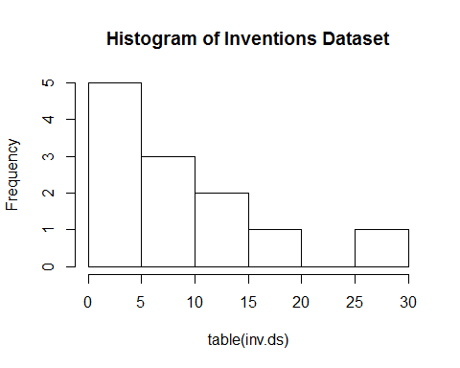 + By looking at the histogram and frequency table, it can be seen the distribution seems to be similar to poisson distribution

1. Poissonness Plot

# Draw Poisson Plot  
distplot(table(inv.ds), type = "poisson")

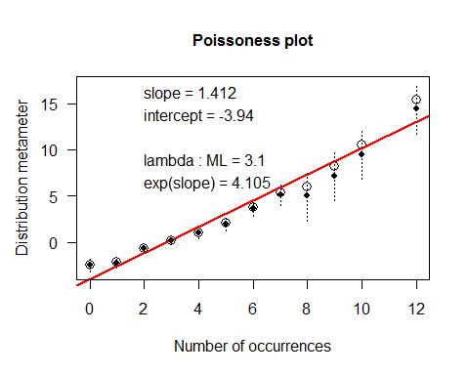

skewness(table(inv.ds))

## [1] 0.8758157

kurtosis(table(inv.ds))

## [1] -0.4820701

# Freeman Tukey Residuals  
ft.res<-FTres(table(inv.ds), sapply(as.array(table(inv.ds)),function(x){(1.142*x-3.94)}))

## Warning in sqrt(4 * fit[i] + 1): NaNs produced

## Warning in sqrt(4 * fit[i] + 1): NaNs produced

## Warning in sqrt(4 * fit[i] + 1): NaNs produced

## Warning in sqrt(4 * fit[i] + 1): NaNs produced

par(mfrow=c(1,2))  
plot(ft.res)  
abline(h=c(-2,0,2),lty=c(2,1,2),col=c(2,1,2))  
qqnorm(ft.res)  
qqline(ft.res)

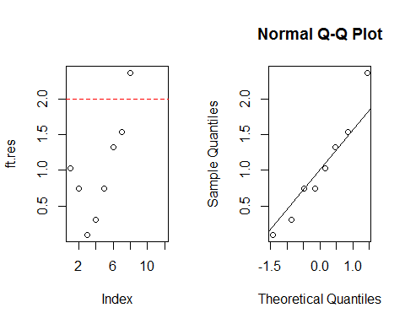

* From the qq plot, it can be inferred that if the distribution is similar to poisson, the freeman-tukey residuals have a normal distribution
* Few points deviate from the poissonness plot.

1. For an observed frequency $n_{i}$ and the estimated frequency $m_{i}$, Freeman Tukey residuals are given by $\sqrt{n_{i}}+\sqrt{n_{i}+1}-\sqrt{4m_{i}+1}$. From lecture notes, it is suggested that the above residuals are used to stabilize the variance in thr transformed data, whose behaviour resembles an standard normal. As with the theory, the qq plot shown in the last subdivision proves that this is normally distrbuted and the FT residuals does look reasonable.
2. Median Polish for Co2 Data

r1<-c(16,13.6,16.2,14.2,9.3,15.1,10.6,12,11.3,10.5,7.7,10.6)  
 r2<-c(30.4,27.3,32.4,24.1,27.3,21,19.2,22,19.4,14.9,11.4,18)  
 r3<-c(34.8,37.1,40.3,30.3,35,38.1,26.2,30.6,25.8,18.1,12.3,17.9)  
 r4<-c(37.2,41.8,42.1,34.6,38.8,34,30,31.8,27.9,18.9,13,17.9)  
 r5<-c(35.3,40.6,42.9,32.5,38.6,38.9,30.9,32.4,28.5,19.5,12.5,17.9)  
 r6<-c(39.2,41.4,43.9,35.4,37.5,39.6,32.4,31.1,28.1,22.2,13.7,18.9)  
 r7<-c(39.7,44.3,45.5,38.7,42.4,41.4,35.5,31.5,27.8,21.9,14.4,19.9)  
  
 df<-rbind(r1,r2,r3,r4,r5,r6,r7)  
 colnames(df)<-c(111,211,311,412,512,612,721,821,921,1022,1122,1222)  
 rownames(df)<-c(95,175,250,350,500,675,1000)  
 results<-medpolish(df)

## 1: 174.4  
## 2: 162.35  
## Final: 161.5375

results

##   
## Median Polish Results (Dataset: "df")  
##   
## Overall: 33.0125  
##   
## Row Effects:  
## 95 175 250 350 500 675 1000   
## -20.1375 -9.9625 -2.0500 0.0000 0.2125 1.3750 3.0000   
##   
## Column Effects:  
## 111 211 311 412 512 612 721 821   
## 3.8375 7.0125 9.3500 1.0500 4.2500 5.2125 -2.3250 -1.0500   
## 921 1022 1122 1222   
## -5.1125 -12.8625 -20.0125 -15.1125   
##   
## Residuals:  
## 111 211 311 412 512 612 721 821  
## 95 -0.7125 -6.2875 -6.0250 0.2750 -7.8250 -2.9875 0.0500 0.1750  
## 175 3.5125 -2.7625 0.0000 0.0000 0.0000 -7.2625 -1.5250 0.0000  
## 250 0.0000 -0.8750 -0.0125 -1.7125 -0.2125 1.9250 -2.4375 0.6875  
## 350 0.3500 1.7750 -0.2625 0.5375 1.5375 -4.2250 -0.6875 -0.1625  
## 500 -1.7625 0.3625 0.3250 -1.7750 1.1250 0.4625 0.0000 0.2250  
## 675 0.9750 0.0000 0.1625 -0.0375 -1.1375 0.0000 0.3375 -2.2375  
## 1000 -0.1500 1.2750 0.1375 1.6375 2.1375 0.1750 1.8125 -3.4625  
## 921 1022 1122 1222  
## 95 3.5375 10.4875 14.8375 12.8375  
## 175 1.4625 4.7125 8.3625 10.0625  
## 250 -0.0500 0.0000 1.3500 2.0500  
## 350 0.0000 -1.2500 0.0000 0.0000  
## 500 0.3875 -0.8625 -0.7125 -0.2125  
## 675 -1.1750 0.6750 -0.6750 -0.3750  
## 1000 -3.1000 -1.2500 -1.6000 -1.0000

The Row and Column effects of the Dataset are as above. Regarding the patterns in residuals,

symbolPlot<-function(mat){  
 result<-medpolish(mat)  
 res<-c(result$residuals)  
 genNos<-expand.grid(1:7,1:12)  
 plotvar<-cbind(genNos$Var2,genNos$Var1,res)  
 pos<-plotvar[plotvar[,3]>=0,]  
 max<-sum(abs(pos[,3]))  
 symbols(pos[,1],pos[,2],squares = 3*(abs(pos[,3]/(max))),inches = FALSE,xlab="Columns",ylab="Rows",main="Symbol Plot")  
 pos<-plotvar[plotvar[,3]<0,]  
 symbols(pos[,1],pos[,2],circles = 3*(abs(pos[,3]/(max))),inches = FALSE,add = TRUE)  
}  
  
symbolPlot(df)

## 1: 174.4  
## 2: 162.35  
## Final: 161.5375

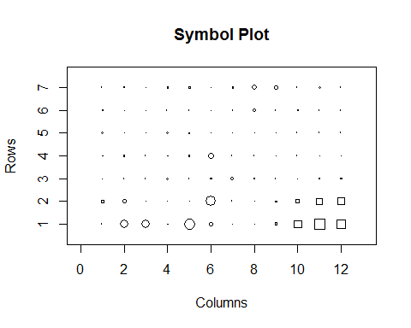

* It can be seen that there are no visible patterns in the residuals, which is good. ie the model explains the variability and the data well.

1. Measure to calculate variability:

Analog_R_Square<- 1-((sum(abs(results$residuals))) /(sum(abs(df-results$overall))))  
 print(paste("Variability Measure, Analog R Square :",Analog_R_Square))

## [1] "Variability Measure, Analog R Square : 0.808064755680974"

1. Diagnostic Plot:

diag.MP <- function(fit){  
 source("rrline.r")  
 fit.comp <- matrix(fit$row,ncol=1) %*% matrix(fit$col,nrow=1)/fit$overall  
 plot(fit.comp, fit$res,xlab="Comparison value",ylab="Residual",cex=0.5)  
 abline(v=0,h=0,lty=2)  
 ls <- lm(c(fit$res)~c(fit.comp))  
 abline(ls,col="red",lty=3)   
 rr <- run.rrline(fit.comp,fit$res,iter=10)   
 abline(rr$a, rr$b, col="red")  
 pwr1 <- 1 - rr$b  
 pwr2 <- 1 - ls$coef[2]  
 title("",paste("Approximate power =",format(round(pwr1,2))," or ", format(round(pwr2,2))))  
}  
  
diag.MP(results)

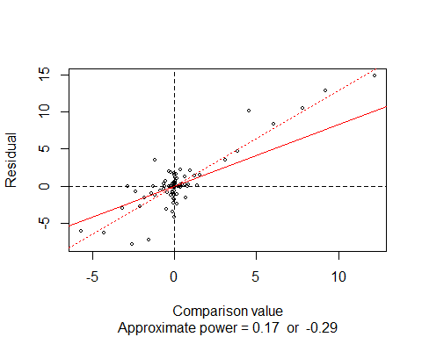

## a b |res|  
## 1 0.01939 0.90105 104.3848  
## 2 -0.01756 -0.08196 108.8667  
## 3 0.00145 0.01096 108.2604  
## 4 -0.00011 -0.00083 108.3064  
## 5 0.00001 0.00006 108.3029  
## 6 0.00000 0.00000 108.3032  
## 7 0.00000 0.00000 108.3032  
## 8 0.00000 0.00000 108.3032  
## 9 0.00000 0.00000 108.3032  
## 10 0.00000 0.00000 108.3032  
## 0.00318 0.82928 108.3032

* Diagnostic plots help to indicate a power transform for "Transform for additivity".
* With median polish as conext, diagnostic plot have comparision values $\frac{a_{i}b_{i}}{m}$ vs the residual when the model for additivity is $y_{ij}=m+a_{i}+b_{j}+r_{ij}$, where m, $a_{i},b_{j}$ are resistantly determined estimates for the common value
* And $r_{ij}=y_{ij}-(m+a_{i}+b_{j})$ the residuals from additive fit.

1. Re-Expression as suggested by Diagnostic Plot.
   * As suggested by the diagnostic plot, an re-expression is done as follows,

#Power Transform  
df.t<-(df)^(0.17)  
results.t<-medpolish(df.t)

## 1: 1.76713  
## 2: 1.487822  
## Final: 1.47599

#Diagnostic Plot of Transformed Data  
diag.MP(results.t)

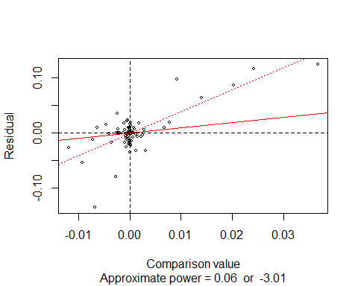

## a b |res|  
## 1 0 0.35964 1.42878  
## 2 0 0.20010 1.40399  
## 3 0 0.13288 1.38757  
## 4 0 0.08825 1.37667  
## 5 0 0.05861 1.36943  
## 6 0 0.03892 1.36462  
## 7 0 0.02585 1.36143  
## 8 0 0.01717 1.35930  
## 9 0 0.01140 1.35790  
## 10 0 0.00757 1.35696  
## 0 0.94037 1.35696

Analog_R_Square<- 1-((sum(abs(results.t$residuals))) /(sum(abs(df.t-results.t$overall))))  
print(paste("Variability Explained after Re-Expression : ",Analog_R_Square))

## [1] "Variability Explained after Re-Expression : 0.847646504570185"

* Also the the residuals are near zero, which is expected.

1. Stem-Leaf Plots

stem(results.t$residuals,2)

##   
## The decimal point is 2 digit(s) to the left of the |  
##   
## -12 | 5  
## -10 |   
## -8 |   
## -6 | 9  
## -4 | 4  
## -2 | 422663100  
## -0 | 774442298877644322111100  
## 0 | 0000000000000011223335667790000014678899  
## 2 | 146  
## 4 |   
## 6 | 4  
## 8 | 68  
## 10 | 6  
## 12 | 5

* There are not many outliers, however the first entry 5 seems to be an outlier.

1. Box Plots for Residual Analysis

boxplot(results.t$residuals,main = "Residuals Along Columns")

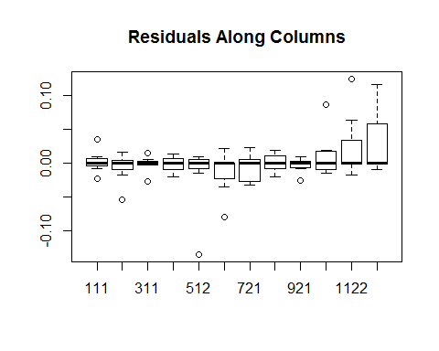

boxplot(t(results.t$residuals),main = "Residuals Along Rows")

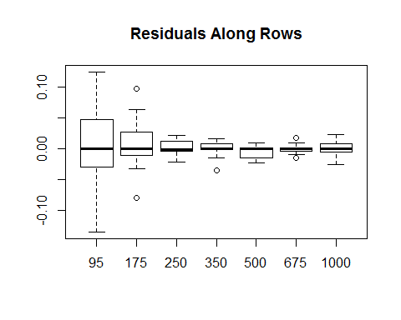

1. Forget-it Plot

forgetitplot <- function(outmpol,outlim=0,...) {  
 # outmpol is output of medpolish in library(eda) or library(stats)  
 # be sure to assign dimnames to matrix being polished  
 oldpar <- par()  
 par(fig=c(0,.7,0,1))  
 nc <- length(outmpol$col)  
 nr <- length(outmpol$row)  
 a <- rep(outmpol$row,nc)  
 b <- rep(outmpol$col,rep(nr,nc))   
 sqrt2 <- sqrt(2)  
 ab <- cbind((a-b)/sqrt2,(a+b)/sqrt2)  
 xrange <- range(ab[,1]) + c(-.1,.1)*(max(ab[,1])-min(ab[,1]))  
 yrange <- range(ab[,2]) + c(-.1,.1)*(max(ab[,2])-min(ab[,2]))  
 dx <- (xrange[2]-xrange[1])/50  
 dy <- (yrange[2]-yrange[1])/50  
 plot(ab[,1],ab[,2],axes=F,xlim=xrange,ylim=yrange,xlab="",ylab="",...)  
 segments((min(a)-outmpol$col)/sqrt2, (min(a)+outmpol$col)/sqrt2,  
 (max(a)-outmpol$col)/sqrt2, (max(a)+outmpol$col)/sqrt2,lty=3)  
 segments((outmpol$row-min(b))/sqrt2, (outmpol$row+min(b))/sqrt2,  
 (outmpol$row-max(b))/sqrt2, (outmpol$row+max(b))/sqrt2,lty=3)  
 # segments((outmpol$row)/sqrt2-min(b), (outmpol$row)/sqrt2+min(b),  
 # (outmpol$row)/sqrt2-max(b), (outmpol$row)/sqrt2+max(b),lty=3)  
 yrowloc <- rep(max(b),nr)  
 xrowloc <- outmpol$row  
 # text((xrowloc-yrowloc)/sqrt2-dx,dy+(xrowloc+yrowloc)/sqrt2,format(1:nr))  
 text((xrowloc-yrowloc)/sqrt2-dx,dy+(xrowloc+yrowloc)/sqrt2,  
 names(sort(outmpol$row)))  
 xcolloc <- rep(max(a),nc)  
 ycolloc <- outmpol$col  
 # text(dx+(xcolloc-ycolloc)/sqrt2,dy+(xcolloc+ycolloc)/sqrt2,format(1:nc))  
 text(dx+(xcolloc-ycolloc)/sqrt2,dy+(xcolloc+ycolloc)/sqrt2,  
 names(sort(outmpol$col)))  
 ynames <- format(round(outmpol$overall + sqrt2*pretty(ab[,2])))  
 axis(2,at=pretty(ab[,2]),labels=ynames)  
 # add vertical lines when there is an outlier  
 if(abs(outlim) > 1e-4) {  
 out.index <- which(abs(outmpol$res) > outlim, arr.ind=T)  
 # find (r,c) for outlier indices  
 zz.x <- outmpol$row[out.index[,1]]  
 zz.y <- outmpol$col[out.index[,2]]  
 # outlier points at (zz.x-zz.y)/sqrt2, (zz.x+zz.y)/sqrt2  
 # draw segment from here to end of residual  
 segments((zz.x-zz.y)/sqrt2, (zz.x+zz.y)/sqrt2,  
 (zz.x-zz.y)/sqrt2, (zz.x+zz.y)/sqrt2 + outmpol$res[out.index])  
 }  
 par <- oldpar  
 invisible()  
}  
  
#forgetitplot(results.t)

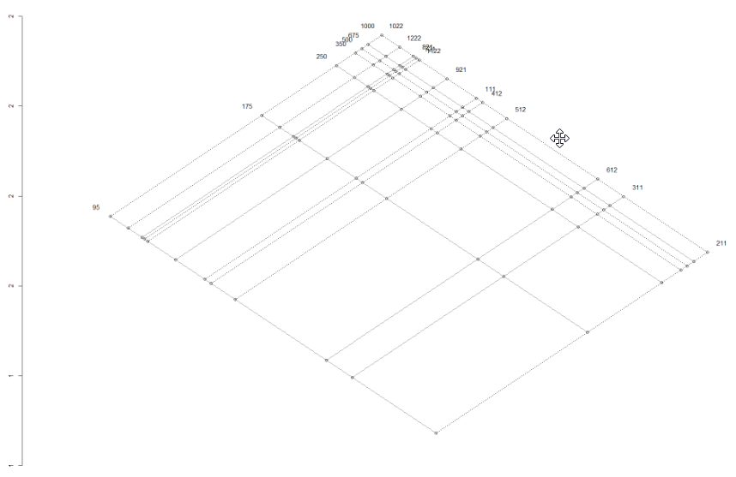

* Co2 of type 1000 had the maximum effect at plant 0311
* C02 of type 95 is more infulential than the others.

1. Boost Strap Estimates for Median Polish Overall:

vectorize.medpolish<-function(residuals.mp){  
 residualslist <- c(residuals.mp)  
 residuals.ret <- c()  
 for (i in 1:nrow(residuals.mp)){  
 residuals.ret <- rbind(residuals.ret,c(sample(residualslist,ncol(residuals.mp),replace = TRUE)))  
 }  
 return (residuals.ret)  
}  
  
  
bootstrap.medpolish<-function(mat,sims){  
 nrows <- nrow(mat)  
 ncols <- ncol (mat)  
 row.est <- matrix(0,nrow=sims,ncol=nrows)  
 col.est <- matrix(0,nrow=sims,ncol=ncols)  
 overall.est <- c()  
 org.result<-medpolish(mat)  
 sample.mat <- org.result$residuals  
 sample.result <- org.result  
 for (j in 1:sims){  
 new.residuals <- vectorize.medpolish(sample.mat)  
 bs.mat <- new.residuals+t(rbind(sample.result$row,sample.result$row,sample.result$row,sample.result$row,sample.result$row,sample.result$row,sample.result$row,sample.result$row,sample.result$row,sample.result$row,sample.result$row,sample.result$row))+sapply(c(sample.result$col),function(x) rep(x,nrow(sample.result$residuals)))+matrix(sample.result$overall,nrow=length(sample.result$row),ncol=length(sample.result$col))  
 sample.result <- medpolish(bs.mat,maxiter = 1000)  
 sample.mat<-sample.result$residuals  
 #print(row.est[j,])  
 #print(bs.mat)  
 #print(c(sample.result$row))  
 row.est[j,]<-c(sample.result$row)  
 col.est[j,]<-c(sample.result$col)  
 overall.est[j]<-sample.result$overall  
 }  
 return(list(row.est=row.est,col.est=col.est,overall.est=overall.est))  
}  
  
b<-bootstrap.medpolish(df,50)  
  
overall.serror<-sd(b$overall.est)/sqrt(length(df))  
b.rowest<-rbind(c(mean(b$row.est[,1]),mean(b$row.est[,2]),mean(b$row.est[,3]),mean(b$row.est[,4]),mean(b$row.est[,5]),mean(b$row.est[,6]),mean(b$row.est[,7])))  
colnames(b.rowest)<-rownames(df)  
b.colest<-rbind(c(mean(b$col.est[,1]),mean(b$col.est[,2]),mean(b$col.est[,3]),mean(b$col.est[,4]),mean(b$col.est[,5]),mean(b$col.est[,6]),mean(b$col.est[,7]),mean(b$col.est[,8]),mean(b$col.est[,9]),mean(b$col.est[,10]),mean(b$col.est[,11]),mean(b$col.est[,12])))  
colnames(b.colest)<-colnames(df)  
b.serowest<-rbind(c(mean(b$row.est[,1])/sqrt(length(b$row.est[,1])),mean(b$row.est[,2])/sqrt(length(b$row.est[,1])),mean(b$row.est[,3])/sqrt(length(b$row.est[,1])),mean(b$row.est[,4])/sqrt(length(b$row.est[,1])),mean(b$row.est[,5])/sqrt(length(b$row.est[,1])),mean(b$row.est[,6])/sqrt(length(b$row.est[,1])),mean(b$row.est[,7])/sqrt(length(b$row.est[,1]))))  
colnames(b.serowest)<-rownames(df)  
b.secolest<-rbind(c(mean(b$col.est[,1])/sqrt(length(b$col.est[,1])),mean(b$col.est[,2])/sqrt(length(b$col.est[,1])),mean(b$col.est[,3])/sqrt(length(b$col.est[,1])),mean(b$col.est[,4])/sqrt(length(b$col.est[,1])),mean(b$col.est[,5])/sqrt(length(b$col.est[,1])),mean(b$col.est[,6])/sqrt(length(b$col.est[,1])),mean(b$col.est[,7])/sqrt(length(b$col.est[,1])),mean(b$col.est[,8])/sqrt(length(b$col.est[,1])),mean(b$col.est[,9])/sqrt(length(b$col.est[,1])),mean(b$col.est[,10])/sqrt(length(b$col.est[,1])),mean(b$col.est[,11])/sqrt(length(b$col.est[,1])),mean(b$col.est[,12])/sqrt(length(b$col.est[,1]))))  
colnames(b.secolest)<-colnames(df)

## [1] "Bootstrap Estimates for overall : 33.5475810618335"

## [1] "The standard error of Bootstrap Estimates 0.0486387314618759"

## [1] "--------------------------------------------------"

## [1] "Boot strapped Row Estimates:"

## 95 175 250 350 500 675 1000  
## [1,] -18.65091 -9.580678 -1.802223 0.01963037 0.8639511 1.93773 2.771877

## [1] "Bootstrapped Column Estimates:"

## 111 211 311 412 512 612 721  
## [1,] 0.1553666 15.19159 7.047301 0.9811789 3.30727 4.162722 -3.944642  
## 821 921 1022 1122 1222  
## [1,] 0.06968543 -6.244833 -13.33086 -18.37562 -17.03355

## [1] "--------------------------------------------------"

## [1] "Standard Errors for Row estimates"

## 95 175 250 350 500 675  
## [1,] -2.637636 -1.354912 -0.2548729 0.002776154 0.1221811 0.2740364  
## 1000  
## [1,] 0.3920026

## [1] "Standard Errors for Column estimates"

## 111 211 311 412 512 612  
## [1,] 0.02197216 2.148415 0.9966388 0.1387597 0.4677186 0.5886977  
## 721 821 921 1022 1122 1222  
## [1,] -0.5578566 0.009855008 -0.8831527 -1.885269 -2.598706 -2.408907

Observations:

* 1. The bootstrap estimates and the standard errors were the out of bootstrapped sample of 50 simulations.
  2. Consider the Row effect [ai, bi, …. Ni], the bootstrapped row effect is the mean of ai over the simulations, ie

$$Bootstrapped Row Effects=[\frac{\sum_{1}^{n sims}{a_{i}}}{n},\frac{\sum_{1}^{n sims}{b_{i}}}{n}…. \frac{\sum_{1}^{n sims}{N_{i}}}{n}]$$

The Standard Errors are given as $\frac{(\frac{\sum_{1}^{n sims}{a_{i}}}{n})}{\sqrt{sims}}$ for every row/column effect element

Also it can be seen that the bootstrapped estimates and the original estimates are nearly equal, and the error is as described above in the estimates.

Acknowledgements and References

* + 1. G-H estimates, Forget it plot, Diagnostic Plot, Resistant Regression, L-Value plots – Credits to Dr. King. These plot helped a lot throughout the course!
    2. Acknowledgements to corresponding library authors.