**Programming and Database Fundamentals**

**Final Project**

**EDA on Google Merchandise Store**

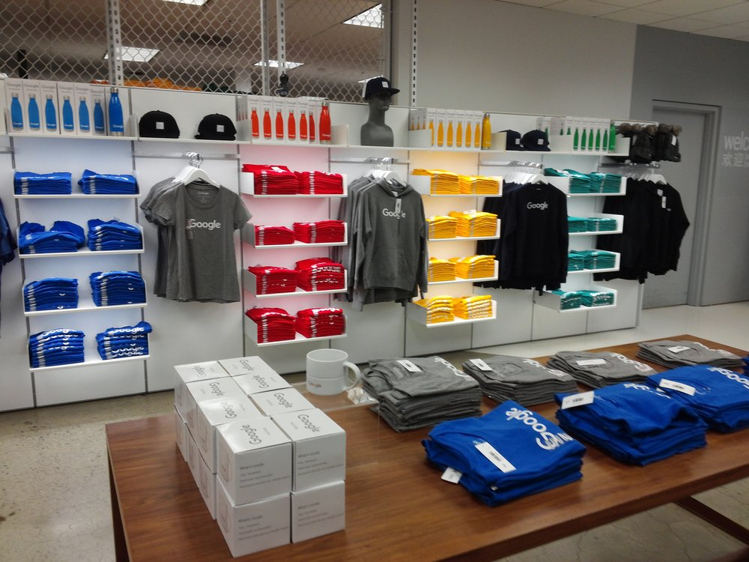

**Contributors:**

Narendra Badam

Abhishek Kumar

December 5, 2019

1. **Abstract**

In sales and marketing there is a general conception that almost 80% of the revenue come from just around 20% of the customer base. This is known as the 80/20 rule and is a base assumption for many strategies. Hence, it is very imperative to make appropriate investments in advertisements and promotional activities which is precise and targeted. To target the correct set of population it is important to analyze and determine the traits of people who buy products versus those who don’t.

Here we did some exploratory data analysis to unearth some of those features that implicitly determine the likelihood of transaction from the customer visiting the Google Merchandise Store (GStore).

1. **Introduction**

We have used several plots and diagrams to explore the datasets and identify patterns within it and discover traits that are characteristic to one of the two classes i.e revenue generating customers vs non-revenue generating customers.

1. **Data**
2. **Analysis**
3. **Results and Conclusion**
4. **Future Research Direction**
5. **References**