**Department of Computer Science**

This is to certify that a team of students,

____________________________________________________ ____________________________________________________ has successfully completed a project work as a part of SEM II,

M. Sc. (Computer Science) Part I course under the guidance of __________________________________________ in the academic year 2021-22.

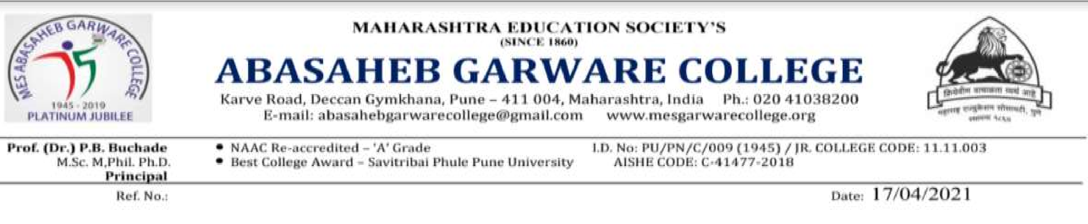

Project Title: _______________________________________

Project Guide Head

Internal Examiner External Examiner

**ACKNOWLEDGEMENT**

It is our pleasure to be indebted to various people, who directly or indirectly contributed in the development of this work and who influenced our thinking, behaviour, and acts during the course of study.

We are thankful to **Prof. Parag Tamhankar sir** (Project Guide) for their support, cooperation, and motivation provided to us during the Study of project.

We also extend my sincere appreciation to **Mrs. Rasika Hardikar mam** who provided her valuable suggestions and precious time in accomplishing our project report.

We are also thankful to my friends, colleagues and all our instructors and teachers for helping in the project.

Ganesh Shinde (15408)

Pankaj Bankar (15409)

Pranav karwan (15423)

**Contents**

|  |  |  |  |  |  |
| --- | --- | --- | --- | --- | --- |
| **Sr.No.** | **Name** | | **Page No.** | | |
| 1. | **Introduction** | | 3 | | |
| 2. | **Project Charter** | | 4 | | |
| 3. | **WBS** | | 5 | | |
| 4. | **Problem Definition** | | 6 | | |
| 5. | **Need of the System** | | 7 | | |
| 6. | **Scope of the System** | | 8 | | |
| 7. | **Requirement Analysis**  5.1Software Specifications  5.2 Hardware Specification | | 9 | | |
| 8. | **Feasibility Study**   * 1. Technical Feasibility   2. Operational Feasibility   3. Economical Feasibility | | 10 | | |
| 9. | | **Data Tables & Data Dictionary** | | 12 |
| 10. | | **Diagrams**  9.1 Class Diagram  9.2 Use-Case Diagram  9.3 Activity Diagram  9.4 Sequence Diagram  9.5 Data Flow Diagram (DFD)  9.6 ER Diagram | | 15-20 |
| 11. | | **Gantt Chart** | | 21 |
| 12. | | **Network Diagram** | | 22 |
| 13. | | **Screenshots** | | 25 |
| 14. | | **System testing** | | 28 |
| 15. | | **Limitations** | | 29 |
| 16. | | **Future Enhancement** | | 30 |
| 17. | | **Bibliography** | | 31 |

**Introduction**

Online Metro-Ticket Booking System is a web-based tool which helps people renewing and registering Metro Tickets online. This system is made to automize the current process of ticket bookings, the user can get the ticket online instead of going to the metro station and stand in a queue.

This System is designed by keeping in mind both users: User & Admin and it allows users to register their details with the system, and then Admin to allow user to use this software to the system after logged in successfully.

This is faster way than old system. This site can be accessed throughout the world with proper login provided. This system can be used for newly registration for passes, renewing old passes etc. This system reduces time and provides proper management.

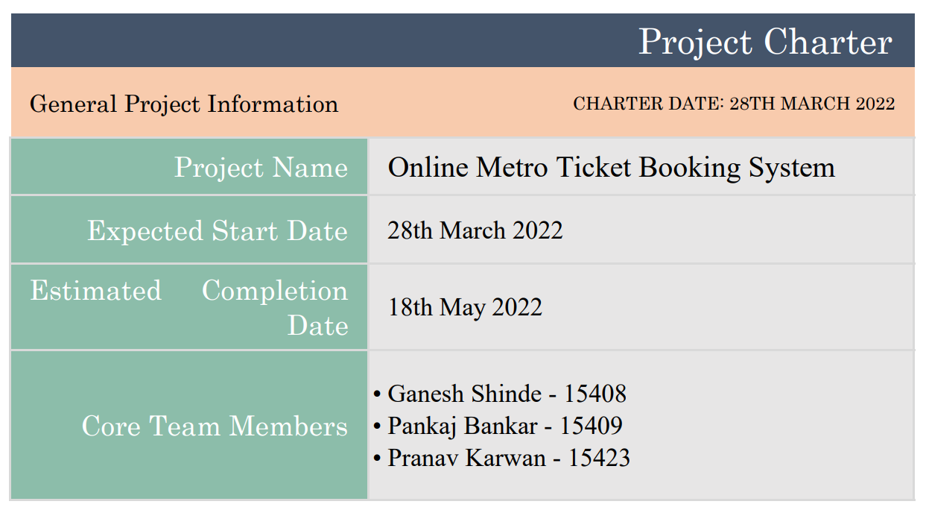

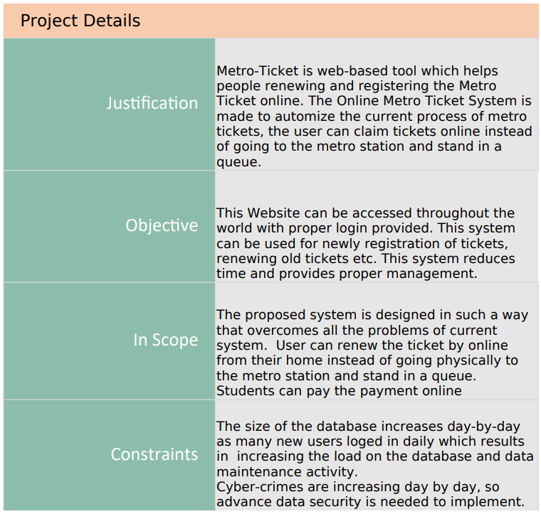

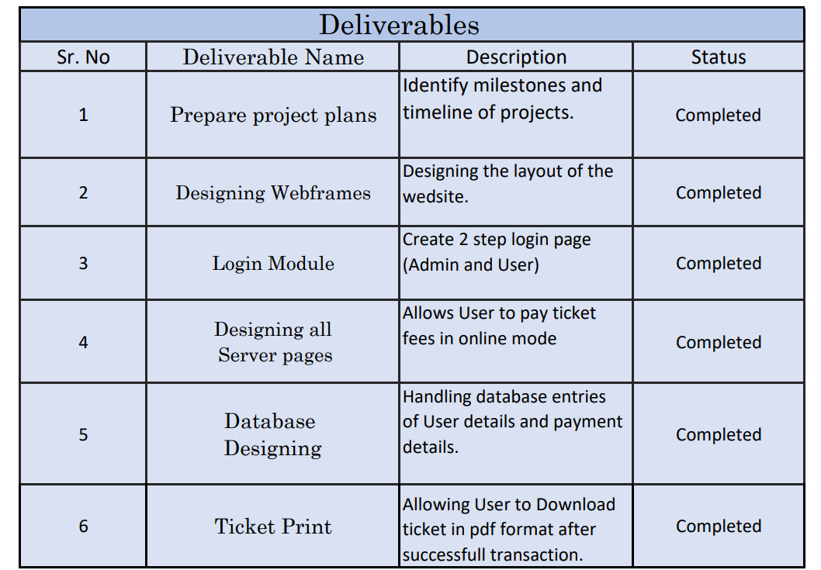

**WBS**

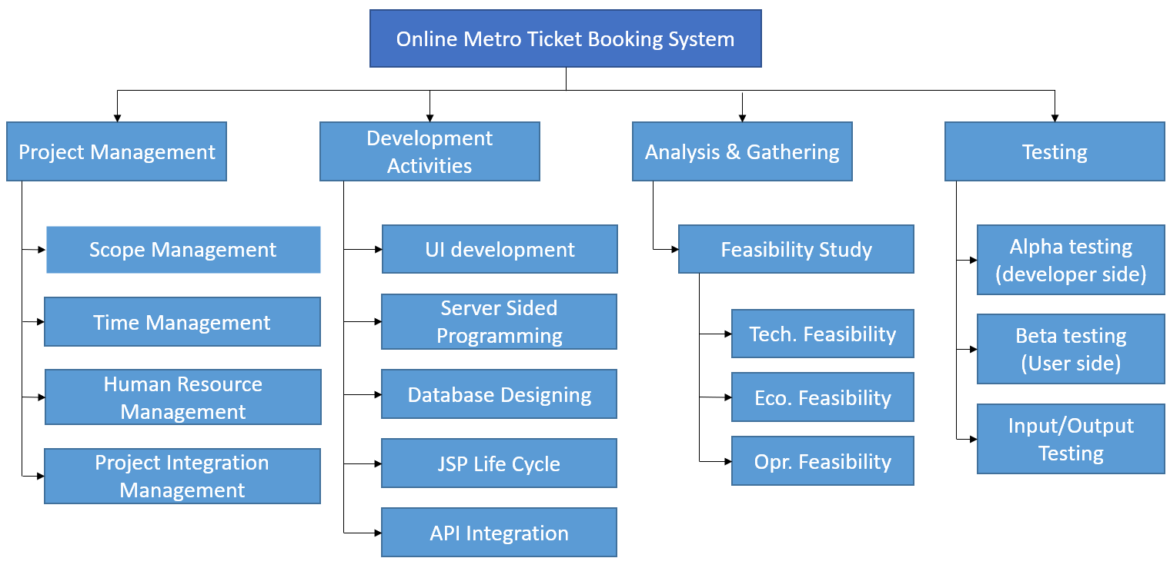

**Problem Definition**

Now-a-days public transport is increasing. Public Transport System is an efficient user of space and energy, with reduced level of air and noise pollution. With the growing economy and inadequate public transport services, the passengers shall shift to private modes, which is already evident from the high vehicle ownership trends in the region. This would not only aggravate the congestion on streets but also increase the pollution. Hence, it is essential to plan and provide for a Metro System in this area. So, to issue tickets/passes for metro instead of buying ticket every day, makes easy to travel and saves money.

But to issue tickets/passes we have to go at the metro station and we have to stand in queue as well as we have to suffer for validation of our documents.

So, to reduce these efforts this system is designed.

**Need of the System**

People must go to Metro Station and stand in a queue for getting the tickets/pass as well as renew the metro pass. If someone leaving in rural area then he/she have to travel to respective area’s / village’s station to issue tickets. This is so time consuming process, so there is need of new system which reduces unnecessary efforts and make it easy.

The current system is manual system in which transport user has to go to the metro station for getting the ticket/pass as well as renew the pass.

The proposed system is design in such a way that overcomes all the problems of current system.

**Scope of the Proposed System**

* The proposed system is design in such a way that overcomes all the problems of current system
* User can renew the pass by online from their home instead of going physically to the station and stand in a queue.
* User can get pass from any metro station.
* Students can pay the payment by online.

**Requirement Analysis**

Requirement analysis produces in the specification of software operational characteristics:

It indicates software interface with other system element.

It establishes constraint that should accomplish.

* Requirement analysis provides information, function & behavior that can be translated into architectural interface & component level design.
* This translation is performed during construction of analysis model.
* It includes:
* It decides and adds all important function which is maintained in the requirements.
* It decides and adds important function which is not maintained in the requirements, but it is essential to build.

It defines all interfaces of the software to be developed

* **Software Requirements (for development)**

Operating System : Windows ,Linux or Further

Languages : Java, HTML

Front End : Java script.

Platform : Java

Web Servers : Tomcat Server

Backend : PostgreSQL

* **Hardware Requirements (for working)**

Processor : Pentium III or Any Advanced Processor

RAM : 256 MB or More

Hard disk : 40 GB or more

**Feasibility Study**

Preliminary investigation examines project feasibility, the likelihood the system will be useful to the organization. The main objective of the feasibility study is to test the Technical, Operational and Economical feasibility for adding new modules and debugging old running system. All system is feasible if they are unlimited resources and infinite time. There are aspects in the feasibility study portion of the preliminary investigation:

* Technical Feasibility
* Operation Feasibility
* Economical Feasibility

**3.1. Technical Feasibility**

The technical issue usually raised during the feasibility stage of the investigation includes the following:

* Does the necessary technology exist to do what is suggested?
* Do the proposed equipment have the technical capacity to hold the data required to use the new system?
* Will the proposed system provide adequate response to inquiries, regardless of the number or location of users?
* Can the system be upgraded if developed?
* Are there technical guarantees of accuracy, reliability, ease of access and data security

Earlier no system existed to cater to the needs of ‘Secure Infrastructure Implementation System’. The current system developed is technically feasible. It is a web-based user interface. Thus it provides an easy access to the users. The database’s purpose is to create, establish and maintain a workflow among various entities in order to facilitate all concerned users in their various capacities or roles. Permission to the users would be granted based on the roles specified. Therefore, it provides the technical guarantee of accuracy, reliability and security. The software and hard requirements for the development of this project are not many and are already available as free as open source. The work for the project is done with the current equipment and existing software technology. Necessary bandwidth exists for providing a fast feedback to the users irrespective of the number of users using the system.

**3.2. Operational Feasibility**

Proposed projects are beneficial only if they can be turned out into information system. That will meet the organization’s operating requirements. Operational feasibility aspects of the project are to be taken as an important part of the project implementation. Some of the important issues raised are to test the operational feasibility of a project includes the following: -

* Is there sufficient support for the management from the users?
* Will the system be used and work properly if it is being developed and implemented?
* Will there be any resistance from the user that will undermine the possible application benefits?

This system is targeted to be in accordance with the above-mentioned issues. Beforehand, the management issues and user requirements have been taken into consideration. So, there is no question of resistance from the users that can undermine the possible application benefits.

The well-planned design would ensure the optimal utilization of the computer resources and would help in the improvement of performance status.

**3.3. Economic Feasibility**

A system can be developed technically and that will be used if installed must still be a good investment for the organization. In the economical feasibility, the development cost in creating the system is evaluated against the ultimate benefit derived from the new systems. Financial benefits must equal or exceed the costs.

The system is economically feasible. It does not require any addition hardware or software. Since the interface for this system is developed using the existing resources and technologies are available. There is nominal expenditure and economical feasibility for certain.

**Data Dictionary**

**Database Name: metro**

***Table Name: admin_rejection_list***

|  |  |  |
| --- | --- | --- |
| **FieldName** | **DataType** | **Description** |
| rejection_id | Varchar(10) | RejectionIDPrimaryKey Not Null |
| description_of_rejection | Varchar(200) | DescriptionOfRejection |
| application_form_id | Varchar(20) | application_form_id |

Indexes:

"admin_rejection_list_pkey" PRIMARY KEY, btree (rejection_id)

Foreign-key constraints:

"admin_rejection_list_application_form_id_fkey" FOREIGN KEY (application_form_id) REFERENCES passenger_form(application_form_id) ON UPDATE CASCADE ON DELETE CASCADE

***Table Name: passenger_form***

|  |  |  |
| --- | --- | --- |
| **FieldName** | **DataType** | **Description** |
| application_form_id | Varchar(20) | NotNullPrimaryKey |
| passenger_name | Varchar(50) | Passenger Name |
| full_address | Varchar(100) | Full Address |
| passenger_dob | Date | Passenger DOB |
| route_from | Varchar(50) | Route From |
| route_to | Varchar(50) | Route To |
| register_date | Date | Register Date |
| City | Varchar(30) | City |
| Gender | Varchar(8) | Gender |
| submit_status | Integer | Submit Status |
| payment_status | Integer | Payment Status |
| approve_status | Integer | Approve Status |
| Photo | Varchar(500) | Photo |
| aadhar_card | Varchar(500) | Aaddhar Card |
| login_status | Integer | Login Status |
| passenger_id | Varchar(10) | Passenger Id |

Indexes:

"passenger_form_pkey" PRIMARY KEY, btree (application_form_id)

Foreign-key constraints:

"passenger_form_passenger_id_fkey" FOREIGN KEY (passenger_id) REFERENCES passenger_register(passenger_id) ON UPDATE CASCADE ON DELETE CASCADE

Referenced by:

TABLE "admin_rejection_list" CONSTRAINT "admin_rejection_list_application_form_id_fkey" FOREIGN KEY (application_form_id) REFERENCES passenger_form(application_form_id) ON UPDATE CASCADE ON DELETE CASCADE

TABLE "payment_details" CONSTRAINT "payment_details_application_form_id_fkey" FOREIGN KEY (application_form_id) REFERENCES passenger_form(application_form_id) ON UPDATE CASCADE ON DELETE CASCADE

TABLE "renew_pass" CONSTRAINT "renew_pass_application_form_id_fkey" FOREIGN KEY (application_form_id) REFERENCES passenger_form(application_form_id) ON UPDATE CASCADE ON DELETE CASCADE

***Table Name: passenger_register***

|  |  |  |
| --- | --- | --- |
| **FieldName** | **DataType** | **Description** |
| passenger_id | Varchar(10) | PrimaryKeyNotNull |
| passenger_name | Varchar(60) | Passenger Name |
| email_id | Varchar(30) | Email Id |
| Phone_no | Varchar(10) | Phone No |
| Password | varchar(20) | Password |

Indexes:

"passenger_register_pkey" PRIMARY KEY, btree (passenger_id)

Referenced by:

TABLE "passenger_form" CONSTRAINT "passenger_form_passenger_id_fkey" FOREIGN KEY (passenger_id) REFERENCES passenger_register(passenger_id) ON UPDATE CASCADE ON DELETE CASCADE

***Table Name: payment_details***

|  |  |  |
| --- | --- | --- |
| **FieldName** | **DataType** | **Description** |
| payment_id | Varchar(10) | PrimaryKeyNotNull |
| payment_amount | Double precision | PaymentAmount |
| application_form_id | Varchar(20) | ApplicationFormId |

***I***ndexes:

"payment_details_pkey" PRIMARY KEY, btree (payment_id)

Foreign-key constraints:

"payment_details_application_form_id_fkey" FOREIGN KEY (application_form_id) REFERENCES passenger_form(application_form_id) ON UPDATE CASCADE ON DELETE CASCADE

***Table Name: renew_pass***

|  |  |  |
| --- | --- | --- |
| **FieldName** | **DataType** | **Description** |
| renew_id | Varchar(10) | PrimaryKeyNotNull |
| from_date | Date | FromDate |
| payment_status | Integer | PaymentStatus |
| application_form_id | Varchar(20) | ApplicationFormId |

Indexes:

"renew_pass_pkey" PRIMARY KEY, btree (renew_id)

Foreign-key constraints:

"renew_pass_application_form_id_fkey" FOREIGN KEY (application_form_id) REFERENCES passenger_form(application_form_id) ON UPDATE CASCADE ON DELETE CASCADE

**Diagrams**

**ER-Diagram:**



**Class Diagram:**



**Use-Case Diagram:**

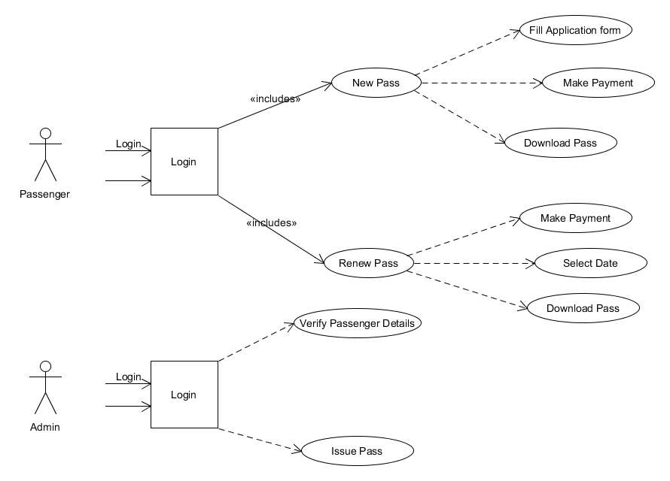

**Activity Diagram:**

Admin validations

New

Log Out

Download Pass

Generate Pass

Payment

Fill Form

Renew

Register

Login

If new

yes no

**Sequence Diagram:**

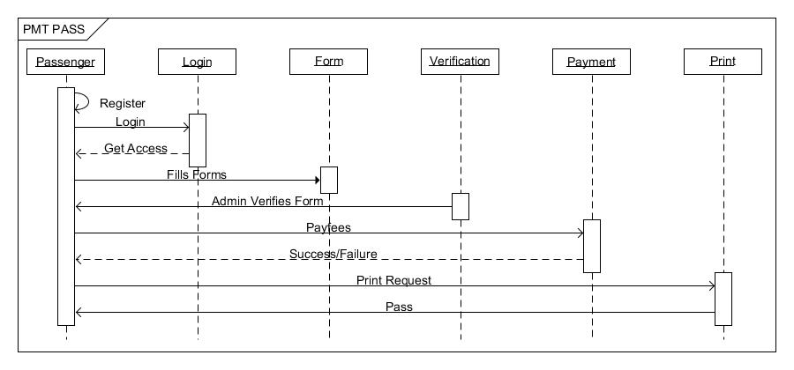

metro

**Component Diagram:**

Fill Application from

New Register

New pass

Make payment

login

Already

Register

Select Date

renew pass

Make payment

**GANTT CHART**

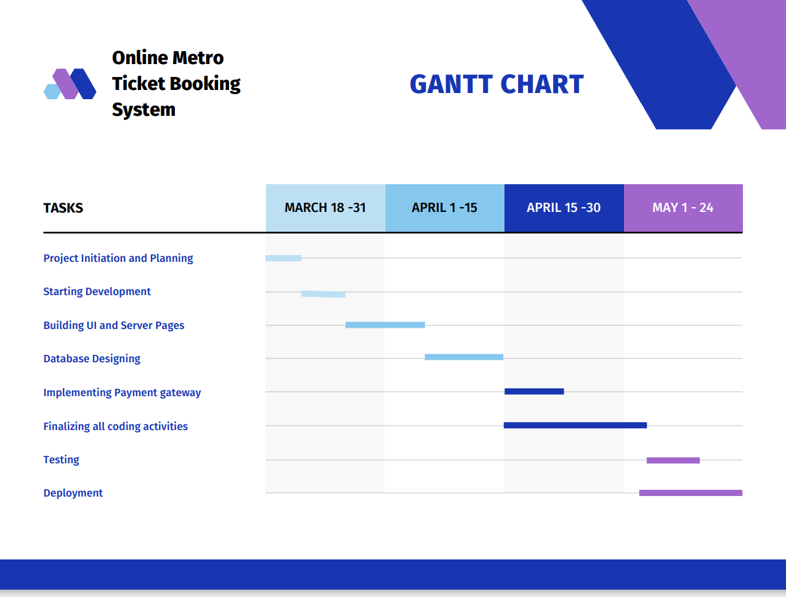

**NETWORK DAIGRAM**

**(Project start date: 18th March 2022)**

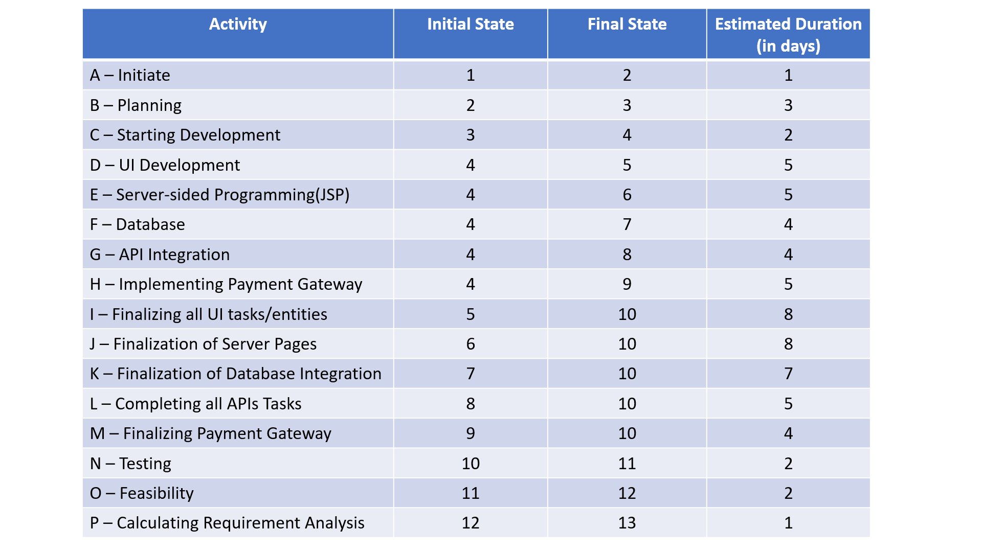

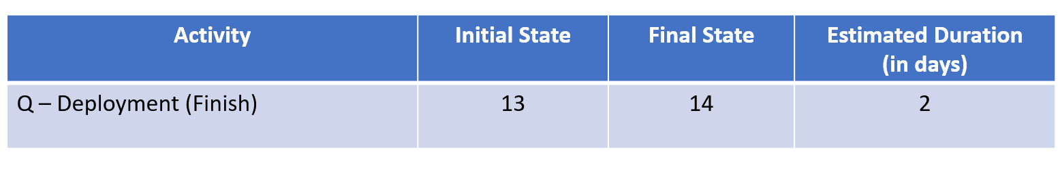

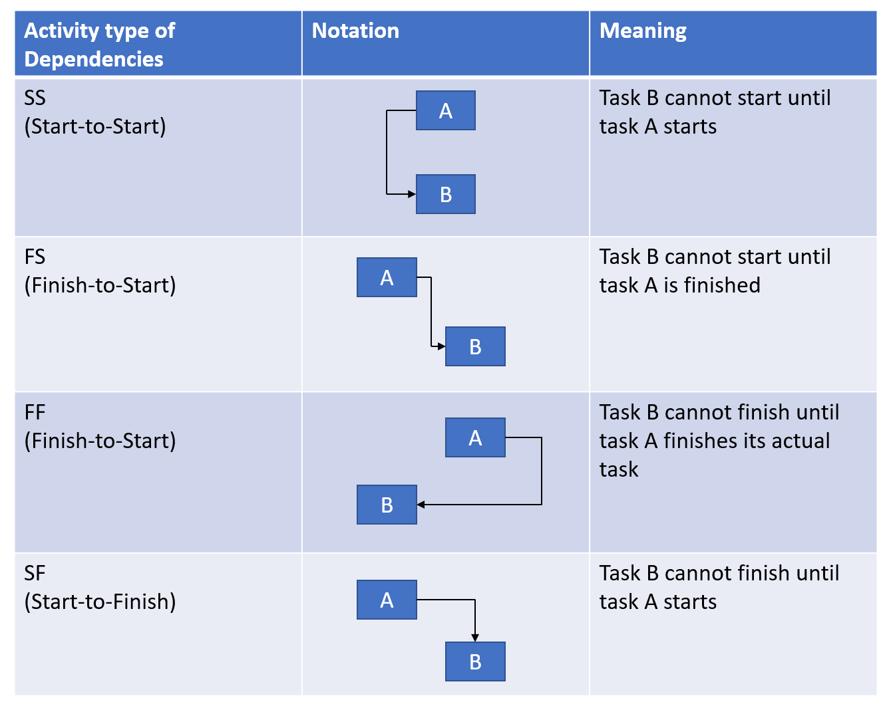

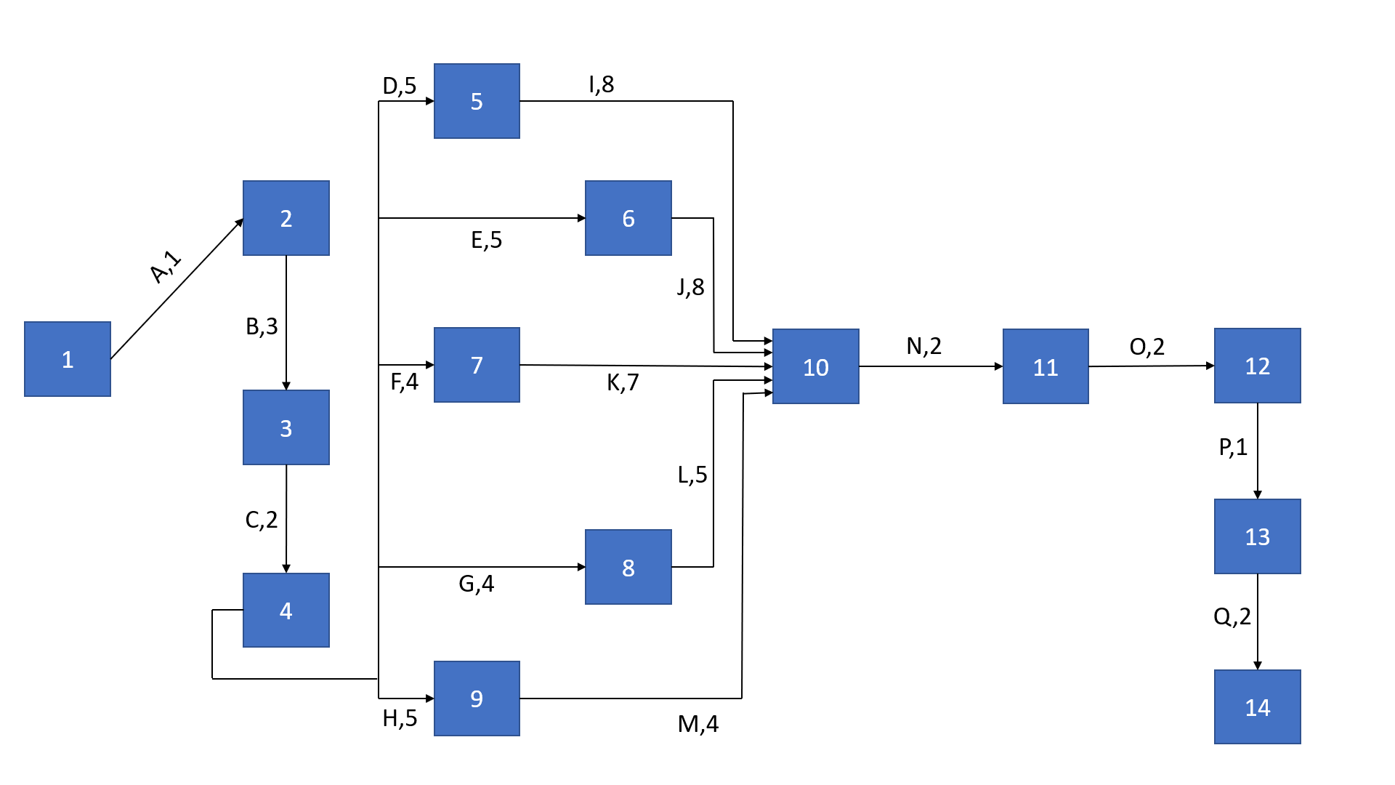

**Screenshots**

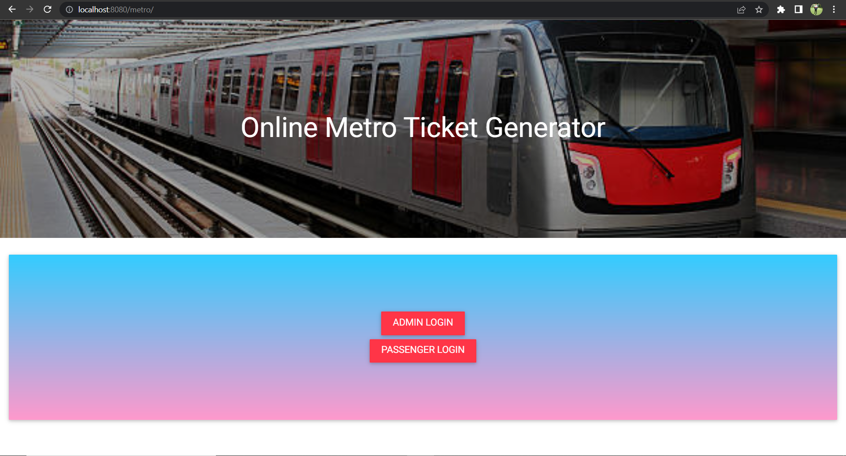

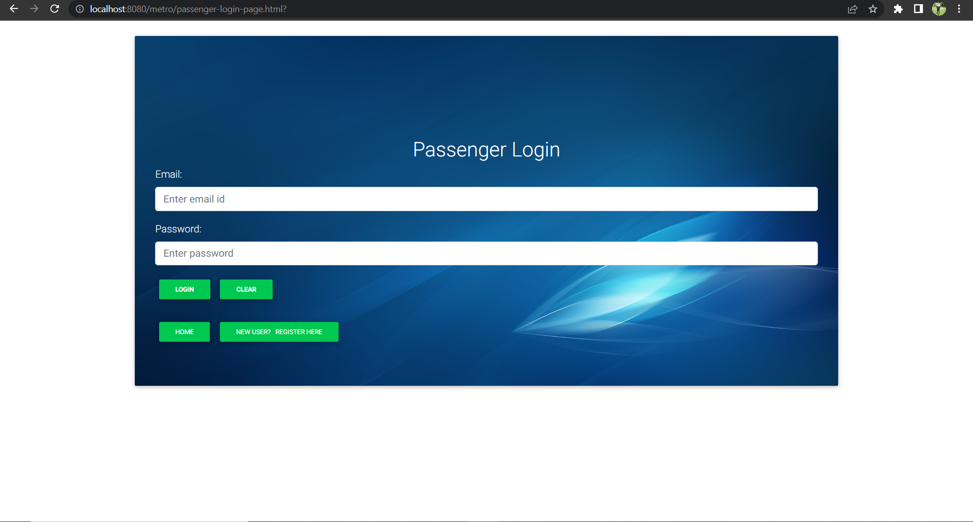

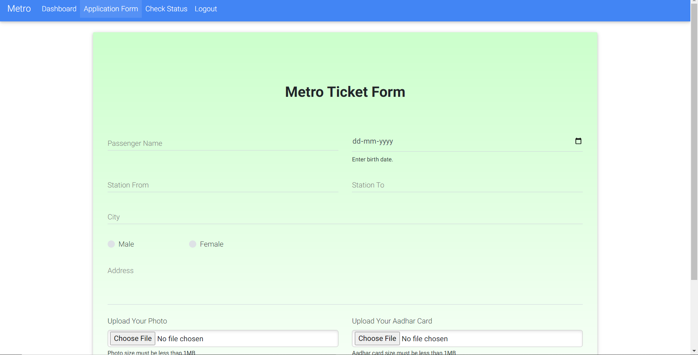

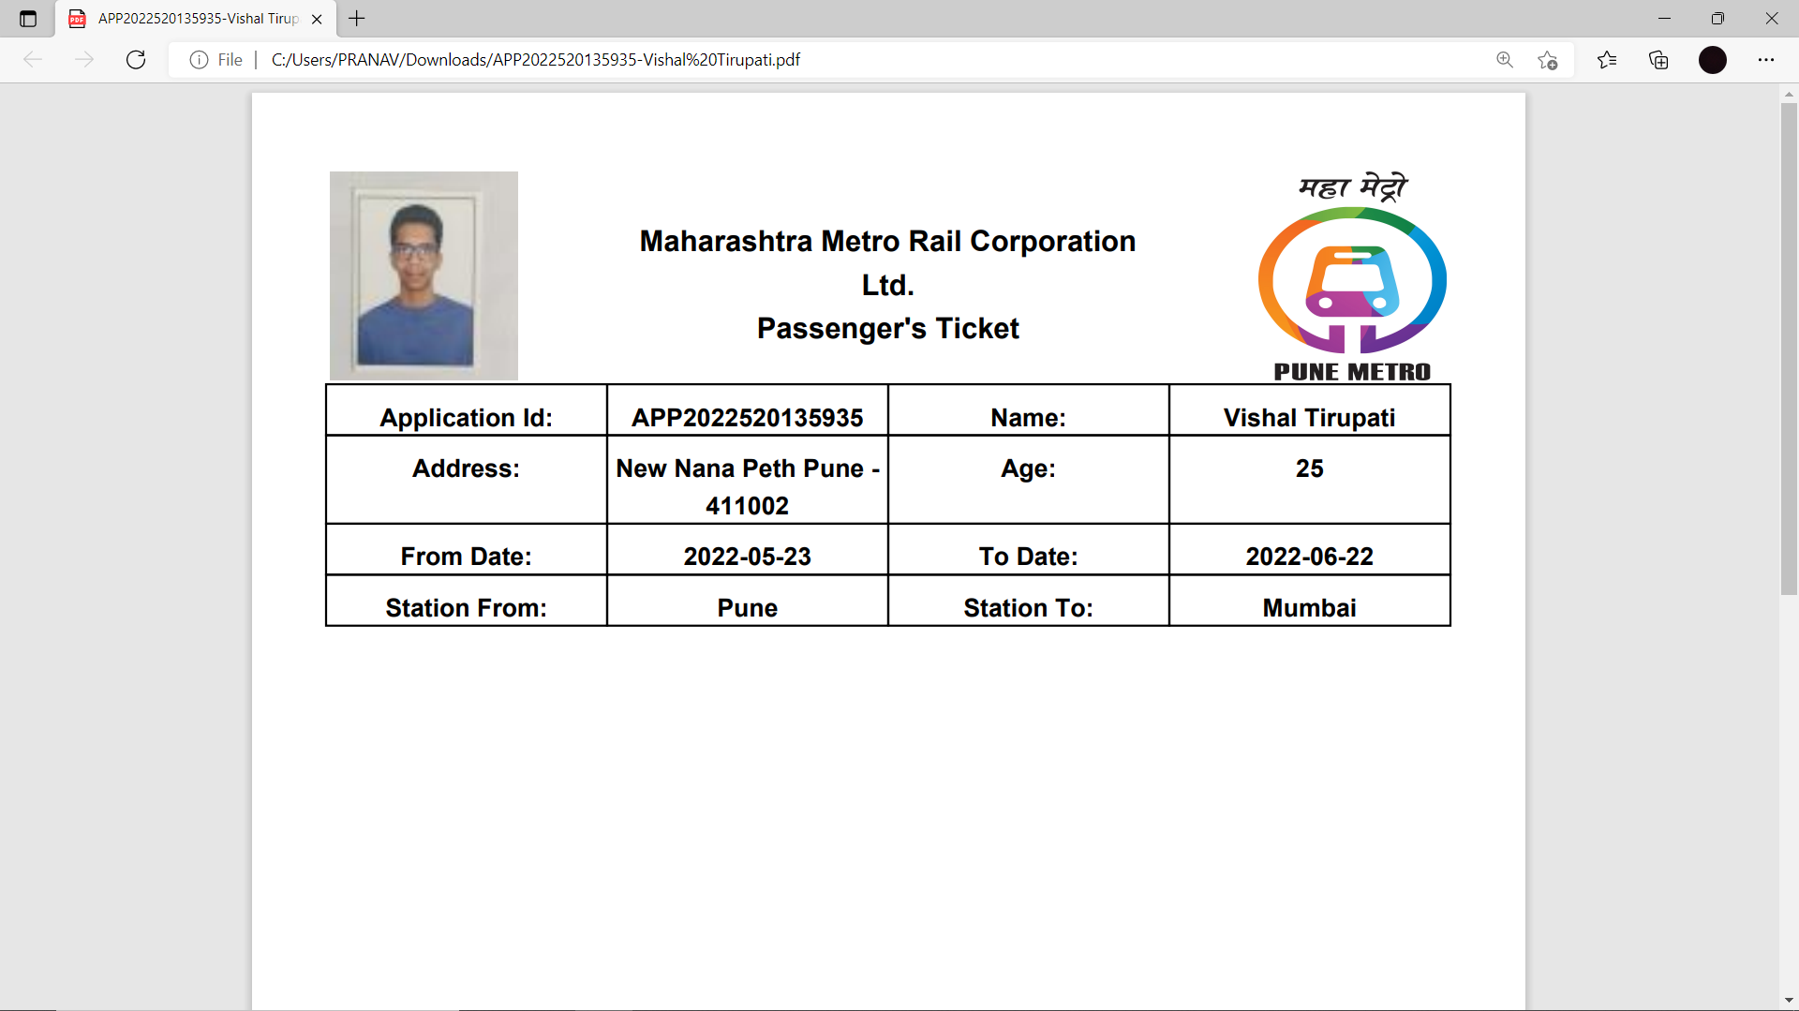

**System Testing**

* The system was tested with usual test routines with the intent of finding an error to detect bugs and to test the quality of the software.
* There are three main kinds of system testing:-
* **Alpha testing** was conducted at the developer side by the end users.
* **Beta testing** was carried out by the selected group of friendly customers, conducted at the end user side.
* **Acceptance testing** was performed by the customer himself to determine whether the system should be accepted or rejected.
* The system begins its first test by **unit testing** one & only one unit is tested as such.
* Testing procedures were carried following the **Bottom-up testing approach**. According to the Bottom-up approach each unit is tested as and when it developed. This units are combining into modules are also individually tested. And finally all the modules are integrated to form the entire system.
* **Integrated testing** is then performed on this developed system.
* An entire code is return in java. The system is object oriented. Thus the entire code is encapsulated into classes so it was easy to perform the testing procedure system was developed progressively taking one module at a time. Finally when all the modules were ready they were integrated to form the entire system.
* Finally, when all the modules were integrated and the entire system was ready, I/O testing, performance testing and stress testing was carried out to test for all the conditions, exception handling capabilities, etc.
* **Input/output testing** was carried to check whether the system generated consistent files of the desired format. Also Input / Output testing helped to confirm whether the files were successfully uploaded at the server or downloaded from the server.

**Limitations**

* The size of the database increases day-by-day, increasing the load on the database back up and data maintenance activity.
* Training for simple computer operations is necessary for the users working on the system.
* Cyber-crimes are increasing day by day, so advance data security is needed to implement.

**Future Enhancement**

* This System being web-based and an undertaking of Cyber Security Division, needs to be thoroughly tested to find out any security gaps.
* Cyber-crimes are increasing day by day, so advance data security will be implemented in future.
* More searching options will be provided to the employer (company) in the future.
* The Payment Gateway implemented here is a dummy module with credit/debit card validation. In future using any third party payment gateways will be used to allow user to pay ticket amount online.

**Bibliography**

‘Online Metro Ticket Booking System’

by

‘Ganesh Shinde, Pankaj Bankar, Pranav Karwan’, ‘20/05/2022’

**ONLINE REFERENCE:**

[**https://project.pm/network-diagrams/**](https://project.pm/network-diagrams/)

[**https://www.javatpoint.com/**](https://www.javatpoint.com/)

[**https://www.geeksforgeeks.org/**](https://www.geeksforgeeks.org/)

[**https://www.canva.com/graphs/gantt-charts/**](https://www.canva.com/graphs/gantt-charts/)