**LAB :- 01**

1: write program to test Hello World.

**public** **class** A1HelloWorld

{

**public** **static** **void** main(String[] args)

{

System.***out***.println("Hello World");

}

}

Output : Hello World



-------------------------------------------

2:Write a program to adddition of two numbers .

**public** **class** A2AdditionTwoNumber

{

**public** **static** **void** main(String[]args)

{

**int** a=10;

**int** b=20;

**int** c=a+b;

System.***out***.println("The addition of two number is = "+c);

}

}

Output :

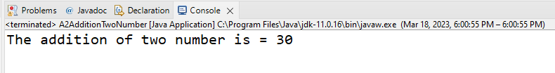

-------------------------------------------

3:Write a program to swap two numbers.

**public** **class** A3SwapingNumber1

{

**public** **static** **void** main(String[] args)

{

**int** a=2;

**int** b=4;

**int** temp;

temp=a;

a=b;

b=temp;

System.***out***.println("value of a = "+a);

System.***out***.println("value of b = "+b);

}

}

Output :

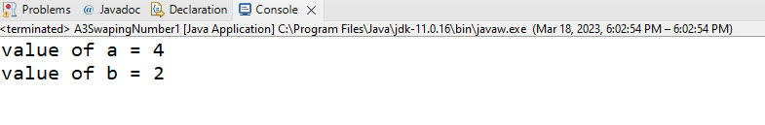

**public** **class** A4SwapingNumber2

{

**public** **static** **void** main(String[] args)

{

**int** a=4;

**int** b=5;

a=a*b;

b=a/b;

a=a/b;

System.***out***.println("value of a is a ="+a);

System.***out***.println("value of a is b ="+b);

}

}

Output :

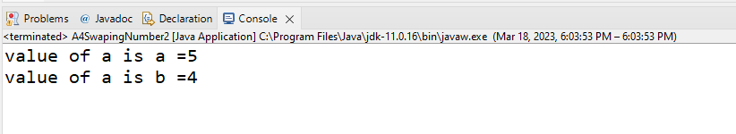

-------------------------------------------

4:Write a program to find factorial of a given number.

**import** java.util.Scanner;

**public** **class** A5FactorialOfNumber

{

**public** **static** **void** main(String[] args)

{

Scanner sc=**new** Scanner(System.***in***);

System.***out***.println("enter a number ");

**int** a=sc.nextInt();

**int** fact=a;

**for**(**int** i=1;i<a;i++)

{

fact=fact*i;

}

System.***out***.println(fact);

}

}

Output :

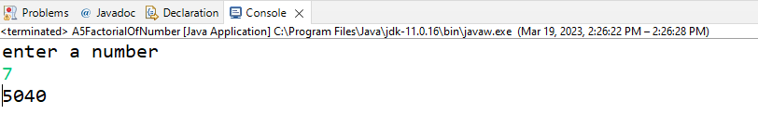

-------------------------------------------

5:Write a program to find m to the power n.

**import** java.util.Scanner;

**public** **class** A6M_to_the_power_N

{

**public** **static** **void** main(String[] args)

{

Scanner sc=**new** Scanner(System.***in***);

System.***out***.println("enter a base number");

**int** M=sc.nextInt();

System.***out***.println("enter a base to the power number");

**int** N=sc.nextInt();

**int** result=1;

**for**(**int** i=1;i<=N;i++)

{

result=result*M;

}

System.***out***.println("Ans is = "+result);

}

}

Output :

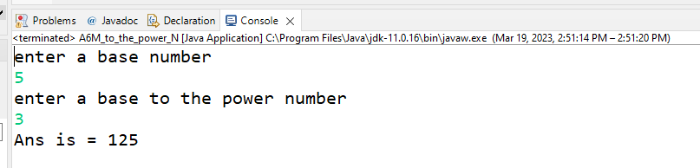

6:Check if number is a prime number or not.

**import** java.util.Scanner;

**public** **class** A7prime_number

{

**public** **static** **void** main(String[] args)

{

Scanner sc=**new** Scanner(System.***in***);

System.***out***.println("enter a number");

**int** a=sc.nextInt();

**int** count=0;

**for**(**int** i=2;i<a;i++)

{

**if**(a%i==0)

{

count++;

**break**;

}

}

**if**(count==1)

{

System.***out***.println("number is not prime");

}

**else**

{

System.***out***.println("number is prime");

}

}

}

Output :

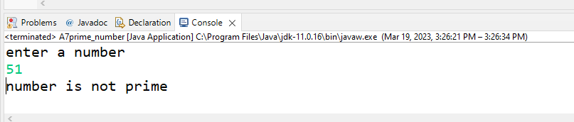

-------------------------------------------

7:Sum of series :

1+2+3+….+n

**import** java.util.Scanner;

**public** **class** A8Sum_of_series

{

**public** **static** **void** main(String[] args)

{

Scanner sc=**new** Scanner(System.***in***);

System.***out***.println("enter a number");

**int** a=sc.nextInt();

**int** result=0;

**for**(**int** i=1;i<=a;i++)

{

result=result +i;

}

System.***out***.println("The sum of series = "+result);

}

}

Output :

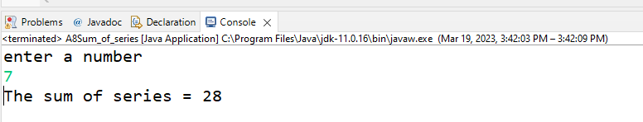

-------------------------------------------

8:Write a program to find sum of all even and odd numbers between 1 to n.

**import** java.util.Scanner;

**public** **class** A9Sum_even_odd_numbers

{

**public** **static** **void** main(String[] args)

{

Scanner sc= **new** Scanner(System.***in***);

System.***out***.println("enter a number");

**int** n=sc.nextInt();

**int** even=0;

**int** odd=0;

**for** (**int** i=1;i<=n;i++)

{

**if** (i%2==0)

{

even=even+i;

}

**else**

{

odd=odd+i;

}

}

System.***out***.println("sum of even numbers = "+even);

System.***out***.println("sum of even numbers = "+odd);

}

}

Output :

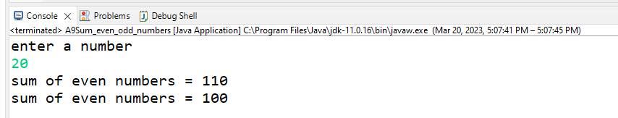-------------------------------------------

10: Write a program to enter a number and print its reverse.

**import** java.util.Scanner;

**public** **class** B10ReverseNumber

{

**public** **static** **void** main(String[] args)

{

Scanner sc=**new** Scanner(System.***in***);

System.***out***.println("enter a number");

**int** a= sc.nextInt();

**int** que=0;

que=que*10+a%10;

a=a/10;

System.***out***.print(que);

System.***out***.println(a);

}

}

Output :

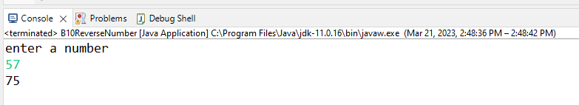

-------------------------------------------

11:Write a program to print all Prime numbers between 1 to n.

**import** java.util.Scanner;

**public** **class** B11PrimeNumber

{

**public** **static** **void** main(String[] args)

{

Scanner sc=**new** Scanner(System.***in***);

System.***out***.println("Enter the number upto you want prime number");

**int** n=sc.nextInt();

**for**(**int** i=2;i<=n;i++)

{

**int** count=0;

**for** (**int** j=2;j<=i/2;j++)

{

**if**(i%j==0)

{

count++;

**break**;

}

}

**if**(count==0)

{

System.***out***.print(i+" ");

}

}

sc.close();

}

}

Output :

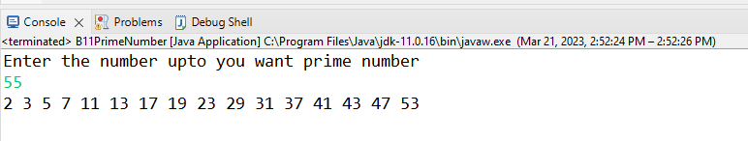

-------------------------------------------

12:Write a program to check entered number is Armstrong number or not.

**import** java.util.Scanner;

**public** **class** B12ArmstrongNumber

{

**public** **static** **void** main(String[] args)

{

Scanner sc=**new** Scanner(System.***in***);

System.***out***.println("Enter the number you want to check that a armstrong or not");

**int** n=sc.nextInt();

**int** result=0,rem,temp=n;

**while**(n!=0)

{

rem=n%10;

result+=(rem*rem*rem);

n=n/10;

}

System.***out***.println(result);

**if**(temp==result)

{

System.***out***.println("Armstrong");

}

**else** {

System.***out***.println("Not Armstrong");

}

}

}

Output :

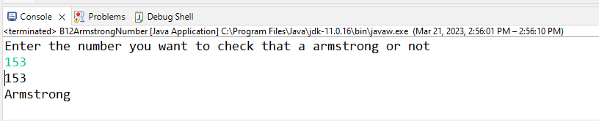

-------------------------------------------

13:Write a program to find greatest of three numbers using nested if-else.

**import** java.util.Scanner;

**public** **class** B13Greatest_Number {

**public** **static** **void** main(String[] args) {

Scanner sc=**new** Scanner(System.***in***);

System.***out***.println("enter number A ");

**int** A =sc.nextInt();

System.***out***.println("enter number B");

**int** B =sc.nextInt();

System.***out***.println("enter number C");

**int** C =sc.nextInt();

**if** (A>B && A>C)

{

System.***out***.println("A is grestet number");

}

**else** **if**(B>C)

{

System.***out***.println("B is grestet number");

}

**else** System.***out***.println("C is grestet number");

}

}

Output :

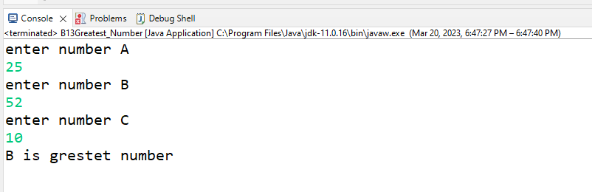-------------------------------------------

14:Create menu driven program for Pizza Shop.And display total amount.

**import** java.util.Scanner;

**public** **class** B14Pizza

{

**public** **static** **void** main(String[] args)

{

Scanner sc=**new** Scanner(System.***in***);

**int** qty, amount = 0,choice;

**do**

{

System.***out***.println("Choose the option from menu 1.Veg Pizza 2.Non-Veg Pizza 3.Extra topping 4.Coldrink 5.Total Bill 6. Exit");

choice = sc.nextInt();

**switch** (choice) {

**case** 1:

System.***out***.println("Enter the type of Veg pizza you want 1. Margherita 200Rs 2.Mushroom 300Rs 3. Indo Tandoori Paneer 400Rs 4.Jumbo Pizza 500Rs");

**int** n = sc.nextInt();

**switch** (n) {

**case** 1:

System.***out***.println("Enter the quantity");

qty = sc.nextInt();

amount += qty * 200;

**break**;

**case** 2:

System.***out***.println("Enter the quantity");

qty = sc.nextInt();

amount += qty * 300;

**break**;

**case** 3:

System.***out***.println("Enter the quantity");

qty = sc.nextInt();

amount += qty * 400;

**break**;

**case** 4:

System.***out***.println("Enter the quantity");

qty = sc.nextInt();

amount += qty * 500;

**break**;

**default**:

System.***out***.println("Invalid Choice");

}

**break**;

**case** 2:

System.***out***.println("Enter the type of Veg pizza you want 1. Chicken Tandoori 400Rs 2.Chicken Tikka 500Rs 3. Mughlai 600Rs 4. Jumbo 700Rs");

**int** m = sc.nextInt();

**switch** (m) {

**case** 1:

System.***out***.println("Enter the quantity");

qty = sc.nextInt();

amount += qty * 400;

**break**;

**case** 2:

System.***out***.println("Enter the quantity");

qty = sc.nextInt();

amount += qty * 500;

**break**;

**case** 3:

System.***out***.println("Enter the quantity");

qty = sc.nextInt();

amount += qty * 600;

**break**;

**case** 4:

System.***out***.println("Enter the quantity");

qty = sc.nextInt();

amount += qty * 700;

**break**;

**default**:

System.***out***.println("Invalid Choice");

}

**break**;

**case** 3:

System.***out***.println("Choose the topping you want 1. Roasted Mushroom 100Rs 2. Roasted Jallepino 100Rs 3. Nonveg Sauce 150Rs 4.Extra Cheese 120Rs");

**int** o = sc.nextInt();

**switch** (o) {

**case** 1:

System.***out***.println("Enter the quantity");

qty = sc.nextInt();

amount += qty * 100;

**break**;

**case** 2:

System.***out***.println("Enter the quantity");

qty = sc.nextInt();

amount += qty * 100;

**break**;

**case** 3:

System.***out***.println("Enter the quantity");

qty = sc.nextInt();

amount += qty * 150;

**break**;

**case** 4:

System.***out***.println("Enter the quantity");

qty = sc.nextInt();

amount += qty * 120;

**break**;

**default**:

System.***out***.println("Invalid Choice");

}

**break**;

**case** 4:

System.***out***.println("Choose the coldrink you want 1.coke small 40Rs 2.coke large 80Rs 3.fanta 60Rs 4. Sprite 60Rs");

**int** p = sc.nextInt();

**switch** (p) {

**case** 1:

System.***out***.println("Enter the quantity");

qty = sc.nextInt();

amount += qty * 40;

**break**;

**case** 2:

System.***out***.println("Enter the quantity");

qty = sc.nextInt();

amount += qty * 80;

**break**;

**case** 3:

System.***out***.println("Enter the quantity");

qty = sc.nextInt();

amount += qty * 60;

**break**;

**case** 4:

System.***out***.println("Enter the quantity");

qty = sc.nextInt();

amount += qty * 60;

**break**;

**default**:

System.***out***.println("Invalid Choice");

}

**break**;

**case** 5:

System.***out***.println("Total Bill Amount is "+amount);

**break**;

**case** 6:

System.***out***.println("Thank you for coming. Welcome Again");

**break**;

**default**:

System.***out***.println("Invalid Choice");

}

}**while**(choice!=6);

}

}

Output :

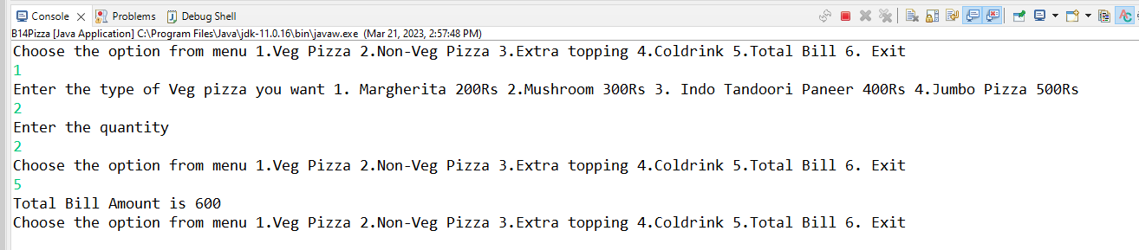

-------------------------------------------

15:Create Menu driven program for array operations.

1:Read Array 2:Print Array 3:Search element in array 4:Reverse Array 5:Even number from array6:sum of array element

**import** java.util.Scanner;

**public** **class** B15ArrayOperation

{

**public** **static** **void** main(String[] args)

{

Scanner sc=**new** Scanner(System.***in***);

System.***out***.println("Enter the size of array");

**int** n=sc.nextInt();

**int** key;

**int**[] arr=**new** **int**[n];

**int** a;

System.***out***.println("Enter the elements of array");

**for**(**int** i=0;i<arr.length;i++)

{

arr[i]=sc.nextInt();

}

**do** {

System.***out***.println("Enter the operation you want to perform 1. Read Array 2. Print array 3. Search element in array 4.Even number from array 5. Sum of array Elements 6.Reverse the array 7.Exit");

a=sc.nextInt();

**switch** (a)

{

**case** 1:

System.***out***.println("After reading");

**for**(**int** x:arr)//for each loop read only in forward direction

{

System.***out***.println(x);

}

**break**;

**case** 2:

{

System.***out***.println("After printing");

**for**(**int** i=0;i<arr.length;i++)

{

System.***out***.print(arr[i]+" ");

}

System.***out***.println();

**break**;

}

**case** 3:

{

System.***out***.println("Enter the element you want to search in array");

key = sc.nextInt();

**int** count=0;

**for** (**int** i = 0; i < arr.length; i++)

{

**if** (key == arr[i])

count++;

}

**if**(count>0)

System.***out***.println(key + " is found in array");

**else**

System.***out***.println(key + " is not found in array");

**break**;

}

**case** 4:

{

System.***out***.print("Even numbers in array are: ");

**for**(**int** i=0;i< arr.length;i++)

{

**if**(arr[i]%2==0)

System.***out***.print(arr[i]+" ");

}

System.***out***.println();

**break**;

}

**case** 5:

**int** sum=0;

**for**(**int** i=0;i< arr.length;i++)

{

sum+=arr[i];

}

System.***out***.println("Sum of all array elements is "+sum);

**break**;

**case** 6:

System.***out***.println("Before reversing");

**for**(**int** i=0;i<n;i++)

{

System.***out***.print(arr[i]+" ");

}

System.***out***.println();

System.***out***.println("After reversing");

**for**(**int** i=n-1;i>=0;i--)

{

System.***out***.print(arr[i]+" ");

}

System.***out***.println();

**break**;

**case** 7:

System.***out***.println("Ending program....");

**default**:

System.***out***.println("Invalid choice");

}

}

**while**(a!=6);

}

}

Output :

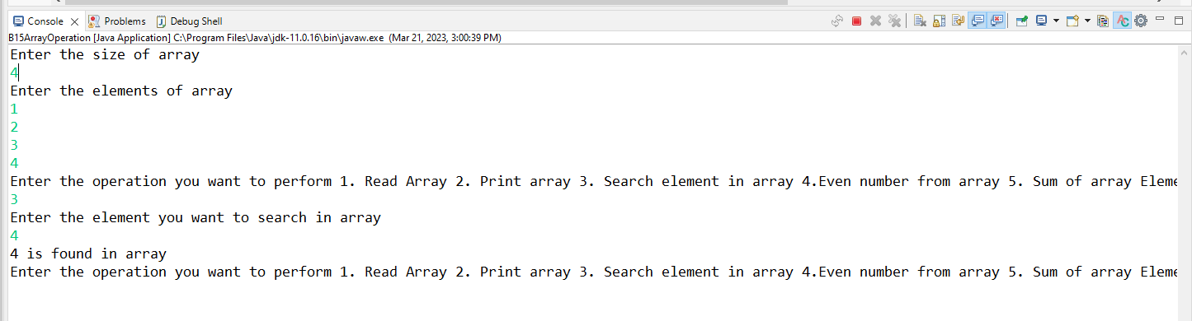

-------------------------------------------

16:read two int array...and store both in third array and display third array

1 2 3

5 6 7 8 9

1 2 3 5 6 7 8 9

package assignments;

import java.util.Arrays;

import java.util.Scanner;

public class mergearrays {

public static void main(String[] args) {

Scanner input = new Scanner(System.in);

System.out.print("Enter the size of the first array: ");

int n = input.nextInt();

int[] arr1 = new int[n];

System.out.println("Enter the elements of the first array: ");

for (int i = 0; i < n; i++) {

arr1[i] = input.nextInt();

}

System.out.print("Enter the size of the second array: ");

int m = input.nextInt();

int[] arr2 = new int[m];

System.out.println("Enter the elements of the second array: ");

for (int i = 0; i < m; i++) {

arr2[i] = input.nextInt();

}

int[] mergedArr = new int[n + m];

for (int i = 0; i < n; i++) {

mergedArr[i] = arr1[i];

}

for (int i = 0; i < m; i++) {

mergedArr[n + i] = arr2[i];

}

System.out.println("The merged array is: " + Arrays.toString(mergedArr));

}

}

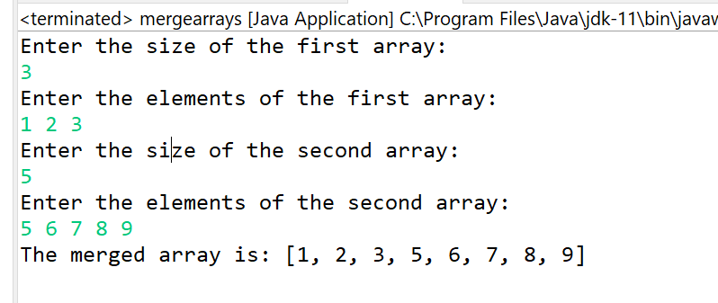

-------------------------------------------

**LAB :- 03**

//1:Create Date class with members day,month ,year.

//Write no argument and parameterised constructor .Create two object s and initialize them using no argument and parameterised constructor

//respectively.Print date using display function.

**package** Assignment3;

**public** **class** A1Date

{

**private** **int** date;

**private** **int** month;

**private** **int** year;

**public**  A1Date()

    {

    date=1;

    month=12;

    year=2023;

    }

**public**  A1Date(**int** date,**int** month,**int** year )

{

**this**.date=date;

**this**.month=month;

**this**.year=year;

}

**public** **void** printdate()

     {

     System.***out***.println(date+" "+month+" "+year);

     }

}

**package** Assignment3;

**import** java.util.Scanner;

**public** **class** A2DateTester

{

**public** **static** **void** main(String[] args)

{

  Scanner sc=**new** Scanner(System.***in***);

A1Date a=**new** A1Date();

    a.printdate();

    System.***out***.println("enter a date month year ");

    A1Date b=**new** A1Date(sc.nextInt(),sc.nextInt(),sc.nextInt());

    b.printdate();

}

}

Output :-

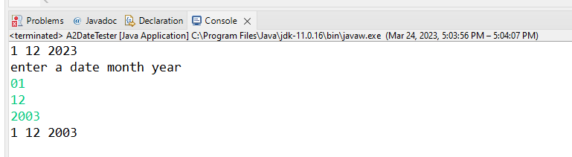

-------------------------------------------

2:Create Employee class with members id(int),name(string),dob(Date).Use above created Date class.

Write default and parameterised constructor in Employee Class.Write accept() function to accept information and display() to display emp information.

**package** assignments;

**public** **class** Employee {

**public**

**int** id;

String name;

**int** Date;

**public** **void** accept(String n, **int** d, **int** i) {

name = n;

id = i;

Date = d;

}

**public** **void** display() {

System.***out***.println(name+" "+id+" "+Date);

}

**public** **static** **void** main(String[] args) {

Employee obj1 = **new** Employee();

Employee obj2 = **new** Employee();

obj1.accept("Ganesh", 4857, 1898 );

obj2.accept("Salunke", 1234, 1899);

obj1.display();

obj2.display();

}

}

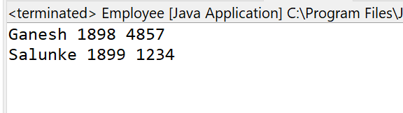

------------------------------------------------------------------------------------

3. Create a class Person with data members as name, age, city. Write getters and setters for all the data

members. Also add the display function. Create Default and Parameterized constructors. Create the

object of this class in main method and invoke all the methods in that class.

**package** assignments;

**import** java.util.Scanner;

**public** **class** Person {

Scanner sc = **new** Scanner(System.***in***);

**private** String name;

**private** **int** age;

**private** String city;

**public** **void** setName(String n) {

name = n;

}

**public** **void** setCity(String c) {

city = c;

}

**public** **void** setAge(**int** a) {

age = a;

}

**public** String getName() {

**return** name;

}

**public** String getCity() {

**return** city;

}

**public** **int** getAge() {

**return** age;

}

**public** **void** display() {

System.***out***.println("Name:" + name + " age:" + age + " city:" + city);

}

}

**package** assignments;

**import** java.util.Scanner;

**public** **class** persontester {

**public** **static** **void** main(String[] args) {

Scanner sc = **new** Scanner(System.***in***);

Person p1 = **new** Person();

Person p2 = **new** Person();

System.***out***.println("Enter Name");

p1.setName(sc.next());

System.***out***.println("Enter Age");

p1.setAge(sc.nextInt());

System.***out***.println("Enter City");

p1.setCity(sc.next());

System.***out***.println("Enter Name");

p2.setName(sc.next());

System.***out***.println("Enter Age");

p2.setAge(sc.nextInt());

System.***out***.println("Enter City");

p2.setCity(sc.next());

p1.display();

p2.display();

}

}

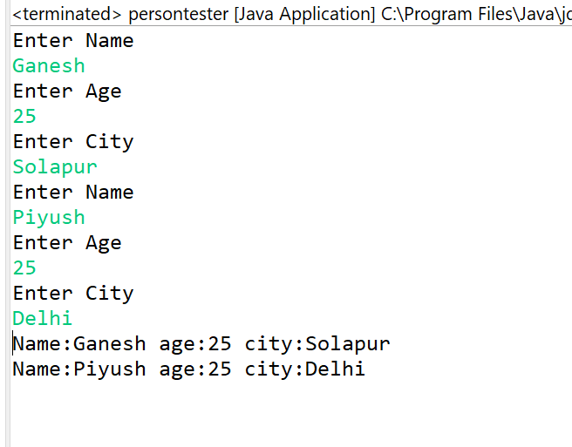

-------------------------------------------

4: Create a class Book with data members as bname,id,author,price. Write getters and setters for all the data members. Also add the display function.

Create the object of this class in main method and invoke all the methods in that class.

**package** assignments;

**import** java.util.Scanner;

**public** **class** Book {

Scanner sc = **new** Scanner(System.***in***);

**private** String bname;

**private** **int** id;

**private** **int** price;

**private** String author;

**public** **void** setbname(String n) {

bname = n;

}

**public** **void** setauthor(String c) {

author = c;

}

**public** **void** setid(**int** a) {

id = a;

}

**public** **void** setprice(**int** a) {

price = a;

}

**public** String getbname() {

**return** bname;

}

**public** String getauthor() {

**return** author;

}

**public** **int** getprice() {

**return** price;

}

**public** **int** getid() {

**return** id;

}

**public** **void** display() {

System.***out***.println("Book Name:" + bname + " id:" + id + " author:" + author + " price" + price);

}

}

**package** assignments;

**import** java.util.Scanner;

**public** **class** booktester {

**public** **static** **void** main(String[] args) {

Scanner sc = **new** Scanner(System.***in***);

Book b1 = **new** Book();

Book b2 = **new** Book();

System.***out***.println("Enter Book Name");

b1.setbname(sc.next());

System.***out***.println("Enter Id");

b1.setid(sc.nextInt());

System.***out***.println("Enter Author");

b1.setauthor(sc.next());

System.***out***.println("Enter Price");

b1.setprice(sc.nextInt());

System.***out***.println("Enter book Name");

b2.setbname(sc.next());

System.***out***.println("Enter Id");

b2.setid(sc.nextInt());

System.***out***.println("Enter Author");

b2.setauthor(sc.next());

System.***out***.println("Enter Price");

b2.setprice(sc.nextInt());

b1.display();

b2.display();

}

}

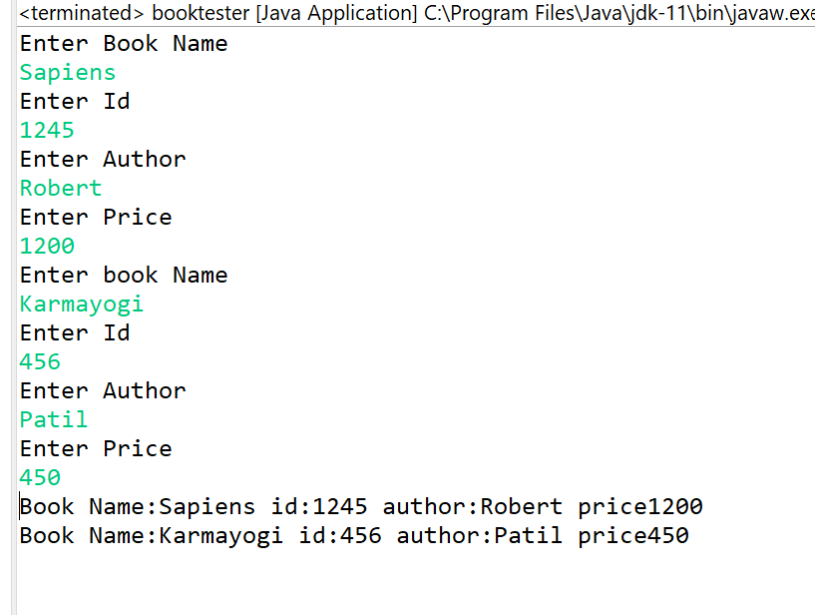

------------------------------------------------------------------------------------

5. Create a class Point with data members as x,y. Write

getters and setters for all the data members. Also add the display function. Create the object of this class in main method and invoke all the methods in that class.

**package** assignments;

**import** java.util.Scanner;

**public** **class** Point {

**private** **double** x;

**private** **double** y;

Scanner sc=**new** Scanner(System.***in***);

**public** **double** getX() {

**return** x;

}

**public** **void** setX(**double** x) {

**this**.x = x;

}

**public** **double** getY() {

**return** y;

}

**public** **void** setY(**double** y) {

**this**.y = y;

}

//to read point

**public** **void** accept()

{

System.***out***.println("Enter th point");

x=sc.nextDouble();

y=sc.nextDouble();

}

**public** **void** display()

{

System.***out***.println("X="+x+" Y="+y);

}

}

**package** assignments;

**public** **class** TestPoint {

**public** **static** **void** main(String[] args) {

// **TODO** Auto-generated method stub

Point p=**new** Point();

//read point from user

p.accept();

// disaplay the point

p.display();

//modify the x co ordinate

p.setX(30);

//update value

System.***out***.println("Updated x="+p.getX());

}

}

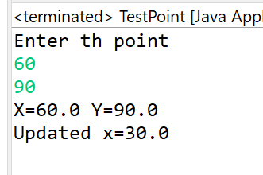

-------------------------------------------

6. Create a class ComplexNumber with data members real, imaginary. Write getters and setters for all the data members. Also add the display function. Create the object of this class in main method and invoke all the methods in that class.

**package** assignments;

**import** java.util.Scanner;

**public** **class** ComplexNumber {

**private** **double** real;

**private** **double** imag;

Scanner sc=**new** Scanner(System.***in***);

// setters and getters

**public** **double** getReal() {

**return** real;

}

**public** **void** setReal(**double** real) {

**this**.real = real;

}

**public** **double** getImag() {

**return** imag;

}

**public** **void** setImag(**double** imag) {

**this**.imag = imag;

}

//to accept complex number

**public** **void** accept()

{

System.***out***.println("enter the complex No:-");

real=sc.nextDouble();

imag=sc.nextDouble();

}

**public** **void** display()

{

System.***out***.println("REAL="+real+" IMAG="+imag);

System.***out***.println("complex no="+real+"+"+imag+"i");

}

}

**package** assignments;

**public** **class** TestComplex {

**public** **static** **void** main(String[] args) {

ComplexNumber c=**new** ComplexNumber();

//read point from user

c.accept();

// disaplay the point

c.display();

//modify the x co ordinate

c.setImag(30);

//update value

System.***out***.println("Updated Imag="+c.getImag());

}

}

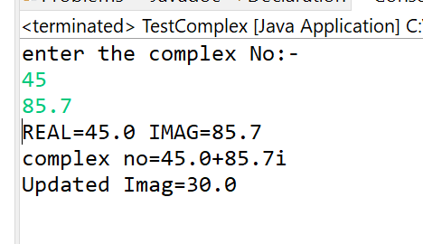

------------------------------------------------------------------------------------

**LAB :- 04**

1:Write a program to create student class with data members rollno, marks1,mark2,mark3.

Accept data (acceptInfo()) and display using display member function.

Also display total,percentage and grade.

**package** Student;

**import** java.util.Scanner;

**public** **class** Student {

**private** **int** rollno;

**private** **int** m1;

**private** **int** m2;

**private** **int** m3;

**private** **double** percentage;

**private** **int** total;

**private** String grade;

**public** **void** acceptData()

{

System.***out***.println("Enter Student Data: ");

Scanner sc=**new** Scanner(System.***in***);

System.***out***.println("Enter Student Roll No: ");

rollno=sc.nextInt();

System.***out***.println("Enter M1 marks: ");

m1=sc.nextInt();

System.***out***.println("Enter M2 marks: ");

m2=sc.nextInt();

System.***out***.println("Enter M3 marks: ");

m3=sc.nextInt();

}

**public** **void** printData()

{

System.***out***.println("Roll No:- "+rollno);

System.***out***.println("Marks of M1= "+m1 +"Marks of M2= "+m2 +"Marks of M3= "+m3);

}

**public** **void** totalMarks()

{

total=m1+m2+m3;

System.***out***.println("Total Marks="+total);

}

**public** **void** percentage()

{

percentage=(total/3);

System.***out***.println("Student Percentage= "+percentage+"%");

}

**public** **void** grade()

{

**if**(percentage>75)

System.***out***.println("Grade A+");

**else**

System.***out***.println("Grade A ");

}

}

**Tester code :-**

**package** Student;

**import** Student.Student;

**public** **class** TesterStudent {

**public** **static** **void** main(String[] args) {

Student a1= **new** Student();

a1.acceptData();

a1.printData();

a1.totalMarks();

a1.percentage();

a1.grade();

}

}

Output :-

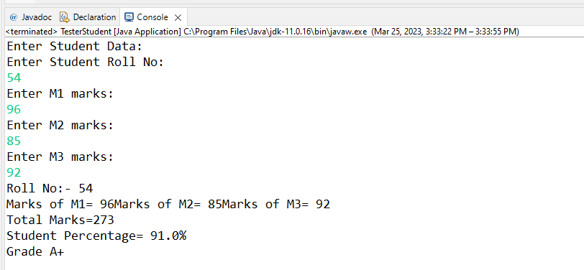

------------------------------------------------------------------------------------

2. Create a class Person with data members as name, age, city. Write getters and setters for all the data

members. Also add the display function. Create Default and Parameterized constructors. Create the

object of this class in main method and invoke all the methods in that class.

**package** assignments;

**public** **class** Student {

**private** **int** rollNo;

**private** String name,adress;

**private** **static** **int** *num*;

**public** Student(String name, String adress) {

**this**.rollNo=++*num*;

**this**.name = name;

**this**.adress = adress;

}

**public** String getName() {

**return** name;

}

**public** **void** setName(String name) {

**this**.name = name;

}

**public** String getAdress() {

**return** adress;

}

**public** **void** setAdress(String adress) {

**this**.adress = adress;

}

**public** **int** getRollNo() {

**return** rollNo;

}

@Override

**public** String toString() {

**return** "Student details= [rollNo=" + rollNo + ", name=" + name + ", adress=" + adress + "]";

}

}

**package** assignments;

**public** **class** TestStudent {

**public** **static** **void** main(String[] args) {

Student s=**new** Student("Ganesh","Pune");

System.***out***.println(s);

Student s1=**new** Student("Piyush","Solapur");

System.***out***.println(s1);

Student [] arr=**new** Student[5];

**for**(**int** i=0;i<arr.length;i++)

{

arr[i]=**new** Student("Ganesh","Solapur");

System.***out***.println(arr[i].getName());

}

}

}

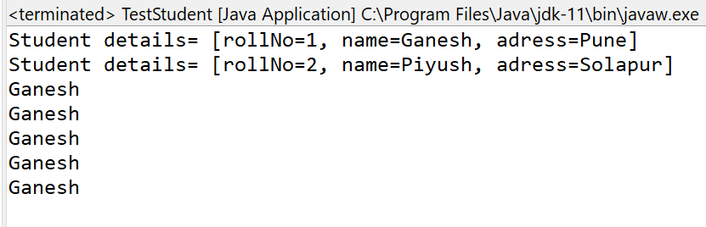

**-------------------------------------------------------------------------------------------------------------**

3. Create a class Book with data members as bname,id,author,price. Write getters and setters for all the

data members. Also add the display function. Create Default and Parameterized constructors. Create

the object of this class in main method and invoke all the methods in that class.

**package** assignments;

**import** java.util.Scanner;

**public** **class** Book {

Scanner sc = **new** Scanner(System.***in***);

**private** String bname;

**private** **int** id;

**private** **int** price;

**private** String author;

**public** **void** setbname(String n) {

bname = n;

}

**public** **void** setauthor(String c) {

author = c;

}

**public** **void** setid(**int** a) {

id = a;

}

**public** **void** setprice(**int** a) {

price = a;

}

**public** String getbname() {

**return** bname;

}

**public** String getauthor() {

**return** author;

}

**public** **int** getprice() {

**return** price;

}

**public** **int** getid() {

**return** id;

}

**public** **void** display() {

System.***out***.println("Book Name:" + bname + " id:" + id + " author:" + author + " price" + price);

}

}

**package** assignments;

**import** java.util.Scanner;

**public** **class** booktester {

**public** **static** **void** main(String[] args) {

Scanner sc = **new** Scanner(System.***in***);

Book b1 = **new** Book();

Book b2 = **new** Book();

System.***out***.println("Enter Book Name");

b1.setbname(sc.next());

System.***out***.println("Enter Id");

b1.setid(sc.nextInt());

System.***out***.println("Enter Author");

b1.setauthor(sc.next());

System.***out***.println("Enter Price");

b1.setprice(sc.nextInt());

System.***out***.println("Enter book Name");

b2.setbname(sc.next());

System.***out***.println("Enter Id");

b2.setid(sc.nextInt());

System.***out***.println("Enter Author");

b2.setauthor(sc.next());

System.***out***.println("Enter Price");

b2.setprice(sc.nextInt());

b1.display();

b2.display();

}

}



------------------------------------------------------------------------------------

4. Create a class Point with data members as x,y. Create Default and Parameterized constructors. Write

getters and setters for all the data members. Also add the display function. Create the object of this

class in main method and invoke all the methods in that class.

**package** assignments;

**import** java.util.Scanner;

**public** **class** Point {

**private** **double** x;

**private** **double** y;

Scanner sc=**new** Scanner(System.***in***);

**public** **double** getX() {

**return** x;

}

**public** **void** setX(**double** x) {

**this**.x = x;

}

**public** **double** getY() {

**return** y;

}

**public** **void** setY(**double** y) {

**this**.y = y;

}

//to read point

**public** **void** accept()

{

System.***out***.println("Enter th point");

x=sc.nextDouble();

y=sc.nextDouble();

}

**public** **void** display()

{

System.***out***.println("X="+x+" Y="+y);

}

}

**package** assignments;

**public** **class** TestPoint {

**public** **static** **void** main(String[] args) {

// **TODO** Auto-generated method stub

Point p=**new** Point();

//read point from user

p.accept();

// disaplay the point

p.display();

//modify the x co ordinate

p.setX(30);

//update value

System.***out***.println("Updated x="+p.getX());

}

}



-------------------------------------------

5. Create a class ComplexNumber with data members real, imaginary. Create Default and Parameterized constructors. Write getters and setters for all the data members. Also add the display function. Create the object of this class in main method and invoke all the methods in that class.

**package** assignments;

**import** java.util.Scanner;

**public** **class** ComplexNumber {

**private** **double** real;

**private** **double** imag;

Scanner sc=**new** Scanner(System.***in***);

// setters and getters

**public** **double** getReal() {

**return** real;

}

**public** **void** setReal(**double** real) {

**this**.real = real;

}

**public** **double** getImag() {

**return** imag;

}

**public** **void** setImag(**double** imag) {

**this**.imag = imag;

}

//to accept complex number

**public** **void** accept()

{

System.***out***.println("enter the complex No:-");

real=sc.nextDouble();

imag=sc.nextDouble();

}

**public** **void** display()

{

System.***out***.println("REAL="+real+" IMAG="+imag);

System.***out***.println("complex no="+real+"+"+imag+"i");

}

}

**package** assignments;

**public** **class** TestComplex {

**public** **static** **void** main(String[] args) {

ComplexNumber c=**new** ComplexNumber();

//read point from user

c.accept();

// disaplay the point

c.display();

//modify the x co ordinate

c.setImag(30);

//update value

System.***out***.println("Updated Imag="+c.getImag());

}

}



------------------------------------------------------------------------------------

6:create BankAccount aaplication for operations like withdraw ,deposite and moneyTransfer.

Create menu drive program for bank operations..

**package** assignments;

**public** **class** Account {

**private** **int** actid;

**private** String name,email,city;

**private** **double** balance;

**public** Account(**int** actid,String name,String email,String city,**double** balance)

{

**this**.actid=actid;

**this**.name=name;

**this**.email=email;

**this**.city=city;

**this**.balance=balance;

}

**public** **void** setName(String name)

{

**this**.name=name;

}

**public** String getName()

{

**return** name;

}

**public** **void** setEmail(String email) {

**this**.email=email;

}

**public** String getEmail()

{

**return** email;

}

**public** **void** setCity(String city)

{

**this**.city=city;

}

**public** String getCity()

{

**return** city;

}

**public** **int** getActid()

{

**return** actid;

}

**public** **double** getBalance()

{

**return** balance;

}

**public** **void** withdraw(**double** amount)

{

**if**(balance>amount)

{

**this**.balance=**this**.balance-amount;

System.***out***.println("Balance After Withdraw= "+**this**.balance);

}

**else**

System.***out***.println("Insufficient Balance");

}

**public** **void** deposite(**double** amount)

{

**this**.balance=**this**.balance+amount;

System.***out***.println("Balance After Deposite= "+**this**.balance);

}

**public** **void** display()

{

System.***out***.println("Account Id="+actid+" Name="+name+ " Email="+email+" City="+city+" Balance="+balance);

}

**public** **void** moneyTransfer(Account receiver,**double** amount)

{

**this**.balance=**this**.balance-amount;

receiver.balance=receiver.balance+amount;

System.***out***.println("Money is transfered from "+**this**.name+" to "+receiver.name);

System.***out***.println("Sender Balance="+**this**.getBalance()+" receiver Balance= "+receiver.getBalance());

}

}

**package** assignments;

**import** java.util.Scanner;

**import** assignments.Account;

**public** **class** AxisBank {

**public** **static** **void** main(String[] args) {

Scanner sc=**new** Scanner(System.***in***);

Account[] axisBank= **new** Account[2];

**int** choice,index=0;

Account act=**null**;

System.***out***.println("1.Create Account");

System.***out***.println("2.Show Account");

System.***out***.println("3.Withdraw");

System.***out***.println("4.Deposite");

System.***out***.println("5.Check Balance");

System.***out***.println("6.Update Name");

System.***out***.println("7.Update Email");

System.***out***.println("8.Update City");

System.***out***.println("9.Transfer");

System.***out***.println("10.Exit");

**do**

{

System.***out***.println("Enter Choice: ");

choice=sc.nextInt();

**switch**(choice)

{

**case** 1:

**if**(index<axisBank.length)

{

System.***out***.println("To create Account: ");

System.***out***.println("Enter Account Id Name Email City Balance");

act = **new** Account(sc.nextInt(), sc.next(), sc.next(), sc.next(), sc.nextDouble());

axisBank[index] = act;

index++;

}

**else**

{

System.***out***.println("Array is Full");

}

**break**;

**case** 2:

System.***out***.println("----------Account Details--------");

System.***out***.println("index="+index);

**for**(**int** i=0;i<index;i++)

{

axisBank[i].display();

}

**break**;

**case** 3:

System.***out***.println("------Withdraw details------");

System.***out***.println("Enter Account Id: ");

**int** id=sc.nextInt();

**boolean** flag=**false**;

**for**(**int** i=0;i<index;i++)

{

**if**(axisBank[i].getActid()==id)

{

System.***out***.println("Hi "+axisBank[i].getName());

System.***out***.println("Enter Amount to withdraw: ");

axisBank[i].withdraw(sc.nextDouble());

flag=**true**;

**break**;

}

**else**

flag=**false**;

}

**if**(flag==**false**)

System.***out***.println("Account Does not Exists");

**break**;

**case** 4:

System.***out***.println("------Deposite details------");

System.***out***.println("Enter Account Id: ");

id=sc.nextInt();

flag=**false**;

**for**(**int** i=0;i<index;i++)

{

**if**(axisBank[i].getActid()==id)

{

System.***out***.println("Enter Amount to deposite: ");

axisBank[i].deposite(sc.nextDouble());

flag=**true**;

**break**;

}

**else**

flag=**false**;

}

**if**(flag==**false**)

System.***out***.println("Account Does not Exists");

**break**;

**case** 5:

System.***out***.println("Enter Account Id: ");

id=sc.nextInt();

flag=**false**;

**for**(**int** i=0;i<index;i++)

{

**if**(axisBank[i].getActid()==id)

{

System.***out***.println("Your Balance="+axisBank[i].getBalance());

flag=**true**;

**break**;

}

**else**

flag=**false**;

}

**if**(flag==**false**)

System.***out***.println("Account Does not Exists");

**break**;

**case** 6:

System.***out***.println("Enter Account Id: ");

id=sc.nextInt();

flag=**false**;

**for**(**int** i=0;i<index;i++)

{

**if**(axisBank[i].getActid()==id)

{

System.***out***.println("Enter Name to Update: ");

axisBank[i].setName(sc.next());

flag=**true**;

**break**;

}

**else**

flag=**false**;

}

**if**(flag==**false**)

System.***out***.println("Account Does not Exists");

**break**;

**case** 7:

System.***out***.println("Enter Account Id: ");

id=sc.nextInt();

flag=**false**;

**for**(**int** i=0;i<index;i++)

{

**if**(axisBank[i].getActid()==id)

{

System.***out***.println("Enter Email to Update: ");

axisBank[i].setEmail(sc.next());

flag=**true**;

**break**;

}

**else**

flag=**false**;

}

**if**(flag==**false**)

System.***out***.println("Account Does not Exists");

**break**;

**case** 8:

System.***out***.println("Enter Account Id: ");

id=sc.nextInt();

flag=**false**;

**for**(**int** i=0;i<index;i++)

{

**if**(axisBank[i].getActid()==id)

{

System.***out***.println("Enter City to Update: ");

axisBank[i].setCity(sc.next());

flag=**true**;

**break**;

}

**else**

flag=**false**;

}

**if**(flag==**false**)

System.***out***.println("Account Does not Exists");

**break**;

**case** 9:

System.***out***.println("Enter Sender's Account Id: ");

id=sc.nextInt();

flag=**false**;

**boolean** flag1=**false**;

**for**(**int** i=0;i<index;i++)

{

**if**(axisBank[i].getActid()==id)

{

System.***out***.println("Enter Receiver's Account Id: ");

**int** id1=sc.nextInt();

System.***out***.println("Enter Amount: ");

**double** amount=sc.nextDouble();

**for**(**int** j=0;j<index;j++)

{

**if**(id1==axisBank[j].getActid())

{

axisBank[i].moneyTransfer(axisBank[j],amount);

flag1=**true**;

**break**;

}

**else**

flag1=**false**;

}

**if**(flag1==**false**)

{

System.***out***.println("Account Does not Exists");

}

flag=**true**;

**break**;

}

**else**

flag=**false**;

}

**if**(flag==**false**)

System.***out***.println("Account Does not Exists");

**break**;

**case** 10:

**break**;

**default**:

System.***out***.println("Invalid!!!");

}

}**while**(choice!=9);

}

}

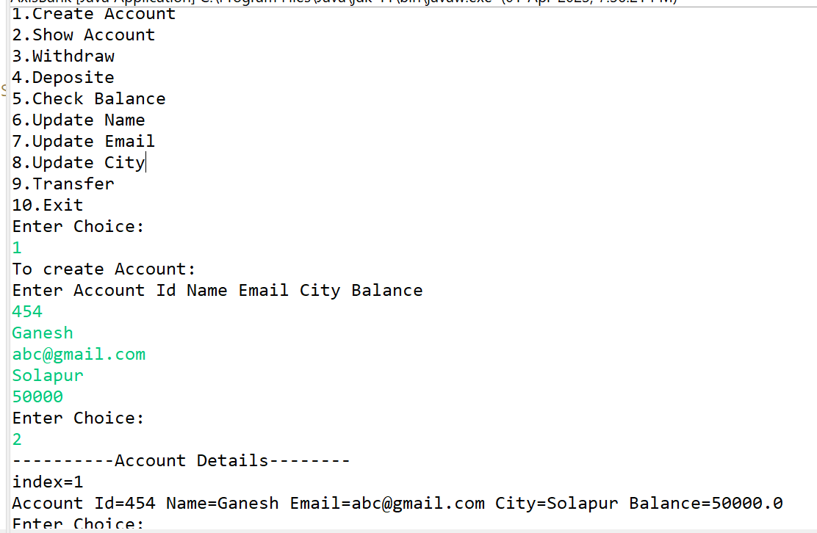

**-------------------------------------------------------------------------------------------------------------**

7.1 Test Student class by creating 5 diff object.and display aal details(chk rollno created automatically)

**package** assignments;

**public** **class** Student {

**private** **int** rollno;

**private** String name;

**private** String address;

**private** **static** **int** *counter*;

**static**

{

System.***out***.println("-----Inside Static------");

*counter*=0;

}

**public** Student() {

**this**.rollno=0;

**this**.name = **null**;

**this**.address = **null**;

}

**public** Student(String name, String address) {

*counter*++;

**this**.rollno=*counter*;

**this**.name = name;

**this**.address = address;

}

**public** String getName() {

**return** name;

}

**public** **void** setName(String name) {

**this**.name = name;

}

**public** String getAddress() {

**return** address;

}

**public** **void** setAddress(String address) {

**this**.address = address;

}

**public** **int** getRollno() {

**return** rollno;

}

**public** **void** displayInfo()

{

System.***out***.println("roll no :: "+rollno+"\tName :: "+**this**.name+"\tAddress :: "+**this**.address);

}

}

**package** assignments;

**import** java.util.Scanner;

**public** **class** TestStudent {

**public** **static** **void** main(String[] args) {

Scanner sc=**new** Scanner(System.***in***);

System.***out***.println("Enter Student name and Address");

Student s1=**new** Student(sc.next(),sc.next());

System.***out***.println("Enter Student name and Address");

Student s2=**new** Student(sc.next(),sc.next());

System.***out***.println("Enter Student name and Address");

Student s3=**new** Student(sc.next(),sc.next());

System.***out***.println("Enter Student name and Address");

Student s4=**new** Student(sc.next(),sc.next());

System.***out***.println("Enter Student name and Address");

Student s5=**new** Student(sc.next(),sc.next());

s1.displayInfo();

s2.displayInfo();

s3.displayInfo();

s4.displayInfo();

s5.displayInfo();

}

}

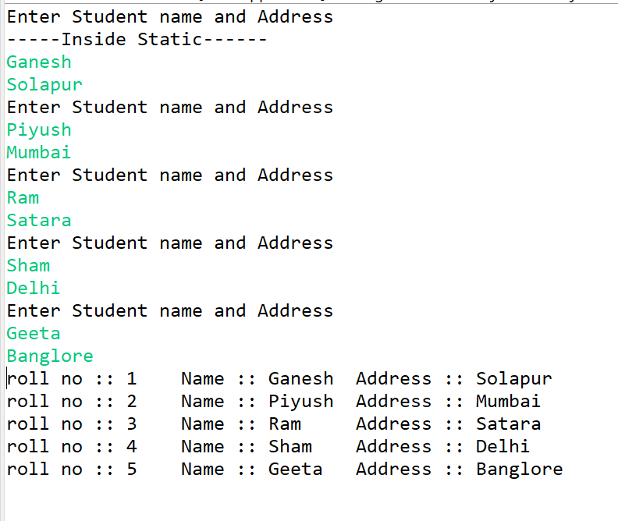

**-------------------------------------------------------------------------------------------------------------**

7.2 Create an array of 5 students and show only names

**package** assignments;

**public** **class** Student {

**private** **int** rollno;

**private** String name;

**private** String address;

**private** **static** **int** *counter*;

**static**

{

System.***out***.println("-----Inside Static------");

*counter*=0;

}

**public** Student() {

**this**.rollno=0;

**this**.name = **null**;

**this**.address = **null**;

}

**public** Student(String name, String address) {

*counter*++;

**this**.rollno=*counter*;

**this**.name = name;

**this**.address = address;

}

**public** String getName() {

**return** name;

}

**public** **void** setName(String name) {

**this**.name = name;

}

**public** String getAddress() {

**return** address;

}

**public** **void** setAddress(String address) {

**this**.address = address;

}

**public** **int** getRollno() {

**return** rollno;

}

**public** **void** displayInfo()

{

System.***out***.println("roll no :: "+rollno+"\tName :: "+**this**.name+"\tAddress :: "+**this**.address);

}

}

**package** assignments;

**import** java.util.Scanner;

**public** **class** TestStudent2 {

**public** **static** **void** main(String[] args) {

Scanner sc=**new** Scanner(System.***in***);

Student[] s=**new** Student[5];

**for**(**int** i=0;i<5;i++)

{

System.***out***.println("Enter Student name and Address");

s[i]=**new** Student(sc.next(),sc.next());

}

**for**(**int** i=0;i<5;i++)

{

System.***out***.println(s[i].getName());

}

sc.close();

}

}

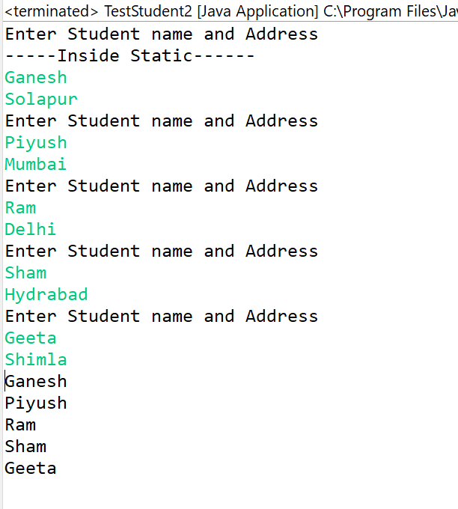

**-------------------------------------------------------------------------------------------------------------**

**LAB :- 07**

**Task 1 :-**

**package** assignments;

**import** java.math.*;

**public** **class** Point2D {

**private** **int** x;

**private** **int** y;

**public** Point2D() {

**super**();

**this**.x = 1;

**this**.y = 1;

}

**public** Point2D(**int** x, **int** y) {

**super**();

**this**.x = x;

**this**.y = y;

}

**public** String show()

{

**return** "X="+**this**.x+" Y="+y;

}

**public** **boolean** isEqual(Point2D p)

{

**if**(**this**.x==p.x && **this**.y==p.y)

{

**return** **true**;

}

**else**

**return** **false**;

}

**public** **double** calculateDistance(Point2D p)

{

**return** Math.*sqrt*(((p.x-**this**.x)*(p.x-**this**.x))+((p.y-**this**.y)*(p.y-**this**.y)));

}

}

**package** assignments;

**import** java.util.Scanner;

**import** assignments.Point2D;

**public** **class** TestPoints {

**public** **static** **void** main(String[] args) {

Scanner sc=**new** Scanner(System.***in***);

// System.out.println(" enter x and y coordinates for point 1");

// Point2D p1=new Point2D(sc.nextInt(),sc.nextInt());

// System.out.println(" enter x and y coordinates for point 2");

// Point2D p2=new Point2D(sc.nextInt(),sc.nextInt());

//

// boolean b=p1.isEqual(p2);

//

// if(b==false)

// {

// System.out.println("Two points are not same");

// System.out.println("Distance calculated is :: "+ p1.calculateDistance(p2));

// }

// else

// {

// System.out.println("Two ponits are equal\nDistance calculated is=0");

// }

System.***out***.println("1 . Accepting the corordinates \n 2.Display the corrdinates \n 3.calculate distance \n 4.Exit ");

System.***out***.println("Enter the size of array ::");

**int** size=sc.nextInt();

**int** index=0,ch=0;

Point2D [] arr=**new** Point2D[size];

**do** {

System.***out***.println("Enter choice :: ");

ch=sc.nextInt();

**switch**(ch)

{

**case** 1:

**for**(**int** i=0;i<arr.length;i++)

{

System.***out***.println(" enter x and y coordinates for point "+i+1+":");

arr[i]=**new** Point2D(sc.nextInt(),sc.nextInt());

}

**break**;

**case** 2:

**for**(**int** i=0;i<arr.length;i++)

{

System.***out***.println("Cordinates: ");

System.***out***.println(arr[i].show());

}

**break**;

**case** 3:

System.***out***.println(" enter x and y coordinates for point 1");

Point2D p3=**new** Point2D(sc.nextInt(),sc.nextInt());

System.***out***.println(" enter x and y coordinates for point 2");

Point2D p4=**new** Point2D(sc.nextInt(),sc.nextInt());

System.***out***.println("Distance calculated is :: "+ p3.calculateDistance(p4));

**break**;

**case** 4:

System.***out***.println("Thank you");

**break**;

**default**:

System.***out***.println("Invalid");

**break**;

}

}**while**(ch !=4);

}

}

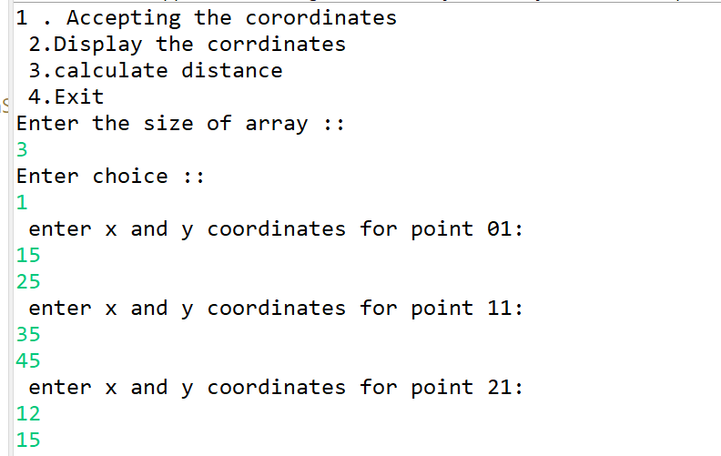

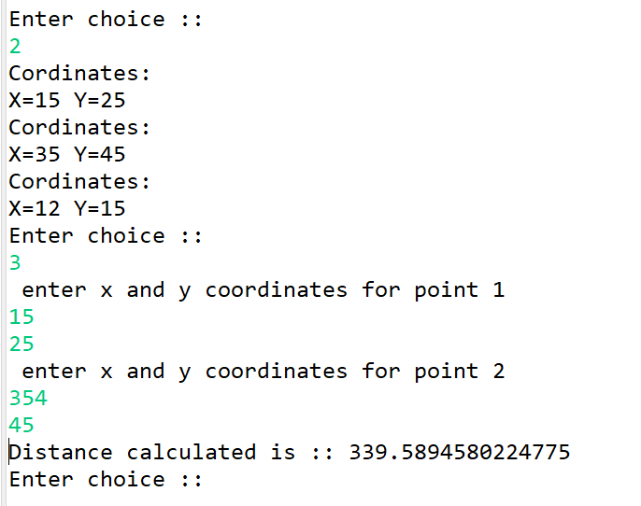

**-------------------------------------------------------------------------------------------------------------**

**Task 2 :-**

**Fruit class :**

**package** assignments;

**public** **class** Fruit {

**protected** String name,color;

**protected** **double** weight;

**protected** **boolean** fresh;

**public** Fruit()

{

**this**.name=**null**;

**this**.color="white";

**this**.weight=0.2;

**this**.fresh=**true**;

}

**public** Fruit(String name, String color, **double** weight) {

**super**();

**this**.name = name;

**this**.color = color;

**this**.weight = weight;

**this**.fresh=**true**;

}

**public** String toString()

{

**return** "Name:"+name+" Color: "+color+" Weight:"+weight;

}

**public** String taste()

{

**return** "No specific taste!!!!";

}

**public** **void** markStale(**boolean** stale)

{

**this**.fresh=stale;

}

**public** **void** markAllSourStale()

{

**if**(**this**.taste().equals("sour"))

{

**this**.markStale(**false**);

}

}

}

**Apple class:**

**package** assignments;

**public** **class** Apple **extends** Fruit{

**public** Apple(String name,String color,**double** weight)

{

**super**(name,color,weight);

}

**public** **void** jam()

{

System.***out***.println("Name:"+**this**.name+" Color:"+color+" Making jam");

}

**public** String toString()

{

**return** **super**.toString()+" Weight:"+weight;

}

**public** String taste()

{

**return** "sweet and sour";

}

}

**Mango class :**

**package** assignments;

**public** **class** Mango **extends** Fruit {

**public** Mango(String name,String color,**double** weight)

{

**super**(name,color,weight);

}

**public** **void** pulp()

{

System.***out***.println("Name="+**this**.name+" Color:"+**this**.color+" Creating pulp");

}

**public** String toString()

{

**return** **super**.toString()+" Weight:"+weight;

}

**public** String taste()

{

**return** "sweet";

}

}

**Orange class:**

**package** assignments;

**public** **class** Orange **extends** Fruit{

**public** Orange(String name,String color,**double** weight)

{

**super**(name,color,weight);

}

**public** **void** juice()

{

System.***out***.println("Name:"+**this**.name+" Color:"+**this**.color+" Extracting Juice");

}

**public** String toString()

{

**return** **super**.toString()+" Weight:"+weight;

}

**public** String taste()

{

**return** "sour";

}

}

**Fruitbasket:**

**package** assignments;

**import** java.util.*;

**public** **class** FruitBasket {

**public** **static** **void** main(String[] args) {

// **TODO** Auto-generated method stub

Scanner sc=**new** Scanner(System.***in***);

System.***out***.println("Enter size of basket: ");

**int** size=sc.nextInt();

Fruit[] basket=**new** Fruit[size];

**int** index=0;

**int** ch=0;

System.***out***.println("1.Add Mango\n2.Add Orange\n3.Add Apple\n4.Display Names\n5.Display all details\n6.Mark Stale");

**do** {

System.***out***.println("Enter choice: ");

ch=sc.nextInt();

**switch**(ch)

{

**case** 1:

**if**(index<basket.length)

{

System.***out***.println("-------Mango Details------");

System.***out***.println("Enter Name Color Weight ");

Mango m = **new** Mango(sc.next(), sc.next(), sc.nextDouble());

basket[index] = m;

index++;

}

**else**

System.***out***.println("Basket is full!!!!");

**break**;

**case** 2:

**if**(index<basket.length)

{

System.***out***.println("-------Orange Details------");

System.***out***.println("Enter Name Color Weight");

Orange o = **new** Orange(sc.next(), sc.next(), sc.nextDouble());

**if** (o.fresh == **true**)

{

basket[index] = o;

index++;

}

}

**else**

System.***out***.println("Basket is full!!!!");

**break**;

**case** 3:

**if**(index<basket.length)

{

System.***out***.println("-------Apple Details------");

System.***out***.println("Enter Name Color Weight");

Apple a = **new** Apple(sc.next(), sc.next(), sc.nextDouble());

**if** (a.fresh == **true**)

{

basket[index] = a;

index++;

}

}

**else**

System.***out***.println("Basket is full!!!!");

**break**;

**case** 4:

**for**(**int** i=0;i<index;i++)

{

System.***out***.println(basket[i].name);

}

**break**;

**case** 5:

**for**(**int** i=0;i<index;i++)

{

System.***out***.println(basket[i]+" Taste:"+basket[i].taste());

}

**break**;

**case** 6:

System.***out***.println("Enter index of fruit to make it stale: ");

**int** index1=sc.nextInt();

**if**(index1<index)

{

basket[index1].markStale(**false**);

}

**else**

System.***out***.println("Invalid index");

**break**;

**case** 7:

**for**(**int** i=0;i<index;i++)

{

basket[i].markAllSourStale();

}

**break**;

**case** 8:

**for**(**int** i=0;i<index;i++)

{

**if**(basket[i] **instanceof** Mango)

{

((Mango)basket[i]).pulp();

}

**else** **if**(basket[i] **instanceof** Orange)

{

((Orange)basket[i]).juice();

}

**else**

((Apple)basket[i]).jam();

}

**break**;

**default**:

System.***out***.println("Invalid!!!");

**break**;

}

}**while**(ch!=9);

}

}

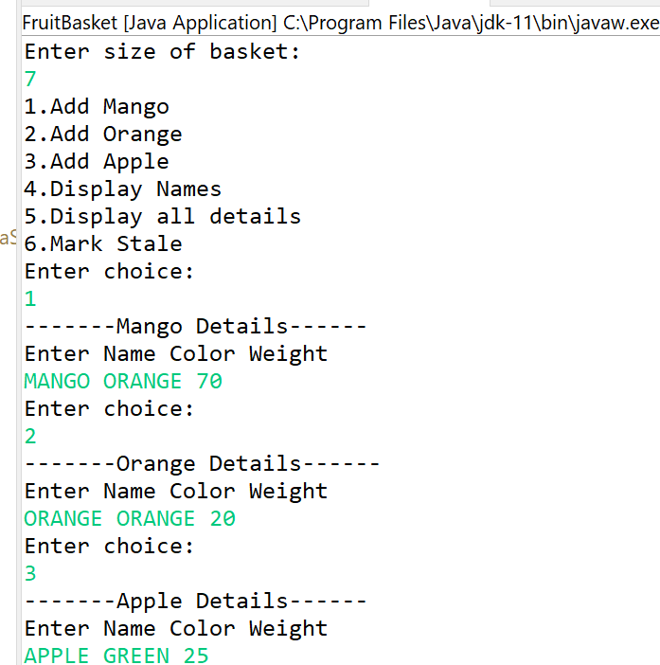

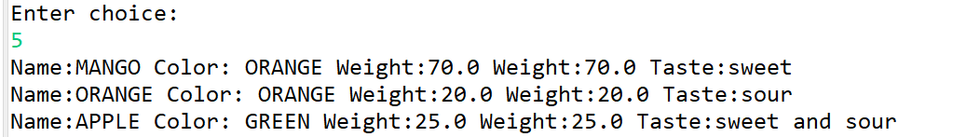

**-------------------------------------------------------------------------------------------------------------**

**Task  3 :-**

**Employee class:**

**package** assignments;

**public** **class** Employee {

**private** **int** empId,deptId;

**private** String firstName,lastName;

**protected** **double** basic;

**private** **static** **int** *counter*;

**static**

{

*counter*=0;

}

**public** Employee(String firstName, String lastName,**int** deptId,**double** basic) {

**super**();

*counter*++;

**this**.empId=*counter*;

**this**.deptId = deptId;

**this**.firstName = firstName;

**this**.lastName = lastName;

**this**.basic = basic;

}

**public** **double** computeNetSalary()

{

**return** **this**.basic;

}

**public** String toString()

{

**return** "Emp Id:"+**this**.empId+" Name:"+**this**.firstName+" "+**this**.lastName+" Dept Id:"+**this**.deptId+" Basic:"+**this**.basic;

}

**public** **double** getBasic() {

**return** basic;

}

**public** **void** setBasic(**double** basic) {

**this**.basic = basic;

}

**public** **int** getEmpId() {

**return** empId;

}

}

**Manager class:**

**package** assignments;

**public** **class** Manager **extends** Employee{

**private** **int** perfBonus;

**public** Manager(String firstName, String lastName, **int** deptId, **double** basic, **int** perfBonus) {

**super**(firstName, lastName, deptId, basic);

**this**.perfBonus = perfBonus;

}

**public** **double** computeNetSalary()

{

**return** **super**.basic+**this**.perfBonus;

}

**public** **int** getPerfBonus() {

**return** perfBonus;

}

**public** **void** setPerfBonus(**int** perfBonus) {

**this**.perfBonus = perfBonus;

}

**public** String toString()

{

**return** **super**.toString()+" Performance Bonus:"+**this**.perfBonus;

}

}

**Worker class:**

**package** assignments;

**public** **class** Worker **extends** Employee{

**private** **int** hoursWorked,hourlyRate;

**public** Worker(String firstName, String lastName, **int** deptId, **double** basic, **int** hoursWorked, **int** hourlyRate) {

**super**(firstName, lastName, deptId, basic);

**this**.hoursWorked = hoursWorked;

**this**.hourlyRate = hourlyRate;

}

**public** String toString()

{

**return** **super**.toString()+" Hours Worked:"+**this**.hoursWorked+" Hourly Rate:"+**this**.hourlyRate;

}

**public** **double** computeNetSalary()

{

**return** **super**.basic+(**this**.hoursWorked\***this**.hourlyRate);

}

**public** **int** getHourlyRate() {

**return** hourlyRate;

}

**public** **void** setHourlyRate(**int** hourlyRate) {

**this**.hourlyRate = hourlyRate;

}

}

**Test organisation:**

**package** assignments;

**import** java.util.Scanner;

**public** **class** TestOrganization {

**public** **static** **void** main(String[] args) {

Scanner sc=**new** Scanner(System.***in***);

System.***out***.println("1.Hire Manager\n2.Hire Worker\n3.Display\n4.To change Salary\n5.Exit");

System.***out***.println("Enter No.of Employee: ");

**int** size=sc.nextInt();

Employee[] e=**new** Employee[size];

**int** ch=0,index=0;

**do** {

System.***out***.println("Enter Choice: ");

ch=sc.nextInt();

**switch**(ch)

{

**case** 1:

**if**(index<e.length)

{

System.***out***.println("-------Enter details for Manager-----");

System.***out***.println("Enter First Name Last Name Department Id Basic Salary Performance Bonus");

e[index]=**new** Manager(sc.next(),sc.next(),sc.nextInt(),sc.nextDouble(),sc.nextInt());

index++;

}

**else**

System.***out***.println("----Array is full------");

**break**;

**case** 2:

**if**(index<e.length)

{

System.***out***.println("-------Enter details for Worker-----");

System.***out***.println("Enter First Name Last Name Department Id Basic Salary Hours Worked Hourly Rate");

e[index]=**new** Worker(sc.next(),sc.next(),sc.nextInt(),sc.nextDouble(),sc.nextInt(),sc.nextInt());

index++;

}

**else**

System.***out***.println("----Array is full------");

**break**;

**case** 3:

**for**(Employee i:e)

{

**if**(i!=**null**)

{

System.***out***.println(i+" Net SAlary:"+i.computeNetSalary());

}

}

**break**;

**case** 4:

System.***out***.println("------To update Salary-----");

System.***out***.println("Enter Employee Id:");

**int** id=sc.nextInt();

**for**(**int** i=0;i<index;i++)

{

**if**(id==e[i].getEmpId())

{

System.***out***.println("Enter Salary: ");

e[i].setBasic(sc.nextDouble());

}

}

**break**;

**case** 5:

**break**;

**default**:

System.***out***.println("Invalid!!!");

**break**;

}

}**while**(ch!=5);

}

}



