Data structures are the building blocks of any computer program as they help in organising and manipulating data in an efficient manner. Without data structures, the computer would be unable to understand how to follow a program's instructions properly. It also defines their relationship with one another.

Arrays, Linked Lists, Stacks, Queues, and others are examples of Data Structure. Data structures also provide clarity, organization and structure to the program's code while also helping the programmer ensure that each line of code performs its function correctly.

Data Structure is classified in basically two main categories -

Primitive Data Structure
Non-Primitive Data Structure

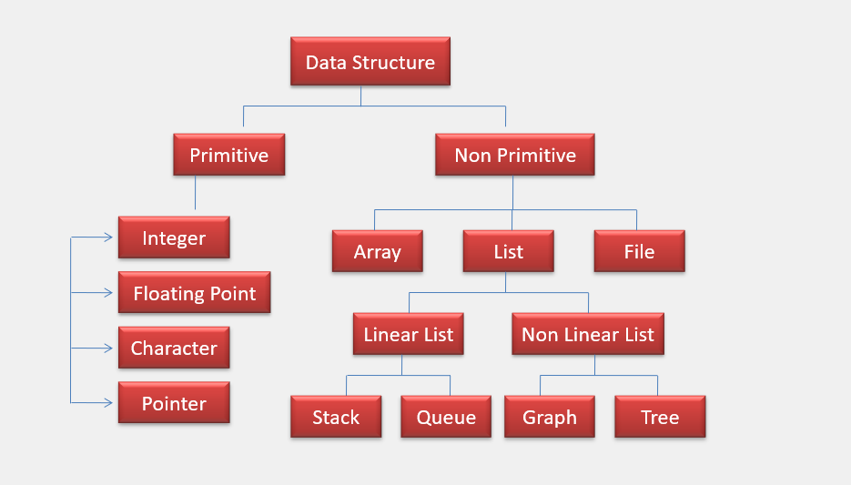

Interview question
https://www.interviewbit.com/data-structure-interview-questions/

Primitive data structure is a fundamental type of data structure that stores the data of only one type whereas the non-primitive data structure is a type of data structure which is a user-defined that stores the data of different types in a single entity.

Linear Data Structure: A data structure that includes data elements arranged sequentially or linearly, where each element is connected to its previous and next nearest elements, is referred to as a linear data structure. Arrays and linked lists are two examples of linear data structures.

Non-Linear Data Structure: Non-linear data structures are data structures in which data elements are not arranged linearly or sequentially. We cannot walk through all elements in one pass in a non-linear data structure, as in a linear data structure. Trees and graphs are two examples of non-linear data structures.

Can you explain the difference between file structure and storage structure?
File Structure: Representation of data into secondary or auxiliary memory say any device such as a hard disk or pen drive that stores data which remains intact until manually deleted is known as a file structure representation.

Storage Structure: In this type, data is stored in the main memory i.e RAM, and is deleted once the function that uses this data gets completely executed.
The difference is that the storage structure has data stored in the memory of the computer system, whereas the file structure has the data stored in the auxiliary memory.

Recursion
Way of solving problems by having a function calling itself
Trying the same method with different parameters until solve the problem
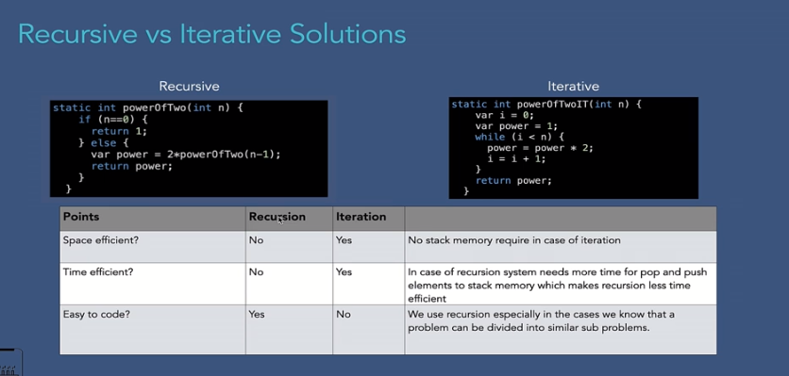

Time Complexity

Big o notation

It represents the upper bound of the runtime of an algorithm. Big O Notation's role is to calculate the longest time an algorithm can take for its execution, i.e., it is used for calculating the worst-case time complexity of an algorithm.

Omega Notation (Ω(n)): It represents the lower bound of the runtime of an algorithm. It is used for calculating the best time an algorithm can take to complete its execution, i.e., it is used for measuring the best case time complexity of an algorithm.

Theta Notation (Θ(n)): It carries the middle characteristics of both Big O and Omega notations as it represents the lower and upper bound of an algorithm.

Ex . int[] = {1,2,3,4,5,6,7}

Finding smallest number from above list will take 1 loop that is Omega notation
Finding middle number from above list will take 4 loop that is Theta notation
Finding highest number from above list will take 7 loop that is Big O notation

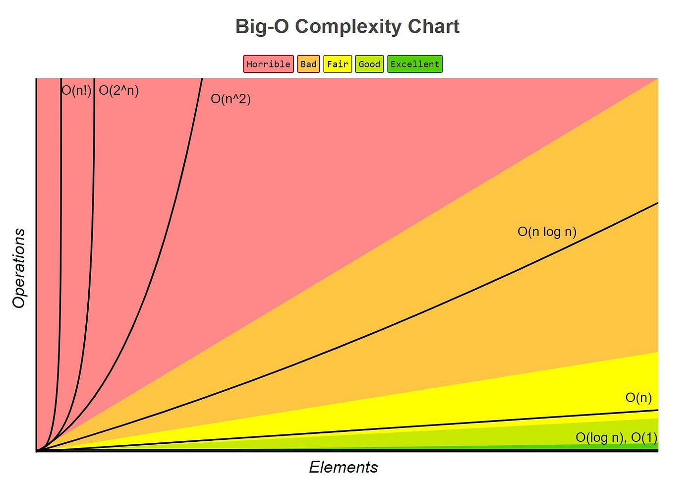
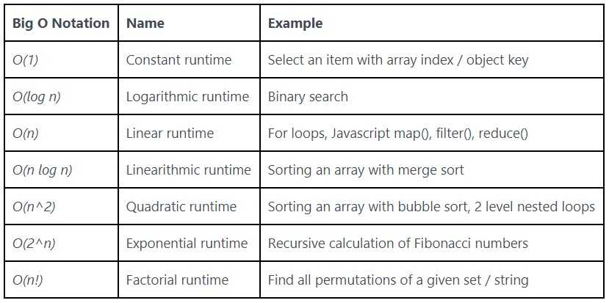
https://www.udemy.com/course/java-data-structures-and-algorithms-masterclass/learn/lecture/37271752#content

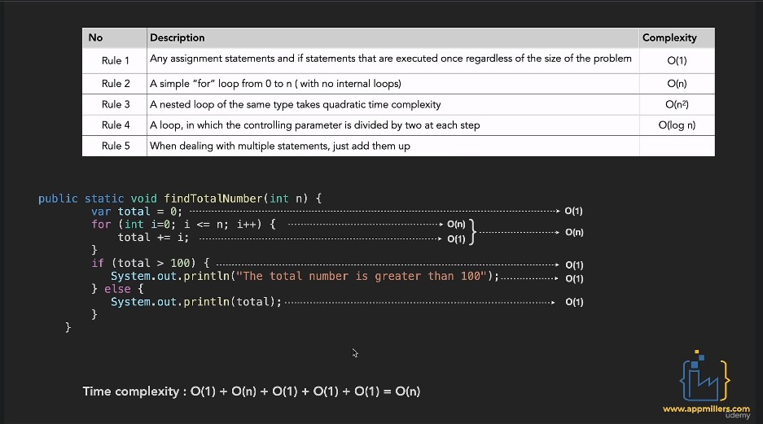

https://www.sahinarslan.tech/posts/comprehensive-big-o-notation-guide-in-plain-english-using-javascript

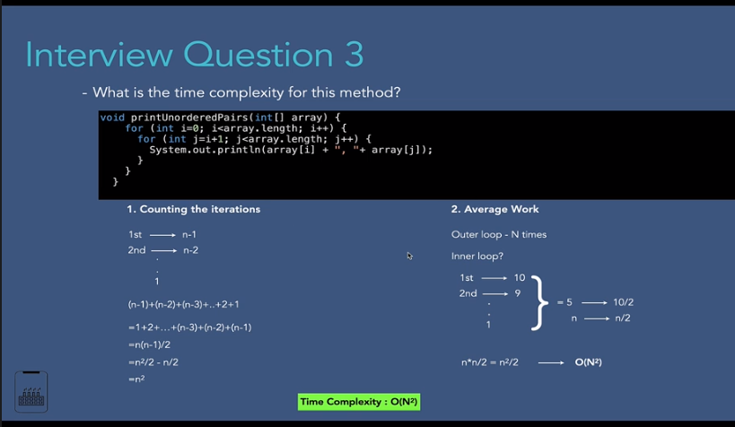

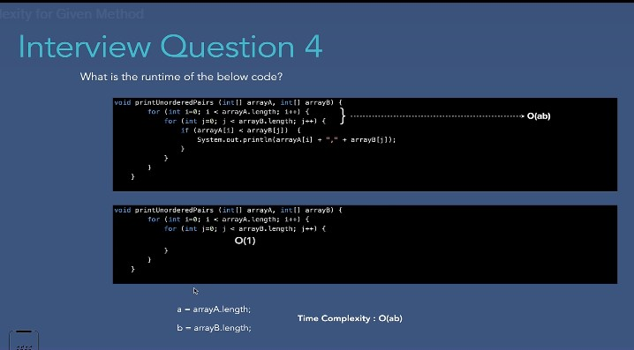

Space complexity

Space complexity refers to the total amount of memory space used by an algorithm/program, including the space of input values for execution. Calculate the space occupied by variables in an algorithm/program to determine space complexity

A permutation is an arrangement of objects in a definite order. The members or elements of sets are arranged here in a sequence or linear order. For example, the permutation of set A={1,6} is 2, such as {1,6}, {6,1}.

We can find permutation using nested for loop

Array
Array there are one directional and multidirectional array
All array store in memory as one directional array

we can not delete element from array
Shifting of element is time consuming in array
Array reserve memory if declare array length

Search algorithm
Linear Serach algorithm is simple algorithm in which sorted/insorted array will iterate till target element not found

Binary search algorithm is work on sorted array . it will find middle element then compare with target.
Binary search implementation is bit complex

Sorting Algorithm

Selection Sort
Merge Sort
Buble Sort
Insertion Sort
Quick Sort
Bucket sort

DATA STRUCTURE Selection
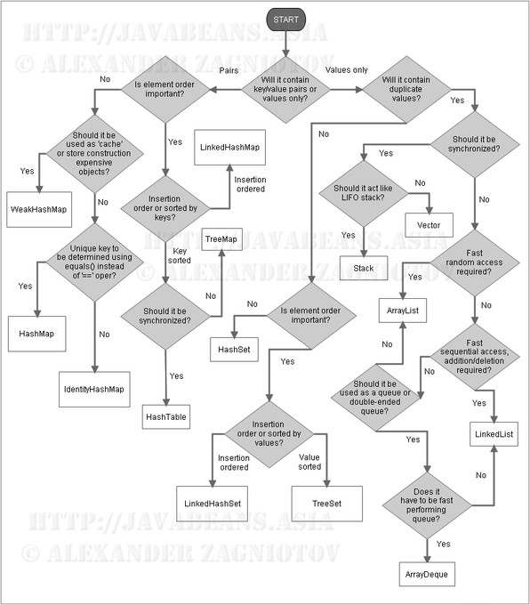

Graph
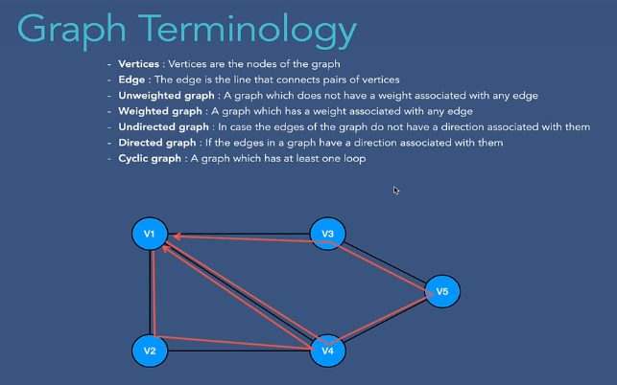
Graph representation
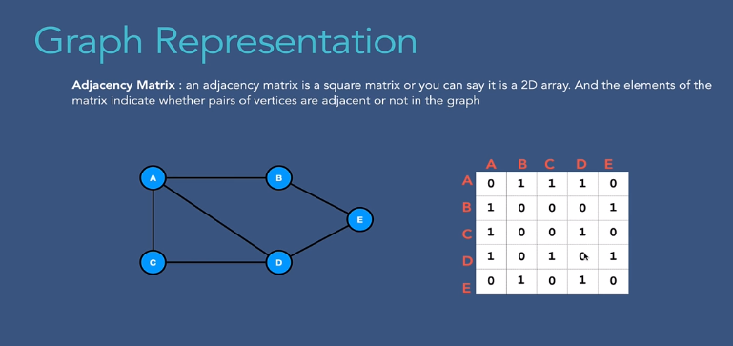
https://www.javatpoint.com/java-graph

Collection hierarchy

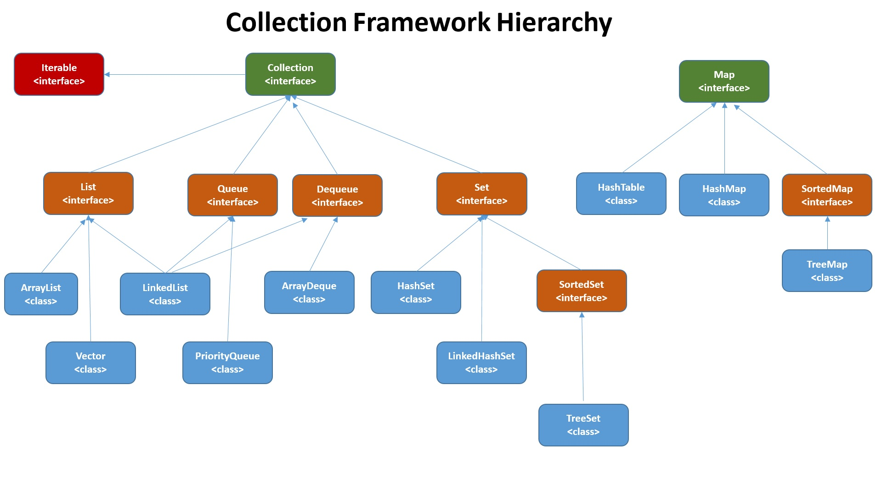

The Collection in Java is a framework that provides an architecture to store and manipulate the group of objects.

Java Collections can achieve all the operations that you perform on a data such as searching, sorting, insertion, manipulation, and deletion.

Java Collection means a single unit of objects. Java Collection framework provides many interfaces (Set, List, Queue, Deque) and classes (ArrayList, Vector, LinkedList, PriorityQueue, HashSet, LinkedHashSet, TreeSet).

Iterable Interface: This is the root interface for the entire collection framework. The collection interface extends the iterable interface. Therefore, inherently, all the interfaces and classes implement this interface. The main functionality of this interface is to provide an iterator for the collections. Therefore, this interface contains only one abstract method which is the iterator. It returns the

Collection Interface: This interface extends the iterable interface and is implemented by all the classes in the collection framework. This interface contains all the basic methods which every collection has like adding the data into the collection, removing the data, clearing the data, etc.

List Interface

The List interface in Java provides a way to store the ordered collection.
It is a child interface of Collection.
It is an ordered collection of objects in which duplicate values can be stored. List can store null element.
Since List preserves the insertion order, it allows positional access and insertion of elements.

The List interface is found in java.util package and inherits the Collection interface.
It is a factory of ListIterator interface.
Through the ListIterator, we can iterate the list in forward and backward directions. The implementation classes of the List interface are ArrayList, LinkedList, Stack.
ArrayList and LinkedList are widely used in Java programming.

Since List is an interface, objects cannot be created of the type list. We always need a class that implements this List in order to create an object.

List is an ‘interface’, implemented by the ArrayList class, pre-defined in the java.util package.

LIST DECLARATION
public interface List<E> extends Collection<E> ;

Methods of the List Interface
add(int index,element);
addAll(int index, Collection collection);
size();
clear();
remove(element);
get(int index);
set(int index, element)

SET INTERFACE

Reference : https://www.geeksforgeeks.org/set-in-java/

The set interface is present in java.util package and extends the Collection interface.
It is an unordered collection of objects in which duplicate values cannot be stored.
It is an interface that implements the mathematical set.

There are two interfaces that extend the set implementation namely SortedSet and NavigableSet.

Since Set is an interface, we cannot create objects from it.

In order to use functionalities of the Set interface, we can use these classes:

HashSet
LinkedHashSet
EnumSet
TreeSet

These classes are defined in the Collections framework and implement the Set interface.

// Set implementation using HashSet
Set<String> animals = new HashSet<>();
The Java Set interface allows us to perform basic mathematical set operations like union, intersection, and subset.

Union - to get the union of two sets x and y, we can use x.addAll(y)
Intersection - to get the intersection of two sets x and y, we can use x.retainAll(y)
Subset - to check if x is a subset of y, we can use y.containsAll(x)

SET interface
Used to store unique value ex. hashset , linkedlistSet, tree

LIST VS SET

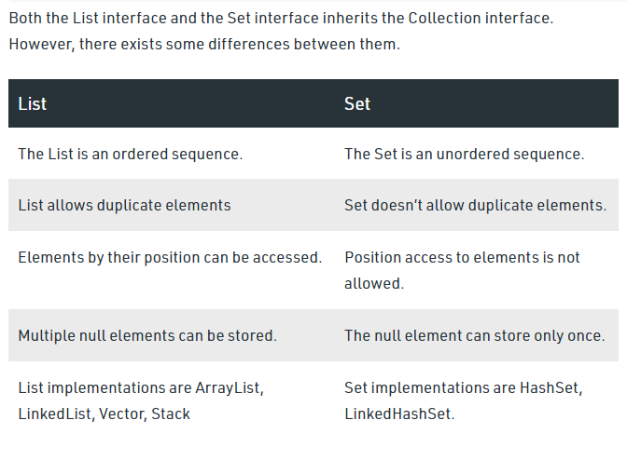

Java ArrayList

Feature :
- Java ArrayList class can contain duplicate elements.
- Java ArrayList class maintains insertion order.
- Java ArrayList class is non-synchronized.
- Java ArrayList class initial capacity is 10.
- Java ArrayList allows random access because the array works on an index basis.
- In ArrayList, manipulation is a little bit slower than the LinkedList in Java because a lot of shifting needs to occur if any element is removed from the array list.
- We can not create an array list of the primitive types, such as int, float, char, etc. It is required to use the required wrapper class in such cases.
- Java ArrayList gets initialized by the size. The size is dynamic in the array list, which varies according to the elements getting added or removed from the list.

Reference : https://www.geeksforgeeks.org/arraylist-in-java/

import java.util.ArrayList;
public class CollectionArrayList {
public static void main(String[] args) {
// TODO Auto-generated method stub
ArrayList<String> al = new ArrayList<>();
al.add("ganesh");
al.add("sadashiv");
al.add("avhad");
System.out.println(al);
al.add(1,"snehal");
System.out.println(al);
al.set(1, "vishal");
System.out.println(al);
al.remove("sadashiv");
System.out.println(al);
for (int i = 0; i < al.size(); i++) {
System.out.println(al.get(i) + " ");
}
for (String str : al)
System.out.print(str + " ")
}
}

How to implement an ArrayList in Java from scratch

LinkedList
Java LinkedList class uses a doubly linked list to store the elements. It provides a linked-list data structure. It inherits the AbstractList class and implements List and Deque interfaces.

In the case of a doubly linked list, we can add or remove elements from both sides.

The important points about Java LinkedList are:

Java LinkedList class can contain duplicate elements.
Java LinkedList class maintains insertion order.
Java LinkedList class is non-synchronized.
In Java LinkedList class, manipulation is fast because no shifting needs to occur.
Java LinkedList class can be used as a list, stack or queue.

Both ArrayList and LinkedList are implementation of List interface. They both maintain the elements insertion order which means while displaying ArrayList and LinkedList elements the result set would be having the same order in which the elements got inserted into the List

Methods of Java LinkedList
void addFirst(E e) It is used to insert the given element at the beginning of a list.
void addLast(E e) It is used to append the given element to the end of a list.
boolean add(E e) It is used to append the specified element to the end of a list.
E getFirst() It is used to return the first element in a list.
E getLast() It is used to return the last element in a list.
E pop() It pops an element from the stack represented by a list.
int size() It is used to return the number of elements in a list.

import java.util.*;
public class LinkedList4{
public static void main(String args[]){

LinkedList<String> ll=new LinkedList<String>();
ll.add("Ravi");
ll.add("Vijay");
ll.add("Ajay");
//Traversing the list of elements in reverse order
Iterator i=ll.descendingIterator();
while(i.hasNext())
{
System.out.println(i.next());
}
}
}

ArrayList vs LinkedList
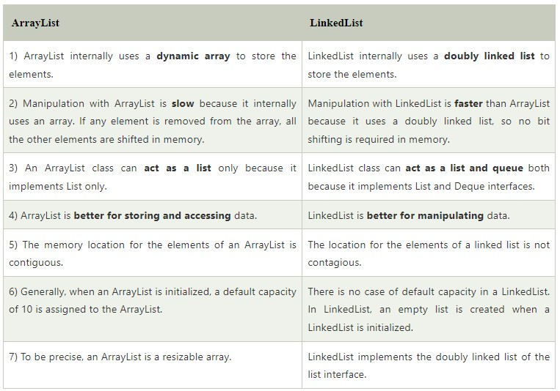

Type Of LinkList

- Single link list : ex train
- Circular link list : ex carom board player
- Doubly link list : ex.music palyer
- Circular doubly link list : ex image slider

https://www.geeksforgeeks.org/types-of-linked-list/

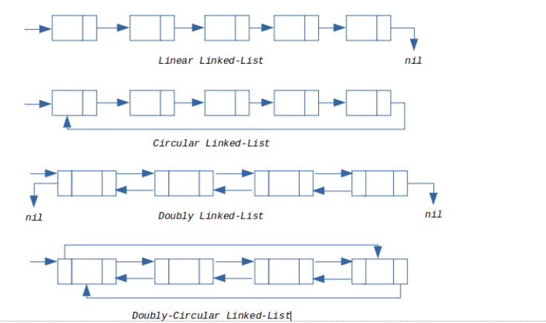

Single Link List

The singly linked list is a linear data structure in which each element of the list contains a pointer which points to the next element in the list. Each element in the singly linked list is called a node. Each node has two components: data and a pointer next which points to the next node in the list. The first node of the list is called as head, and the last node of the list is called a tail. The last node of the list contains a pointer to the null. Each node in the list can be accessed linearly by traversing through the list from head to tail.

https://www.javatpoint.com/java-program-to-create-and-display-a-singly-linked-list

https://www.geeksforgeeks.org/data-structures/linked-list/singly-linked-list/

Link List Insertion
We can insert elements at beginning, middle and at end of linked list. eg . anywhere

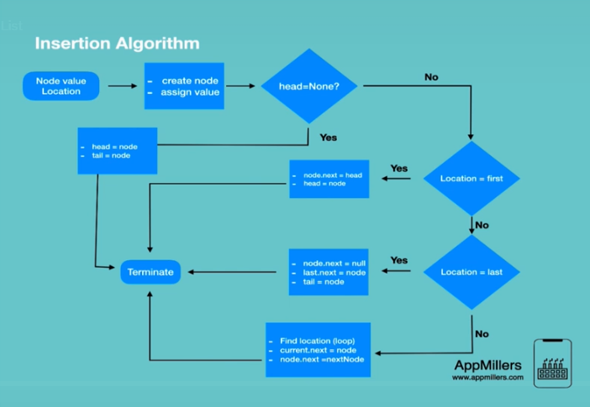

Circular singly linked list
The circular linked list is a linked list where all nodes are connected to form a circle. In a circular linked list, the first node and the last node are connected to each other which forms a circle. There is no NULL at the end.
There are two type :
- circular singly linked list
- circular doubly linked list
https://www.geeksforgeeks.org/circular-linked-list/

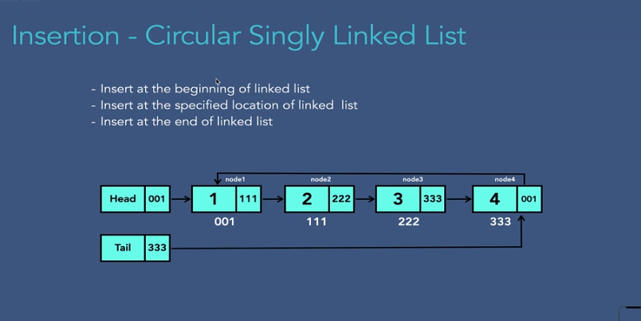
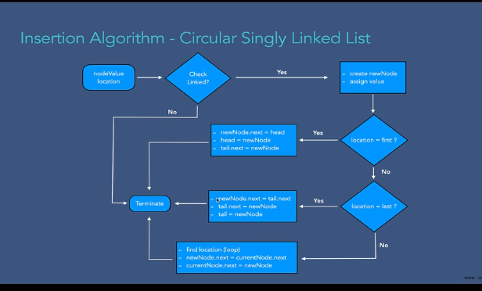

Delete singly circular link list

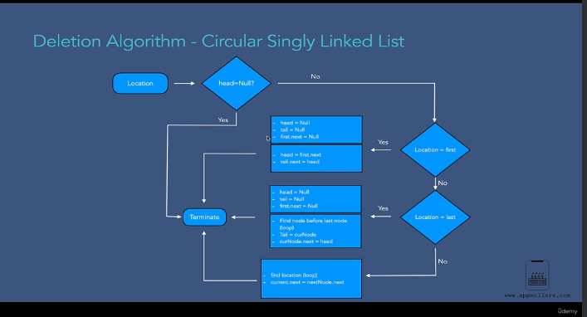

Doubly Link List

Doubly linked list is a data structure that has reference to both the previous and next nodes in the list. It provides simplicity to traverse, insert and delete the nodes in both directions in a list.

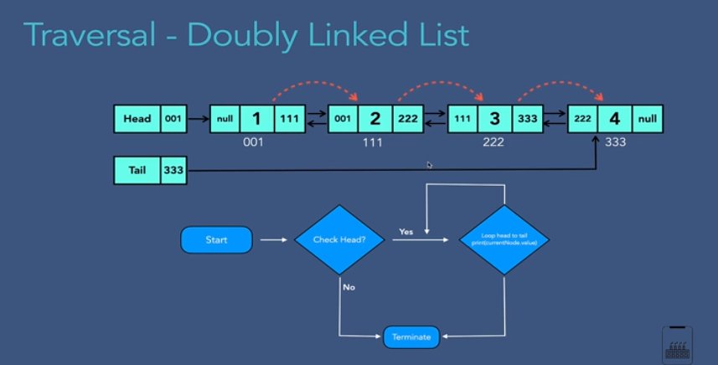

HashSet
Java HashSet class is used to create a collection that uses a hash table for storage. It inherits the AbstractSet class and implements Set interface.

The important points about Java HashSet class are:

HashSet stores the elements by using a mechanism called hashing.
HashSet contains unique elements only.
HashSet allows null value.
HashSet class is non synchronized.
HashSet doesn't maintain the insertion order. Here, elements are inserted on the basis of their hashcode.
HashSet is the best approach for search operations.
The initial default capacity of HashSet is 16, and the load factor is 0.75

https://www.logicbig.com/tutorials/core-java-tutorial/java-collections/java-collection-cheatsheet.html

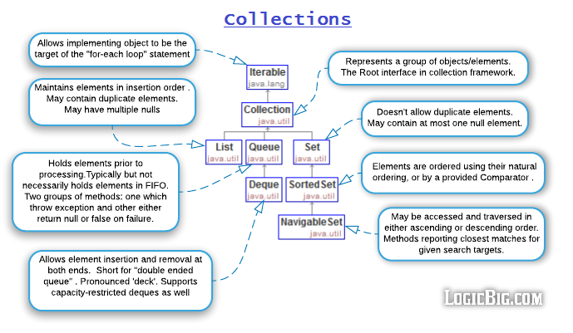

Sorted Map

https://www.geeksforgeeks.org/sortedmap-java-examples/

Stack
Stack is a linear data structure that follows a particular order in which the operations are performed. The order may be LIFO(Last In First Out) or FILO(First In Last Out). LIFO implies that the element that is inserted last, comes out first and FILO implies that the element that is inserted first, comes out last.

Ex web browser back/next button
Undo . rendo button

Queue

Serving requests on a single shared resource, like a printer, CPU task scheduling etc.

https://www.fullstack.cafe/interview-questions/queues

Hash

https://www.java67.com/2017/08/top-10-java-hashmap-interview-questions.html

https://www.geeksforgeeks.org/hashtable-in-java/

Hashmap vs hashset vs hashtable
https://www.w3schools.blog/hashset-hashmap-hashtable-java

