What is Java ?
Java is a high-level, object-oriented programming language developed by Sun Microsystems (now owned by Oracle). It is designed to be platform-independent, meaning that Java programs can run on any device with a Java Virtual Machine (JVM). Key features of Java include:

1. Write Once, Run Anywhere (WORA): Java code can be written on one device and run on any other device with a compatible JVM, promoting portability.

2. Object-Oriented: Java follows the object-oriented programming paradigm, allowing developers to create modular and reusable code through the use of classes and objects.

3. Platform-Independent: Java applications are compiled into an intermediate bytecode that can be executed on any device with a JVM, providing platform independence.

4.Automatic Memory Management: Java uses a garbage collector to automatically manage memory, freeing developers from manual memory management tasks.

5.Rich Standard Library: Java comes with a comprehensive set of libraries and APIs that simplify development tasks, ranging from input/output operations to networking and graphical user interface (GUI) development.

6.Security: Java has built-in security features, such as the ability to run applets in a restricted environment and a security manager that controls access to system resources.

7.Multi-threading: Java supports concurrent programming through built-in support for multithreading, allowing developers to create applications that can perform multiple tasks simultaneously.

Overall, Java is a versatile and widely used programming language, particularly in enterprise applications, web development, mobile app development (Android), and large-scale systems.
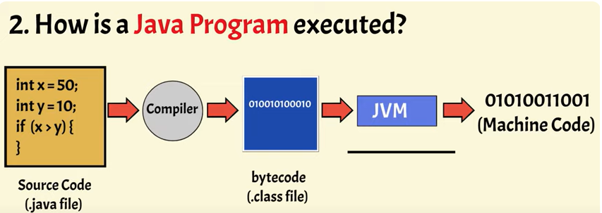
Java programs are executed in a two-step process: compilation and interpretation.

1. **Compilation:**
- Java source code is initially written in plain text files with a `.java` extension.
- The Java compiler (`javac`) translates the human-readable Java source code into an intermediate form known as bytecode.
- Bytecode is a set of instructions for the Java Virtual Machine (JVM), rather than being specific to any particular hardware or operating system.
This produces `MyClass.class`, which contains the bytecode.

2. **Interpretation/Execution:**
- The Java Virtual Machine (JVM) is responsible for executing Java bytecode.
- The JVM reads and interprets the bytecode line by line, executing the corresponding machine-level instructions.
- During execution, the JVM performs Just-In-Time (JIT) compilation, translating bytecode into native machine code for the specific hardware on which the program is running. This improves performance by avoiding the interpretation overhead.

The `java` command launches the JVM, which loads and executes the bytecode from `MyClass.class`. In this example, it prints "Hello, World!" to the console.

This combination of compilation to bytecode and interpretation/execution by the JVM allows Java programs to be platform-independent, as long as a JVM is available for the target platform. The WORA (Write Once, Run Anywhere) principle is achieved by having the same bytecode run on any device with a compatible JVM.
Access specifiers

In Java, access specifiers (also known as access modifiers) are keywords used to control the visibility or accessibility of classes, methods, fields, and other members within a program. There are four access specifiers in Java:

1. `public`:
- Members declared as `public` are accessible from any other class.
- There are no restrictions on accessing `public` members.

2. `private`:
- Members declared as `private` are accessible only within the same class.
- They are not visible to other classes, even subclasses.

3. `protected`:
- Members declared as `protected` are accessible within the same class, package, and subclasses (even if they are in different packages).
- However, they are not accessible outside the package if not in a subclass relationship.

4. `default` (no modifier):
- If no access specifier is specified, the default access level is package-private (also known as default or package-local).
- Members with default access are accessible within the same package but not from outside the package.

It's important to choose the appropriate access specifier based on the desired level of encapsulation and the design of your program. Using access specifiers helps in implementing encapsulation and controlling the visibility of members, contributing to better code organization and maintenance.
What is Static Method in Java

In Java, a static method is a method that belongs to a class rather than an instance of the class. This means you can call a static method on the class itself, without creating an instance of the class. The `static` keyword is used to declare a static method.

Here's an example of a static method:

public class MyClass {
// Static method
public static void myStaticMethod() {
System.out.println("This is a static method.");
}

public static void main(String[] args) {
// Calling the static method without creating an instance of MyClass
MyClass.myStaticMethod();
}
}

Key points about static methods:

- *No Instance Required:* Unlike instance methods, you can invoke a static method without creating an instance of the class. In the example above, `myStaticMethod` can be called using `MyClass.myStaticMethod()` without creating a `MyClass` object.

- *Class-Level Operation:* Static methods are associated with the class itself rather than with any specific instance of the class. They can be seen as class-level operations.

- *Cannot Access Instance Variables:* Since static methods are not associated with an instance, they cannot directly access instance variables or call instance methods. They can only access other static members.

- *Common Use Cases:* Static methods are often used for utility functions that don't rely on the state of an object, as well as for factory methods or methods that perform operations at the class level.

public class MathUtils {
// Example of a static utility method
public static int add(int a, int b) {
return a + b;
}

public static void main(String[] args) {
int result = MathUtils.add(5, 3);
System.out.println("Result: " + result);
}
}

In the example above, the `add` method is a static utility method that can be called without creating an instance of `MathUtils`.
Method OverLoading
Method overloading is a feature in Java that allows a class to have multiple methods with the same name but different parameters. The idea is to provide flexibility and clarity when calling methods, as long as the parameter lists of the methods differ.

Key points about method overloading:

1. **Same Method Name:**
- In an overloaded set of methods, all methods must have the same name.
- The compiler differentiates between the methods based on the number, types, and order of their parameters.

2. **Different Parameter Lists:**
- The methods in an overloaded set must have different parameter lists. This can involve differences in the number of parameters, their types, or both.

3. **Return Type Doesn't Matter:**
- Method overloading is not based on the return type of the method. Two methods can have the same name and parameter lists but different return types, and this is not considered method overloading.

Here's a simple example of method overloading:

public class MathOperations {
// Overloaded methods with different parameter lists
public int add(int a, int b) {
return a + b;
}

public double add(double a, double b) {
return a + b;
}

public String add(String a, String b) {
return a + b;
}

public static void main(String[] args) {
MathOperations math = new MathOperations();

// Calling different overloaded methods
int sumInt = math.add(5, 3);
double sumDouble = math.add(2.5, 3.7);
String concatenatedString = math.add("Hello, ", "world!");

System.out.println("Sum (int): " + sumInt);
System.out.println("Sum (double): " + sumDouble);
System.out.println("Concatenation: " + concatenatedString);
}
}

In this example, the `add` method is overloaded with three different versions, each taking a different set of parameters. The appropriate method is called based on the arguments passed during the method invocation.

Method overloading enhances code readability and provides a way to create more flexible and intuitive APIs within a class.

Method Overriding

Method overriding in Java allows a subclass to provide a specific implementation of a method that is already defined in its superclass. When a subclass defines a method that is already present in its superclass with the same method signature (method name, return type, and parameters), it is said to override that method. Method overriding is a key concept in achieving runtime polymorphism in object-oriented programming.

Constuctor
In Java, a constructor is a special type of method that is used to initialize objects. It is called when an object is created using the `new` keyword and is used to perform tasks such as initializing instance variables, allocating resources, or any other setup that needs to be done when an object is created.

Key characteristics of constructors:

1. **Same Name as the Class:**
- A constructor must have the same name as the class in which it is declared.

2. **No Return Type:**
- Unlike regular methods, constructors do not have a return type, not even `void`.

3. **Implicit Invocation:**
- Constructors are automatically invoked when an object is created using the `new` keyword.

4. **Can Be Overloaded:**
- Like other methods, constructors can be overloaded, meaning a class can have multiple constructors with different parameter lists.

public class MyClass {
// Instance variable
private int myNumber;

// Constructor with no parameters (default constructor)
public MyClass() {
// Initialization or setup code
myNumber = 0;
}

// Constructor with a parameter
public MyClass(int number) {
// Initialization code using the parameter
myNumber = number;
}

// Getter method for myNumber
public int getMyNumber() {
return myNumber;
}

public static void main(String[] args) {
// Creating objects and invoking constructors
MyClass obj1 = new MyClass(); // Using the default constructor
MyClass obj2 = new MyClass(42); // Using the parameterized constructor

// Accessing instance variables through getter method
System.out.println("obj1: " + obj1.getMyNumber()); // Output: 0
System.out.println("obj2: " + obj2.getMyNumber()); // Output: 42
}
}

In this example, `MyClass` has two constructors—one without parameters (default constructor) and another with a parameter. When objects are created, the appropriate constructor is invoked, and the instance variable `myNumber` is initialized accordingly. Constructors play a crucial role in the initialization of objects in Java.
Inheritance
Inheritance is a fundamental concept in object-oriented programming (OOP) that allows a class (subclass or derived class) to inherit the characteristics (fields and methods) of another class (superclass or base class). In Java, inheritance is implemented using the `extends` keyword.

Key points about inheritance in Java:

1. **Superclass and Subclass:**
- The class that is being inherited from is called the superclass or base class.
- The class that inherits from another class is called the subclass or derived class.

2. **"is-a" Relationship:**
- Inheritance represents an "is-a" relationship. For example, if `Dog` is a subclass of `Animal`, you can say that a `Dog` "is a" type of `Animal`.

3. **Code Reusability:**
- Inheritance promotes code reusability by allowing the subclass to inherit fields and methods from the superclass. The subclass can then extend or override inherited behavior.

4. **Access to Superclass Members:**
- The subclass inherits all non-private members (fields and methods) of the superclass.
- The `protected` access modifier allows access to inherited members within the subclass.

Here's a simple example:

// Superclass
class Animal {
String name;

Animal(String name) {
this.name = name;
}

void eat() {
System.out.println(name + " is eating.");
}
}

// Subclass inheriting from Animal
class Dog extends Animal {
Dog(String name) {
// Call the constructor of the superclass using super()
super(name);
}

// Override the eat() method
@Override
void eat() {
System.out.println(name + " is eating dog food.");
}

// New method specific to Dog
void bark() {
System.out.println(name + " is barking.");
}
}

public class InheritanceExample {
public static void main(String[] args) {
// Creating objects of the subclass
Animal animal = new Animal("Generic Animal");
Dog dog = new Dog("Buddy");

// Calling methods
animal.eat(); // Output: Generic Animal is eating.
dog.eat(); // Output: Buddy is eating dog food.
dog.bark(); // Output: Buddy is barking.
}
}

In this example, `Animal` is the superclass, and `Dog` is the subclass. The `Dog` class inherits the `name` field and the `eat` method from the `Animal` class. The `Dog` class also overrides the `eat` method and introduces a new method, `bark`. When objects of these classes are created, they demonstrate the principles of inheritance and polymorphism.
Final
In Java, the `final` keyword is a modifier that can be applied to classes, methods, and variables, providing certain restrictions and behaviors.

1. **Final Variables (Constants):**
- When applied to a variable, the `final` keyword indicates that the variable's value cannot be changed after it has been assigned a value. It essentially makes the variable a constant.
- The variable must be initialized at the time of declaration or within the constructor.

public class Example {
final int constantValue = 42;

public void modifyValue() {
// Compilation error: Cannot assign a value to a final variable
// constantValue = 10;
}
}

2. **Final Methods:**
- When applied to a method, the `final` keyword indicates that the method cannot be overridden by subclasses. This is commonly used in the context of method overriding and inheritance.

public class Parent {
// Final method
public final void finalMethod() {
// Method implementation
}
}

public class Child extends Parent {
// Compilation error: Cannot override the final method from Parent
// public void finalMethod() { ... }
}

3. **Final Classes:**
- When applied to a class, the `final` keyword indicates that the class cannot be subclassed. It prevents other classes from extending it.

final class FinalClass {
// Class implementation
}

// Compilation error: Cannot inherit from final FinalClass
// class SubClass extends FinalClass { ... }

- Making a class `final` is often done for security, efficiency, or design reasons when the developer intends to prevent further extension of the class.

4. **Final Parameters:**
- When applied to method parameters, the `final` keyword indicates that the parameter's value cannot be modified within the method.

public void process(final int value) {
// Compilation error: Cannot assign a value to final variable 'value'
// value = 10;
// ... rest of the method
}

The use of the `final` keyword is a way to make elements of your code more predictable, secure, and maintainable. It helps express your intentions clearly and can be a tool for compiler optimization.

Final Finally Finalize

final: Imposes restrictions on variables, methods, or classes.
finally: Used in exception handling for code that must be executed regardless of whether an exception occurs.
finalize: Used for cleanup operations before an object is garbage collected, but its usage is not as common in modern Java development. The finalize method is called by the garbage collector before reclaiming an object's memory. It allows the object to perform cleanup operations before being destroyed.

packages
In Java, packages are used to organize classes and interfaces into a hierarchical structure. This helps in avoiding naming conflicts, improving code organization, and providing better modularization. There are two main types of packages in Java: built-in packages and user-defined packages.

1. Built-in Packages:

import java.util.ArrayList;
import java.util.List;

Example
Java.lang
Java.util
Java.Math
Java.io
Java.net
Java.sql

In this example, the `java.util` package is used, and two classes (`ArrayList` and `List`) from this package are imported and used in the `PackageExample` class.

2. User-Defined Packages:

Example: Creating a User-Defined Package

// File: geometry/Circle.java
package geometry;

In this example, a user-defined package named `geometry` is created, and a class `Circle` is placed inside this package. The `MainApp` class then imports and uses the `Circle` class from the `geometry` package.

Package Structure and Naming Conventions:

- Package names in Java are usually lowercase and follow a reverse domain naming convention to avoid naming conflicts (e.g., `com.example.myapp`).
- The directory structure should match the package structure. For example, the `geometry` package should be in a directory named `geometry`.

Packages help in organizing and managing large codebases, improving code readability, and facilitating collaboration among developers by providing a namespace for classes and reducing naming conflicts.
abstract class
In Java, an abstract class is a class that cannot be instantiated on its own and is meant to be subclassed by other classes. It serves as a blueprint for other classes and may contain abstract methods, which are declared but not implemented in the abstract class. Subclasses of the abstract class are then required to provide concrete implementations for these abstract methods.

Key features of abstract classes in Java:

1. **Abstract Methods:**
- Abstract classes can have abstract methods, which are declared without providing an implementation.
- Subclasses must provide concrete implementations for all abstract methods.

2. **Cannot Be Instantiated:**
- You cannot create an instance of an abstract class using the `new` keyword. It's meant to be subclassed.

3. **May Contain Concrete Methods:**
- Abstract classes can also contain regular (concrete) methods with an implementation.
- Subclasses inherit both abstract and concrete methods.

4. **May Contain Constructors:**
- Abstract classes can have constructors, and these constructors are invoked when an instance of a concrete subclass is created.

Here's an example of an abstract class:

// Abstract class
abstract class Shape {
// Abstract method
abstract double calculateArea();

// Concrete method
void display() {
System.out.println("This is a shape.");
}
}

// Concrete subclass
class Circle extends Shape {
private double radius;

Circle(double radius) {
this.radius = radius;
}

// Implementation of the abstract method
@Override
double calculateArea() {
return Math.PI * radius * radius;
}
}

public class AbstractClassExample {
public static void main(String[] args) {
// Cannot create an instance of the abstract class Shape
// Shape shape = new Shape(); // Compilation error

// Creating an instance of the concrete subclass Circle
Circle circle = new Circle(5.0);

// Calling methods
circle.display(); // Output: This is a shape.
double area = circle.calculateArea();
System.out.println("Area of the circle: " + area);
// Output: Area of the circle: 78.53981633974483
}
}

In this example, `Shape` is an abstract class with an abstract method `calculateArea()` and a concrete method `display()`. The `Circle` class is a concrete subclass of `Shape` that provides an implementation for the abstract method. Note that you cannot create an instance of `Shape` directly, but you can create instances of its concrete subclasses, such as `Circle`.
Create Object in java
https://www.geeksforgeeks.org/different-ways-create-objects-java/?ref=lbp
https://www.javatpoint.com/how-to-create-object-in-java

Different ways to create objects in java

- Using new keyword ex .NewExample1 obj = new NewExample1();
- Using new instance ex.
- Using clone() method
- Using deserialization
- Using newInstance() method of Constructor class

WAR, JAR, EAR
JAR files allow us to package multiple files in order to use it as a library, plugin, or any kind of application. On the other hand, WAR files are used only for web applications.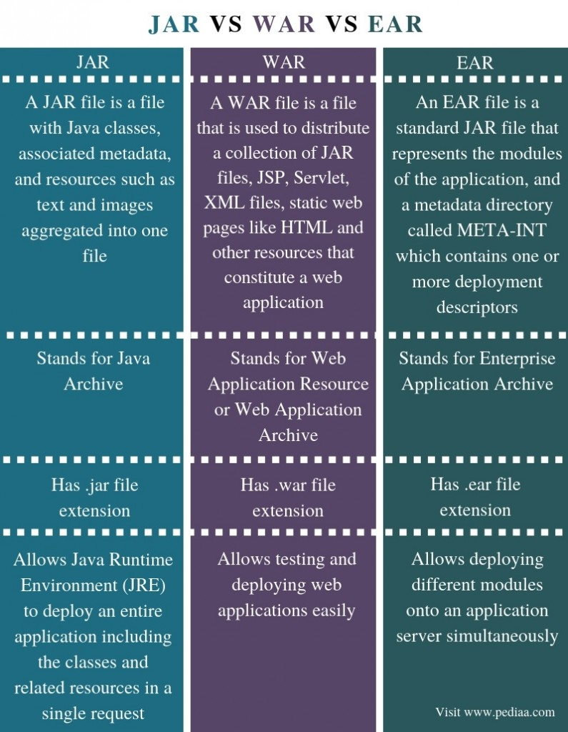

JAVA Array

Ref https://www.javatpoint.com/array-in-java
Syntax to Declare an Array in Java
dataType[] arr; (or)
dataType []arr; (or)
dataType arr[];
Example
String one[] = {"one","two","three"};
String[] two = {"one","two","three"};
int[] three = {4,5,6,7};

int a[]=new int[5]; //declaration and instantiation
a[0]=10;//initialization
a[1]=20;
a[2]=70;
a[3]=40;
a[4]=50;

ArrayIndexOutOfBoundsException
The Java Virtual Machine (JVM) throws an ArrayIndexOutOfBoundsException if length of the array in negative, equal to the array size or greater than the array size while traversing the array.
//declaring and initializing 2D array
int arr[][]={{1,2,3},{2,4,5},{4,4,5}};
//printing 2D array
for(int i=0;i<3;i++){
for(int j=0;j<3;j++){
System.out.print(arr[i][j]+" ");
}
System.out.println();

THIS keyword
There can be a lot of usage of Java this keyword. In Java, this reference variable refers to the current object.

this can be used to refer current class instance variable.
this can be used to invoke current class method (implicitly)
this() can be used to invoke current class constructor.
this can be passed as an argument in the method call.
this can be passed as argument in the constructor call.
this can be used to return the current class instance from the method.

Super Keyword
The super keyword in Java is a reference variable which is used to refer to immediate parent class objects.
Whenever you create the instance of a subclass, an instance of parent class is created implicitly which is referred by super reference variable.
Usage of Java super Keyword
super can be used to refer to immediate parent class instance variable.
super can be used to invoke the immediate parent class method.
super() can be used to invoke an immediate parent class constructor.

Why is the Java main method static?
It is because the object is not required to call a static method. If it were a non-static method, JVM
creates an object first then call main() method that will lead the problem of extra memory allocation.

Upcasting and Downcasting
https://www.javatpoint.com/upcasting-and-downcasting-in-java

String buffer and String builder

When to use interface and when to use abstract class?
Ans : https://www.tutorialspoint.com/when-to-use-an-abstract-class-and-when-to-use-an-interface-in-java

Generics in Java

https://www.geeksforgeeks.org/generics-in-java/

Generics means parameterized types. The idea is to allow type (Integer, String, … etc., and user-defined types) to be a parameter to methods, classes, and interfaces. Using Generics, it is possible to create classes that work with different data types. An entity such as a class, interface, or method that operates on a parameterized type is a generic entity.

Wildcards in generics

https://www.geeksforgeeks.org/wildcards-in-java/

Enum Class
Enum class used for static value
In Java, enum was introduced to replace the use of int constants.
https://www.programiz.com/java-programming/enums

Java Serialization and deserialization

https://www.geeksforgeeks.org/serialization-in-java/

https://www.tutorialspoint.com/java/java_serialization.htm

Pillar of java oops

