Exception handling in Java allows you to manage runtime errors and unexpected situations in a structured way. Java provides a robust mechanism for handling exceptions using the `try`, `catch`, `finally`, `throw`, and `throws` keywords.

Here's an overview of how exception handling works in Java:

1. **Try-Catch Blocks:**
- Use `try` to enclose the code that might throw an exception.
- Use `catch` to handle the exception if it occurs.

try {
// Code that might throw an exception
} catch (ExceptionType e) {
// Code to handle the exception
}

Example:

try {
int result = 10 / 0; // This will throw an ArithmeticException
} catch (ArithmeticException e) {
System.out.println("Error: " + e.getMessage());
}

2. **Multiple Catch Blocks:**
- You can have multiple `catch` blocks to handle different types of exceptions.

try {
// Code that might throw an exception
} catch (ExceptionType1 e1) {
// Code to handle ExceptionType1
} catch (ExceptionType2 e2) {
// Code to handle ExceptionType2
}

3. **Finally Block:**
- The `finally` block is optional and is used to specify code that will be executed whether an exception is thrown or not.

try {
// Code that might throw an exception
} catch (ExceptionType e) {
// Code to handle the exception
} finally {
// Code to be executed regardless of whether an exception occurred or not
}

4. **Throwing Exceptions:**
- You can use the `throw` keyword to manually throw an exception.

if (someCondition) {
throw new SomeException("Some error message");
}

5. **Checked and Unchecked Exceptions:**
- Checked exceptions (e.g., `IOException`) must be either caught or declared in the method's signature using the `throws` keyword.
- Unchecked exceptions (e.g., `RuntimeException`) do not require explicit handling or declaration.

public void readFile() throws IOException {
// Code that might throw IOException
}

6. **Custom Exceptions:**
- You can create your own exception classes by extending the `Exception` class or one of its subclasses.

class MyCustomException extends Exception {
// Custom exception code
}

Example:

try {
throw new MyCustomException("This is a custom exception");
} catch (MyCustomException e) {
// Handle the custom exception
}

Java's exception handling provides a powerful way to deal with errors and unexpected situations, promoting cleaner and more maintainable code.
RUNTIME vs COMPILE Time Exception
Compile time is the period when the programming code (such as C#, Java, C, Python) is converted to the machine code (i.e. binary code). Runtime is the period of time when a program is running and generally occurs after compile time.

What are compile time /checked exceptions or runtime exceptions /unchecked exceptions ?

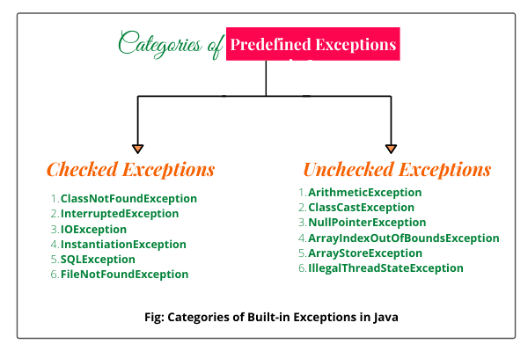

Reference : https://www.baeldung.com/cs/runtime-vs-compile-time
Exception Handling
https://www.javatpoint.com/exception-handling-in-java

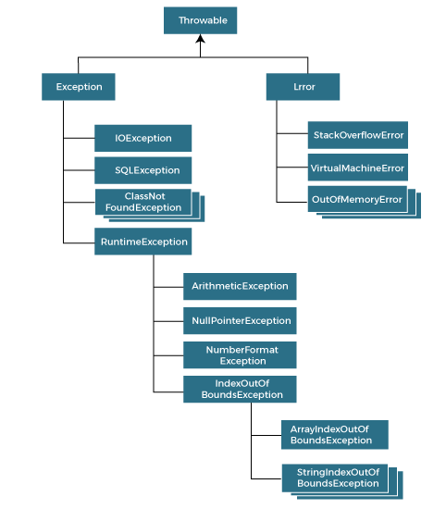

In Java, `throw` and `throws` are keywords related to exception handling, but they are used in different contexts.

1. **`throw`:**
- The `throw` keyword is used to explicitly throw an exception within a program. It is typically used in situations where the programmer encounters an error or an exceptional condition and wants to interrupt the normal flow of the program by throwing an exception.
- Syntax:

throw new SomeException("This is an example of throwing an exception");

- Example:
if (someCondition) {
throw new IllegalArgumentException("Invalid argument");
}

2. **`throws`:**
- The `throws` keyword is used in the method declaration to indicate that the method might throw a particular type of exception. It is part of the method signature and is used to specify the types of exceptions that the method might not handle and will be propagated to the calling code.
- Syntax:

void myMethod() throws SomeException {
// method code
}

- Example:
public void readFile() throws IOException {
// code that might throw IOException
}

- You can specify multiple exceptions using a comma-separated list:

void myMethod() throws ExceptionType1, ExceptionType2 {
// method code

**Usage Scenario:**
- Use `throw` when you want to explicitly throw an exception within your code.
- Use `throws` in a method declaration to indicate the types of exceptions that might be thrown by that method.

**Example:**

public class Example {
// Using throws in method declaration
public void processFile() throws FileNotFoundException, IOException {
// code that might throw FileNotFoundException or IOException
}

// Using throw to explicitly throw an exception
public int divide(int dividend, int divisor) {
if (divisor == 0) {
throw new ArithmeticException("Cannot divide by zero");
}
return dividend / divisor;
}
}

In the example above, `processFile` method declares that it might throw `FileNotFoundException` or `IOException`. In the `divide` method, the `throw` keyword is used to throw an `ArithmeticException` when attempting to divide by zero.

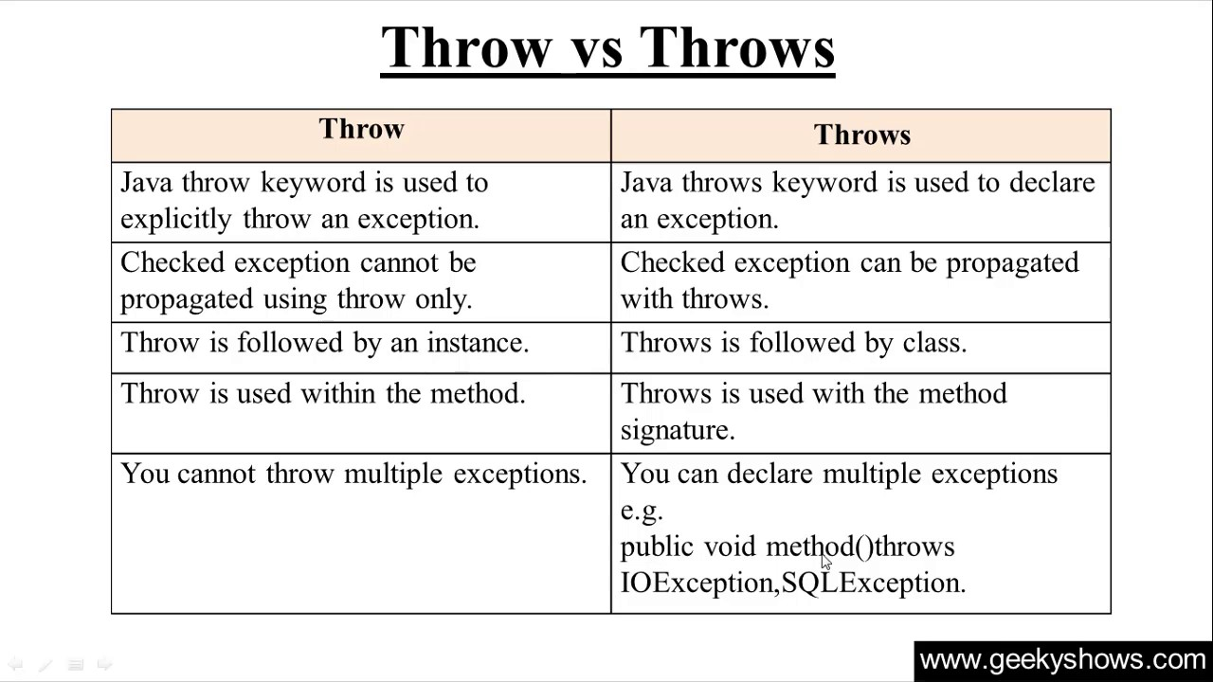

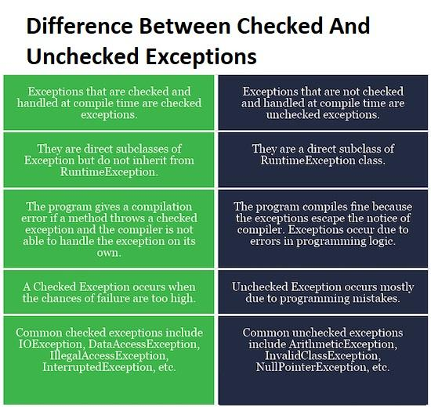

In Java, errors and exceptions are both types of throwable objects, but they serve different purposes and are used in distinct situations.

**1. Errors:**
- **Purpose:** Errors are typically reserved for serious, unrecoverable issues that are beyond the control of the application. They usually indicate problems at the system level or issues that may cause the Java Virtual Machine (JVM) to terminate. Examples include `OutOfMemoryError`, `StackOverflowError`, and `VirtualMachineError`.
- **Handling:** In general, errors should not be caught or handled by application code because they represent situations that are not recoverable. Attempting to handle errors might lead to unpredictable behavior, and it's usually better to let the JVM handle them.

**2. Exceptions:**
- **Purpose:** Exceptions, on the other hand, are used to represent exceptional conditions that can occur during the normal execution of a program. Exceptions are often recoverable, and they allow the program to respond to unexpected situations. Examples include `IOException`, `NullPointerException`, and `ArithmeticException`.
- **Handling:** Exceptions should be caught and handled appropriately in the code to prevent the program from crashing and to provide a graceful way to respond to errors. This is typically done using `try`, `catch`, and `finally` blocks.

In summary, errors are meant to indicate severe problems at the system level that might lead to the termination of the application, and they are not usually caught or handled by the application code. Exceptions, on the other hand, are used for exceptional conditions within the control of the application and should be caught and handled to ensure a more robust and fault-tolerant program.

In Java, you can create custom exceptions by extending the `Exception` class or one of its subclasses. This allows you to define your own exception types that are specific to your application's needs. Here's a simple example of how to create and use custom exceptions:

// Define a custom exception by extending the Exception class
class MyCustomException extends Exception {
// You can add custom fields or methods if needed

// Constructor to provide a custom error message
public MyCustomException(String message) {
super(message);
}
}

public class CustomExceptionExample {
// Example method that throws a custom exception
public void performCustomOperation() throws MyCustomException {
// Perform some logic
boolean errorCondition = true;

// Check for an error condition
if (errorCondition) {
// If an error condition is met, throw the custom exception
throw new MyCustomException("Custom error message: Something went wrong.");
}

// Continue with normal processing if no exception is thrown
}

public static void main(String[] args) {
CustomExceptionExample example = new CustomExceptionExample();

try {
// Call the method that might throw the custom exception
example.performCustomOperation();
} catch (MyCustomException e) {
// Catch and handle the custom exception
System.out.println("Caught custom exception: " + e.getMessage());
}
}
}

In this example:

1. We define a custom exception class `MyCustomException` by extending the `Exception` class.
2. The custom exception class has a constructor that allows you to provide a custom error message.
3. The `performCustomOperation` method in the `CustomExceptionExample` class demonstrates throwing the custom exception based on some error condition.
4. In the `main` method, we catch and handle the custom exception when calling `performCustomOperation`.

Custom exceptions are useful when you want to represent specific error conditions in your application and provide meaningful information about what went wrong. They can also be used to create a hierarchy of exceptions that makes it easier to handle different types of errors in a more granular way.
In Java, exceptions propagate through method calls using a mechanism called exception propagation or exception forwarding. When an exception occurs in a method and is not caught (handled) within that method, the exception is propagated to the calling method. This process continues until the exception is either caught and handled or until it reaches the top level of the call stack, where the program terminates, and the exception is displayed.

Here's an example to illustrate how exceptions propagate through method calls:

public class ExceptionPropagationExample {

public static void main(String[] args) {
try {
topLevelMethod();
} catch (Exception e) {
System.out.println("Exception caught in main method: " + e.getMessage());
}
}

public static void topLevelMethod() throws Exception {
try {
intermediateMethod();
} catch (Exception e) {
System.out.println("Exception caught in topLevelMethod: " + e.getMessage());
throw e; // Re-throw the exception
}
}

public static void intermediateMethod() throws Exception {
try {
innerMethod();
} catch (Exception e) {
System.out.println("Exception caught in intermediateMethod: " + e.getMessage());
throw e; // Re-throw the exception
}
}

public static void innerMethod() throws Exception {
// Simulate an exception
throw new Exception("Exception in innerMethod");
}
}

In this example:

1. The `main` method calls `topLevelMethod`.
2. The `topLevelMethod` calls `intermediateMethod`.
3. The `intermediateMethod` calls `innerMethod`, where an exception is intentionally thrown.
4. The exception propagates backward through the call stack until it is caught and handled in the `innerMethod`. The catch block in `innerMethod` prints a message and re-throws the exception.
5. The exception is then caught and handled in the `intermediateMethod`, and the process repeats until it reaches the `main` method.
6. In the `main` method, the exception is caught in the `catch` block, and a message is printed.

This example demonstrates how exceptions are propagated up the call stack until they are caught or until the program terminates. It's important to note that methods in the call stack can declare exceptions using the `throws` clause, indicating the types of exceptions they might propagate. The calling method must either catch these exceptions or declare that it also throws them.
Exception handling is a critical aspect of writing robust and maintainable Java code. Here are some best practices for exception handling:

1. **Use Specific Exceptions:**
- Catch and handle specific exceptions rather than using broad, general exceptions. This allows you to respond more precisely to different error conditions.
- **Bad Practice:**

try {
// some code
} catch (Exception e) {
// catch-all block
}

- **Good Practice:**
try {
// some code
} catch (IOException e) {
// handle IOException
} catch (SQLException e) {
// handle SQLException
}

2. **Avoid Catching Throwable:**
- Avoid catching `Throwable` unless absolutely necessary. Catching `Throwable` may catch even system-level errors, making it harder to diagnose and recover.
- **Bad Practice:**

try {
// some code
} catch (Throwable t) {
// catch-all block
}

- **Good Practice:**

try {
// some code
} catch (Exception e) {
// handle specific exceptions
}

3. **Use Finally Sparingly:**
- Use `finally` blocks for cleanup code that must be executed whether an exception is thrown or not. Avoid placing complex logic in `finally` blocks.
- **Bad Practice:**

try {
// some code
} finally {
// complex logic
}

- **Good Practice:**

try {
// some code
} finally {
// simple cleanup code
}

4. **Provide Descriptive Error Messages:**
- When catching and handling exceptions, provide meaningful error messages to aid in debugging and troubleshooting.
- **Bad Practice:**

catch (IOException e) {
System.out.println("An error occurred.");
}

- **Good Practice:**

catch (IOException e) {
System.out.println("Error reading file: " + e.getMessage());
}

5. **Log Exceptions:**
- Log exceptions using a logging framework (e.g., SLF4J, Log4j). Logging helps in diagnosing issues in production environments.
- **Bad Practice:**

catch (Exception e) {
e.printStackTrace();
}

- **Good Practice:**

catch (Exception e) {
logger.error("An error occurred:", e);
}

6. **Throw Checked Exceptions Judiciously:**
- Only declare methods to throw checked exceptions if the caller can reasonably be expected to handle or recover from them.
- **Bad Practice:**

public void readFile() throws Exception {
// some code
}

- **Good Practice:**

public void readFile() throws IOException {
// some code
}

7. **Avoid Swallowing Exceptions:**
- Avoid catching exceptions and then not taking any action. If you catch an exception, either handle it appropriately or rethrow it.
- **Bad Practice:**

try {
// some code
} catch (Exception e) {
// doing nothing
}

- **Good Practice:**

try {
// some code
} catch (Exception e) {
// log the exception or rethrow it
throw e;
}

8. **Use Try-With-Resources for AutoCloseable Resources:**
- When working with resources that implement the `AutoCloseable` interface (e.g., streams, database connections), use try-with-resources to ensure proper resource management.
- **Bad Practice:**

BufferedReader reader = null;
try {
reader = new BufferedReader(new FileReader("file.txt"));
// some code
} catch (IOException e) {
// handle exception
} finally {
if (reader != null) {
try {
reader.close();
} catch (IOException e) {
// handle exception
}
}
}

- **Good Practice:**

try (BufferedReader reader = new BufferedReader(new FileReader("file.txt"))) {
// some code
} catch (IOException e) {
// handle exception
}

By following these best practices, you can write more maintainable, readable, and robust code that handles exceptions effectively. Exception handling is an essential part of writing reliable software, and thoughtful consideration should be given to how exceptions are handled throughout the codebase.
`try-with-resources` is a feature introduced in Java 7 to simplify the handling of resources that need to be closed after their operations. It is designed to automatically close resources like files, sockets, or database connections when they are no longer needed, reducing the likelihood of resource leaks.

The syntax for `try-with-resources` is straightforward and involves declaring and initializing resources within the parentheses of the `try` statement. The resources must implement the `AutoCloseable` or `Closeable` interface.

Here's a basic example of using `try-with-resources` with a `BufferedReader`:

import java.io.BufferedReader;
import java.io.FileReader;
import java.io.IOException;

public class TryWithResourcesExample {

public static void main(String[] args) {
// Using try-with-resources to automatically close the BufferedReader
try (BufferedReader reader = new BufferedReader(new FileReader("example.txt"))) {
String line;
while ((line = reader.readLine()) != null) {
System.out.println(line);
}
} catch (IOException e) {
// Handle exceptions, if any
e.printStackTrace();
}
}
}

In this example:

- The `BufferedReader` is declared and initialized within the parentheses of the `try` statement.
- Since `BufferedReader` implements the `AutoCloseable` interface, it will be automatically closed when the `try` block is exited, either normally or due to an exception.
- The code reads lines from a file ("example.txt" in this case) and prints them to the console.

Benefits of `try-with-resources`:

1. **Automatic Resource Management:** Resources are automatically closed when they are no longer needed, reducing the chances of resource leaks and simplifying cleanup code.

2. **Readability:** The code becomes more concise and readable compared to using traditional `try` and `finally` blocks for resource management.

3. **Exception Handling:** Exceptions that occur during resource closure are suppressed, and any exceptions that occur during the try block are still propagated, making it easier to identify the root cause of an issue.

It's important to note that for a resource to be used with `try-with-resources`, it must implement the `AutoCloseable` interface (or its subinterface `Closeable`). If you're working with a class that doesn't implement one of these interfaces, you can create your own wrapper class that implements `AutoCloseable` to enable its use with `try-with-resources`.

In Java, starting from Java 7 with the introduction of the try-with-resources statement, a feature called "suppressed exceptions" was also introduced. Suppressed exceptions are exceptions that occur during the closing of a resource in a try-with-resources block, after an exception has already been thrown in the associated try block.

Consider the following example:

public class SuppressedExceptionExample {

static class MyResource implements AutoCloseable {
@Override
public void close() throws Exception {
throw new Exception("Exception during close");
}

public void doSomething() throws Exception {
throw new Exception("Exception during operation");
}
}

public static void main(String[] args) {
try (MyResource resource = new MyResource()) {
resource.doSomething();
} catch (Exception e) {
System.out.println("Caught exception: " + e.getMessage());
for (Throwable suppressed : e.getSuppressed()) {
System.out.println("Suppressed: " + suppressed.getMessage());
}
}
}
}

In this example:

1. The `MyResource` class implements the `AutoCloseable` interface and intentionally throws an exception during its `close` method.

2. In the `main` method, an instance of `MyResource` is used within a try-with-resources block. The `doSomething` method of `MyResource` is called, which throws an exception.

3. When the `try` block is exited, the `close` method of `MyResource` is called automatically due to the try-with-resources statement. However, an exception occurs during the `close` method.

4. The catch block catches the exception thrown by the `doSomething` method, and then it also checks for suppressed exceptions using the `getSuppressed` method.

Output:

Caught exception: Exception during operation
Suppressed: Exception during close

In the output, you can see that the exception thrown during the `close` method is marked as a suppressed exception. The primary exception caught is the one thrown by the `doSomething` method, and the suppressed exception is from the `close` method.

This feature is useful because it ensures that the primary exception (the one thrown during the operation in the try block) is not lost when an exception occurs during the closing of the resource. The suppressed exceptions provide additional information about issues that occurred during resource cleanup.

Exception chaining, also known as exception wrapping or nested exceptions, refers to the practice of including one exception (the cause) within another exception. This allows you to associate additional context or information with an exception while preserving the information about the original cause of the problem.

In Java, exception chaining can be achieved using the `initCause(Throwable cause)` method or by passing the cause as an argument to the constructor of the new exception. Starting from Java 1.4, you can use the `getCause()` method to retrieve the original cause of an exception.

Here's an example demonstrating exception chaining:

public class ExceptionChainingExample {

static class DatabaseException extends Exception {
public DatabaseException(String message, Throwable cause) {
super(message);
initCause(cause); // or use the constructor super(message, cause);
}
}

static class DataAccessException extends Exception {
public DataAccessException(String message, Throwable cause) {
super(message);
initCause(cause); // or use the constructor super(message, cause);
}
}

public static void main(String[] args) {
try {
// Simulate a database operation
connectToDatabase();

} catch (DatabaseException e) {
// Catch and wrap the DatabaseException in a DataAccessException
throw new DataAccessException("Error accessing data", e);
}
}

static void connectToDatabase() throws DatabaseException {
try {
// Simulate a database connection failure
throw new SQLException("Connection failed");
} catch (SQLException e) {
// Catch and wrap the SQLException in a DatabaseException
throw new DatabaseException("Error connecting to the database", e);
}
}
}

In this example:

1. `DatabaseException` and `DataAccessException` are custom exception classes that extend `Exception`.
2. The `connectToDatabase` method simulates a database connection failure by throwing a `SQLException`. This exception is caught, and a `DatabaseException` is created, wrapping the original `SQLException`.
3. In the `main` method, a `DatabaseException` is caught and rethrown as a `DataAccessException` with the original `DatabaseException` as the cause.

When you catch an exception that may be relevant at a higher level of abstraction, wrapping it in a more specific exception can make your code more expressive and help convey the context of the problem. Always ensure that the cause exception is preserved, as it contains valuable information about the root cause of the issue.
Java 8 introduced some enhancements to exception handling, primarily focused on simplifying and improving the readability of code. The notable improvement is the introduction of the `java.util.function` package, which provides functional interfaces that can be used with lambda expressions and the Stream API.

Here are some key features related to exception handling in Java 8:

1. **Functional Interfaces for Exception Handling:**
- Java 8 introduced functional interfaces that allow lambda expressions to be used in exception handling. For example, the `java.util.function.Consumer` interface can be used to handle exceptions within lambda expressions.
- Example:

import java.util.function.Consumer;

public class ExceptionHandlingExample {
public static void main(String[] args) {
// Using a lambda expression for exception handling
handleException((input) -> {
// Code that may throw an exception
System.out.println("Processing: " + input);
if (input.length() < 5) {
throw new IllegalArgumentException("Input is too short");
}
System.out.println("Processed successfully");
}, "example");
}

static <T> void handleException(Consumer<T> consumer, T input) {
try {
consumer.accept(input);
} catch (Exception e) {
System.err.println("Exception caught: " + e.getMessage());
}
}
}

2. **Optional and Exception Handling:**
- The `Optional` class introduced in Java 8 provides methods for handling exceptional cases in a more functional style. For example, the `orElseThrow` method allows you to throw a specific exception if a value is not present.
- Example:

import java.util.Optional;

public class OptionalExceptionHandlingExample {
public static void main(String[] args) {
String value = null;

try {
String result = Optional.ofNullable(value)
.orElseThrow(() -> new IllegalArgumentException("Value is null"));
System.out.println("Result: " + result);
} catch (IllegalArgumentException e) {
System.err.println("Exception caught: " + e.getMessage());
}
}
}

3. **Streams API and Exception Handling:**
- When working with the Stream API, exceptions thrown in stream operations can be handled using the `try-catch` block inside the `forEach` method.
- Example:

import java.util.Arrays;

public class StreamExceptionHandlingExample {
public static void main(String[] args) {
Arrays.asList("apple", "banana", "cherry")
.stream()
.forEach(item -> {
try {
// Code that may throw an exception
System.out.println(item.toUpperCase());
} catch (Exception e) {
System.err.println("Exception caught: " + e.getMessage());
}
});
}
}

These features in Java 8 provide more concise and expressive ways to handle exceptions, particularly in the context of functional programming and the Stream API. They contribute to cleaner and more readable code.

Handling checked exceptions in streams can be a bit challenging since lambda expressions in Java streams are not allowed to throw checked exceptions directly. However, there are several workarounds to handle checked exceptions in streams. One common approach is to use a helper method or a wrapper function that converts the checked exception into an unchecked exception (typically a `RuntimeException`).

Here's an example of how you can handle checked exceptions in streams using a wrapper function:

import java.util.Arrays;
import java.util.List;
import java.util.stream.Collectors;

public class StreamExceptionHandlingExample {

public static void main(String[] args) {
List<String> fruits = Arrays.asList("apple", "banana", "cherry");

List<String> uppercasedFruits = fruits.stream()
.map(wrapperFunction(item -> uppercaseItem(item)))
.collect(Collectors.toList());

uppercasedFruits.forEach(System.out::println);
}

// Wrapper function to handle checked exceptions
private static <T, R> FunctionWithException<T, R, RuntimeException> wrapperFunction(
ThrowingFunction<T, R, Exception> throwingFunction) {
return item -> {
try {
return throwingFunction.apply(item);
} catch (Exception e) {
throw new RuntimeException(e);
}
};
}

// Function that may throw a checked exception
private static String uppercaseItem(String item) throws Exception {
if ("banana".equals(item)) {
throw new Exception("Bananas are not allowed!");
}
return item.toUpperCase();
}

// Functional interface representing a function that may throw an exception
@FunctionalInterface
public interface ThrowingFunction<T, R, E extends Exception> {
R apply(T t) throws E;
}

// Functional interface representing a function that may throw an exception (with two parameters)
@FunctionalInterface
public interface ThrowingBiFunction<T, U, R, E extends Exception> {
R apply(T t, U u) throws E;
}

// Functional interface representing a function that may throw an exception (with three parameters)
@FunctionalInterface
public interface ThrowingTriFunction<T, U, V, R, E extends Exception> {
R apply(T t, U u, V v) throws E;
}
}

In this example:

- The `wrapperFunction` method is a generic function that takes a throwing function and converts it into a function that throws a `RuntimeException`.
- The `ThrowingFunction` functional interface represents a function that may throw an exception.
- The `uppercaseItem` method is an example of a function that may throw a checked exception.
- The `map` operation in the stream uses the `wrapperFunction` to handle the checked exception and convert it into an unchecked exception (`RuntimeException`).

Keep in mind that this approach involves creating additional interfaces and wrapper functions, and it might add some verbosity to the code. However, it provides a way to handle checked exceptions within stream operations.

Exception handling in asynchronous programming in Java, especially with frameworks like Java's CompletableFuture, involves dealing with exceptions that may occur in the context of asynchronous computations or tasks. Here are some considerations for handling exceptions in asynchronous programming:

1. CompletableFuture Exception Handling:

1.1. **Handle Async Exceptions Using `exceptionally` Method:**
- The `exceptionally` method allows you to handle exceptions asynchronously and return a default value or perform recovery.

CompletableFuture<Integer> future = CompletableFuture.supplyAsync(() -> {
// some async computation
throw new RuntimeException("Async exception");
});

CompletableFuture<Integer> result = future.exceptionally(ex -> {
// handle exception and provide a default value
System.err.println("Exception occurred: " + ex.getMessage());
return 0;
});

1.2. **Handle Async Exceptions Using `handle` Method:**
- The `handle` method is more flexible and allows you to handle both success and failure cases.

CompletableFuture<Integer> future = CompletableFuture.supplyAsync(() -> {
// some async computation
throw new RuntimeException("Async exception");
});

CompletableFuture<Integer> result = future.handle((value, ex) -> {
if (ex != null) {
// handle exception and provide a default value
System.err.println("Exception occurred: " + ex.getMessage());
return 0;
}
// handle success case
return value;
});

1.3. **Combine CompletableFutures with `exceptionally` or `handle`:**
- When combining multiple CompletableFutures, you can use `exceptionally` or `handle` on the combined CompletableFuture.

CompletableFuture<Integer> future1 = CompletableFuture.supplyAsync(() -> 42);
CompletableFuture<Integer> future2 = CompletableFuture.supplyAsync(() -> {
throw new RuntimeException("Async exception");
});

CompletableFuture<Integer> combined = future1.thenCombine(future2, (result1, result2) -> result1 + result2)
.exceptionally(ex -> {
System.err.println("Exception occurred in combined CompletableFuture: " + ex.getMessage());
return 0;
});

2. Exception Handling in Asynchronous Methods:

2.1. **CompletableFuture in Async Methods:**
- When working with asynchronous methods, ensure that exceptions are properly handled within the CompletableFuture.

CompletableFuture<Integer> asyncMethod() {
return CompletableFuture.supplyAsync(() -> {
// some async computation
throw new RuntimeException("Async exception");
});
}

CompletableFuture<Integer> result = asyncMethod().exceptionally(ex -> {
System.err.println("Exception occurred in asyncMethod: " + ex.getMessage());
return 0;
});

2.2. **CompletableFuture in Exceptional Cases:**
- If you are handling exceptions within an asynchronous method, ensure that CompletableFuture is completed exceptionally in case of an error.

CompletableFuture<Integer> asyncMethod() {
CompletableFuture<Integer> future = new CompletableFuture<>();
try {
// some async computation
throw new RuntimeException("Async exception");
// If successful, complete the CompletableFuture
// future.complete(result);
} catch (Exception ex) {
// Complete the CompletableFuture exceptionally
future.completeExceptionally(ex);
}
return future;
}

3. `join` Method:
- When using asynchronous computations, consider using the `join` method instead of `get` to retrieve the result. The `join` method doesn't throw checked exceptions, simplifying the exception handling.

CompletableFuture<Integer> future = CompletableFuture.supplyAsync(() -> {
// some async computation
throw new RuntimeException("Async exception");
});

try {
Integer result = future.join();
System.out.println("Result: " + result);
} catch (Exception ex) {
System.err.println("Exception occurred: " + ex.getMessage());
}

4. Logging:
- In asynchronous programming, logging exceptions is crucial for diagnosing issues in production. Ensure that exceptions are logged appropriately.

5. Executors and Thread Pools:
- When using custom executors or thread pools with CompletableFuture, ensure that uncaught exceptions are handled properly by setting an `UncaughtExceptionHandler`.

ExecutorService executorService = Executors.newFixedThreadPool(5);
CompletableFuture<Integer> future = CompletableFuture.supplyAsync(() -> {
// some async computation
throw new RuntimeException("Async exception");
}, executorService);

// Set UncaughtExceptionHandler for the executor
((ThreadPoolExecutor) executorService).setUncaughtExceptionHandler((thread, ex) ->
System.err.println("Uncaught exception in thread " + thread.getName() + ": " + ex.getMessage()));

Exception handling in asynchronous programming requires careful consideration of how exceptions are propagated, logged, and handled in the context of asynchronous tasks. CompletableFuture provides powerful mechanisms for handling exceptions in a functional and expressive manner.
Exception handling in multithreading involves dealing with exceptions that occur in the context of concurrent execution. Handling exceptions in a multithreaded environment adds complexity because exceptions in one thread might not be directly observed by other threads. Java provides mechanisms to manage exceptions in multithreading, and here are some considerations:

1. **Uncaught Exception Handler:**
- You can set an uncaught exception handler for a thread. This handler is invoked when a thread terminates due to an uncaught exception.
- Example:

Thread.setDefaultUncaughtExceptionHandler((thread, exception) -> {
System.err.println("Uncaught exception in thread " + thread.getName() + ": " + exception.getMessage());
});

2. **ThreadGroup Uncaught Exception Handler:**
- Each thread group in Java has its own uncaught exception handler. You can set an uncaught exception handler for a specific thread group.
- Example:

ThreadGroup group = new ThreadGroup("MyThreadGroup");
group.uncaughtException(thread, exception) -> {
System.err.println("Uncaught exception in thread " + thread.getName() + ": " + exception.getMessage());
});

3. **Try-Catch Inside Run Method:**
- Place a try-catch block inside the `run` method of the `Runnable` or `Thread` class to catch exceptions that occur during the execution of that thread.
- Example:

Thread thread = new Thread(() -> {
try {
// thread logic
} catch (Exception e) {
System.err.println("Exception in thread: " + e.getMessage());
}
});

4. **Thread Pool Exception Handling:**
- When using a thread pool (e.g., `ExecutorService`), exceptions that occur in threads submitted to the pool need to be handled. The `Future` returned by the `submit` method can be used to retrieve exceptions.
- Example:

ExecutorService executorService = Executors.newFixedThreadPool(5);
Future<?> future = executorService.submit(() -> {
// thread logic
});
try {
future.get(); // This will throw an ExecutionException if an exception occurred in the thread
} catch (ExecutionException e) {
System.err.println("Exception in thread: " + e.getCause().getMessage());
}

5. **Thread Interrupts:**
- When a thread is interrupted using `Thread.interrupt()`, it can throw an `InterruptedException`. Handle this exception appropriately.
- Example:

Thread thread = new Thread(() -> {
try {
// thread logic
Thread.sleep(1000); // May throw InterruptedException
} catch (InterruptedException e) {
System.err.println("Thread interrupted: " + e.getMessage());
}
});

6. **Thread Death:**
- If a thread terminates due to an uncaught exception, the `ThreadDeath` error is propagated up the call stack. This error usually indicates a programming error.
- Example:

Thread thread = new Thread(() -> {
throw new RuntimeException("Uncaught exception");
});
thread.start();

It's essential to carefully handle exceptions in a multithreaded environment to prevent unpredictable behavior and improve the robustness of concurrent programs. Use the appropriate mechanisms based on the threading model you're working with and the specific requirements of your application.

