Budget-Aware Shopping App
Department of Integrated M.Tech (SE)
by
Ganesh B-23MIS0110
Hemanth S-23MIS0581
Under the guidance of
Dr. KALAIVANI S

For
ISWE407L-USER INTERFACE AND USER EXPERIENCE DESIGN
School of Computer Science Engineering and Information Systems
VIT, Vellore

October, 2026

UI/UX PROJECT REPORT
Budget-Aware Shopping App
1. Project Scope and Domain
1.1 Project Overview
The Budget-Aware Shopping App is a user-friendly e-commerce application designed to help users shop for products while staying within a predefined budget. The application allows users to set a spending limit, browse products, compare prices, add products to their shopping cart, and monitor their total spending before completing a purchase.
The main objective of this project is to improve the online shopping experience by helping users make informed purchasing decisions and avoid unnecessary spending. The user interface is designed to be simple, intuitive, and accessible, allowing users to manage their shopping activities efficiently.
1.2 Project Scope
The scope of the project includes the following functionalities:
- Budget Management: Users can set a shopping budget and monitor their spending.
- Product Browsing: Users can explore products organized into different categories.
- Product Search: Users can search for products using names or keywords.
- Price Comparison: Users can compare product prices to select affordable options.
- Shopping Cart Management: Users can add, remove, or update the quantity of products in their cart.
- Budget Tracking: The application displays the total cart value, remaining budget, and amount spent.
- Product Recommendations: The interface can suggest affordable alternatives based on the user's budget.
- Checkout: Users can review their cart and proceed to checkout.
- Order Summary: Users can view the final cost of their selected products before confirming an order.
The project primarily focuses on designing the user interface and user experience using Figma. The implementation of a real payment gateway, live inventory, and backend services is outside the scope of the UI/UX prototype unless developed separately.
1.3 Project Domain
Domain: E-commerce and Personal Budget Management
The project combines online shopping with personal financial planning. Traditional shopping applications primarily focus on product discovery and purchasing, whereas the Budget-Aware Shopping App emphasizes budget visibility and spending control throughout the shopping journey.
The application is suitable for students, families, and budget-conscious consumers who want to purchase products without exceeding their spending limits.
1.4 Target Users
- Students with limited monthly spending.
- Individuals who want to manage shopping expenses.
- Families planning purchases within a fixed budget.
- Online shoppers looking for affordable alternatives.
1.5 Project Objectives
- To design a simple and intuitive online shopping interface.
- To help users establish and maintain a shopping budget.
- To display the total cost of selected products clearly.
- To reduce overspending through visible budget indicators.
- To simplify product discovery and cart management.
- To improve the overall shopping experience through effective UI/UX design.

2. Functional Requirements
Functional requirements describe the operations and features that the application must provide to users.
Requirement ID | Functional Requirement | Description
FR-01 | User Registration and Login | The application allows users to register and log in, if authentication is included.
FR-02 | Budget Setup | Users can enter and update their shopping budget.
FR-03 | Product Display | The application displays available products with names, images, and prices.
FR-04 | Product Search | Users can search for products by entering keywords.
FR-05 | Product Categories | Users can browse products through category-based menus.
FR-06 | Product Details | Users can view product descriptions, prices, and other available details.
FR-07 | Price Comparison | Users can compare prices of available alternatives.
FR-08 | Add to Cart | Users can add selected products to their shopping cart.
FR-09 | Cart Management | Users can remove products and modify quantities.
FR-10 | Budget Tracking | The application displays the total amount spent and the remaining budget.
FR-11 | Budget Alerts | The application provides a visual warning when spending approaches or exceeds the budget.
FR-12 | Affordable Alternatives | The application can display lower-priced alternatives when available.
FR-13 | Checkout | Users can review their cart and proceed to the checkout interface.
FR-14 | Order Summary | The application displays the product subtotal and applicable charges before confirmation.
FR-15 | Order History | Users can view previous orders if order management is included.
FR-16 | Profile Management | Users can view or update their profile and preferences, if supported.
2.1 Non-Functional Requirements
Although the main requirement is functional design, the following quality requirements are also relevant:
- Usability: Navigation and important actions should be easy to understand.
- Consistency: Colors, typography, buttons, icons, and spacing should remain consistent.
- Responsiveness: The interface should adapt to different screen sizes if responsive layouts are included.
- Accessibility: Text should be readable, and important information should not rely only on color.
- Performance: Product lists and screens should load efficiently in the implemented application.
- Security: Personal information and payment details must be protected in a production application.

3. Conceptual Design
3.1 Selected Conceptual Design: User Flow Design
A User Flow Diagram is selected as the conceptual design for the Budget-Aware Shopping App. It represents the sequence of screens and actions a user follows from setting a budget to reviewing the shopping cart and proceeding to checkout.
The user flow helps designers identify the main navigation paths and ensure that budget information remains accessible throughout the shopping process.
3.2 User Flow Diagram
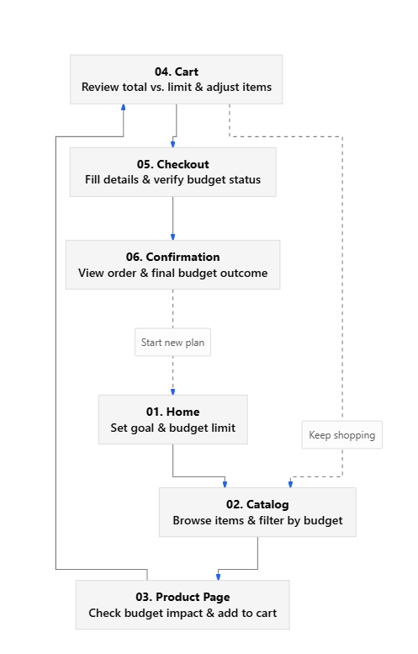

3.3

Explanation of the Conceptual Design
- Home Screen: The user enters the application and accesses the main shopping features.
- Set Budget: The user specifies the maximum amount they intend to spend.
- Browse Products: The user searches for products or explores available categories.
- View Product Details: The user examines product information and price.
- Add to Cart: Selected products are added to the cart.
- Check Budget Status: The application compares the cart total against the budget.
- Manage Spending: If the cart total exceeds the budget, the user can remove products or select cheaper alternatives.
- Review Cart: The user checks the final product list and total cost.
- Checkout: The user proceeds to checkout and reviews the order summary.
3.4 Advantages of the Selected Design
- Provides a clear sequence of user actions.
- Reduces confusion during navigation.
- Makes budget management a central part of the shopping journey.
- Identifies the screens required for the Figma prototype.
- Helps maintain consistency between low-fidelity and high-fidelity designs.

4. Deriving the Menus from the Design
The application menus are derived from the user flow and the functional requirements. Each menu provides access to a related set of features and helps users navigate the application efficiently.
4.1 Main Navigation Menu
Menu Item | Submenu / Options | Purpose
Home | Featured products, budget overview | Provides access to the main dashboard.
Categories | Category list, subcategories | Organizes products for browsing.
Search | Search field, filters, sorting | Helps users locate specific products.
Budget | Set budget, edit budget, spending summary | Allows users to manage their spending limit.
My Cart | Cart items, quantity controls, total cost | Displays selected products and their costs.
Orders | Order history, order details | Allows users to review previous purchases.
Profile | Personal information, preferences | Provides access to account settings.
The exact menus should be adjusted to match the screens and navigation elements present in the actual Figma design.
4.2 Menu Hierarchy
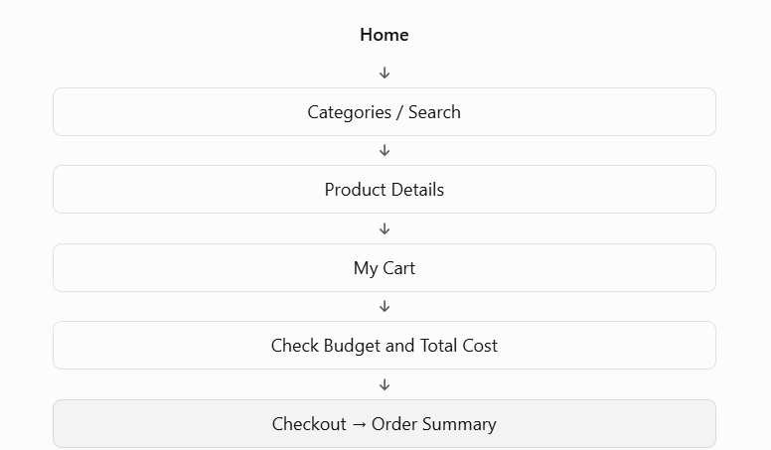

5. Low-Fidelity Design Screenshots
Low-Fidelity Screenshot
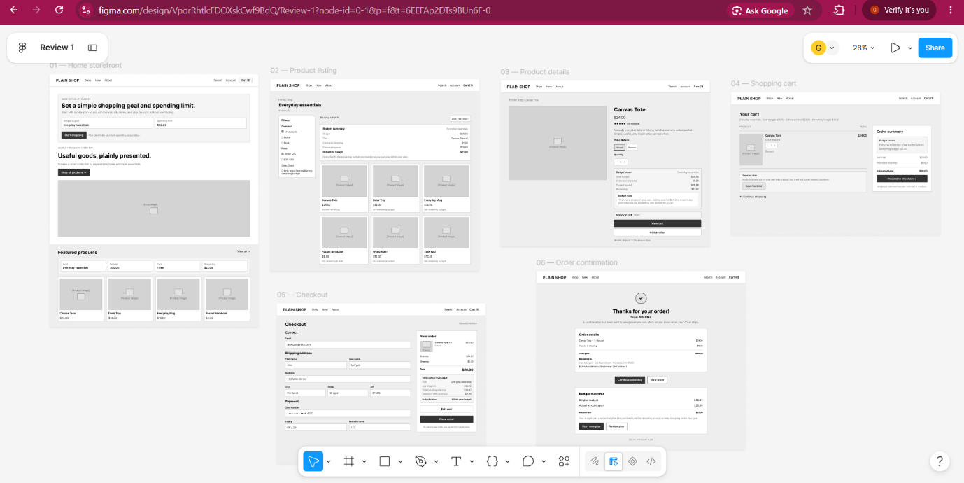
6. High-Fidelity Design Screenshots
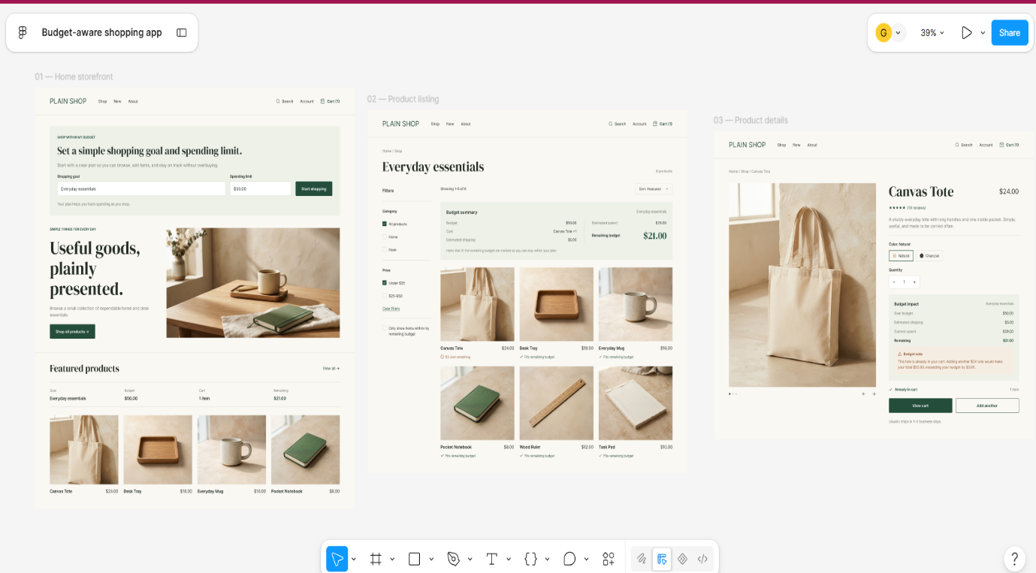
High-Fidelity Screenshot 1

High-Fidelity Screenshot 2
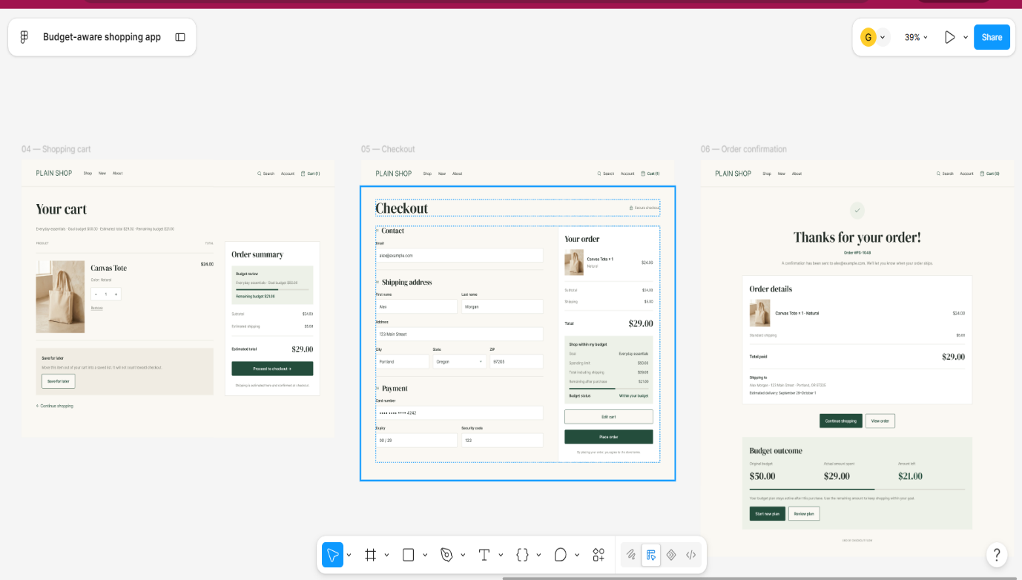
7. Conclusion
The Budget-Aware Shopping App is a UI/UX design project that combines online product browsing with budget management. The project scope identifies the principal features, while the functional requirements describe the operations expected from the application.
The user flow conceptual design establishes the sequence of interactions from setting a budget to reviewing an order. The menu hierarchy is derived from this flow to provide clear and organized navigation.
Low-fidelity wireframes help establish the structure of the application, whereas high-fidelity designs demonstrate the intended visual appearance and interaction patterns. Together, these design stages provide a foundation for a user-friendly shopping application that encourages informed purchasing decisions and responsible spending.

