Acoustic walls

GENERAL

General
A. Scope
The work of this section includes but is not limited to the following items:

QuietWave acoustic plasterboard is the most economic 6-star acoustic wall system available. The thinnest and lightest way to achieve the highest acoustic performance, QuietWave is a class above minimum NCC requirements.
Effective for low frequencies to counter everyday noise from home audio and theatre systems, QuietWave consists of a flexible visco-elastic membrane and patented constrained layer membrane, combined with vibration damping material. Easily penetrated without compromising performance, a finished QuietWave wall is solid and has similar resonance to masonry.
At just 1.2 mm thick QuietWave provides a saving of 50% in the width of the wall against a comparable 6-star wall system and can be easily installed by just one person.

Supply and installation of QuietWave wall system – SINGLE STUD CONSTRUCTION

Timber Stud sections

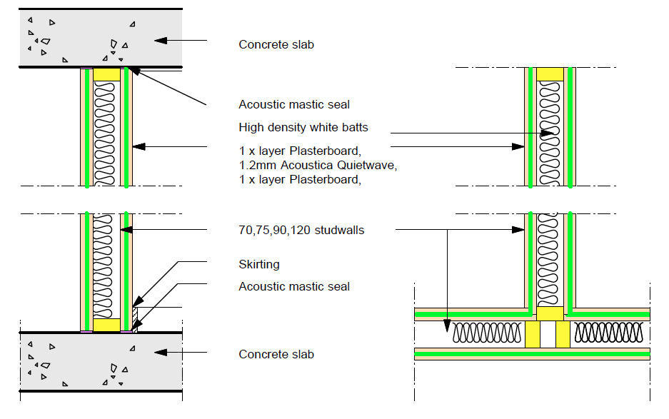

Stud mm + plasterboard mm | Wall mm | Acoustic opinion  Rw+Ctr (Decibels) | FRL
70-10 SD | 113 | 54 db | -
70-13 SD | 125 | 51 db | -
70-13 FC | 125 | 53 db | -/120/120
70-16 FC | 137 | 55 db | -/120/120
70-10 SC | 113 | 52 db | -
70-13 SC | 125 | 56 db | -
75-10 SD | 118 | 51 db | -
75-13 SD | 130 | 54 db | -
75-13 FC | 130 | 56 db | -/120/120
75-13 FC | 142 | 52 db | -/120/120
75-10 SC | 118 | 56 db | -
75-13 SC | 130
90-10 SD | 133 | 49 db | -
90-13 SD | 145 | 53 db | -
90-13 FC | 145 | 55 db | -/120/120
90-16 FC | 157 | 57 db | -/120/120
90-10 SC | 133 | 54 db | -
90-13 SC | 145 | 58 db | -
120-10 SD | 163 | 52 db | -
120-13 SD | 175 | 55 db | -
120-13 FC | 175 | 57 db | -/120/120
120-16 FC | 187 | 59 db | -/120/120
120-10 SC | 163 | 56 db | -
120-13 SC | 175 | 60 db | -

Fire rated > 50 RW + ctr walls
Standard >50 RW + ctr walls

Legend:
SD: Standard plasterboard
FC: Fyrchek plasterboard
SC: Soundchek plasterboard

Note:
Gap between ceiling and wall to be filled with Bostik Fireban 1 or equal in fire rated wall

Steel Stud sections

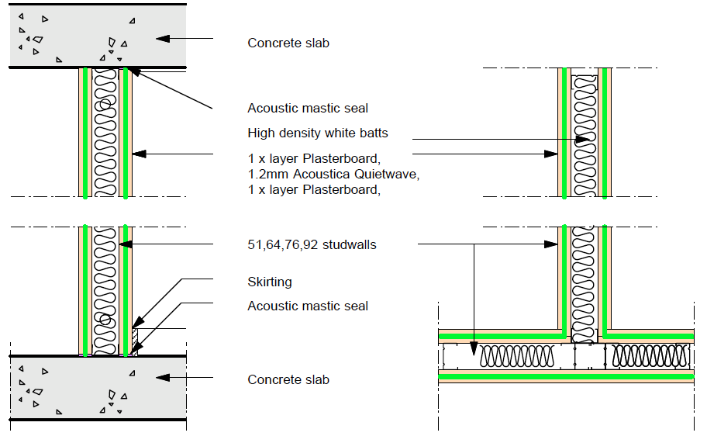

Stud mm + plasterboard mm | Wall mm | Acoustic opinion  Rw+Ctr (Decibels) | FRL
51-10 SD | 94 | 45 db | -
51-13 SD | 106 | 48 db | -
51-13 FC | 106 | 51 db | -/120/120
51-16 FC | 118 | 53 db | -/120/120
51-10 SC | 94 | 49 db | -
51-13 SC | 106 | 53 db | -
64-10 SD | 107 | 47 db | -
64-13 SD | 119 | 50 db | -
64-13 FC | 119 | 53 db | -/120/120
64-13 FC | 131 | 55 db | -/120/120
64-10 SC | 107 | 51 db | -
64-13 SC | 119 | 55 db | -
76-10 SD | 119 | 48 db | -
76-13 SD | 131 | 51 db | -
76-13 FC | 131 | 54 db | -/120/120
76-16 FC | 143 | 56 db | -/120/120
76-10 SC | 119 | 52 db | -
76-13 SC | 131 | 56 db | -
92-10 SD | 135 | 49 db | -
92-13 SD | 147 | 53 db | -
92-13 FC | 147 | 55 db | -/120/120
92-16 FC | 159 | 57 db | -/120/120
92-10 SC | 135 | 54 db | -
92-13 SC | 147 | 68 db | -

Fire rated > 50 RW + ctr walls
Standard >50 RW + ctr walls

Legend:
SD: Standard plasterboard
FC: Fyrchek plasterboard
SC: Soundchek plasterboard

Note:
Gap between ceiling and wall to be filled with Bostik Fireban 1 or equal in fire rated wall

Supply and installation of QuietWave wall system – DISCONTINUOUS CONSTRUCTION

Timber Stud sections
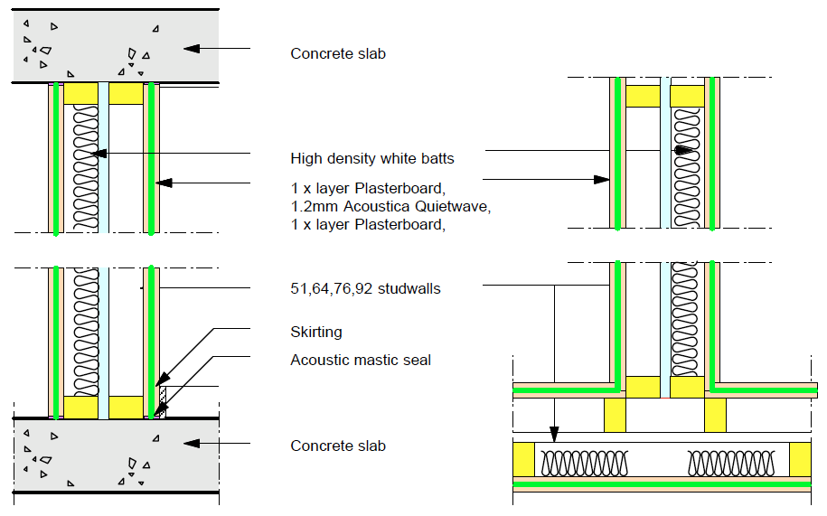

Stud mm + plasterboard mm | Wall mm | Acoustic opinion  Rw+Ctr (Decibels) | FRL
70-10 SD | 208 | 54 db | -
70-13 SD | 220 | 57 db | -
70-13 FC | 220 | 59 db | -/120/120
70-16 FC | 232 | 61 db | -/120/120
70-10 SC | 208 | 58 db | -
70-13 SC | 220 | 62 db | -
75-10 SD | 213 | 54 db | -
75-13 SD | 225 | 57 db | -
75-13 FC | 225 | 59 db | -/120/120
75-13 FC | 237 | 61 db | -/120/120
75-10 SC | 213 | 58 db | -
75-13 SC | 225 | 62 db
90-10 SD | 243 | 55 db | -
90-13 SD | 255 | 58 db | -
90-13 FC | 255 | 60 db | -/120/120
90-16 FC | 267 | 62 db | -/120/120
90-10 SC | 243 | 59 db | -
90-13 SC | 255 | 63 db | -
120-10 SD | 303 | 57 db | -
120-13 SD | 315 | 60 db | -
120-13 FC | 315 | 63 db | -/120/120
120-16 FC | 327 | 65 db | -/120/120
120-10 SC | 303 | 61 db | -
120-13 SC | 315 | 65 db | -

Fire rated > 50 RW + ctr walls
Standard >50 RW + ctr walls

Legend:
SD: Standard plasterboard
FC: Fyrchek plasterboard
SC: Soundchek plasterboard

Note:
Gap between ceiling and wall to be filled with Bostik Fireban 1 or equal in fire rated wall

Steel Stud sections
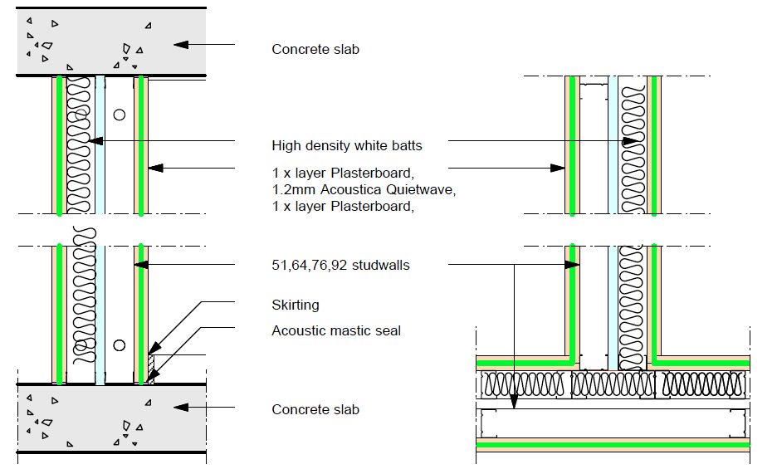

Stud mm + plasterboard mm | Wall mm | Acoustic opinion  Rw+Ctr (Decibels) | FRL
51-10 SD | 165 | 52 db | -
51-13 SD | 177 | 55 db | -
51-13 FC | 177 | 57 db | -/120/120
51-16 FC | 189 | 59 db | -/120/120
51-10 SC | 165 | 56 db | -
51-13 SC | 177 | 59 db | -
64-10 SD | 191 | 53 db | -
64-13 SD | 203 | 56 db | -
64-13 FC | 203 | 59 db | -/120/120
64-13 FC | 215 | 61 db | -/120/120
64-10 SC | 191 | 57 db | -
64-13 SC | 203 | 61 db | -
76-10 SD | 215 | 54 db | -
76-13 SD | 227 | 57 db | -
76-13 FC | 227 | 60 db | -/120/120
76-16 FC | 239 | 62 db | -/120/120
76-10 SC | 215 | 58 db | -
76-13 SC | 227 | 62 db | -
92-10 SD | 247 | 55 db | -
92-13 SD | 259 | 58 db | -
92-13 FC | 259 | 60 db | -/120/120
92-16 FC | 271 | 63 db | -/120/120
92-10 SC | 247 | 60 db | -
92-13 SC | 259 | 63 db | -

Fire rated > 50 RW + ctr walls
Standard >50 RW + ctr walls

Legend:
SD: Standard plasterboard
FC: Fyrchek plasterboard
SC: Soundchek plasterboard

Note:
Gap between ceiling and wall to be filled with Bostik Fireban 1 or equal in fire rated wall

Supply and installation of QuietWave wall system – SINGLE STAGGERED STUD CONSTRUCTION

Timber Stud sections
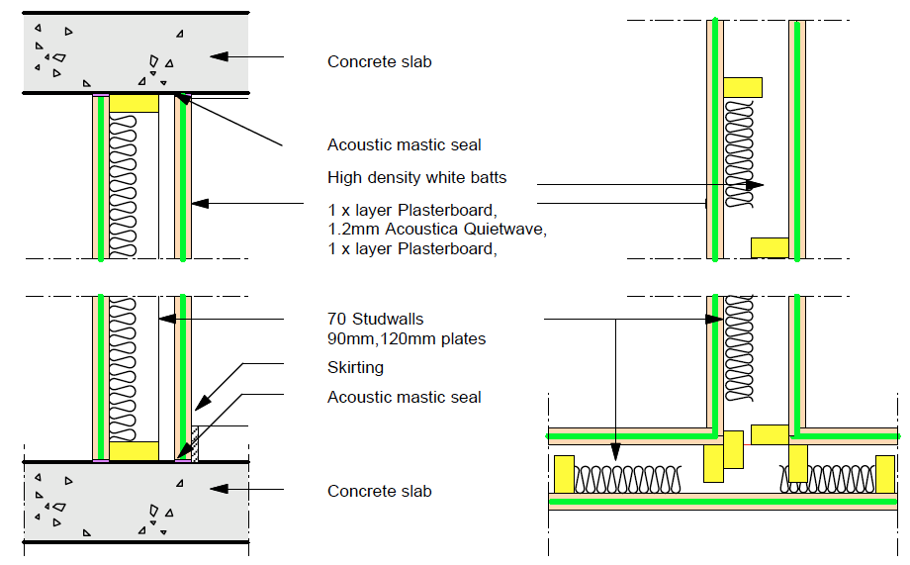

Stud mm + plasterboard mm | Wall mm | Acoustic opinion  Rw+Ctr (Decibels) | FRL
90-10 SD | 133 | 50 db | -
90-13 SD | 145 | 53 db | -
90-13 FC | 145 | 55 db | -/120/120
90-16 FC | 157 | 57 db | -/120/120
90-10 SC | 133 | 54 db | -
90-13 SC | 145 | 58 db | -
120-10 SD | 163 | 52 db | -
120-13 SD | 175 | 55 db | -
120-13 FC | 175 | 57 db | -/120/120
120-16 FC | 187 | 59 db | -/120/120
120-10 SC | 163 | 56 db | -
120-13 SC | 145 | 60 db | -

Fire rated > 50 RW + ctr walls
Standard >50 RW + ctr walls

Legend:
SD: Standard plasterboard
FC: Fyrchek plasterboard
SC: Soundchek plasterboard

Note:
Gap between ceiling and wall to be filled with Bostik Fireban 1 or equal in fire rated wall

B. Examine documents: Examine parts of the drawings and this specification for requirements which affect the work of this specification. In particular, take note of other trades involved.

C. Co-ordination: Co-ordinate with other trades affecting or affected by work of this section, co-operating as necessary to ensure steady and satisfactory progress of the work.

Other trades

Co-ordinate and co-operate with the following trades:

-Disconnection of existing services by appropriate other trades if necessary.
-Carpentry
-Framing work
-Suspended ceiling system
-Plumbing
-Electrical alterations and installations
-Mechanical ventilation alterations and installation
-Fire protection
-Data & communication

Quality Assurance

Installation should be executed as per specification by experienced installers.

Compliances

-Comply with applicable portions of the Australian Standards
-Comply with applicable clauses of the current version of the NCC.
-Follow instructions contain in Engineers reports and Engineers specifications
-Comply with Applicable building regulations and any statutory authority having jurisdiction,
-Comply with Local council codes, regulations and approval conditions
-Comply with site specific W&S procedure

Public and Property Protection

Provide measures required by municipal and state ordinances, laws, and regulations for the protection of surrounding property, footpaths, streets, kerbs, the public, occupants and workmen during installation operations.
Comply with the above ordinances, laws etc. in carrying out measures including barricades, fences, warning lights and signs, rubbish chutes, etc..
Make good to original condition, damage to substrate which results from installation operations. Perform restoration work without expense to the Proprietor.

Services
Before installation commences ensure that all related services work have been completed. If some services need to be altered during the course of the installation, ensure that all services trade-person have been notified and that required coordination work has been organised.

Photographic Record
Arrange for photographic record of the progress of installation. Produce for the Proprietor if requested JPEG files of “before and after” installation of the work involved.

Products

QuietWave acoustic membrane

QuietWave Acoustic Membrane from Acoustica Pty Ltd
Rolls: 1300 x 5400 x 1.2mm
Visit site and inspect conditions, comparing conditions to the Drawings before delivery of materials to site. Report any discrepancy or unsuitability of substrate.
Start of work means total acceptance of conditions.
All installation drawings outlined in above scope are to be used as a guide only. For specific applications and instructions, please contact Acoustica below.

Contact:
25 Plasser Crescent
North St Marys, NSW, 2760
Tel: 02 95502900
Email:
info@acoustica.com.au

Equipment

A. Supply equipment required to perform the work of sufficient capacity to meet the stated completion date.
B. Provide access equipment necessary to execute the work
C. Provide disposal containers for disposal required.
D. No containers may be located on public streets or pavements without obtaining required municipal permits for same. Co-operate with Sub-Contractors doing work in or near container locations to prevent disruption of their work.

EXECUTION

Examination
Visit site and inspect conditions, comparing conditions to the Drawings before delivery of materials to site. Report any discrepancy or unsuitability of substrate.
Start of work means total acceptance of conditions.

Preparation
Co-ordinate with and ensure preparatory work by other trades is done prior to commencement of work.

Installation

QuietWave membrane to be sandwiched between 2 layers of plasterboard, MDF, yellow tongue, plywood or other lining material)

Install stud and tracks as per manufacturer’s instructions.
Verify that all framing work has been installed in accordance with the drawings.
Install acoustic insulation as per specified on the drawings...see previous

Layer 1: Lining

-Install 1st substrate layer (Plasterboard, Ply, or other Lining) as per manufacturer’s instructions.
-lining must be cut accurately leaving only 2mm gaps around walls or ceiling edges
-Seal all joints and edges with silicone

Layer 2: QuietWave membrane

-Install 1st substrate layer (Plasterboard, Ply, or other Lining) as per manufacturer’s instructions.
-lining must be cut accurately leaving only 2mm gaps around walls or ceiling edges
-Seal all joints and edges with silicone

Similar logic for ceiling installation

Second layer of plasterboard

4.1 Put up the second layer of plasterboard in a vertical direction as per
manufacturer’s instructions or ensure that the first layer of plasterboard joints
do not coincide with the second layer joints.

4.2 Seal the joints.

4.3 Cut the edges neatly leaving a maximum 2mm gap around the wall.

4.4 Seal edges with resilient sealant (Silicone or No More Gaps)

Clean up as the work proceeds.

Installation Particulars

Finishing Details

Install as per detail drawings

Protection
Protect finished work until work has been. Make good damage in every respect at no additional cost to the Proprietor.

Cleaning
Clean exposed surfaces. Remove all debris and waste and dispose

Completion
Complete contracted work in accordance with contract documents and written variation orders issued by the Architect or Superintendent.

END OF SECTION

