Acoustic pipes

GENERAL

General
A. Scope
The work of this section includes but is not limited to the following items:

Supply and installation of GreenLAG pipe lagging system.

A revolution in pipe lagging, GreenLAG is the superior solution for waste water acoustic insulation.
Combining a patented visco-elastic QuietWave noise barrier with acoustic foam, GreenLAG increases vibration damping through its soft microcellular material for exceptional sound transmission loss. Wrap it around waste water pipes or use it to minimise the noise break out of duct work, fan housings and valves in residential buildings, commercial and industrial properties.
The thinnest and lightest NCC-compliant acoustic pipe lagging available, GreenLAG is environmentally-friendly requiring no protective wear to install. It’s quick and easy to fit and can be supplied in rolls, bends, strips and junctions.

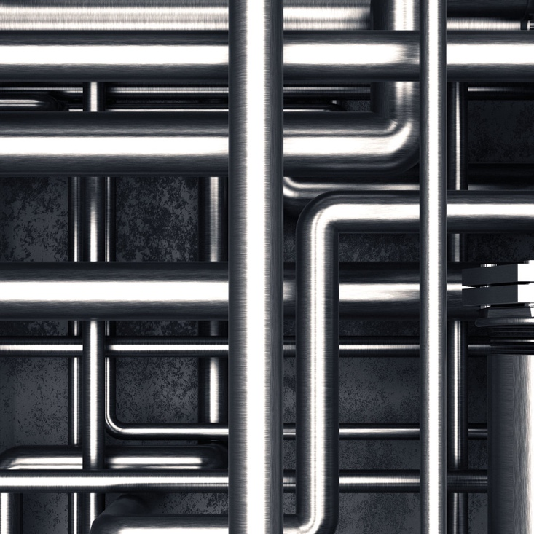

B. Examine documents: Examine parts of the drawings and this specification for requirements which affect the work of this specification. In particular, take note of other trades involved.

C. Co-ordination: Co-ordinate with other trades affecting or affected by work of this section, co-operating as necessary to ensure steady and satisfactory progress of the work.

Other trades

Co-ordinate and co-operate with the following trades:

-Disconnection of existing services by appropriate other trades if necessary.
-Carpentry
-Framing work
-Suspended ceiling system
-Plumbing
-Electrical alterations and installations
-Mechanical ventilation alterations and installation
-Fire protection
-Data & communication

Quality Assurance

Installation should be executed as per specification by experienced installers.

Compliances

-Comply with applicable portions of the Australian Standards
-Comply with applicable clauses of the current version of the NCC.
-Follow instructions contain in Engineers reports and Engineers specifications
-Comply with Applicable building regulations and any statutory authority having jurisdiction,
-Comply with Local council codes, regulations and approval conditions
-Comply with site specific W&S procedure

Public and Property Protection

Provide measures required by municipal and state ordinances, laws, and regulations for the protection of surrounding property, footpaths, streets, kerbs, the public, occupants and workmen during installation operations.
Comply with the above ordinances, laws etc. in carrying out measures including barricades, fences, warning lights and signs, rubbish chutes, etc..
Make good to original condition, damage to substrate which results from installation operations. Perform restoration work without expense to the Proprietor.

Services
Before installation commences ensure that all related services work have been completed. If some services need to be altered during the course of the installation, ensure that all services trade-person have been notified and that required coordination work has been organised.

Photographic Record
Arrange for photographic record of the progress of installation. Produce for the Proprietor if requested JPEG files of “before and after” installation of the work involved.

Products

GreenLAG pipe lagging

GreenLAG pipe lagging from Acoustica Pty Ltd
Rolls: 1.3 x 5m x 15mm (Flat foam), 1.3 x 5m x 25mm (Convoluted foam)

Visit site and inspect conditions, comparing conditions to the Drawings before delivery of materials to site. Report any discrepancy or unsuitability of substrate.
Start of work means total acceptance of conditions.
All installation instructions outlined below are to be used as a guide only. For specific applications and instructions, please contact Acoustica below.

Contact:
25 Plasser Crescent
North St Marys, NSW, 2760
Tel: 02 95502900
Email:
info@acoustica.com.au

Equipment

A. Supply equipment required to perform the work of sufficient capacity to meet the stated completion date.
B. Provide access equipment necessary to execute the work
C. Provide disposal containers for disposal required.
D. No containers may be located on public streets or pavements without obtaining required municipal permits for same. Co-operate with Sub-Contractors doing work in or near container locations to prevent disruption of their work.

EXECUTION

Examination
Visit site and inspect conditions, comparing conditions to the Drawings before delivery of materials to site. Report any discrepancy or unsuitability of substrate.
Start of work means total acceptance of conditions.

Preparation
Co-ordinate with and ensure preparatory work by other trades is done prior to commencement of work.

Installation

GreenLAG pipe lagging to be cut into strips to suit pipe size.
Wrap GreenLAG around the pipe overlapping all joints by 50mm (vertical & horizontal) to avoid potential flanking noise.
Wrap three circumferential wraps of high quality 48-72mm wide reinforced aluminium tape at approximately every 350mm (i.e. 3 wraps every 1m of pipe length) & tape along all seams.

Installation of GreenLAG pipe lagging must be done by qualified pipe laggers/plumbers

Install pipes as per manufacturer’s instructions.
Verify that all pipe and plumbing work has been installed in accordance with the drawings.
Install acoustic insulation as per specified on the attached instructions.

Clean up as the work proceeds.

Installation Particulars

Finishing Details

Install as per detail drawings

Protection
Protect finished work until work has been. Make good damage in every respect at no additional cost to the Proprietor.

Cleaning
Clean exposed surfaces. Remove all debris and waste and dispose

Completion
Complete contracted work in accordance with contract documents and written variation orders issued by the Architect or Superintendent.

END OF SECTION

