Acoustic Floors

GENERAL

General

A. Scope
The work of this section includes but is not limited to the following items:

Supply and installation of AngelStep floor system.

Acoustica’s best performing flooring underlay range, AngelStep is the top choice for discerning residential and commercial developments where maximum impact noise control and sound absorption is needed.

Available in different variations to suit flooring substrates and materials, AngelStep features unique patented technology that combines a sound absorber with impact and vibration damping to consistently achieve up to the highest 6-star acoustic rating dependent on installation.

B. Examine documents: Examine parts of the drawings and this specification for requirements which affect the work of this specification. In particular, take note of other trades involved along with relevant body corporate requirements and/or criterions outlined in the strata by-laws i.e. AAAC star rating.
 | Impact Isolation  of floors Lnt’w | AAAC Description
6 star | 40 | just audible or not audible
5 star | 45 | just audible
4 star | 50 | audible
3 star | 55 | clearly audible
2 star | 65 | clearly audible
BCA | 62 | clearly audible

The NCC provides minimum construction standards for
various building classes including acoustic privacy. The NCC
requirement is a weighted standardised impact sound
pressure level with spectrum adaptation term Ci, of less than
or equal to 62 Lnt,W+Ci. However, the reality is that this is in
most cases unacceptable to occupants and can result in the
need for costly reparation works. In response, the Association
of Australian Acoustic Consultants (AAAC) has developed the
star rating system to rank the acoustical quality of
apartments and provide guidance in the design and
construction process.

C. Co-ordination: Co-ordinate with other trades affecting or affected by work of this section, co-operating as necessary to ensure steady and satisfactory progress of the work.

Other trades

Co-ordinate and co-operate with the following trades:

-Preparation and levelling of floor by appropriate other trades if necessary.
-Cleaning of floor of debris by appropriate other trades if necessary.

Quality Assurance

Installation should be executed as per specification by experienced installers.

Compliances

-Comply with applicable portions of the Australian Standards
-Comply with applicable clauses of the current version of the NCC
-Follow instructions contained in Engineers reports and Engineers specifications
-Comply with applicable building regulations and any statutory authority having jurisdiction
-Comply with Local council codes, regulations and approval conditions
-Comply with site specific W&S procedure

Public and Property Protection

Provide measures required by municipal and state ordinances, laws, and regulations for the protection of surrounding property, footpaths, streets, kerbs, the public, occupants and workmen during installation operations.
Comply with the above ordinances, laws etc. in carrying out measures including barricades, fences, warning lights and signs, rubbish chutes, etc.
Make good to original condition, damage to substrate which results from installation operations. Perform restoration work without expense to the Proprietor.

Services
Before installation commences ensure that all related services work have been completed. If some services need to be altered during the course of the installation, ensure that all services trade-person have been notified and that required coordination work has been organised.

Photographic Record
Arrange for photographic record of the progress of installation. Produce for the Proprietor if requested JPEG files of “before and after” installation of the work involved.

Products

AngelStep acoustic underlays

AngelStep Acoustic Underlays from Acoustica Pty Ltd

AngelStep Gold 8 - Tiles: 1.15 x 1.15m x 8mm

AngelStep Gold 4 - Tiles: 1.15 x 1.15m x 8mm

AngelStep 48P – Tiles: 1.15 x 1.15m x 8mm

AngelStep 484P – Tiles: 1.15 x 1.15m x 10mm

AngelStep 630 – Tiles: 1.2 x 1.2m x 4mm

AngelStep 250 – Roll: 1.2 x 25m x 4mm

Visit site and inspect conditions, comparing conditions to the Drawings before delivery of materials to site. Report any discrepancy or unsuitability of substrate.
Start of work means total acceptance of conditions.
All installation drawings outlined in above scope are to be used as a guide only. For specific applications and instructions, please contact Acoustica below.

Contact:
25 Plasser Crescent
North St Marys, NSW, 2768
Tel: 02 95502900
Email:
info@acoustica.com.au

Equipment

A. Supply equipment required to perform the work of sufficient capacity to meet the stated completion date.
B. Provide access equipment necessary to execute the work
C. Provide disposal containers for disposal required.
D. No containers may be located on public streets or pavements without obtaining required municipal permits for same. Co-operate with Sub-Contractors doing work in or near container locations to prevent disruption of their work.

EXECUTION

Examination
Visit site and inspect conditions, comparing conditions to the Drawings before delivery of materials to site. Report any discrepancy or unsuitability of substrate.
Start of work means total acceptance of conditions.

Preparation
Co-ordinate with and ensure preparatory work by other trades is done prior to commencement of work.

Installation

AngelStep acoustic underlay to be installed correctly according to the applicable sub floor system and corresponding floor finish – see below relevant instructions.

Install sub flooring as per manufacturer’s instructions.
Verify that all flooring work has been installed in accordance with the drawings.
Install acoustic insulation as per specified on the drawings.

AngelStep Installation: Carpet

- Structural floor must be levelled, to parquetry installation standard tolerances.
- Floor to be clean and free of debris.
- Fill gaps and holes in floor if existing. Fix any squeaking in timber floor.
- Install 40mm x (AS thickness -1mm) MDF battens around the perimeter of room
for grip installation.
- Install AngelStep tiles butted together.
- Leave 3mm gap between walls and finish surface.
- Spot glue AngelStep with maxi bond or equal.
- It is preferable to install skirting after floor has been installed. Leave a 2 to 3mm gap
between floor finish and skirting. (seal with silicone sealant)
- Install carpet as per AS standard and manufacturers recommendations.
- Use a Stanley knife or equal to cut AS product.
- Seal gaps between wall & new floor with silicone sealant to form a resilient seal.

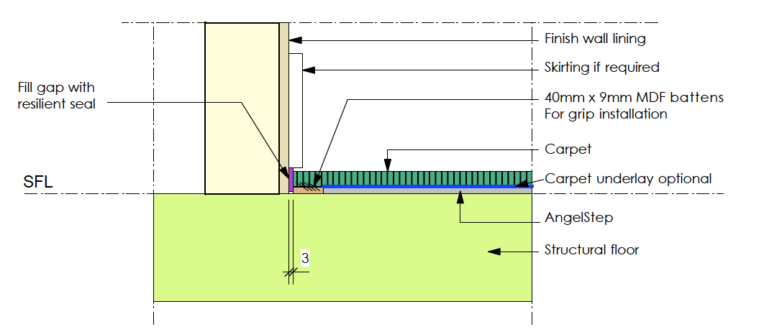

AngelStep Installation: Tongue & Groove Timber

Floating floor using Yellow tongue as substrate for tongue and groove timber
floor.
- Structural floor must be levelled, to parquetry installation standard tolerances.
- Floor to be clean and free of debris.
- Fill gaps and holes in floor if existing. Fix any squeaking in timber floor.
- Install AngelStep tiles butted together.
- Leave 3mm gap between wall and finish surface.
- Spot glue AngelStep with Maxibond or equal.
- Install yellow tongue directly onto AngelStep,
- Ensure that the new floor stay 3 mm from walls.
- It is preferable to install skirting after floor has been installed. Leave a 2 to 3mm gap.
between floor finish and skirting. (seal with silicone sealant)
- Install timber floor as per AS standard and manufacturers recommendations. Fix boards
to yellow tongue only.
- Use a Stanley knife or equal to cut product.
- Seal gaps between wall & new floor with silicone sealant to form a resilient seal.
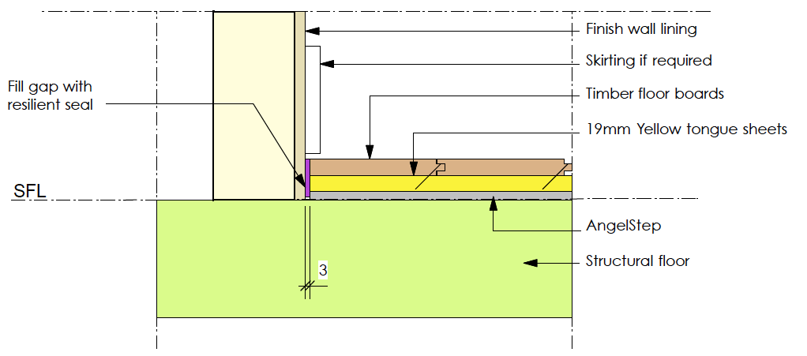

AngelStep Installation: Engineered Timber

Floating floor using Yellow tongue as substrate for engineered timber floor.
- Structural floor must be levelled, to parquetry installation standard tolerances.
- Floor to be clean and free of debris.
- Fill gaps and holes in floor if existing. Fix any squeaking in timber floor.
- Install AngelStep tiles butted together.
- Leave 3mm gap between wall and finish surface.
- Spot glue AngelStep with Maxibond or equal.
- Install timber floor as per AS standard and manufacturers recommendations.
- Ensure that the new floor stay 3 mm from walls.
- It is preferable to install skirting to wall only after floor has been installed.
Leave a 2 to 3mm gap between floor finish and skirting. (seal with silicone sealant).
If installing quads, install only to wall or floor. Maintain separation between wall and floor.
- Use a Stanley knife or equal to cut product.
- Seal gaps between wall & new floor with silicone sealant to form a resilient seal.
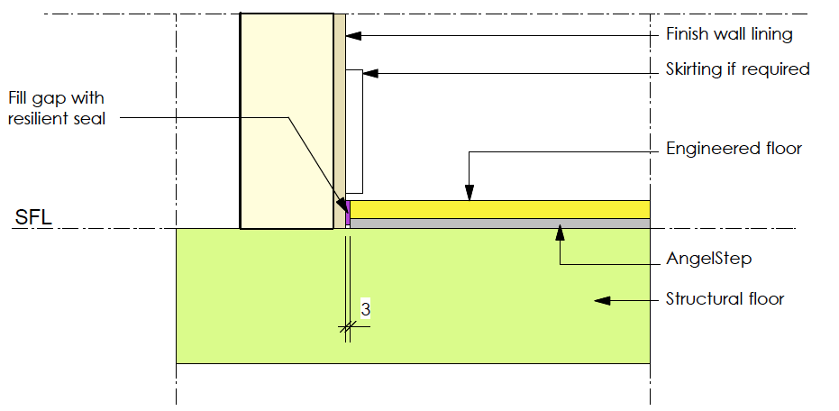

AngelStep Installation: Vinyl finish

Floating floor using Compressed Fibro Cement (CFC) as substrate for vinyl installation.
- Structural floor must be levelled, to parquetry installation standard tolerances.
- Clean and free of debris.
- Install AngelStep tiles butted together.
- Leave 3mm gap between walls and finish surface.
- Spot glue AngelStep with Maxibond or equal.
- Spot glue the first layer of CFC to Angel Step.
- Glue the 2nd layer of CFC together with manufacturer's recommended glue. (contact)
- Do not line up CFC joints, overlap joints to form a floating floor.
- Ensure that the new floor stay 3 mm from walls.
- It is preferable to install skirting after floor has been installed. Leave a 2 to 3mm gap.
between floor finish and skirting. (seal with silicone sealant)
- Install vinyl as per AS standard and manufacturers recommendations.
- Use a Stanley knife or equal to cut product.
- Seal gaps between wall & new floor with silicone sealant to form a resilient seal.

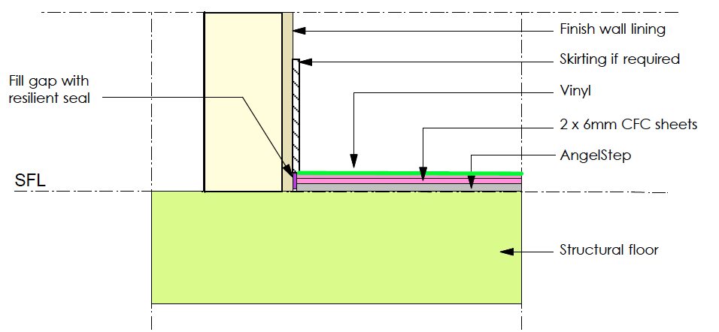

AngelStep Installation: Vinyl finish

Reinforced Screed Floating floor for vinyl installation.
- Structural floor must be levelled, to parquetry installation standard tolerance.
- Clean and free of debris.
- Install AngelStep tiles on floor butted together.
- Install AngelStep Strips around the edges to contain screed.
- Tape at butted joints to avoid screed leakage
- Spot glue AngelStep with Maxibond or equal.
- Pour cement reinforced screed as per AS Standards
- Install vinyl as per AS standard and manufacturers recommendations.
- Use a Stanley knife or equal to cut product.
- Seal gaps between wall & new floor with silicone sealant to form a resilient seal.

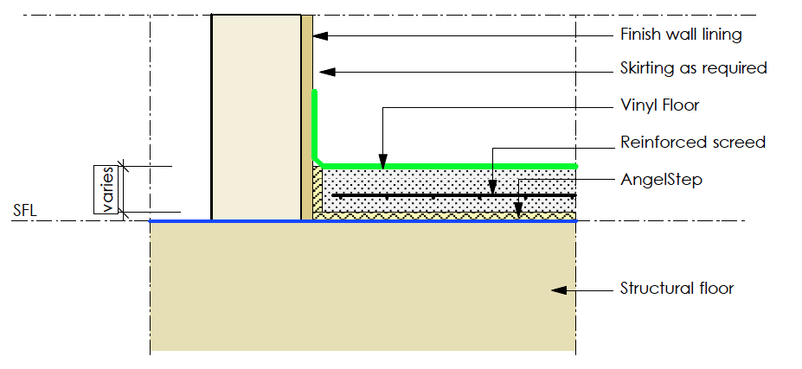

AngelStep Installation: Vinyl finish

Floating floor using Yellow tongue as substrate for vinyl installation.
- Structural floor must be levelled, to parquetry installation standard tolerances.
- Floor to be clean and free of debris.
- Fill gaps and holes in floor if existing. Fix any squeaking in timber floor.
- Install AngelStep tiles butted together.
- Leave 3mm gap between wall and finish surface.
- Spot glue AngelStep with Maxibond or equal.
- Install yellow tongue directly onto AngelStep,
- Ensure that the new floor stay 3 mm from edges.
- It is preferable to install skirting after floor has been installed. Leave a 2 to 3mm gap.
between floor finish and skirting. (seal with silicone sealant)
- Install vinyl as per AS standard and manufacturers recommendations.
- Use a Stanley knife or equal to cut product.
- Seal gaps between wall & new floor with silicone sealant to form a resilient seal.
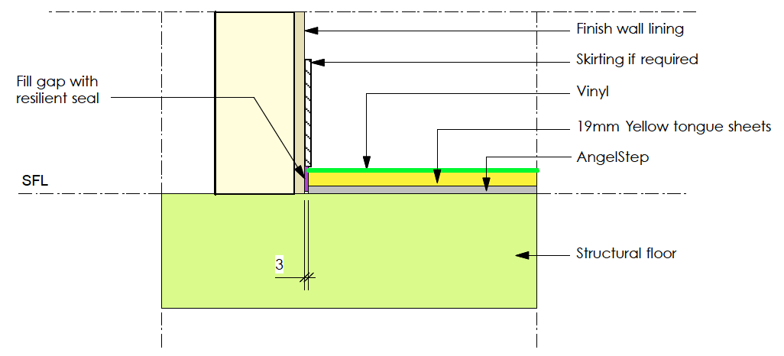

AngelStep Installation: Tiled finish

Floating floor using Compressed Fibro Cement as substrate for tiling installation.
- Structural floor must be levelled, to parquetry installation standard tolerances,
- Clean and free of debris.
- Install AngelStep tiles butted together.
- Leave 3 mm gap between wall and finish surface.
- Spot glue AngelStep with Maxibond or equal.
- Spot glue the first layer of CFC to Angel Step.
- Glue the 2nd layer of CFC together with manufacturer's recommended glue. (Contact)
- Do not line up CFC joints, overlap joints to form a floating floor.
- Ensure that the new floor stay 3 mm from edges. Seal gap silicone sealant.
- Install tiles as per AS Standards and manufacturer’s instructions.
- It is preferable to install skirting after floor has been installed. Leave a 2 to 3mm gap
between floor tiles and skirting.
- Use a Stanley knife or equal to cut product.
- Seal gaps between wall & new floor with silicone sealant to form a resilient seal.

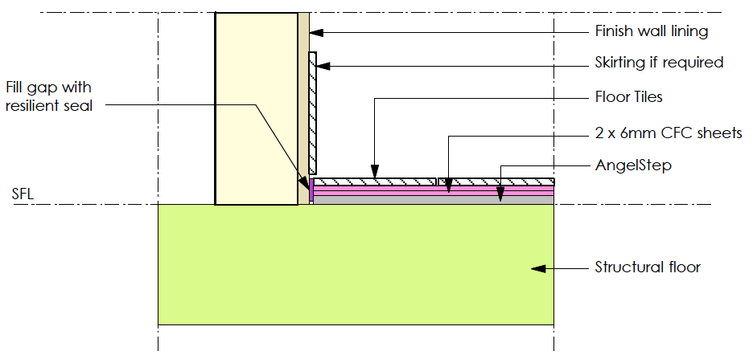

AngelStep Installation: Tiled finish

Reinforced Screed Floating floor for tiles installation.
- Structural floor must be levelled, to parquetry standard tolerance.
- Clean and free of debris.
- Install waterproof membrane if in bathroom. (shown as a blue line)
- Install AngelStep tiles on floor butted together.
- Install AngelStep Strips around the room edges to contain screed.
- Tape at butted joints to avoid screed leakage
- Spot glue AngelStep with Maxibond or equal.
- Pour cement reinforced screed as per AS Standards.
- Install vinyl as per AS standard and manufacturers recommendations.
- Use a Stanley knife or equal to cut product.
- Seal gaps between wall & new floor with silicone sealant to form a resilient seal.
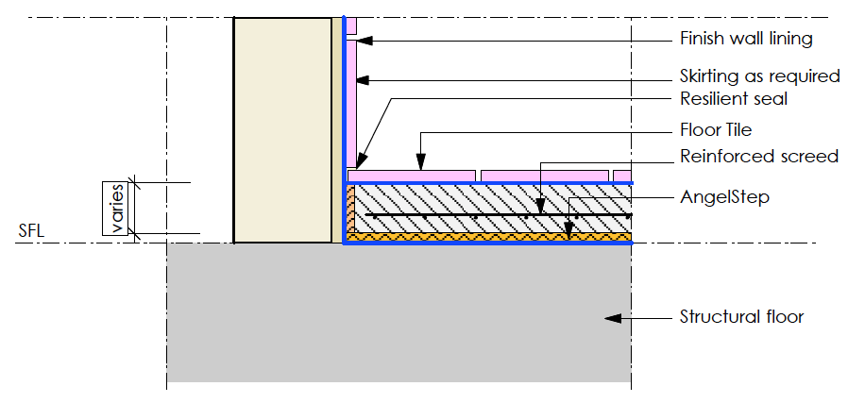

AngelStep Installation: Polished floor finish

Reinforced Screed Floating Polished floor finish
- Structural floor must be levelled, to parquetry installation standard tolerances.
- Clean and free of debris.
- Install AngelStep tiles on floor butted together.
- Install AngelStep Strips around the room edges to contain screed.
- Tape at butted joints to avoid screed leakage
- Spot glue AngelStep with Maxibond or equal.
- Pour cement reinforced screed as per AS Standards
- Polish floor as per AS standard.
- Use a Stanley knife or equal to cut product.
- Seal gaps between wall & new floor with silicone sealant to form a resilient seal.
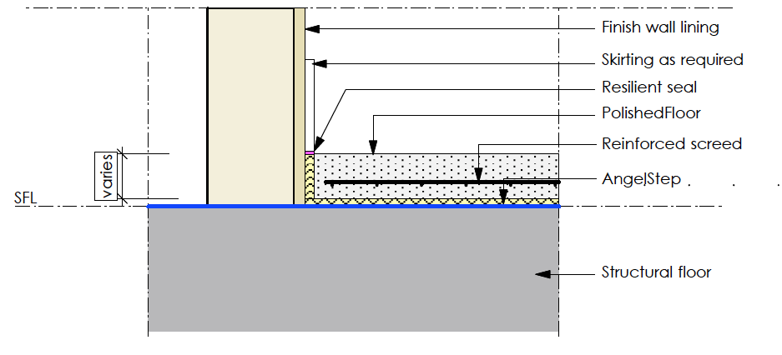

AngelStep Installation: Terrazzo floor finish

Reinforced Screed Floating terrazzo floor finish
- Structural floor must be levelled, to parquetry standard tolerance.
- Clean and free of debris.
- Install AngelStep tiles on floor butted together.
- Install AngelStep Strips around the edges to contain screed.
- Tape at butted joints to avoid screed leakage
- Spot glue AngelStep with Maxibond or equal.
- Pour cement reinforced screed as per AS Standards
- install terrazzo floor as per AS standard. (Screed thickness and terrazzo finish
vary in accordance with installers specifications and recommendations.)
- Use a Stanley knife or equal to cut product.
- Seal gaps between wall & new floor with silicone sealant to form a resilient seal.
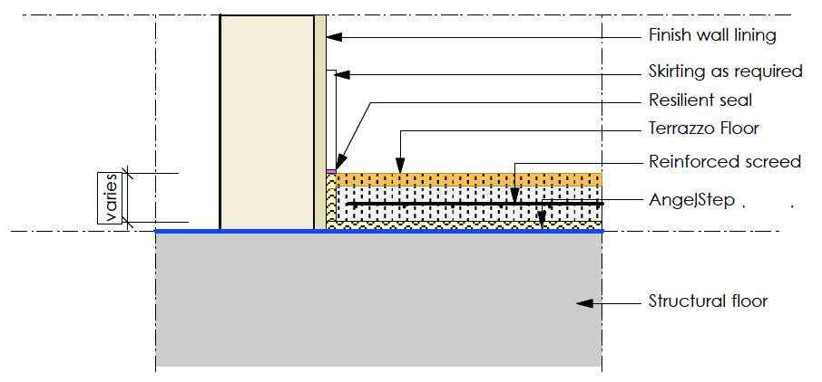

AngelStep Installation: Parquetry floor finish

Parquetry floor
- Structural floor must be levelled, to parquetry installation standard tolerances,
- Clean and free of debris.
- Install AngelStep tiles butted together.
- Leave 3 mm gap between wall and finish surface.
- Glue AngelStep with polyurethane glue
- Spot glue the first layer of CFC to Angel Step.
- Glue the 2nd layer of CFC together with manufacturer's recommended glue.
(Contact) OR ALTERNATIVELY
- Install yellow tongue directly to AngelStep
- Do not line up CFC joints, overlap joints to form a floating floor.
- Ensure that the new floor stay 3 mm from edges. Seal gap silicone sealant.
- Install tiles as per AS Standards and manufacturer’s instructions.
- Install skirting after floor has been installed. Leave a 2 to 3mm gap
between floor tiles and skirting.
- Use a Stanley knife or equal to cut product.
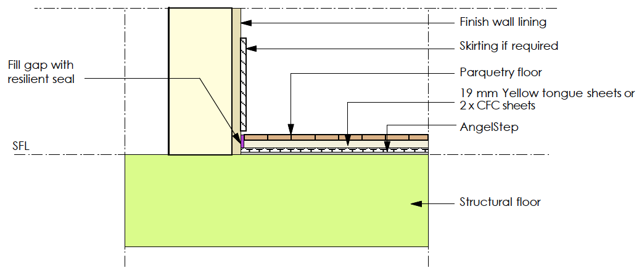
- Seal gaps between wall & new floor with silicone sealant to form a resilient seal.

Clean up as the work proceeds.

Installation Particulars

Finishing Details

Install as per detail drawings above

Protection
Protect finished work until work has been. Make good damage in every respect at no additional cost to the Proprietor.

Cleaning
Clean exposed surfaces. Remove all debris and waste and dispose

Completion
Complete contracted work in accordance with contract documents and written variation orders issued by the Architect or Superintendent.

END OF SECTION

