## Acknowledgement

We take this opportunity to express our sincere gratitude to everyone who contributed to the successful completion of the **Ambika Mobile Shopee Website Project**. Without their support, guidance, and encouragement, this project would not have been possible.

First and foremost, we extend our heartfelt thanks to **Prof. J. D. Gat** for her invaluable guidance, insightful suggestions, and constant motivation throughout the project. Her unwavering support and expertise have been instrumental in shaping our work. We are deeply grateful for the time and resources she provided to ensure the project's success.

We would also like to express our appreciation to all faculty members of our institution for their dedication and efforts in making our learning experience enriching and productive. Their encouragement and knowledge-sharing have greatly contributed to our academic and technical growth.

Additionally, we extend our gratitude to our counselors for their indispensable support and motivation during the project journey. We also acknowledge the assistance of our peers, friends, and all those who have directly or indirectly helped us in various ways.

Lastly, we are immensely thankful to our parents and family members for their unwavering patience, encouragement, and belief in our capabilities. Their support has been a pillar of strength throughout this journey.

**Thank you.**

## Index

|  |  |  |
| --- | --- | --- |
| **SR.NO** | **TITLE** | **PAGE NO.** |
| **1.** | **Introduction to system** | **1** |
| **2.** | **Scope of system** | **2** |
| **3.** | **Objectives of system** | **3** |
| **4.** | **Proposed system** | **4** |
|  | **Analysis** |  |
| **5** | **Fact finding technique** | **5** |
| **6.** | **Feasibility study** | **6** |
| **7.** | **Hardware and Software requirements** | **7** |
|  | **System Design** |  |
| **8.** | **Entity relationship Diagram** | **8** |
| **9.** | **Data Flow Diagram (context level)** | **9** |
| **10.** | **Data Flow Diagram (First Level)** | **9** |
| **11.** | **Data Dictionary** | **10** |
| **\*** | **Form design** |  |
| **12.** | **Input and output screen** | **16** |
| **13.** | **Reports** | **21** |
| **14.** | **Advantages** | **22** |
| **15.** | **Limitations** | **23** |
| **16.** | **Future enhancement** | **23** |
| **17.** | **Bibliography** | **24** |

## Introduction to system

The purpose of the **Ambika Mobile Shopee Website Project** is to create an efficient and user-friendly e-commerce platform for purchasing mobile phones, accessories, and related gadgets. This web-based system aims to enhance the shopping experience by providing a seamless interface where customers can browse products, compare features, and make secure purchases.

The platform enables customers to explore a wide range of mobile products, add items to their cart, and place orders with multiple payment options. It also allows users to track their orders, view purchase history, and receive real-time updates on offers and new arrivals.

A key feature of this project is **secure user authentication and role-based access control**, ensuring that customers, administrators, and store managers have appropriate permissions. The system supports **one-time registration** and maintains comprehensive records of transactions and user interactions. Store managers can add, update, or remove products, manage inventory, and track sales, while customers can enjoy a hassle-free shopping experience with easy navigation and search functionality.

The **administrator** plays a vital role in overseeing the system, managing user accounts, handling product listings, and generating sales reports. Additionally, the platform includes a **notification system** to keep customers informed about order status, discounts, and promotional offers.

This project aims to modernize mobile shopping by offering a **secure, efficient, and customer-centric online platform**, ensuring smooth transactions, better user engagement, and improved business operations.

## Scope of System

The **Ambika Mobile Shopee Website** is designed to provide a seamless and efficient online shopping experience for customers looking to purchase mobile phones, accessories, and related gadgets. The system will store and manage all essential product details, customer information, and transaction records, ensuring smooth operations and easy access to information.

The platform will allow **administrators and store managers** to add, update, or remove products, manage inventory, track sales, and generate reports. **Customers** will have the ability to browse products, compare features, add items to their cart, place orders, and track shipments.

Additionally, the system will feature a **notification module** to keep users informed about order status, special offers, discounts, and new product arrivals. **Secure payment integration** will ensure safe transactions, supporting multiple payment methods, including credit/debit cards, UPI, and digital wallets.

The **scope** of this project extends to creating a **structured, secure, and user-friendly e-commerce platform** that facilitates a **smooth shopping experience, effective product management, and seamless transactions**, ultimately improving customer satisfaction and business growth.

## Objective of System

The objectives of the **Ambika Mobile Shopee Website Project** are:

* **To create a seamless and efficient online shopping platform** that allows customers to browse, compare, and purchase mobile phones and accessories conveniently.
* **To provide a secure and user-friendly interface** for customers to register, log in, and manage their profiles efficiently.
* **To ensure smooth product management** by allowing administrators and store managers to add, update, and remove product listings while keeping inventory organized.
* **To integrate a secure payment system** that supports multiple payment options such as UPI, credit/debit cards, and digital wallets for hassle-free transactions.
* **To enable order tracking and customer support**, ensuring that users receive real-time updates on order status, shipping details, and delivery timelines.
* **To implement an effective notification system** to inform customers about new product arrivals, offers, discounts, and order-related updates.
* **To improve operational efficiency** by automating processes such as inventory management, order processing, and customer inquiries, reducing manual workload.
* **To maintain a centralized database** that securely stores customer details, purchase history, and product information for easy access and updates.

The ultimate goal of this system is **to enhance the online shopping experience**, provide **a secure and efficient platform for mobile purchases**, and support **business growth through digital transformation**.

## Proposed System

Managing and retrieving information in a traditional, offline mobile store can be **time-consuming and inefficient**. Finding product details, tracking inventory, and handling customer orders manually often leads to errors, delays, and mismanagement. The lack of a **centralized system** increases the workload for store managers and staff, resulting in **ineffective order processing and customer dissatisfaction**.

The proposed **Ambika Mobile Shopee Website** is an **e-commerce platform** designed to **streamline the management of mobile products, orders, and customer interactions**. The system will provide a **centralized, web-based solution** where **customers, administrators, and store managers** can manage and access relevant information efficiently.

* **Customers** will be able to **browse products, compare features, add items to their cart, place orders, and track their shipments** seamlessly.
* **Administrators and store managers** will have the ability to **add, update, or remove products, manage inventory, track sales, and generate reports** for business insights.
* **The system will support secure user authentication and role-based access**, ensuring that only authorized users can access and manage sensitive data.
* **A notification system** will keep customers informed about **order confirmations, shipping updates, special discounts, and new product arrivals**.
* **Integrated payment gateways** will allow secure transactions through **credit/debit cards, UPI, and digital wallets**, ensuring smooth financial operations.

The **proposed system** will **reduce dependency on manual work, improve operational efficiency, and provide a seamless shopping experience**. By automating processes like **order tracking, product management, and customer support**, the platform aims to **enhance customer satisfaction and support business growth**.

## Fact Finding Techniques

Developing a **mobile e-commerce platform** requires a **clear understanding of user needs, business requirements, and industry best practices**. The initial requirements may be **informal or incomplete**, making it necessary to refine them into a structured **System Requirements Specification (SRS)**. The fact-finding process ensures that the **Ambika Mobile Shopee Website** is designed effectively to meet customer expectations and business objectives.

**1. Problem Analysis**

* **Understanding Business Needs**: Identifying challenges in the existing manual or offline selling process.
* **User Interviews**: Gathering insights from customers, store managers, and business owners regarding **product browsing, order processing, payment options, and customer service**.
* **Competitor Analysis**: Studying similar e-commerce platforms to **identify best practices and features** that can be implemented.
* **Current System Limitations**: Finding inefficiencies such as **inventory mismanagement, delayed order processing, and lack of online payment support**.

**2. Requirement Specification (SRS)**

The **SRS document** defines the system’s core functionalities, ensuring clarity between **business owners and developers**. Key specifications include:

* **User Roles & Access Control**: Customers, administrators, and store managers with different access levels.
* **Product Management**: Adding, updating, and removing mobile phones, accessories, and offers.
* **Order & Payment System**: Enabling secure **checkout with multiple payment options (UPI, cards, wallets)**.
* **Customer Account Features**: Order history, wishlist, and personalized recommendations.
* **Notifications & Alerts**: SMS/email updates on **orders, discounts, and stock availability**.

**3. Requirement Validation**

* **Verification of Requirements**: Ensuring that **functionalities align with user needs** through feedback loops.
* **Testing for Accuracy**: Checking for **ambiguities, inconsistencies, and missing features** before system design begins.
* **Stakeholder Approval**: Confirming requirements with **business owners, developers, and end users** to prevent **misinterpretation**.

By implementing these **fact-finding techniques**, the **Ambika Mobile Shopee Website** will be developed as a **user-friendly, efficient, and scalable e-commerce platform**, enhancing the **overall shopping experience** for customers while **streamlining store management operations**.

## Feasibility Study

A **feasibility study** evaluates different aspects of the **Ambika Mobile Shopee Website** to determine whether the project is **practical, cost-effective, and achievable**. It helps identify **potential risks and challenges** before investing time and resources, ensuring a **smooth development and implementation process**.

**Benefits of Feasibility Study**

1. **Risk Assessment**
   * Identifies technical, financial, and operational risks.
   * Provides strategies to **mitigate challenges** related to online payment security, order processing, and website traffic handling.
2. **Informed Decision-Making**
   * Helps business owners understand **market demand, competitor strategies, and technology requirements**.
   * Ensures that the **project aligns with customer expectations** and business objectives.
3. **Cost and Resource Management**
   * Estimates **development costs, hosting expenses, and marketing budgets**.
   * Helps in **resource allocation** to avoid unnecessary expenses.
4. **Market Analysis and Competition**
   * Evaluates **customer behavior, pricing strategies, and existing e-commerce platforms**.
   * Identifies **unique selling points** to differentiate from competitors.

**Types of Feasibility Analysis**

1. **Technical Feasibility**
   * Assesses the technology stack (**React.js, Node.js, MongoDB**) for website development.
   * Ensures that the **website is scalable, responsive, and secure**.
   * Evaluates hosting options like **AWS, DigitalOcean, or Firebase**.
2. **Economic Feasibility**
   * Estimates **initial investment, operational costs, and potential revenue**.
   * Analyzes whether the **website can generate profits** through product sales, advertisements, or subscription plans.
3. **Operational Feasibility**
   * Ensures that the **website can handle orders, inventory management, and customer service efficiently**.
   * Checks for **integration with delivery partners and payment gateways**.
4. **Legal Feasibility**
   * Verifies compliance with **Indian e-commerce laws, taxation (GST), and data privacy regulations**.
   * Ensures secure transactions through **SSL/TLS encryption** and **GDPR compliance**.

By conducting a **detailed feasibility study**, the **Ambika Mobile Shopee Website** will be **technically sound, financially viable, operationally efficient, and legally compliant**, ensuring **a successful launch and long-term sustainability**.

**1.HARDWARE REQUIREMENTS**

Processer: Pentium III onwards

RAM :512 MB & Above

Hard disk :1GB & Above

**2.SOFTWARE REQUIREMENT**

Operating System: Windows 10 & Onwards

Front End: HTML, CSS, JavaScript

## Entity Relationship Diagram

## 

## Data Flow Context Diagram

**Level 0 DFD (Context Diagram):**

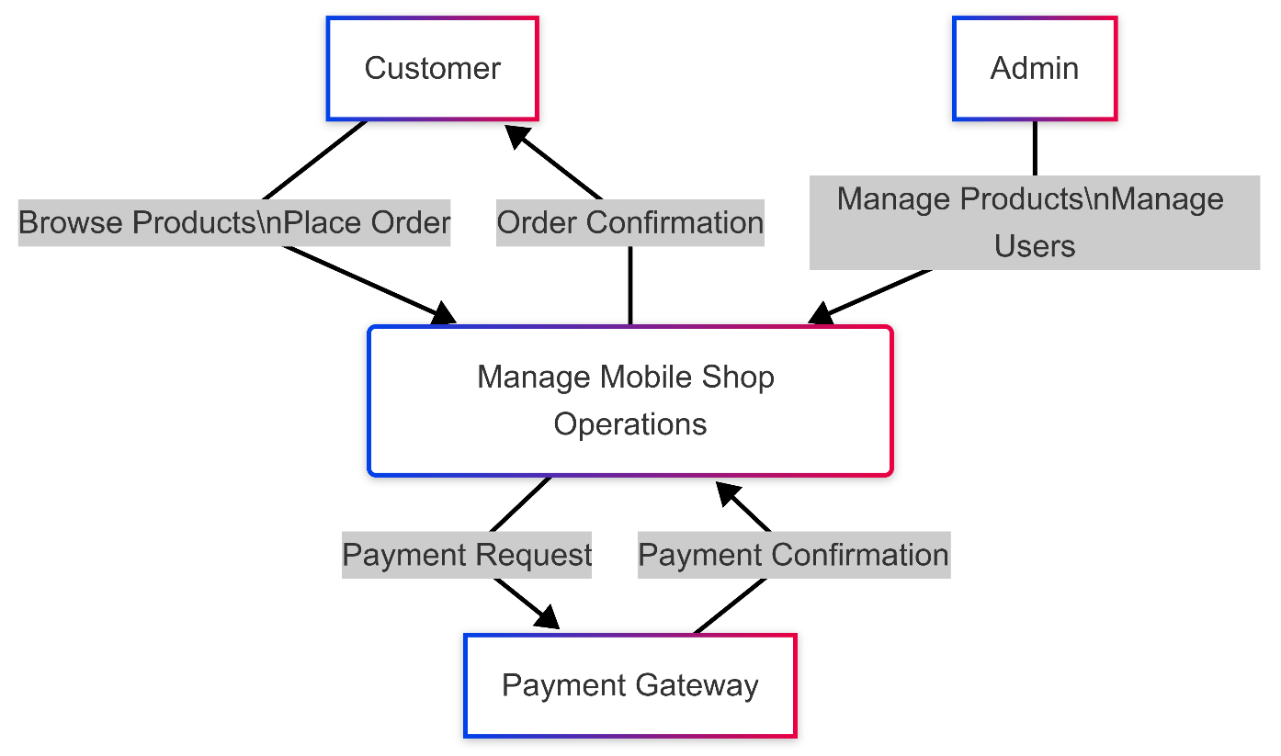

**Level 1 DFD (Process Decomposition):**

**Data Model**

## Input Screens

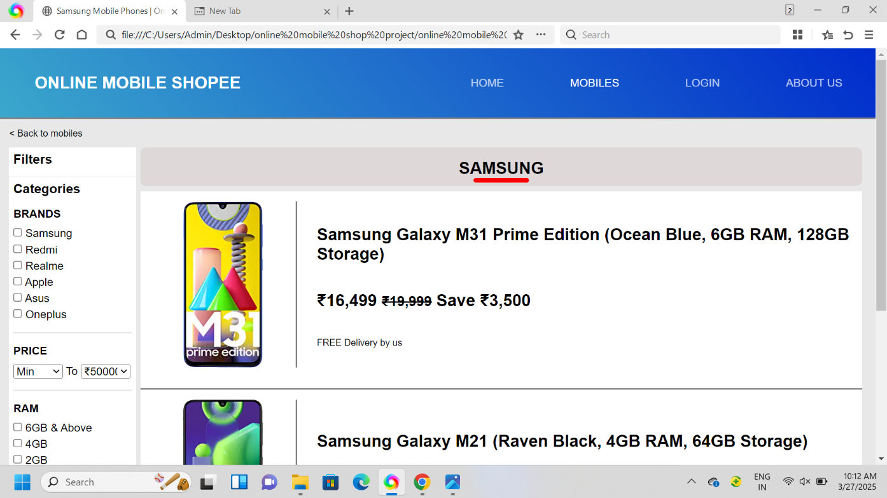

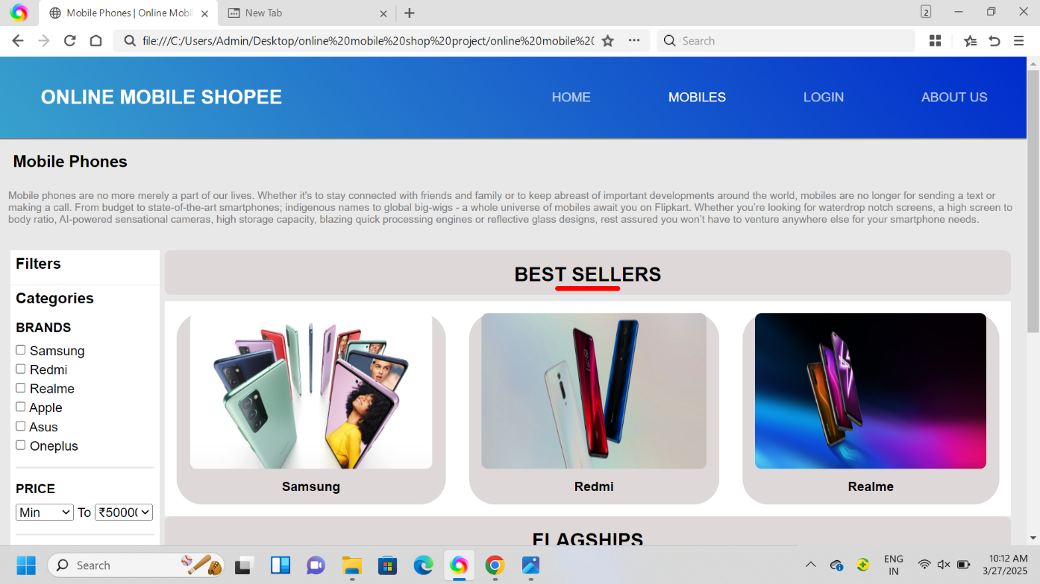

## Reports

The **Ambika Mobile Shopee Website** consists of three core modules: **Admin, Customer, and Vendor**. Each module is designed to handle specific functionalities, ensuring a **smooth user experience and efficient business operations**. The system integrates **structured data handling and optimized algorithms** to generate **accurate and insightful reports**.

**1. Admin Module**

The **Admin Module** serves as the backbone of the system, responsible for **overall management and monitoring**. Admin functionalities include:

✔ **User Management:** Manage vendor and customer accounts.  
✔ **Product and Inventory Control:** Approve and manage product listings.  
✔ **Order Processing:** Monitor order statuses, payments, and deliveries.  
✔ **System Settings & Permissions:** Configure website policies and security measures.  
✔ **Reports Generation:**

* **Sales Reports:** Track revenue, transactions, and refunds.
* **User Activity Reports:** Analyze customer engagement and purchase trends.
* **Stock Reports:** Monitor inventory levels and supplier restocking needs.

**2. Customer Module**

The **Customer Module** focuses on providing a seamless shopping experience. Key functionalities include:

✔ **Customer Registration & Login:** Users can create accounts and manage their profiles.  
✔ **Product Browsing & Search:** Explore mobile phones, accessories, and deals.  
✔ **Order & Payment Processing:** Secure checkout and multiple payment options.  
✔ **Order Tracking & Support:** View order history, delivery status, and contact support.  
✔ **Reports Generation:**

* **Purchase History:** Customers can track past orders and invoices.
* **Wishlist & Cart Reports:** Insights on saved items and abandoned carts.

**3. Vendor Module**

The **Vendor Module** enables sellers to **manage their products and track performance**. Key functionalities include:

✔ **Product Management:** Upload new products, update prices, and manage inventory.  
✔ **Order Fulfillment:** Process received orders and handle shipping.  
✔ **Discounts & Promotions:** Offer discounts and manage promotional campaigns.  
✔ **Reports Generation:**

* **Sales Performance Reports:** Analyze best-selling products and revenue trends.
* **Customer Insights:** Identify frequent buyers and customer preferences.
* **Inventory Reports:** Track stock levels and predict demand.

By structuring these modules efficiently, the **Ambika Mobile Shopee Website** ensures **effective management, smooth user interaction, and data-driven decision-making**, leading to **better business growth and customer satisfaction**.

### Advantages

The **Ambika Mobile Shopee Website** offers multiple advantages that enhance the **shopping experience, vendor management, and business efficiency**.

**1. Efficient Order & Inventory Management**

✔ **Seamless Order Processing:** Customers can **browse, order, and track** their purchases easily.  
✔ **Real-time Inventory Tracking:** Vendors and admins can **monitor stock levels** and receive alerts when products need restocking.

**2. Enhanced Customer Experience**

✔ **User-Friendly Interface:** The website is **easy to navigate**, ensuring a smooth shopping journey.  
✔ **Multiple Payment Options:** Secure transactions via **UPI, credit/debit cards, and cash on delivery (COD)**.  
✔ **Order Tracking & Notifications:** Customers get **real-time updates** about their order status.

**3. Secure & Reliable System**

✔ **Data Protection:** The system implements **encryption and access control** to ensure secure transactions.  
✔ **Role-Based Access:** Different users (Admin, Vendor, Customer) have **restricted access** based on their roles.  
✔ **Cloud-Based Storage:** All data is stored securely, ensuring **scalability and data recovery**.

**4. Business Growth & Marketing**

✔ **Customer Insights & Analytics:** Admins and vendors can **analyze sales trends**, helping them make **data-driven decisions**.  
✔ **Promotions & Discounts:** Vendors can create **special offers, coupon codes, and seasonal discounts** to attract customers.  
✔ **SEO & Online Visibility:** Optimized product listings improve **search rankings and customer reach**.

**5. Vendor Empowerment**

✔ **Easy Product Listing & Management:** Vendors can **add, update, and remove products** with ease.  
✔ **Sales & Performance Reports:** Vendors can track **best-selling products, revenue, and customer preferences**.  
✔ **Customer Feedback System:** Vendors can gather **reviews and ratings** to improve their services.

**6. Cost-Effective & Scalable**

✔ **Reduces Operational Costs:** Automating **sales, inventory, and customer management** minimizes manual work.  
✔ **Scalable Infrastructure:** The platform supports **growing product catalogs and increasing user traffic**.  
✔ **24/7 Availability:** Customers can shop **anytime, anywhere**, boosting sales.

By leveraging these **features and advantages**, the **Ambika Mobile Shopee Website** ensures a **reliable, efficient, and profitable** e-commerce ecosystem for both customers and vendors.

## Limitations

**Limitations of Ambika Mobile Shopee Website**

🚫 **Accurate Product Data Entry is Essential**  
The system heavily relies on **correct product details, pricing, and stock levels**. Any **incorrect entries** may lead to customer dissatisfaction.

🚫 **Limited for Small to Medium-Scale Businesses**  
The platform is designed primarily for **small to medium-scale mobile stores** and may require **enhancements for large-scale e-commerce operations**.

🚫 **No Offline Functionality**  
The website requires **an active internet connection** for browsing, purchasing, and managing orders, limiting **offline accessibility**.

🚫 **Storage Limitations for Reports**  
Currently, sales and customer reports are stored **on a periodic basis (e.g., monthly)**, which may **limit long-term trend analysis**.

🚫 **Scalability Concerns with High Traffic**  
As the number of users and products grows, **performance optimization and server upgrades** may be required to maintain speed and efficiency.

These **limitations provide opportunities for future improvements** to enhance the system’s performance and scalability.

## Future Enhancement

**1️⃣ Multi-Language Support 🌍**

* **Add support for Marathi, Hindi, and other regional languages to improve accessibility for a wider audience.**

**2️⃣ Enhanced Security Measures 🔐**

* **Implement Two-Factor Authentication (2FA) for secure logins.**
* **Strengthen SSL encryption to protect user data.**
* **Improve role-based access control to prevent unauthorized access.**

**3️⃣ AI-Powered Product Recommendations 🤖**

* **Use machine learning to suggest mobile phones and accessories based on customer preferences and past purchases.**

**4️⃣ Progressive Web App (PWA) Support 📱**

* **Develop a PWA version for offline browsing, push notifications, and faster loading speeds.**

**5️⃣ Advanced Analytics & Reports 📊**

* **Integrate real-time sales tracking, user behavior analysis, and inventory forecasting for better decision-making.**

**📖 Bibliography**

**📚 Books:**

* *Learning Management Systems: Concepts and Applications* – O’Reilly Publication
* *Mastering LMS Platforms* – BPB Publication
* *LMS for Beginners* – SPD Publication

**🌐 Websites:**

* [YouTube](https://www.youtube.com)
* [LMS World](https://www.lmsworld.com)
* [W3Schools](https://www.w3schools.com)