Table of Contents
1. 🧾 Introduction 2
2. 🛠️ Technologies Used 3
3. 📐 Architecture Diagram 4
4. ⚙️ Implementation Steps 4
5. 🌟 Features 12
6. ✅ Testing & Results 12
7. 🐛 Challenges & Solutions 14
8. 🚀 Future Enhancements 14
9. 🏁 Conclusion 14

1. 🧾 Introduction
In today's fast-paced digital world, communication is a key component of organizational workflows—especially when it comes to hiring processes. HR teams, recruiters, and academic coordinators often need to send bulk emails to a large pool of applicants, informing them of their selection or rejection status. Manually composing and sending these emails is time-consuming, error-prone, and inefficient.
MailMatrix is a cloud-native, serverless web application designed to automate the bulk emailing process by leveraging the power of AWS services and a simple user-friendly interface. The goal of this project is to provide a seamless experience for users to upload applicant data and automatically send personalized offer or rejection emails based on the status indicated in a CSV file.
The system supports the following core functionalities:
- User Registration & Login: Authenticated users can sign up, log in, and manage their uploads securely.
- Bulk CSV Upload: Users can upload a CSV file that contains recipient email addresses, names, status (selected/rejected), and optionally the file name of their offer letter.
- Automatic Email Dispatch:
  - If the status is selected, the system attaches the candidate's offer letter (in PDF format) and sends a congratulatory email.
  - If the status is rejected, a polite rejection email is sent without any attachment.
- Offer Letter Upload: Users can upload multiple PDF files in advance to associate with selected candidates.
- History Tracking: Every file uploaded by the user is logged along with the recipients, their status, associated company, and timestamp.
- Profile Management: Users can view and update their organization details, phone number, and password.
MailMatrix is powered by AWS S3, Lambda, SES (Simple Email Service), RDS (MySQL), and Flask (Python). By combining these technologies with a serverless event-driven architecture, the platform offers high scalability, cost efficiency, and minimal maintenance.
This system is particularly useful for:
- HR teams sending large volumes of job offers and rejection emails.
- University coordinators notifying internship or project allotment outcomes.
- Any organization handling bulk personalized communication securely.
Through this project, we also aimed to explore best practices in cloud-native application development, AWS automation, secure user authentication, and seamless frontend-backend integration.

2. 🛠️ Technologies Used
- Frontend: HTML, CSS
Main project folder named: mailmatrix-app
HTML codes stored in mailmatrix-app/templates/ and CSS and required images stored in mailmatrix-app/static
- Backend: Python (Flask)
backend code stored as app.py in mailmatrix-app folder
- Cloud Services:
  - Amazon S3: File storage
Used to store uploaded recipient CSV files and offer letter PDFs securely and reliably, while also triggering email automation via event notifications.
  - Amazon SES: Email service
Sends personalized emails (with or without attachments) to recipients, handling both transactional and bulk email dispatch.
  - AWS Lambda: Backend logic
Executes the backend email dispatch logic in a serverless environment when a file is uploaded to S3, eliminating the need to manage or scale servers.
  - Amazon RDS (MySQL): User and upload history database
Stores user registration data, including email, organization, phone number, and is also queried by Lambda to fetch company names dynamically.
  - Amazon EventBridge: S3 event trigger handler
used to build advanced scheduling and event routing for S3 triggers via creating a rule and connecting it to Lambda function
  - CloudWatch: Lambda log viewer
Monitors Lambda executions, logs events, errors, and print statements to help debug and maintain the serverless backend.
  - IAM: Provides secure and scoped permissions for Lambda to access S3, SES, and RDS.
- Tools: DBeaver (for database, connected with RDS)
Consists of 2 tables “users” and “upload_history” to store user details like name, email, password, mobile number, company name etc. and details of the uploaded history by each user to verify the candidates that were selected/rejected and received an offered from a particular company respectively.

3. 📐 Architecture Diagram

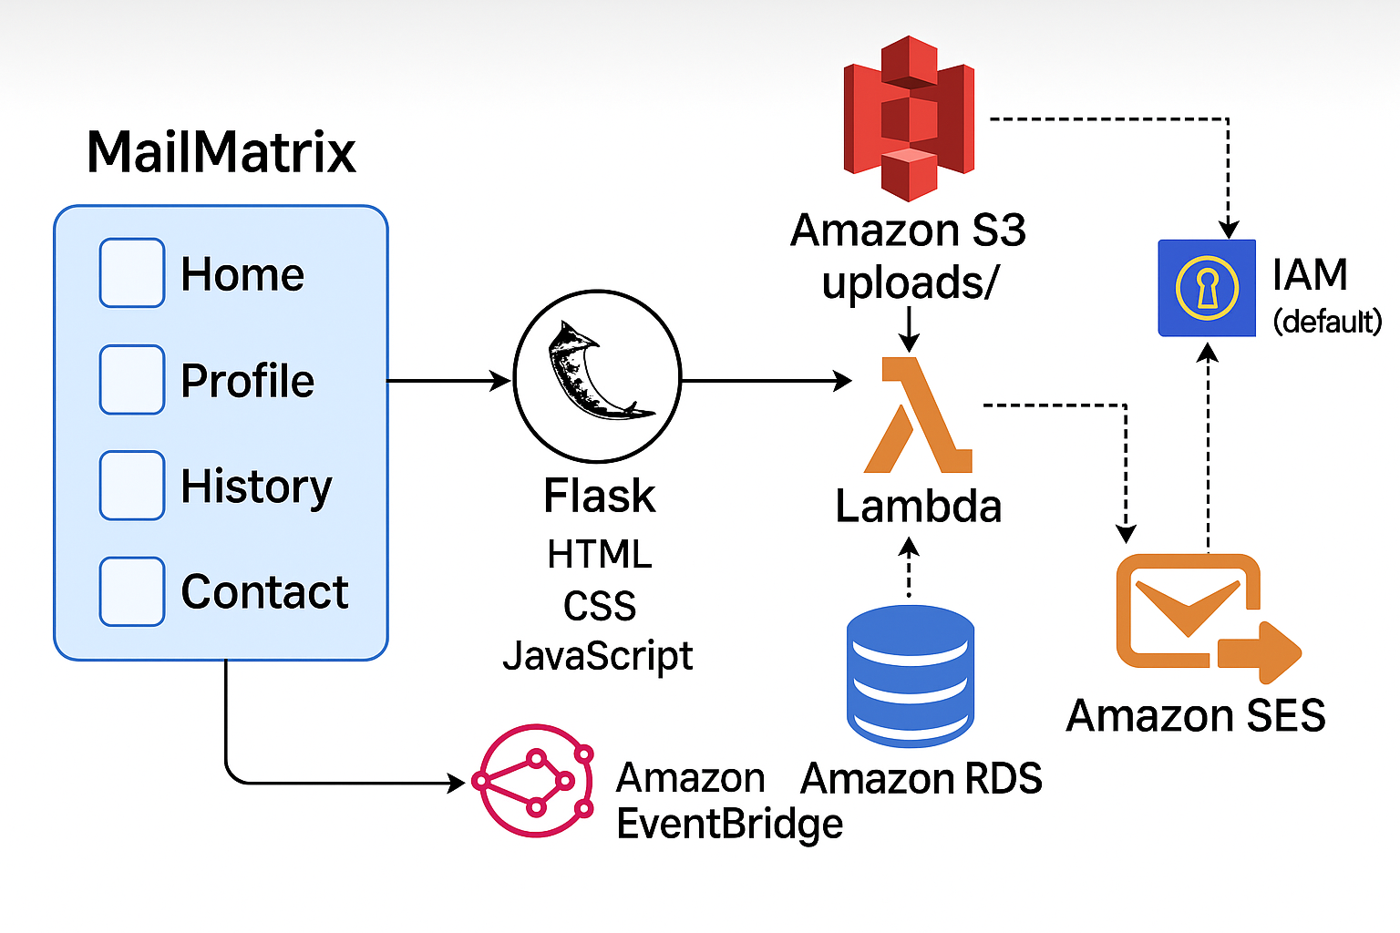

4. ⚙️ Implementation Steps
The MailMatrix system was implemented using AWS cloud services and a custom-built Flask-based web application. Below is a comprehensive, step-by-step guide for setting up the project.

1. Frontend & Backend Setup
A. Project Structure
- app.py – Flask backend
- templates/ – Contains HTML templates: login.html, register.html, home.html, profile.html, history.html, contact.html
- static/ – CSS files: style.css, register.css, home.css, profile.css, history.css, contact.css
- uploads/ – Temporary folder for uploaded files before sending to S3

B. Flask Configuration
- Set up a Python virtual environment:
bash
CopyEdit
python -m venv venv
source venv/bin/activate
- Install necessary libraries:
bash
CopyEdit
pip install flask flask_sqlalchemy pymysql boto3 werkzeug bcrypt
- Configure app.py:
  - Connect Flask to AWS RDS for MySQL
  - Store user sessions and handle registration/login
  - Enable file uploads for CSVs and offer letters
  - Implement routes for profile editing, file uploads, and viewing history

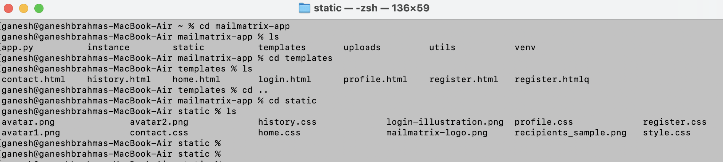

4.2. AWS RDS – MySQL Database Setup

AWS Aurora and RDS was configured to use as a managed relational database service where we used MySQL as the Database to store the “users” and “upload_history” tables. We connected it to DBeaver in order to manage and view the tables.
Purpose:
Stores user profile information such as email, first name, and company (organization).
Used by Lambda to dynamically retrieve the sender's company name when generating personalized email content.
- Navigate to RDS → Databases → Create database
- Select:
  - Engine: MySQL
  - DB instance size: db.t4g.micro
  - Database name: mailmatrix-db
  - Master username as admin and password as admin123
- Enable Public access
- Create a Security Group Rule:
  - Type: MySQL/Aurora (3306)
  - Source: Your IP
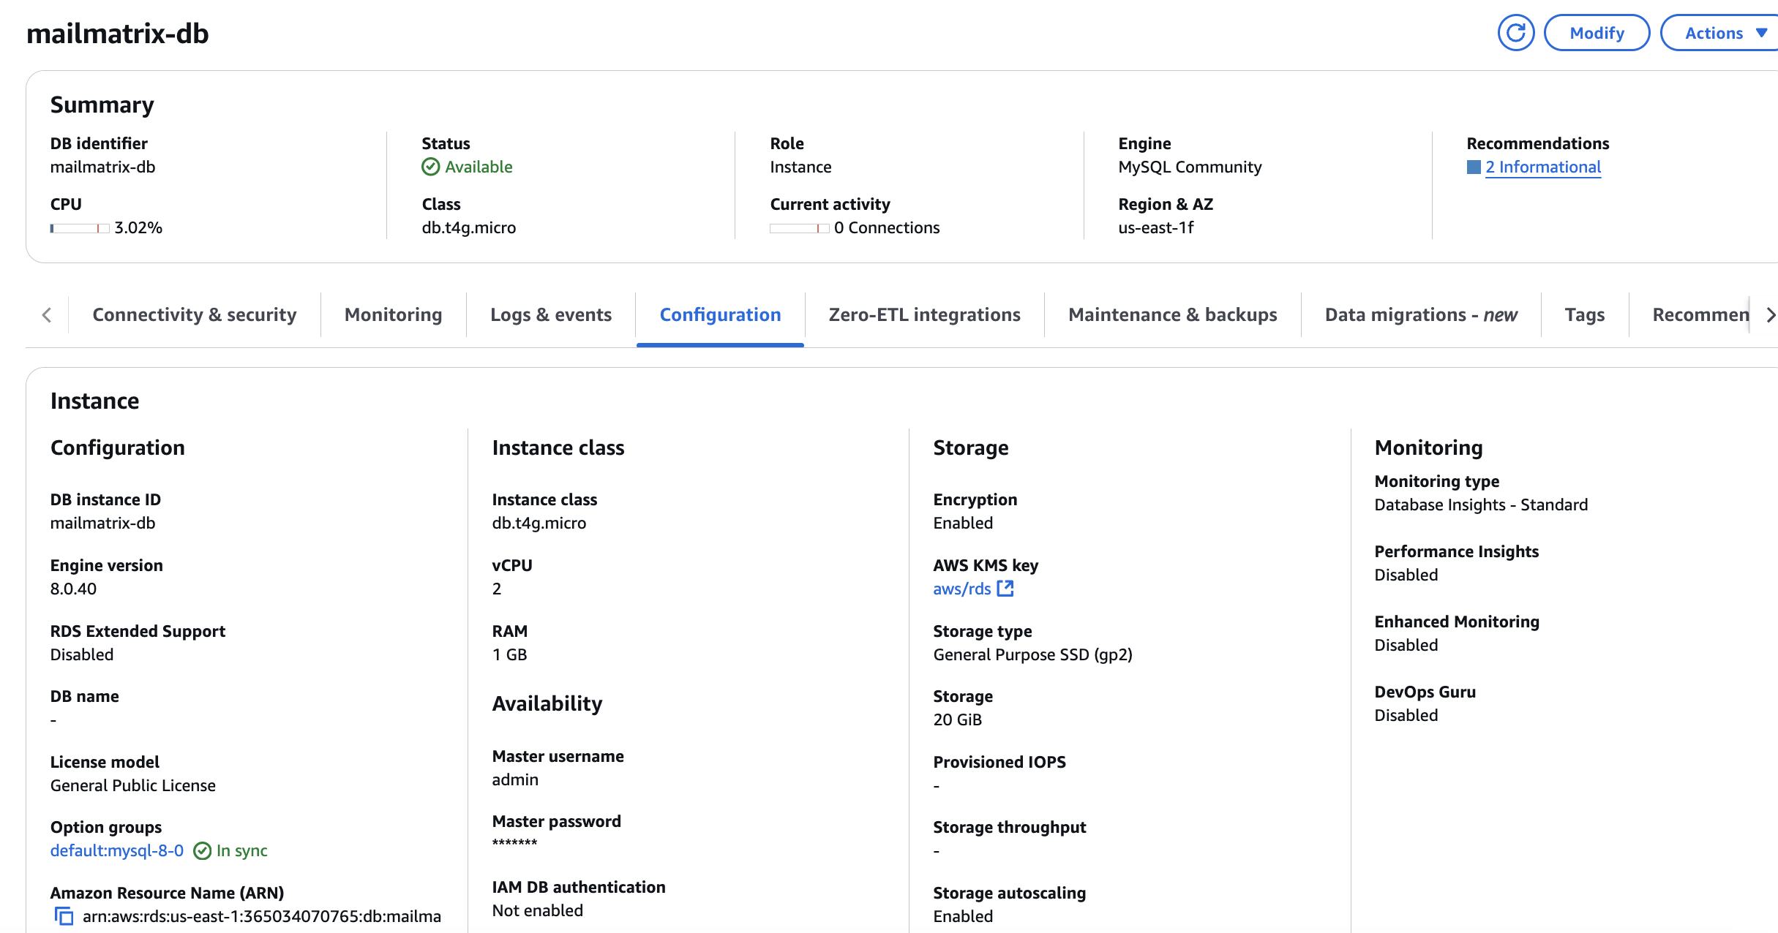

- Launch the database and connect via DBeaver using RDS endpoint and create tables:
users table:
CREATE TABLE users (
id VARCHAR(10),
email VARCHAR(30),
password VARCHAR(50),
first_name VARCHAR(100),
last_name VARCHAR(100),
mobile VARCHAR(30),
country_code VARCHAR(10),
organization VARCHAR(100)
);
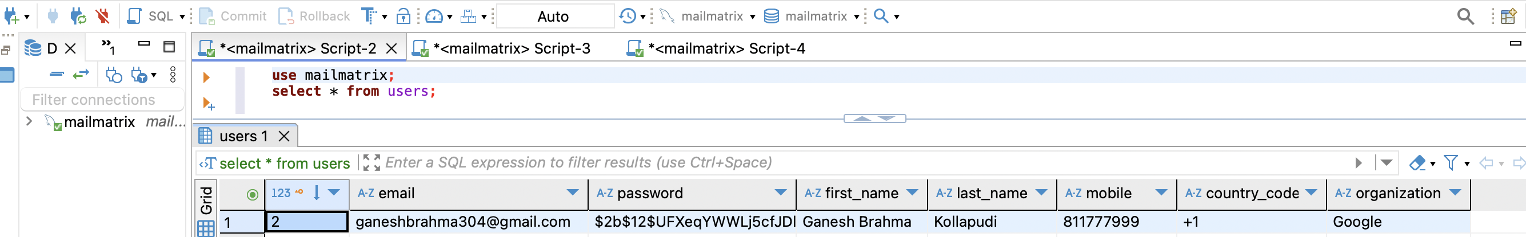

upload_history table:
CREATE TABLE upload_history (
id INT AUTO_INCREMENT PRIMARY KEY,
user_email VARCHAR(100),
file_name VARCHAR(255),
upload_type VARCHAR(20),
action VARCHAR(20),
recipient_email VARCHAR(100),
status VARCHAR(20),
timestamp TIMESTAMP DEFAULT CURRENT_TIMESTAMP
);
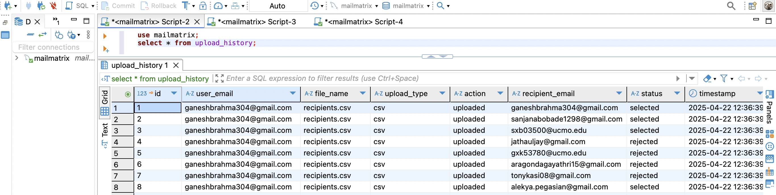
4.3. AWS S3 – Storage Configuration
AWS S3 (Scalable Storage Service) was configured to store the recipient csv and offer letter files. When users upload recipient data and offer letters via the Flask frontend, the files are stored in dedicated S3 folders (uploads/ and offer_letters/). Triggers downstream processing via EventBridge when new CSV files are added.
Purpose:
Used as the central file storage for both recipient CSV files and offer letter PDFs.
- Go to S3 → Create Bucket
  - Name: mailmatrix-csv-bucket
  - Enable default settings (Block Public Access)
- Create folders inside bucket:
  - uploads/ – For recipient CSV files
  - offer_letters/ – For PDF attachments
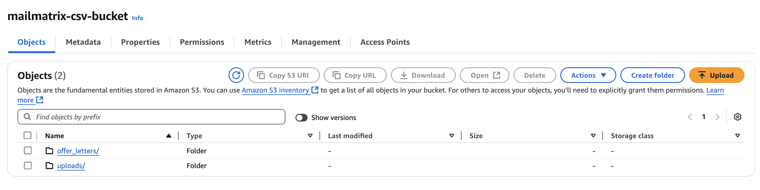Once a user register’s and log in, the user uploaded offer letters will be stored in the folder “offer_letters” and the recipients csv will store in the folder “uploads”
4.4. AWS SES – Email Configuration
AWS SES (Simple Email Service) is configured to send bulk emails and reduce the manual efforts of a company’s HR, while a candidate is selected or rejected. It sends an email to all the selected candidates along with an attached offer letter and a plain rejection email to the candidates that couldn’t make it.
Purpose:
Handles the sending of bulk emails (offer or rejection) based on the CSV content. SES was chosen for its low cost, high deliverability, and tight integration with Lambda.
- Go to SES → Identities
- Add and verify email addresses used for sending/receiving via Create Identity. The user will receive an email on their mentioned email Id to verify it.
- In app.py and Lambda, use the below for connection of backend code with SES.
python
CopyEdit
ses = boto3.client('ses')

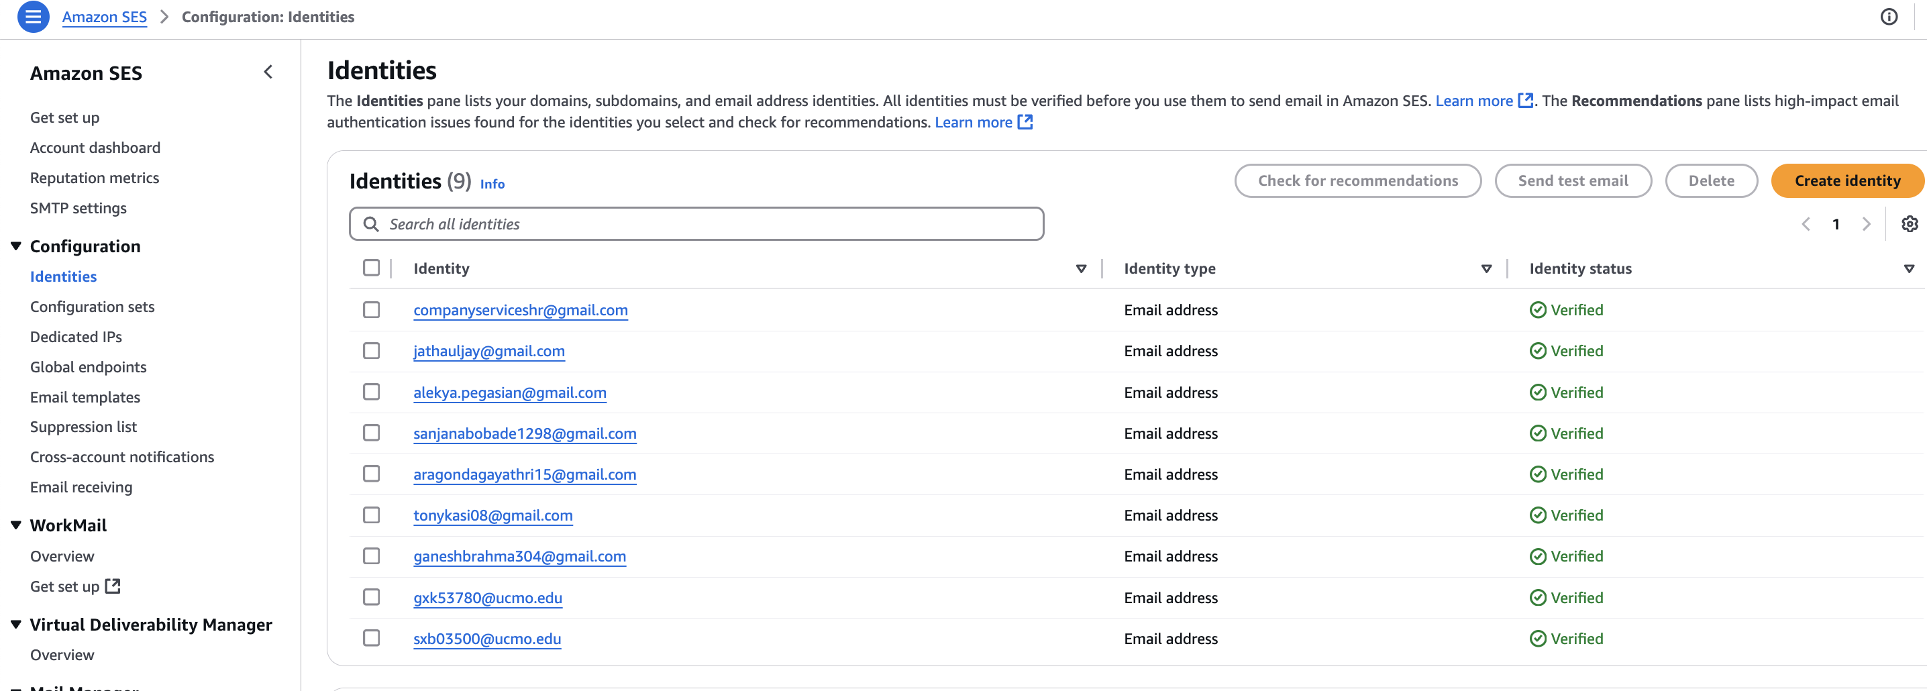

4.5. AWS Lambda – Email Processor
AWS Lambda function was configured and integrated along with S3 as a trigger. When a user uploads “recipient.csv” file, it gets stored in S3 bucket inside the uploads/ folders and triggers the lambda function. It reads the uploaded CSV, determines whether to send an offer or rejection email, and triggers SES accordingly. It also fetches company information from Amazon RDS.
Purpose:
Used to automatically process uploaded CSV files and send emails without any servers.
- Go to Lambda → Create Function
  - Runtime: Python 3.9
  - Name: mailmatrix-processor
  - Create a new role with basic Lambda permissions
- Paste and deploy the Lambda code “lambda_function.py” and add the S3 trigger with the lambda mailmatrix-processor.
- S3 Trigger:
  - Navigate to your bucket → Properties → Event Notifications
  - Add event for prefix uploads/, suffix .csv to trigger Lambda
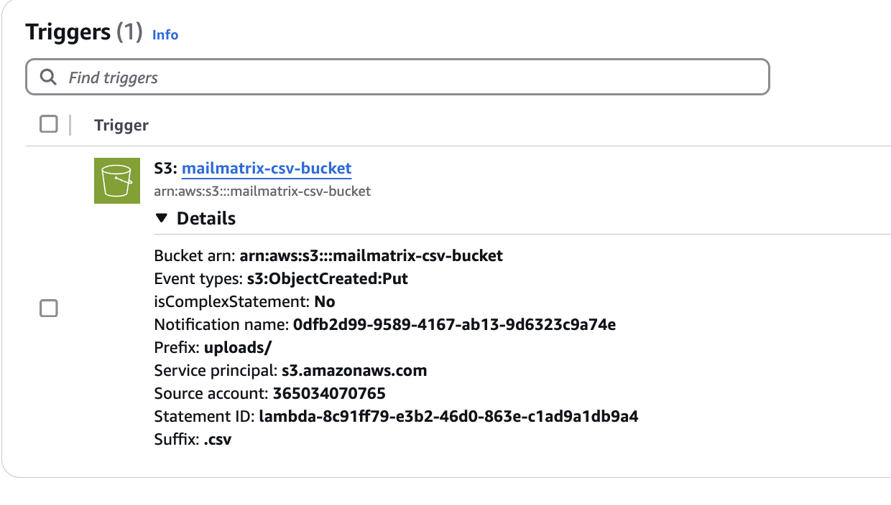


4.6. EventBridge – Trigger
The AWS EventBridge was configured as a trigger to listens to S3 events (like object creation) and triggers Lambda asynchronously, enabling a fully automated, serverless pipeline.
Purpose:
Acts as the event router to invoke Lambda functions when a new recipient CSV file is uploaded to S3.
- Go to Amazon EventBridge → Rules → Create Rule
- Event source: S3 Object Created
- Define event pattern with:
  - Bucket: mailmatrix-csv-bucket
  - Prefix: uploads/
- Set target as the Lambda function

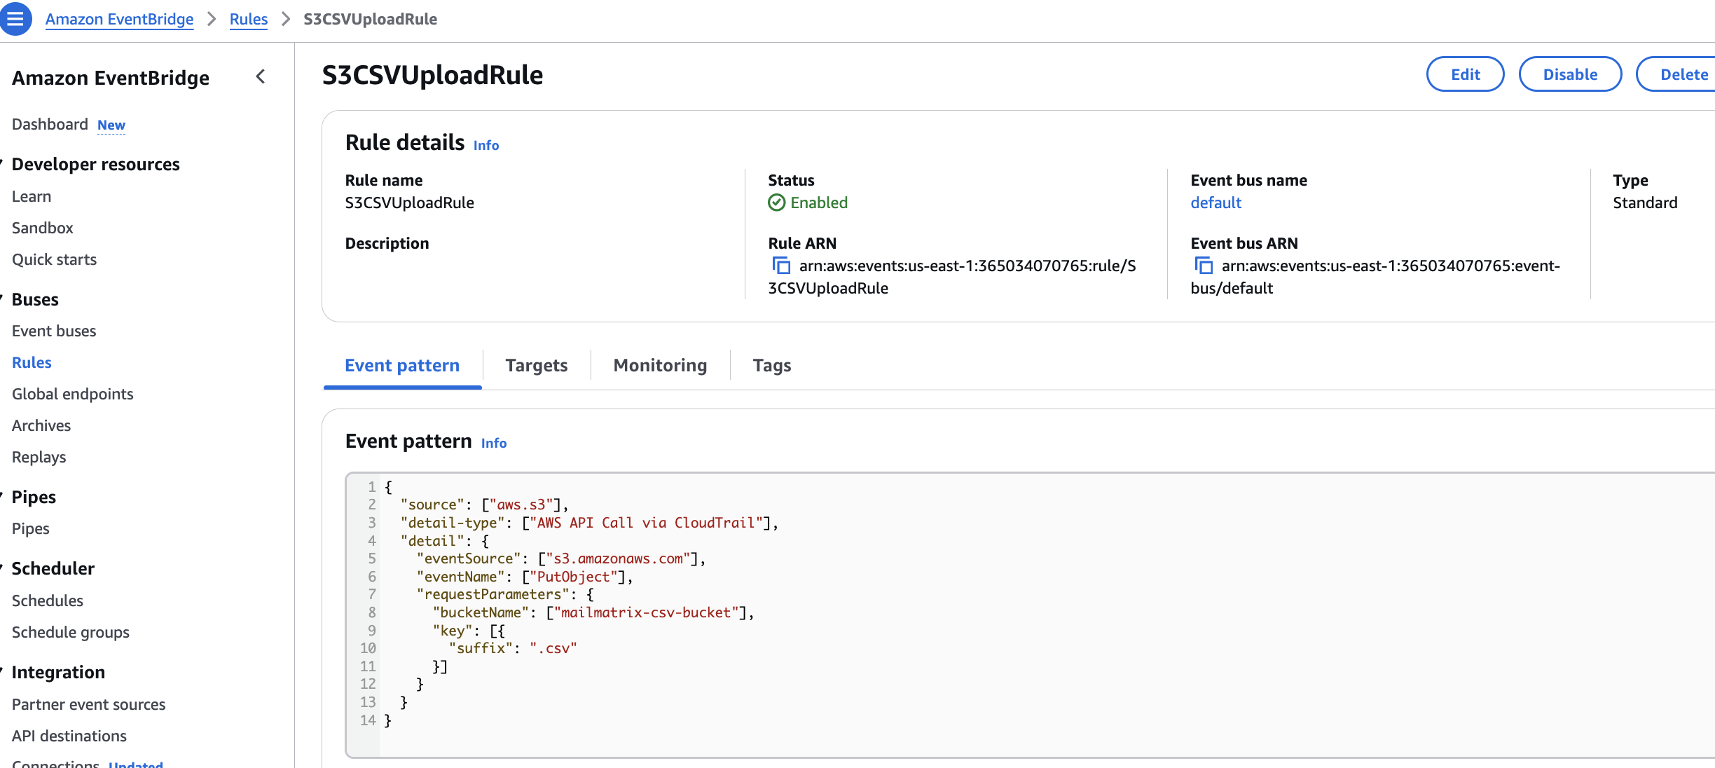
4.7. Configure Amazon CloudWatch for Monitoring
Amazon CloudWatch was configured to monitor the execution of Lambda functions and track logs for any processing issues.
Purpose:
Used for logging, debugging, and monitoring Lambda executions.
Helps in real-time tracking of failures, logs every event processed by Lambda, and allows creating alerts based on error thresholds.
- Navigate to the CloudWatch Console.
- Under Logs, select Log groups.
- Find the log group for your Lambda function (e.g., /aws/lambda/send_email_function).
- View real-time logs for every Lambda invocation including any errors, such as missing fields, S3 issues, or email delivery problems.
CloudWatch allowed us to track errors, monitor function performance, and debug issues effectively throughout development and testing.
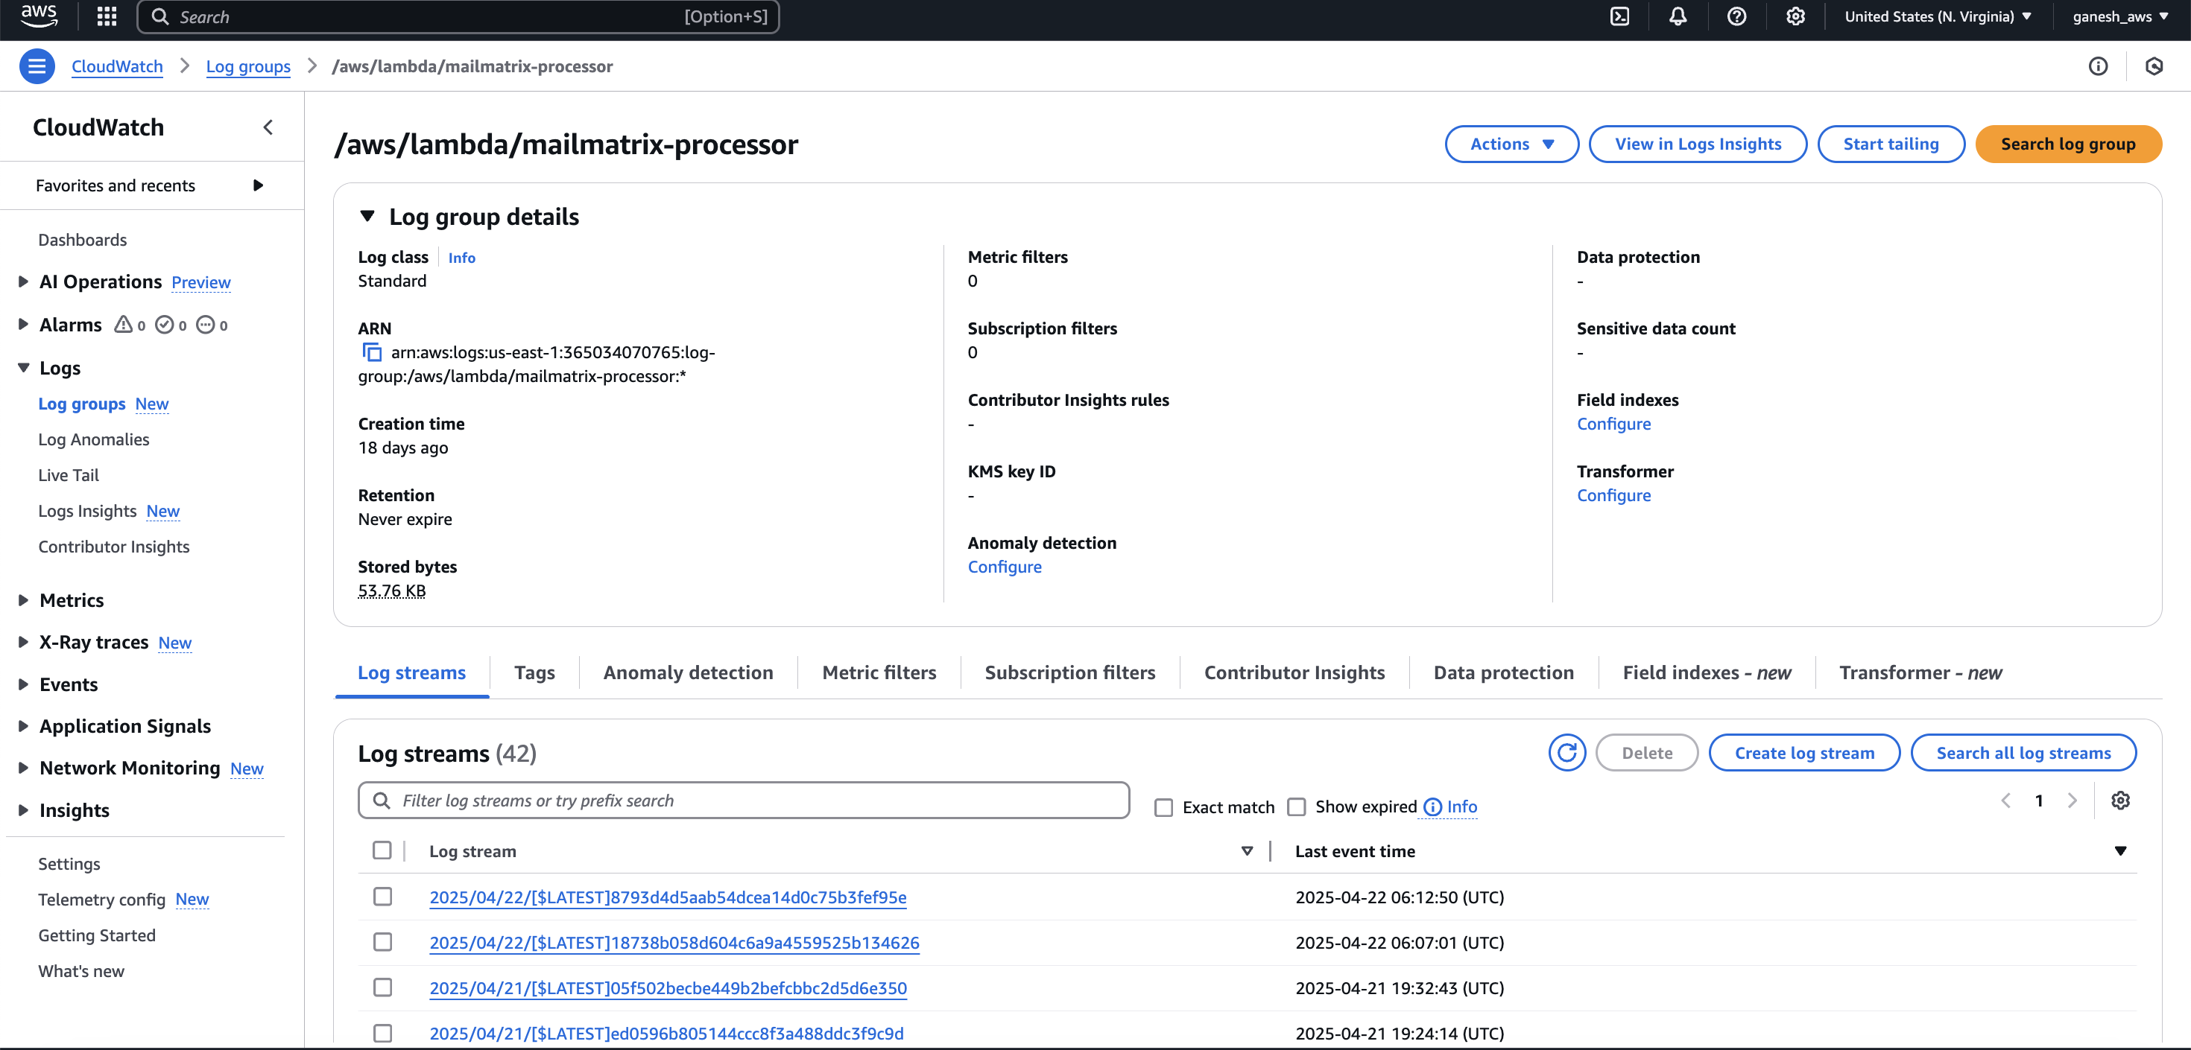

4.8. AWS IAM (Identity and Access Management)
A default AWS IAM execution role is attached to the Lambda function, ensuring it can read/write to S3, fetch RDS data, and send emails via SES without exposing credentials
Purpose:
Provides secure and scoped permissions for Lambda to access S3, SES, and RDS.
1.Navigate to Lambda Console
- Go to AWS Lambda Console.
- Open your MailMatrix Lambda function.
2.Attach Default Execution Role
- Under the “Configuration” tab → go to “Permissions”.
- If no role is attached, click “Edit” and assign a new Execution Role or select an existing role (we created one called mailmatrix-processor-role).
3.Permissions Required
Ensure the role has the following policies attached:
- ✅ AmazonS3ReadOnlyAccess → to download recipient CSVs and offer letters.
- ✅ AmazonSESFullAccess → to send emails via SES.
- ✅ AmazonRDSFullAccess or a scoped policy to connect to the MailMatrix RDS MySQL instance
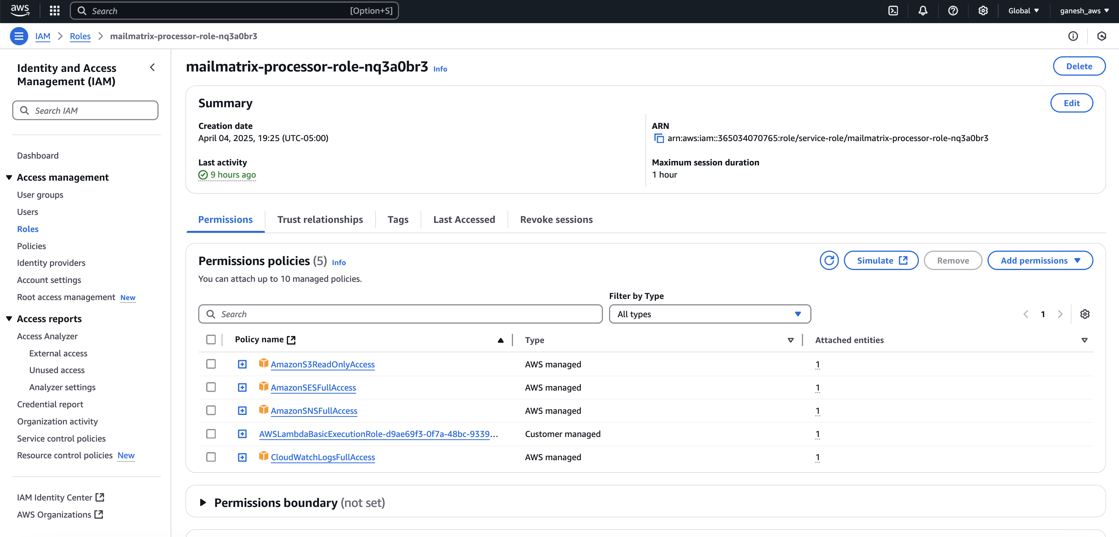

5. 🌟 Features
- Responsive login and upload interface with pastel theme
- File validation and S3 upload with status feedback
- Organization-aware email personalization
- Attachment support via Lambda & SES
- User-specific upload history
- Secure password hashing
- Modular architecture with RDS + S3 + Lambda decoupling

6. ✅ Testing & Results
- Uploaded CSV with a few recipients
- All recipients received appropriate emails
- Offer letters were correctly attached for selected recipients
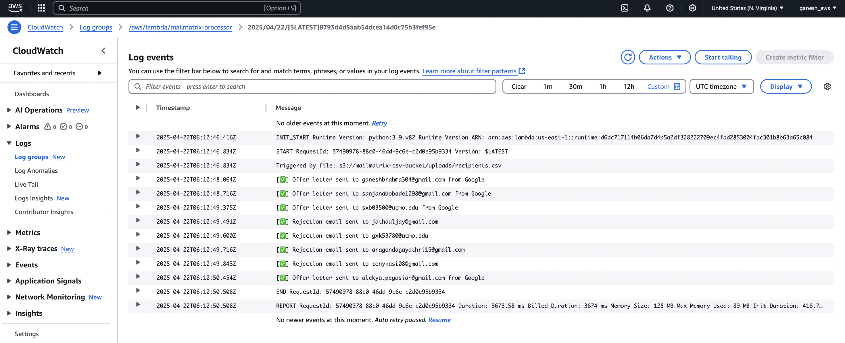
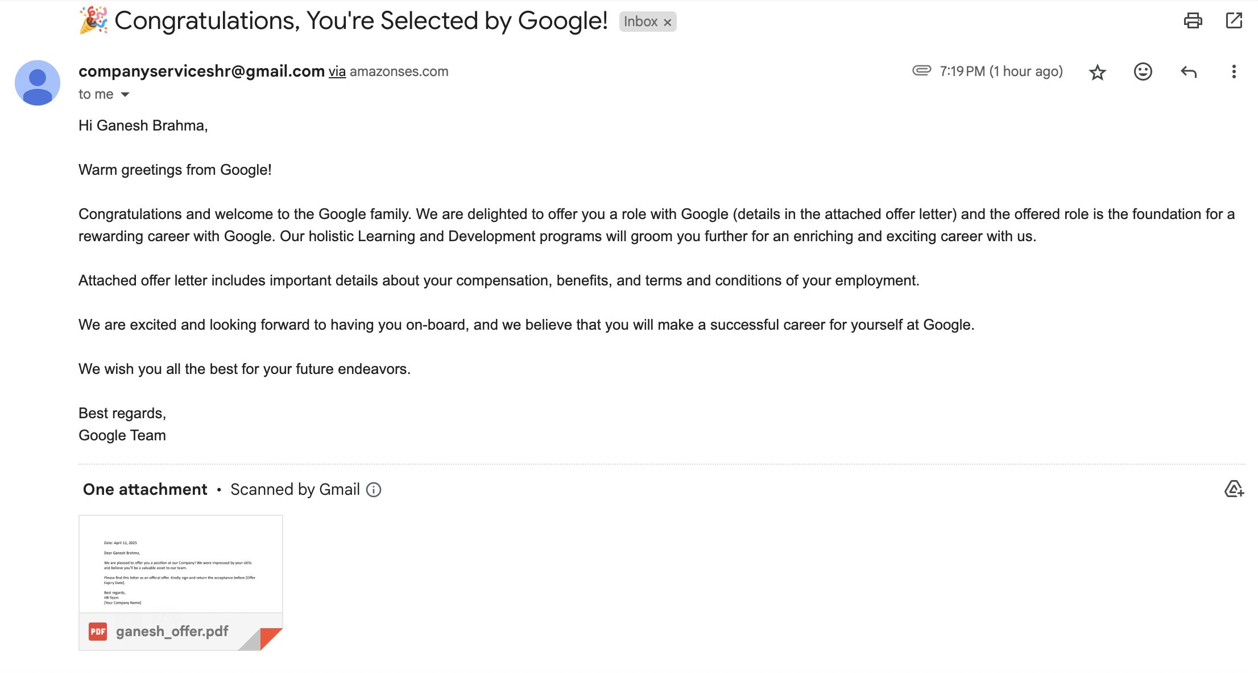

- Rejection emails were correctly sent for rejected recipients
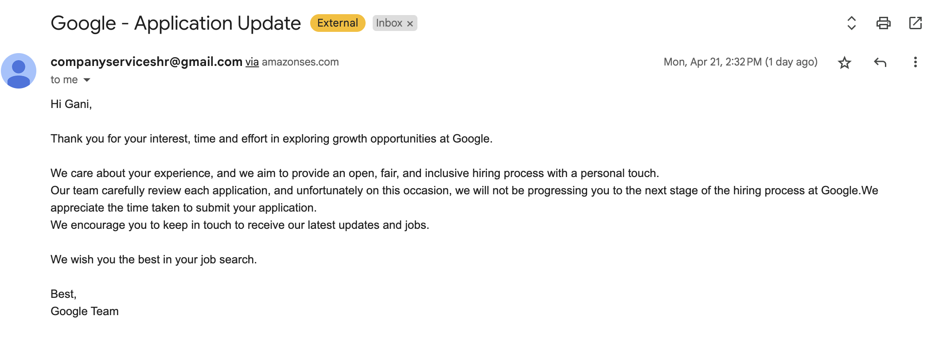

7. 🐛 Challenges & Solutions
Challenge | Solution
Lambda layer missing pymysql | Created and attached Lambda Layer
S3 folder misnaming issue | Reverted to uploads/<useremail>_recipients.csv structure
Password hash mismatch | Used bcrypt with proper decoding
UI alignment & responsiveness | Used centralized CSS theme

8. 🚀 Future Enhancements
- Email tracking (open/click logs)
- Role-based access (admin vs HR)
- Drag and drop file upload
- Customizable HTML email templates
- Dashboard analytics for bulk mail metrics

9. 🏁 Conclusion
MailMatrix is a scalable, serverless bulk mail automation tool that demonstrates the power of AWS integrations. It eliminates manual emailing, reduces HR workload, and improves professionalism in candidate communication. With simple enhancements, it is deployable for real-world use.

