**HEALTHCARE PLATFORM: HEALTHY BUFFS**

**Team Members:** Payoj Jain, Rahul Chowdhury, Ganesh Chandra Satish

**Title of the Project:** HealthyBuffs

**Vision:** We are building a platform for CU members to search for doctors, pharmacies, pathologies etc. easily. This product helps people to book appointment instantly and look for medicine availability in nearby pharmacies. People can also consult doctors online anonymously by asking over the platform and get experts' answers.

**Project Description:** HealthyBuffs is a healthcare management platform exclusively for students, faculties and other members of CU Boulder where people can locate doctors, pharmacists, pathologists, consultants and book appointments. This platform can also be used for looking up medicines availability in pharmacies. The portal also manages medical records/history of each patient so that it is easier for doctors to make their diagnosis and pharmacists can suggest medicines to patients.

**Previous Class Diagram:**

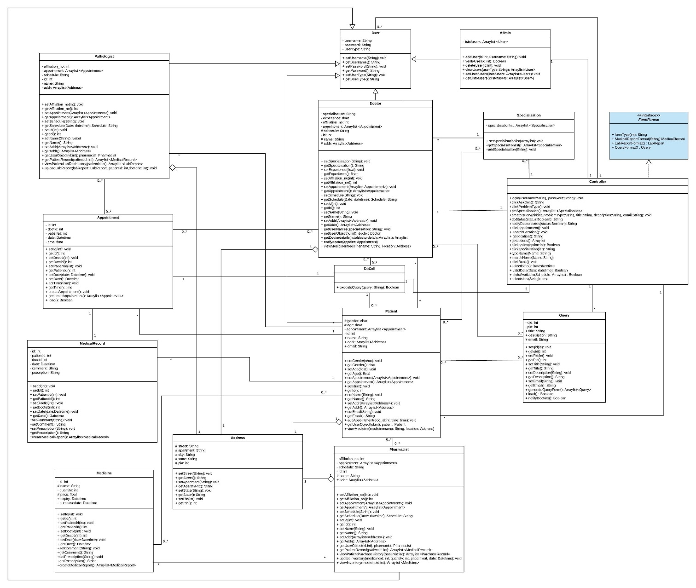

**Completed Class Diagram:**

