Nested function in python?

Declared using semicolons(;) :
flag = 2; ropes = 3; pole = 4
s = 1 + 2 + 3 + \
4 + 5 + 6 + \
7 + 8 + 9
print("Please select operation -\n" \
"1. Add\n" \
"2. Subtract\n" \
"3. Multiply\n" \
"4. Divide\n")

val = input("Enter your value: ")
val = int/float(input("Enter your value: "))
x, y = input("Enter a two value: ").split('@')
x, y = input("Enter a two value: ").split() or .split(‘ ‘) space seperator
///x, y = input("Enter a two value: ").split('') ValueError: empty separator
# taking two input at a time
x, y = [int(x) for x in input("Enter two value: ").split()]

# code for disabling the softspace feature
print('G', 'F', 'G', sep ='')
GFG
# code for disabling the softspace feature
print('G', 'F', 'G', sep ='@')
G@F@G
print('09','12','2016', sep='-')

a, b = 1, 3
print("Geeks\\tForGeeks")
print("Geeks\tForGeeks")

print("geeks", end =" ")
print("geeksforgeeks")

Not or and True False None , is ,is not , in ,not in,global,lambda
if __name__=="__main__":
x=list(range(1, 10,2))
7
print("list=%s,int=%d,float=%.2f, tuple=%s,dict=%s set=%s"%(x,10,10.254,(1,2,3),{'a':1},{1,2,3}))
8

Packing and Unpacking Arguments in Python
We use two operators * (for tuples) and ** (for dictionaries).
Packing
When we don’t know how many arguments need to be passed to a python function, we can use Packing to pack all arguments in a tuple.
# unknown number of arguments
def mySum(*args):
sum = 0
for i in range(0, len(args)):
sum = sum + args[i]
return sum

# Driver code
print(mySum(1, 2, 3, 4, 5))
print(mySum(10, 20))
Unpacking
We can use * to unpack the list so that all elements of it can be passed as different parameters.
def fun(a, b, c, d):
print(a, b, c, d)

# Driver Code
my_list = [1, 2, 3, 4]

# Unpacking list into four arguments
fun(*my_list)

** is used for dictionaries

def fun(a, b, c):
print(a, b, c)

# A call with unpacking of dictionary
d = {'a':2, 'b':4, 'c':10}
fun(**d)

# A Python program to demonstrate packing of
# dictionary items using **
def fun(**kwargs):

# kwargs is a dict
print(type(kwargs))

# Printing dictionary items
for key in kwargs:
print("%s = %s" % (key, kwargs[key]))

# Driver code
fun(name="geeks", ID="101", language="Python")

Any & All in Python
Any-
Returns true if any of the items is True. It returns False if empty or all are false.
print (any([3==3, False, False, False]))

# Python | a += b is not always a = a + b
list1 = [5, 4, 3, 2, 1]
list2 = list1
list1 += [1, 2, 3, 4]

print(list1)
print(list2)

[5, 4, 3, 2, 1, 1, 2, 3, 4]
[5, 4, 3, 2, 1, 1, 2, 3, 4]

list1 = [5, 4, 3, 2, 1]
list2 = list1
list1 = list1 + [1, 2, 3, 4]

# Contents of list1 are same as above
# program, but contents of list2 are
# different.
print(list1)
print(list2)
[5, 4, 3, 2, 1, 1, 2, 3, 4]
[5, 4, 3, 2, 1]
- expression list1 += [1, 2, 3, 4] modifies the list in-place, means it extends the list such that “list1” and “list2” still have the reference to the same list.
- expression list1 = list1 + [1, 2, 3, 4] creates a new list and changes “list1” reference to that new list and “list2” still refer to the old list.

////////////////////////////////////////////////////////////////////////////////////////////////////////////////////
1. int(a,base) : This function converts any data type to integer. ‘Base’ specifies thebase in which string is if data type is string.
2. float() : This function is used to convert any data type to a floating point number
3. ord() : This function is used to convert a character to integer.
4. hex() : This function is to convert integer to hexadecimal string.
5. oct() : This function is to convert integer to octal string.
6. tuple() : This function is used to convert to a tuple.
7. set() : This function returns the type after converting to set.
8. list() : This function is used to convert any data type to a list type.
9. dict() : This function is used to convert a tuple of order (key,value) into a dictionary.
10. str() : Used to convert integer into a string.
11. complex(real,imag) : : This function converts real numbers to complex(real,imag) number.
# Examples of Bitwise operators
a = 10
b = 4

# Print bitwise AND operation
print(a & b)

# Print bitwise OR operation
print(a | b)

# Print bitwise NOT operation
print(~a)

# print bitwise XOR operation
print(a ^ b)

# print bitwise right shift operation
print(a >> 2)

# print bitwise left shift operation
print(a << 2)

///////////////////////////////////////////////////////////////////////////////////////////////////////////////////////
print("\nDictionary Iteration")
d = dict()
d['xyz'] = 123
d['abc'] = 345
for i in d :
print("%s %d" %(i, d[i]))
Dictionary Iteration
xyz 123
abc 345

In Python, to write empty functions, we use pass statement. pass is a special statement in Python that does nothing. It only works as a dummy statement.

Python has five standard data types −
- Numbers
- String
- List
- Tuple
- Dictionary
- set

Python Numbers
Number data types store numeric values. Number objects are created when you assign a value to them.
Python supports four different numerical types −
- int (signed integers)
- long (long integers, they can also be represented in octal and hexadecimal)
- float (floating point real values)
- complex (complex numbers)
- A complex number consists of an ordered pair of real floating-point numbers denoted by x + yj, where x and y are the real numbers and j is the imaginary unit.

Data Type Conversion

Sr.No. | Function & Description
1 | int(x), long(x),float(x)  Converts x to an integer. base specifies the base if x is a string
4 | complex(real [,imag])  Creates a complex number.
5 | str(x)  Converts object x to a string representation.
6 | repr(x)  Converts object x to an expression string.
7 | eval(str)  Evaluates a string and returns an object.
8 | tuple(s),list(s),set(s)  Converts s to a tuple.
11 | dict(d)  Creates a dictionary. d must be a sequence of (key,value) tuples.
12 | frozenset(s)  Converts s to a frozen set.
13 | chr(x)  Converts an integer to a character.
14 | unichr(x)  Converts an integer to a Unicode character.
15 | ord(x)  Converts a single character to its integer value.
16 | hex(x)  Converts an integer to a hexadecimal string.
17 | oct(x)  Converts an integer to an octal string.

%= Modulus AND | It takes modulus using two operands and assign the result to left operand | c %= a is equivalent to c = c % a
**= Exponent AND | Performs exponential (power) calculation on operators and assign value to the left operand | c **= a is equivalent to c = c ** a
//= Floor Division | It performs floor division on operators and assign value to the left operand | c //= a is equivalent to c = c // a

* you can have an if...elif...else:
For loop:
for letter in 'Python': # First Example
print 'Current Letter :', letter

fruits = ['banana', 'apple', 'mango']
for fruit in fruits: # Second Example
print 'Current fruit :', fruit

Python - Numbers

Mathematical Functions
Python includes following functions that perform mathematical calculations.
import math
math.log( x )

Sr.No. | Function & Returns ( description )
1 | abs(x) The absolute value of x: the (positive) distance between x and zero.
2 | ceil(x) The ceiling of x: the smallest integer not less than x
3 | cmp(x, y) -1 if x < y, 0 if x == y, or 1 if x > y
4 | exp(x) The exponential of x: ex
5 | fabs(x) The absolute value of x.
6 | floor(x) The floor of x: the largest integer not greater than x
7 | log(x) The natural logarithm of x, for x> 0
8 | log10(x) The base-10 logarithm of x for x> 0.
9 | max(x1, x2,...) The largest of its arguments: the value closest to positive infinity
10 | min(x1, x2,...) The smallest of its arguments: the value closest to negative infinity
11 | modf(x) The fractional and integer parts of x in a two-item tuple. Both parts have the same sign as x. The integer part is returned as a float.
12 | pow(x, y) The value of x**y.
13 | round(x [,n]) x rounded to n digits from the decimal point. Python rounds away from zero as a tie-breaker: round(0.5) is 1.0 and round(-0.5) is -1.0.
14 | sqrt(x) The square root of x for x > 0

1. trunc() :- This function is used to eliminate all decimal part of the floating point number and return the integer without the decimal part.
2. ceil() :- This function is used to print the least integer greater than the given number.
3. floor() :- This function is used to print the greatest integer smaller than the given integer.
import math

# initializing value
a = 3.4536

# using trunc() to print integer after truncating
print ("The integral value of number is : ",end="")
print (math.trunc(a))

# using ceil() to print number after ceiling
print ("The smallest integer greater than number is : ",end="")
print (math.ceil(a))

# using floor() to print number after flooring
print ("The greatest integer smaller than number is : ",end="")
print (math.floor(a))

The integral value of number is : 3
The smallest integer greater than number is : 4
The greatest integer smaller than number is : 3

Random Number Functions
Random numbers are used for games, simulations, testing, security, and privacy applications. Python includes following functions that are commonly used.
Sr.No. | Function & Description
1 | choice(seq) A random item from a list, tuple, or string.
2 | randrange ([start,] stop [,step]) A randomly selected element from range(start, stop, step)
3 | random() A random float r, such that 0 is less than or equal to r and r is less than 1
4 | seed([x]) sets the integer starting value used in generating random numbers. Call this function before calling any other random module function. Returns None.
5 | shuffle(lst) randomizes the items of a list in place. Returns None.
6 | uniform(x, y) A random float r, such that x is less than or equal to r and r is less than y

Trigonometric Functions
Python includes following functions that perform trigonometric calculations.
Sr.No. | Function & Description
1 | acos(x) Return the arc cosine of x, in radians.
2 | asin(x) Return the arc sine of x, in radians.
3 | atan(x) Return the arc tangent of x, in radians.
4 | atan2(y, x) Return atan(y / x), in radians.
5 | cos(x) Return the cosine of x radians.
6 | hypot(x, y) Return the Euclidean norm, sqrt(x*x + y*y).
7 | sin(x) Return the sine of x radians.
8 | tan(x) Return the tangent of x radians.
9 | degrees(x) Converts angle x from radians to degrees.
10 | radians(x) Converts angle x from degrees to radians.

Mathematical Constants
The module also defines two mathematical constants −
Sr.No. | Constants & Description
1 | pi The mathematical constant pi.
2 | e The mathematical constant e.

Python - Strings

Operator | Description | Example
+ | Concatenation - Adds values on either side of the operator | a + b will give HelloPython
* | Repetition - Creates new strings, concatenating multiple copies of the same string | a*2 will give -HelloHello

Built-in String Methods
Python includes the following built-in methods to manipulate strings −
Sr.No. | Methods with Description
1 | capitalize() Capitalizes first letter of string
2 | center(width, fillchar) Returns a space-padded string with the original string centered to a total of width columns.
3 | count(str, beg= 0,end=len(string)) Counts how many times str occurs in string or in a substring of string if starting index beg and ending index end are given.
4 | decode(encoding='UTF-8',errors='strict') Decodes the string using the codec registered for encoding. encoding defaults to the default string encoding.
5 | encode(encoding='UTF-8',errors='strict') Returns encoded string version of string; on error, default is to raise a ValueError unless errors is given with 'ignore' or 'replace'.
6 | endswith(suffix, beg=0, end=len(string)) Determines if string or a substring of string (if starting index beg and ending index end are given) ends with suffix; returns true if so and false otherwise.
7 | expandtabs(tabsize=8) Expands tabs in string to multiple spaces; defaults to 8 spaces per tab if tabsize not provided.
8 | find(str, beg=0 end=len(string)) Determine if str occurs in string or in a substring of string if starting index beg and ending index end are given returns index if found and -1 otherwise.
9 | index(str, beg=0, end=len(string)) Same as find(), but raises an exception if str not found.
10 | isalnum() Returns true if string has at least 1 character and all characters are alphanumeric and false otherwise.
11 | isalpha() Returns true if string has at least 1 character and all characters are alphabetic and false otherwise.
12 | isdigit() Returns true if string contains only digits and false otherwise.
13 | islower() Returns true if string has at least 1 cased character and all cased characters are in lowercase and false otherwise.
14 | isnumeric() Returns true if a unicode string contains only numeric characters and false otherwise.
15 | isspace() Returns true if string contains only whitespace characters and false otherwise.
16 | istitle() Returns true if string is properly "titlecased" and false otherwise.
17 | isupper() Returns true if string has at least one cased character and all cased characters are in uppercase and false otherwise.
18 | join(seq) Merges (concatenates) the string representations of elements in sequence seq into a string, with separator string.
19 | len(string) Returns the length of the string
20 | ljust(width[, fillchar]) Returns a space-padded string with the original string left-justified to a total of width columns.
21 | lower() Converts all uppercase letters in string to lowercase.
22 | lstrip() Removes all leading whitespace in string.
23 | maketrans() Returns a translation table to be used in translate function.
24 | max(str) Returns the max alphabetical character from the string str.
25 | min(str) Returns the min alphabetical character from the string str.
26 | replace(old, new [, max]) Replaces all occurrences of old in string with new or at most max occurrences if max given.
27 | rfind(str, beg=0,end=len(string)) Same as find(), but search backwards in string.
28 | rindex( str, beg=0, end=len(string)) Same as index(), but search backwards in string.
29 | rjust(width,[, fillchar]) Returns a space-padded string with the original string right-justified to a total of width columns.
30 | rstrip() Removes all trailing whitespace of string.
31 | split(str="", num=string.count(str)) Splits string according to delimiter str (space if not provided) and returns list of substrings; split into at most num substrings if given.
32 | splitlines( num=string.count('\n')) Splits string at all (or num) NEWLINEs and returns a list of each line with NEWLINEs removed.
33 | startswith(str, beg=0,end=len(string)) Determines if string or a substring of string (if starting index beg and ending index end are given) starts with substring str; returns true if so and false otherwise.
34 | strip([chars]) Performs both lstrip() and rstrip() on string.
35 | swapcase() Inverts case for all letters in string.
36 | title() Returns "titlecased" version of string, that is, all words begin with uppercase and the rest are lowercase.
37 | translate(table, deletechars="") Translates string according to translation table str(256 chars), removing those in the del string.
38 | upper() Converts lowercase letters in string to uppercase.
39 | zfill (width) Returns original string leftpadded with zeros to a total of width characters; intended for numbers, zfill() retains any sign given (less one zero).
40 | isdecimal() Returns true if a unicode string contains only decimal characters and false otherwise.

Python – Lists

List = ["Geeks", "For", "Geeks"]
print(*List)
x=list(range(1, 10,2))
print(x)

Python Lists Zip and Unzip
Consider you want to make pair of elements of different lists. Use Zip to make pairs
>>> list1 = ['a','b','c']
>>> list2 = [1,2,3]

>>> z = zip(list1,list2)
>>> z
[('a', 1), ('b', 2), ('c', 3)]
You can see the pairs Lets unzip it.
>>> zip(*z)
[('a', 'b', 'c'), (1, 2, 3)]
Lets zip two Python lists with different length.
>>> list3 = ['x','y']
>>> z = zip(list1, list3)
>>> z
[('a', 'x'), ('b', 'y')]

List Comprehension Work In Python
you only want to multiply the numbers that can be divided by 2. Even this is easy with the help of list comprehension:
[x**2 for x in range(10) if x%2==0]
myList = [(1,2), (2,2), (3,4), (4,4),( 5,6), (6,7), (7,8) ,(8,9),( 9, 10)]
[(y,x) for x,y in myList if y==x]
>>Out[1]: [(2, 2), (4, 4)]
list= ["a","b","b"]
y=[(x,list.count(x)) for x in set(list)]
print("y=",y)
dict(y)
>>y= [['b', 2], ['a', 1]]
>>Out[1]: {'a': 1, 'b': 2}

myList = [3,4,5,6]
# Loop over `myList` and print tuples of all indices and values
for i, val in enumerate(myList):
print(i, val)
>>0 3
1 4
2 5
3 6
or
for i, val in enumerate(myList):
print((i, val),end=',')
>>(0, 3),(1, 4),(2, 5),(3, 6),

# Your initial list of lists
list = [[1,2],[3,4],[5,6]]

# Flatten out your original list of lists with `sum()`
sum(list, [])
>>Out[1]: [1, 2, 3, 4, 5, 6]
The zip function takes length of shortest list.

Built-in List Functions & Methods
Python includes the following list functions −
Sr.No. | Function with Description
1 | cmp(list1, list2) Compares elements of both lists.
2 | len(list) Gives the total length of the list.
3 | max(list) Returns item from the list with max value.
4 | min(list) Returns item from the list with min value.
5 | list(seq) Converts a tuple into list.

FUNCTION | DESCRIPTION
round() | Rounds off to the given number of digits and returns the floating point number
reduce() | apply a particular function passed in its argument to all of the list elements stores the intermediate result and only returns the final summation value
sum() | Sums up the numbers in the list
ord() | Returns an integer representing the Unicode code point of the given Unicode character
cmp() | This function returns 1, if first list is “greater” than second list
sorted()
all() | Returns true if all element are true or if list is empty
any() | return true if any element of the list is true. if list is empty, return false

enumerate() | Returns enumerate object of list
accumulate() | apply a particular function passed in its argument to all of the list elements returns a list containing the intermediate results
filter() | tests if each element of a list true or not
map() | returns a list of the results after applying the given function to each item of a given iterable
lambda() | This function can have any number of arguments but only one expression, which is evaluated and returned.

Python includes following list methods
Sr.No. | Methods with Description
1 | list.append(obj) Appends object obj to list
2 | list.count(obj) Returns count of how many times obj occurs in list
3 | list.extend(seq) Appends the contents of seq to list
4 | list.index(obj) Returns the lowest index in list that obj appears
5 | list.insert(index, obj) Inserts object obj into list at offset index
6 | list.pop(obj=list[-1]) Removes and returns last object or obj from list
7 | list.remove(obj) Removes object obj from list
8 | list.reverse() Reverses objects of list in place
9 | list.sort([func]) Sorts objects of list, use compare func if given

Python - Tuples

Python - Dictionary
Keys are unique within a dictionary while values may not be. The values of a dictionary can be of any type, but the keys must be of an immutable data type such as strings, numbers, or tuples.
dict = {'Name': 'Zara', 'Age': 7, 'Class': 'First'}
print "dict['Name']: ", dict['Name']
print "dict['Age']: ", dict['Age']

dictionary comprehension-
keys = {'a', 'e', 'i', 'o', 'u' }
value = [1]

vowels = { key : list(value) for key in keys }
# you can also use { key : value[:] for key in keys }
print(vowels)
>>{'a': [1], 'u': [1], 'o': [1], 'e': [1], 'i': [1]}

Dict = {1: 'Geeks', 'name': ['For',['ganesh',23],'singh'], 3: 'Geeks'}

# accessing a element using key
print("Acessing a element using key:")
print(Dict['name'][1][1])
>>23

Dict = {1: 'Geeks', 2: 'For',
3:{'A' : 'Welcome', 'B' : 'To', 'C' : 'Geeks'}}

print(Dict[3]['A'][0])
>>W

Built-in Dictionary Functions & Methods
Python includes the following dictionary functions −
Sr.No. | Function with Description
1 | cmp(dict1, dict2) Compares elements of both dict.
2 | len(dict) Gives the total length of the dictionary. This would be equal to the number of items in the dictionary.
3 | str(dict) Produces a printable string representation of a dictionary
4 | type(variable) Returns the type of the passed variable. If passed variable is dictionary, then it would return a dictionary type.

Python includes following dictionary methods −
Sr.No. | Methods with Description
1 | dict.clear() Removes all elements of dictionary dict
2 | dict.copy() Returns a shallow copy of dictionary dict
3 | dict.fromkeys() Create a new dictionary with keys from seq and values set to value.
4 | dict.get(key, default=None) For key key, returns value or default if key not in dictionary
5 | dict.has_key(key) Returns true if key in dictionary dict, false otherwise
6 | dict.items() Returns a list of dict's (key, value) tuple pairs
7 | dict.keys() Returns list of dictionary dict's keys
8 | dict.setdefault(key, default=None) Similar to get(), but will set dict[key]=default if key is not already in dict
9 | dict.update(dict2) Adds dictionary dict2's key-values pairs to dict
10 | dict.values() Returns list of dictionary dict's values

SET-
>> myset = {1, 2} # Directly assigning values to a set
>> myset = set() # Initializing a set
>> myset = set(['a', 'b']) # Creating a set from a list
>> myset
{'a', 'b'}

MODIFYING SETS
Using the add() function:
>> myset.add('c')
>> myset
{'a', 'c', 'b'}
>> myset.add('a') # As 'a' already exists in the set, nothing happens
>> myset.add((5, 4))
>> myset
{'a', 'c', 'b', (5, 4)}
Using the update() function:
>> myset.update([1, 2, 3, 4]) # update() only works for iterable objects
>> myset
{'a', 1, 'c', 'b', 4, 2, (5, 4), 3}
>> myset.update({1, 7, 8})
>> myset
{'a', 1, 'c', 'b', 4, 7, 8, 2, (5, 4), 3}
>> myset.update({1, 6}, [5, 13])
>> myset
{'a', 1, 'c', 'b', 4, 5, 6, 7, 8, 2, (5, 4), 13, 3}
REMOVING ITEMS
Both the discard() and remove() functions take a single value as an argument and removes that value from the set. If that value is not present, discard() does nothing, but remove() will raise a KeyError exception.
>> myset.discard(10)
>> myset
{'a', 1, 'c', 'b', 4, 5, 7, 8, 2, 12, (5, 4), 13, 11, 3}
>> myset.remove(13)
>> myset
{'a', 1, 'c', 'b', 4, 5, 7, 8, 2, 12, (5, 4), 11, 3}

COMMON SET OPERATIONS Using union(), intersection() and difference() functions.
>> a = {2, 4, 5, 9}
>> b = {2, 4, 11, 12}
>> a.union(b) # Values which exist in a or b
{2, 4, 5, 9, 11, 12}
>> a.intersection(b) # Values which exist in a and b
{2, 4}
>> a.difference(b) # Values which exist in a but not in b
{9, 5}
The union() and intersection() functions are symmetric methods:
>> a.union(b) == b.union(a)
True
>> a.intersection(b) == b.intersection(a)
True
>> a.difference(b) == b.difference(a)
False

If we want to add a single element to an existing set, we can use the .add() operation.

.remove(x)
This operation removes element
from the set.
If element
does not exist, it raises a KeyError.
The .remove(x) operation returns None.
Example
>>> s = set([1, 2, 3, 4, 5, 6, 7, 8, 9])
>>> s.remove(5)
>>> print s
set([1, 2, 3, 4, 6, 7, 8, 9])
>>> print s.remove(4)
None
>>> print s
set([1, 2, 3, 6, 7, 8, 9])
>>> s.remove(0)
KeyError: 0

.discard(x)
This operation also removes element
from the set.
If element
does not exist, it does not raise a KeyError.
The .discard(x) operation returns None.
Example
>>> s = set([1, 2, 3, 4, 5, 6, 7, 8, 9])
>>> s.discard(5)
>>> print s
set([1, 2, 3, 4, 6, 7, 8, 9])
>>> print s.discard(4)
None
>>> print s
set([1, 2, 3, 6, 7, 8, 9])
>>> s.discard(0)
>>> print s
set([1, 2, 3, 6, 7, 8, 9])

.pop()
This operation removes and return an arbitrary element from the set.
If there are no elements to remove, it raises a KeyError.
Example
>>> s = set([1])
>>> print s.pop()
1
>>> print s
set([])
>>> print s.pop()
KeyError: pop from an empty set
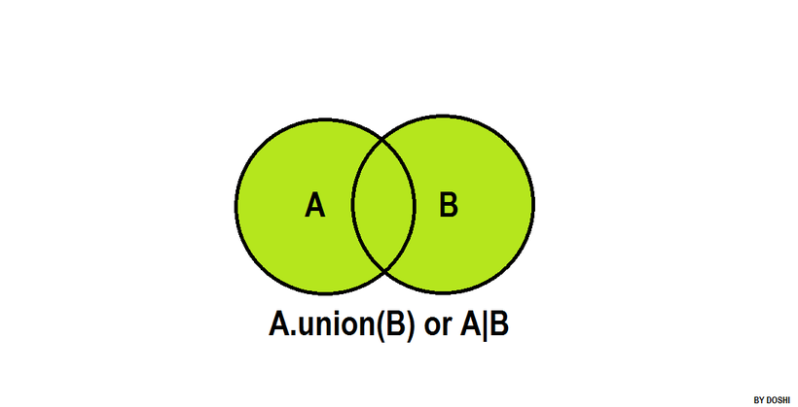
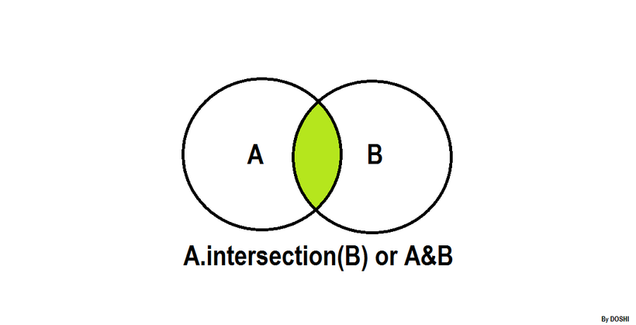

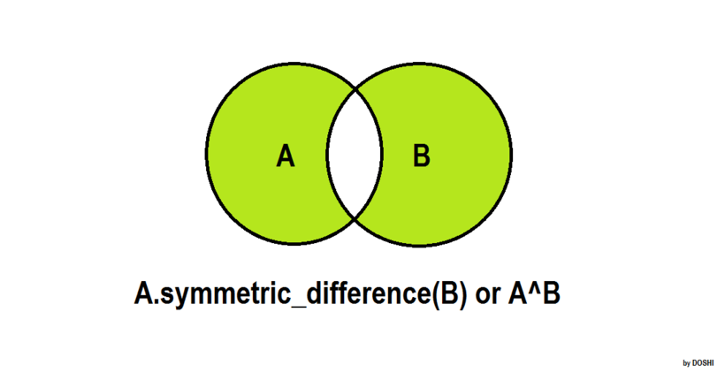
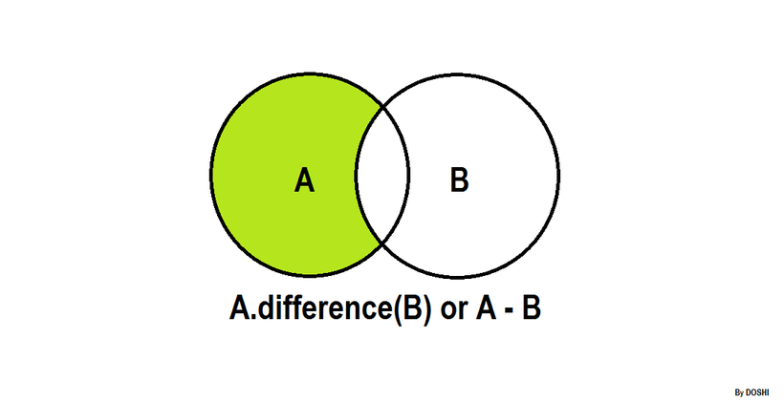

itertools
Enumerate:
Enumerate is built-in python function that takes input as iterator, list etc and returns a tuple containing index and data at that index in the iterator sequence. For example, enumerate(cars), returns a iterator that will return (0, cars[0]), (1, cars[1]), (2, cars[2]), and so on.

# demonstrating use of start in enumerate

cars = ["Aston" , "Audi", "McLaren "]
for x in enumerate(cars, start=1):
print (x[0], x[1])

(1, 'Aston')
(2, 'Audi')
(3, 'McLaren ')

