**LORA TECHNOLOGY BASED CONTROLLING AND MONITORING SMART HOUSE WITH IOT**

**A PROJECT REPORT**

***Submitted by***

**ARUNKUMAR.R [410318106003]**

**LOKESH VARMA.K [410318106012]**

**NAVEEN.S [410318106017]**

**GANESH DATTA.P [410318106020]**

#### *in partial fulfillment for the award of the degree*

#### *of*

#### BACHELOR OF ENGINEERING

**in**

**ELECTRONICS AND COMMUNICATION ENGINEERING**

**ARM COLLEGE OF ENGINEERING AND TECHNOLOGY**

**ANNA UNIVERSITY: CHENNAI 600 025**

JUNE 2022

**ANNA UNIVERSITY : CHENNAI 600 025**

**BONAFIDE CERTIFICATE**

Certified that this project report “**LORA TECHNOLOGY BASED CONTROLLING AND MONITORING SMART HOUSE WITH IOT**” Is

the Bonafide work of **Mr. ARUNKUMAR.R [410318106003], Mr. LOKESH VARMA.K[410318106012],Mr NAVEEN S [410318106017]&Mr.GANESH DATTA.P [410318106020]** who carried out the project under my supervisor.

## 

## SIGNATURE SIGNATURE

## Mr.G.SELVA KUMARAN Mr.G.SELVA KUMARAN

## HEAD OF THE DEPARTMENT SUPERVISOR

Department of Electronics and Department of Electronics and

Communication Engineering Communication Engineering

ARM College of engineering ARM College of engineering

and Technology, and Technology,

Maraimalai Nagar, Maraimalai Nagar,

Chennai **-** 603209. Chennai ­**–­­** 603209.

Submitted for Viva Voice Examination held on ____________

**Internal Examiner External Examiner**

**ABSTRACT**

The home and Society are surrounded by "things" which are connected to each other, either directly or indirectly via the internet of things. To have access to controlling these devices remotely with precision within the network when required is a key factor in the process of home automation. There are numerous aspects in this automation that needs to be developed so as to enhance it. This research gives a solution to having a precise and direct control and automatic detection of current state of devices with the use of android application. It also gives a practical implementation of home automation using LoRa in comparison to other technologies**.**

**ACKNOWLEDGEMENT**

I take this opportunity to place on record my heartfelt thanks to our honourable Founder **Dr. S.ARUNACHALAM**, B.E., M.Sc., Ph.D., M.I.E., M.I.U.U.A., M.I.S.T.E. and the chairman **Dr. A. GANESH KUMAR**, M.E., (Ph.D.)., ARM College of Engineering and Technology for being a part of my learning process and for constantly striving to enhance the standard of education in our college.

I wish to express my thanks to our beloved Principal **Dr.N.RAMADOSS**, M.E., M.TECH., Ph.D., for his motivation and moral support towards me to complete this project.

I would like to thank **Mr. G. SELVA KUMARAN**, M.E., Head of the Department; Department of Electronics and communication Engineering for offering his constant support and encouragement that was instrumental in the successful completion of the project.

I am also thankful to **Mr. G. SELVA KUMARAN**, M.E., Department of Electronics and communication Engineering my project supervisor, for giving me valuable suggestion to make this project successful.

I am also thankful to all the teaching and non-teaching staffs, friends who have given me great moral support in the completion of my project.

|  |  |  |
| --- | --- | --- |
| **CHAPTER**  **NO.** | **TITLE** | **PAGE NO.** |
| 1  2  3  4  5  6  **7** | ABSTRACT  ACKNOWLEDGEMENT  LIST OF TABLES  LIST OF FIGURES  LIST OF ABBREVATIONS  INTRODUCTION  LITERATURE SURVEY  PROJECT METHODOLOGY  3.1 INTRODUCTION  3.2 OBJECTIVE  3.3 EXSISTING SYSTEM  3.4 PROPOSED SYSTEM  3.5 BLOCK DIAGRAM  3.6 HARDWARE REQUIREMENTS  3.7 SOFTWARE REQUIREMENTS  3.8 METHODOLOGY  3.9 ADAPTIVE DATA RATE  HARDWARE DETAILS  4.1 ULTRA SONIC SENSOR  4.2 PASSIVE INFRARED SENSOR  4.3 FLAME SENSOR  4.4 LORA WIRELESS RF SERIAL LINK  4.5 LIQUID CRYSTAL DISPLAY  4.6 ARDUINO  4.7 NODE MCU ESP8266  SOFTWARE DETAILS  5.1 EMBEDDED C  5.2 ARDUINO SOFTWARE (IDE)  RESULT  DISCUSSION  CONCLUSION  REFERENCE | **iii**  **iv**  **vii**  **viii**  **ix**  1  3  8  8  9  10  10  11  13  13  13  14  16  16  18  23  26  29  31  35  38  38  42  45  47  49  50 |

**LIST OF FIGURES**

|  |  |  |
| --- | --- | --- |
| **CHAPTER**  **NO.** | **TITLE** | **PAGE NO.** |
| 3  4  6 | 3.1 BLOCK DIAGRAM TRANSMITTER SECTION  3.2 BLOCK DIAGRAM RECIEVER SECTION  4.1 ULTRA SONIC SENSOR  4.2 HC-SR04 ULTRA SONIC SENSOR PINOUT  4.3 WORKING OF PIR SENSOR  4.4 FLAME SENSOR  4.5 WIR-1286 MODULE  4.6 PIN DIAGRAM OF LCD  4.7 ATMEGA 328 MICRO CONTROLLER  4.8 NODE MCU  4.9 NODE MCU PINOUT  6.1 Various output from Blynk app  6.2 GSM output  6.3 Home section kit  6.4 Receiver section kit | 11  12  16  17  22  24  27  30  32  36  37  45  45  46  46 |

**LIST OF TABLES**

|  |  |  |
| --- | --- | --- |
| **CHAPTER NO.** | **TITLE** | **PAGE NO.** |
| 4 | 4.1 PIN CONFIGURATION | 30 |

**LIST OF ABBREVATIONS**

**LoRa** - Long range technology

**ESP** - Electronic stability program

**PIR** - Passive infrared

**LCD** - Liquid crystal display

**IDE**  - Integrated development environment

**VCC**  - Common collector voltage

**GND**  - Ground

**TxD** - Transmitter data

**RxD** - Receiver data

**CTS** - Current transformers

**ADR** - Adaptive data rate

**RF** - Radio frequency

**WAN**  - Wide area network

**ALHOA** - Random access protocol

**IOT** - Internet of things

**GSM**  - Global system for mobile communications

**CHAPTER 1**

**INTRODUCTION**

The current situation is such that people have to manually operate various kinds of appliances which at times are not workable for busy families and individuals with physical limitations. Also there is no effective means of controlling various accidents due to gas leakage, fire and burglary. Our system will provide proper notifications to users for such incidents and alert them through messages on their mobile phone. Smart home is a very promising area, which has various advantages such as providing increased comfort, safety and security to people. It is rational use of energy and other resources thus contributing to a purposeful savings in terms of time and more secure. Such system will be affordable, portable and compatible so that new devices can be easily integrated in to systems. The technology is easy to use and targeted for people without technical background. Theft has become major issue everywhere (societies, mall, shop etc).

Main purpose to build this project is to provide security at residential and commercial places in both time when we are away from place or we are at home. As everywhere we can see CCTV cameras have been installed for security purposes. But the CCTV cameras are capable of only recording and storing the data. A number of GSM based electronic security systems are available in markets, but these systems can only inform to owner about the theft, it can’t take and store the image of thief. Hence to overcome this disadvantage of existing system we are designing an electronic security system which can detect the presence of intruder, informs (call or sms) to owner about presence of intruder and takes picture of intruder.

We are using the PIR sensors and IR sensors which can detect the presence of intruder, when any human is detected by the PIR or IR sensors these sensors will change its output. This output is given to Arduino controller, which is the main building block of the system.

Depending on the output of the sensors it will perform actions which are given in the program. Then it will send the AT commands to GSM module to make call to a predefined number of the owner of shop or home and also sends command to camera to capture the image of intruder. Security systems are important features of a modern Home. The earliest home security systems date back to the early 1900's. These systems were generally expensive and very hard to monitor. In the past 100 years as technology has changed, home security systems have also changed. Early home security systems were very expensive and surprisingly ineffective.

The requirement for an efficient and cost-effective system to cater the disastrous situations and in order to fulfil the security concerns of home owners when the user is away from home, there was a strong need to develop a cost effective and reliable system to satisfy the security related needs of occupants. Home security has changed a great deal over the last century and will continue to do so as long as technology continues to progress. This paper mainly focuses on the controlling of home appliances remotely and providing security when the user is away from the place. The system is SMS based and uses wireless technology to revolutionize the standards of living. This system provides ideal solution to the problems faced by home owners in daily life. The system is wireless therefore more adaptable and cost-effective. The project is aimed at developing the security of Home against Intruders and Fire. In any of the above cases if any one met while you are out of your home then the device sends SMS to the emergency number provided to it. The device is made up of three components: one or more sensors set up in a remote array depending on the application.

**CHAPTER 2**

**LITERATURE SURVEY**

**2.1 IOT Based Home Automation using Raspberry PI**

**B.P Kulkarani, Ankit V Joshi, Vaibhav V Jadhav, Akshaykumar T Dhamange**

**International Journal of Innovative Technology and Exploring Engineering (IJITEE)-2020**

Availability on high pace cellular networks like 3G,4G or Long Term Evolution united with cheaper or handy clever phones, cell industry has considered a vast increase between terms on presenting a number of purposes yet capabilities at the fingertips on the citizens. It discusses respecting IoT or such may remain chronic because realizing clever domestic automation using Raspberry Pi. Smart telephone is connecting along Raspberry Pi the usage of the IP address over Raspberry Pi via Wi-Fi. The law effectively overcomes the drawbacks in Bluetooth then ZIGBEE technology. Internet regarding Things (IoT) is some of the hopeful technologies as may stand back because of connecting, IP address. Applications ranging beside smart governance, clever education, clever agriculture, clever healthcare, smart home etc. execute usage IoT because of fine transport concerning applications without guide intervention in a more high-quality manner.

**2.2 LoRa-based Communication Technology for Overhead Line Internet of Things**

**Yongling Lu;Yang Liu;Chengbo Hu;Jiangtao Xu;Zhen Wang;Shu Chen**

**4th International Conference on Intelligent Green Building and Smart Grid (IGBSG) - 2019**

Internet of Things technology improves the state awareness level of power grid equipment through large-scale sensor collaboration and information communication network. In this paper, the application of LoRa low power wide area interconnection of things communication technology in overhead line state perception is studied. LoRa-based three-tier network architecture of low-power wide-area interconnection of things for overhead lines is proposed.This paper analyzed the communication and encryption between sensors and communication modules, communication modules and base stations, base stations and base stations. A design scheme of miniaturized state-aware device for overhead line based on LoRa is proposed. Two scenarios of application of LoRa-based state-aware technology for overhead line are listed, which can provide guidance for the popularization and application of the technology of Internet of Things for power equipment.

**2.3 Home automation using Zigbee technology and IOT**

**Sri Sai Chaitanya, Sri Nikhil Pinthepu, S Delfin**

**International journal of advance research, ideas and innovation in technology-2018**

Technology is a never ending process. From the past decade has seen significant advancement in the field of consumer electronics. Various devices such as cellular phones, air- conditioners, home security devices, home theatres, etc. are lead us to smart home/home automation. They have given rise to a PAN (Personal Area Network) in home environment, where all these appliances can be interconnected and monitored using a single controller. Busy individuals and physical limitation/old aged people required home automation and networking to ease their work. Home automation networks uses many systems like wireless embedded sensors and actuators that enable monitoring and control applications for home user and give an efficient home management correct

**2.4** [**Research on Agricultural Environment Information Collection System Based on LoRa**](https://ieeexplore.ieee.org/document/8780762/)

[**Zheng Wang**](https://ieeexplore.ieee.org/author/37086932216)**,** [**Zhen Jiang**](https://ieeexplore.ieee.org/author/37086929513)**,** [**Jing Hu**](https://ieeexplore.ieee.org/author/37403957800)**,** [**Tiecheng Song**](https://ieeexplore.ieee.org/author/37391687100)**,** [**Zhongqiang Cao**](https://ieeexplore.ieee.org/author/37086931937)

[**IEEE 4th International Conference on Computer and Communications (ICCC)**](https://ieeexplore.ieee.org/xpl/conhome/8767367/proceeding) **– 2018**

In order to realize intelligent agricultural environment information collection system with long distance and low power consumption, an information collection system based on LoRa communication was designed in this paper. The SX1278 chip was used as communication module to send and receive data; Communication protocols were designed between sensor nodes and central nodes; sensor nodes take the form of contention-based in the random access time to join LoRa wireless network; The way of time-division multiplexing was applied to send data packets simultaneously for sensor nodes. The system has completed the design of hardware and software, and achieved data collection. By testing, the system runs well, meets application requirements and has full practicability

**2.5 Smart Home Automation and Security System using GSM and ARM7**

**Nadeem Pasha. Varun Koushik K.M, Shahbaaz Ahmed P, Sufia Begum Shaik**

**International Journal of Engineering Research & Technology (IJERT)-2017**

This project investigates the potential of Home Control and security which is the aim of the Home Automation Systems in near future. The analysis and implementation of the home automation technology using Global System for Mobile Communication (GSM) modem to control home appliances such as light, conditional system, and security system via Short Message Service (SMS) text messages is presented in this Project. Security in the form of LPG gas leakage alert, entrance of people without permission alert is added for enhancement of security in house. The proposed project is focused on functionality of the GSM protocol, which allows the user to control the target system away from residential using the frequency bandwidths. The concept of serial communication and AT-commands has been applied towards development of the smart GSM-based home automation system. Home owners will be able to receive alert messages of any home security issue in the home remotely from their mobile phones. Arm 7 LPC2148 microcontroller with the integration of GSM provides the smart automated house system with the desired baud rate of 9600 bps. The proposed prototype of GSM based home automation system was implemented and tested. Additional feature for old people at home is also added when an old person in home presses a button a message is send Needing Help. The security issues were also tested and verified. For the SMS alerts of LPG leakage, invader intimation, and help alert was tested and verified.

**2.6** [**Design and simulation of state-of-art ZigBee transmitter for IoT wireless devices**](https://ieeexplore.ieee.org/document/7394347/)

[**Tarek Elarabi**](https://ieeexplore.ieee.org/author/37085611626)**,** [**Vishal Deep**](https://ieeexplore.ieee.org/author/37085623190)**,** [**Chashamdeep Kaur Rai**](https://ieeexplore.ieee.org/author/37085618243)

[**IEEE International Symposium on Signal Processing and Information Technology (ISSPIT)**](https://ieeexplore.ieee.org/xpl/conhome/7381587/proceeding) **- 2015**

The rapid development in wireless networking has been witnessed in past several years, which aimed on high speed and long range applications. The increasing demand for low data and low power networking led to the development of ZigBee technology. This technology was developed for Wireless Personal Area Networks (WPAN), directed at control and military applications, where low cost, low data rate, and more battery life were main requirements. ZigBee is a standard, which defines set of communication protocols. ZigBee based devices operate in 868 MHz, 915 MHz and 2.4 GHz frequency bands. It has maximum data rate of 250K bits per second. This paper explores the architectural blocks of digital ZigBee transmitter. The advancement in VLSI technology led to the development of more efficient, accurate, small, and fast design. ZigBee has potential application in Internet of Things (IoT), because of the fact that it is a low power and low data rate device. The main focus of the project is to design a ZigBee transmitter using Verilog for IoT applications. A basic digital ZigBee transmitter consists of cyclic redundancy check, Bit-to-Symbol block, Symbol-to-Chip block, and a Modulator. This paper presents digital design and Verilog-HDL simulation of the Cyclic Redundancy Check and Bit-to-Symbol block of the ZigBee transmitter.

**2.7 Wireless Home Automation System Using Zigbee**

**S. Benjamin Arul**

**International Journal of Scientific & Engineering Research -2014**

Home Automation industry is growing rapidly; this is fuelled by provide supporting systems for the elderly and the disabled, especially those who live alone. Coupled with this, the world population is confirmed to be getting older. Home automation systems must comply with the household standards and convenience of usage. This paper details the overall design of a wireless home automation system (WHAS) which has been built and implemented. The automation centers on recognition of voice commands and uses low-power RF ZigBee wireless communication modules which are relatively cheap. The home automation system is intended to control all lights and electrical appliances in a home or office using voice commands. The system has been tested and verified. The verification tests included voice recognition response test, indoor ZigBee communication test. The tests involved a mix of 10 male and female subjects with different Indian languages. 7 different voice commands were sent by each person. Thus the test involved sending a total of 70 commands and 80.05% of these commands were recognized correctly.

**CHAPTER 3**

**PROJECT METHODOLOGY**

**3.1 INTRODUCTION**

Internet of Things (IoT) may be very difficult to explicitly define but it can be described as a system of closely or loosely computing devices, analogous/mechanical and digital machines, animals or people that have been uniquely tagged with identifiers. These things also have some ability to transfer data/information over a network without the interference of either human or computers. Entities that can be termed as thing in the internet of things range from specific capabilities of being assigned some IP address and also have the ability to achieve data transfer over a network. The idea of IoT was given birth to from the confluence of technologies that had been in existence for decades. These technologies include; electromechanical systems, the internet and wireless technologies. To use the idea of IoT to develop home automation has become a thing to desire and have implemented. As with every technology, home automation is in its developmental stages and as such requires a lot of researches and inputs from industries, academia and professionals alike.

LoRa based automation system offers a cost effective and straightforward solution. The LoRa module adopts a modulation technique that is capable of transmitting 300~19,200 bps data on air where transmission consumes 5~20 dBm power with a maximum distance of 12 km. In contrast, the widely used short-range technologies such as Bluetooth, WI-Fi, and Zigbee are not best suited where LoRa has the ability to cover a wide area while consuming low power and using inexpensive wireless connectivity. In this paper, a LoRa based automation system is designed and developed to control appliances such as light, fan, TV, AC, car, and so on. Automation system that is controlled by ESP32 and LoRa with LoRa WAN communication protocol leverages the unlicensed radio spectrum in the Industrial, Scientific and Medical (ISM) band. The LoRa based system can overcome the challenge of low power communication. An application has been developed to use a smart phone to control and monitor the target appliances through the LoRa module.

Over the last few years, scientists and experts introduced various automation systems for making human life smooth and easy. The earlier systems mainly focused on home automation, automatic irrigation system, robotics in automation for home and industry, and laboratory automation. Automation system that is controlled by LoRa with LoRa WAN communication protocol leverages the unlicensed radio spectrum in the industrial, scientific and medical (ISM) band. Furthermore, LoRa WAN can handle the data losses when different nodes are increased to 1000 per gateway.

**3.2 OBJECTIVE**

* The recent technology in home automation provides security, safety and comfortable life at home. That is why in the competitive environment and fast world, home automation technology is required for every person.
* This purposed home automation technology provides smart monitoring and control of the home appliances using Lora with IoT
* To develop an auto-discovery functionality of current state of devices. Devices may be in any of several states (on, off, open, close, high, low, etc.) depending on such devices, it is important to automatically detect the current state before a trigger or actuator is used in the system.

**3.3 EXISTING SYSTEM**

* In contrast, the widely used short-range technologies such as Bluetooth and Zigbee.
* Electrical appliance controlled manually.
* No alert or information to the Owner.

**DISADVANTAGES**

* Short range communication
* Very difficult to monitoring

**3.4 PROPOSED SYSTEM**

* The proposed system has been divided into two parts. The first part is known as the sender end, where the system interconnects users’ mobile phone to an ESP32 module using wireless network. Then the ESP32 module is connected to a LoRa module for transmitting data.
* The second part is the receiver end where a LoRa module is integrated with the ESP32. In this part, wired connections are made with several sensors and the ESP32 module. The receiver side is interconnected with the home appliances.
* The proposed system shows the capability to monitor surrounding environment by observing temperature and humidity and controlling home appliances at the any region where the system is installed.

**ADVANATGES**

* Low cost and power, and in an error-free
* Hazardless way from a long distance
* Alert system to owner

**3.5 BLOCK DIAGRAM**

**HOME SECTION**

Power Supply

**ARDUINO**

**UNO**

Ultrasonic Sensor

4 Ch-Relay

Temperature

Sensor

Loads

Fire Sensor

Lora

PIR Sensor

Vibration Sensor

Buzzer

Gas Sensor

Figure 3.1

Block diagram transmitter section

**CONTROLLING AND MONITORING**

**RECEIVER SECTION**

Power Supply

**ESP8266**

**Node MCU**

LCD

Lora

Cloud Server

GSM

Figure 3.2

Block diagram receiver section

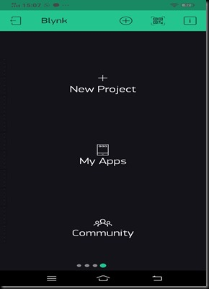

**3.6 HARDWARE REQUIREMENTS**

* ESP8266
* Arduino
* LCD
* Ultrasonic sensor
* PIR
* Relay
* Loads
* Vibration sensor
* Temperature sensor
* Fire Sensor
* Lora
* Power Supply unit

**3.7 SOFTWARE REQUIREMENTS**

* Arduino IDE
* Proteus
* Language: Embedded C
* Cloud Server

**3.8 METHODOLOGY**

Primarily, the proposed system has been divided into two parts. The first part is known as the sender end, where the system interconnects users’ mobile phone to an ESP32 module using wireless network. Then the ESP32 module is connected to a LoRa module for transmitting data. The second part is the receiver end where a LoRa module is integrated with the ESP32. In this part, wired connections are made with several sensors and the ESP32 module. The receiver side is interconnected with the home appliances.

The system checks the circuitry connections of the associated devices after supplying power to each device. In this system, the LoRa module has served as the data or signal transmitter among the users’ devices. The status of all sensors, appliances and other accessories is displayed at the users’ mobile application including the sensors’ reading data. The status can be changed and displayed immediately when the user toggles the switches between the gadgets. By using such virtual switches, users can control opening and closing of doors and windows, switching of appliances such as light, fan, electric heater, AC, and so on. The proposed system shows the capability to monitor surrounding environment by observing temperature and humidity at the any region where the system is installed. The system can also monitor undesirable objects at muted time frame and notify the user instantly.

**3.9 ADAPTIVE DATA RATE**

Adaptive Data Rate (ADR) is a mechanism for optimizing data rates, airtime and energy consumption in the network.

The ADR mechanism controls the following transmission parameters of an end device.

* Spreading factor
* Bandwidth
* Transmission power

ADR can optimize device power consumption while ensuring that messages are still received at gateways. When ADR is in use, the network server will indicate to the end device that it should reduce transmission power or increase data rate. End devices which are close to gateways should use a lower spreading factor and higher data rate, while devices further away should use a high spreading factor because they need a higher link budget.

ADR should be enabled whenever an end device has sufficiently stable RF conditions. This means that it can generally be enabled for static devices. If the static end device can determine that RF conditions are unstable (for example, when a car is parked on top of a parking sensor), ADR should (temporarily) be disabled.

Mobile end devices should be able to detect when they are stationary for a longer times, and enable ADR during those times. End devices decide if ADR should be used or not, not the application or the network.

* End Devices - sensors or actuators send LoRa modulated wireless messages to the gateways or receive messages wirelessly back from the gateways. .
* Gateways - receive messages from end devices and forward them to the Network Server.
* Network Server - a piece of software running on a server that manages the entire network.
* Application servers - a piece of software running on a server that is responsible for securely processing application data.
* Join Server - a piece of software running on a server that processes join-request messages sent by end devices

End devices communicate with nearby gateways and each gateway is connected to the network server. LoRaWAN networks use an ALOHA based protocol, so end devices don’t need to peer with specific gateways. Messages sent from end devices travel through all gateways within range. These messages are received by the Network Server. If the Network Server has received multiple copies of the same message, it keeps a single copy of the message and discards others. This is known as message deduplication.

**CHAPTER 4**

**HARDWARE DETAILS**

**4.1 Ultrasonic Sensor:**

An Ultrasonic sensor is a device that can measure the distance to an object by using sound waves. It measures distance by sending out a sound wave at a specific frequency and listening for that sound wave to bounce back. By recording the elapsed time between the sound wave being generated and the sound wave bouncing back, it is possible to calculate the distance between the sonar sensor and the object.

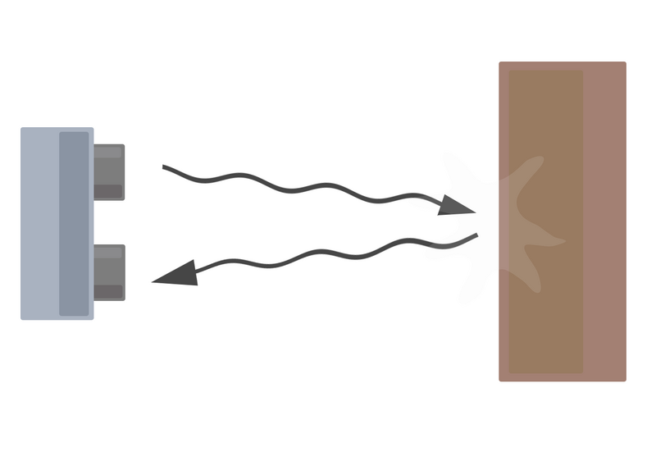

Figure 4.1

Ultra sonic sensor

Since it is known that sound travels through air at about 344 m/s (1129 ft/s), you can take the time for the sound wave to return and multiply it by 344 meters (or 1129 feet) to find the total round-trip distance of the sound wave. Round-trip means that the sound wave travelled 2 times the distance to the object before it was detected by the sensor; it includes the 'trip' from the sonar sensor to the object AND the 'trip' from the object to the Ultrasonic sensor (after the sound wave bounced off the object). To find the distance to the object, simply divide the round-trip distance in half.

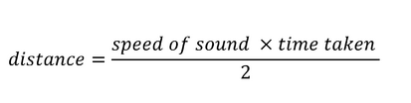

It is important to understand that some objects might not be detected by ultrasonic sensors. This is because some objects are shaped or positioned in such a way that the sound wave bounces off the object, but are deflected away from the Ultrasonic sensor. It is also possible for the object to be too small to reflect enough of the sound wave back to the sensor to be detected. Other objects can absorb the sound wave all together (cloth, carpeting, etc), which means that there is no way for the sensor to detect them accurately. These are important factors to consider when designing and programming a robot using an ultrasonic sensor.

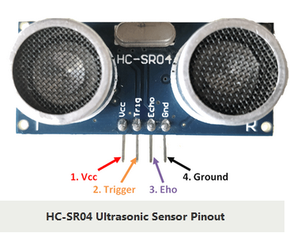

Figure 4.2

HC-SR04 Ultra sonic sensor pinout

Ultrasonic Sensor Pinout Configuration

|  |  |  |
| --- | --- | --- |
| Pin Number | Pin Name | Description |
| 1 | Vcc | The Vcc pin powers the sensor, typically with +5V |
| 2 | Trigger | Trigger pin is an Input pin. This pin has to be kept high for 10us to initialize measurement by sending US wave. |
| 3 | Echo | Echo pin is an Output pin. This pin goes high for a period of time which will be equal to the time taken for the US wave to return back to the sensor. |
| 4 | Ground | This pin is connected to the Ground of the system. |

HC-SR04 Sensor Features

* Operating voltage: +5V
* Theoretical  Measuring Distance: 2cm to 450cm
* Practical Measuring Distance: 2cm to 80cm
* Accuracy: 3mm
* Measuring angle covered: <15°
* Operating Current: <15mA
* Operating Frequency: 40Hz

**4.2 PASSIVE INFRARED SENSOR (PIR)**

A PIR detector is a motion detector that senses the heat emitted by a living body. These are often fitted to security lights so that they will switch on automatically if approached. They are very effective in enhancing home security systems.

The sensor is passive because, instead of emitting a beam of light or microwave energy that must be interrupted by a passing person in order to “sense” that person, the PIR is simply sensitive to the infrared energy emitted by every living thing. When an intruder walks into the detector’s field of vision, the detector “sees” a sharp increase in infrared energy.

A PIR sensor light is designed to turn on when a person approaches, but will not react to a person standing still. The lights are designed this way. A moving person exhibits a sudden change in infrared energy, but a slower change is emitted by a motionless body. Slower changes are also caused by gradual fluctuations in the temperature of the environment. If the light were sensitive to these slower changes, it would react to the sidewalk cooling off at night, instead of the motion of a burglar.

If you have a PIR light, you may notice that it is more sensitive on cold days than on warm days. This is because the difference in temperature between the ambient air and the human body is greater on cold days, making the rise in temperature easier for the sensor to detect. This has drawbacks, though; if the sensor is too sensitive, it will pick up things you don’t want it to such as the movement of small animals.   
Passive infrared sensor is an electronic device, which measures infrared light radiating from objects in its field of view. PIRs are often used in the construction of PIR-based motion detectors. Apparent motion is detected when an infrared source with one Temperature, such as a human, passes in front of an infrared source with another temperature, such as a wall.

All objects emit what is known as black body radiation. This energy is invisible to the human eye but can be detected by electronic devices designed for such a purpose. The term 'Passive' in this instance means the PIR does not emit energy of any type but merely accepts incoming infrared radiation.

Infrared radiation enters through the front of the sensor, known as the sensor face. At the core of a PIR is a solid state sensor or set of sensors, made from approximately 1/4 inches square of natural or artificial pyroelectric materials, usually in the form of a thin film, out of gallium nitride (GaN), caesium nitrate (CsNO3), polyvinyl fluorides, derivatives of phenylpyrazine, and cobalt phthalocyanine. (See pyroelectric crystals.) Lithium tantalate (LiTaO3) is a crystal exhibiting both piezoelectric and pyroelectric properties.

The sensor is often manufactured as part of an integrated circuit and may consist of one (1), two (2) or four (4) 'pixels' of equal areas of the pyroelectric material. Pairs of the sensor pixels may be wired as opposite inputs to a differential amplifier. In such a configuration, the PIR measurements cancel each other so that the average temperature of the field of view is removed from the electrical signal; an increase of IR energy across the entire sensor is self-cancelling and will not trigger the device. This allows the device to resist false indications of change in the event of being exposed to flashes of light or field-wide illumination. (Continuous bright light could still saturate the sensor materials and render the sensor unable to register further information)

At the same time, this differential arrangement minimizes common-mode interference; this allows the device to resist triggering due to nearby electric fields. However, a differential pair of sensors cannot measure temperature in that configuration and therefore this configuration is specialized for motion detectors.

In a PIR-based motion detector, the PIR sensor is typically mounted on a printed circuit board, which also contains the necessary electronics required to interpret the signals from the chip. The complete circuit is contained in a housing, which is then mounted in a location where the sensor can view the area to be monitored. Infrared energy is able to reach the sensor through the window because the plastic used is transparent to infrared radiation (but only translucent to visible light). This plastic sheet prevents the introduction of dust and insects, which could obscure the sensor's field of view.

**OPERATION OF PIR SENSOR:**

A few mechanisms have been used to focus the distant infrared energy onto the sensor surface. The window may have Fresnel lenses molded into it. Alternatively, sometimes PIRsensors are used with plastic segmented parabolic mirrors to focus the infrared energy; when mirrors are used, the plastic window cover has no Fresnel lenses molded into it. A filtering window (or lens) may be used to limit the wavelengths to 8-14 micrometers, which is most sensitive to human infrared radiation (9.4 micrometers being the strongest).

The PIR device can be thought of as a kind of infrared ‘camera’, which remembers the amount of infrared energy focused on its surface. Once power is applied to the PIR the electronics in the PIR shortly settle into a quiescent state and energize a small relay. This relay controls a set of electrical contacts, which are usually connected to the detection input of an alarm control panel. If the amount of infrared energy focused on the sensor changes within a configured time period, the device will switch the state of the alarm output relay. The alarm output relay is typically a "normally closed (NC)" relay; also known as a "Form B" relay.

A person entering the monitored area is detected when the infrared energy emitted from the intruder's body is focused by a Fresnel lens or a mirror segment and overlaps a section on the chip, which had previously been looking at some much cooler part of the protected area. That portion of the chip is now much warmer than when the intruder wasn't there. As the intruder moves, so does the hot spot on the surface of the chip. This moving hot spot causes the electronics connected to the chip to de-energize the relay, operating its contacts, thereby activating the detection input on the alarm control panel. Conversely, if an intruder were to try to defeat a PIR perhaps



Figure 4.3

Working of PIR sensor

By holding some sort of thermal shield between himself and the PIR, a corresponding 'cold' spot moving across the face of the chip will also cause the relay to de-energize unless the thermal shield has the same temperature as the objects behind it.

Manufacturers recommend careful placement of their products to prevent false alarms. They suggest mounting the PIRs in such a way that the PIR cannot 'see' out of a window. Although the wavelength of infrared radiation to which the chips are sensitive does not penetrate glass very well, a strong infrared source (a vehicle headlight, sunlight reflecting from a vehicle window) can overload the chip with enough infrared energy to fool the electronics and cause a false (non-intruder caused) alarm. A person moving on the other side of the glass however would not be 'seen' by the PIR. They also recommended that the PIR not be placed in such a position that an HVAC vent would blow hot or cold air onto the surface of the plastic, which covers the housing's window. Although air has very low emissivity (emits very small amounts of infrared energy), the air blowing on the plastic window cover could change the plastic's temperature enough to, once again, fool the electronics.

PIRs come in many configurations for a wide variety of applications. The most common used in home security systems has numerous Fresnel lenses or mirror segments and has an effective range of about thirty feet. Some larger PIRs are made with single segment mirrors and can sense changes in infrared energy over one hundred feet away from the PIR. There are also PIRs designed with reversible orientation mirrors, which allow either broad coverage (110° wide) or very narrow 'curtain' coverage.

PIRs can have more than one internal sensing element so that, with the appropriate electronics and Fresnel lens, it can detect direction. Left to right, right to left, up or down and provide an appropriate output signal.

**4.3 Flame Sensor:**

Flame sensor is the most sensitive to ordinary light that is why its reaction is generally used as flame alarm purposes. This module can detect flame or wavelength in 760 nm to 1100 nm range of light source. The sensor and flame should keep a certain distance to avoid high temperature damage to the sensor. If the flame is bigger, test it with farther distance. The detection distance is up to 100 cm. The detection angle is 60 degrees so the flame spectrum is especially sensitive. The Flame sensor can output digital or analog signal. It can be used as a flame alarm or in fire fighting robots.

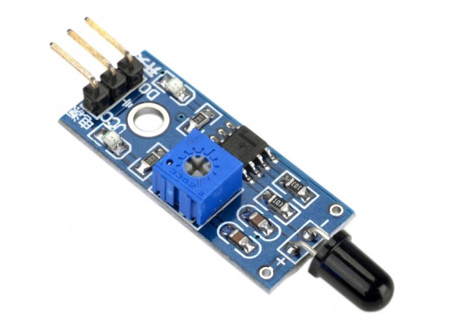

Figure 4.4

Flame sensor

**Features:**

* Operating voltage:3.3V-5V
* Detection distance: 20cm ~ 100cm
* Adjustable detection range
* Comparator chip LM393 makes module readings stable
* Detects a flame or a light source of a wavelength in the range of 760nm-1100nm
* Power indicator and digital switch output indicator
* Digital Output(D0): 0 and 1
* Analog Output(A0): Analog voltage output

A flame sensor detects the presence of fire or flames. In extremely hazardous environments, flame sensors work to minimise the risks associated with fire. There are several different types of flame sensor - some will raise an alarm while others may activate a fire suppression system or deactivate a combustible fuel line. Among the many different types of flame sensor, ultraviolet flame sensors, near IR array flame sensors, infrared flame sensors and IR3 flame detection sensors are the most prominent.

In a hazardous environment, such as a petrochemical processing plant, failing to detect gas leaks, fires or explosions could prove disastrous. However, more needs to be done to help distinguish dangerous gas leaks or flames from annoying false alarms. In this article, Artificial Neural Network Technology Improves Gas & Flame Detection in Hazardous Areas, we take a closer look at the different ways we can reduce false alarms.

**Different types of flame sensor**

**Ultraviolet flame sensors**

Ultraviolet flame sensors work within wavelengths of no more than 300 nm. Within 3-4 milliseconds, ultraviolet flame sensors can detect explosions and fires by measuring the levels of radiation in the atmosphere (additional radiation is emitted at the moment of ignition). Unfortunately, false alarms are fairly commonplace. Other UV sources, such as lighting, arc welding and even sunlight can all trigger the sensor. In order to counter this, many ultra violet flame sensors feature a built-in time delay.

**Near IR array flame sensors**

Near IR array flame sensors, which are also known as “visual flame detectors”, boast flame recognition technologies. These sensors confirm the presence of flames by “reading” near IR radiation via the pixel array of a CCD.

**Infrared flame sensors**

Infrared flame sensors are designed to work within the infrared spectral band. When an explosion occurs, certain hot gasses will emit patterns in the infrared region, which can then be analysed using a specialised thermal imaging camera. Infrared flame sensors are somewhat prone to false alarms, so generally feature an inbuilt time delay.

**IR3 flame detection sensors**

Most IR3 flame detection sensors have been designed to disregard background radiation. These devices measure the modulated elements of radiation only. IR3 sensors are, therefore, less susceptible to false alarms than their ultraviolet and infrared counterparts.

Other notable types of flame sensor include ionisation current flame detection and thermocouple flame detection. Ionisation current flame detection systems are generally used in conjunction with large industrial processes gas heaters and are connected to the flame control system. Thermocouple fame detection systems are found in gas-powered ovens and heating systems.

**4.4 LORA WIRELESS RF SERIAL LINK 868MHZ**

The WIR-1286 module is a low-power and high range wireless communication solution that is ideal for Smart Grid, home automation, smart lighting, industrial sensor data acquisition and remote control applications. This module integrates LORA SX1276, an extremely low-power sub-GHz transceiver, an MCU for wireless network control, data handling and hardware interface, a PCB antenna and matching circuitry.

Right out- of-the-box this module supports simple point-to-multipoint serial communication over-the-air. It has a small 22mm x 36mm form-factor for easy integration.

This module operates at 868MHz band and has 5 channel options. It can offer up to 2 kilometers* over the air range and even more if modules configured as repeaters are used. It should be connected to any 5V TTL/CMOS logic serial RXD and TXD lines and can support baud-rate of 9600bps to 115200bps.

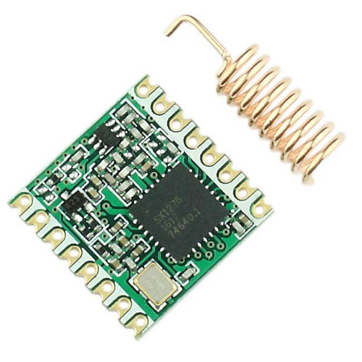

Figure 4.5

WIR-1286 module

**Features**

* RF center frequency of 868MHz
* Small 22mm x 36mm x 3mm form factor. Can fit into almost anything.
* Standard UART interface with hardware flow-control (Clear-to-Send CTS) for long data packet handling
* Easy to integrate into current devices that support RS-485, RS-232, RS-422 or 3.3V TTL serial data
* Compatible to 5V power-supply and interface.
* +20 dBm - 100 mW constant RF output vs. V supply.
* Listen-before-talk and random back-off algorithm
* 16bit node address and 16bit network address
* Acknowledgement based point-to-point communication with data hopping over repeaters
* Settable channels, baud-rate, air-data rate and RF transmit power
* Configurable parameters, signal-strength limit, ack timeout, network and point address
* Up to 2Kilometers outdoor open air node-to-node range

**PinOut**

* GND
* VCC 5V DC
* CTS- clear to send module output
* TXD - module input
* RXD - module output
* PROG

**Applications**

* Wireless telemetry for transmitting meter readings, sensor data
* Remote control applications with fast response requirements
* Wireless Home Networking applications
* Point-to-point and point-to-multipoint network topologies
* Wireless mouse, wireless keyboard and other wireless user interface devices
* Wireless data logging applications
* Audience response systems
* Smart Grid systems
* Home Automation Systems

**4.5 LCD (Liquid Crystal Display)**

The display used is 16x2 LCD (Liquid Crystal Display); which means 16 characters per line by 2 lines. The standard is referred as HD44780U, which refers to the controller chip which receives data from an external source (Here Atmega16) and communicates directly with the LCD. Here 8-bit mode of LCD is used, i.e., using 8-bit data bus.

The three control lines are EN, RS, and RW.

The EN line is called "Enable." This [5] control line is used for telling the LCD that we are sending data. For sending data to the LCD, the program should make sure that the line is low (0) and then set the other two control lines or put data on the data bus. When the other lines are ready completely, bring EN high (1) and should wait for the minimum time required by the LCD datasheet and end by bringing it low (0) again.

The RS line is "Register Select" line. When RS is low (0), the data is treated as a command or special instruction (such as clear screen, position cursor, etc.). When the RS is high (1), the data sent is text data which is displayed on the screen. For example, to display the letter "B" on the screen you would set RS high.

The RW line is “Read/Write" control line. When RW is low (0), the information on the data bus is written to the LCD. When RW is high (1), the program is effectively questioning (or reading) the LCD. Only one instruction ("Get LCD status") is read command. All the others are write commands--so RW will always be low.

In case of an 8-bit data bus, the lines are referred to as DB0, DB1, DB2, DB3, DB4, DB5, DB6, and DB7.

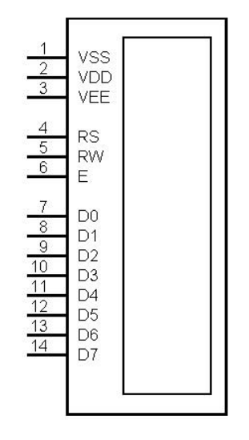

Figure 4.6: Pin Diagram of LCD

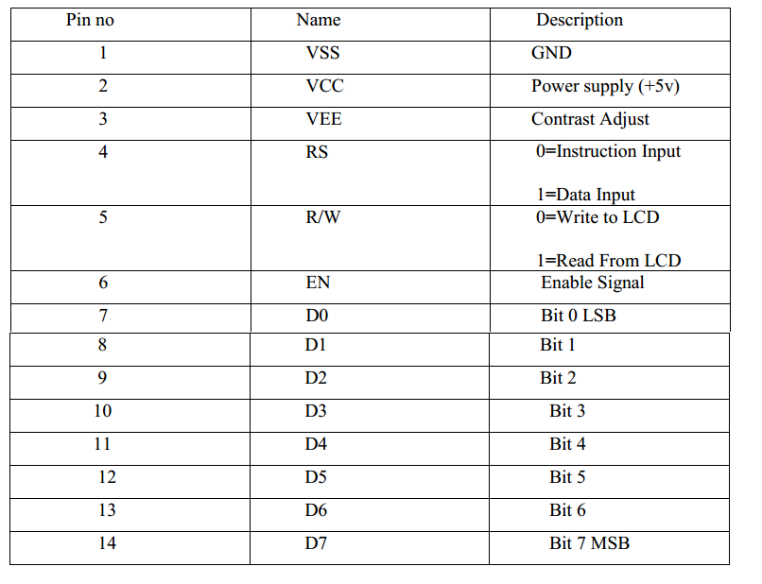

Table 4.1 Pin configuration

**4.6 ARDUINO:**

Arduino ATMEGA-328 microcontroller consist of 14 input and output analog and digital pins (from this 6 pins are considered to be a PWM pins), 6 analog inputs and remaining digital inputs. Power jack cable is used to connect arduino board with the computer. Externally battery is connected with the arduino microcontroller for the power supply. Arduino is an open source microcontroller from which there is no feedback present in the microcontroller. This arduino board consist of I2C bus that can be able to transfer the data from arduino board to the output devices. These arduino boards are programmed over RS232 serial interface connections with ATmega arduino microcontrollers. The operating volt ranges from 5v. The input voltage recommended for arduino microcontroller is from 7v and the maximum of 12v. The DC input current given to the arduino board is in the range of 40mA.

It consists of different types of memories such as flash memory, EEPROM, SRAM. The length of the arduino board is nearly about 68.64mm and the width of the microcontroller is about 53.4mm. The weight of the arduino microcontroller is about 20g. We can use various types of microcontroller such as 8 bit AVL Atmel microcontroller and 32 bit Atmel arm microprocessor. From these different kinds of processors, we can use those processors for various engineering projects as well as industrial applications. Some of the examples of using the arduino in the industrial applications are controlling the actuators and sensors. Some of the examples of arduino microcontrollers are Arduino Duemilanove, Arduino UNO, Arduino Leonardo, Arduino Mega, and Arduino MEGA 2560 R3, Arduino MEGA 2560 R3, Arduino Nano, Arduino Due, LilyPadArduino, micro arduino. We have already mentioned, arduino has been programmed by using c and c++ programming language. These c and c++ are high level languages. Normally it has 18 number of input and output pins. Among those 6 pins are considered to be an analog inputs.From these analog inputs, we can be able to work the arduino microcontroller using analog inputs supply. Normally analog inputs can be in the range of 0-5V. Similar to that digital inputs are present in the microcontroller which can act the use of microcontroller using digital inputs. Digital inputs can be in the range of 5V.

**PIN DIAGRAM**

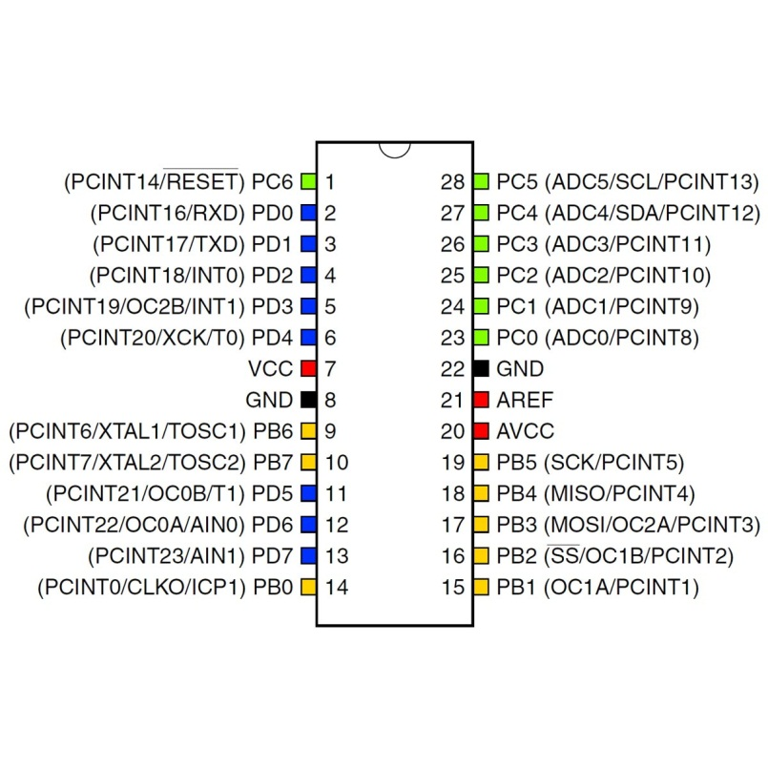  
Figure 4.7 ATMEGA 328 microcontroller

ATMEGA 328 microcontroller, which acts as a processor for the arduino board. Nearly it consists of 28 pins. From these 28 pins, the inputs can be controlled by transmitting and receiving the inputs to the external device. It also consists of pulse width modulation (PWM). These PWM are used to transmit the entire signal in a pulse modulation. Input power supply such as Vcc and Gnd are used. These IC mainly consists of analog and digital inputs. These analog and digital inputs are used for the process of certain applications.

The power pins are as follows:

* VIN: The input voltage to the Arduino board when it's using an external power source (as opposed to 5 volts from the USB connection or other regulated power source). You can supply voltage through this pin, or, if supplying voltage via the power jack, access it through this pin.
* 5V: The regulated power supply used to power the microcontroller and other components on the board. This can come either from VIN via an on-board regulator, or be supplied by USB or another regulated 5V supply.
* 3V3: A 3.3 volt supply generated by the on-board regulator. Maximum current draw is 50 mA.
* GND: Ground pins.

Each of the 14 digital pins on the Uno can be used as an input or output, using pinMode(), digitalWrite(), and digitalRead() functions. They operate at 5 volts. Each pin can provide or receive a maximum of 40 mA and has an internal pull-up resistor (disconnected by default) of 20-50 kOhms. In addition, some pins have specialized functions:

* Serial: 0 (RX) and 1 (TX): Used to receive (RX) and transmit (TX) TTL serial data. These pins are connected to the corresponding pins of the ATmega8U2 USB-to-TTL Serial chip.
* External Interrupts: 2 and 3. These pins can be configured to trigger an interrupt on a low value, a rising or falling edge, or a change in value. See the attachInterrupt() function for details.
* PWM: 3, 5, 6, 9, 10, and 11. Provide 8-bit PWM output with the analogWrite() function.

SPI: 10 (SS), 11 (MOSI), 12 (MISO), 13 (SCK). These pins support SPI communication, which, although provided by the underlying hardware, is not currently included in the Arduino language.

* LED: 13. There is a built-in LED connected to digital pin 13. When the pin is HIGH value, the LED is on, when the pin is LOW, it's off.
* 2C: 4 (SDA) and 5 (SCL). Support I2C (TWI) communication using the Wire library.
* AREF. Reference voltage for the analog inputs. Used with analogReference().
* Reset. Bring this line LOW to reset the microcontroller. Typically used to add a reset button to shields which block the one on the board.

**Analog input :**

Arduino atmega-328 microcontroller board consist of 6 analog inputs pins. These analog inputs can be named from A0 to A5. From these 6 analog inputs pins, we can do the process by using analog inputs. Analog inputs can be used in the operating range of 0 to 5V. Analog signal is considered as the continuous time signal, from which these analog signal can be used for certain applications. These are also called as non-discrete time signal. Inputs such as voltage, current etc.., are considered to beeither analog signal or digital signal only by analysing thetime signal properties. Various applications of arduinomicrocontroller can use only an analog input instead of digital inputs. For these applications, analog input ports or pins can be used.

**Digital Input:**

Digital inputs can be defined as the non-continuous time signal with discrete input pulses. It can be represented as 0’s and 1’s. These digital inputs can be either on state or in off state. Arduino atmega328 microcontroller also consists of 12 digital input pins. It can be stated as D0 to D11. Nearly 12 inputs can be used for digital input/output applications. The working of the digital input ports is where the discrete input pulses can be triggered and supplied to the ports. These ports receive the input and therefore the port can be used for both input and output process. These digital pins can access only the digital inputs.

**Power Jack Cable / USB PORT:**

This Arduino atmega-328 microcontroller can be interfaced with the other electronic devices such as computer by using USB port or power jack cable from these power jack cable, we can upload the program of Arduino for their applications. At first, the program can be initialised or can be edited by using Arduino software tools. Then these programs can be transferred through arduino microcontroller board by using usb cable or power jack cable.

**Power Supply:**

There is an additional power supply source present in Arduino microcontroller. Power supply port is present at the corner of the arduino microcontroller. Either we can use this power supply port by connecting with external power supply.(ie, ac power supply), or by connecting an dc power supply through input pins. These power supplies produce an active form to the arduino microcontroller. These arduino microcontrollers can accept a range of power supply. When the power supply voltage range exceeds, the microcontroller gets damaged. Hence, only the particular range of power supply should be given to the arduino microcontroller.

**4.7 NodeMCU ESP8266**

NodeMCU is an open source IoT stage. It incorporates firmware which keeps running on the ESP8266 Wi-Fi SoC from Expressive Systems, and equipment which depends on the ESP-12 module. The term NodeMCU typically refers to the firmware, whereas the board is termed Devkit. NodeMCU Devkit 1.0 consists of associate ESP-12E on a board that facilitates its use. It additionally contains a transformer, a USB interface. The expression "NodeMCU" of course alludes to the firmware as opposed to the improvement units. The firmware utilizes the Lua scripting dialect

The NodeMCU (Node Micro Controller Unit) is an open source software and hardware development environment that is built around a very inexpensive System-on-a-Chip (SoC) called the ESP8266. The ESP8266 is designed and manufactured by Express, contains all crucial elements of the modern computer: CPU, RAM, networking (wi-fi), and even a modern operating system and SDK. When purchased at bulk, the ESP8266 chip costs only $2 USD a piece. That makes it an excellent choice for this system design. The NodeMCU aims to simplify ESP8266 development. It has two key components.

1. An open source ESP8266 firmware that is built on top of the chip manufacturer's proprietary SDK. The firmware provides a simple programming environment based on eLua (embedded Lua), which is a very simple and fast scripting language with an established developer community. For new comers, the Lua scripting language is easy to learn. And to add on NodeMCU can be programmed with the Android IDE too.
2. A development kit board that incorporates the ESP8266 chip on a standard circuit board. The board has a built-in USB port that is already wired up with the chip, a hardware reset button, Wi-Fi antenna, LED lights, and standard-sized GPIO (General Purpose Input Output) pins that can plug into a bread board. Figure 2 below shows the NodeMCU development board.

Figure 4.8 NodeMCU

There are various platforms for IoT system one of them is NodeMCU. It provides lower level control on devices which is known as firmware. These control runs on ESP8266 Wi-Fi SoC, which hardware is based on ESP-12 module.Esp8266 is a Wi-Fi based communication system’s microchip. It uses TCP/IP protocol for communicating with internet through router. It uses 802.11b/g/n slandered technology for Wi-Fi communication. It is a Tensilica L106 32-bit RISC instruction unite microprocessor with 32 KB instruction RAM, 32KB instruction Cache RAM, 80KB Data memory.ESP8266 (Pin) and Arduino Mega’s (Pin) common pins are GND TX (0)-3.3V, RX (0), 3.3V. For running the ESP8266 on Arduino platform we need to install ESP8266 package in Arduino IDE. As a board is using, we need to give the additional board manager.

**Figure 4.9 NodeMCU Pin Out**

As shown in Fig it has 12 GPIO pins. One ADC pin. For this project 7 GPIO pins have been used. They are D0 to D6 which delivers digital outputs.

**CHAPTER 5**

**SOFTWARE DETAILS**

**5.1 EMBEDDED C**

Embedded C is a set of language extensions for the C Programming the C standards committee to address commonality issues that exist between C extensions for different embedded systems. Historically, embedded C programming requires nonstandard extensions to the C language in order to support exotic features such as fixed point arithmetic, multiple distinct memory banks and basic input output operations. In 2008, the C Standards Committee extended the C language to address these issues by providing a common standard for all implementations to adhere to. It includes a number of features not available in normal C, such as, fixed-point arithmetic, named address spaces, and basic I/O hardware addressing. Embedded C use most of the syntax and semantics of standard C, e.g., main () function, variable definition, data type declaration, conditional statements (if, switch. case), loops (while, for), functions, arrays and strings, structures and union, bit operations, macros, unions, etc.

**INTRODUCTION TO EMBEDDED C**

Looking around, we find ourselves to be surrounded by various types of embedded systems. Be it a digital camera or a mobile phone or a washing machine, all of them has some kind of processor functioning inside it. Associated with each processor is the embedded software. If hardware forms the body of an embedded system, embedded processor acts as the brain, and embedded software forms its soul. It is the embedded software which primarily governs the functioning of embedded systems. During infancy years of microprocessor based systems, programs were developed using assemblers and fused into the EPROMs. There used to be no mechanism to find what the program was doing. LEDs, switches, etc. were used to check correct execution of the program. Some ‘very fortunate’ developers had In-circuit Simulators (ICEs), but they were too costly and were not quite reliable as well.

As time progressed, use of microprocessor-specific assembly-only as the programming language reduced and embedded systems moved onto C as the **embedded programming language**of choice. C is the most widely used programming language for embedded processors/controllers. Assembly is also used but mainly to implement those portions of the code where very high timing accuracy, code size efficiency, etc. are prime requirements.

Initially C was developed by Kernighan and Ritchie to fit into the space of 8K and to write (portable) operating systems. Originally it was implemented on UNIX operating systems. As it was intended for operating systems development, it can manipulate memory addresses. Also, it allowed programmers to write very compact codes. This has given it the reputation as the language of choice for hackers too.

**EMBEDDED SYSTEMS PROGRAMMING**

Embedded systems programming is different from developing applications on a desktop computers. Key characteristics of an embedded system, when compared to PCs, are as follows:

* Embedded devices have resource constraints(limited ROM, limited RAM, limited stack space, less processing power)
* Components used in embedded system and PCs are different; embedded systems typically uses smaller, less power consuming components.
* Embedded systems are more tied to the hardware.

Two salient **features of Embedded Programming** are code speed and code size. Code speed is governed by the processing power, timing constraints, whereas code size is governed by available program memory and use of programming language.  Goal of embedded system programming is to get maximum features in minimum space and minimum time.

Embedded systems are programmed using different type of languages:

* Machine Code
* Low level language, i.e., assembly
* High level language like C, C++, Java, Ada, etc.
* Application level language like Visual Basic, scripts, Access, etc.

  Assembly language maps mnemonic words with the binary machine codes that the processor uses to code the instructions. Assembly language seems to be an obvious choice for programming embedded devices. However, use of assembly language is restricted to developing efficient codes in terms of size and speed. Also, assembly codes lead to higher software development costs and code portability is not there. Developing small codes are not much of a problem, but large programs/projects become increasingly difficult to manage in assembly language. Finding good assembly programmers has also become difficult nowadays. Hence high level languages are preferred for embedded systems programming.

**USE OF C IN EMBEDDED SYSTEMS:**

* It is small and reasonably simpler to learn, understand, program and debug.
* C Compilers are available for almost all embedded devices in use today, and there is a large pool of experienced C programmers.
* Unlike assembly, C has advantage of processor-independence and is not specific to any particular microprocessor/ microcontroller or any system. This makes it convenient for a user to develop programs that can run on most of the systems.
* As C combines functionality of assembly language and features of high level languages, C is treated as a ‘middle-level computer language’ or ‘high level assembly language’
* It is fairly efficient
* It supports access to I/O and provides ease of management of large embedded projects.

Many of these advantages are offered by other languages also, but what sets C apart from others like Pascal, FORTRAN, etc. is the fact that it is a middle level language; it provides direct hardware control without sacrificing benefits of high level languages .Compared to other high level languages, C offers more flexibility because C is relatively small, structured language; it supports low-level bit-wise data manipulation. Compared to assembly language, C Code written is more reliable and scalable, more portable between different platforms (with some changes). It is easier to write good code in C & convert it to an efficient assembly code rather than writing an efficient code in assembly itself. Benefits of assembly language programming over C are negligible when we compare the ease with which C programs are developed by programmers.

**5.2 ARDUINO SOFTWARE (IDE):**

The Arduino Integrated Development Environment - or Arduino Software (IDE) - contains a text editor for writing code, a message area, a text console, a toolbar with buttons for common functions and a series of menus. It connects to the Arduino and Genuino hardware to upload programs and communicate with them.

**Writing Sketches:**

Programs written using Arduino Software (IDE) are called sketches. These sketches are written in the text editor and are saved with the file extension .ino. The editor has features for cutting/pasting and for searching/replacing text. The message area gives feedback while saving and exporting and also displays errors. The console displays text output by the Arduino Software (IDE), including complete error messages and other information. The bottom right-hand corner of the window displays the configured board and serial port. The toolbar buttons allow you to verify and upload programs, create, open, and save sketches, and open the serial monitor.

**NB:** Versions of the Arduino Software (IDE) prior to 1.0 saved sketches with the extension .pde. It is possible to open these files with version 1.0, you will be prompted to save the sketch with the .ino extension on save.

**Verify:** Checks your code for errors compiling it.

**Upload:** Compiles your code and uploads it to the configured board. See uploading below for details.

Note: If you are using an external programmer with your board, you can hold down the "shift" key on your computer when using this icon. The text will change to "Upload using Programmer"

**New:** Creates a new sketch.

**Open:** Presents a menu of all the sketches in your sketchbook. Clicking one will open it within the current window overwriting its content.

Note: due to a bug in Java, this menu doesn’t scroll; if you need to open a sketch late in the list, use the File | Sketchbook menu instead.

**Save:** Saves your sketch.

**Serial Monitor**: Opens the serial monitor.

Additional commands are found within the five menus: File, Edit, Sketch, Tools, and Help. The menus are context sensitive, which means only those items relevant to the work currently being carried out are available.

**FILE**

**New:** Creates a new instance of the editor, with the bare minimum structure of a sketch already in place.

**Open:** Allows to load a sketch file browsing through the computer drives and folders.

**Open Recent:** Provides a short list of the most recent sketches, ready to be opened.

**Sketchbook:** Shows the current sketches within the sketchbook folder structure; clicking on any name opens the corresponding sketch in a new editor instance.

**Examples:** Any example provided by the Arduino Software (IDE) or library shows up in this menu item. All the examples are structured in a tree that allows easy access by topic or library.

**Close:** Closes the instance of the Arduino Software from which it is clicked.

**Save:** Saves the sketch with the current name. If the file hasn't been named before, a name will be provided in a "Save as.." window.

**Save as:** Allows to save the current sketch with a different name.

**Page Setup:** It shows the Page Setup window for printing.

**Print:** Sends the current sketch to the printer according to the settings defined in Page Setup.

**Preferences:** Opens the Preferences window where some settings of the IDE may be customized, as the language of the IDE interface.

**Quit**: Closes all IDE windows. The same sketches open when Quit was chosen will be automatically reopened the next time you start the IDE.

**CHAPTER 6**

**RESULTS**

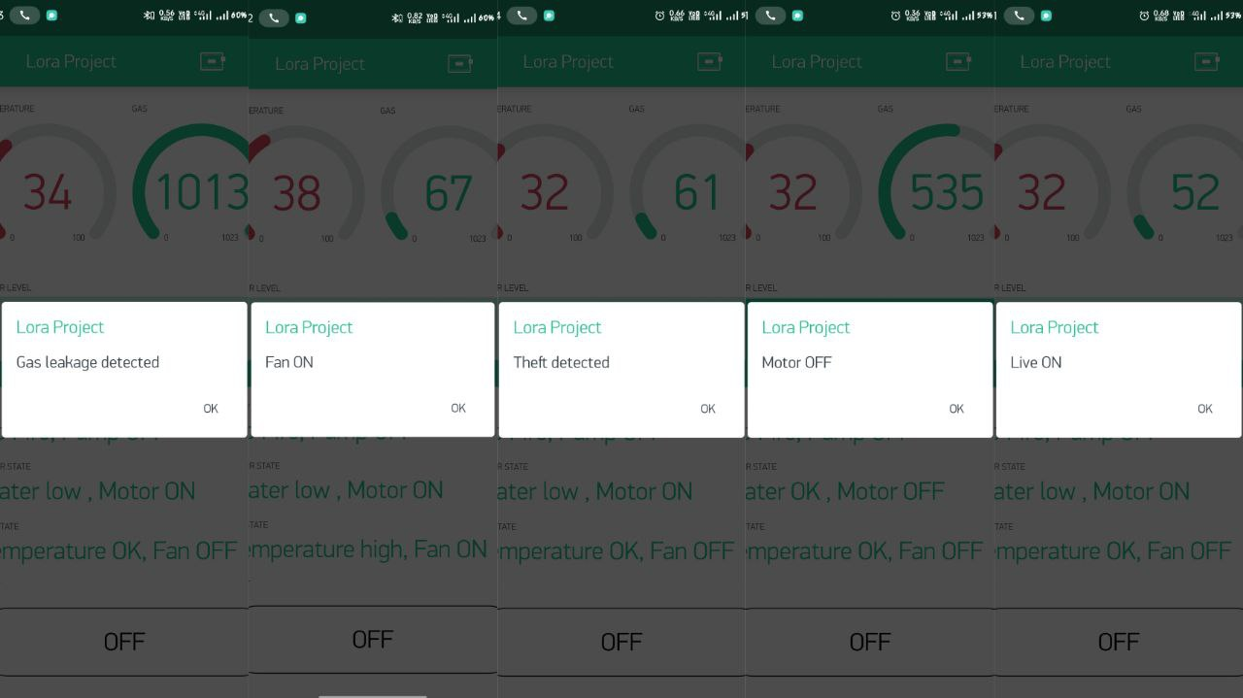

Figure 6.1 Various output from Blynk app

Figure 6.2 GSM output

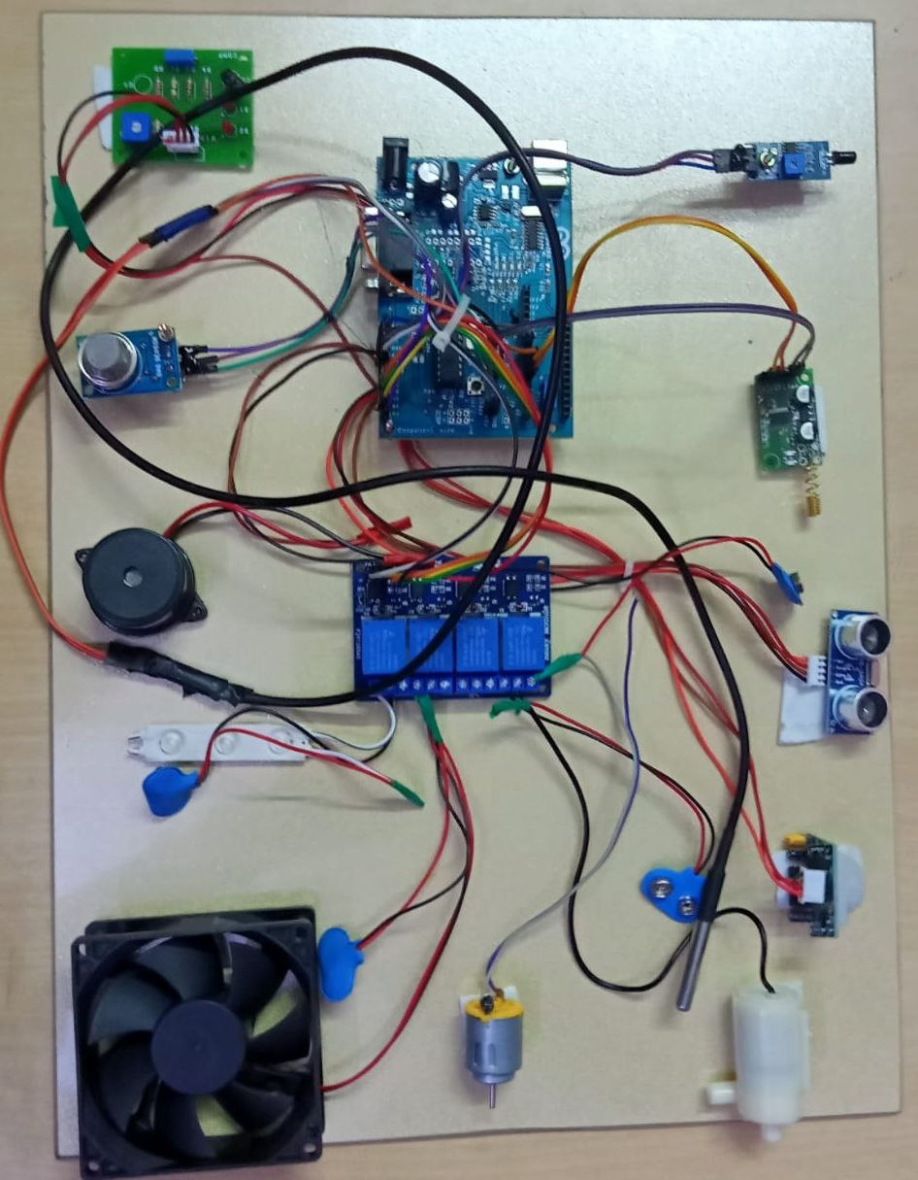

Figure 6.3 Home Section Kit

Figure 6.4 Receiver Section Kit

**DISCUSSION**

The use of LoRa technology in an automated communication system has been demonstrated to be effective in longer distance communication. Furthermore, a proof of concept of LoRa based automation system with few real-life scenarios was also demonstrated. This technology has the potential to be further expanded in future in developing smart communication frameworks for different areas such as home, institute, agriculture, healthcare etc. However, issues such as scalability, security and integration of data analytics stills need to be resolved for large-scale deployment in both domestic, commercial and industrial applications

Figures 6.1 & 6.2 shows the output obtained from the Blynk app and GSM module and the Figures 6.3 & 6.4 shows the Final proposed system of this paper. The Home section is separated from the receiver section for maximum distance of 3 to 15 kms. The operating of the appliances is done via Blynk app. The LoRa module has transmitter and a receiver. The transmitter section is placed in home section and the receiver is placed in the receiver section this LoRa can create a network environment by using this we can control and monitor our home from anywhere in the world at any time.

**CHAPTER 7**

**CONCLUSION**

In this investigation, a smart automation system has been designed, developed and tested for effective remote controlling of appliances at home, institute or industry. The system was developed at low cost with a capability of monitoring and controlling from a distance ranging from 3 km to 12 km through LoRa based wireless communication. Technologies deployed for home automation that are available in the market are based on platforms which help to connect devices or things around the home, the key point is to make the home intelligent or smart with ease. To achieve this with precision by the use of static IP addresses and having the ability to detect the current state of devices by use of state function was achieved in this project. In conclusion, it has been seen that home automation using internet of things over LoRa technology with the help of Android application is both user friendly and cost effective.

**REFERENCES**

1. Lee, K.M., Teng, W.G. and Hou, T.W., "Point-n-Press: An Intelligent Universal Remote Control System for Home Appliances," IEEE Transactions on Automation Science and Engineering. 2016, 13(3), pp 1308 – 1317.

2. Qu, Y., Xu, K., Wang, H., Wang, D. and Wu, B., December. "Lifetime maximization in rechargeable wireless sensor networks with charging interference," In 2015 IEEE 34th International Performance Computing and Communications Conference (IPCCC) 2015, pp. 1-8.

3. Hsieh, C.W., Chi, K.H., Jiang, J.H. and Ho, C.C., 2014. "Adaptive binding of wireless devices for home automation," IEEE Wireless Communications, 21(5), pp.62-69.

4. Sheng, W., Matsuoka, Y., Ou, Y., Liu, M. and Mastrogiovanni, F.,. "Guest Editorial Special Section on Home Automation," IEEE Transactions on Automation Science and Engineering, 2015, 12(4), pp.1155-1156.

5. Gill, K., Yang, S.H. and Wang, W.L., "Secure remote access to home automation networks," IET Information Security, 2013, 7(2), pp.118-125.

6. Langhammer, N. and Kays, R., "Performance evaluation of wireless home automation networks in indoor scenarios," IEEE Transactions on Smart Grid, 2012, 3(4), pp.2252-2261.

7. Kumar SP, Rao SV. RF Module Based Wireless Secured Home Automation System Using FPGA. Journal of Theoretical and Applied Information Technology. 2015, 77(2)

8. Kumar PM, Sandhya N. “Bluetooth Based Wireless Home Automation System Using FPGA”. Journal of Theoretical and Applied Information Technology. 2015, 77(3)

9. ElShafee A, Hamed KA. “Design and implementation of a WIFI based home automation system”. World academy of science, engineering and Technology. 2012, 2177-80.

10. Tseng SP, Li BR, Pan JL, Lin CJ. “An application of Internet of things with motion sensing on smart house”. In Orange Technologies (ICOT), 2014 IEEE International Conference on 2014 Sep 20 pp. 65-68

11. Teymourzadeh R, Ahmed SA, Chan KW, Hoong MV. “Smart GSM based home automation system”. InSystems, Process & Control (ICSPC), 2013 IEEE Conference on 2013 Dec 13, pp. 306-309.

12. Sivakrishnan J., Esakki Vigneswaran E. and Sakthi Vishnu R. “Home Automation Control and Monitoring System Using BLE Device”. Middle-East Journal of Scientific Research, 2016 pp. 78-82

13. Bor, Martin, John Edward Vidler, and Utz Roedig. "LoRa for the Internet of Things." (2016): 361-366.

14. Tadimeti, H.C. and Pulipati, M., "Overview of Automation Systems and Home Appliances Control using PC and Microcontroller," Int. Jr. of Sci. Res, 2013, 2, pp.127-31.