^{CURRICULUM VITAE}  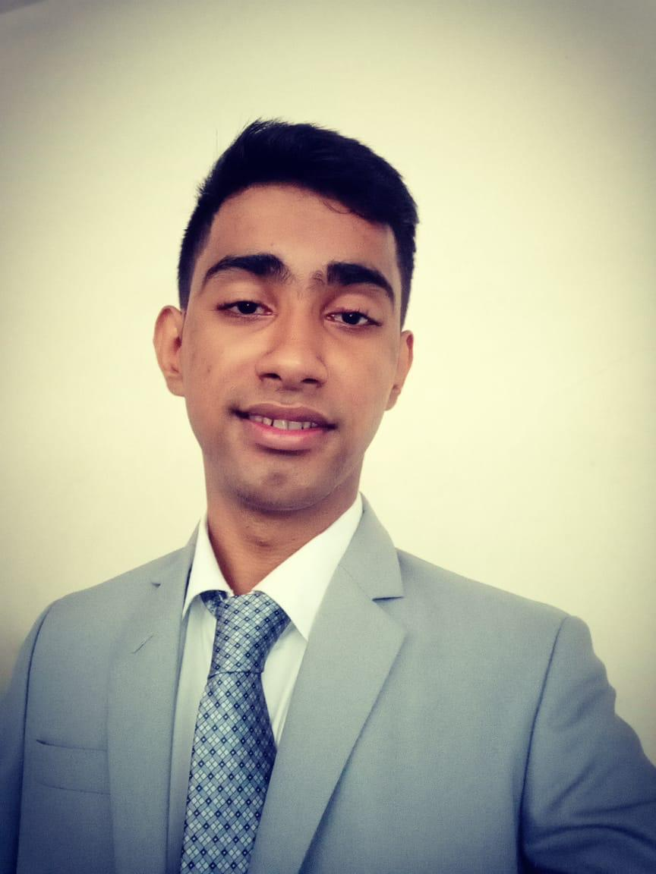  PRABHAT SINGH  Contact Information:  E Mail:-  Ps8898714850@gmail.com  Contact:-  9137945364  Personal Data:  Date Of Birth : 08.11.1996.  Nationality: Indian  Address: Flat No-704Teetha Apt, Indralok,phase6, bhayandereast-04  Languages Known:  English, Hindi & Marathi  Interests:  - Playing Cricket  - Reading book  - Social media | CAREER OBJECTIVE  Work Towards Customer Satisfaction and Gaols of the Organization achieve the broader.  Organizational Experience  - Job training in Peninsula Mumbai For 6 Month  - Store Captain in Jumboking from 19th July to 16 February  Industrial Training  I successfully completed my industrial training with the Radisson 20th November 2017 to 8th April 2018  Course Contents  MANAGEMENT QUALIFICATION:  - HOTEL MANAGEMENT COURSE (B.Sc Hmct) Rizvi College of HMCT Mumbai  QUALIFICATION:  - Passed 10+2 from Maharashtra Board  - Passed 10 from St.Lawernce High School (Maharashtra State Board)  Computer Proficiency:  I am Comfortable with the following application packages:  - Diploma in Basic Computer  - Basic Excel  Competencies:  - Participated in College Events and Comida Fiesta  - RSP Certificate from State Government  - Diploma in Basic Computer  Strengths :  - Trust Worthy  - Ability to Handle Pressure in Difficult Situations  - Punctuality in Work  Declaration:  I confirm that the information provided by me is true to the best of my knowledge and belief.  Date : Signatures:  PRABHAT SINGH

