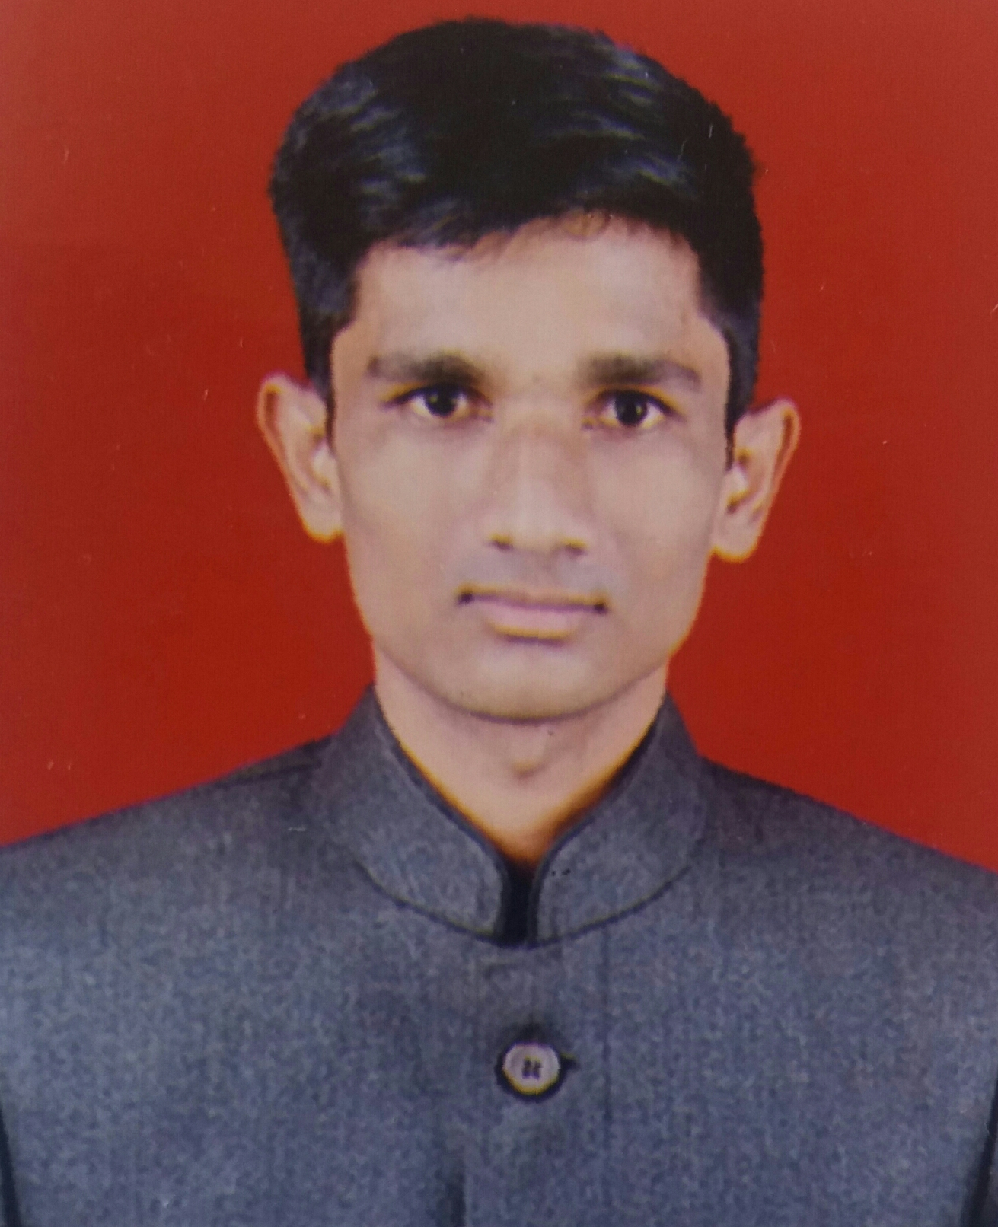
Name Of Student : Mr. Ganesh Shinde
Address: At.Post Kaulane(Gaa.) Tal Malegoan Dist Nashik
Contact No. : 7507062567
Email: sganesh767@gmail.com
Website: ganeshshinde.000webhostapp.com
ganeshdshinde01.000webhostapp.com

Objectives :

To ensure a challenging position in a growing organization where I will be able to use all my technical and non-technical skills to its fullest and in turn make the organization to prosper with my skills.

Academic Details :

BE Computer from Sandip Institute of Engineering and Management Nashik (Pursuing)
TE Computer from Sandip Institute of Engineering and Management Nashik with 61.53%(2016-17)
SE Computer from Sandip Institute of Engineering and Management Nashik with57.27%(2015-16)
Diploma from K.B.H Plytechnic Malegoan with 70.53% (2014-15)
HSC from S.S.S.S.P. Junior College Arvi with 54% (2012-13)
SSS from G.C.S. J.M Highschool kaulane(Gaa)with 58% (2010-11)
Technical Skills :

Programming Languages: C,C++,JAVA ,HTML,CSS,PHP ,JavaScript
Databases: MySQL,Oracle
Working Platforms: Windows/Linux
Software Worked on: Netbeen,Eclips,Android Studio,Dreamweaver
Framework: CodeIgniter

Personal Qualities :

Positive atitude
Hard working
Fully dedication
Good team player

Achievements & Extra Curricular Skills :

Successfully completed "Applied CS With Android" by Google
Successfully completed "Certified Information Security Specialist" by CyberCure solutions
Successfully completed “ State Level Workshop on Compiler Design and Data Mining”
Successfully completed “complete web development workshop by OS3 InfoTech”

Internal Projects :

[1]Online college web site www.kbhpolytechnic.com
Technology used : HTML, CSS , JavaScript, PHP, MySQL
The main objective of this project is college website for student or college. In this website academic information, college events, admission information etc.

[2]Online Book Store
Technology used: Java, MySQL, Net Beans.
This is mini project of online book store this project store book information and buy book online

Hobbies :

Surfing internet, learning new programing Languages

I hereby acknowledge you that the above details about me are precisely correct this date.

Place: Nashik Ganesh Dilip Shinde
Date: (Name of Student)

