# ReadCSV

|  |  |
| --- | --- |
| Functionality | This application reads a CSV file and uploads the customer data to a MySQL Database. |
| Steps to Import | This is a Maven project and can be directly imported into IDEs such as IntelliJ or Eclipse. Run : maven clean & Maven Install |
| Configuration | After importing the project, make sure to update the property file values appropriately. |
| Pre-requisites | Before running the application, ensure that the Spring Boot Application is up and running. Failure to do so may result in errors such as *IOException Connection refused: connect  Could not Create customer : 1.* |

# REST Service

|  |  |
| --- | --- |
| Functionality | This application provides two endpoints and connects to a MySQL server. |
| Steps to Import | This is a Maven project and can be directly imported into IDEs such as IntelliJ or Eclipse. Run : maven clean & Maven Install |
| Configuration | Update the application properties for Port and Mysql Details POST (/createcustomer): Accepts JSON body and creates a customer. Currently supports creating one customer at a time but can be modified to handle a full customer array (which would avoid the service call from Read CSV Application / Class).  GET (/getcustomer/<customer_ref>): Retrieves a customer by querying the database based on the input customer reference. If the customer is not found, it returns a text message stating, "User not found". |
| Pre-requisites | Before running the Spring Boot application, ensure that the MySQL server is up. Docker image can be used for this purpose. |

# MySQL Configuration

|  |  |
| --- | --- |
| User Creation | CREATE USER 'egsadmin'@'localhost' IDENTIFIED BY 'egsadmin'; |
| DataBase | CREATE DATABASE egs; |
| Grant Privileges | GRANT ALL PRIVILEGES ON egs.* TO 'egsadmin'@'localhost'; |
| Assign Database to User | ALTER USER 'egsadmin'@'localhost' DEFAULT DATABASE egs; |
| Table Creation | CREATE TABLE customer (  customerref BIGINT PRIMARY KEY,  customername VARCHAR(255),  addressline1 VARCHAR(255),  addressline2 VARCHAR(255),  town VARCHAR(255),  county VARCHAR(255),  country VARCHAR(255),  postcode VARCHAR(10)  ); |

API Endpoints:

Add Customer:

Endpoint: <http://localhost:8000/createcustomer/>  
After successful import.

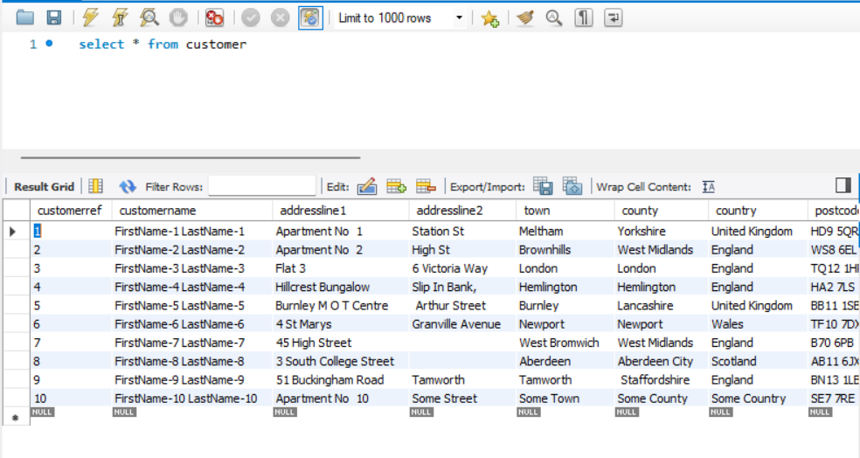

Retrieve Customer:

[http://localhost:8000/getcustomer/<customer_ref](http://localhost:8000/getcustomer/%3ccustomer_ref)>

