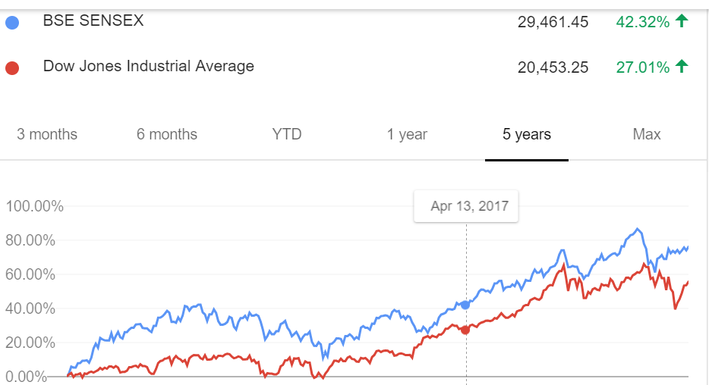

1. GDP India - quarterly
2. Interest rates india - quarterly
3. Inflation india - quarterly
4. IIP india - quarterly
5. LABEL:Class:BSE Sensex % change