Task -1) -- create 2 public and 3 private subnet and provide public internet access with the help of internet gateway, NAT gateway and creating route table.
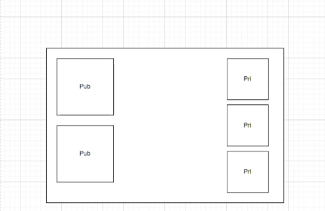

Task--2 create two subnet private and public and with provide intergateway with public intenet to vpc
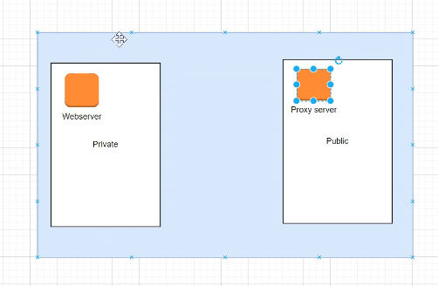
Solution https://webrobots.io/how-to-setup-a-free-proxy-server-on-amazon-ec2/
Task- 3-> create three vpc and peering it .

