Day-2:

$ docker save -o <tarfile name> <image-name>
$ docker load -I <tarfile name>

$ docker scout cves image-name
$ docker scout recommendations image-name
$ docker scout sbom image-name

⭐ What is Docker Compose? (Full Explanation)
Docker Compose is a tool used to define and run multi-container applications using a YAML file.
It allows you to describe all your services, networks, volumes, environment variables, and dependencies in one place.
In short:
Compose = Multi-container application management on a single machine.
You write a file called:
$ docker-compose.yml
Then run:
$ docker compose up
…and all your services start together with proper networking and shared volumes.

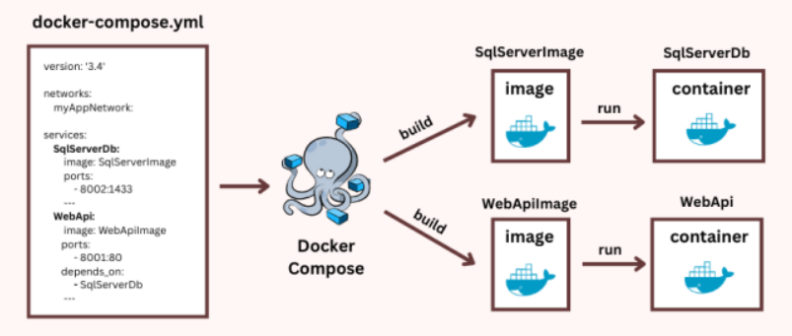

⭐ Why Docker Compose Is Useful
✔ Define entire environment in one YAML
✔ Start/stop everything with one command
✔ Shared networks & volumes automatically created
✔ Works for development, testing, staging
✔ Easy service dependencies & environment variables
✔ Allows multi-file overrides
✔ Portable between machines

⭐ Docker Compose File Structure Breakdown
A typical Compose file contains:
- services: Each container you want to run
- volumes: Persistent storage
- networks: Internal networks
- configs/secrets (Swarm mode only)

⭐ Docker Compose Example (Full Application)
Below is a real 3-service application:
Nginx (reverse proxy) + API (Node.js) + PostgreSQL (database)

📄 docker-compose.yml
version: "3.9"

services:

nginx:
image: nginx:latest
ports:
- "80:80"
volumes:
- ./nginx.conf:/etc/nginx/nginx.conf
depends_on:
- api
networks:
- frontend

api:
build: ./api # builds using API's Dockerfile
environment:
- DB_HOST=db
- DB_USER=app
- DB_PASS=app123
ports:
- "3000:3000"
depends_on:
- db
networks:
- frontend
- backend

db:
image: postgres:15
environment:
- POSTGRES_USER=app
- POSTGRES_PASSWORD=app123
- POSTGRES_DB=appdb
volumes:
- pgdata:/var/lib/postgresql/data
networks:
- backend

volumes:
pgdata:

networks:
frontend:
backend:

⭐ How to Run This Compose File
Start everything:
docker compose up -d
Check running services:
docker compose ps
See logs:
docker compose logs -f
Restart only one service:
docker compose restart api
Stop + remove containers:
docker compose down
Remove volumes also:
docker compose down -v

⭐ Important Compose Features
✔ Build images automatically
api:
build: ./api
✔ Service dependencies
depends_on:
- db
✔ Auto-created private networks
Each service can talk to others using service name:
api → http://db:5432
nginx → http://api:3000
✔ Persistent volumes
volumes:
- pgdata:/var/lib/postgresql/data
✔ Environment variables
environment:
- KEY=value
✔ Override files for dev/stage/prod
docker-compose.yml
docker-compose.override.yml
docker-compose.prod.yml

⭐ Docker Compose Use Cases
✔ Local development
✔ Testing microservices
✔ CI environment setup
✔ Running small apps on a single host
✔ Fast prototyping
Compose is NOT an orchestrator.
It DOES NOT:
- self-heal
- reschedule containers
- provide rolling updates
- distribute workloads across nodes
For that → Docker Swarm / Kubernetes is needed.

⭐ Docker Stack — What It Is Used For
Docker Stack uses a Compose-like YAML file to deploy multi-container apps to a Docker Swarm cluster.

🔥 Docker Compose vs Docker Stack
Feature | Docker Compose | Docker Stack
Scope | Single machine | Multi-node Swarm cluster
Format | docker-compose.yml | Same file but interpreted by Swarm
Build images | YES | NO (must push images)
Self-healing | NO | YES
Scheduling | NO | YES
Rolling updates | NO | YES
Secrets | Limited | Full Swarm secrets
Networking | Bridge | Overlay multi-host network

⭐ Docker Stack Command
docker stack deploy -c docker-compose.yml mystack
This:
- Creates services across the cluster
- Sets replica count
- Applies update/rollback rules
- Creates overlay networks
- Handles secrets/configs
- Ensures desired state

⭐ Stack Management Commands
Action | Command
Deploy | docker stack deploy -c file.yml mystack
List stacks | docker stack ls
List services | docker stack services mystack
List tasks | docker stack ps mystack
Remove stack | docker stack rm mystack

⭐ Example Stack File (Compose v3 for Swarm)
version: "3.8"

services:
web:
image: nginx
deploy:
replicas: 3
update_config:
parallelism: 1
order: start-first
rollback_config:
parallelism: 1
ports:
- "80:80"
networks:
- frontend

api:
image: myorg/api:1.0
deploy:
replicas: 5
resources:
limits:
cpus: "1.0"
memory: 512M
networks:
- frontend
- backend

db:
image: postgres:15
deploy:
placement:
constraints:
- node.labels.db==true
volumes:
- dbdata:/var/lib/postgresql/data
networks:
- backend

networks:
frontend:
driver: overlay
backend:
driver: overlay

volumes:
dbdata:

⭐ In One Sentence Summary
Docker Compose is for multi-container apps on a single machine.
Docker Stack deploys those apps—using the same YAML format—to a highly available multi-node Docker Swarm cluster with scaling, healing, and rollouts.

⭐ What is Docker Swarm? (In Simple + Clear Terms)
Docker Swarm is Docker’s built-in container orchestration system.
It allows you to run containers across multiple machines as if they were one large system.
Swarm provides:
- Clustering
- Scheduling
- Load balancing
- Scaling
- Rolling updates
- Desired-state self-healing
In short:
Swarm turns multiple Docker hosts into one unified cluster that runs containers reliably and at scale.

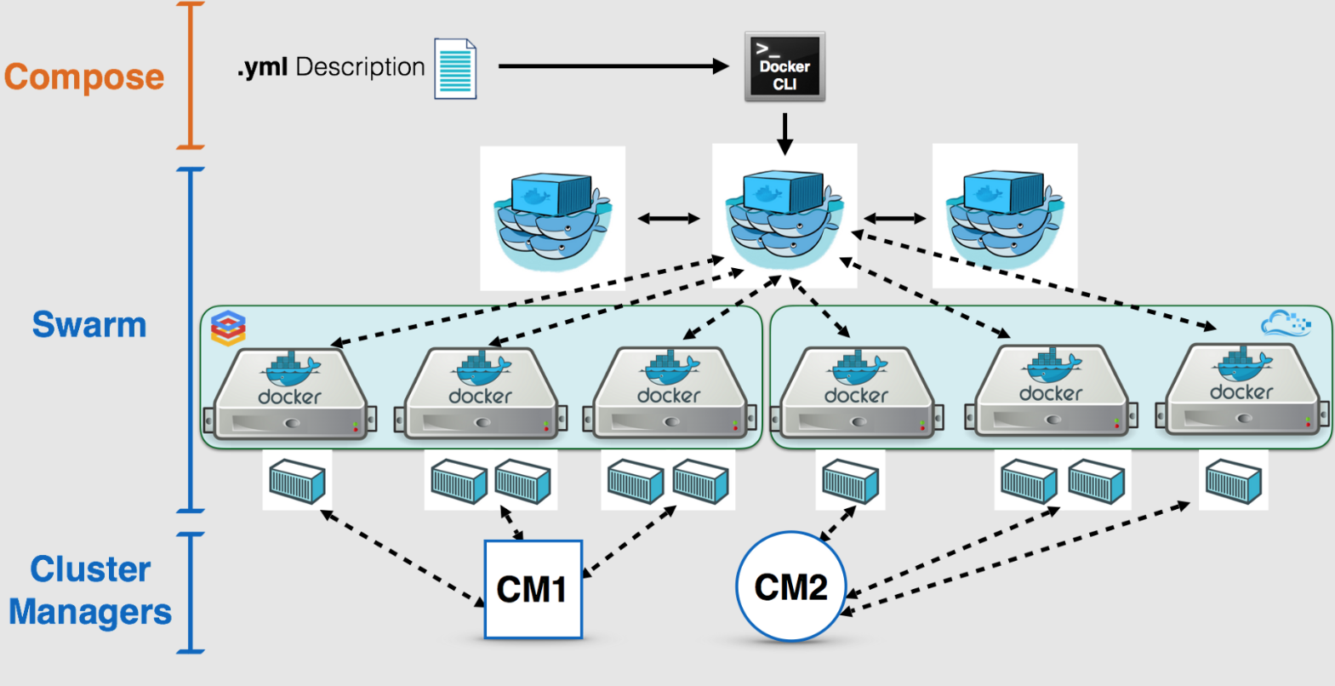

⭐ 1. Docker Swarm Architecture
A Swarm cluster has two types of nodes:
✔ Manager Nodes
- Handle cluster state
- Run the Raft consensus database
- Schedule services
- Manage desired state
- Issue certificates to nodes
One manager = OK for lab
3 or 5 managers = production (quorum)

✔ Worker Nodes
- Run containers (“tasks”)
- Receive instructions from managers
- Contribute compute capacity
You can join or remove workers anytime.

2. Key Concepts in Swarm
✔ Service
The declarative definition of a task (image, ports, replicas, constraints).
✔ Task
A running instance of a container managed by Swarm.
✔ Overlay Network
Cross-node network for multi-container apps.
✔ Desired State
Swarm ensures the declared number of replicas always run.
✔ Routing Mesh
All nodes can accept traffic for any service, even if the service is not running on that node.

⭐ 3. Docker Swarm Setup — Commands
Below is a full walkthrough of how to install and set up Docker Swarm.

Step 1 — Initialize the First Manager
$ docker swarm init --advertise-addr <MANAGER_IP>
This outputs:
- A manager join token
- A worker join token
View them again later:
docker swarm join-token manager
docker swarm join-token worker

Step 2 — Join Worker Nodes
On each worker:
docker swarm join --token <WORKER_TOKEN> <MANAGER_IP>:2377

Step 3 — View Cluster Nodes
docker node ls

Step 4 — Promote/Demote Nodes
Promote worker → manager:
docker node promote NODE-ID
Demote manager → worker:
docker node demote NODE-ID

⭐ 4. Running Services on Swarm (Commands)
Swarm uses docker service for deploying and managing applications.

Create a Service
docker service create \
--name web \
--replicas 3 \
--publish 80:80 \
nginx

List Services
docker service ls

Check where replicas are running
docker service ps web

Scale the Service
docker service scale web=10

Update the Service (Rolling Update)
docker service update --image nginx:stable web

Rollback a Failed Update
docker service rollback web

Remove a Service
docker service rm web

⭐ 5. Docker Swarm Networking
Create overlay network
docker network create -d overlay mynet
Use it in a service
docker service create \
--name api \
--network mynet \
myorg/api:1.0

$ docker service create \
--name=webapp \
--replicas=2 \
--network=mynet \
--mount=type=bind,src=./data,dst=/var/www/html \
--constraint 'node.hostname == docker-desktop' \
--publish 80:80 \
ganeshhp/webserver:112125

Create Docker volume with service creation with constraints

$ docker service create \
--name db \
--constraint 'node.hostname == docker-desktop' \
--mount type=volume,source=./mydata,target=/var/lib/mysql \
mysql:8

Create Docker volume separately.
$ docker volume create \
--driver local \
--opt type=nfs \
--opt o=addr=10.0.0.10,rw \
--opt device=:/export/data \
Nfsdata
Using it in Docker Swarm.

$ docker service create \
--name app \
--mount type=volume,source=nfsdata,target=/app/data \
myapp:1.0

⭐ 6. Docker Compose + Swarm (Docker Stack Deployment)
Swarm uses Compose v3 (stack files) for multi-container applications.
- You write a docker-compose.yml
- Deploy using docker stack deploy
Swarm ignores build images must be pre-built and pushed.

⭐ **7. Docker Compose (Stack) File — Example 1
Simple Multi-Service App**
version: "3.8"

services:
web:
image: nginx:latest
deploy:
replicas: 3
restart_policy:
condition: on-failure
ports:
- "80:80"
networks:
- frontend

api:
image: myorg/api:1.0
deploy:
replicas: 4
networks:
- frontend
- backend

db:
image: postgres:15
environment:
POSTGRES_PASSWORD: example
volumes:
- pgdata:/var/lib/postgresql/data
deploy:
placement:
constraints:
- node.role == manager
networks:
- backend

networks:
frontend:
driver: overlay
backend:
driver: overlay

volumes:
pgdata:

⭐ Deploying the stack
docker stack deploy -c docker-compose.yml mystack

⭐ Monitor the stack
docker stack ls
docker stack services mystack
docker stack ps mystack
docker service logs mystack_web -f

⭐ **8. Docker Compose (Stack) File — Example 2
With Rolling Updates, Healthchecks, Constraints**
version: "3.8"

services:
api:
image: myorg/api:2.0
deploy:
replicas: 5
update_config:
parallelism: 2
delay: 10s
order: start-first
rollback_config:
parallelism: 1
resources:
limits:
cpus: "1.0"
memory: 512M
restart_policy:
condition: on-failure
healthcheck:
test: ["CMD-SHELL", "curl -f http://localhost/health || exit 1"]
interval: 30s
timeout: 10s
retries: 3
networks:
- backend

networks:
backend:
driver: overlay
Features included:
✔ Rolling update strategy
✔ Rollback strategy
✔ Healthchecks
✔ Resource limits
✔ Replicas
✔ Overlay networks

⭐ 9. Volume Management in Swarm
Local volumes work only on that node.
For shared volumes use:
- NFS
- Ceph
- GlusterFS
- Portworx
- EFS (AWS)
Example volume:
volumes:
shareddata:
driver: local
Used as:
services:
db:
volumes:
- shareddata:/var/lib/postgresql/data

⭐ 10. Secrets in Swarm
Create secret:
echo "Admin@123" | docker secret create db_password -
Reference in compose file:
services:
api:
secrets:
- db_password

secrets:
db_password:
external: true
Swarm delivers secrets securely and encrypted.

⭐ 11. Configs (for non-sensitive files)
Create config:
docker config create nginx_conf ./nginx.conf
Use in compose:
services:
reverse:
configs:
- source: nginx_conf
target: /etc/nginx/nginx.conf

⭐ 12. Docker Swarm Cheat Sheet (Commands Summary)
Task | Command
Initialize swarm | docker swarm init
Join worker | docker swarm join --token worker
Join manager | docker swarm join --token manager
List nodes | docker node ls
Promote node | docker node promote
Create service | docker service create
Scale | docker service scale svc=10
Rolling update | docker service update
Rollback | docker service rollback
Deploy stack | docker stack deploy
List stack services | docker stack services mystack
Service logs | docker service logs svc

⭐ Summary (Short & Clear)
Docker Swarm lets you deploy and manage multi-container applications across many machines with:
- Desired-state scheduling
- Rolling updates
- Self-healing
- Secure secrets management
- Multi-host overlay networking
- Declarative stack files
It works using simple Docker-native commands and Docker Compose files.

