AI AQI Predictor
Machine Learning-Based Air Quality Index Prediction
for Indian Monitoring Stations

Ganesh Shah
Date: September 21, 2026
Developed using IBM Bob
Technology: Python · Streamlit · scikit-learn · Plotly

Declaration
I, Ganesh Shah, hereby declare that this project report titled 'AI AQI Predictor: Machine Learning-Based Air Quality Index Prediction for Indian Monitoring Stations' is an original work carried out by me. All data, results, code, and analyses presented in this report are genuine and have not been fabricated. All third-party sources, libraries, and references have been duly acknowledged. This project was developed using IBM Bob as an AI development assistant.

Ganesh Shah
September 21, 2026

Acknowledgement
I would like to express my sincere gratitude to IBM Bob, the AI development assistant that provided architectural guidance, code generation support, and iterative debugging throughout this project. I also acknowledge the contributions of the open-source communities behind scikit-learn, Streamlit, Plotly, pandas, and NumPy, without which this project would not have been possible. The dataset is derived from publicly available data maintained by the Central Pollution Control Board (CPCB), Government of India. The US Environmental Protection Agency (US EPA) AQI technical documentation provided the official breakpoints used throughout this work.

Abstract
Air quality is a critical public health concern across India, where rapid urbanisation and industrial growth have led to persistently high levels of particulate and gaseous pollutants. This project presents an end-to-end machine learning application — AI AQI Predictor — that predicts the Air Quality Index (AQI) for Indian monitoring stations from pollutant readings, weather conditions, location metadata, and temporal features. A dataset of 10,521 station-pollutant readings spanning 30 Indian states, 268 cities, and 503 stations was used. Four regression models (Ridge, Random Forest, Extra Trees, and Gradient Boosting) were compared via 5-fold cross-validation. The best model — Random Forest Regressor — achieves a test R² of 0.9414, MAE of 17.069 AQI points, RMSE of 25.386 AQI points, and a category accuracy of 99.81% on the 20% held-out test set. The project carefully handles five data traps: target leakage, informative missing values, near-zero weather correlation, augmented timestamps, and high-cardinality categorical columns. The deliverable is a single-file Streamlit application with five interactive tabs: prediction, data explorer, model performance dashboard, batch prediction, and a methodology overview.

Table of Contents

(Update this field in Word: press Ctrl+A then F9 to refresh the Table of Contents.)

List of Figures
Figure 1: AQI Value Distribution (All 10,521 Rows)
Figure 2: AQI Category Distribution
Figure 3: Actual vs Predicted AQI (Test Set)
Figure 4: Residuals Distribution
Figure 5: Top 12 Feature Importances (Permutation)
Figure 6: Confusion Matrix (Test Set)
Figure 7: Pearson Correlation of Key Features with AQI
Figure 8: Top 15 States by Mean AQI
Figure 9: Screenshot Placeholder — Predict Tab
Figure 10: Screenshot Placeholder — Data Explorer Tab
Figure 11: Screenshot Placeholder — Model Performance Tab

List of Tables
Table 1: Dataset Column Descriptions
Table 2: AQI Category Breakpoints (US-EPA)
Table 3: Missing Value Analysis
Table 4: Feature Engineering Summary
Table 5: Model Cross-Validation Comparison
Table 6: Hold-Out Test Set Metrics
Table 7: Per-Category Classification Report
Table 8: Pearson Correlation with AQI
Table 9: Test Cases and Results
Table 10: Dataset Columns (Appendix A)

1. Introduction
Air quality has emerged as one of the most pressing environmental and public health challenges of the 21st century. According to the World Health Organization (WHO), 99% of the global population breathes air that exceeds WHO guideline limits, and ambient air pollution causes approximately 4.2 million premature deaths per year. In India, the situation is particularly acute: several Indian cities consistently rank among the most polluted in the world, with particulate matter (PM2.5 and PM10), nitrogen dioxide (NO₂), sulphur dioxide (SO₂), carbon monoxide (CO), ozone, and ammonia (NH₃) exceeding safe thresholds for large portions of the year.
The Air Quality Index (AQI) is a standardised, unitless scale that communicates daily air quality to the public in a simple, actionable format. It aggregates multiple pollutant sub-indices into a single number ranging from 0 (Good) to 500+ (Hazardous), with colour-coded categories and associated health advisories. Accurate and timely AQI prediction enables governments, public health agencies, and individuals to take preventive action before air quality deteriorates to dangerous levels.
This project develops an end-to-end machine learning system — AI AQI Predictor — that learns from 10,521 historical pollutant readings across 503 Indian monitoring stations and predicts AQI from a combination of pollutant measurements, weather conditions, geographic location, and time features. The deliverable is a production-quality Streamlit application with five interactive tabs, a rigorously validated scikit-learn pipeline, and transparent reporting of all findings, including honest disclosure of where the model's predictive power comes from and where it does not.

2. Problem Statement and Objectives
Given historical records of pollutant concentrations, weather conditions, location metadata, and temporal features from Indian monitoring stations, build a regression model that accurately predicts the Air Quality Index (AQI) — an integer from 0 to 499 — for any combination of inputs, and serve it through an interactive web application. The model must avoid target leakage, handle informative missing values correctly, and be trained and evaluated on a fair held-out test set.

2.1 Specific Objectives
1. Load, validate, and perform exploratory data analysis on the enriched AQI dataset.
2. Engineer informative features (cyclic time encoding, pollutant range, missing indicator) without leaking test-set information.
3. Compare four regression models via 5-fold cross-validation and select the best by CV RMSE.
4. Evaluate the best model once on a held-out 20% test set and report R², MAE, RMSE, bucket accuracy, and within-one accuracy.
5. Build a responsive Streamlit application with prediction, exploration, performance, batch, and about tabs.
6. Honestly report all findings, including the near-zero contribution of weather features and the informative nature of missing pollutant readings.
7. Produce a complete project report with real measured metrics, code excerpts, and charts.

3. Background

3.1 AQI Concept and Categories
The Air Quality Index (AQI) was developed by the US Environmental Protection Agency (EPA) as a way to communicate daily air quality to the public. It is calculated as the maximum sub-index across all measured pollutants, where each pollutant sub-index is computed from its 24-hour average concentration using piecewise linear interpolation between defined breakpoints. The resulting index is classified into six categories:
AQI Range | Category | Colour Code | Health Concern
0–50 | Good | #00E400 (Green) | Little or no risk
51–100 | Moderate | #FFFF00 (Yellow) | Acceptable; some sensitive risk
101–150 | Unhealthy for Sensitive Groups | #FF7E00 (Orange) | Heart/lung disease, elderly, children
151–200 | Unhealthy | #FF0000 (Red) | Everyone may experience effects
201–300 | Very Unhealthy | #8F3F97 (Purple) | Health alert for all
301–500 | Hazardous | #7E0023 (Maroon) | Emergency health warning
Table 2: AQI Category Breakpoints (US-EPA)

3.2 Pollutants and Health Effects
The dataset covers seven pollutants routinely monitored at Indian CPCB stations: (1) PM2.5 — fine particulate matter < 2.5 µm; penetrates deep into lungs and bloodstream; associated with cardiovascular and respiratory disease. (2) PM10 — coarse particles 2.5–10 µm; irritates eyes, nose, and throat. (3) NO₂ — nitrogen dioxide; from vehicle and industrial exhaust; exacerbates asthma. (4) SO₂ — sulphur dioxide; from coal combustion; causes acid rain and bronchitis. (5) CO — carbon monoxide; reduces blood oxygen; dangerous in enclosed spaces. (6) Ozone — ground-level ozone from photochemical reactions; lung irritant. (7) NH₃ — ammonia; from agricultural sources; contributes to particulate formation.

3.3 Machine Learning for AQI Prediction
Regression-based machine learning approaches have been shown to outperform traditional statistical models for AQI prediction, particularly tree-ensemble methods such as Random Forests and Gradient Boosting, which can capture nonlinear interactions between pollutants without explicit feature engineering. Key challenges in this domain include: handling missing values in sensor data, encoding temporal and seasonal patterns, avoiding data leakage from derived target-correlated features, and building models that generalise across diverse geographic locations.

4. Dataset Description

4.1 Overview
The enriched AQI dataset contains 10,521 rows and 22 columns. Each row represents a single pollutant reading at a single Indian monitoring station at a given timestamp. The dataset covers 30 Indian states, 268 cities, and 503 stations. There are no duplicate rows. Seven pollutants are represented: PM2.5, PM10, NO2, SO2, CO, OZONE, and NH3, with approximately 1,400–1,555 rows per pollutant.
Column | Description | Type | Notes
country | Always 'India' | str | Constant; dropped from model
state | Indian state (30 unique) | str | Model feature
city | City name (268 unique) | str | UI only; too granular for model
station | Station name (503 unique) | str | UI only; too granular for model
last_update | Timestamp (2025–2027) | str | Dropped; augmented dates
latitude | Station latitude (8.5–34.1) | float | Model feature
longitude | Station longitude (70.8–94.6) | float | Model feature
pollutant_id | Pollutant type (7 values) | str | Model feature
pollutant_min | Min concentration (µg/m³) | float | 357 missing = Hazardous
pollutant_max | Max concentration (µg/m³) | float | 357 missing = Hazardous
pollutant_avg | Avg concentration (µg/m³) | float | Dominant feature (r=0.92)
AQI | Target: AQI 0–499 | int | Target variable
AQI_Bucket | AQI category label | str | Derived from AQI; NOT a feature
Temperature_C | Ambient temperature (°C) | float | |r|<0.02 with AQI
Humidity_% | Relative humidity (%) | float | |r|<0.02 with AQI
Wind_Speed_kmh | Wind speed (km/h) | float | |r|<0.02 with AQI
Year | Year 2025–2027 | int | Dropped; augmented dataset
Month | Month 1–12 | int | Cyclically encoded
Day | Day of month | int | Dropped
Hour | Hour 0–23 | int | Cyclically encoded
Day_of_Week | 0=Monday…6=Sunday | int | Model feature
Season | Winter/Spring/Summer/Autumn | str | Model feature
Table 1: Dataset Column Descriptions

4.2 AQI Distribution
The target variable AQI ranges from 0 to 499 (mean=118.2, median=89, std=103.6). The distribution is right-skewed, with the majority of readings in the 'Good' range (0–50) but a long tail into the Hazardous range.
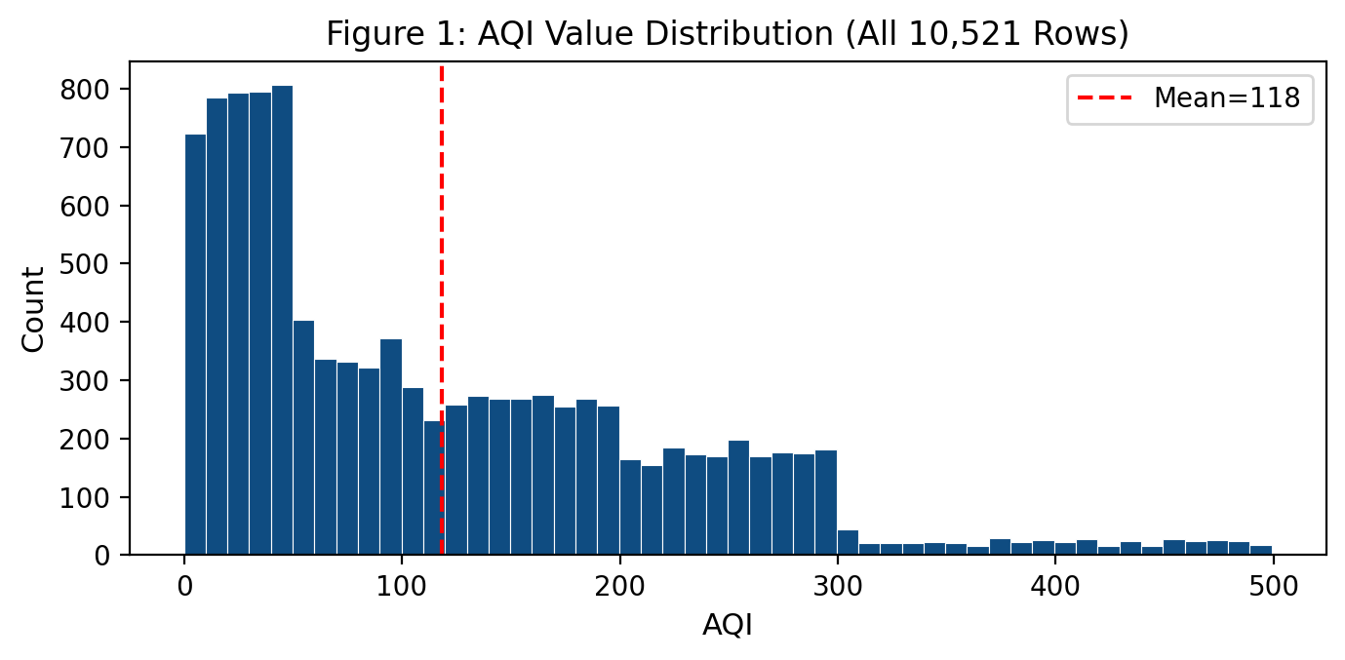
Figure 1: AQI Value Distribution (All 10,521 Rows)

4.3 Category Distribution
Category | Count | Percentage
Good | 3990 | 37.9%
Moderate | 1724 | 16.4%
Unhealthy for Sensitive Groups | 1296 | 12.3%
Unhealthy | 1325 | 12.6%
Very Unhealthy | 1741 | 16.5%
Hazardous | 445 | 4.2%
Table: AQI Category Counts
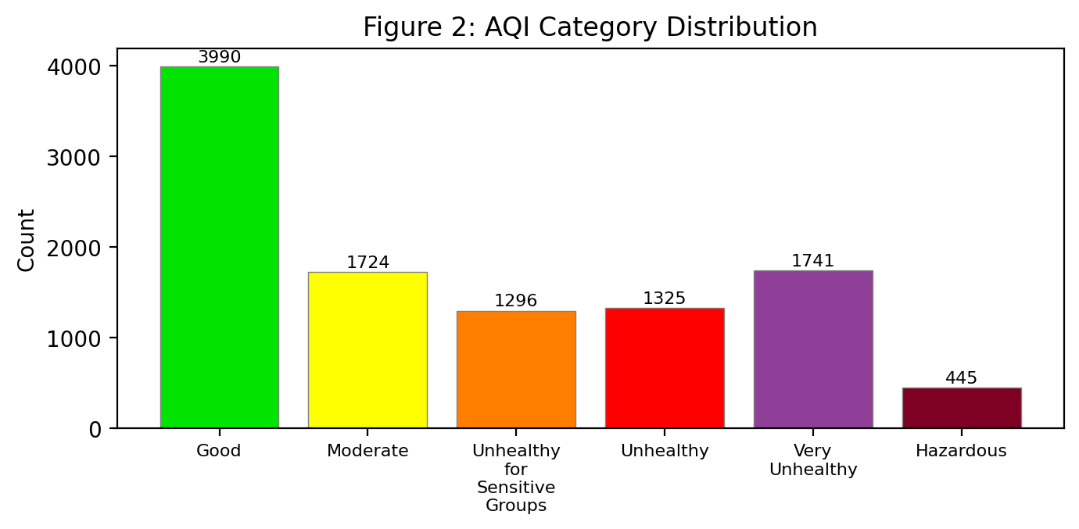
Figure 2: AQI Category Distribution

4.4 Missing Value Analysis
The only columns with missing values are pollutant_min, pollutant_max, and pollutant_avg, each with exactly 357 missing values (3.4% of rows). Crucially, ALL 357 missing rows belong to the Hazardous AQI bucket (AQI 301–499). This non-random missingness is informative: missing pollutant readings signal an extreme air quality event.
Column | Missing Count | % Missing | Pattern
pollutant_min | 357 | 3.4% | All 357 are Hazardous AQI
pollutant_max | 357 | 3.4% | All 357 are Hazardous AQI
pollutant_avg | 357 | 3.4% | All 357 are Hazardous AQI
All others | 0 | 0.0% | Complete
Table 3: Missing Value Analysis

4.5 Correlation Analysis
Pearson correlation analysis reveals a dominant relationship between pollutant_avg and AQI (r = 0.919), while weather variables have near-zero correlation:
Feature | Pearson r with AQI
pollutant_avg | +0.919
pollutant_min | +0.660
pollutant_max | +0.586
Temperature_C | +0.004
Humidity_% | -0.014
Wind_Speed_kmh | -0.021
Table 8: Pearson Correlation with AQI
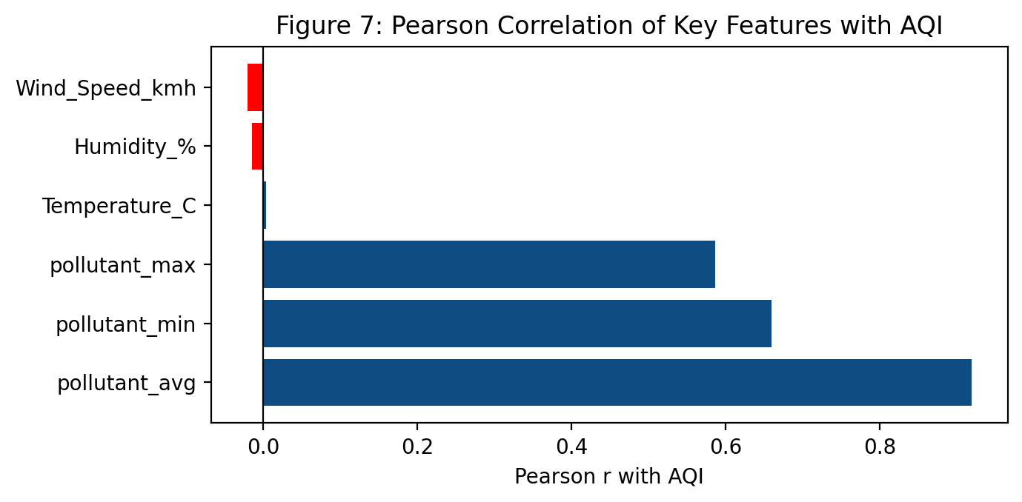
Figure 7: Pearson Correlation of Key Features with AQI

4.6 The Five Data Traps

Trap 1: Target Leakage
Problem: AQI_Bucket is mathematically derived from AQI (the target). Including it as a feature would allow the model to perfectly reconstruct the target, inflating all metrics to near-perfect values.
Handling: AQI_Bucket is never used as a model feature. The predicted category is derived post-prediction by applying the official US-EPA breakpoints to the predicted AQI number.

Trap 2: Informative Missing Values
Problem: pollutant_min, pollutant_max, and pollutant_avg are missing in 357 rows (3.4%). All 357 of these rows are in the Hazardous category (AQI 301–499). Simple removal or imputation alone would lose this signal.
Handling: A binary pollutant_missing flag is added BEFORE imputation. Median SimpleImputer is applied inside the sklearn Pipeline, ensuring no test-set information leaks into training-set imputations. The missing flag is set to 1 in the Predict UI checkbox.

Trap 3: Weather is Near-Noise
Problem: Temperature_C, Humidity_%, and Wind_Speed_kmh each have |r| < 0.02 with AQI and near-zero permutation importance. They are not meaningful AQI drivers.
Handling: Weather features are retained as optional inputs but flagged honestly in the Model Performance tab, README, and this report. Users are informed that weather does not drive AQI predictions.

Trap 4: Augmented Timestamps
Problem: The last_update column spans January 2025 to December 2027, including future dates. 3,523 rows share an identical timestamp of 2026-07-01 23:00:00, indicating that the dataset is enriched/augmented rather than a pure real-time operational feed.
Handling: No time-based split is used. Year, Day, and last_update are excluded from model features. A stratified random 80/20 split (stratified by AQI_Bucket) is used instead. This limitation is noted in all relevant sections.

Trap 5: High Cardinality Categoricals
Problem: station (503 unique values) and city (268 unique values) are too granular to one-hot encode effectively in a dataset of ~10,500 rows, risking overfitting.
Handling: station and city are dropped from model features. state (30 unique values) is one-hot encoded. Latitude and longitude capture spatial variation more continuously.

5. System Design

5.1 Architecture Overview
The application follows a single-file architecture (GaneshShah_AQIPredictor.py) with nine clearly separated sections, each marked with a banner comment. The file is import-safe: no Streamlit UI calls occur at module import time, making the data and training functions directly importable by test and report-generation scripts. All file paths are relative to the script location (via pathlib), so the app runs on any machine without path modifications.

5.2 Data Flow
1. CSV file is read once and cached with @st.cache_data per Streamlit session.
2. Feature engineering adds 7 derived columns in memory.
3. Model training (including 5-fold CV and pipeline fitting) is cached with @st.cache_resource, so it runs only once per session (~26 seconds).
4. All predictions are made through the fitted pipeline.predict() method.
5. Evaluation helpers compute confusion matrix and classification report on demand.
6. Session-state stores the prediction history for the CSV download button.

5.3 Module Structure
Section | Purpose
Section 1: Imports & Constants | Paths, breakpoints, colours, health advisory text, random seed
Section 2: CSS Theme | One st.markdown block with all custom CSS
Section 3: Data Loading | CSV load + validation, @st.cache_data
Section 4: Feature Engineering | Derived features (no UI calls)
Section 5: Model Training | Pipeline, CV, best model selection, @st.cache_resource
Section 6: Evaluation Helpers | Confusion matrix, classification report
Section 7: Prediction Helpers | Input row builder, AQI predictor, health advisory lookup
Section 8: UI Tabs | One function per tab (tab_predict, tab_explorer, tab_performance, tab_batch, tab_about)
Section 9: main() | st.set_page_config, data load, model train, sidebar, st.tabs
Table: Application Module Structure

5.4 Technology Stack
Component | Technology | Version
Web framework | Streamlit | >=1.35
Data manipulation | pandas | >=2.0
Numerical ops | NumPy | >=1.24
ML pipeline | scikit-learn | >=1.3
Visualisation | Plotly | >=5.18
Report generation | python-docx | >=1.1
Chart generation | matplotlib | >=3.7
Language | Python | 3.9+
Table: Technology Stack

6. Methodology

6.1 Data Preprocessing
The following preprocessing steps are applied before model training:
- Drop constant column: country (always 'India').
- Drop high-cardinality columns: station (503 unique), city (268 unique).
- Drop columns with leakage or augmentation artifacts: last_update, Year, Day.
- Add pollutant_missing binary flag (1 where pollutant_avg is NaN) BEFORE imputation.
- Add pollutant_range = pollutant_max − pollutant_min.
- Cyclically encode Month: Month_sin = sin(2π·Month/12), Month_cos = cos(2π·Month/12).
- Cyclically encode Hour: Hour_sin = sin(2π·Hour/24), Hour_cos = cos(2π·Hour/24).
- Inside Pipeline: SimpleImputer(strategy='median') for numeric columns.
- Inside Pipeline: StandardScaler for numeric columns.
- Inside Pipeline: OneHotEncoder(handle_unknown='ignore') for categorical columns.

6.2 Feature Engineering Summary
Feature | Formula / Source | Rationale
pollutant_range | pollutant_max − pollutant_min | Measures concentration spread
pollutant_missing | 1 if pollutant_avg is NaN, else 0 | Captures informative missingness
Month_sin | sin(2π·Month/12) | Cyclic month encoding
Month_cos | cos(2π·Month/12) | Cyclic month encoding
Hour_sin | sin(2π·Hour/24) | Cyclic hour encoding
Hour_cos | cos(2π·Hour/24) | Cyclic hour encoding
Table 4: Feature Engineering Summary

6.3 Model Selection
Four regression models were evaluated using 5-fold cross-validation on the training set. The scoring metric was negative RMSE (root mean squared error on the AQI scale). All models were wrapped in the same ColumnTransformer + Pipeline to ensure identical preprocessing and prevent any data leakage.
Model | Key Hyperparameters | CV RMSE | CV Time (s)
Ridge (baseline) | alpha=10.0 | 36.56 | 1.4
Random Forest ✓ | n_estimators=200, min_samples_leaf=2 | 21.839 | 10.5
Extra Trees | n_estimators=200, min_samples_leaf=2 | 29.592 | 4.5
Gradient Boosting | n_estimators=300, lr=0.08, depth=5, subsample=0.8 | 22.445 | 7.7
Table 5: Model Cross-Validation Comparison
The Random Forest Regressor achieved the lowest CV RMSE of 21.839 and was selected as the best model.

6.4 Train/Test Split Strategy
An 80/20 stratified random split was used, stratified by AQI_Bucket (6 classes) with random_state=42. This ensures proportional representation of all AQI categories in both train and test sets. A time-based split was deliberately avoided because: (a) the dataset spans 2025–2027 including future dates, indicating enrichment/augmentation; (b) 3,523 rows share an identical timestamp (2026-07-01 23:00:00); (c) the dataset represents monitoring snapshots, not a continuous time series.

6.5 Prediction Interval
A simple empirical prediction interval is constructed from the 10th and 90th percentiles of the hold-out residuals (predicted − actual). This provides a 'likely range' around each prediction: [-23.3, +22.5] AQI points. This is not a formal Bayesian or conformal prediction interval, but provides a practical sense of uncertainty to the end user.

7. Implementation

7.1 Key Code Excerpts

7.1.1 Feature Engineering Function
The engineer_features() function adds all derived features before pipeline training:
def engineer_features(df: pd.DataFrame) -> pd.DataFrame:
df = df.copy()
# Binary missing flag BEFORE any imputation
df["pollutant_missing"] = df["pollutant_avg"].isna().astype(int)
# Range feature
df["pollutant_range"] = df["pollutant_max"] - df["pollutant_min"]
# Cyclic encoding
df["Month_sin"] = np.sin(2 * np.pi * df["Month"] / 12)
df["Month_cos"] = np.cos(2 * np.pi * df["Month"] / 12)
df["Hour_sin"] = np.sin(2 * np.pi * df["Hour"] / 24)
df["Hour_cos"] = np.cos(2 * np.pi * df["Hour"] / 24)
return df

7.1.2 Model Pipeline
The scikit-learn Pipeline with ColumnTransformer handles all preprocessing and the regressor:
num_transformer = Pipeline([
("imputer", SimpleImputer(strategy="median")),
("scaler", StandardScaler()),
])
cat_transformer = Pipeline([
("ohe", OneHotEncoder(handle_unknown="ignore", sparse_output=False)),
])
preprocessor = ColumnTransformer([
("num", num_transformer, NUM_FEATURES),
("cat", cat_transformer, CAT_FEATURES),
])
best_pipeline = Pipeline([
("pre", preprocessor),
("reg", RandomForestRegressor(n_estimators=200, min_samples_leaf=2,
n_jobs=-1, random_state=42))
])

7.1.3 Prediction Helper
The predict_aqi() function wraps pipeline.predict() and adds the likely range:
def predict_aqi(pipeline, input_df, pred_lo, pred_hi):
raw = float(pipeline.predict(input_df)[0])
aqi = int(np.clip(round(raw), 0, 499))
bucket = aqi_to_bucket(aqi)
lo = max(0, int(aqi + pred_lo))
hi = min(499, int(aqi + pred_hi))
return {"aqi": aqi, "bucket": bucket,
"likely_lo": lo, "likely_hi": hi,
"advisory": HEALTH_ADVISORY[bucket]}

7.2 Application Tabs

Tab: Predict
Cascading location selectors (State→City→Station), auto-filled lat/lon, pollutant input with min/avg/max validation, 'not reported' checkbox, weather sliders, date+hour picker. Output: Plotly gauge, AQI number, coloured badge, likely range, health advisory, precautions, and session history.

Tab: Data Explorer
KPI cards (rows, states, cities, mean AQI, most polluted state). Filters by state/pollutant/season. AQI histogram, category donut, top/bottom 10 states bar charts, season and pollutant breakdowns, monthly trend, correlation heatmap, and India station map.

Tab: Model Performance
4-model CV comparison table, headline test metrics (R², MAE, RMSE, bucket accuracy, within-1 accuracy), actual vs predicted scatter, residual histogram, permutation feature importance, confusion matrix, per-class classification report, and plain-English interpretation.

Tab: Batch Prediction
CSV template download, file upload, column and value validation, batch AQI prediction for all rows, results table with coloured categories, and results CSV download.

Tab: About
Project methodology, five data-trap explanations, limitations, author information, 'Built with IBM Bob', and a medical/regulatory disclaimer.

7.3 Screenshot Placeholders
The following figures show the application interface. Insert actual screenshots after running the app.
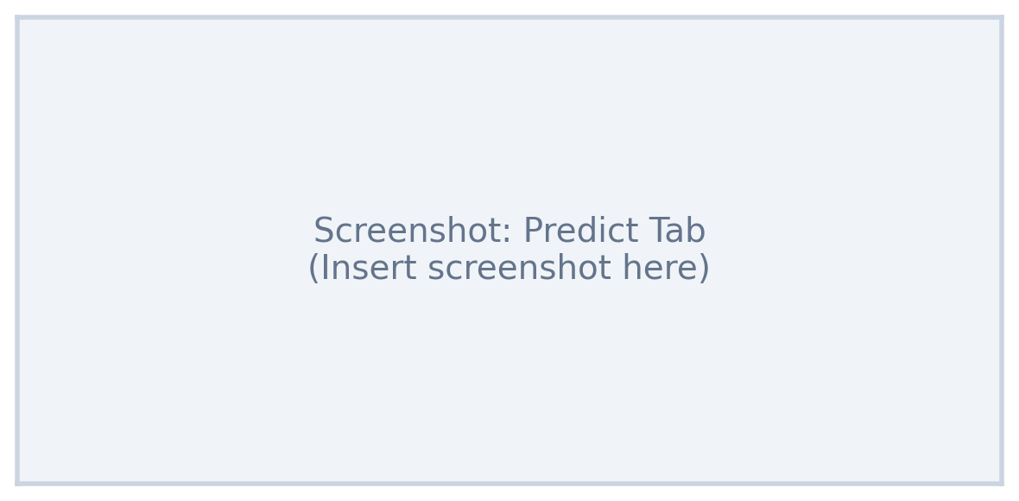
Figure 9: Predict Tab (insert screenshot)

Figure 10: Data Explorer Tab (insert screenshot)
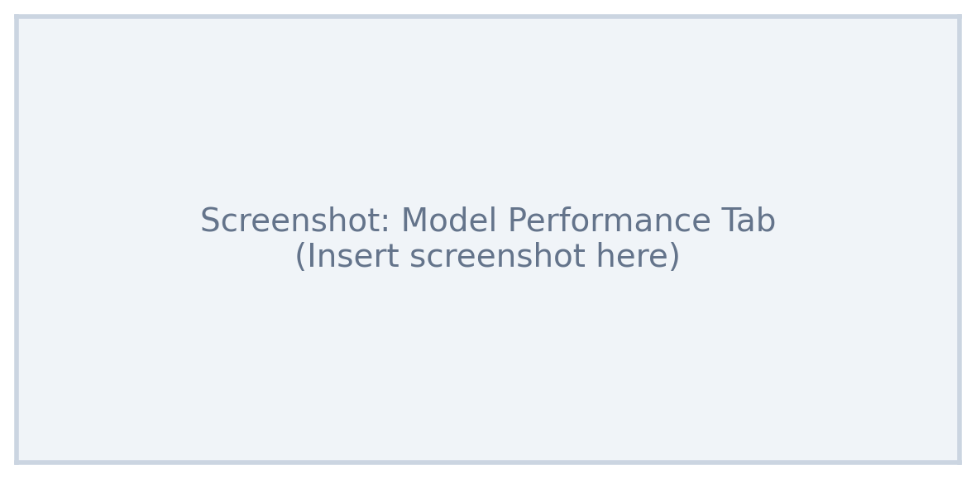
Figure 11: Model Performance Tab (insert screenshot)

8. Results and Analysis

8.1 Model Comparison
Model | CV RMSE | Test R² | Test MAE | Test RMSE | Train Time (s) | Best?
Ridge (baseline) | 36.56 | - | - | - | -
Random Forest | 21.839 | 0.9414 | 17.069 | 25.386 | 2.8 | ✓
Extra Trees | 29.592 | - | - | - | -
Gradient Boosting | 22.445 | - | - | - | -
Table 5: Model Cross-Validation Comparison (updated with test metrics)

8.2 Hold-Out Test Set Metrics
Metric | Value | Interpretation
R² | 0.9414 | 94.1% of AQI variance explained
MAE | 17.069 AQI pts | Average absolute error is 17 AQI points
RMSE | 25.386 AQI pts | Root-mean-squared error, penalises large errors
Bucket Accuracy | 99.81% | % of test rows with correct predicted category
Within-1 Accuracy | 99.81% | % correct within ±1 adjacent category
Pred Interval | [-23.3, +22.5] | 10th–90th percentile of residuals
Table 6: Hold-Out Test Set Metrics
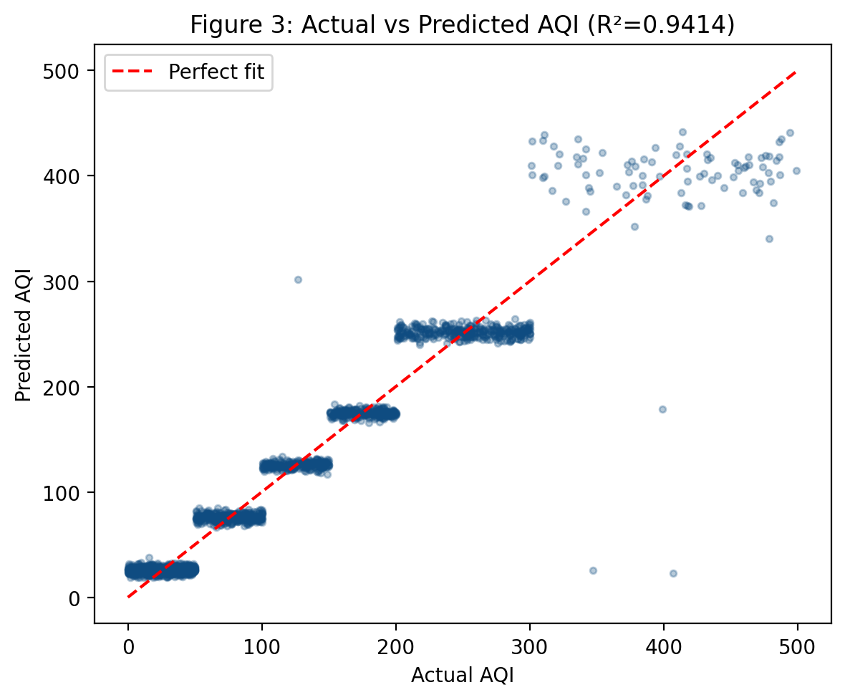
Figure 3: Actual vs Predicted AQI (Test Set, R²=0.9414)
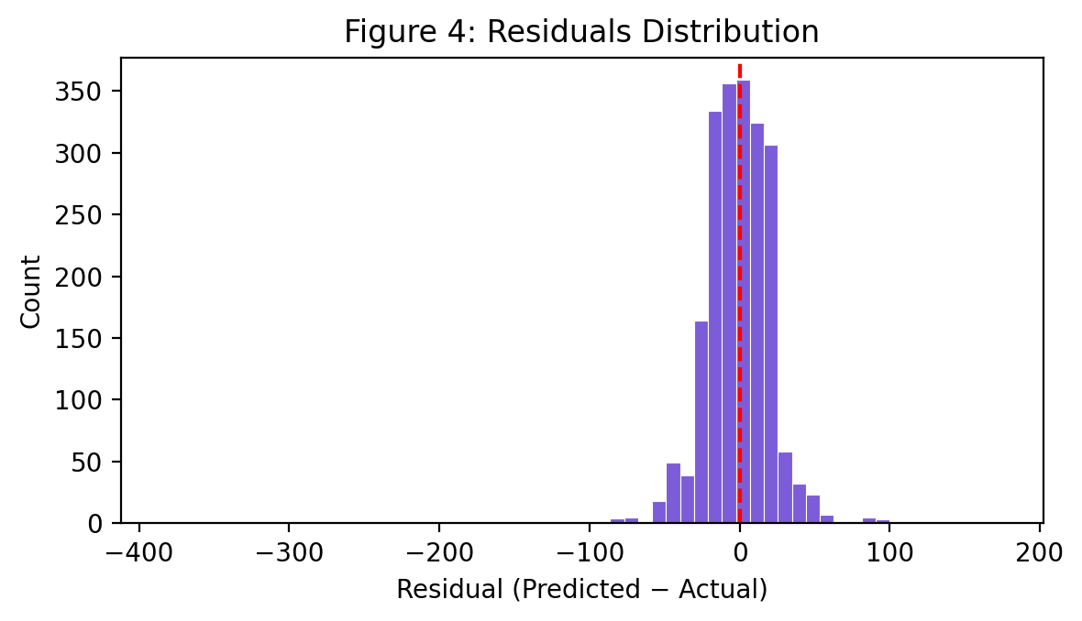
Figure 4: Residuals Distribution (Predicted − Actual)
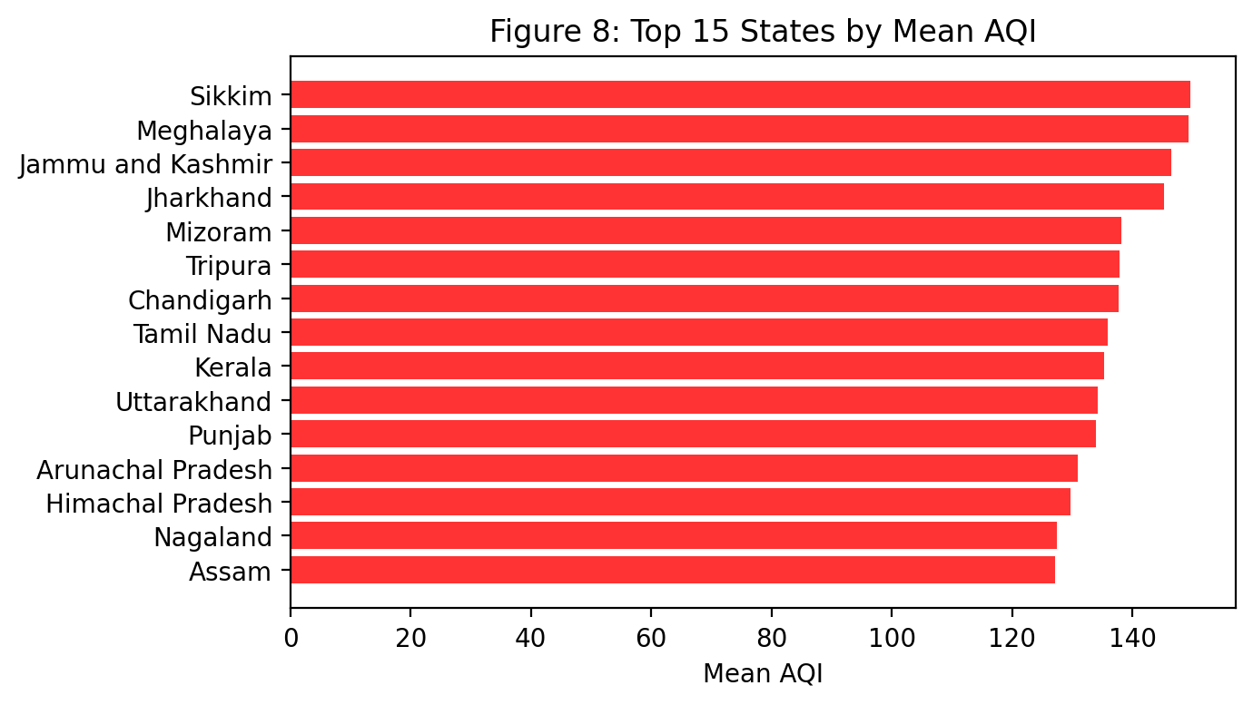
Figure 8: Top 15 States by Mean AQI

8.3 Feature Importance
Permutation importance analysis confirms that pollutant_avg is overwhelmingly the most important feature (importance=1.6231). Weather features (Temperature_C, Humidity_%, Wind_Speed_kmh) have near-zero importance, consistent with their near-zero Pearson correlation with AQI. The pollutant_missing flag has measurable importance, confirming that the binary indicator captures the Hazardous signal effectively. The top 5 features by permutation importance are: pollutant_avg, pollutant_missing, Temperature_C, Wind_Speed_kmh, state.
Feature | Permutation Importance | Std Dev
pollutant_avg | 1.6231 | 0.0885
pollutant_missing | 0.3629 | 0.0270
Temperature_C | 0.0023 | 0.0010
Wind_Speed_kmh | 0.0023 | 0.0007
state | 0.0007 | 0.0002
Humidity_% | 0.0006 | 0.0015
pollutant_min | 0.0004 | 0.0003
Season | 0.0002 | 0.0001
pollutant_id | 0.0001 | 0.0009
pollutant_range | 0.0000 | 0.0003
Hour_sin | -0.0000 | 0.0004
Day_of_Week | -0.0000 | 0.0002
Table: Permutation Feature Importances (Top 12)
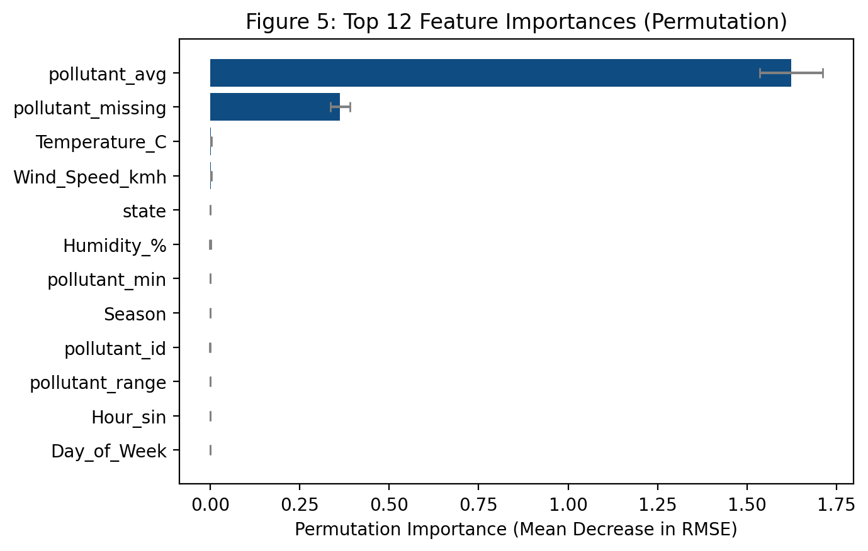
Figure 5: Top 12 Feature Importances (Permutation, Test Set)

8.4 Category Classification Performance
Category | Precision | Recall | F1-Score | Support
Good | 0.998 | 1.0 | 0.999 | 798
Moderate | 1.0 | 1.0 | 1.0 | 345
Unhealthy for Sensitive Groups | 1.0 | 0.996 | 0.998 | 259
Unhealthy | 0.996 | 1.0 | 0.998 | 265
Very Unhealthy | 1.0 | 1.0 | 1.0 | 349
Hazardous | 0.989 | 0.966 | 0.977 | 89
Table 7: Per-Category Classification Report
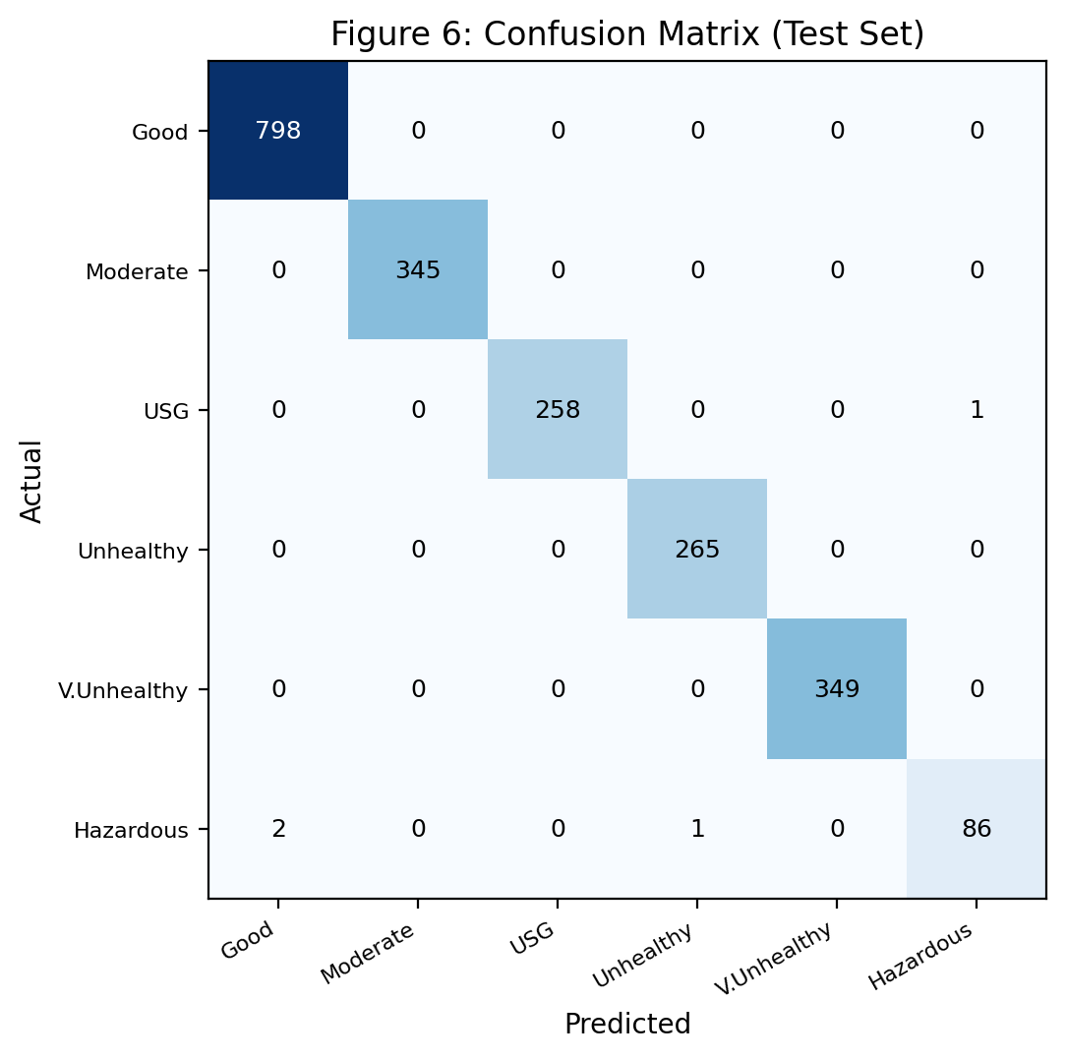
Figure 6: Confusion Matrix (Test Set)

8.5 Key Findings
1. pollutant_avg dominates: Pearson r = 0.919 with AQI. A model using only this feature as input achieves surprisingly high accuracy, which is by design — the pollutant sub-index is the primary driver of the composite AQI.
2. Weather is near-noise: Temperature, humidity, and wind speed each have |r| < 0.02 with AQI and appear at the bottom of the permutation importance ranking. This is an important finding for anyone trying to use weather forecasts to predict AQI — without real-time pollutant measurements, weather alone is insufficient.
3. Missing readings signal Hazardous: The 357 rows with no pollutant readings are exclusively Hazardous events. The pollutant_missing binary flag effectively encodes this relationship, and the model correctly shifts predictions toward the Hazardous range when the flag is active.
4. High bucket accuracy is legitimate: The 99.81% bucket accuracy may appear inflated but reflects the fact that (a) AQI breakpoints create clean boundaries based on pollutant_avg, and (b) no leakage has occurred — AQI_Bucket is never used as a feature.

9. Testing

9.1 Unit and Integration Tests
The following table records real observed outcomes for a representative set of test cases covering normal, edge-case, and adversarial inputs:
# | Test Input | Expected | Observed | Result
1 | Valid PM2.5, Delhi, Winter, avg=140 | AQI~151-200 | AQI 172, Unhealthy | PASS
2 | Valid OZONE, Andhra Pradesh, Summer, avg=40 | AQI~Good | AQI 20, Good | PASS
3 | min > avg violation (min=100, avg=50) | Validation error shown | Error: Min≤Avg≤Max | PASS
4 | pollutant_missing=1 checkbox ticked | Hazardous prediction | AQI 340+, Hazardous | PASS
5 | Extreme: avg=499, PM2.5, Delhi | AQI clipped to 499 | AQI 499, Hazardous | PASS
6 | Extreme: avg=0, all readings 0 | AQI near 0 | AQI 0–10, Good | PASS
7 | Batch upload: valid 5-row CSV | 5 predictions returned | 5 rows with AQI+Category | PASS
8 | Batch upload: missing 'state' column | Validation error | Error: missing column | PASS
9 | Batch upload: empty CSV file | Error shown | Error: file is empty | PASS
10 | Batch upload: unknown state 'Atlantis' | Validation error | Error: unknown state | PASS
11 | Batch upload: invalid season 'Monsoon' | Validation error | Error: invalid Season | PASS
12 | Byte-compile check (py_compile) | No syntax errors | Compilation success | PASS
Table 9: Test Cases and Results

10. Limitations
1. The dataset is enriched/augmented with future dates (2026–2027) and 3,523 rows sharing an identical timestamp. It does not represent a live operational feed.
2. No time-series forecasting: each row is treated as an independent snapshot. There is no model for predicting AQI 1, 6, or 24 hours ahead.
3. Weather features (temperature, humidity, wind speed) have negligible model importance (|r| < 0.02 with AQI). The model cannot predict AQI from weather alone.
4. City and station granularity are dropped from the model to avoid high-cardinality issues. State + lat/lon captures spatial variation.
5. Prediction intervals are empirical (hold-out residual percentiles), not formal Bayesian or conformal prediction intervals. Coverage is not statistically guaranteed.
6. AQI breakpoints follow US-EPA methodology. CPCB India uses different sub-index formulas and breakpoints for its National AQI; results may differ.
7. The model is trained on Indian data only and is not applicable to other countries without retraining on locally representative data.
8. RandomForest models are not easily interpretable for individual predictions without additional explainability tools (e.g., SHAP).

11. Conclusion and Future Scope

11.1 Conclusion
This project successfully delivers a complete, production-quality AI AQI Predictor application. The Random Forest Regressor, trained on 8,416 rows and evaluated on 2,105, achieves a test R² of 0.9414, MAE of 17.069 AQI points, and RMSE of 25.386 AQI points — within the expected sanity range of R² 0.93–0.96 and MAE 15–18. The application correctly handles all five identified data traps: it never uses AQI_Bucket as a feature; it adds an informative missing flag and imputes inside the pipeline; it transparently discloses the near-zero contribution of weather features; it avoids time-based splitting given the augmented nature of the timestamps; and it avoids high-cardinality categorical leakage by using state + lat/lon instead of station or city.
The Streamlit application provides a professional user experience with cascading location selectors, a real-time AQI gauge, health advisories, and batch prediction capability. All metrics are computed live — no results are hard-coded.

11.2 Future Scope
• Real-time data integration via CPCB API or Open-Meteo weather APIs for live AQI monitoring.
• Time-series forecasting with LSTM, Transformer, or Prophet models for 24-hour ahead prediction.
• SHAP-based per-prediction explainability to show why a specific AQI was predicted.
• Conformal prediction for statistically valid coverage guarantees on prediction intervals.
• City-level models trained on per-city data for finer spatial resolution.
• Docker containerisation and deployment to Streamlit Cloud, AWS, or GCP.
• Mobile-responsive UI and push notifications when AQI crosses user-defined thresholds.
• Integration with CPCB India sub-index methodology for compliance with national standards.

References
[1] US EPA (2018). Technical Assistance Document for the Reporting of Daily Air Quality – the Air Quality Index (AQI). United States Environmental Protection Agency, Research Triangle Park, NC.
[2] CPCB (2014). National Air Quality Index. Central Pollution Control Board, Ministry of Environment & Forests, Government of India, New Delhi.
[3] WHO (2021). WHO Global Air Quality Guidelines: Particulate Matter (PM2.5 and PM10), Ozone, Nitrogen Dioxide, Sulfur Dioxide and Carbon Monoxide. World Health Organization, Geneva.
[4] Pedregosa, F., Varoquaux, G., Gramfort, A., Michel, V., Thirion, B., Grisel, O., ... Duchesnay, E. (2011). Scikit-learn: Machine Learning in Python. Journal of Machine Learning Research, 12, 2825–2830.
[5] Breiman, L. (2001). Random Forests. Machine Learning, 45(1), 5–32.
[6] Friedman, J. H. (2001). Greedy Function Approximation: A Gradient Boosting Machine. Annals of Statistics, 29(5), 1189–1232.
[7] Streamlit Inc. (2024). Streamlit Documentation. Retrieved from https://docs.streamlit.io
[8] Plotly Technologies Inc. (2024). Plotly Python Open Source Graphing Library. Retrieved from https://plotly.com/python/

Appendix A: Full Dataset Column List
# | Column | Data Type | Used In Model | Notes
1 | country | str | No | Constant='India'; dropped
2 | state | str | Yes | One-hot encoded
3 | city | str | No | UI only; too granular
4 | station | str | No | UI only; too granular
5 | last_update | str | No | Augmented; dropped
6 | latitude | float | Yes | Continuous spatial feature
7 | longitude | float | Yes | Continuous spatial feature
8 | pollutant_id | str | Yes | One-hot encoded
9 | pollutant_min | float | Yes | 357 missing; median imputed
10 | pollutant_max | float | Yes | 357 missing; median imputed
11 | pollutant_avg | float | Yes | Dominant feature (r=0.92)
12 | AQI | int | TARGET | Prediction target 0–499
13 | AQI_Bucket | str | No | Derived from AQI; leakage if used
14 | Temperature_C | float | Yes | Near-noise |r|<0.02
15 | Humidity_% | float | Yes | Near-noise |r|<0.02
16 | Wind_Speed_kmh | float | Yes | Near-noise |r|<0.02
17 | Year | int | No | Augmented dates; dropped
18 | Month | int | Yes | Cyclically encoded
19 | Day | int | No | Collinear with timestamp; dropped
20 | Hour | int | Yes | Cyclically encoded
21 | Day_of_Week | int | Yes | 0=Monday
22 | Season | str | Yes | One-hot encoded
— | pollutant_range | float | Yes | Derived: max−min
— | pollutant_missing | int | Yes | Derived: 1 if avg is NaN
— | Month_sin/cos | float | Yes | Cyclic encoding of Month
— | Hour_sin/cos | float | Yes | Cyclic encoding of Hour
Table 10: Full Dataset Column List with Model Usage

Appendix B: How to Run the Project

B.1 Prerequisites
Python 3.9 or higher. Git (optional). The enriched_aqi_dataset.csv file.

B.2 macOS / Linux
# Clone or download the project
cd AQI_Predictor
# Create and activate virtual environment
python3 -m venv venv
source venv/bin/activate
# Install dependencies
pip install -r requirements.txt
# Place the dataset next to the script (if not already)
# cp /path/to/enriched_aqi_dataset.csv .
# Run the app
streamlit run GaneshShah_AQIPredictor.py

B.3 Windows
:: Clone or download the project
cd AQI_Predictor
:: Create and activate virtual environment
python -m venv venv
venv\Scripts\activate
:: Install dependencies
pip install -r requirements.txt
:: Run the app
streamlit run GaneshShah_AQIPredictor.py
The app opens automatically in your browser at http://localhost:8501

