Silver Rate Flow – Expression Explanation Document

Introduction:
This document explains the expressions used in the automated silver rate tracking flow in a simple and easy-to-understand manner.
The flow is designed to be flexible and user-friendly, allowing future modifications without complex changes.
The automation can be redesigned or extended based on business requirements.
Instead of tracking only a single metal (such as silver), the same logic can be reused to track and compare multiple metals like gold, platinum, or copper.
This makes the solution scalable, adaptable, and suitable for evolving analytical needs.
The data we are getting by using web scrapping method.

Full Flow Diagram:

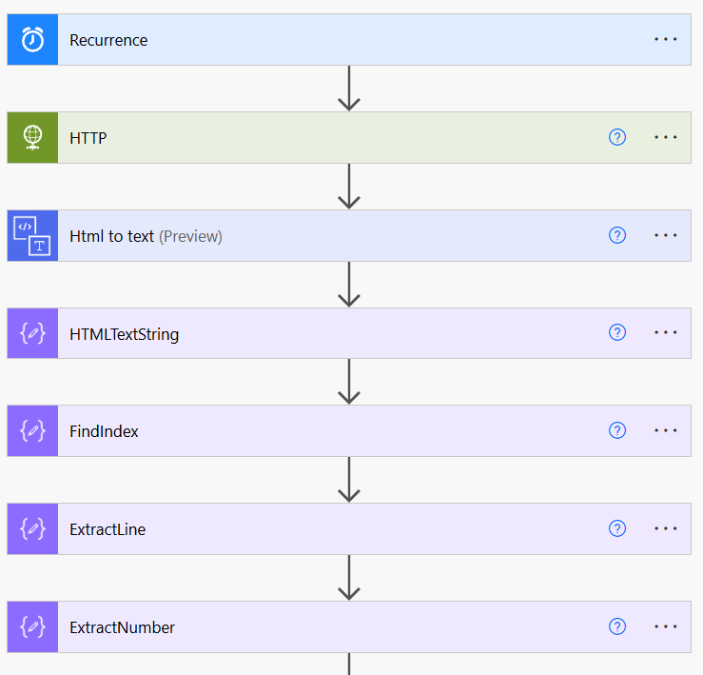
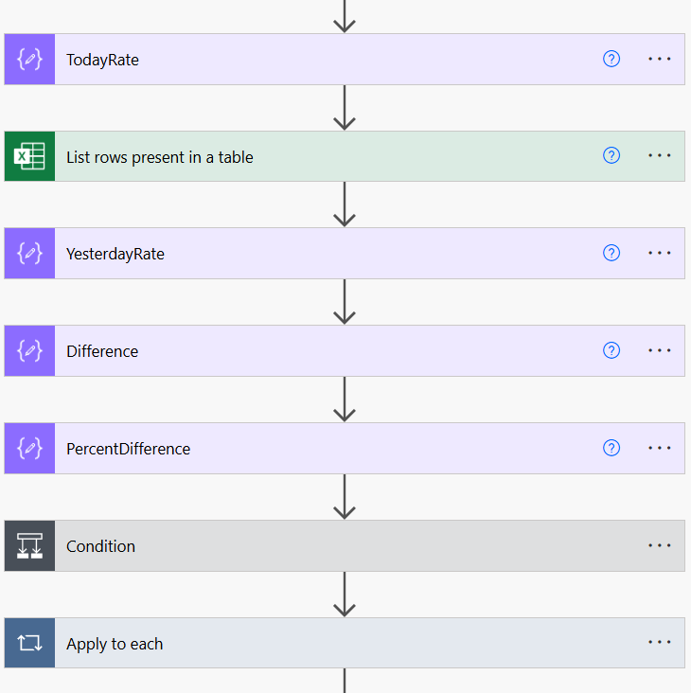

Purpose:
This document explains each expression used in automation.

Step 1:
This step is setting up of an Automatic recurrence trigger. This is designed in such a way that it automatically triggers the flow every day on 9:30 AM IST.
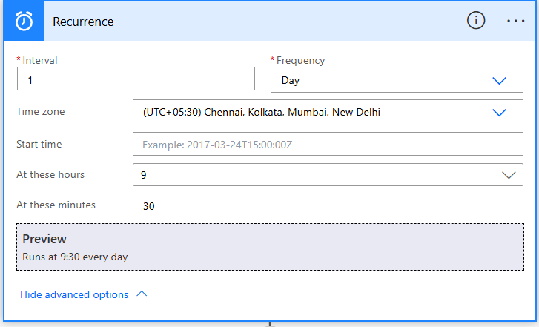

Step 2:
By using the Get method HTTP action we are getting the contents from the source – which is Todays Silver Rate in Chennai, Silver Price on 19 January 2026 - Goodreturns. This is done to do web scrapping in the upcoming tasks.
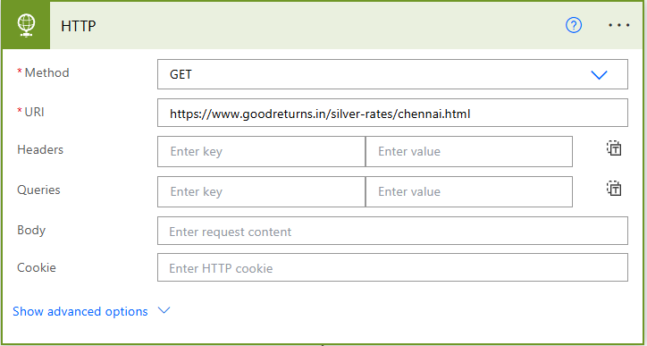

Step 3:
Now, the HTTP sources need to be previewed to Text for that we used HTML to text action in Power Automate.
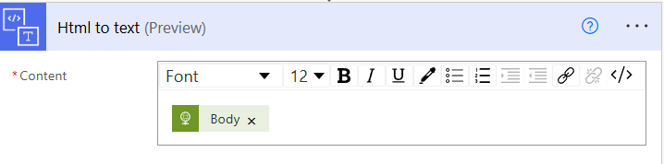

Step 4:
By using HTML Text string action, we are giving the output of the body of the HTML to Text as Input to this Action. This converts into String.
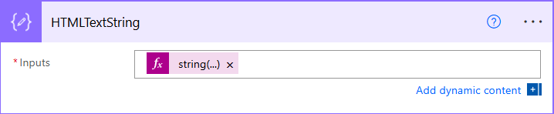
Expression: string(body(‘HTML_to_text’))
Explanation: Converts the extracted HTML content into plain text so it can be processed easily.

Step 5:
From the String we need to find the Exact index where the data is located. It will search for the keyword – ‘Silver /g’
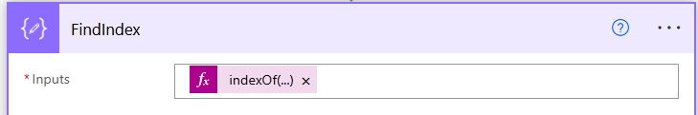
Expression: indexOf(outputs(‘HTMLTextString’), ‘Silver /g’)
Explanation: Finds the position of the text ‘Silver /g’ inside the converted text.

Step 6:
Now we need to extract the selected line from the previous tasks. For that we have used compose action again to capture the output from the previous task.
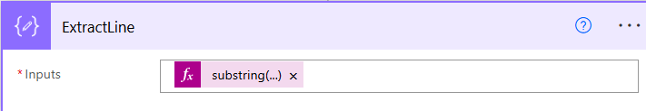
Expression: substring(outputs(‘HTMLTextString’), outputs(‘FindIndex’), 40)
Explanation: Extracts 40 characters starting from where ‘Silver /g’ appears.

Step 7 & 8:
This step is Important because, it extract the number from the site and it places the variable in the newly created compose action named – TodayRate.
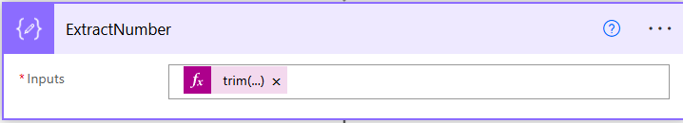
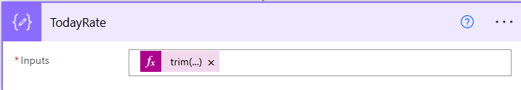
Expression: trim(replace(replace(split(outputs(‘ExtractLine’), ‘₹’)[1], ‘+’, ‘‘), ‘-’, ‘‘))
Explanation:
- Splits the text using the Rupee symbol.
- Takes only the numeric part.
- Removes + and - symbols.
- Removes extra spaces.

Step 9:
An Excel spreadsheet online version was created earlier.
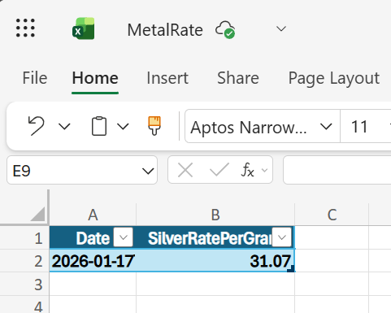
During this task the spreadsheet is checked for the previous day rate and it stores into the Compose variable which is mentioned in Step 10.
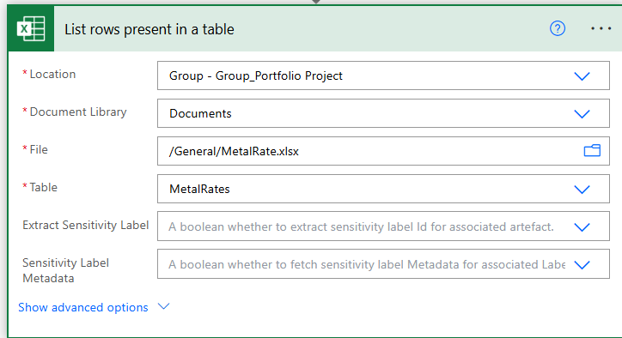

Step 10:
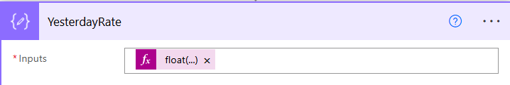
Expression: float(first(body(‘List_rows_present_in_a_table’)?[‘value’])?[‘SilverRatePerGram’])
Explanation: Fetches yesterday’s silver rate from Excel and converts it into a number.

Step 11:
The Difference in the Yesterday’s rate and Today’s rate is calculated and stored here.
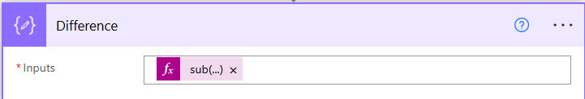
Expression:
sub(float(replace(string(coalesce(outputs(‘TodayRate’),’0’)),’,’,’’)),
float(replace(string(coalesce(outputs(‘YesterdayRate’),’0’)),’,’,’’)))
Explanation: Calculates the difference between today’s and yesterday’s rate.

Step 12:
The Percentage difference is calculated in this step.
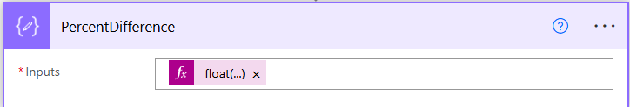
Expression:
float(formatNumber(mul(div(sub(outputs(‘YesterdayRate’), outputs(‘TodayRate’)), outputs(‘YesterdayRate’)),100),’0.00’))
Explanation: Calculates the percentage change between yesterday and today.

Step 13:
If the Today’s price is less than the Yesterday’s price it is considered as the condition satisfies so it goes through Yes branch and sends an Email.
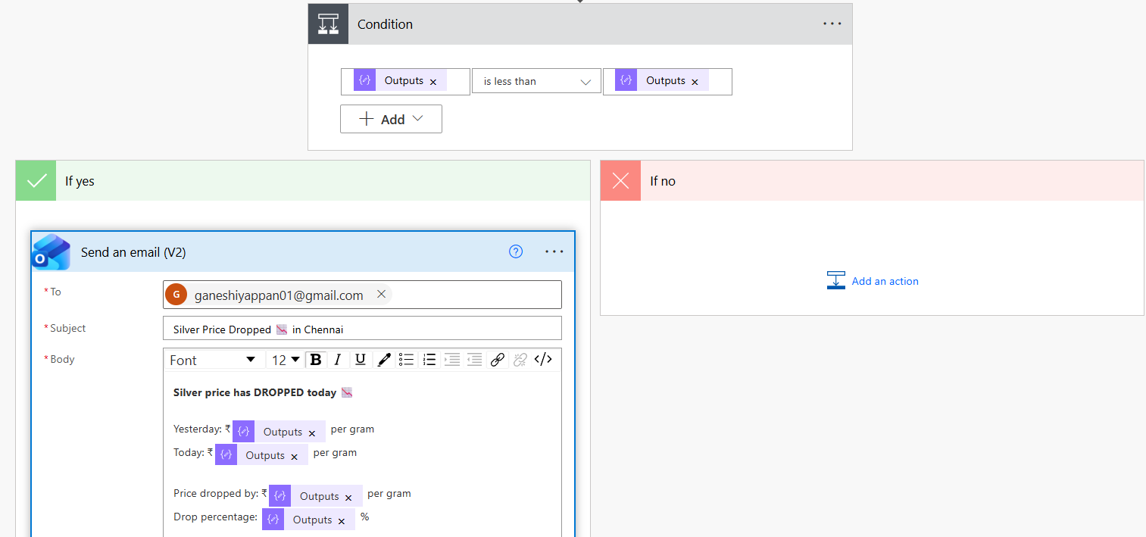

Step 14:
This step will delete the older date data from Excel.
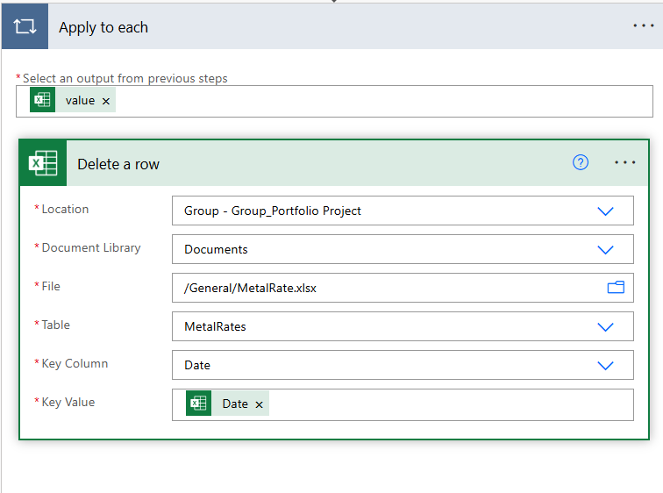

Step 15:
Once after the older data is deleted it needs to be replaced by today’s rate so that It will pick again this rate as Yesterdays rate.
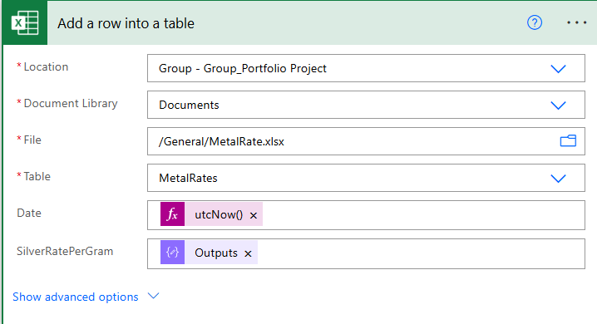

Result:
Once all this condition and tasks satisfy it is considered as success and Automatic email will be triggered.
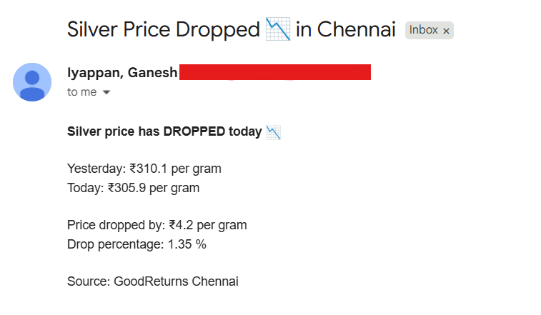
The flow compares silver prices and identifies whether the price increased or decreased.

