# HOSPITAL MANAGEMENT WEBSITE

A Skill Oriented Course Web Application / Project report

Submitted in the partial fulfillment of the requirements for

the award of the degree of

Bachelor of Technology in Computer Science and Engineering by

JAGGINENI GANESH

21761A0590

Under the guidance of

R. Ashok Assistant Professor, Dept. of CSE

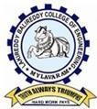

**Department of Computer Science and Engineering**

**Lakireddy Bali Reddy College of Engineering (Autonomous)**

**Accredited by NAAC & NBA (Under Tier - I)**

**Affiliated to JNTUK, Kakinada; ISO 9001:2015 Certified 2021-22**

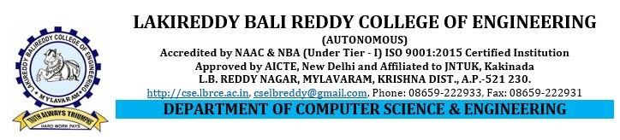

# Certificate

This is to certify that the Skill Oriented Course Web Application / Project entitled

“A hospital alone shows what war is” is being submitted by **JAGGINENI GANESH** in partial fulfillment for the award of B. Tech in Computer Science & Engineering to the Jawaharlal Nehru Technological University Kakinada is a record obonafide work carried out by him/her under our guidance.

The results embodied in this Skill Oriented Course Web Application / Project report have

not been submitted to any other University or Institute for the award of any degree or diploma.

**Project Guide Head of the department**

Mr. R. Ashok Dr.D.Veeraiah

Assistant Professor Professor

**External Examiner**

**ACKNOWLEDGEMENT**

I would like to thank **Mr. R.Ashok** Assistant Professor**,** CSE department for the encouraging and support in carrying out this Skill Oriented Course Web Application / Project.

I also take the privilege to record my thanks to **Dr. D. Veeraiah,** Professor, Head of the Department of CSE whose encouragement, cooperation and valuable support crown my success.

I express my thanks to the support given by management in completing my Web

Application / Project. I also express my sincere gratitude & deep sense of respect to the Principal, **Dr.K. Appa Rao** for making us available all the required assistance and his support and inspiration to carry out this Skill Oriented Course Web Application / Project in the Institute.

I am thankful to the teaching and non-teaching staff of CSE department for their direct as

well as indirect help in my Skill Oriented Course Web Application / Project.

I am elated to avail my selves to this opportunity to express my deep sense of gratitude to

my parents.

i

# HOSPITAL MANAGEMENT SYSTEM

**Abstract**

Our project Hospital Management system includes registration of patients, storing their details into the system, and also booking their appointments with doctors. Our software has the facility to give a unique id for every patient and stores the details of every patient and the staff automatically. User can search availability of a doctor and the details of a patient using the id. The Hospital Management System can be entered using a username and password. It is accessible either by an administrator or receptionist. Only they can add data into the database. The data can be retrieved easily. The interface is very user-friendly. The data are well protected for personal use and makes the data processing very fast. It is having mainly two modules. One is at Administration Level and other one is of user I.e. of patients and doctors. The Application maintains authentication in order to access the application. Administrator task includes managing doctors information, patient’s information. To achieve this aim a database was designed one for the patient and other for the doctors which the admin can . The complaints which are given by user will be referred by authorities. The Patient modules include checking appointments, prescription. User can also pay doctor’s Fee online.

ii