CASE STUDY REPORT

BIS Smart Assistant
SUBMITTED BY:

Name: R. Teja - 160124748056

Name: K.Ganesh - 160124748302

Name: MD.Sohail Ahmed - 160124748307

Branch: CSE (AI&ML) Semester: V

SUBMITTED TO:

Ms. Falak Naaz
Department of Computer Science and Engineering (Artificial Intelligence and Machine Learning) (CSE&AI&Ml)

CHAITANYA BHARATHI INSTITUTE OF TECHNOLOGY (A)
(Affiliated to Osmania University) Gandipet, Hyderabad - 500075

DATE: 25/08/2026
Case Study: AI-Powered Intelligent Assistant for Indian Standards and BIS Services for Industries and Consumers

1. Introduction
The Bureau of Indian Standards (BIS) publishes thousands of Indian Standards and provides a wide range of services, including product certification, hallmarking, laboratory recognition, Standards Clubs, training, consumer affairs, and conformity assessment. At present, industries, MSMEs, startups, students, and consumers find it difficult to identify the applicable Indian Standards for their products, the certification requirements, relevant BIS schemes, licensing procedures, testing requirements, related standards, and answers to general technical queries. Searching across multiple documents, portals, and PDFs is time-consuming and often leads to incomplete or incorrect information.
This case study is important in the context of full stack development because it demonstrates how a modern web application can be combined with an AI/RAG (Retrieval-Augmented Generation) layer to deliver accurate, context-aware, and source-backed answers, instead of relying purely on static keyword search. The problem statement, "AI-powered Intelligent Assistant for Indian Standards and BIS Services for Industries and Consumers", was released under the Ministry of Consumer Affairs, Food & Public Distribution, Department of Consumer Affairs (DoCA), and requires a conversational assistant that understands natural-language queries, retrieves information from authorised BIS knowledge sources, and responds with references to the applicable documents or clauses.
Real-world applications of such a system include regulatory-compliance assistants for government departments, product-certification advisory bots for MSMEs and startups, consumer helpdesks for hallmarking and quality queries, and multilingual self-service portals that reduce the load on human help desks.

2. Methods Compared
Two broad approaches to building this assistant are compared: an AI/RAG-driven full stack architecture and a traditional full stack (portal + keyword search) architecture.
- RAG-based Conversational Full Stack (proposed solution) – Combines a React.js client, a Node.js/Express REST API layer, and a Python/FastAPI “AI Core” that runs a LangChain-based Retrieval-Augmented Generation (RAG) pipeline over embedded BIS documents, returning natural-language answers with citations.
- Traditional Web Stack (baseline for comparison) – A conventional portal where users manually browse or keyword-search a database/PDF repository of standards; the frontend and backend use separate, loosely-integrated technologies with no natural-language understanding layer.
- Vector Database Retrieval vs Relational/Keyword Search – Comparing similarity search over embeddings (ChromaDB) against traditional SQL “LIKE”/full-text search for locating relevant standards and clauses.
Technologies referenced:
- React.js – Frontend UI (Chat Interface and PDF Viewer)
- Node.js / Express.js – Backend REST API layer (routing, authentication, controllers)
- Python / FastAPI – AI Core service hosting the LangChain / RAG pipeline
- BGE Embedding Model – Converts document text into vector embeddings
- ChromaDB – Vector database for semantic similarity search
- MongoDB (GridFS + Collections) – Document storage (original PDFs, chunks) and metadata storage (user profiles, chat history, document metadata map)

3. Architecture
The proposed system follows a five-layer architecture, shown in the diagram below, that separates concerns between presentation, API orchestration, AI/retrieval, and storage.
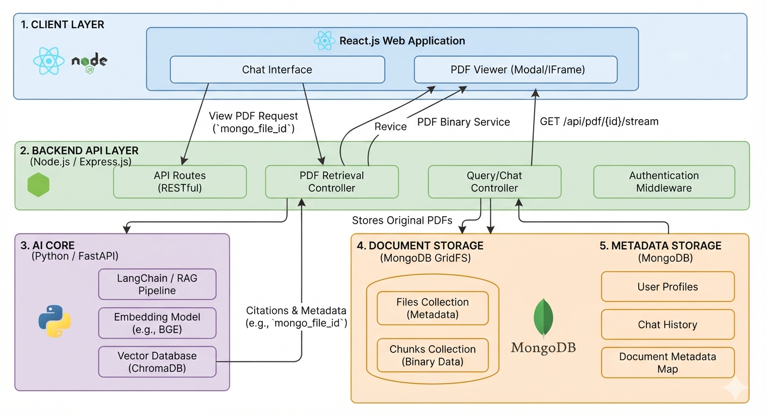
Figure 1: Five-layer architecture of the BIS Intelligent Assistant
- Client Layer (React.js) – A Chat Interface for natural-language queries and a PDF Viewer (modal/iframe) for viewing the referenced standard document.
- Backend API Layer (Node.js / Express.js) – Exposes RESTful API Routes, a PDF Retrieval Controller, a Query/Chat Controller, and Authentication Middleware that together orchestrate requests between the client, the AI Core, and storage.
- AI Core (Python / FastAPI) – Runs the LangChain/RAG pipeline: the user query is embedded using the BGE embedding model, matched against the ChromaDB vector database, and the most relevant chunks/citations (with their mongo_file_id) are returned to the Query/Chat Controller.
- Document Storage (MongoDB GridFS) – Stores the original PDF standards as binary data, organised into a Files Collection (metadata) and a Chunks Collection (binary data) for efficient retrieval and streaming.
- Metadata Storage (MongoDB) – Stores User Profiles, Chat History, and the Document Metadata Map used to link chat responses back to the correct source document.
Example Flow:
- 1. The user types a natural-language query in the Chat Interface (e.g., “What standard applies to LED bulbs?”).
- 2. The React app sends the request through the API Routes to the Query/Chat Controller.
- 3. The Query/Chat Controller forwards the query to the AI Core, where the RAG pipeline embeds the query and performs a similarity search in ChromaDB.
- 4. The AI Core returns the answer along with citations and metadata (e.g., mongo_file_id) to the Query/Chat Controller.
- 5. The Query/Chat Controller logs the interaction to Chat History (Metadata Storage) and sends the response back to the Chat Interface.
- 6. If the user wants to view the source document, the PDF Retrieval Controller streams the original PDF from Document Storage (GridFS) to the PDF Viewer via GET /api/pdf/{id}/stream.

4. Implementation
The Client Layer was implemented in React. The Chat Interface component sends the user's query to the Backend API and renders the answer with clickable citation chips; the PDF Viewer component slides in to show the cited clause and streams the full document from MongoDB GridFS via the Backend API. The corresponding Express controller on the Backend API Layer orchestrates the call to the AI Core and logs each exchange to Chat History.
src/components/ChatInterface.jsx — Chat Interface (Client Layer)
// src/components/ChatInterface.jsx
import { useState, useRef, useEffect } from "react";
import "./chat-interface.css";

/**
* Chat Interface (Client Layer)
* - Sends the user's natural-language query to the Backend API's
* Query/Chat Controller (POST /api/chat).
* - Renders the assistant's answer along with citation chips.
* - Clicking a citation chip opens the PdfViewer with the cited
* mongo_file_id and highlights the referenced clause.
*/
export default function ChatInterface({ onOpenSource }) {
const [messages, setMessages] = useState([]);
const [input, setInput] = useState("");
const [loading, setLoading] = useState(false);
const threadRef = useRef(null);

useEffect(() => {
threadRef.current?.scrollTo(0, threadRef.current.scrollHeight);
}, [messages]);

async function sendMessage() {
const query = input.trim();
if (!query) return;

setMessages((prev) => [...prev, { role: "user", text: query }]);
setInput("");
setLoading(true);

try {
const res = await fetch("/api/chat", {
method: "POST",
headers: { "Content-Type": "application/json" },
body: JSON.stringify({ query }),
});
const data = await res.json(); // { answer, citations: [{ label, mongo_file_id, clause }] }

setMessages((prev) => [
...prev,
{ role: "assistant", text: data.answer, citations: data.citations },
]);
} catch (err) {
setMessages((prev) => [
...prev,
{ role: "assistant", text: "Sorry, I couldn't reach the assistant service. Please try again.", citations: [] },
]);
} finally {
setLoading(false);
}
}

return (
<main className="chat-main">
<header className="topbar">
<div>
<h1>Product Certification</h1>
<p className="sub">Ask about applicable standards, certification schemes and timelines</p>
</div>
<span className="badge">Source-verified answers</span>
</header>

<div className="thread" ref={threadRef}>
{messages.map((m, i) => (
<div key={i} className={`msg ${m.role}`}>
{m.role === "assistant" && <div className="who">BIS Sahayak</div>}
<div className="bubble">{m.text}</div>

{m.citations?.length > 0 && (
<div className="sources">
{m.citations.map((c) => (
<button
key={c.mongo_file_id + c.clause}
className="cite-chip"
onClick={() => onOpenSource(c)}
>
<span className="mini-seal" />
{c.label} · {c.clause}
</button>
))}
</div>
)}
</div>
))}
{loading && <div className="msg assistant"><div className="bubble">Thinking…</div></div>}
</div>

<form
className="composer"
onSubmit={(e) => {
e.preventDefault();
sendMessage();
}}
>
<div className="composer-box">
<textarea
rows={1}
value={input}
placeholder="Ask about a standard, scheme or certification process…"
onChange={(e) => setInput(e.target.value)}
onKeyDown={(e) => {
if (e.key === "Enter" && !e.shiftKey) {
e.preventDefault();
sendMessage();
}
}}
/>
<button type="button" className="icon-btn" title="Voice input">🎙</button>
<button type="submit" className="send-btn" title="Send">➤</button>
</div>
<p className="hint">Answers are generated from official BIS documents and always include a source reference.</p>
</form>
</main>
);
}

src/components/PdfViewer.jsx — PDF Viewer panel (Client Layer)
// src/components/PdfViewer.jsx
import "./pdf-viewer.css";

/**
* PDF Viewer (Client Layer — Modal / slide-in panel)
* - Receives the citation the user clicked (mongo_file_id, clause).
* - Streams the source PDF from the Backend API's PDF Retrieval
* Controller: GET /api/pdf/{mongo_file_id}/stream
* - `source` = { label, mongo_file_id, clause, page, snippet }
*/
export default function PdfViewer({ source, onClose }) {
if (!source) return null;

const streamUrl = `/api/pdf/${source.mongo_file_id}/stream#page=${source.page ?? 1}`;

return (
<aside className="pdf-panel open">
<div className="pdf-head">
<div>
<div className="pdf-title">{source.label}</div>
<div className="pdf-sub">{source.subtitle}</div>
</div>
<button className="close-btn" onClick={onClose}>✕</button>
</div>

<div className="pdf-doc">
{/* Inline preview of the cited clause, returned by the RAG pipeline */}
<div className="doc-page">
<div className="doc-num">Page {source.page} of {source.totalPages}</div>
<h2>{source.clauseTitle}</h2>
<div className="doc-code">{source.label} · Clause {source.clause}</div>
<p dangerouslySetInnerHTML={{ __html: source.snippet }} />
</div>
</div>

<div className="pdf-foot">
{/* Falls back to the full PDF stream/iframe for the complete document */}
<a className="open-full" href={streamUrl} target="_blank" rel="noreferrer">
Open full document ↗
</a>
</div>
</aside>
);
}

src/App.jsx — composes the Sidebar, Chat Interface and PDF Viewer
// src/App.jsx
import { useState } from "react";
import ChatInterface from "./components/ChatInterface";
import PdfViewer from "./components/PdfViewer";
import Sidebar from "./components/Sidebar";

export default function App() {
const [activeSource, setActiveSource] = useState(null);

return (
<div className="app">
<Sidebar />
<ChatInterface onOpenSource={setActiveSource} />
<PdfViewer source={activeSource} onClose={() => setActiveSource(null)} />
</div>
);
}

server/controllers/chatController.js — Query/Chat & PDF Retrieval Controllers (Backend API Layer)
// server/controllers/chatController.js (Backend API Layer — Node.js/Express)
const { runRagPipeline } = require("../services/aiCoreClient"); // calls the FastAPI AI Core
const ChatHistory = require("../models/ChatHistory");

// POST /api/chat
exports.handleChatQuery = async (req, res) => {
try {
const { query } = req.body;
const userId = req.user?.id;

// 1. Forward the query to the AI Core (Python/FastAPI RAG pipeline)
const { answer, citations } = await runRagPipeline(query);
// citations: [{ label, mongo_file_id, clause, page, snippet }]

// 2. Persist the exchange to Metadata Storage (Chat History)
await ChatHistory.create({ userId, query, answer, citations, at: new Date() });

// 3. Return the answer with source references to the client
res.json({ answer, citations });
} catch (err) {
res.status(500).json({ error: "Unable to process query at this time." });
}
};

// GET /api/pdf/:id/stream (PDF Retrieval Controller)
const { getGridFsBucket } = require("../lib/mongoGridFs");

exports.streamPdf = async (req, res) => {
const bucket = getGridFsBucket();
res.set("Content-Type", "application/pdf");
bucket.openDownloadStream(req.params.id)
.on("error", () => res.status(404).end())
.pipe(res);
};

5. Results
The screenshots below show the working Chat Interface for the Product Certification topic, styled to match the architecture in Figure 1. The assistant answers in natural language and attaches source-backed citation chips (e.g. IS 16102 (Part 1):2020 · §4.2); clicking a chip opens the PDF Viewer panel, which highlights the exact clause the answer was drawn from.
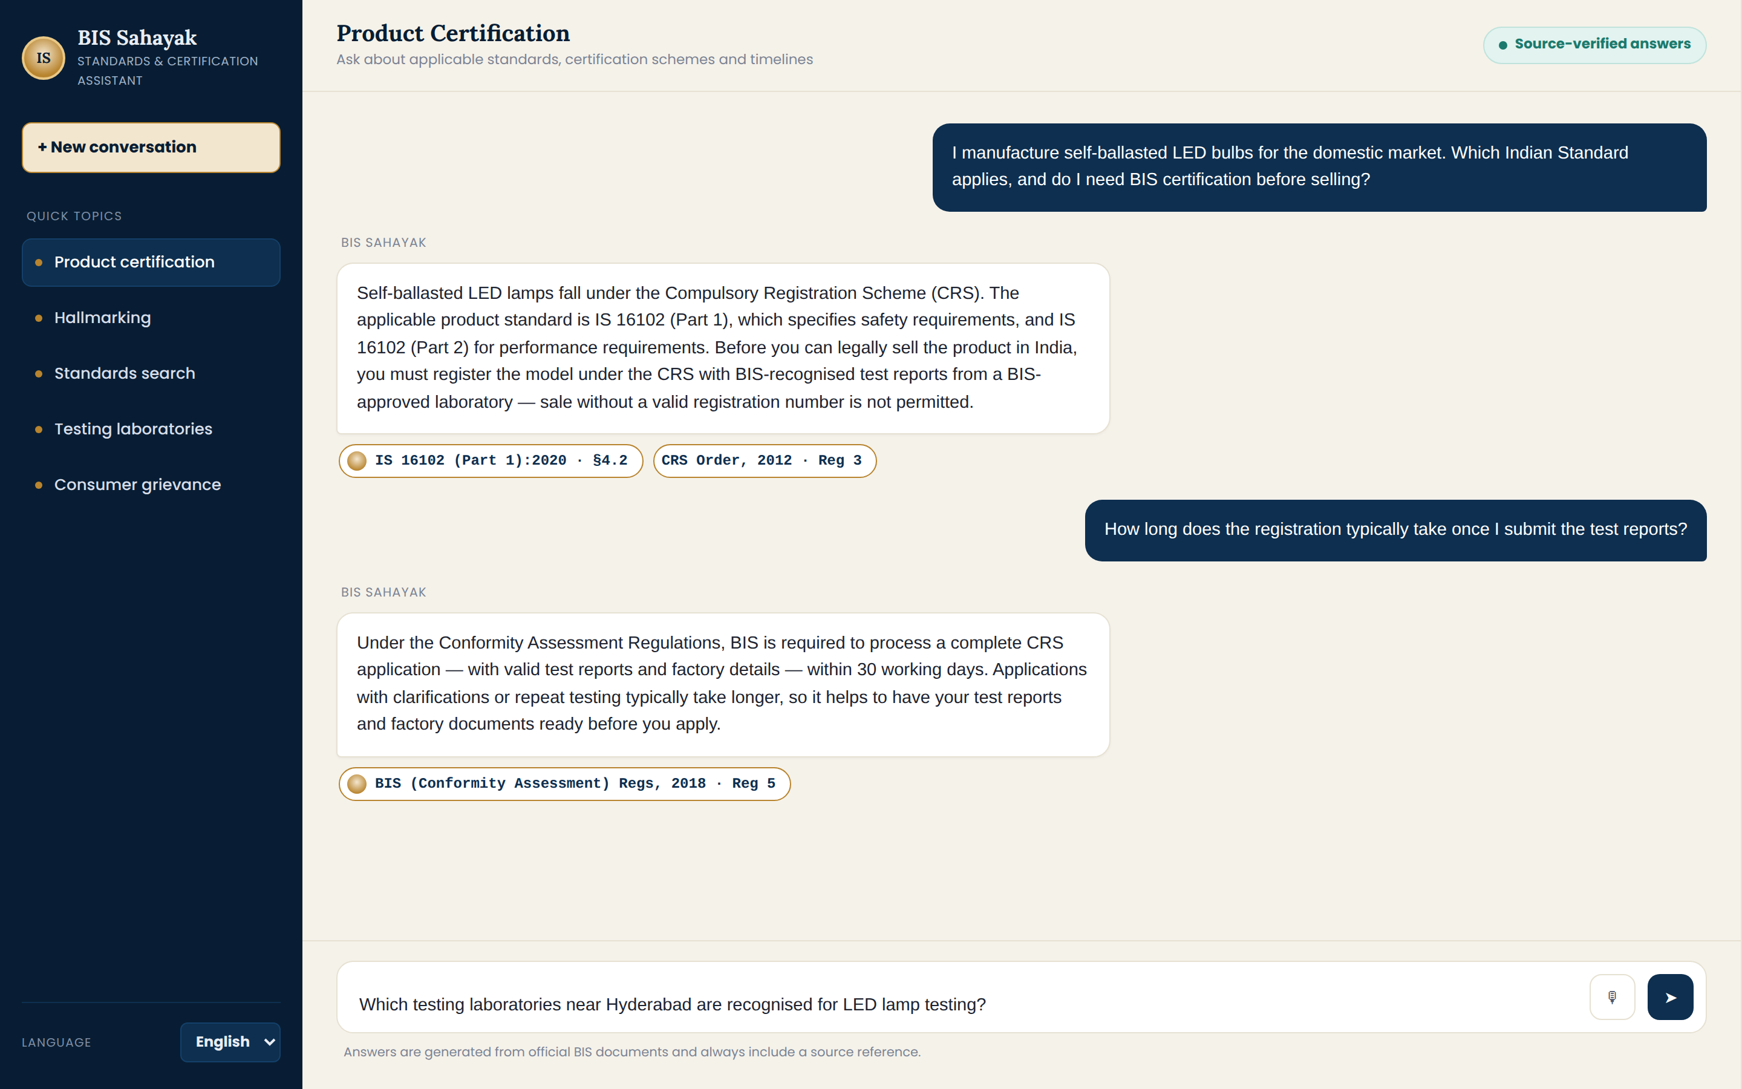
Figure 2: Chat Interface — multi-turn conversation with source-backed citation chips
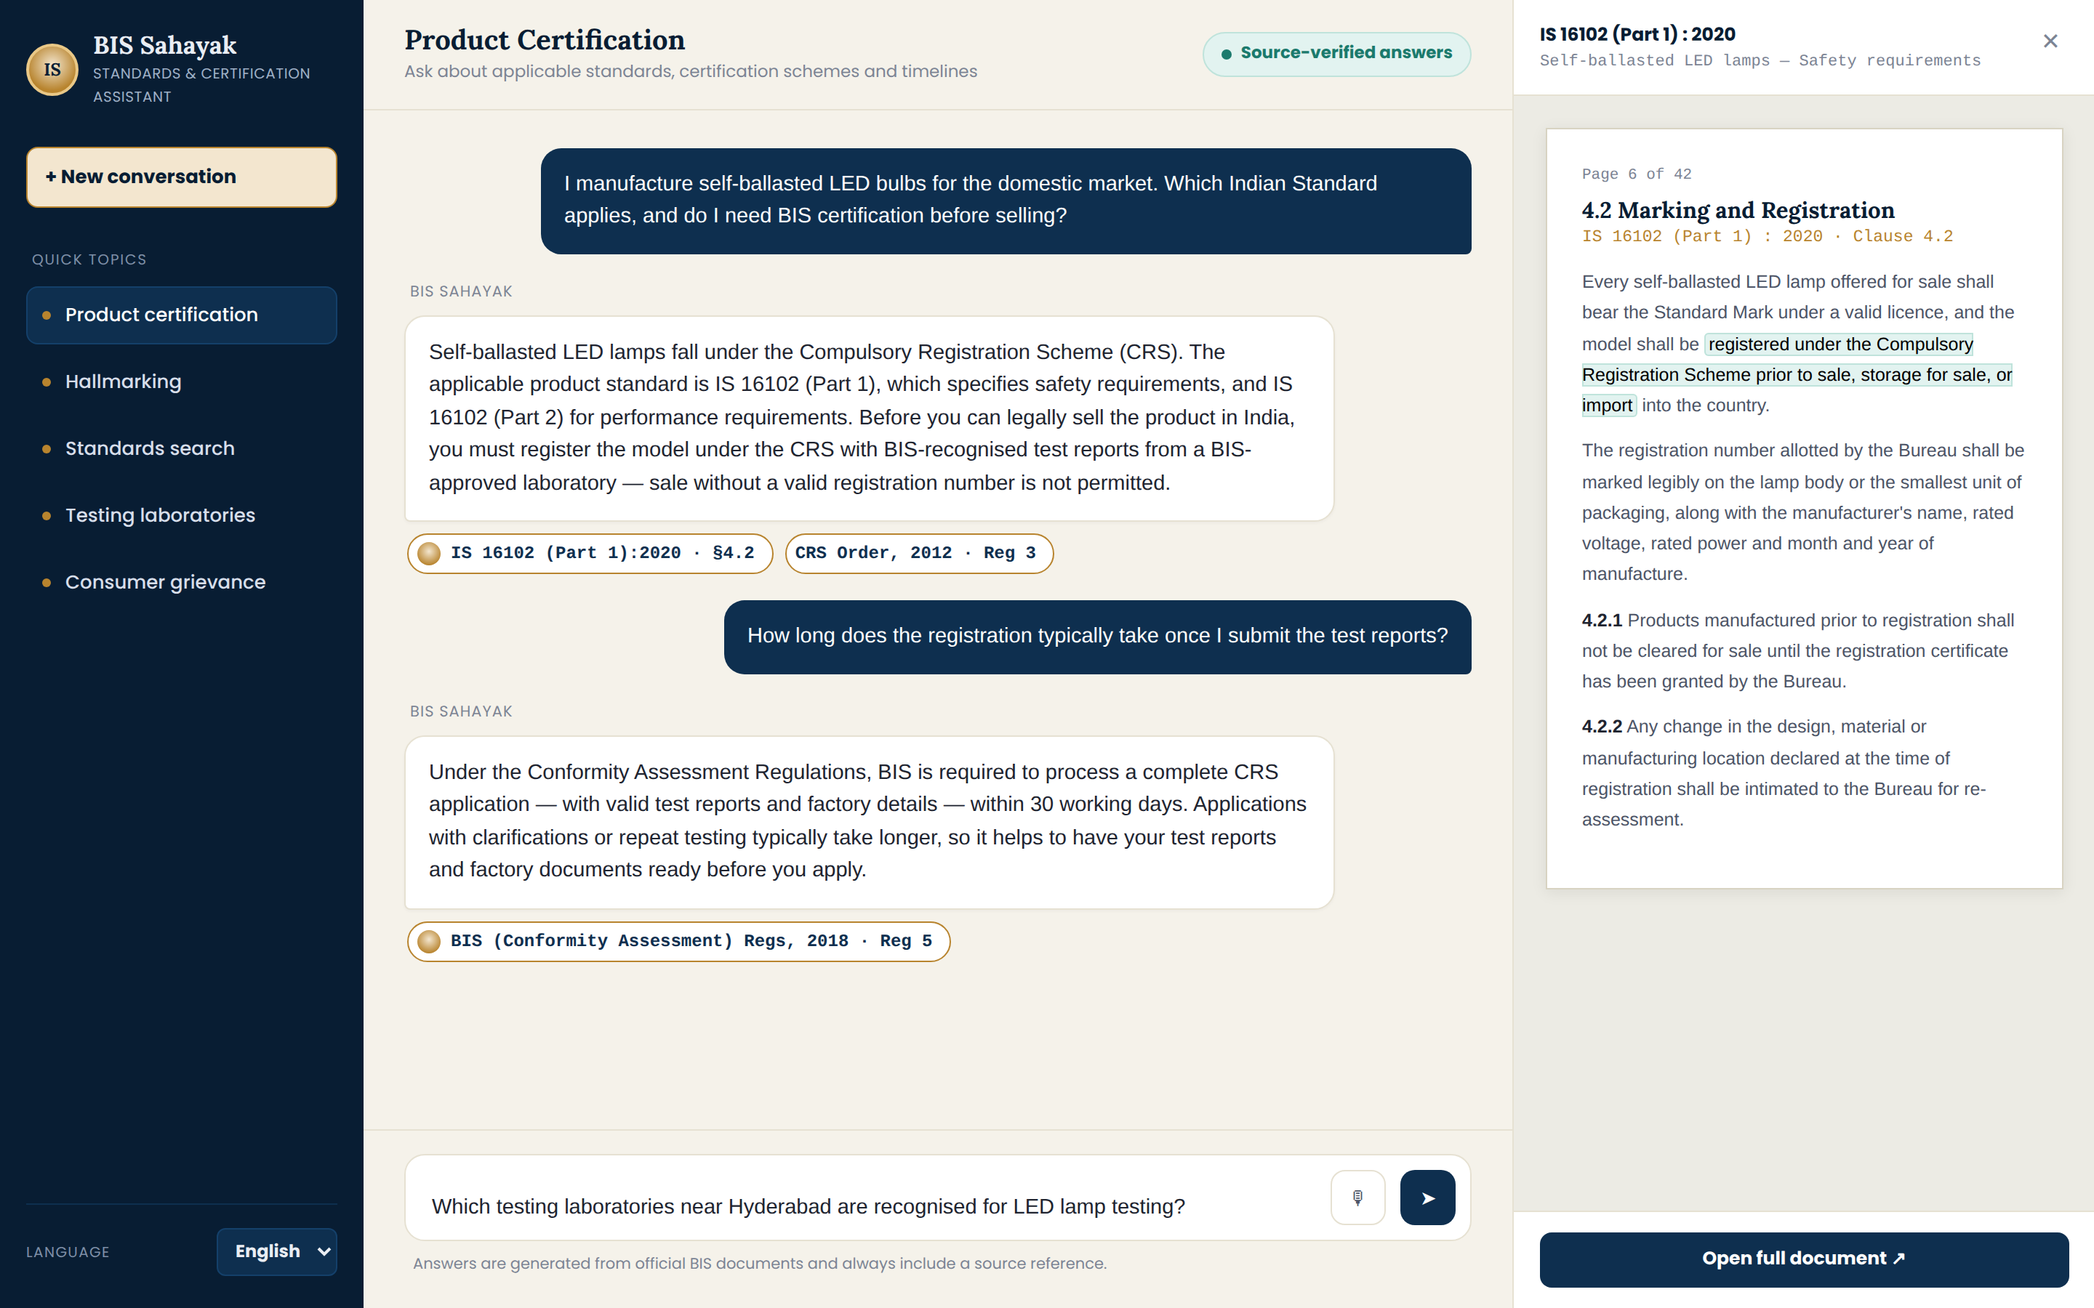
6. Conclusion
The RAG-based full stack architecture demonstrates clear advantages over a traditional portal-based search system for a knowledge-intensive domain such as BIS standards: it understands natural-language queries, retrieves semantically relevant content instead of exact keyword matches, and returns source-backed citations that build user trust. The layered design (Client, Backend API, AI Core, Document Storage, Metadata Storage) keeps the system modular, allowing the AI Core to be upgraded independently (e.g., swapping embedding models or vector databases) without impacting the client or API layers.
Future scope includes adding multilingual query support, integrating BIS certification-scheme recommendation logic based on product descriptions, connecting to a live directory of testing laboratories, and adding conversational memory for multi-turn certification guidance.

