For keyboard actions
https://demoqa.com/text-box
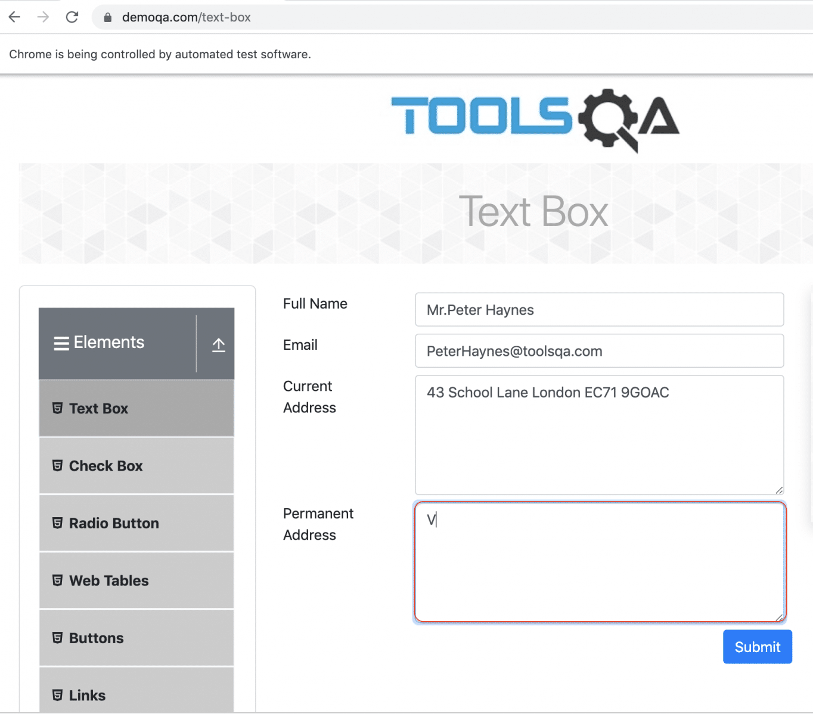

Note:
Fill values for Full name, Email and Current Address
Copy the contents of Current Address to Permanent Address

