Write a program to automate the following website and implement Page object Model design pattern.
https://www.saucedemo.com/

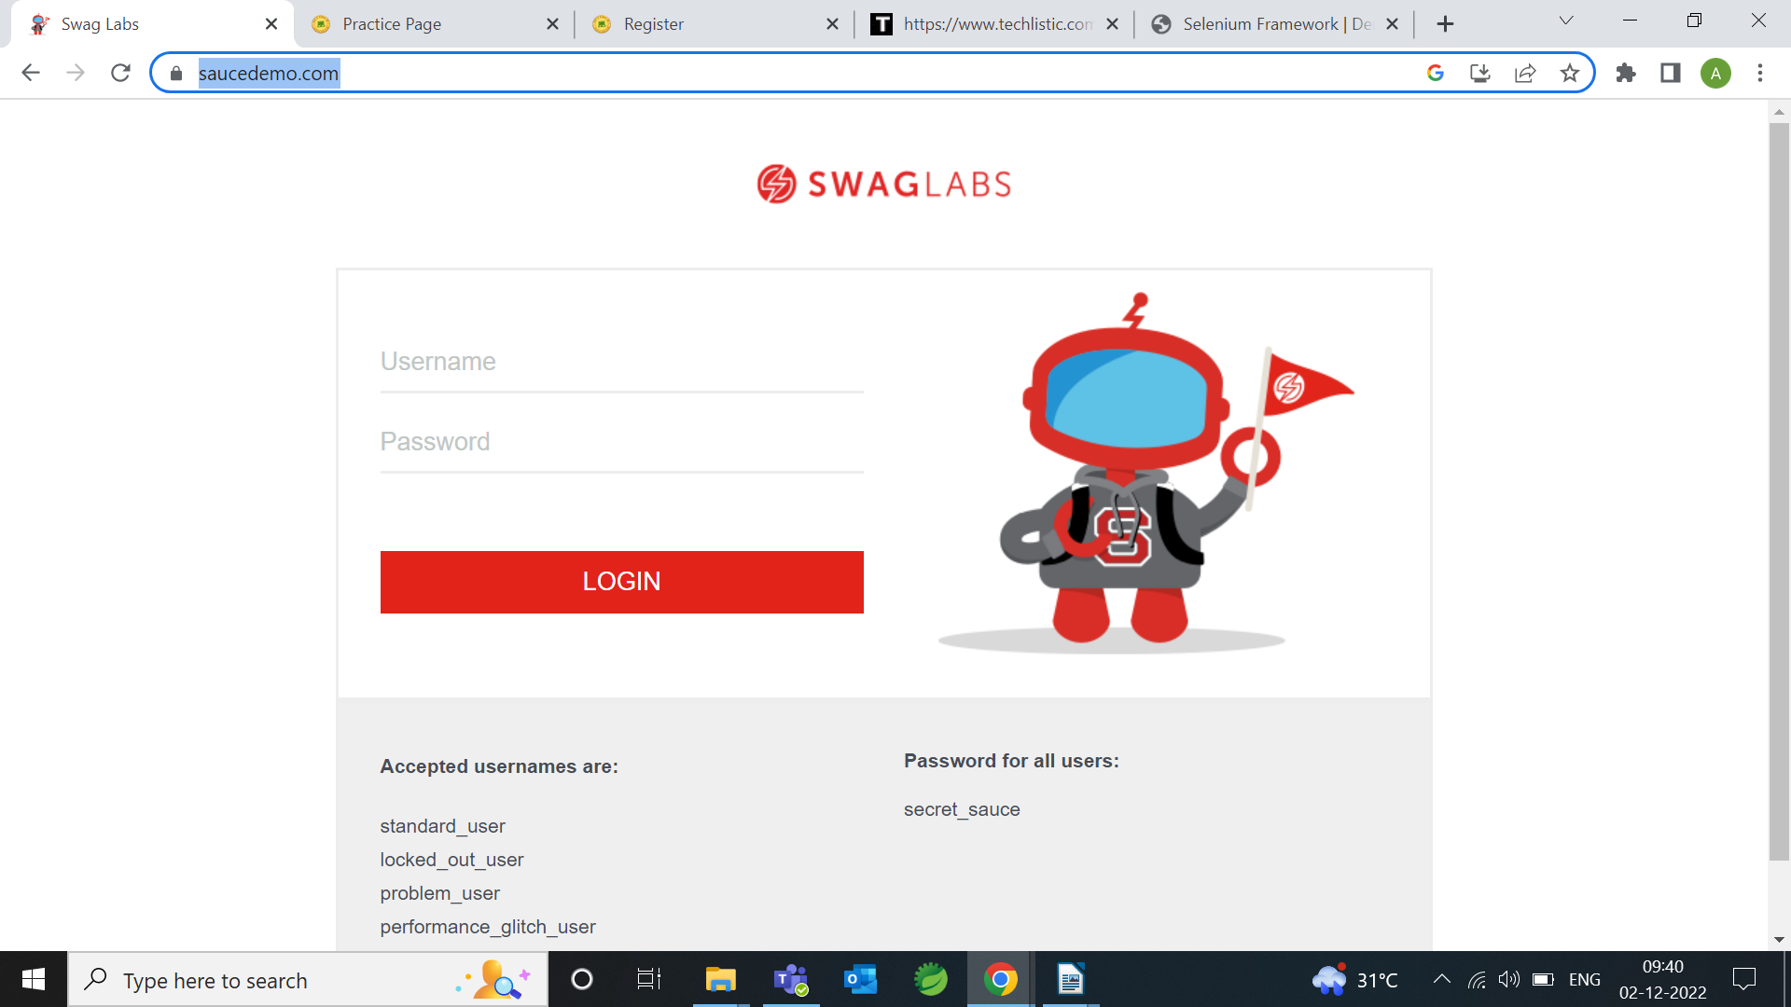

i. Launch the Page
ii. Enter the username after checking the field is enabled/not and check whether username entered is correct or not
iii. Enter the password after checking the field is enabled/not and check whether password entered is correct or not
iv. Press login after checking the field is enabled/not
v. Verify the new Page Url contains https://www.saucedemo.com/inventory.html
vi. Check whether you have element name Products in the navigated page
Vii. Check the number products in the pages is equivalent to 6.
viii. Add few products into the cart and goto cart menu
ix. Checkout the details by filling the details in the form, before filling check the element is enabled/not and after filling ensure that you have entered correct data.
x. Click on Finish button and Back Home button after checking the field is enabled/not
xi. Do a page level testing to ensure that you landed up in a Product Home page.
Xii. Finally click logout button to logout from the application after checking logout element is enabled/not

