Write a playwright test scripts to automate the below site, read test data from excel/DB/JSON file and generate various reports like List,Line, Dot, JSON, Junit, HTML and Allure.
https://training.openspan.com/login
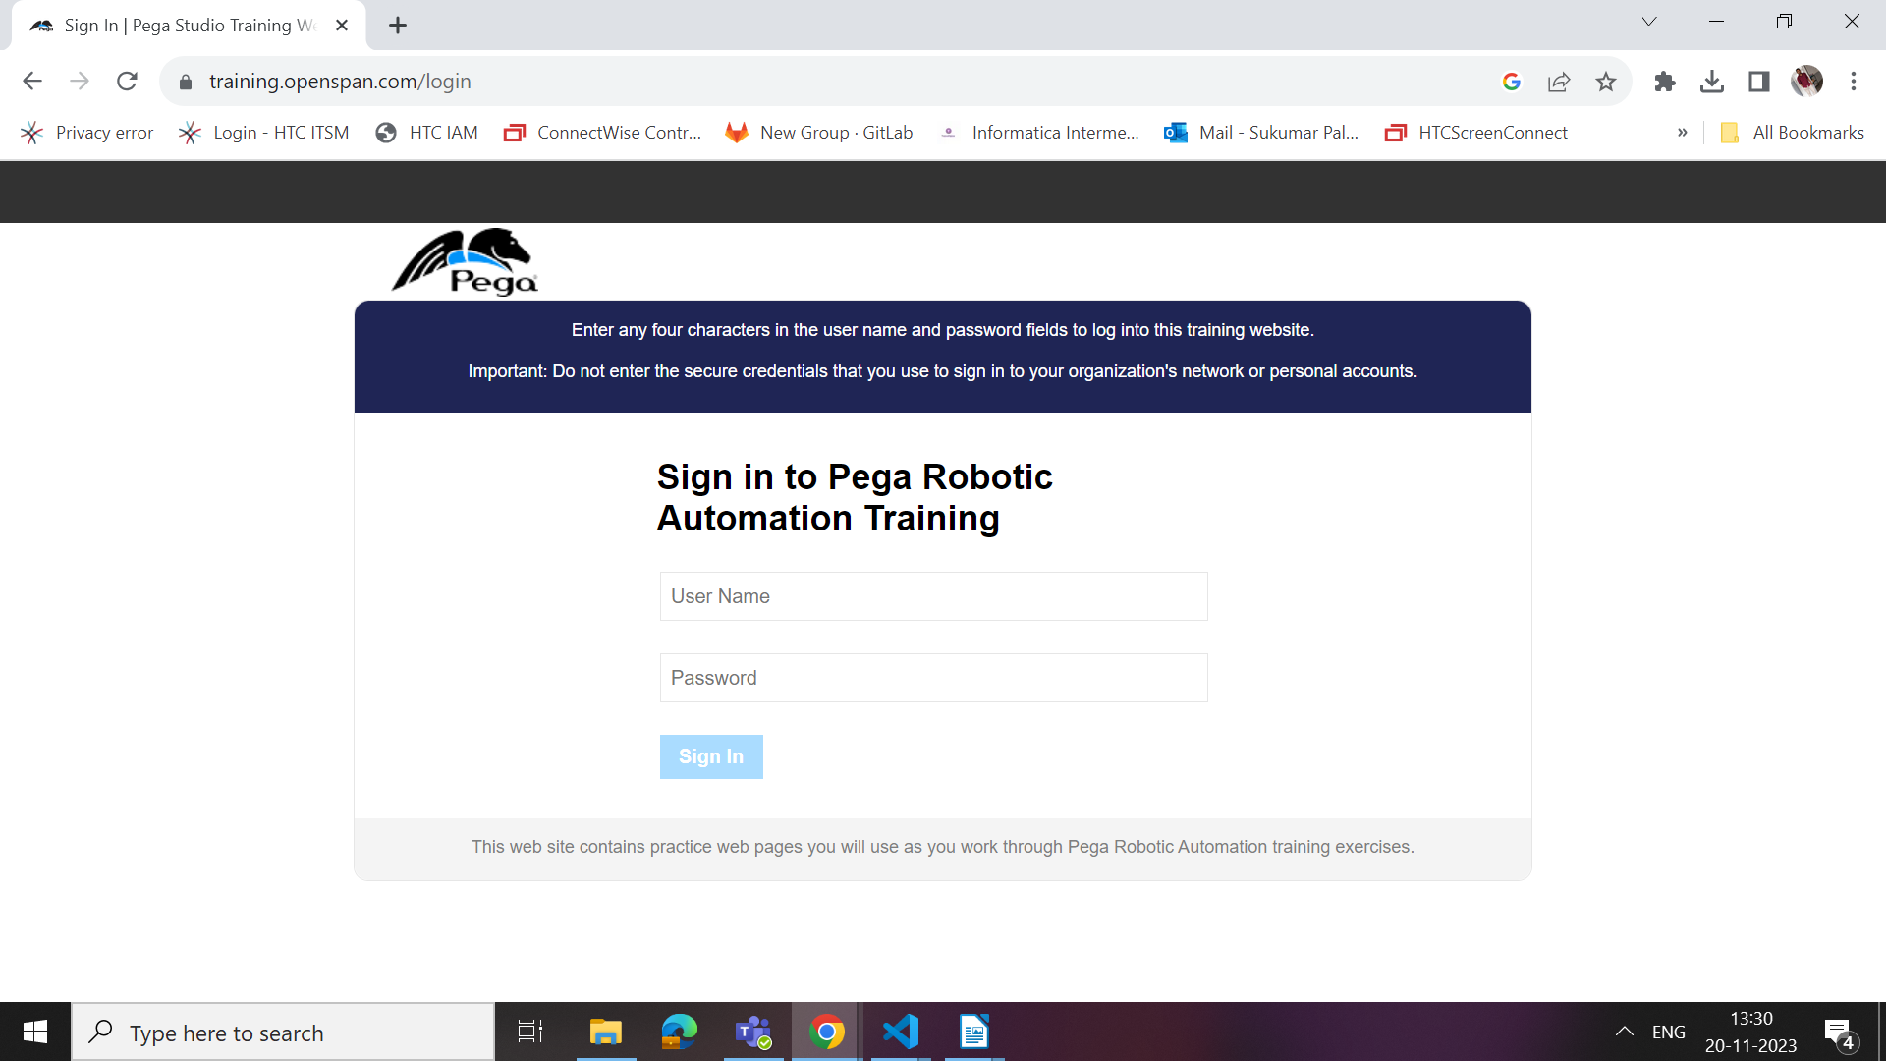
i. Launch the Page
ii. Enter the username after checking the field is enabled/not and check whether username entered is correct or not
iii. Enter the password after checking the field is enabled/not and check whether password entered is correct or not
iv. Press login after checking the field is enabled/not
v. Verify the new Page Url contains https://training.openspan.com/home
vi. Check whether you have logged in with correct username in the navigated page
vii. Check the number of product types and products of each category
viii. Select product type and product name and click on view details after checking the field is enabled/not
ix. Select the Quantity and make an order and repeat the process of ordering based on requirements
x. Click on cart menu and place your order by clicking next button after checking the field is enabled/not
xi. Fill the billing and shipping address by reading the details from excel/db/json file and before filling check the element is enabled/not and after filling ensure that you have entered correct data.
xii. Select the payment type, fill necessary details and click submit after checking the field is enabled/not
xiii. Verify the successful order message ‘Thank you for placing an order with ACME! ’
xiv. Finally click logout button to logout from the application after checking logout element is enabled/not
xv. Do a page level testing to ensure that you landed up in a login page.

