Write a playwright test script to automate input box, radio button and check box.

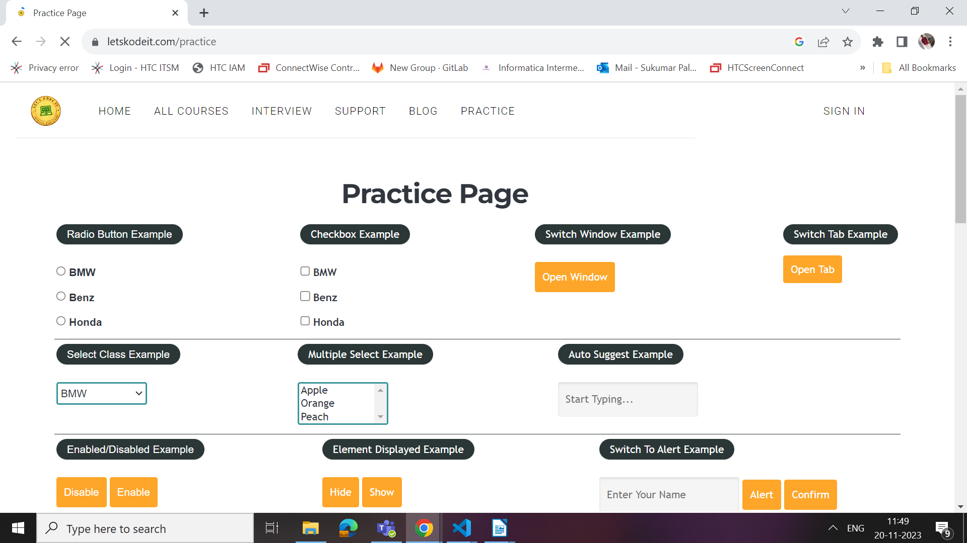

Note:
- Try to select particular radio button and add possible assertions
- Try to fill some value in the any available input boxes and add all possible assertions before and after filling the values
- Try these following actions with check box and add all possible assertions
- select specific check box
- select all check boxes
- select specific set of check boxes

